Exploratory Data Analysis Report
Children's Screen Time & Digital Health Impact
Prepared by
Neha Bhatt
Junior HR Data Analyst Intern
Dataset: Kids_Screen_Time.csv | 9,712 Records | India
August 2026

1. Executive Summary
This report presents an exploratory data analysis (EDA) of screen time behaviour among 9,712 Indian children aged 8 to 18, drawn from the Kids_Screen_Time dataset. The analysis examines how age, gender, primary device, and residential setting (urban or rural) relate to daily screen time and self-reported digital health impacts, with the goal of informing parents, educators, and policymakers on healthier screen usage guidelines.
The dataset shows that the overwhelming majority of children exceed recommended screen time limits, and that exceeding those limits is strongly linked to a higher rate of reported health impacts such as poor sleep, eye strain, anxiety, and obesity risk. Four headline figures summarise the scale of the issue:
4.35 hrs  Average daily screen time | 85.5%  Children exceeding recommended limit | 66.9%  Reporting at least one health impact | 50.1%  Reporting poor sleep

Screen time rises with age, smartphones are the most-used device, and children who exceed recommended limits are markedly more likely to report negative health effects than those who stay within them. Notably, this dataset shows only marginal differences in screen time by gender or by urban/rural setting, suggesting that in this sample, usage patterns and their health associations cut across those demographic lines rather than being concentrated in any one group.

2. Introduction & Objective

2.1 Background
Excessive screen time among children is a growing healthcare concern. Prolonged exposure to screens is associated with physical issues such as eye strain, headaches, poor posture, and disrupted sleep cycles caused by blue light exposure. Psychologically, it may contribute to anxiety, attention problems, and reduced social interaction, while also correlating with a more sedentary lifestyle and an elevated risk of obesity.

2.2 Objective
The objective of this EDA project is to analyse the Kids_Screen_Time dataset to identify patterns, relationships, and insights related to children's screen usage, its association with health, and the demographic and behavioural factors that contribute to it. The analysis is intended to help parents, educators, and policymakers understand the current landscape of screen time among Indian children and to inform further research or intervention design.

2.3 Tools Used
- Python (Jupyter Notebook)
- Pandas & NumPy — data loading, cleaning, and aggregation
- Matplotlib & Seaborn — data visualisation

3. Dataset Overview
The dataset “Kids_Screen_Time.csv” contains 9,712 records and 8 columns describing children aged 8 to 18. After removing rows with missing core fields, the working dataset used for this analysis retained all 9,712 records; only the Health_Impacts field contains blanks, which were treated as “None” (no reported health impact).
Column | Description
Age | Age of the child in years (Integer, range 8–18)
Gender | Gender of the child (Male / Female)
Avg_Daily_Screen_Time_hr | Average daily screen time in hours (Float)
Primary_Device | Main device used for screen time (Smartphone / Laptop / TV / Tablet)
Exceeded_Recommended_Limit | Whether screen time exceeded the recommended limit (True / False)
Educational_to_Recreational_Ratio | Ratio of time spent on educational vs. recreational content (0–1)
Health_Impacts | Comma-separated list of reported health impacts (Poor Sleep, Eye Strain, Anxiety, Obesity Risk, or None)
Urban_or_Rural | Whether the child resides in an urban or rural area

Data quality: the dataset is clean and largely complete, with no missing values in any field except Health_Impacts, where blanks were interpreted as “no reported impact.” This makes the dataset well-suited for direct analysis without extensive pre-processing.

4. Demographic Profile
The sample spans ages 8 to 18, with a median age of 13. Gender representation is close to even, and the sample skews toward urban children, who make up roughly seven in ten records.
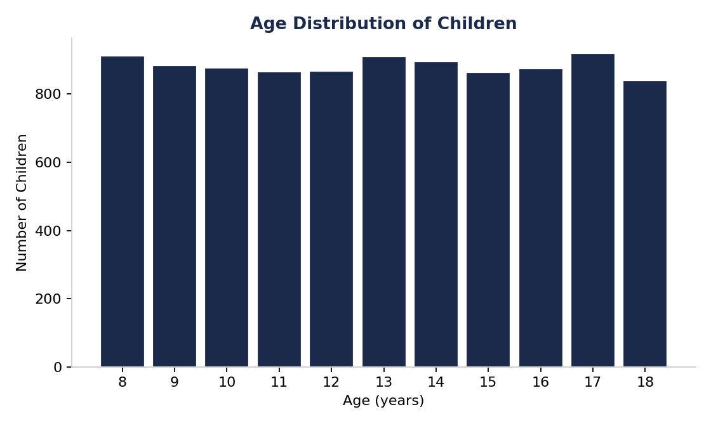
Figure 1: Age distribution of children in the dataset (8–18 years).
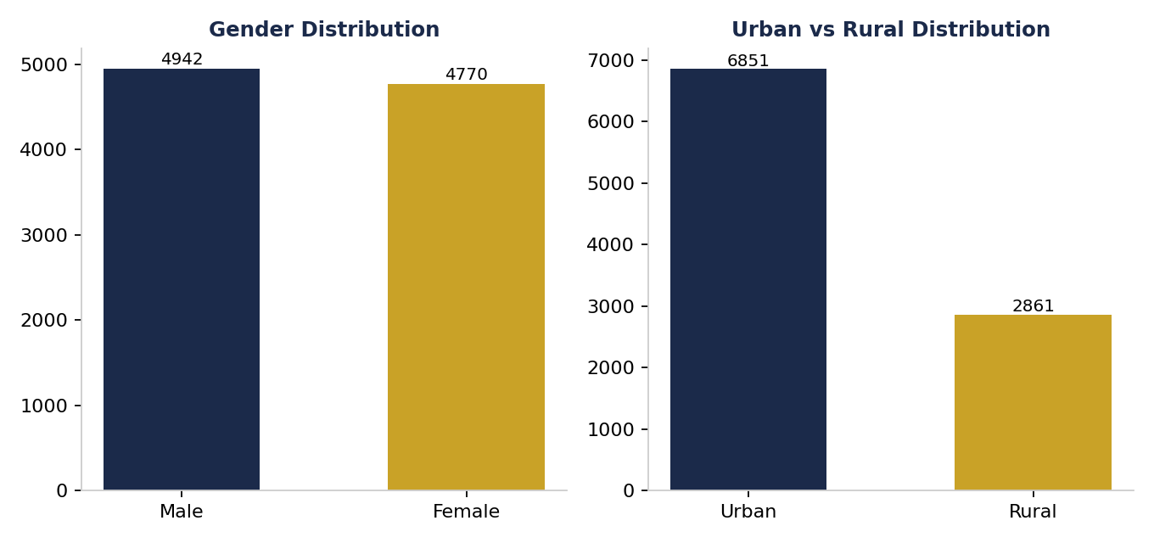
Figure 2: Gender split (Male 50.9%, Female 49.1%) and Urban/Rural split (Urban 70.5%, Rural 29.5%).
- Age: fairly evenly spread across the 8–18 range, with a median of 13 years and no single age group dominating the sample.
- Gender: near-even split — 4,942 boys (50.9%) and 4,770 girls (49.1%) — supporting balanced, unbiased gender comparisons.
- Location: 6,851 children (70.5%) are from urban areas versus 2,861 (29.5%) from rural areas, reflecting greater representation of urban households in the sample.

5. Screen Time Patterns

5.1 Overall Usage & Recommended Limits
Across the full sample, children average 4.35 hours of daily screen time, more than double the 1–2 hour range typically recommended by paediatric and WHO guidelines for this age group. As a result, 8,301 children — 85.5% of the sample — exceed the recommended limit, while only 14.5% stay within it.
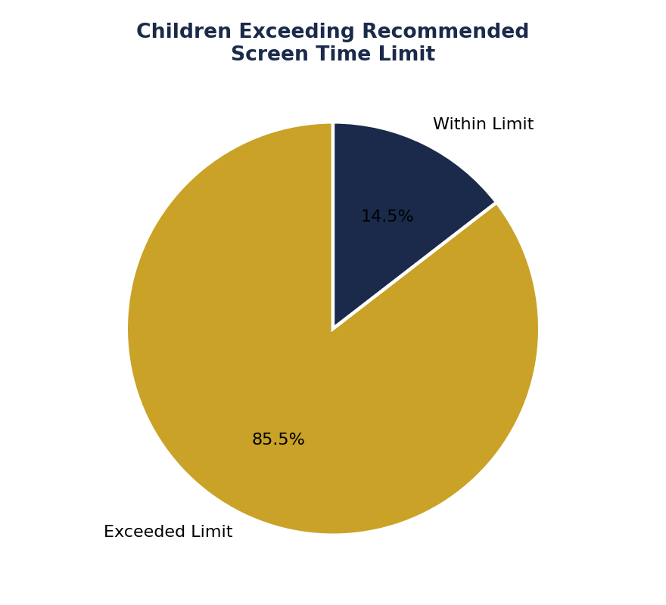
Figure 3: 85.5% of children exceed the recommended daily screen time limit.

5.2 Primary Device Used
Smartphones are the dominant device, used as the primary screen by 4,568 children (47.0%), followed by TV (2,487, 25.6%), Laptop (1,433, 14.8%), and Tablet (1,224, 12.6%).
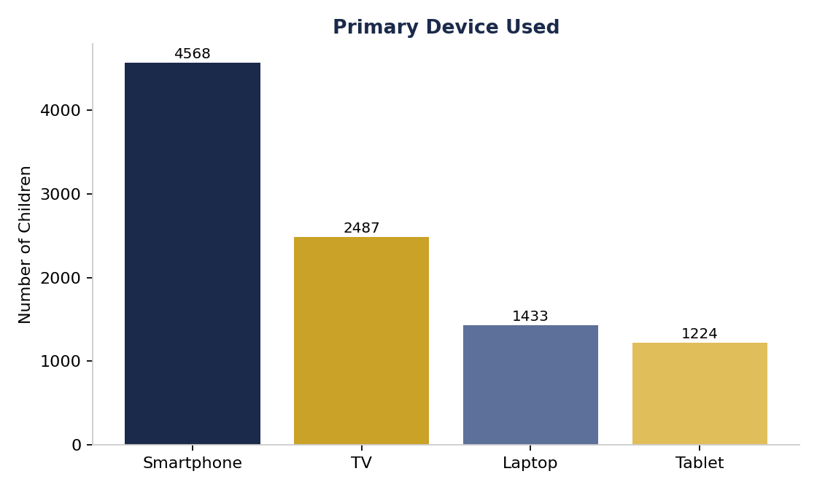
Figure 4: Distribution of children by primary device used.

5.3 Screen Time by Age
Average daily screen time increases from 3.93 hours in the youngest band (ages 8–10) to around 4.5 hours across all older age bands (11–13, 14–15, and 16–18), where usage levels off rather than continuing to climb steadily. In other words, the sharpest jump happens in early adolescence, after which screen time stays elevated but fairly flat.
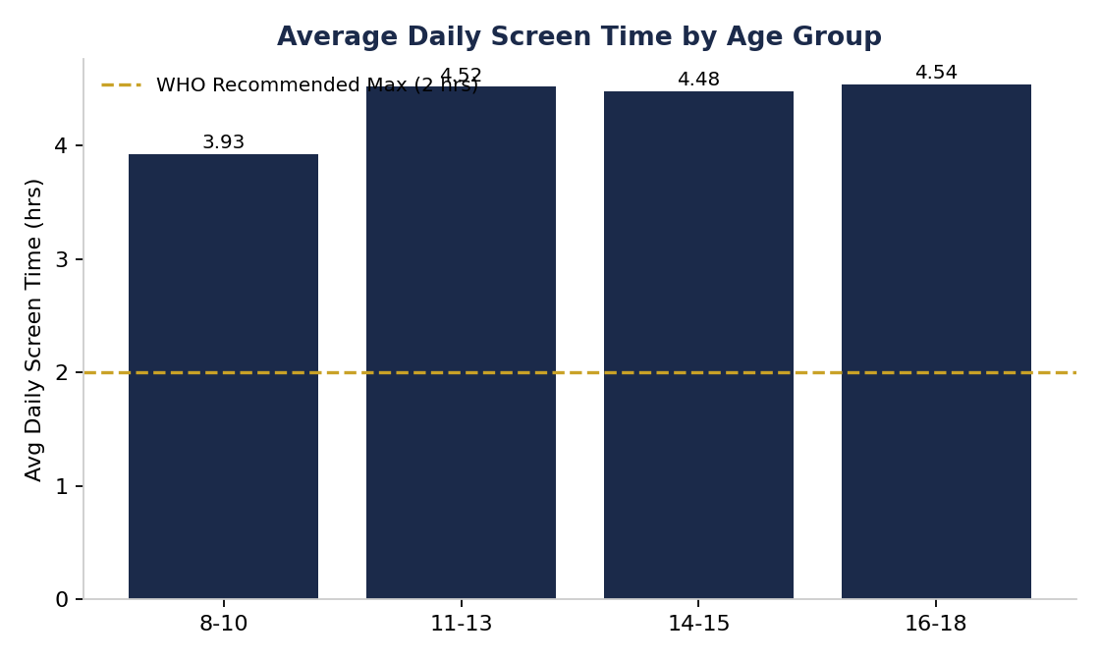
Figure 5: Average daily screen time by age group, against the WHO-recommended 2-hour benchmark.

5.4 Screen Time by Device
Contrary to the common assumption that smartphones alone drive the highest usage, this dataset shows average screen time is fairly similar across devices, with laptops (4.46 hrs) and smartphones (4.39 hrs) slightly ahead of TV (4.29 hrs) and tablets (4.23 hrs). Smartphones' outsized impact in this dataset comes more from how many children use them as their primary device than from unusually high hours per user.
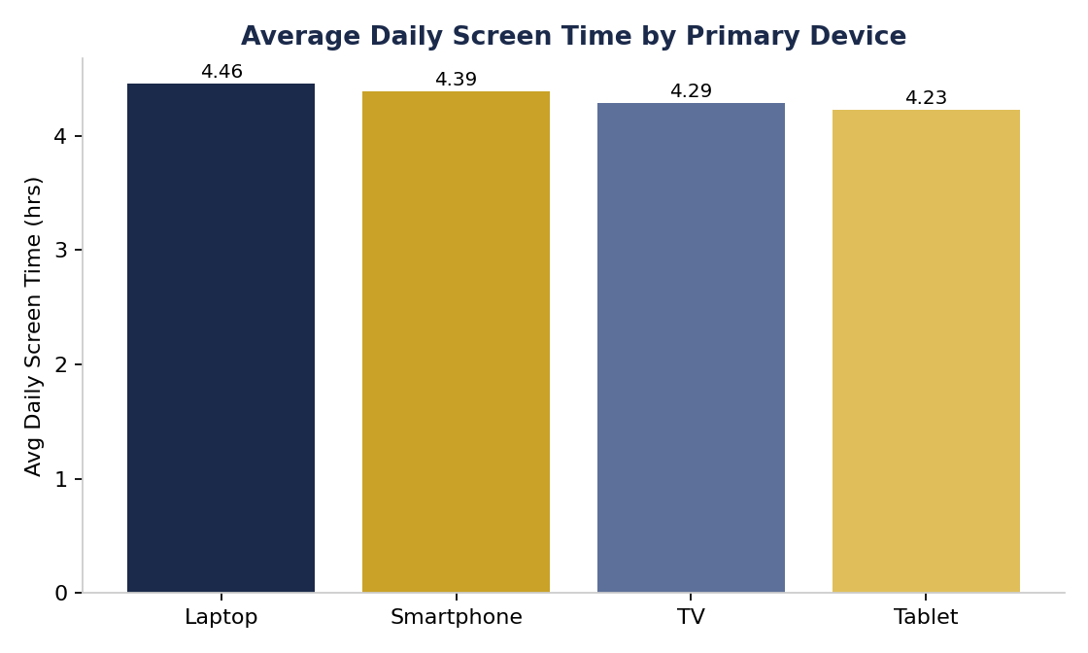
Figure 6: Average daily screen time by primary device.

5.5 Urban vs. Rural & Gender Differences
Screen time and limit-exceedance rates are nearly identical between urban and rural children (4.34 vs. 4.37 average hours; 85.5% vs. 85.4% exceeding the limit) and between boys and girls (4.38 vs. 4.33 average hours). This suggests that, in this dataset, high screen time is a broad-based pattern rather than one concentrated in a specific demographic segment. Device choice differs only slightly by location: smartphones are marginally more common in urban areas (47.4% vs. 46.1%), while tablets are somewhat more common in rural areas (13.7% vs. 12.1%).
Age shows a weak positive correlation with screen time (r = 0.12), and the educational-to-recreational content ratio shows a weak negative correlation (r = ‐09), meaning that children with heavier screen time tend to spend a slightly smaller share of it on educational content relative to recreational content — though neither relationship is strong.

6. Health Impact Analysis
66.9% of children in the dataset report at least one screen-time-related health impact, while 33.1% report none. Poor sleep is by far the most common issue, followed by eye strain, anxiety, and obesity risk.
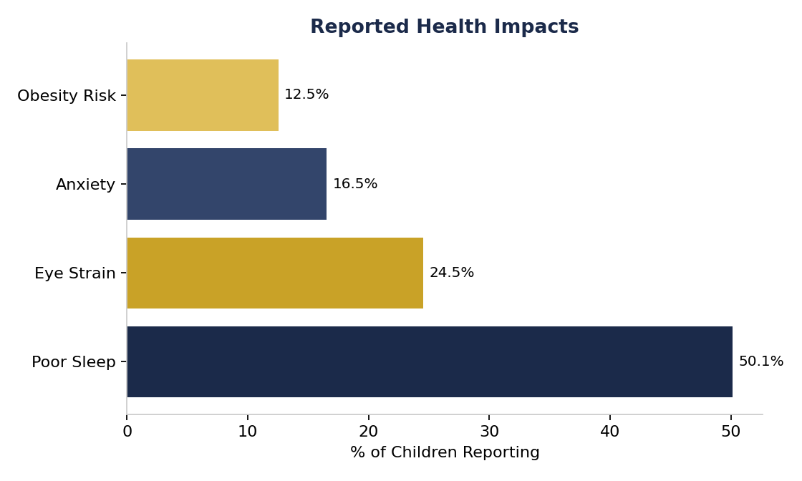
Figure 7: Share of children reporting each type of health impact (impacts can overlap, e.g., a child may report both Poor Sleep and Eye Strain).

6.1 Exceeding the Limit and Health Outcomes
The relationship between exceeding the recommended screen time limit and reporting a health impact is stark: 78.2% of children who exceed the limit report at least one health impact, compared to 0% of those who stay within it. Children who exceed the limit also average 4.82 hours of daily screen time versus 1.58 hours for those within it — underscoring that the health associations in this dataset track closely with total screen time rather than with any single device or demographic group.
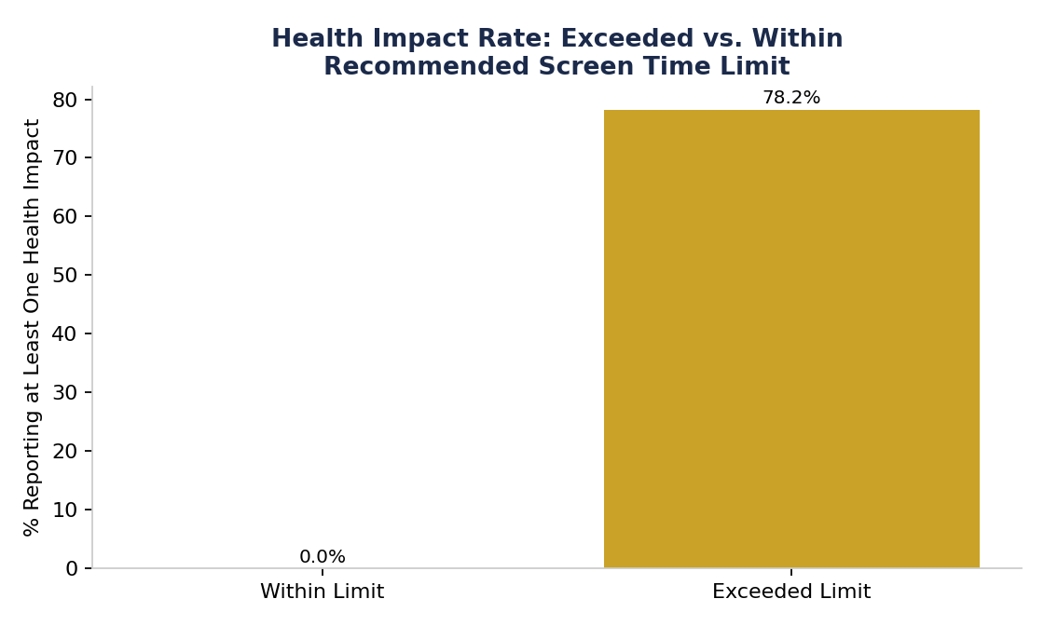
Figure 8: Health impact rate for children exceeding vs. staying within the recommended limit.

6.2 Eye Strain by Age
Eye strain is markedly less common among the youngest children (16.8% for ages 8–10) and roughly 60% more prevalent from age 11 onward (26–28% across the 11–13, 14–15, and 16–18 bands), suggesting a step-change around early adolescence rather than a gradual increase.
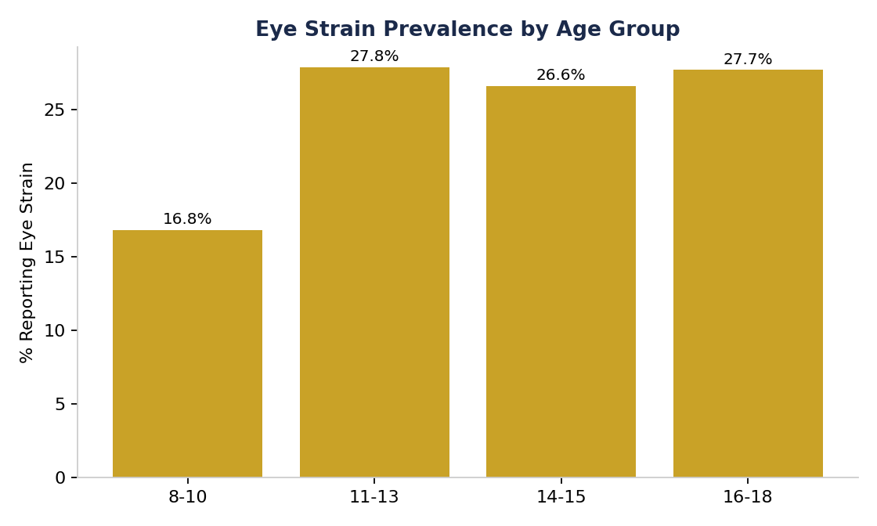
Figure 9: Prevalence of reported eye strain by age group.

6.3 Other Notable Patterns
- Obesity risk is reported exclusively among children who exceed the recommended screen time limit (14.7% of that group, versus 0% of those within the limit).
- Anxiety prevalence is similar between urban (16.4%) and rural (16.9%) children, showing no meaningful urban–rural gap in this sample.
- Children whose primary device is a laptop report a slightly higher average number of simultaneous health issues (1.15) than smartphone (1.06), TV (0.97), or tablet (0.98) users, though the differences are modest.
- Health impact rates are broadly similar by gender — 67.6% of boys and 66.1% of girls report at least one impact — indicating no strong gender skew in this dataset.

7. Key Insights Summary
# | Insight
1 | The dataset is clean and complete, with the only gaps in Health_Impacts (treated as “None”).
2 | Children average 4.35 hours of daily screen time — more than double typical paediatric guidelines.
3 | 85.5% of children exceed the recommended screen time limit.
4 | Smartphones are the most-used primary device (47.0%), followed by TV, laptop, and tablet.
5 | Screen time rises sharply between ages 8–10 and 11+, then levels off through the teen years.
6 | Average hours per device are fairly close (laptop and smartphone slightly ahead of TV and tablet).
7 | Urban/rural and gender differences in screen time and health impact rates are minimal in this dataset.
8 | 66.9% of children report at least one health impact; poor sleep is the most common (50.1%).
9 | Health impact rate jumps from 0% (within limit) to 78.2% (exceeding limit) — the single strongest pattern in the data.
10 | Eye strain prevalence nearly doubles from ages 8–10 (16.8%) to ages 11+ (26–28%).

8. Recommendations

8.1 For Parents & Families
- Set daily screen time limits: follow WHO and paediatric guidance of roughly 1–2 hours per day, with closer monitoring from age 11 onward when usage and eye strain both rise.
- Encourage device-free zones and times, such as no screens during meals or in the hour before bedtime, to reduce the poor-sleep association observed in this data.
- Model balanced screen habits: children often mirror adult behaviour, so parental usage patterns matter.

8.2 For Schools & Educators
- Promote screen-free activities such as outdoor sports, reading, and hobbies as alternatives to recreational screen use.
- Introduce curriculum-integrated digital wellness education and routine non-digital breaks during the school day.
- Prioritise awareness at the 11+ transition, where both screen time and eye strain increase most sharply.

8.3 For Policymakers & Healthcare Providers
- Encourage routine digital health screenings in schools to catch early signs of screen-related sleep, vision, or weight issues.
- Since health impact rates track total screen time far more than any single device or demographic group, awareness campaigns should target overall daily usage rather than any one platform.
- Support tailored, evidence-based interventions for early adolescents (ages 11+), where the data shows the largest step-change in both usage and health impact.

9. Conclusion
This analysis of 9,712 Indian children's screen time confirms that excessive screen usage is widespread — affecting the large majority of the sample regardless of gender, location, or preferred device — and is strongly associated with self-reported health impacts, particularly poor sleep and eye strain. The clearest signal in the data is not which device children use or where they live, but whether their total screen time exceeds recommended limits: children who do so are dramatically more likely to report negative health effects. This points to a straightforward, actionable takeaway for parents, educators, and policymakers alike — reducing total daily screen time, rather than targeting any single device or group, is likely to have the greatest impact on children's digital health outcomes.

