23CSE202 DATABASE MANAGEMENT SYSTEMS
S3 B.Tech CSE
Department of Computer Science and Engineering
Amrita School of Computing, Amritapuri Campus

2. UI Design Document

Group No :
Team Members :
Roll No | Student Name
AM.SC.U4CSE25117 | G.NEHA ABHIGNA
AM.SC.U4CSE25138 | NEHA B NAIR
AM.SC.U4CSE25143 | P.SRINIJA
AM.SC.U4CSE25166 | JANWI YADAV

Project Title : GRAY LORE

2.1. Functional requirements:
[list the main functionalities required]
1. Profile-based catalog browsing with content availability filtered by region and license window
2. Playback with resume-from-last-position and automatic watch-history logging
3. Subscription plan selection with device-limit enforcement per plan tier

2.2. Non functional requirements:
[list the main qualitative features required]
1. Data integrity — foreign key constraints link Content to Licenses, no orphaned records
2. Responsive glassmorphism UI — usable down to mobile width, consistent visual system across all 5 screens
3. Performance — indexed lookups on Content/Licenses join keep catalog queries fast even as row count grows

2.3. List of AI tools used for building UI(if any):
1. dbdiagram.- Generate an ER diagram from this schema: [paste schema]. Highlight one-to-many and many-to-many relationships (e.g., users-to-genres via preferences).
2. Claude-Write SQL for triggers that update a user's 'last_watched' timestamp automatically, and a stored procedure to recommend content based on genre overlap with watch history.
3. v0.dev -Create a React admin dashboard for an OTT platform showing active
subscribers, revenue by plan tier, and top-watched content, with a clean dark theme
4. ChatGPT-Suggest indexing strategy and query optimization for a watch_history table expected to have millions of rows.
2.4. Prompt (if any) :
Sl. No | Name of the tool | prompts
1
2
3

2.5. List of files:
1. auth.html- Login/Register page
2. profile.html- Profile selection page
3. home.html- Home page
4. player.html- Video player page
5. admin.html- Admin dashboard page
6. app.py- Flask route serving the catalog from MySQL
7. schema.sql- Database schema

2.6. UI Screenshot:
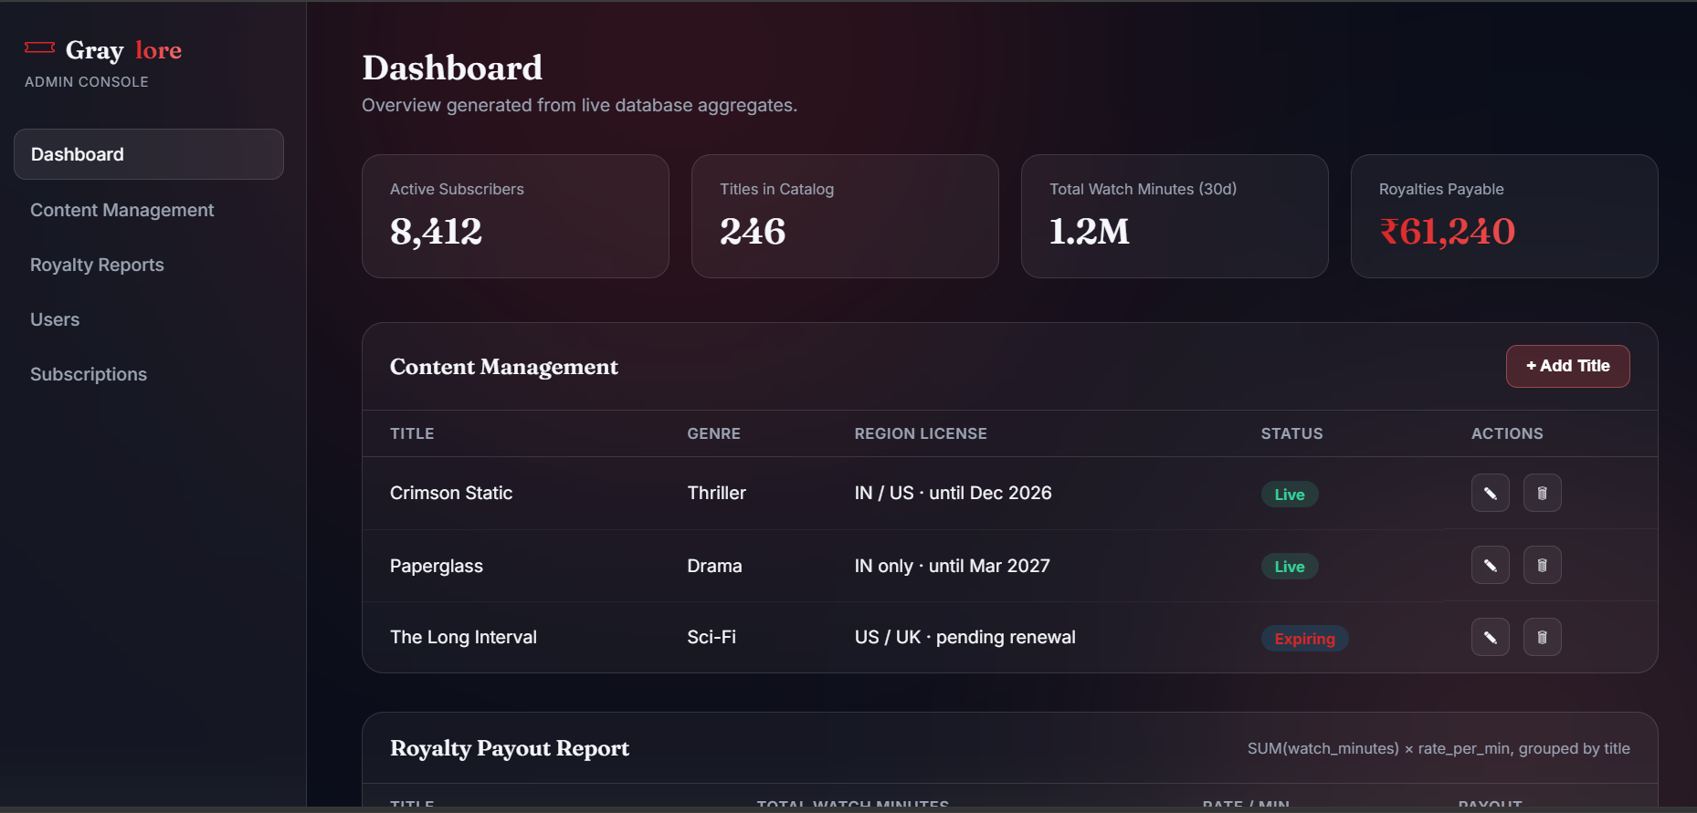

2.7. GitHub Link:
https://github.com/nehabhigna21/graylore.git

