**Roll No:104**

**Name:Pratiksha Patil.**

**Pratical No:2**

**Title: Clone the respository at** [**http://github.com/KBNMU**](http://github.com/KBNMU)

**---------------------------------------------------------------------------------------------------------**

comp@comp143 MINGW64 ~

$ git --help

usage: git [-v | --version] [-h | --help] [-C <path>] [-c <name>=<value>]

[--exec-path[=<path>]] [--html-path] [--man-path] [--info-path]

[-p | --paginate | -P | --no-pager] [--no-replace-objects] [--bare]

[--git-dir=<path>] [--work-tree=<path>] [--namespace=<name>]

[--config-env=<name>=<envvar>] <command> [<args>]

These are common Git commands used in various situations:

start a working area (see also: git help tutorial)

clone Clone a repository into a new directory

init Create an empty Git repository or reinitialize an existing one

work on the current change (see also: git help everyday)

add Add file contents to the index

mv Move or rename a file, a directory, or a symlink

restore Restore working tree files

rm Remove files from the working tree and from the index

examine the history and state (see also: git help revisions)

bisect Use binary search to find the commit that introduced a bug

diff Show changes between commits, commit and working tree, etc

grep Print lines matching a pattern

log Show commit logs

show Show various types of objects

status Show the working tree status

grow, mark and tweak your common history

branch List, create, or delete branches

commit Record changes to the repository

merge Join two or more development histories together

rebase Reapply commits on top of another base tip

reset Reset current HEAD to the specified state

switch Switch branches

tag Create, list, delete or verify a tag object signed with GPG

collaborate (see also: git help workflows)

fetch Download objects and refs from another repository

pull Fetch from and integrate with another repository or a local branch

push Update remote refs along with associated objects

'git help -a' and 'git help -g' list available subcommands and some

concept guides. See 'git help <command>' or 'git help <concept>'

to read about a specific subcommand or concept.

See 'git help git' for an overview of the system.

comp@comp143 MINGW64 ~

$ git --version

git version 2.43.0.windows.1

comp@comp143 MINGW64 ~

$ git clone https://github.com/21Pratiksh/KBCNMU2.git

Cloning into 'KBCNMU2'...

remote: Enumerating objects: 9, done.

remote: Counting objects: 100% (9/9), done.

remote: Compressing objects: 100% (7/7), done.

remote: Total 9 (delta 0), reused 0 (delta 0), pack-reused 0

Receiving objects: 100% (9/9), done.

comp@comp143 MINGW64 ~

$

**Create repository:**

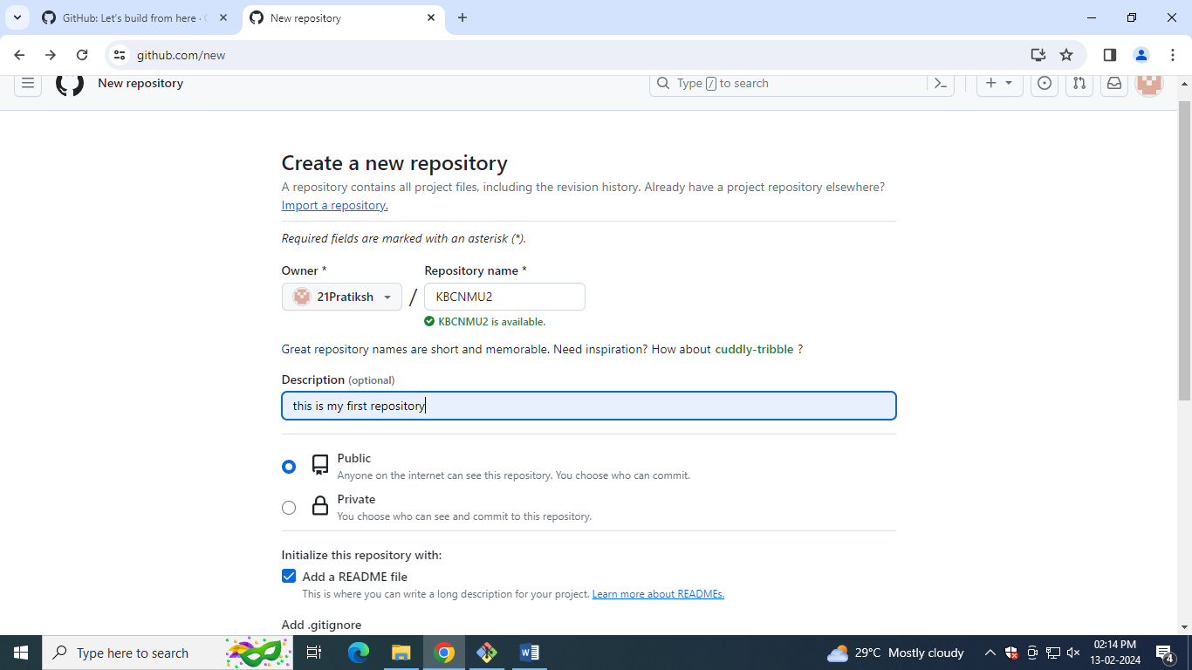

**Remote repository:**

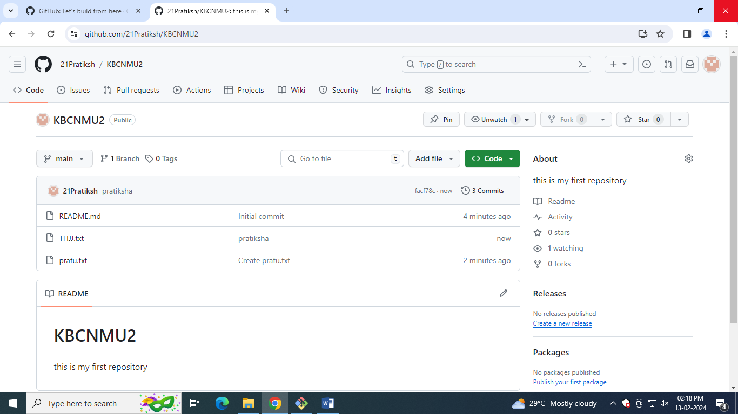

**Local repository:**

