JAVASCRIPT EXERCISE

- Prompt for amount, interest rate and no. of years and calculate simple interest.

<!DOCTYPE html>
<html lang="en">
<head>
<meta charset="utf-8">
<title> To Calculate Simple Interest</title>
</head>
<script type="text/javascript">
function simpleinterest()
{
var p,r,t;
p=parseFloat(prompt("Please Enter Principle Amount"));
r=parseFloat(prompt("Please Enter Rate Amount"));
t=parseFloat(prompt("Please Enter Time(year)"));
var si=(p*r*t)/100;
document.write("Simple Interest (calculated anually) is: "+si);
}
</script>
<body>
<input type="button" value="Calculate Simple Interest" onclick="simpleinterest()" />
</body>
</html>
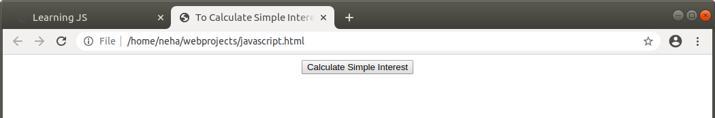
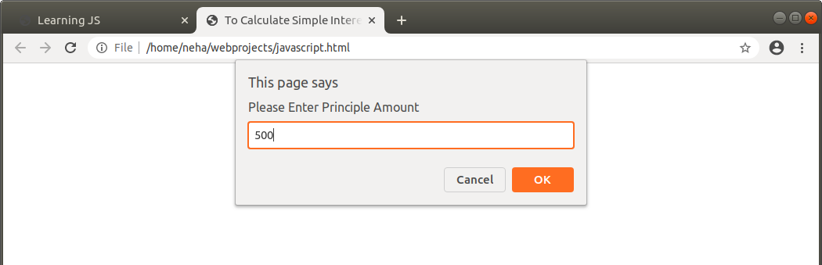

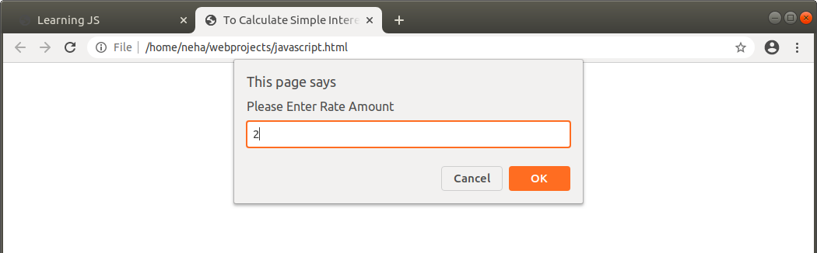
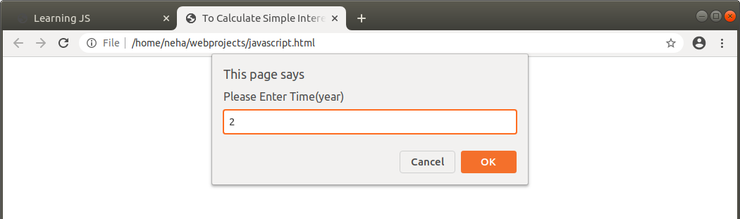

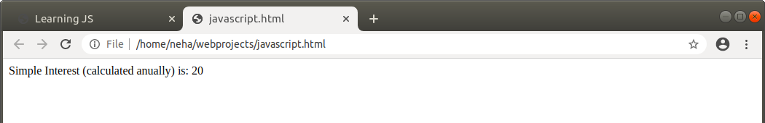
- is palindrome string

palindrome.html

<html>
<head>
<title>Check Palindrome with JavaScript Program</title>
<style>
input{
padding: 10px;
}
</style>
</head>
<body>
<script src="./palindrome.js"></script>
<h3>JavaScript Palindrome Program from Tutorialsmade.com</h3>
<input type="text" id="txtbox" placeholder="Enter String" />
<input type="button" onclick="myFunction()" value="Check Palindrome" />
</body>
</html

palindrome.js
function myFunction()
{
var str = document.getElementById('txtbox').value;
var result = checkPalindrome(str);
alert('The Entered String "'+str +'" is "'+result+'"');
}
function checkPalindrome(str)
{
var orignalStr;
var reg= /\s/g;
str = str.toLowerCase().replace(reg,'');
orignalStr = str;
str = str.split('');
str = str.reverse();
str = str.join('');
var reverseStr = str;
if(orignalStr == reverseStr){
return 'Palindrome'; // return "Palindrome" if true
}else{
return 'Not Palindrome';
}
}
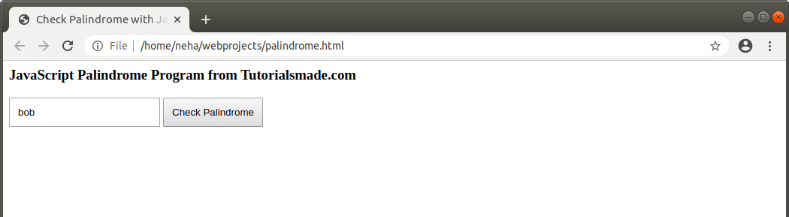
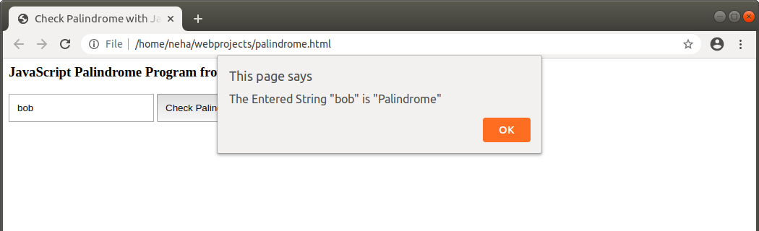

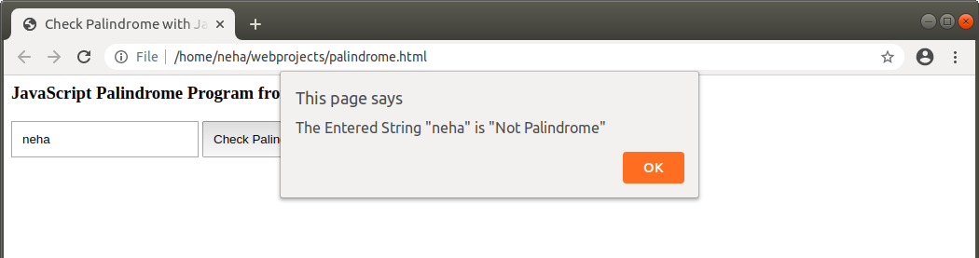

- Area of circle

<html>
<head>
<title>Find the area and circumference of a circle</title>
<script>
var radius=window.prompt("Enter the radius");
function area(radius)
{
return 3.14*radius*radius;
}
var circlearea=area(radius)
document.write("The area of the circle is: " +circlearea);
</script>
</head>
</html>
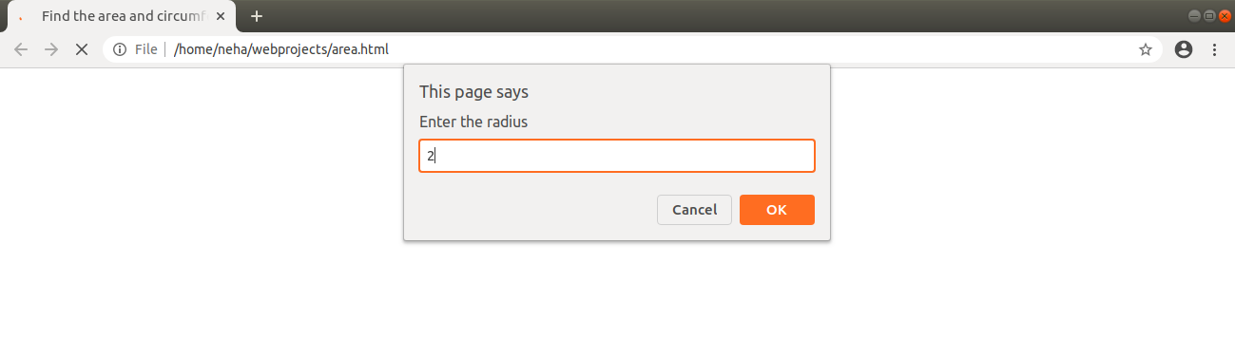
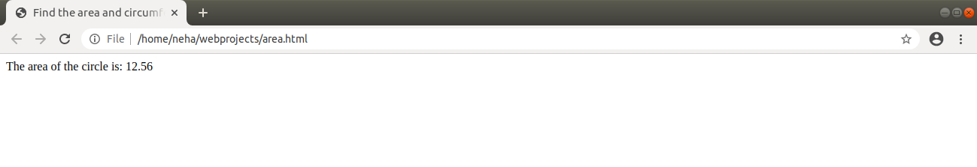

- Copy information of one object to another and log it to console.

<html>
<head>
<title>To copy the objects in console</title>
<script>
var obj1={
Name:"Neha",
Age:22,
Gender:"Female"
};
var copy={
Name:"Ashu",
Age:24,
Gender:"male"
};
copy=obj1;
document.write("Printed in console");
console.log(typeof(copy));
console.log(copy.Name);
console.log(copy.Age);
console.log(copy.Gender);
console.log(copy);
console.log(obj1);
</script>
</head>
</html>
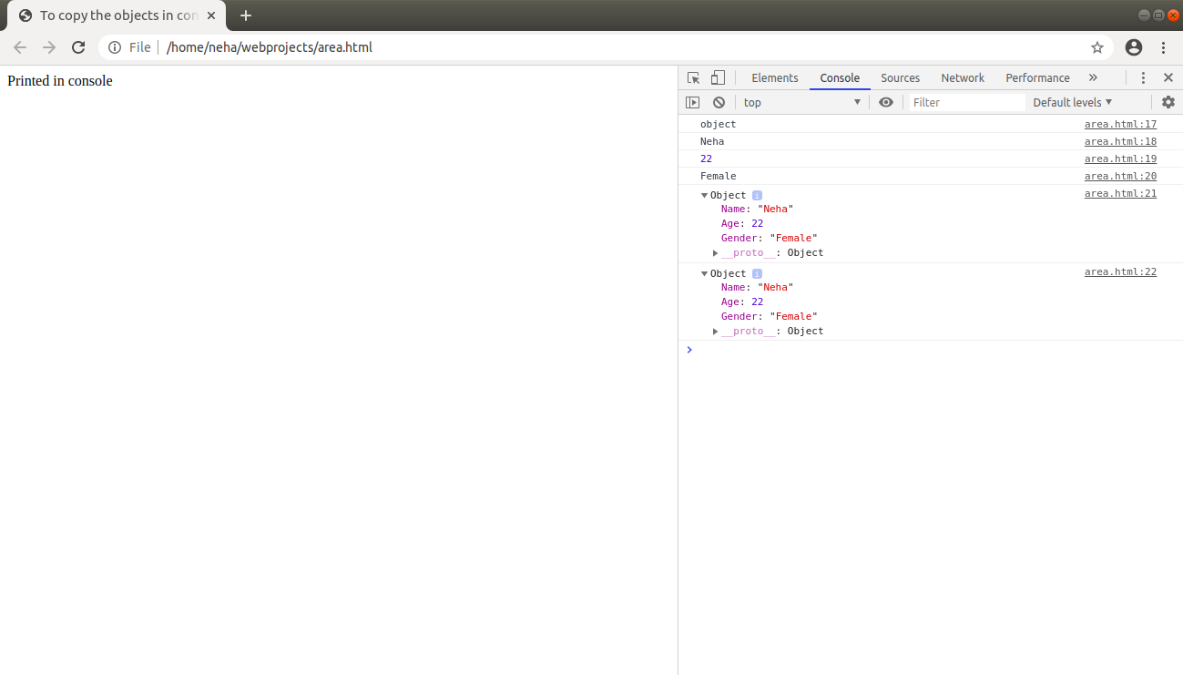

- Create a list of objects of Employee with info as follow :
- Name, age, salary ,DOB
- filter all employees with salary greater than 5000
- group employee on the basis of their age
- fetch employees with salary less than 1000 and age greater than 20. Then give them an increment 5 times their salary

<html>
<head>
<script>
var employee=[
{
Name:"Neha",
Age:23,
Salary:1500,
Dob:'1/06/96'
},
{
Name:"Ashu",
Age:22,
Salary:220,
Dob:'08/12/97'
},
{
Name:"Akshita",
Age:24,
Salary:20000,
Dob:'20/06/96'
},
{
Name:"Drishti",
Age:21,
Salary:200,
Dob:'07/10/96'
},
{
Name:"Shreya",
Age:23,
Salary:19000,
Dob:'06/10/95'
},
{
Name:"Nisha",
Age:23,
Salary:25000,
Dob:'08/01/95'
},
];
console.log(employee);
function hsalary(employee) {
var highestSalary = employee.filter(function(item)
{
return item.Salary > 5000;
});
// highestSalary.forEach(element => {
//document.getElementById("salaryDiv").innerHTML += "Name: " + element.Name + "," +" Salary: " + element.Salary;
console.log(highestSalary);
};
function checksalary(employee)
{
var checksal=employee.filter(function(item1)
{
return item1.Age == 23;
});
console.log(checksal);
}
function third(employee)
{
var check2=employee.filter(function(item2)
{
return item2.Salary<1000 && item2.Age>20;
});
console.log(check2);
var group1=check2.map(sal=>
{
var obj={};
obj[sal.Salary]=sal.Salary*5;
return obj;
});
console.log(group1);
}
</script>
</head>
<body>
<p>Click the button to get Persons having salary less than 5000.</p>
<input type="button" value="Salary" id="myButton" onclick="hsalary(employee)">
<p><div id="salaryDiv" ></div></p>
<p> Click the button to group persons according to age</p>
<input type="button" value="Group Age" id="myButton1" onclick="checksalary(employee)">
<p> Click the button to get persons by increasing salaries</p>
<input type="button" value="GroupSA" id="myButton2" onclick="third(employee)">
</body>
</html>

