HIBERNATE EXERCISE PART 1

1) Create an Employee Entity which contains following fields:
Name
Id
Age
Location

package com.example.HibernateExercise;
import javax.persistence.Entity;
import javax.persistence.Id;
import javax.persistence.Table;
@Entity
@Table
public class Employee
{
@Id
private int id;
private int age;
private String name;
private String location;
public int getId() {
return id;
}
public void setId(int id) {
this.id = id;
}
public int getAge() {
return age;
}
public void setAge(int age) {
this.age = age;
}
public String getName() {
return name;
}
public void setName(String name) {
this.name = name;
}
public String getLocation() {
return location;
}
public void setLocation(String location) {
this.location = location;
}
}

(2) Set up EmployeeRepository with Spring Data JPA
In the application.properties:
spring.datasource.url=jdbc:mysql://localhost:3306/Mydatabase
spring.datasource.username=root
spring.datasource.password=ttn
EmployeeRepo Interface
package com.example.HibernateExercise;
import org.springframework.data.repository.CrudRepository;
public interface EmployeeRepo extends CrudRepository<Employee,Integer>
{
}

(3) Perform Create Operation on Entity using Spring Data JPA

HibernateExerciseapplicationTest.java
package com.example.HibernateExercise;
import org.junit.jupiter.api.Test;
import org.springframework.beans.factory.annotation.Autowired;
import org.springframework.boot.test.context.SpringBootTest;
@SpringBootTest
class HibernateExerciseApplicationTests
{
@Autowired
EmployeeRepo employeeRepo;
@Test
void contextLoads() {
}
@Test
public void EmployeeCreate()
{
Employee employee=new Employee();
employee.setId(1);
employee.setAge(12);
employee.setName("Neha");
employee.setLocation("Patel Nagar");
Employee employee1=new Employee();
employee1.setId(2);
employee1.setAge(14);
employee1.setName("Ashu");
employee1.setLocation("Moti Nagar");
Employee employee2=new Employee();
employee2.setId(3);
employee2.setAge(20);
employee2.setName("Shreya");
employee2.setLocation("Ramesh Nagar");
employeeRepo.save(employee);
employeeRepo.save(employee1);
employeeRepo.save(employee2);
}
}

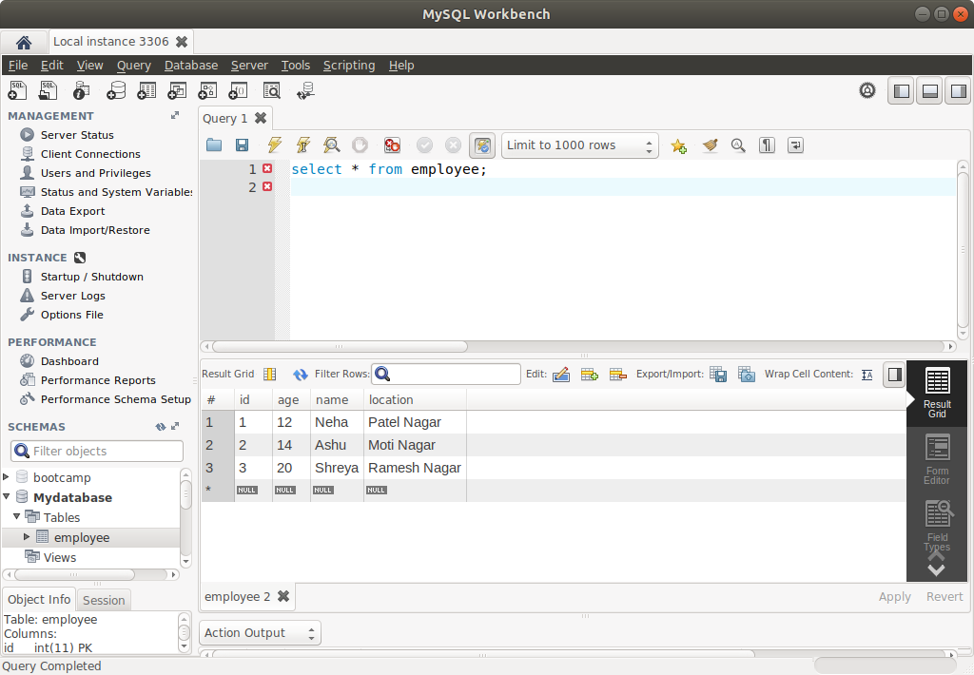
(4) Perform Update Operation on Entity using Spring Data JPA

HibernateExerciseapplicationTest.java

package com.example.HibernateExercise;
import org.junit.jupiter.api.Test;
import org.springframework.beans.factory.annotation.Autowired;
import org.springframework.boot.test.context.SpringBootTest;
@SpringBootTest
class HibernateExerciseApplicationTests
{
@Autowired
EmployeeRepo employeeRepo;
@Test
void contextLoads() {
}

@Test
public void EmployeeUpdate()
{
Employee employeeoptional=employeeRepo.findById(1).get();
employeeoptional.setName("Udit");
employeeRepo.save(employeeoptional);
}
Before updating

After updation
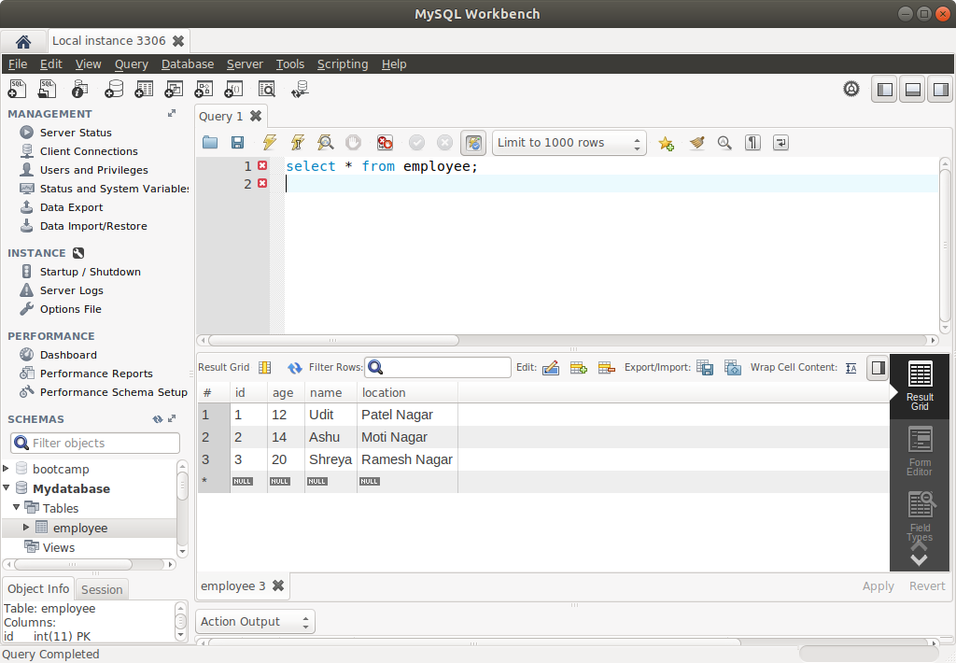

(5) Perform Delete Operation on Entity using Spring Data JPA

HibernateExerciseapplicationTest.java

package com.example.HibernateExercise;
import org.junit.jupiter.api.Test;
import org.springframework.beans.factory.annotation.Autowired;
import org.springframework.boot.test.context.SpringBootTest;
@SpringBootTest
class HibernateExerciseApplicationTests
{
@Autowired
EmployeeRepo employeeRepo;
@Test
void contextLoads() {
}

@Test
public void Employeedelete()
{
employeeRepo.deleteById(2);
}

Before deleting

After deleting

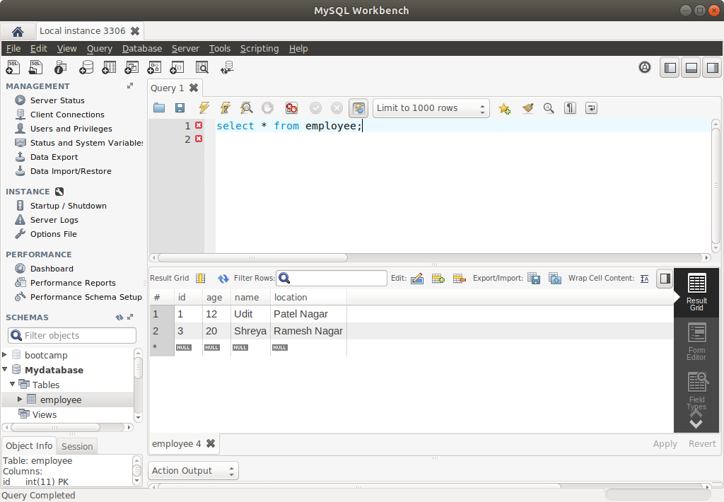

(6) Perform Read Operation on Entity using Spring Data JPA

HibernateExerciseapplicationTest.java

package com.example.HibernateExercise;
import org.junit.jupiter.api.Test;
import org.springframework.beans.factory.annotation.Autowired;
import org.springframework.boot.test.context.SpringBootTest;
@SpringBootTest
class HibernateExerciseApplicationTests
{
@Autowired
EmployeeRepo employeeRepo;
@Test
void contextLoads() {
}

@Test
public void EmployeeRead()
{
Employee employeeoptional=employeeRepo.findById(3).get();
assertNotNull(employeeoptional);
assertEquals("Shreya",employeeoptional.getName());
System.out.println(">>>>>>>>>>>" +employeeoptional.getName());
}

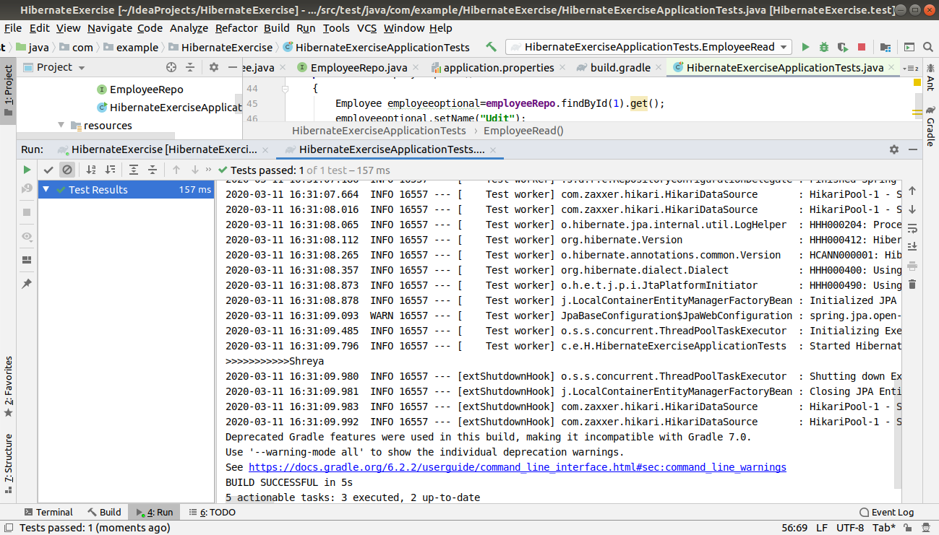
(7) Get the total count of the number of Employees

HibernateExerciseapplicationTest.java

package com.example.HibernateExercise;
import org.junit.jupiter.api.Test;
import org.springframework.beans.factory.annotation.Autowired;
import org.springframework.boot.test.context.SpringBootTest;
@SpringBootTest
class HibernateExerciseApplicationTests
{
@Autowired
EmployeeRepo employeeRepo;
@Test
void contextLoads() {
}

@Test
public void EmployeeCount()
{
System.out.println(employeeRepo.count());
}
}

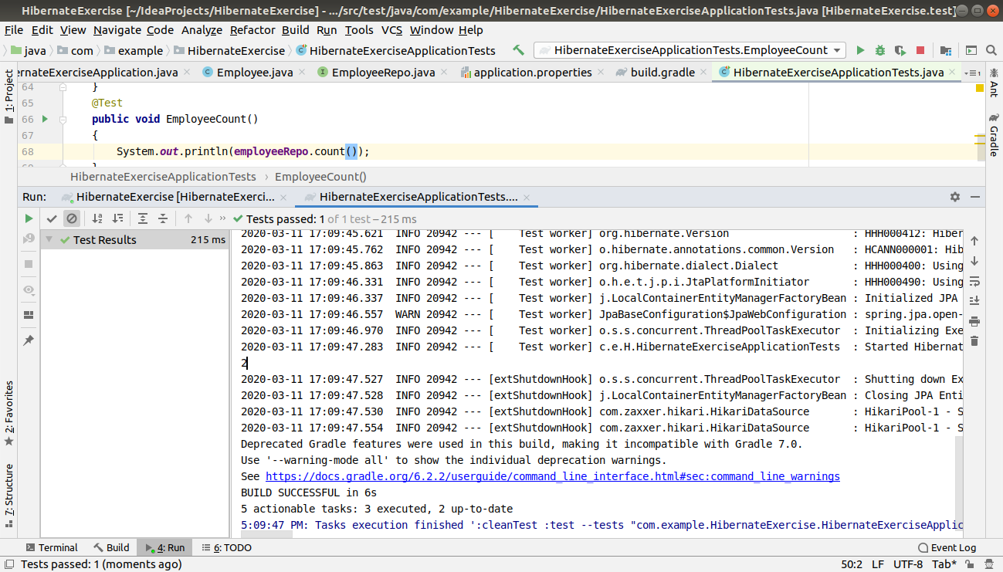

(8) Implement Pagination and Sorting on the bases of Employee Age

HibernateExerciseapplicationTest.java

package com.example.HibernateExercise;
import org.junit.jupiter.api.Test;
import org.springframework.beans.factory.annotation.Autowired;
import org.springframework.boot.test.context.SpringBootTest;
@SpringBootTest
class HibernateExerciseApplicationTests
{
@Autowired
EmployeeRepo employeeRepo;
@Test
void contextLoads() {
}

@Test
public void testPagingAndSorting()
{
Pageable pageable=PageRequest.of(0,4, Sort.Direction.DESC,"age");
Pageable pageable1=PageRequest.of(1,4,Sort.Direction.DESC,"age");
employeePaging.findAll(pageable).map(field->field.getName() + "="
+field.getAge()).forEach(System.out::println);
System.out.println("-----------------------------------------------");
employeePaging.findAll(pageable1).map(field->field.getName() + "="
+field.getAge()).forEach(System.out::println);
}
}
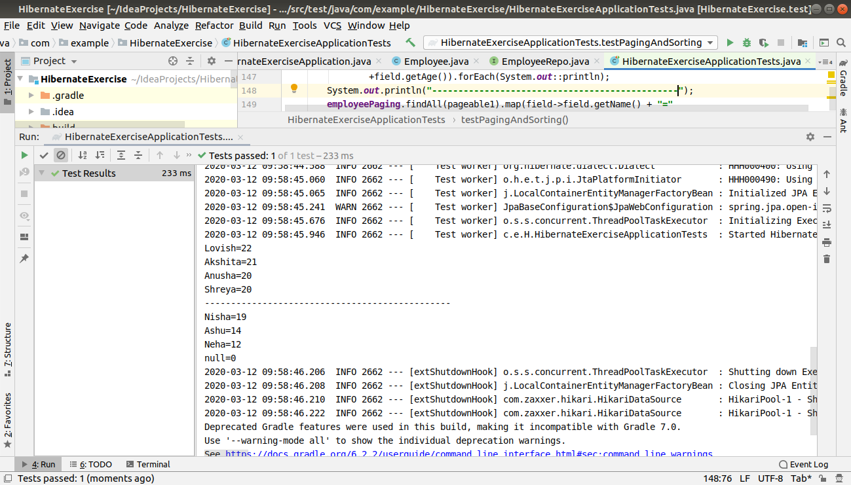

(9) Create and use finder to find Employee by Name

HibernateExerciseapplicationTest.java

package com.example.HibernateExercise;
import org.junit.jupiter.api.Test;
import org.springframework.beans.factory.annotation.Autowired;
import org.springframework.boot.test.context.SpringBootTest;
@SpringBootTest
class HibernateExerciseApplicationTests
{
@Autowired
EmployeeRepo employeeRepo;
@Test
void contextLoads() {
}

@Test
public void findByName()
{
List<Employee> employeeList=employeeRepo.findByName("Neha");
employeeList.forEach(e -> System.out.println(e.getAge()));
}

EmployeeRepo.java

public interface EmployeeRepo extends CrudRepository<Employee,Integer>
{
List<Employee> findByName(String name);
List<Employee> findByNameLike(String name);
List<Employee> findByAgeBetween(int age1,int age2);
}

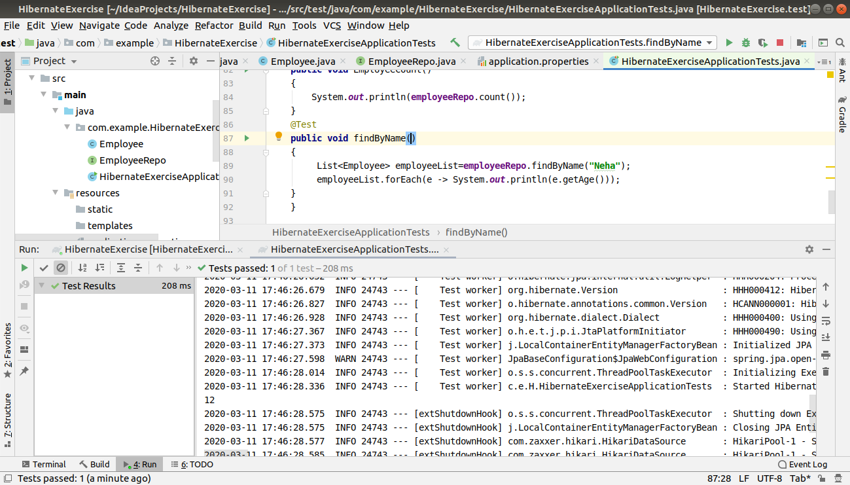

(10) Create and use finder to find Employees starting with A character

HibernateExerciseapplicationTest.java

package com.example.HibernateExercise;
import org.junit.jupiter.api.Test;
import org.springframework.beans.factory.annotation.Autowired;
import org.springframework.boot.test.context.SpringBootTest;
@SpringBootTest
class HibernateExerciseApplicationTests
{
@Autowired
EmployeeRepo employeeRepo;
@Test
void contextLoads() {
}

@Test
public void findByNameLike()
{
List<Employee> employeeList=employeeRepo.findByNameLike("A%");
employeeList.forEach(e -> System.out.println(e.getName()));
}
}
EmployeeRepo.java

public interface EmployeeRepo extends CrudRepository<Employee,Integer>
{
List<Employee> findByName(String name);
List<Employee> findByNameLike(String name);
List<Employee> findByAgeBetween(int age1,int age2);
}

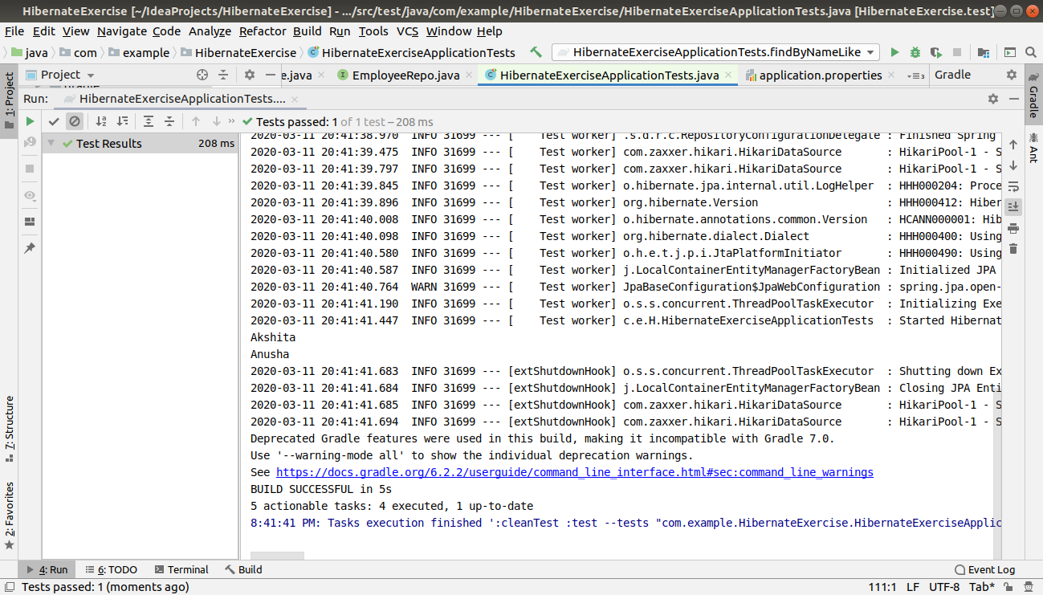

(11) Create and use finder to find Employees Between the age of 28 to 32

HibernateExerciseapplicationTest.java

package com.example.HibernateExercise;
import org.junit.jupiter.api.Test;
import org.springframework.beans.factory.annotation.Autowired;
import org.springframework.boot.test.context.SpringBootTest;
@SpringBootTest
class HibernateExerciseApplicationTests
{
@Autowired
EmployeeRepo employeeRepo;
@Test
void contextLoads() {
}

@Test
public void testfindByAgeBetween()
{
List<Employee> employeeList=employeeRepo.findByAgeBetween(12,20);
employeeList.forEach(e -> System.out.println(e.getName()));
}

EmployeeRepo.java

public interface EmployeeRepo extends CrudRepository<Employee,Integer>
{
List<Employee> findByName(String name);
List<Employee> findByNameLike(String name);
List<Employee> findByAgeBetween(int age1,int age2);
}

