HTML/CSS EXERCISE

1.How are inline and block elements different from each other?
Ans: A block-level element always starts on a new line and takes up the full width available (stretches out to the left and right as far as it can).
An inline element does not start on a new line and only takes up as much width as necessary.

<!DOCTYPE html>
<html lang="en">
<head>
<meta charset="UTF-8">
<title>Title</title>
</head>
<div style="border: 1px solid black">Hello Block element</div>
<p>The DIV element is a block element, and will always start on a new line and take up the full width available (stretches out to the left and right as far as it can).</p>
<p>This is an inline span <span style="border: 1px solid black">Hello span element</span> element inside a paragraph.</p>
<p>The SPAN element is an inline element, and will not start on a new line and only takes up as much width as necessary.</p>
<body>
</body>
</html>
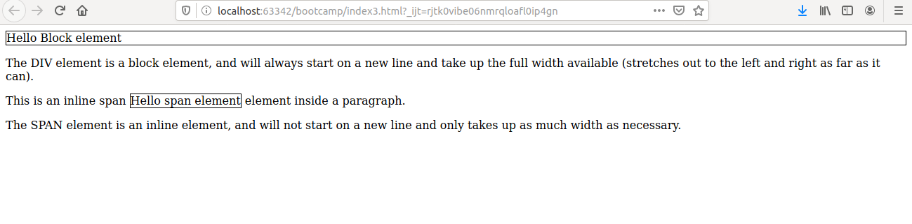
2.Explain the difference between visibility:hidden and display:none
Ans: Hiding an element can be done by setting the display property to none. The element will be hidden, and the page will be displayed as if the element is not there:
visibility:hidden- also hides an element.
However, the element will still take up the same space as before. The element will be hidden, but still affect the layout

<!DOCTYPE html>
<html lang="en">
<head>
<meta charset="UTF-8">
<title>Title</title>
</head>
<style>
h1.hidden {
display: none;
}
h2.hidden {
visibility: hidden;
}
</style>
</head>
<body>
<h1>This is a visible heading</h1>
<h1 class="hidden">This is a heading which is visible </h1>
<p>Notice that the h1 element with display: none; does not take up any space.</p>
<h2>This is a visible heading</h2>
<h2 class="hidden">This is a hidden heading</h2>
<p>Notice that the hidden heading still takes up space.</p>
</body>
</html>
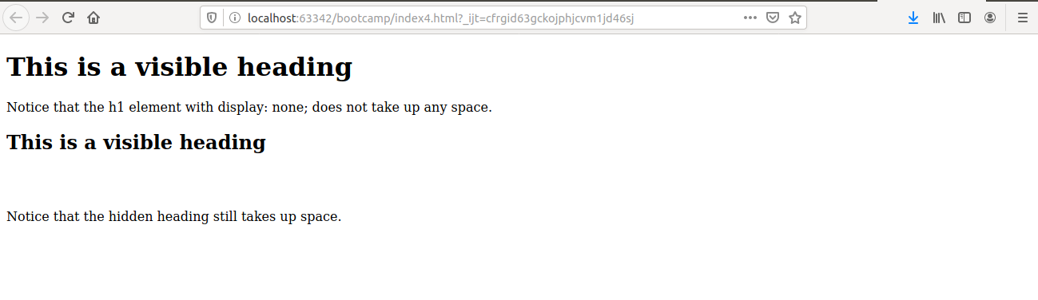
3. Explain the clear and float properties.
Ans: The CSS float property specifies how an element should float.
<!DOCTYPE html>
<html lang="en">
<head>
<meta charset="UTF-8">
<title>Title</title>
</head>
<style>
img {
float: left;
}
</style>
<body>
<p>In this example, the image will float to the right in the paragraph, and the text in the paragraph will wrap around the image.</p>
<p> <img src="image1.jpg" alt="image1" style="width:170px;height:170px;margin-right:25px;">
Lorem ipsum dolor sit amet, consectetur adipiscing elit. Phasellus imperdiet, nullet
dictum interdum, nisi lorem egestas odio, vitae scelerisque enim ligula venenatis dolor.Maecenas nisl est, ultrices nec congue eget, auctor vitae massa. Fusce luctus vestibulu maugue ut aliquet. Mauris ante ligula, facilisis sed ornare eu, lobortis in odio.Praesent convallis urna a lacus interdum ut hendrerit risus congue. Nunc sagittis dictum nisi, sed ullamcorper ipsum dignissim ac. In at libero sed nunc venenatis imperdiet sed ornare turpis.
Donec vitae dui eget tellus gravida venenatis. Integer fringilla congue eros non fermentum.Sed dapibus pulvinar nibh tempor porta. Cras ac leo purus. Mauris quis diam velit.</p>
</body>
</html>
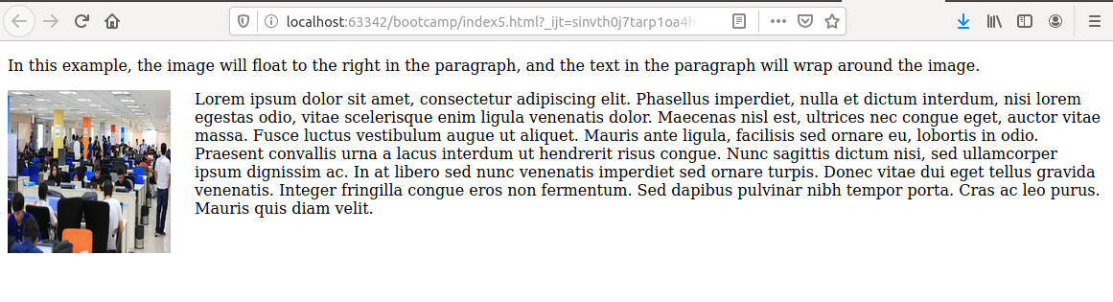

The CSS clear property specifies what elements can float beside the cleared element and on which side.
<!DOCTYPE html>
<html lang="en">
<head>
<meta charset="UTF-8">
<title>Title</title>
<style>
.div1 {
float: left;
width: 100px;
height: 50px;
margin: 10px;
border: 3px solid #73AD21;
}
.div2 {
border: 1px solid red;
}
.div3 {
float: left;
width: 100px;
height: 50px;
margin: 10px;
border: 3px solid #73AD21;
}
.div4 {
border: 1px solid red;
clear: left;
}
</style>
</head>
<body>
<h2>Without clear</h2>
<div class="div1">div1</div>
<div class="div2">div2 - Notice that div2 is after div1 in the HTML code. However, since div1 floats to the left, the text in div2 flows around div1.</div>
<br><br>
<h2>With clear</h2>
<div class="div3">div3</div>
<div class="div4">div4 - Here, clear: left; moves div4 down below the floating div3. The value "left" clears elements floated to the left. You can also clear "right" and "both".</div>
</body>
</html>
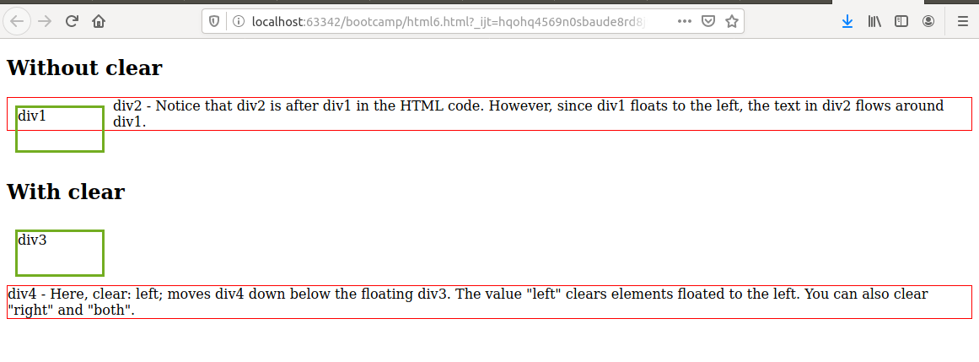
4. Explain difference between absolute, relative,fixed and static.

Ans: An element with position: static; is not positioned in any special way; it is always positioned according to the normal flow of the page

An element with position: relative; is positioned relative to its normal position.Setting the top, right, bottom, and left properties of a relatively-positioned element will cause it to be adjusted away from its normal position. Other content will not be adjusted to fit into any gap left by the element.

An element with position: fixed; is positioned relative to the viewport, which means it always stays in the same place even if the page is scrolled. The top, right, bottom, and left properties are used to position the element. A fixed element does not leave a gap in the page where it would normally have been located.

An element with position: absolute; is positioned relative to the nearest positioned ancestor (instead of positioned relative to the viewport, like fixed).However; if an absolute positioned element has no positioned ancestors, it uses the document body, and moves along with page scrolling.

<!DOCTYPE html>
<html lang="en">
<head>
<meta charset="UTF-8">
<title>Title</title>
</head>
<style>
div.static {
position: static;
border: 3px solid #73AD21;
}
div.relative {
position: relative;
left: 30px;
border: 3px solid #73AD21;
}
div.fixed {
position: fixed;
bottom: 0;
right: 0;
width: 300px;
border: 3px solid #73AD21;
}
</style>
</head>
<body>
<h2>position: static;</h2>
<p>An element with position: static; is not positioned in any special way; it is
always positioned according to the normal flow of the page:</p>
<div class="static">
This div element has position: static;
</div>
<h2>position: relative;</h2>
<p>An element with position: relative; is positioned relative to its normal position:</p>
<div class="relative">
This div element has position: relative;
</div>
<h2>position: fixed;</h2>
<p>An element with position: fixed; is positioned relative to the viewport, which means it
always stays in the same place even if the page is scrolled:</p>
<div class="fixed">
This div element has position: fixed;
</div>
</body>
</html>
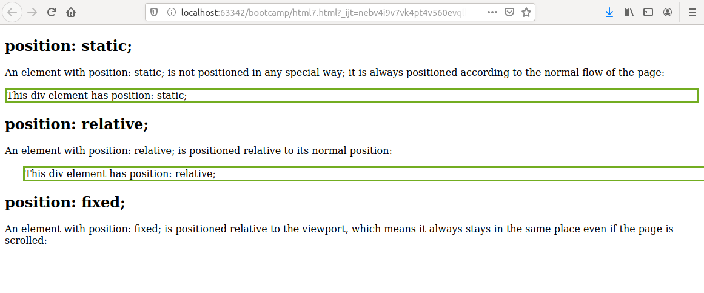
<!DOCTYPE html>
<html lang="en">
<head>
<meta charset="UTF-8">
<title>Title</title>
</head>
<style>
div.relative {
position: relative;
width: 400px;
height: 200px;
border: 3px solid #73AD21;
}
div.absolute {
position: absolute;
top: 80px;
right: 0;
width: 200px;
height: 100px;
border: 3px solid #73AD21;
}
</style>
</head>
<body>
<h2>position: absolute;</h2>
<p>An element with position: absolute; is positioned relative to the nearest positioned ancestor (instead of positioned relative to the viewport, like fixed):</p>
<div class="relative">This div element has position: relative;
<div class="absolute">This div element has position: absolute;</div>
</div>
</body>
</html>
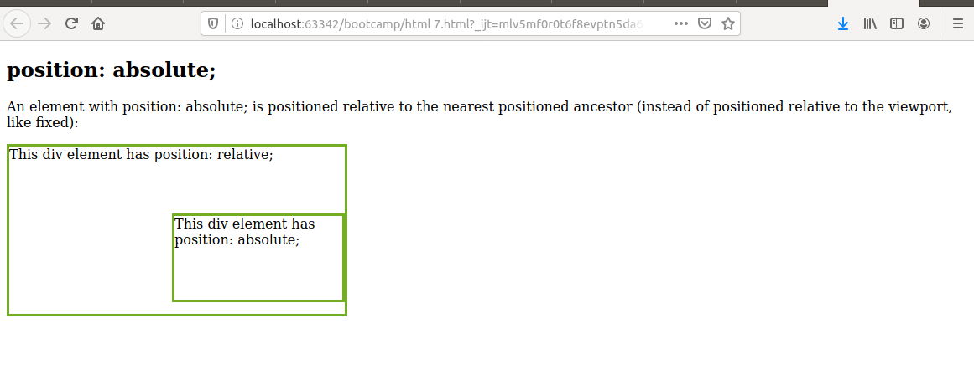

5. Write the HTML code to create a table in which there are 4 columns( ID , Employee Name, Designation, Department) and at least 6 rows. Also do some styling to it.
Ans:
<!DOCTYPE html>
<html lang="en">
<head>
<meta charset="UTF-8">
<meta name="keywords" content="Java,Javascript,html">
<meta name="description" content="This is the table">
<title>To The New</title>
<style>
table{
width:50%;
margin:auto;
border:1px solid grey;
}
tr:nth-child(even){
background-color:lightgrey;
}
th{
background-color:green;
color:white;
}
th,td{
text-align:center;
padding:15px;
}
</style>
</head>
<body>
<table>
<tbody>
<tr>
<th> ID</th>
<th> Employee Name</th>
<th> Designation</th>
<th> Department</th>
</tr>
<tr>
<td> 1</td>
<td> Neha</td>
<td> JVM Developer</td>
<td> IT Department</td>
</tr>
<tr>
<td> 2</td>
<td> Akshita </td>
<td> JVM Developer </td>
<td> IT Department</td>
</tr>
<tr>
<td> 2 </td>
<td> Nisha </td>
<td> Tester </td>
<td> IT Department</td>
</tr>
<tr>
<td> 3</td>
<td> Joshit </td>
<td> Sales</td>
<td> Sales Department</td>
</tr>
<tr>
<td> 4 </td>
<td> Akansha </td>
<td> Front-end </td>
<td> IT Department</td>
</tr>
</tbody>
</table>
</body>
</html>

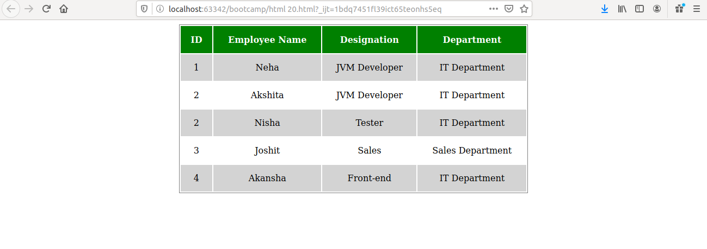

6. Why do we use meta tags?
Ans: The <meta> tag provides metadata about the HTML document. Metadata will not be displayed on the page, but will be machine parsable. Meta elements are typically used to specify page description, keywords, author of the document, last modified, and other metadata.
The metadata can be used by browsers (how to display content or reload page), search engines (keywords), or other web services.

<!DOCTYPE html>
<html lang="en">
<head>
<meta charset="UTF-8">
<meta name="description" content="Free Web tutorials">
<meta name="keywords" content="HTML,CSS,XML,JavaScript">
<meta name="author" content="John Doe">
<meta name="viewport" content="width=device-width, initial-scale=1.0">
</head>
<body>
<p>All meta information goes in the head section. It is not shown..</p>
</body>
</html>

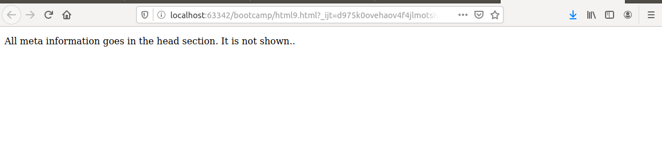

7. Explain box model.
Ans: All HTML elements can be considered as boxes. In CSS, the term "box model" is used when talking about design and layout.
The CSS box model is essentially a box that wraps around every HTML element. It consists of: margins, borders, padding, and the actual content. The image below illustrates the box model
<!DOCTYPE html>
<html lang="en">
<head>
<meta charset="UTF-8">
<title>Title</title>
</head>
<style>
div {
background-color: lightgrey;
width: 300px;
border: 15px solid green;
padding: 50px;
margin: 20px;
}
</style>
</head>
<body>
<h2>Demonstrating the Box Model</h2>
<p>The CSS box model is essentially a box that wraps around every HTML element. It consists of: borders, padding, margins, and the actual content.</p>
<div>This text is the content of the box. We have added a 50px padding, 20px margin and a 15px green border. Ut enim ad minim veniam, quis nostrud exercitation ullamco laboris nisi ut aliquip ex ea commodo consequat. Duis aute irure dolor in reprehenderit in voluptate velit esse cillum dolore eu fugiat nulla pariatur. Excepteur sint occaecat cupidatat non proident, sunt in culpa qui officia deserunt mollit anim id est laborum.</div>
</body>
</html>
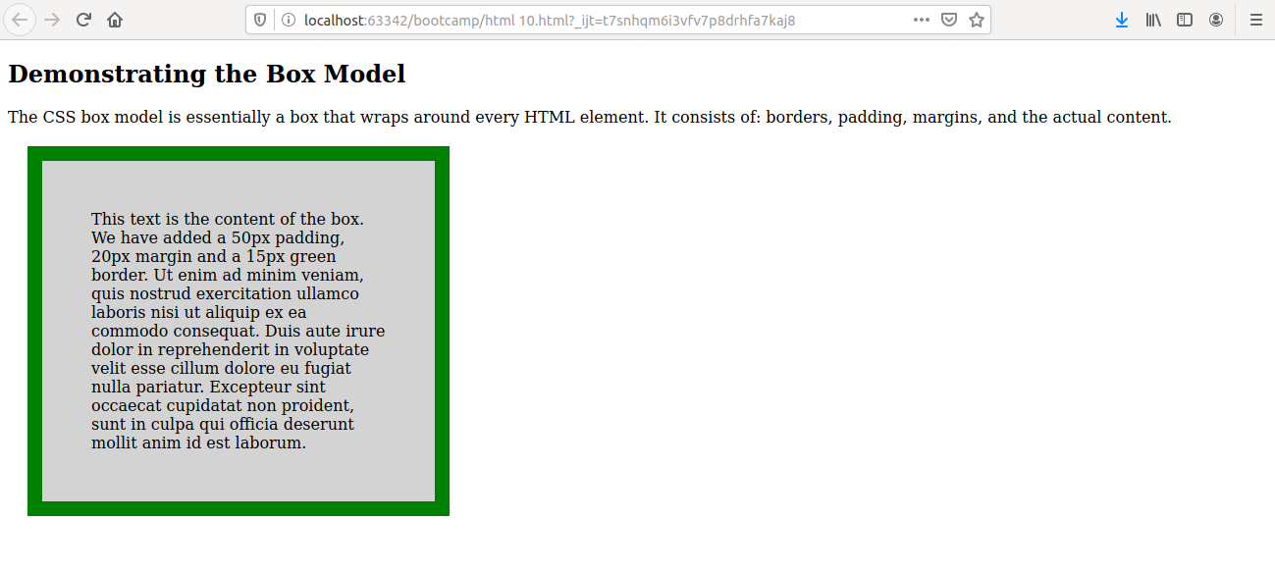

8. What are the different types of CSS Selectors?
Ans: CSS selectors are used to "find" (or select) the HTML elements you want to style.
We can divide CSS selectors into five categories:
- Simple selectors (select elements based on name, id, class)
- Combinator selectors (select elements based on a specific relationship between them)
- Pseudo-class selectors (select elements based on a certain state)
- Pseudo-elements selectors (select and style a part of an element)
- Attribute selectors (select elements based on an attribute or attribute value)
Element,id,class selectors
<!DOCTYPE html>
<html lang="en">
<head>
<meta charset="UTF-8">
<title>Title</title>
<style>
p {
text-align: center;
color: red;
}
#para1 {
text-align: center;
color:black;
}
.center {
text-align: center;
color: green;
}
</style>
</head>
<p>Every paragraph will be affected by the style.</p>
<p id="para1">Me too!</p>
<p>And me!</p>
<p class="center">Red and center-aligned paragraph.</p>
</body>
</html>

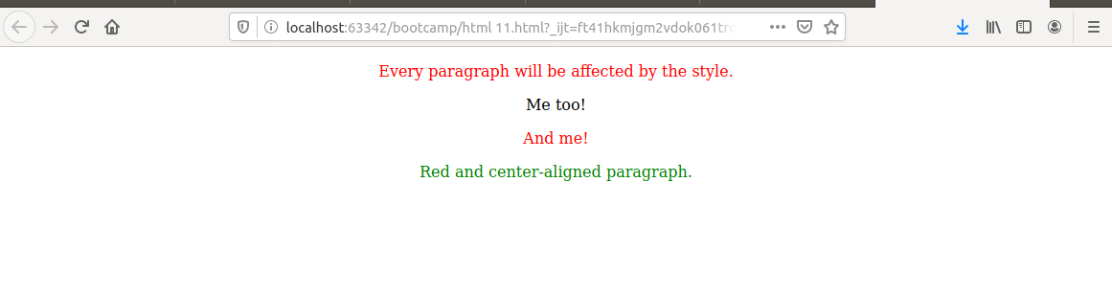

Universal selectors
<!DOCTYPE html>
<html lang="en">
<head>
<meta charset="UTF-8">
<title>Title</title>
<style>
* {
text-align: center;
color: cornflowerblue;
}

</style>
</head>
<body>
<h1>Hello world!</h1>
<p>Every element on the page will be affected by the style.</p>
<p id="para1">Me too!</p>
</body>
</html>
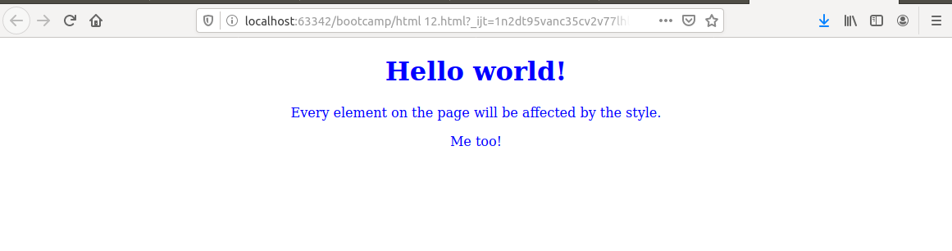

Grouping selectors

<!DOCTYPE html>
<html lang="en">
<head>
<meta charset="UTF-8">
<title>Title</title>
<style>
h1, h2, p {
text-align: center;
color: red;
}
</style>
</head>
<body>
<h1>Hello HTML!</h1>
<h2>Smaller than h1!</h2>
<p>This is a paragraph.</p>
</body>
</html>

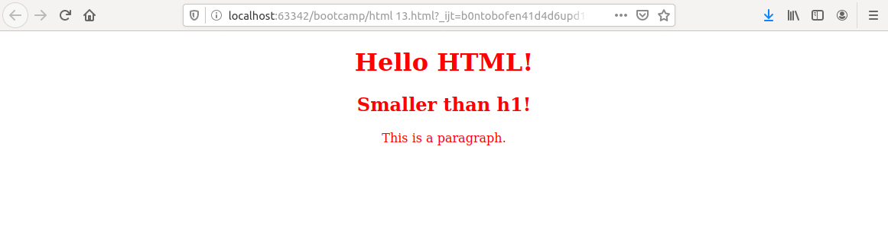

9. Define Doctype.
Ans: The <!DOCTYPE> declaration is not an HTML tag; it is an instruction to the web browser about what version of HTML the page is written in.
<!DOCTYPE html>
<html lang="en">
<head>
<meta charset="UTF-8">
<title>Title</title>
</head>
<body>
<p>This is an example of Doctype </p>
</body>
</html>
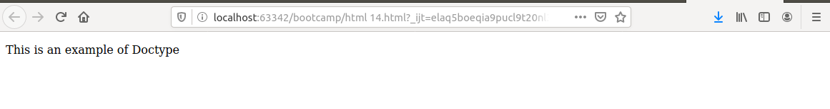

10. Explain 5 HTML5 semantic tags.
Ans:
- Section tag
The <section> element defines a section in a document.
<!DOCTYPE html>
<html lang="en">
<head>
<meta charset="UTF-8">
<title>Title</title>
</head>
<body>
<section>
<h1>WWF</h1>
<p>The World Wide Fund for Nature (WWF) is an
international organization working on issues regarding the conservation,
research and restoration of the environment, formerly named the World Wildlife Fund. WWF was founded in 1961.</p>
</section>
<section>
<h1>WWF's Panda symbol</h1>
<p>The Panda has become the symbol of WWF.
The well-known panda logo of WWF originated from a panda named Chi Chi
that was transferred from the Beijing Zoo to the London Zoo in the same year of the establishment of WWF.</p>
</section>
</body>
</html>

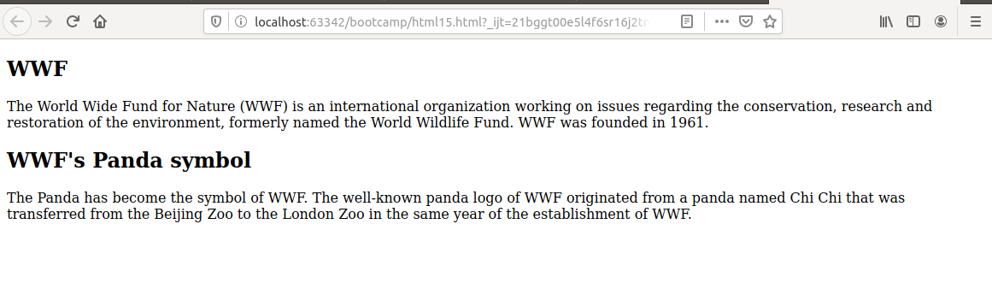
b) Article tag
The <article> element specifies independent, self-contained content.
An article should make sense on its own, and it should be possible to read it independently from the rest of the web site.
<!DOCTYPE html>
<html lang="en">
<head>
<meta charset="UTF-8">
<title>Title</title>
</head>
<body>
<article>
<h1>What Does WWF Do?</h1>
<p>WWF's mission is to stop the degradation of our planet's natural environment,
and build a future in which humans live in harmony with nature.</p>
</article>
</body>
</html>
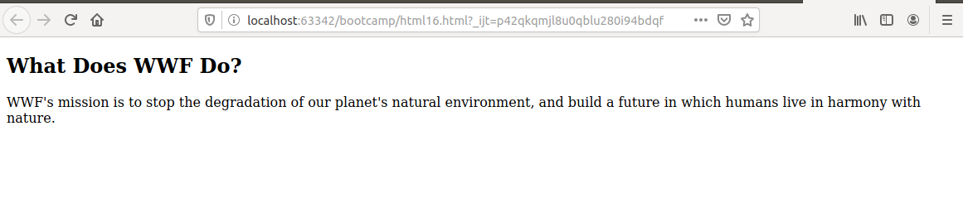

c) Header element
The <header> element specifies a header for a document or section.
<!DOCTYPE html>
<html lang="en">
<head>
<meta charset="UTF-8">
<title>Title</title>
</head>
<body>
<article>
<header>
<h1>What Does WWF Do?</h1>
<p>WWF's mission:</p>
</header>
<p>WWF's mission is to stop the degradation of our planet's natural environment,
and build a future in which humans live in harmony with nature.</p>
</article>
</body>
</html>
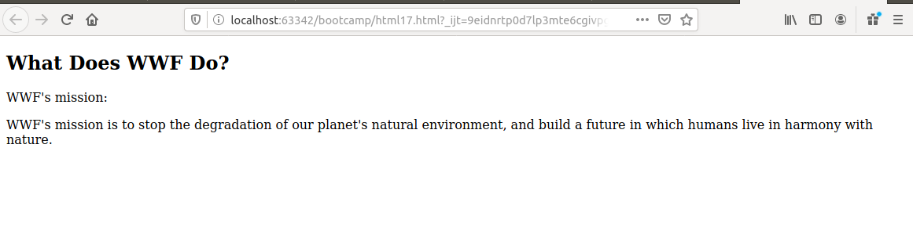

d) Footer element
The <footer> element specifies a footer for a document or section.
A <footer> element should contain information about its containing element.
<!DOCTYPE html>
<html lang="en">
<head>
<meta charset="UTF-8">
<title>Title</title>
</head>
<body>
<article>
<header>
<h1>What Does WWF Do?</h1>
<p>WWF's mission:</p>
</header>
<p>WWF's mission is to stop the degradation of our planet's natural environment,
and build a future in which humans live in harmony with nature.</p>
</article>
<br>
<br>
<br>
<br>
<footer>
<p>Posted by: Hege Refsnes</p>
<p>Contact information: <a href="http://tothenew.com">TO THE NEW </a>.</p>
</footer>
</body>
</html>
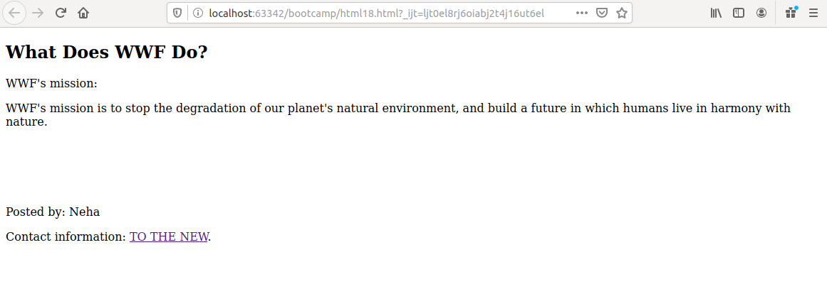
e) <nav>
The <nav> element defines a set of navigation links

<!DOCTYPE html>
<html lang="en">
<head>
<meta charset="UTF-8">
<title>Title</title>
</head>
<body>
<nav>
<a href="https://www.w3schools.com/html/">HTML</a> |
<a href="https://www.w3schools.com/css/">CSS</a> |
<a href="https://www.w3schools.com/js/">JavaScript</a> |
<a href="https://www.w3schools.com/jquery/">jQuery</a>
</nav>
</body>
</html>
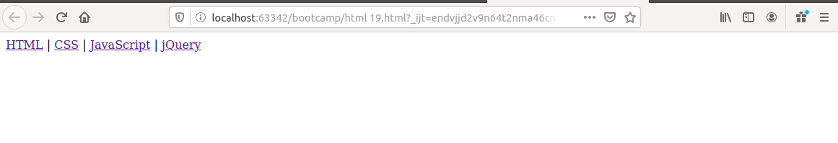
11. Create HTML for web-page.jpg (check resources, highest weightage for answers)
Ans:

index.html

<!DOCTYPE html>
<html lang="en">
<head>
<link rel="stylesheet" href="style.css">
<meta charset="UTF-8">
<meta name="keywords" content="JVM">
<meta name="description" content="Details about web page">
<title> TO THE NEW</title>
</head>
<body>
<div id="header">
<h1> TO THE NEW</h1>
<div id="navigation">
<ul>
<li> <a href="#">HOME </a> </li>
<li> <a href="#">ABOUT US </a> </li>
<li> <a href="#">SERVICES </a> </li>
<li> <a href="#">CONTACT US </a> </li>
</ul>
</div>
<div id="body">
<div id ="article">
<div class="firstimage">
<img src="image3.jpg" alt="TTN image" width="960" height="360">
</div>
</div>
<div class="para">
<p>
We are a digital technology company providing end-to-end product
development services. We leverage the power of experience design,
cutting-edge engineering, and cloud to build disruptive web and mobile
apps enabling digital transformation for business.
</p>
<p>
<h3> <u> Technologies</u> </h3>
We solve complex problems using cutting edge technologies
We take a deep dive into various digital advances and leverage
these technologies to build winning products. We work on breakthrough
technologies and deliver mission critical mobile and web applications.
Some of the technologies that we have mastered include Grails, Angular.js Node.js,and React to name a few.
</p>
</div>
<div class="Image">
<h4> Latest Gallery</h4>
<hr/>
<div class="gallery">
<figure>
<img src="image2.jpg" alt="Image1" width="215" height="300" >
<figcaption style ="color:black">Certification</figcaption>
</figure>
<figure>
<img src="image4.jpg" alt="Image1" width="215" height="300">
<figcaption style="color:black"> Register </figcaption>
</figure>
<figure>
<img src="image5.jpg" alt="Image1" width="215" height="300">
<figcaption style="color:black"> Environment </figcaption>
</figure>
<figure>
<img src="image6.jpg" alt="Image1" width="215" height="300">
<figcaption style="color:black"> Training </figcaption>
</figure>
</div>
</div>
</div>
<div class="footer">
<span class="left"> &copy;All right reserved.2018-20</span>
<span class="right"> By Neha Budhiraja</span>
</div>
</div>
</body>
</html>
style.css
body{
background-color:#696969;
}
#header{
margin:auto;
background-color: grey;
width:90%;
height:150px;
background-color:#808080;
}
#navigation{
margin: auto;
width:95%;
margin-top: 45px;
padding: 5px 2px 5px 2px;
background-color:#696969;
}
#navigation ul {
background-color: #696969;
margin-left: 30px;en
}
#navigation ul li a {
text-decoration: none;
color: white;
}
#body
{
background-color: white;
}
#navigation ul li{
display:inline;
margin-left: 10px;
color:white;
background-color: #696969;
}
.gallery{
display:flex;
margin:0px;
padding: 0px;
box-sizing: border-box;
justify-content:center;
}
.firstimage
{
display:block;
}
#article
{
width:960px;
height:360px;
color:white;
margin:auto;
background-color: #808080;
border:10px solid white;
margin-top: 20px;
}
.left
{
float:left;
margin-left: 20px;
display: inline-block;
margin-top:10px;
}
.right{
float:right;
display: inline-block;
margin-top: 10px;
margin-right: 20px;
}
#body
{
background-color: white;
height:1100px;
margin-top: 30px;
}
.para {
margin-top: 50px;
margin-left:30px;
width: 960px;
padding: 5px 2px 5px 2px;
background-color: #d3d3d3;
}
.Image
{
width:960px;
height: 360px;
margin:auto ;
}
.footer
{
margin-top:5px;
height:60px;
background-color: black;
color:#696969;
}
.gallery figure
{
margin:14px;
padding: 0px;
box-sizing: border-box;
}
.gallery figure img
{
max-width: 100%;
margin: auto;
}
.gallery figure figcaption
{
text-align:center;
}

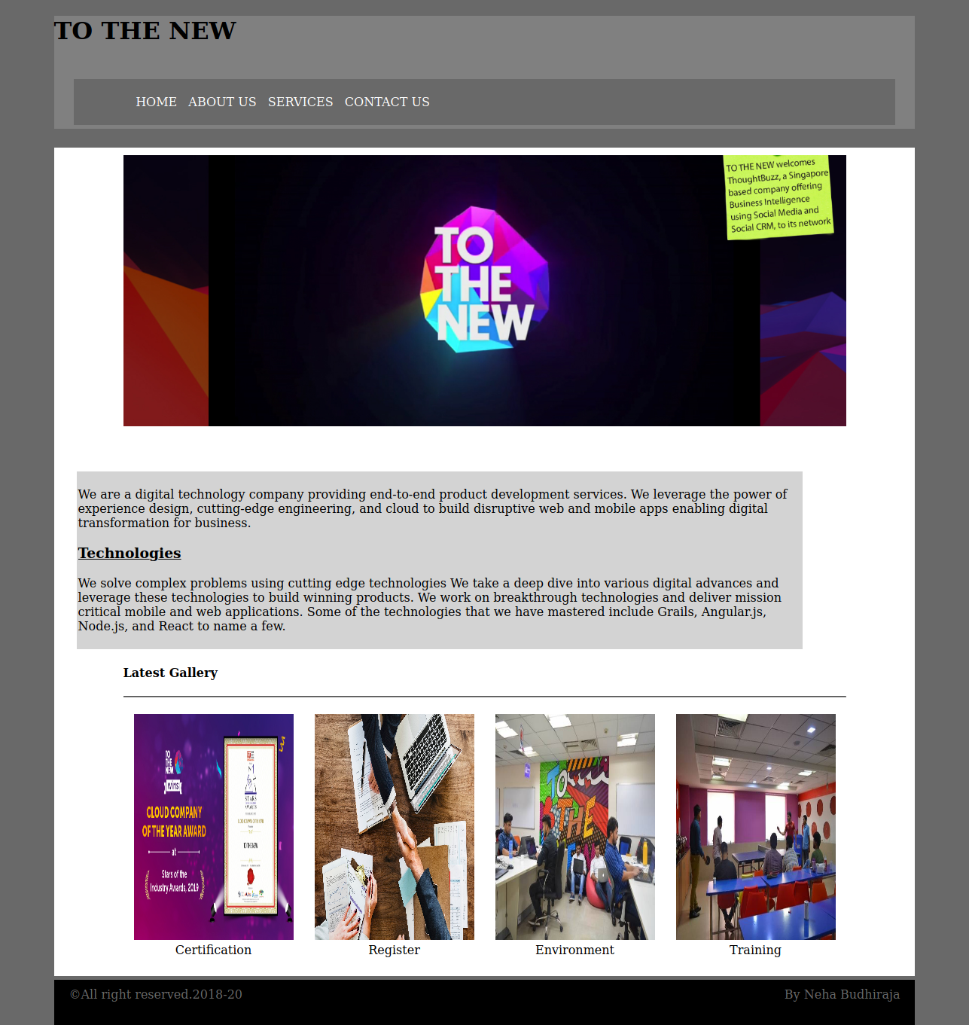
12. Create HTML for form.png (check resources, highest weightage for answers)
index2.html
<!doctype html>
<html lang="en">
<head>
<meta charset="UTF-8">
<meta name="viewport"
content="width=device-width, user-scalable=no, initial-scale=1.0, maximum-scale=1.0, minimum-scale=1.0">
<meta http-equiv="X-UA-Compatible" content="ie=edge">
<title>Document</title>
<link rel="stylesheet" href="style1.css">
</head>
<body>
<div id="head">
<span> TO THE NEW. </span>
<div id="nav">
<ul>
<li> HOME</li>
<li> Quick Help</li>
</ul>
</div>
<h3> BUG REPORT</h3>
<form class="flex_work" method="post" action="#">
<label>
Title*:
</label>
<input type="text" required>
<label>
Description:
</label>
<textarea name="message" rows="5" cols="20" required>
</textarea>
<label>
Operating System:
</label>
<select name="Operating System">
<option class="select" value="Windows XP"> Windows XP </option>
<option class="select" value="Windows 7"> Windows 7 </option>
<option class="select" value="Windows 10"> Windows 10 </option>
<option class="select" value="Windows Vista"> Windows Vista </option>
</select>
<label>
Product:
</label>
<select name="Product">
<option value="Windows XP"> Microsoft Access </option>
<option value="Windows 7"> Microsoft Excel </option>
<option value="Windows 10"> Microsoft Outlook </option>
<option value="Windows Vista"> Microsoft One Note</option>
</select>
<label>
Version:
</label>
<input type="number" name="Version" min="1" max="2">
<label>
License:
</label>
<fieldset>
<input type="radio" name="license" value="Free"> <label> Free</label>
<input type="radio" name="license" value="Business"> <label>Business</label>
</fieldset>
<label>
Severity:
</label>
<select name="Severity">
<option class="select" value="Serious">Serious</option>
<option class="select" value="Danger"> Danger</option>
</select>
<label>
Attachments:
</label>
<input type="file" name="documents" accept="file/*">
<div class="divide">
<input type="Submit" name="Send" value="Submit">
</div>
</form>
<br>
<br>
</div>
</body>
</html>
style1.css
*{
font-family:sans-serif;
}
body{
margin-top:20px;
}
#head{
color:#06A061;
border-bottom:0.5px solid #E7E4E4;
height:50px;
}
#head span{
font-size:20px;
color:#06A061;
}
#nav{
margin-top:-30px;
}
#nav ul li{
display:inline;
margin-left:20px;
float:right;
}
.flex_work{
display:flex;
flex-direction:column;
}
h3{color:white;
width:30%;
padding: 15px 2.5px 15px 2.5px;
margin:auto;
margin-top:80px;
background-color: #E7E4E4;
}
form{
border:2px solid #E7E4E4;
color:black;
margin:auto;
width:30%;
}
form input,select,textarea{
margin-top:20px;
padding:5px 2px 5px 2px;
width:90%;
margin:auto;
border-radius:5px;
border:1px solid #E7E4E4;
}
form label{
font-size:14px;
margin-left:20px;
margin-top:15px;
}
input[type="radio"]{
display:inline-block;
margin-right:20px;
margin-left:-20px;
width:70px;
}
fieldset{
border:none;
}
.select,select{
background-color:#06A061;
color:white;
border:none;
font-weight:500;
}
input[type="submit"]
{
background-color:#06A061;
color:white;
width:60px;
float:right;
margin-top:25px;
}
.divide{
margin-top:5px;
height:50px;
border-radius:5px;
background-color:#E7E4E4;
}

