- Create a directory "exercise" inside your home directory and create nested(dir1/dir2/dir3) directory structure inside "excerise" with single command.

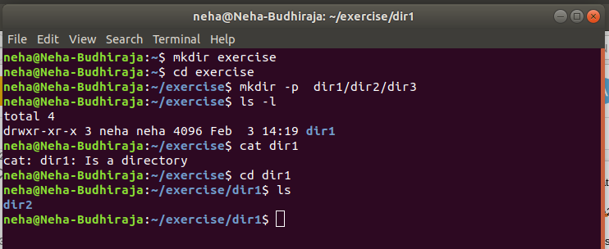

- Create two empty files inside dir2 directory: emptyFile1,emptyFile2 in single command

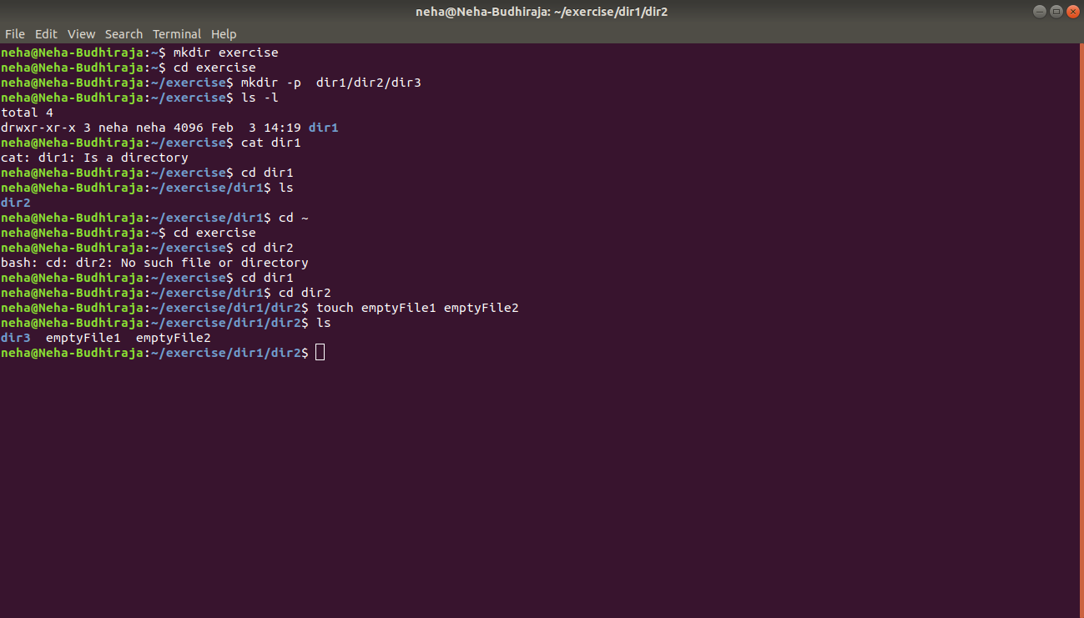

- Create one file file1.txt containing text "hello world" and save it.

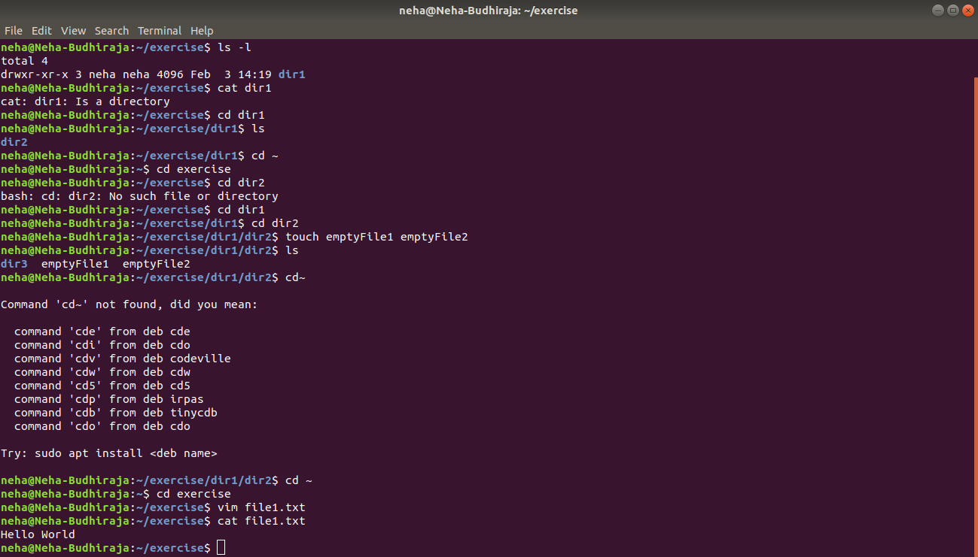

- Find a "passwd" file using find command inside /etc. copy this files as passwd_copy and then rename this file as passwd_backup.

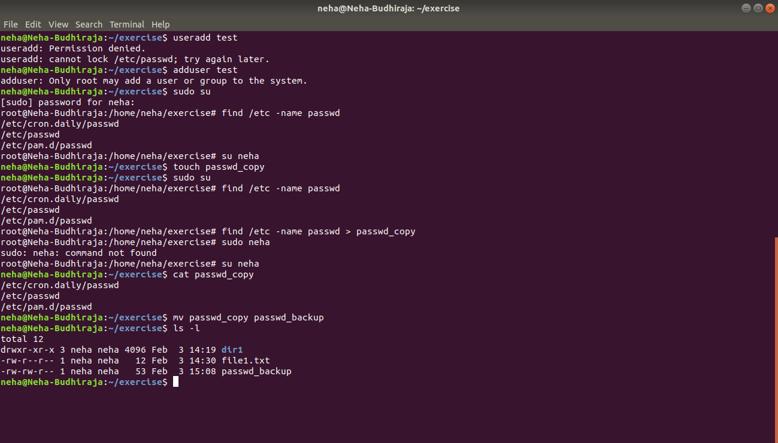

- Try reading passwd_backup file in multiple tools: less,more,cat,strings etc and find the difference in their usage.

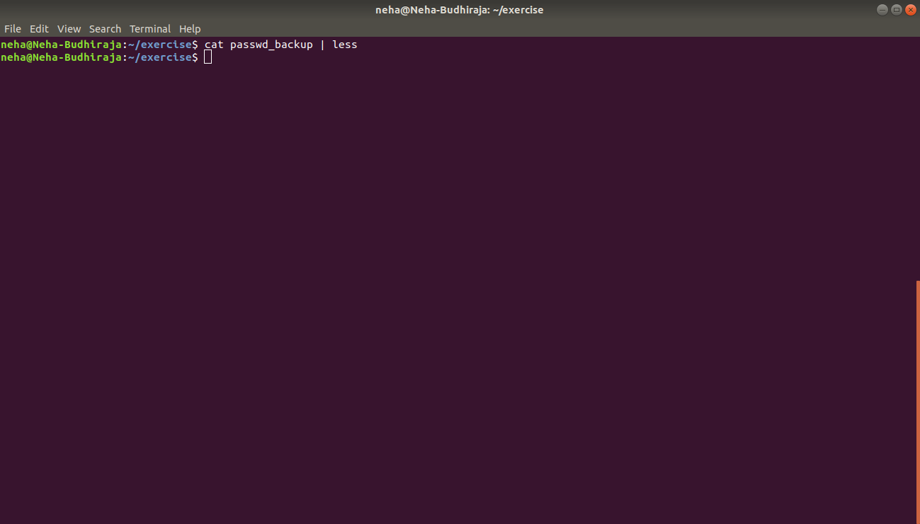
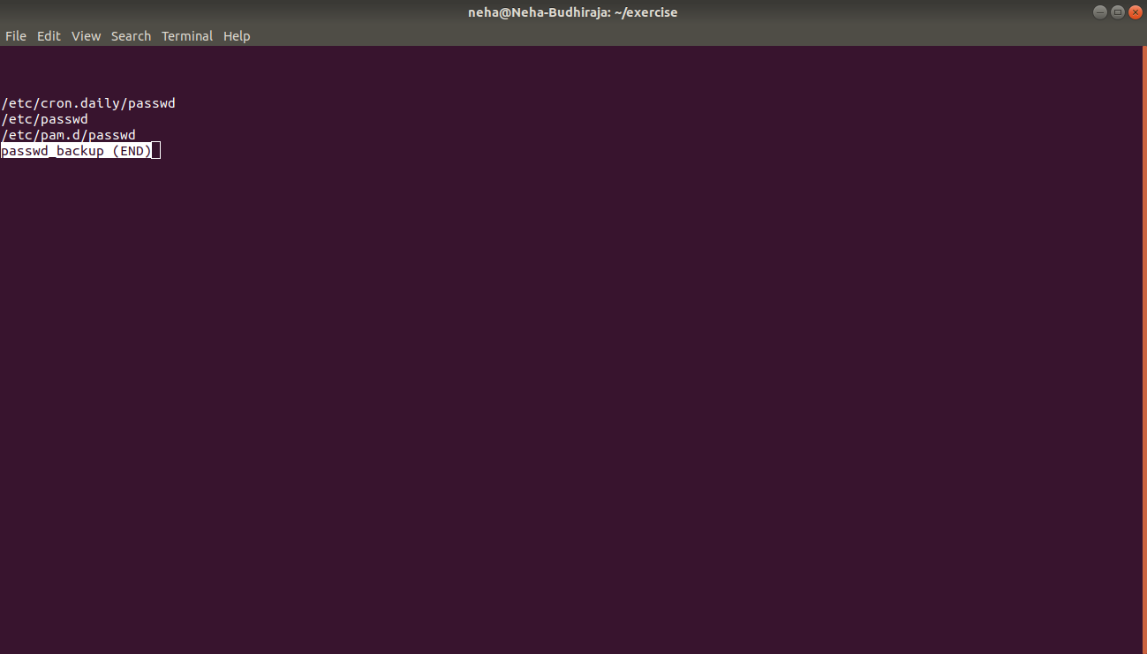

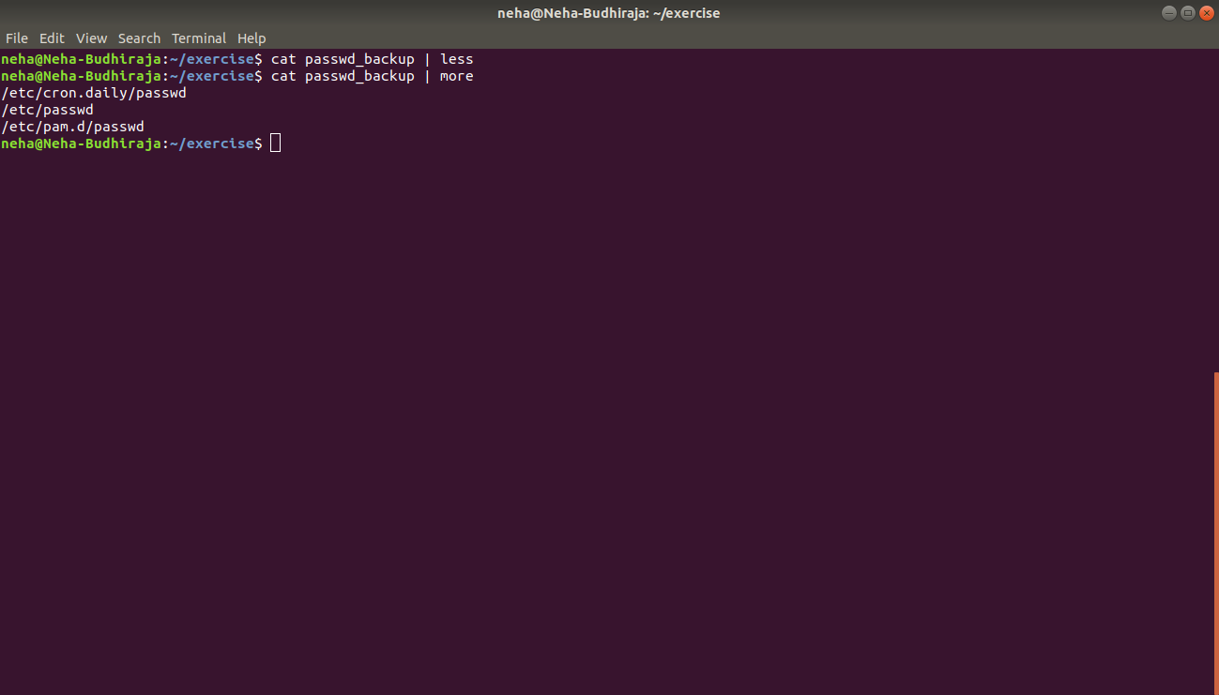

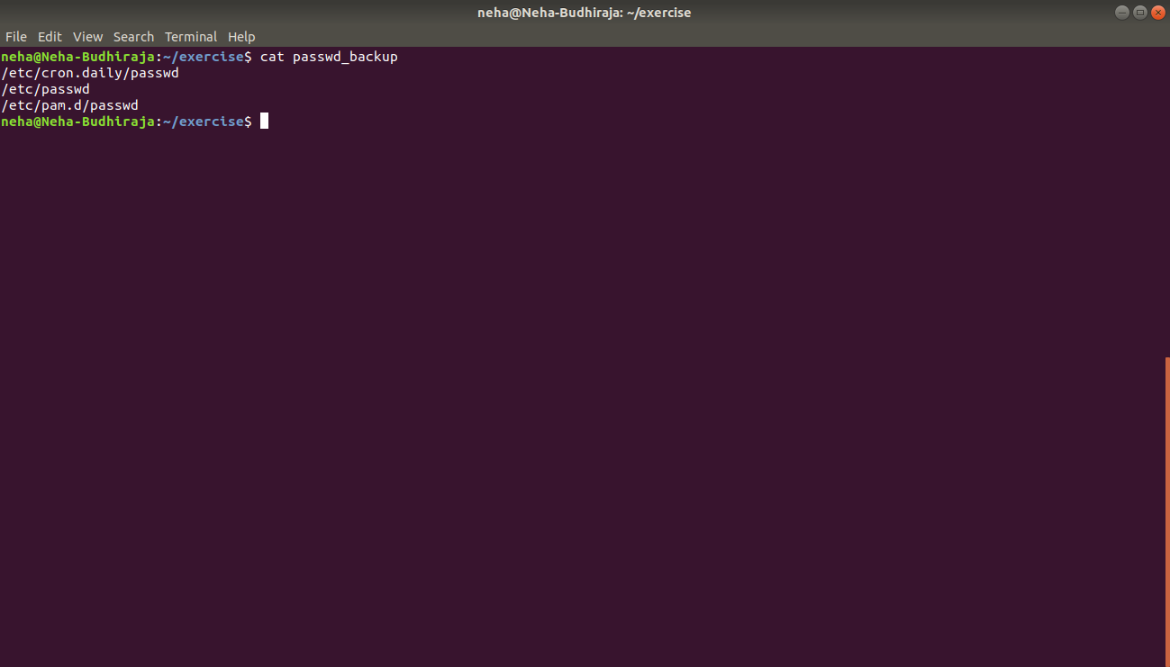
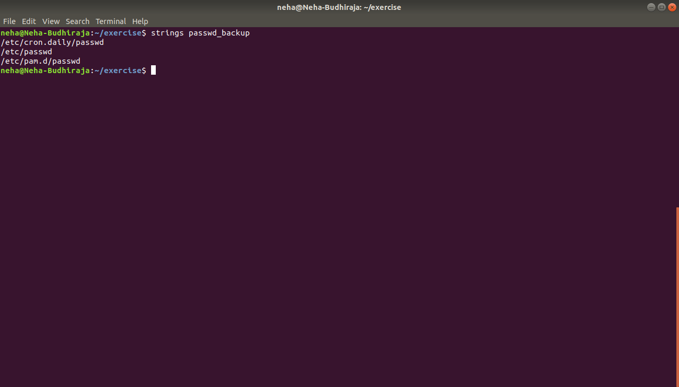

- Find out the number of line in password_backup containing "/bin/false".

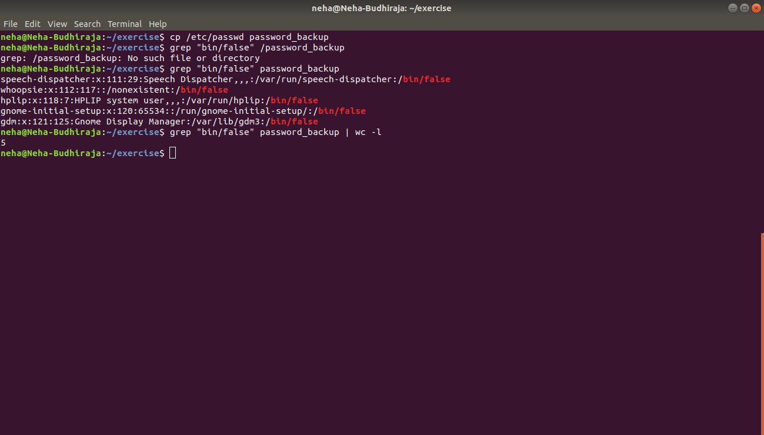

- Get the first 5 lines of a file “password_backup” and Redirect the output of the above commands into file "output".

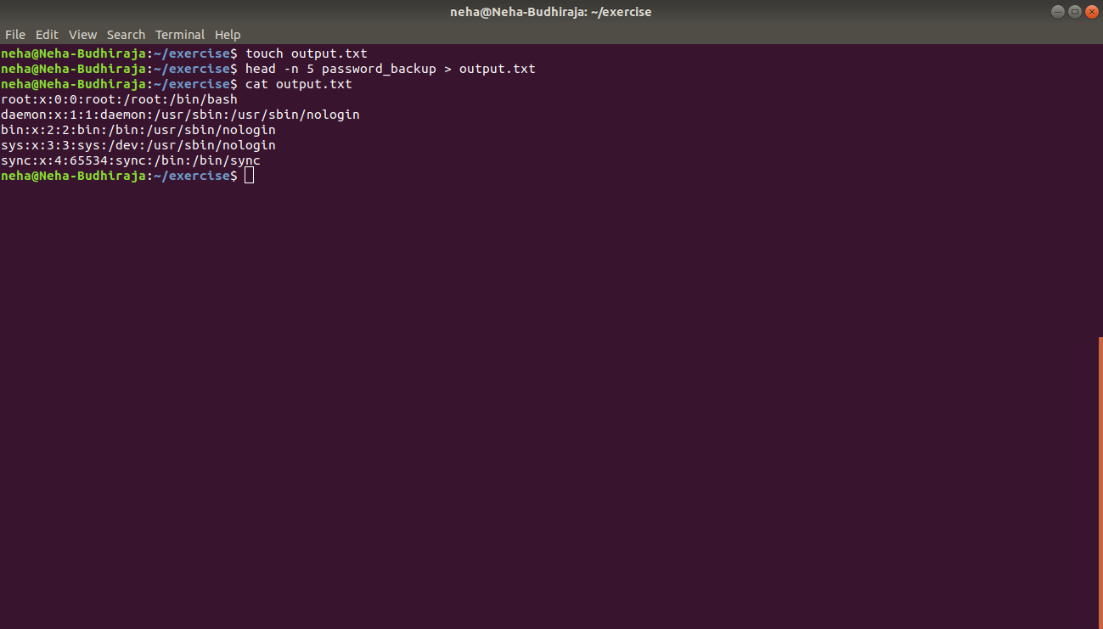

- Create a "test" user,create its password and find out its uid and gid.

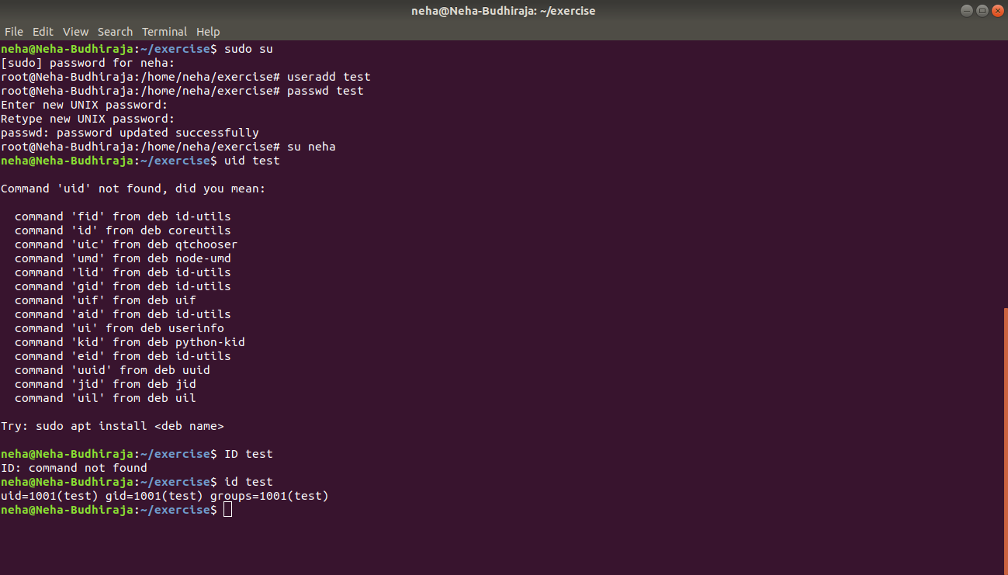

- Change the timestamp of emptyFile1,emptyFile2 which are exist in dir2

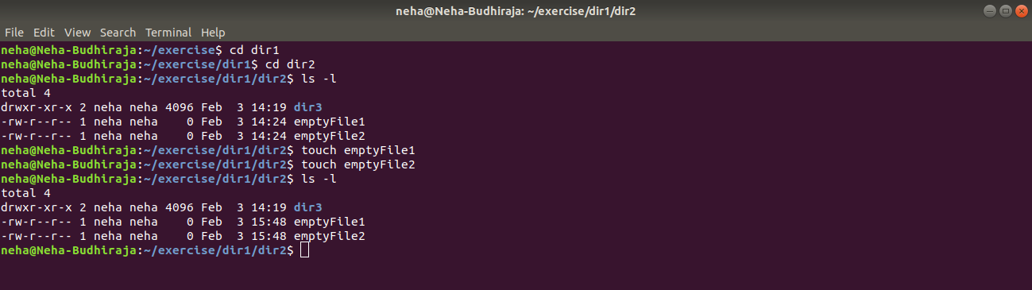

- Login as test user and edit the "output" file created above. Since the permission wont allow you to save the changes. Configure such that test user can edit it.
a) Add group owner of the "output" file as the secondary group of testuser and check/change the "output" file permission if it is editable by group. Once done revert the changes
b) Make the file editable to the world so that test user can access it. Revert the changes after verification
c) Change the ownership to edit the file.
a) Adding test user to “neha” group and assigning write and executable rights to groups of output.txt. Logging into the test user and writing to output.txt
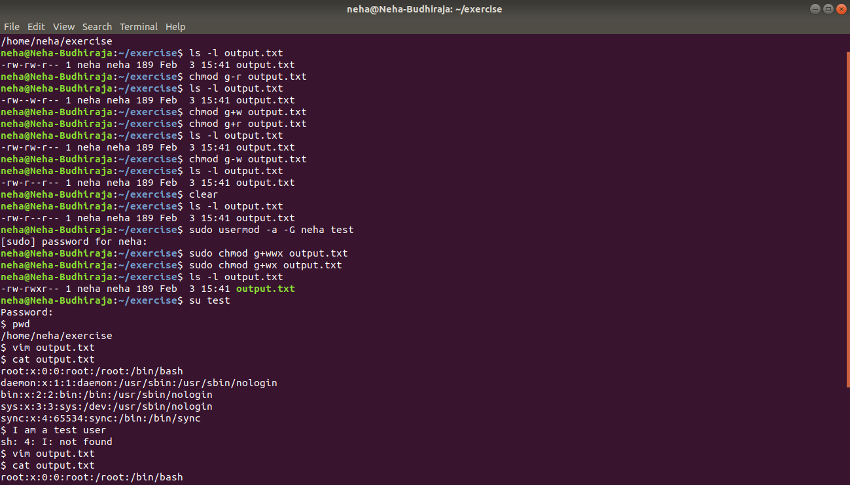

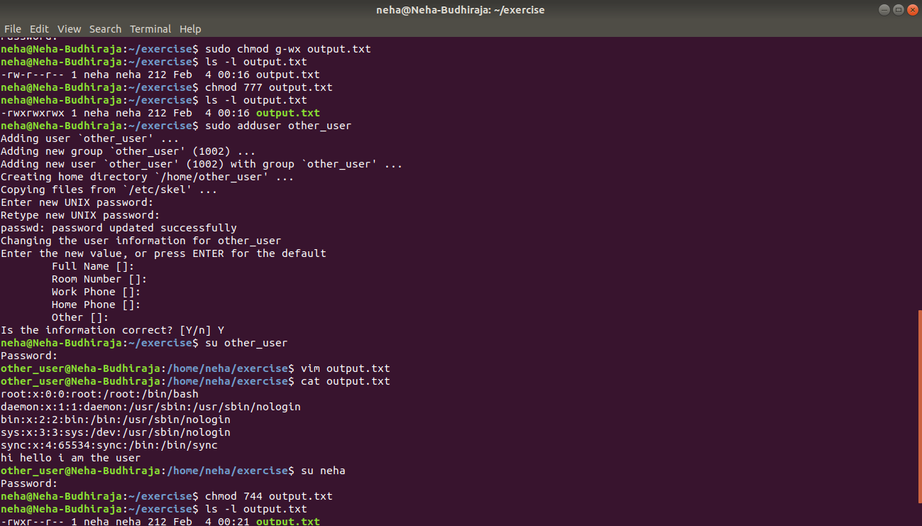

b) Make the file editable to the world so that the test user can access it. Revert the changes after verification. Logging into other user to write to the file, and even reverting the changes

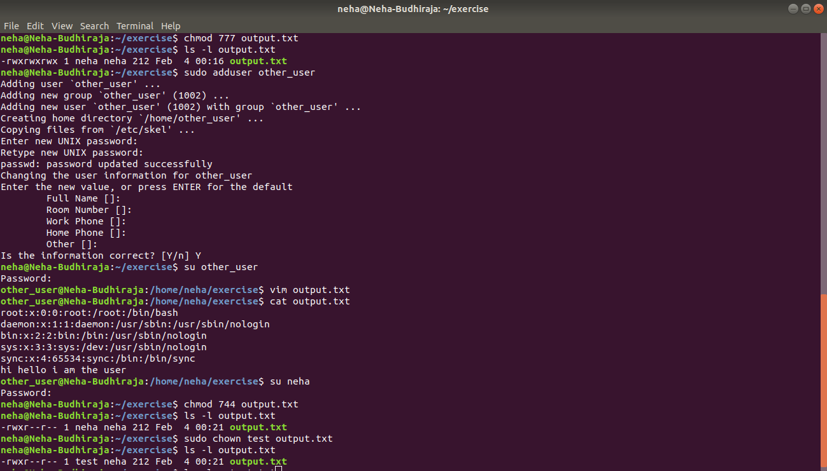

c) Change the ownership “test” user to edit the file

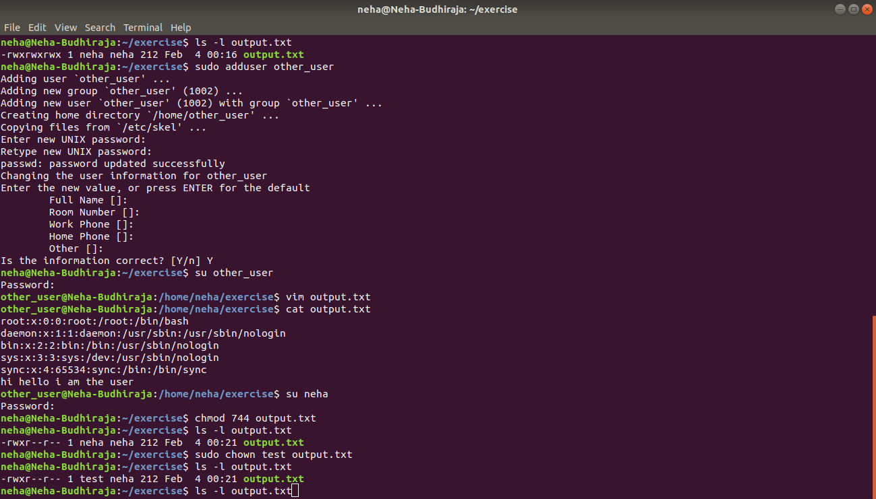

- Create alias with your name so that it creates a file as "/tmp/aliastesting".

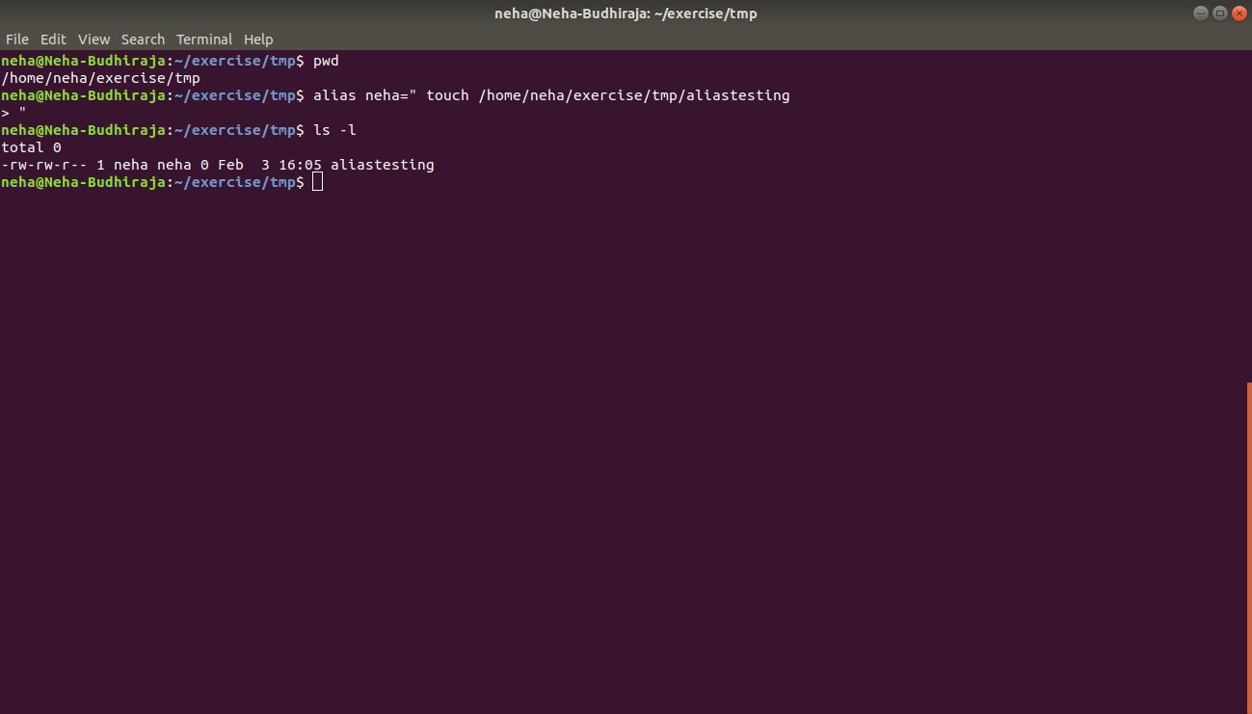

- Edit ~/.bashrc file such that when you change to "test" user it should clear the screen and print "Welcome".

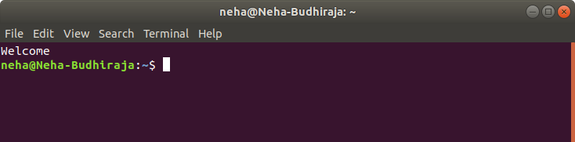

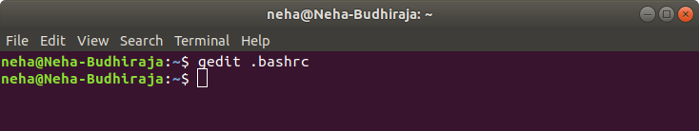

- Install “zip” package.

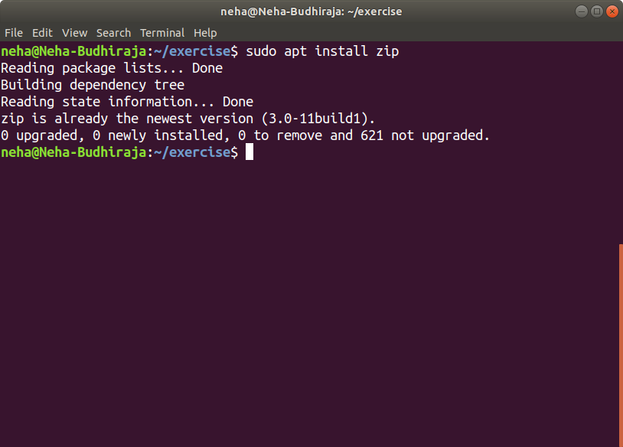

- Compress "output" and "password_backup" files into a tar ball. List the files present inside the tar created.
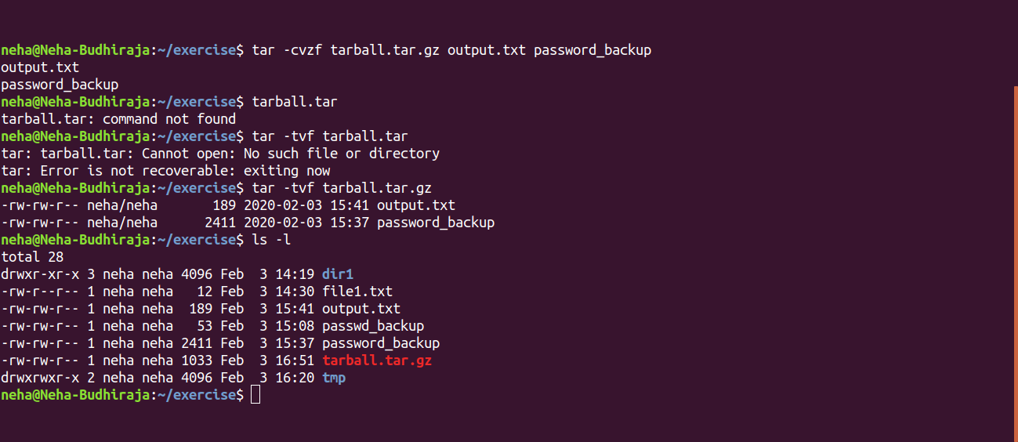

- scp this file to test user

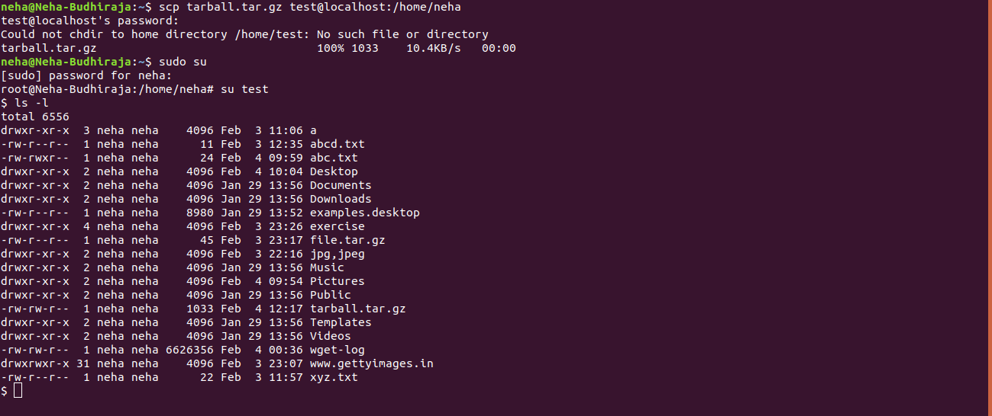

- Unzip this tar bar by logging into the remote server
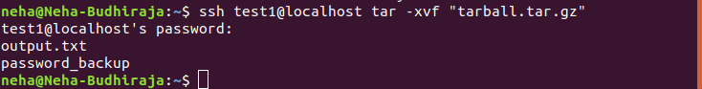

- Download any image from web and move to desktop

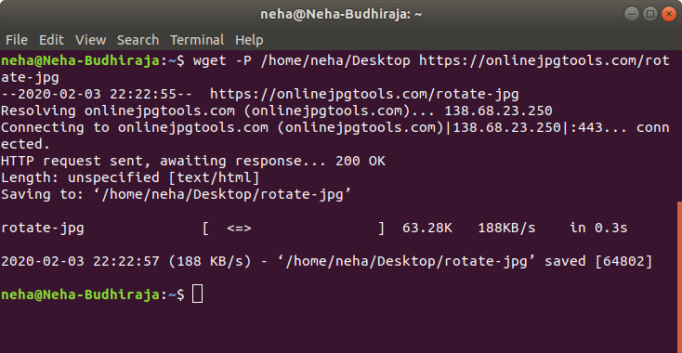

- How to get help of commands usages.
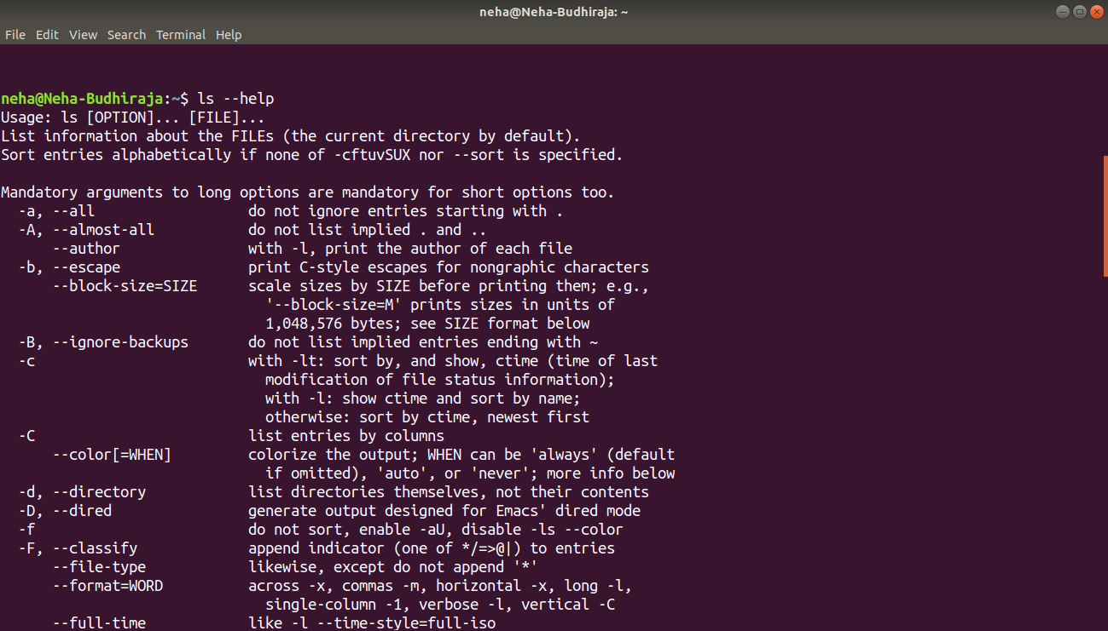

- Create a symlink of /etc/services into /tmp/ports-info
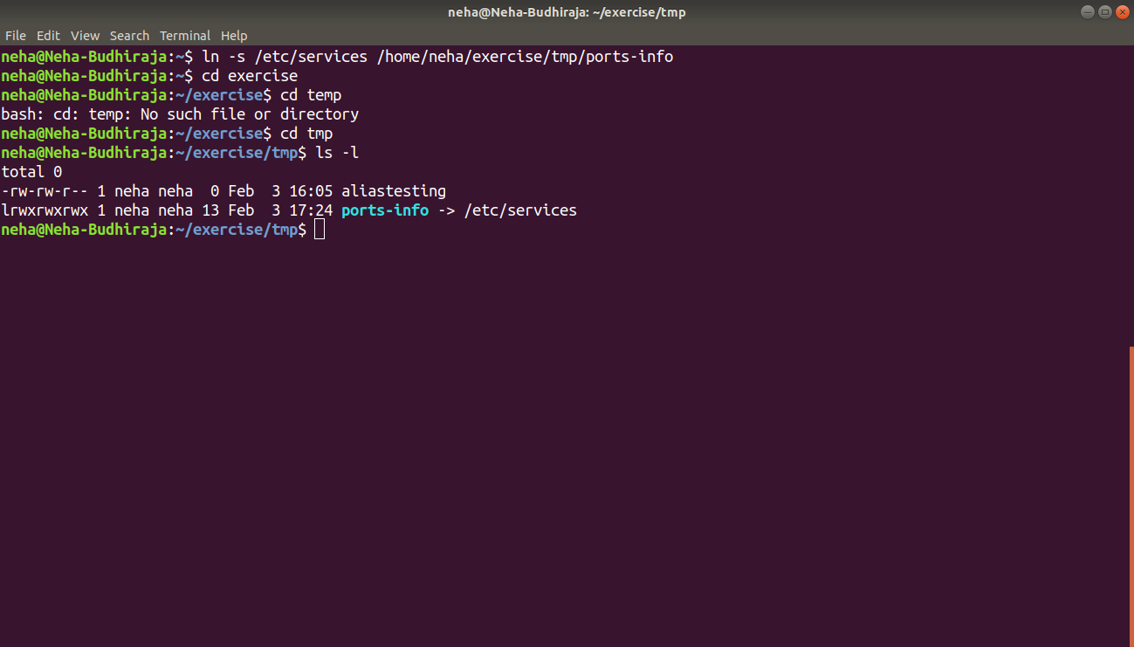
- You are appointed as a Software/DevOps Engineer in ABC media services. On your first day you need to troubleshoot a problem. There is a command “xyz” somewhere installed in that linux system. But as a new joinee you do not have any idea about where is that Installed. How can you check that?
Ans: Can be checked by using whereis command

