JUNIT EXERCISE

1) Write tests for replaceSubstring First.java

package com.im;
import org.junit.jupiter.api.Test;
import org.junit.jupiter.api.function.Executable;
import java.math.BigDecimal;
import java.util.ArrayList;
import java.util.Arrays;
import java.util.List;
import static org.junit.jupiter.api.Assertions.*;
public class FirstTest
{
private First firstTest=new First();
List<BigDecimal> decimalList=new ArrayList<>();
@Test
public void returntrue_if_ispalindrome(String checkstr)
{
//given
String str=checkstr;
//then
boolean outputstr=firstTest.isPallindrome(str);
//when
assertTrue(outputstr);
}
@Test
void returnfalse_if_notpalindrome()
{
//given
String str="Hello world";
//when
boolean outputstr=firstTest.isPallindrome(str);
//then
assertFalse(outputstr);
}
@Test
void shouldthrow_runtimeexception_on_calculateaverage()
{
//given
List<BigDecimal> decimalList1=new ArrayList<>();
//when
Executable executable=()-> firstTest.calculateAverage(decimalList1);
//then
assertThrows(RuntimeException.class,executable);
}
@Test
void should_calculate_correct_average()
{
//given
decimalList.add(new BigDecimal(1));
decimalList.add(new BigDecimal(2));
decimalList.add(new BigDecimal(3));
decimalList.add(new BigDecimal(5));
decimalList.add(new BigDecimal(4));
//when
BigDecimal actual=firstTest.calculateAverage(decimalList);
BigDecimal expected=new BigDecimal(4);
//then
assertEquals(expected,actual);
}
@Test
void should_filter_even_correct()
{
//given
List<Integer> lists=new ArrayList<>(Arrays.asList(3,6,7,8,4,9));
//when
lists=firstTest.filterEvenElements(lists);
List<Integer> expectedlist=new ArrayList<>(Arrays.asList(3,7));
//then
assertEquals(expectedlist,lists);
}
@Test
void should_return_correct_string()
{
//given
String string="Hello World";
String originalstr="Big world";
String duplicatestr="Small";
//when
String expected="Big world World";
String actual=firstTest.replaceSubString(string,originalstr,duplicatestr);
//then
assertEquals(expected,actual);
}
@Test
void to_use_null_replacementstring()
{
//given
String string="Hello world";
String originalstr=null;
String substring="Big";
//when
String expected="Hello world";
String actual=firstTest.replaceSubString(string,originalstr,substring);
//then
assertEquals(expected,actual);
}
}

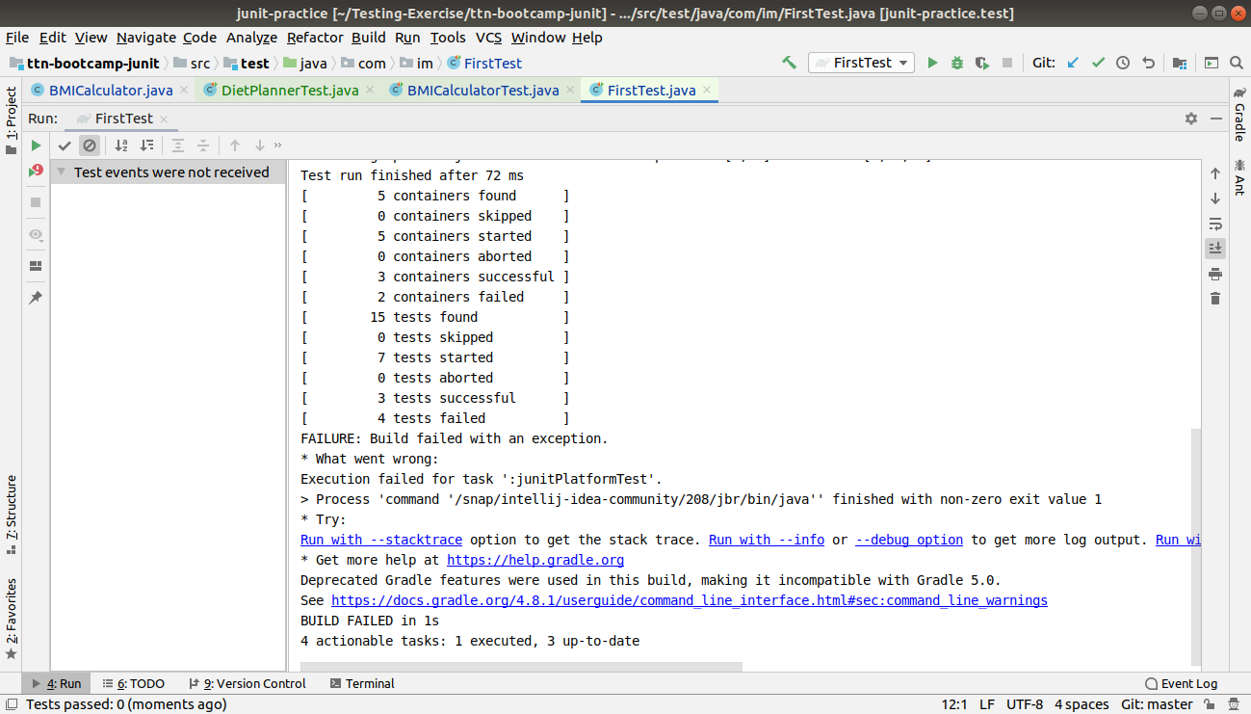

2) Write test cases for BMI calculator

package healthycoderapp;
import org.junit.jupiter.api.AfterAll;
import org.junit.jupiter.api.BeforeAll;
import org.junit.jupiter.api.Test;
import org.junit.jupiter.api.function.Executable;
import java.util.ArrayList;
import java.util.List;
import static org.junit.jupiter.api.Assertions.*;
class BMICalculatorTest {
@Test
void test()
{
assertTrue(BMICalculator.isDietRecommended(90.0,1.72));
// assertTrue(BMICalculator.isDietRecommended(67.0,1.72));
}
@BeforeAll
void before_all()
{
System.out.println("Before the method");
}
@AfterAll
void after_all()
{
System.out.println("After the method");
}
@Test
void should_ReturnTrue_When_Diet_Recommended()
{
//given
double weight=89.0;
double height=1.72;
//when
boolean recommended=BMICalculator.isDietRecommended(weight,height);
//then
assertTrue(recommended);
}
@Test
void should_ReturnFalse_When_Diet_Recommended()
{
//given
double weight=50.0;
double height=1.92;
//when
boolean recommended=BMICalculator.isDietRecommended(weight,height);
//then
assertFalse(recommended);
}
@Test
void should_ThrowArithematic_Exception_When_height_zero()
{
//given
double weight=89.0;
double height=0;
//when
//executable are used to handle exceptions//
Executable executable = ()-> BMICalculator.isDietRecommended(weight,height);
//then
assertThrows(ArithmeticException.class,executable);
}
@Test
void Should_returncoder_withWorstBMI_whencoder_list_notempty()
{
//given
List<Coder> coders=new ArrayList<>();
coders.add(new Coder(1.80,60.0));
coders.add(new Coder(1.82,98.0));
coders.add(new Coder(1.82,64.7));
//when
Coder coderworstBMI=BMICalculator.findCoderWithWorstBMI(coders);
//then
assertAll(
()-> assertEquals(1.82,coderworstBMI.getHeight()),
()-> assertEquals(98.0,coderworstBMI.getWeight())
);
}
@Test
void Should_returncoder_NUll_BMI_whencoder_list_notempty()
{
//given
List<Coder> coders=new ArrayList<>();
//when
Coder coderworstBMI=BMICalculator.findCoderWithWorstBMI(coders);
//then
assertNull(coderworstBMI);
}
@Test
void sould_return_bmiscorecorrect_when_coderlist_is_notempty()
{
//given
List<Coder> coders=new ArrayList<>();
coders.add(new Coder(1.80,60.0));
coders.add(new Coder(1.82,98.0));
coders.add(new Coder(1.82,64.7));
double[] expcted={18.52,29.59,19.53};
//when
double[] bmiscores=BMICalculator.getBMIScores(coders);
//then
assertArrayEquals(expcted,bmiscores);
}
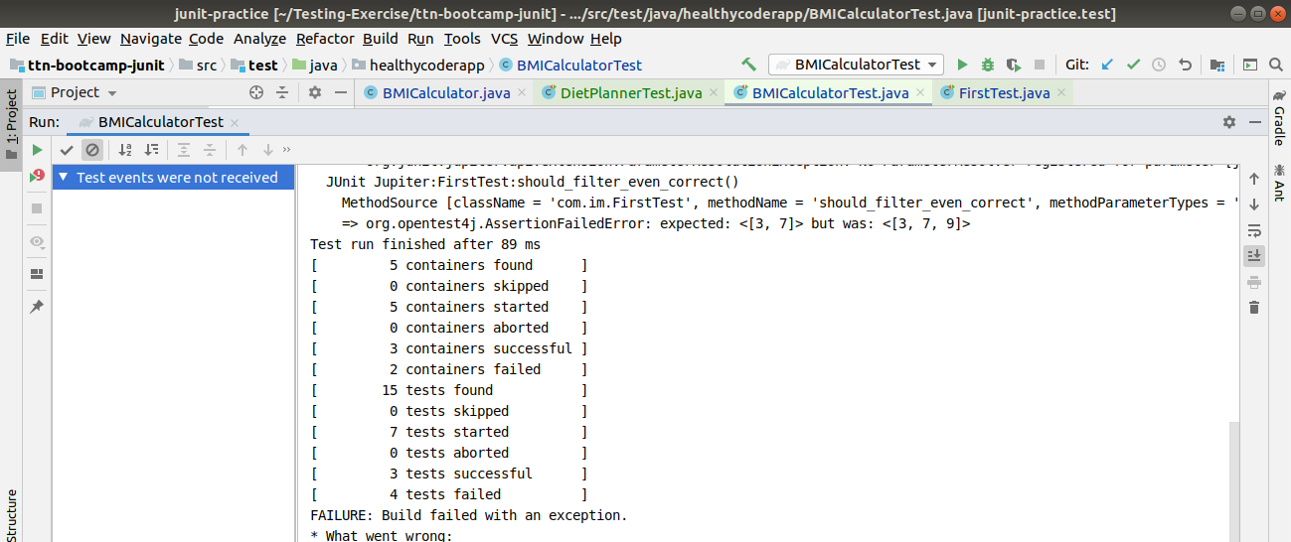
}

3) Write test cases for Diet planner

package healthycoderapp;
import static org.junit.jupiter.api.Assertions.*;
import org.junit.jupiter.api.*;
import org.junit.jupiter.api.function.Executable;
class DietPlannerTest
{
private DietPlanner dietPlanner;
@AfterAll
void after_all()
{
System.out.println("After the method");
}
@BeforeAll
void before_all()
{
System.out.println("Before the method");
}
@BeforeEach
void setup()
{
this.dietPlanner=new DietPlanner(20,30,50);
}
@AfterEach
void after_each()
{
System.out.println("A unit test completed.");
}
@Test
void Shouldreturn_correct_Dietplan_when_correctcoder()
{
//given
Coder coder=new Coder(1.82,75.0,26,Gender.MALE);
DietPlan expected=new DietPlan(2202,110,73,275);
//when
DietPlan actual=dietPlanner.calculateDiet(coder);
//then
assertAll(
()->assertEquals(expected.getCalories(),actual.getCalories()),
()->assertEquals(expected.getProtein(),actual.getProtein()),
()->assertEquals(expected.getFat(),actual.getFat()),
()->assertEquals(expected.getCarbohydrate(),actual.getCarbohydrate())
);
}

}
