HIBERNATE EXERCISE PART-2

- Create an employeeTable table with the following fields: empId, empFirstName, empLastName, empSalary, empAge.
- Create an Employee entity having following fields: id, firstName, lastName, salary, age which maps to the table columns given in above.
JPQL:

1) Display the first name, last name of all employees having salary greater than average salary ordered in ascending by their age and in descending by their salary.

Hiberate2ExerciseApplicationTests

@Test
public void testFindAverageSalary() {
List<Object[]> employeeTableList = employeetableRepository.findAvgSalaryGreaterThanSalary();
for (Object[] employee : employeeTableList) {
System.out.println(employee[0] + " " + employee[1] + " " + employee[2] + " " + employee[3]);
//System.out.println(employee[1]);
}
}
EmployeeRepository.java
@Query("select emp.firstName,emp.lastName,emp.salary,emp.age from EmployeeTable emp where emp.salary>(select AVG(emp.salary ) from EmployeeTable emp)Order By emp.age ASC,emp.salary DESC")
List<Object[]> findAvgSalaryGreaterThanSalary();
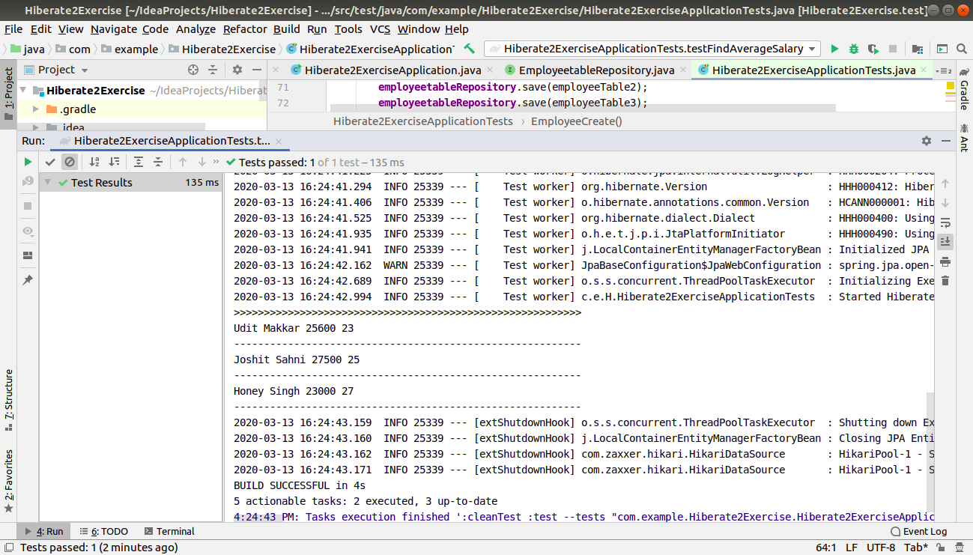

2) Update salary of all employees by a salary passed as a parameter whose existing salary is less than the average salary.

Hiberate2ExerciseApplicationTests

@Test
public void testSalaryGreaterThanAverageSalary() {
employeetableRepository.findAll().forEach(p-> System.out.println("Id :"+p.getId()
+" First Name :"+p.getFirstName()
+" Last Name:"+p.getLastName()
+" Age :"+p.getAge()
+" Salary :"+p.getSalary()));
employeetableRepository.updateSalaryGreaterThanAverageSalary(4532,employeetableRepository.returnAverageSalary());
System.out.println("\n\n\n");
employeetableRepository.findAll().forEach(p-> System.out.println("Id :"+p.getId()
+" First Name :"+p.getFirstName()
+" Last Name:"+p.getLastName()
+" Age :"+p.getAge()
+" Salary :"+p.getSalary()));
}
EmployeeRepository.java

@Query("select AVG(salary) from EmployeeTable")
int returnAverageSalary();
@Transactional
@Modifying
@Query("Update EmployeeTable SET salary = :upsalary where salary < :avgsalary ")
void updateSalaryGreaterThanAverageSalary(@Param("upsalary") int upsalary,@Param("avgsalary")int avgsalary);
}
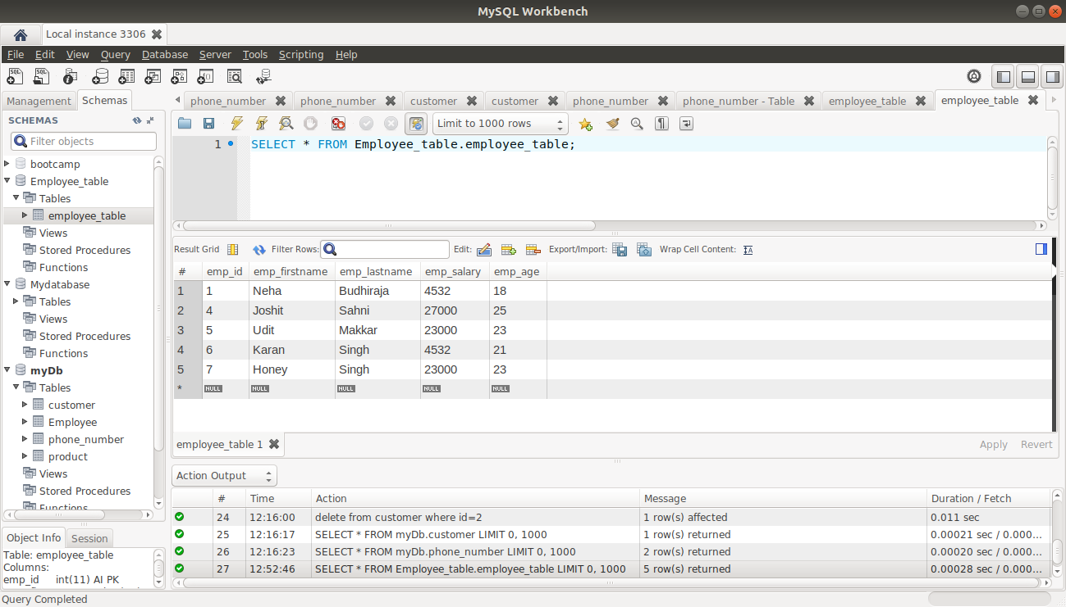

3) Delete all employees with minimum salary.

Hiberate2ExerciseApplicationTests

@Test
public void testdeleteByMinSalary()
{
this.printRecords();
employeetableRepository.deleteByMinimumSalary(employeetableRepository.deletebyMinSalary());
System.out.println("\n\n **********Deleting****************\n\n");
this.printRecords();
}
void printRecords()
{
employeetableRepository.findAll().forEach(p-> System.out.println("Id :"+p.getId()
+" First Name :"+p.getFirstName()
+" Last Name:"+p.getLastName()
+" Age :"+p.getAge()
+" Salary :"+p.getSalary()));
}
}
EmployeeRepository.java

@Query("select MIN(salary) from EmployeeTable")
int deletebyMinSalary();
@Transactional
@Modifying
@Query("delete from EmployeeTable where salary = :minsalary")
void deleteByMinimumSalary(@Param("minsalary")int minsalary);
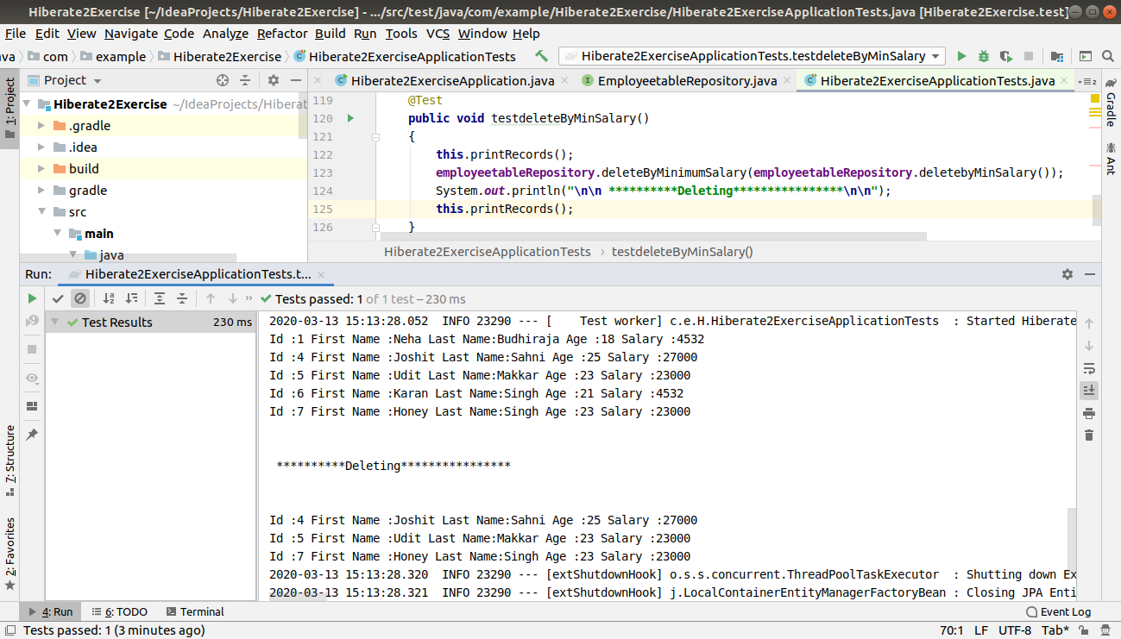

Native SQL Query:

1) Display the id, first name, age of all employees where last name ends with "singh"

package com.example.Hiberate2Exercise;
import org.junit.jupiter.api.RepeatedTest;
import org.junit.jupiter.api.Test;
import org.springframework.beans.factory.annotation.Autowired;
import org.springframework.boot.test.context.SpringBootTest;
import org.springframework.data.domain.Sort;
import org.springframework.test.annotation.Rollback;
import org.springframework.transaction.annotation.Transactional;
import javax.persistence.Table;
import java.util.List;
@SpringBootTest
class Hiberate2ExerciseApplicationTests
{
@Autowired
EmployeetableRepository employeetableRepository;
@Test
void contextLoads() {
}
@Test
public void EmployeeCreate()
{
EmployeeTable employeeTable=new EmployeeTable();
employeeTable.setId(1);
employeeTable.setFirstName("Neha");
employeeTable.setLastName("Budhiraja");
employeeTable.setAge(18);
employeeTable.setSalary(20000);
EmployeeTable employeeTable1=new EmployeeTable();
employeeTable1.setId(2);
employeeTable1.setFirstName("Shreya");
employeeTable1.setLastName("Mago");
employeeTable1.setAge(40);
employeeTable1.setSalary(20000);
EmployeeTable employeeTable2=new EmployeeTable();
employeeTable2.setId(3);
employeeTable2.setFirstName("Akshita");
employeeTable2.setLastName("Tandon");
employeeTable2.setAge(30);
employeeTable2.setSalary(19000);
EmployeeTable employeeTable3=new EmployeeTable();
employeeTable3.setId(4);
employeeTable3.setFirstName("Joshit");
employeeTable3.setLastName("Sahni");
employeeTable3.setAge(25);
employeeTable3.setSalary(27000);
EmployeeTable employeeTable4=new EmployeeTable();
employeeTable4.setId(5);
employeeTable4.setFirstName("Udit");
employeeTable4.setLastName("Makkar");
employeeTable4.setAge(23);
employeeTable4.setSalary(23000);
EmployeeTable employeeTable5=new EmployeeTable();
employeeTable5.setId(6);
employeeTable5.setFirstName("Karan");
employeeTable5.setLastName("Singh");
employeeTable5.setAge(21);
employeeTable5.setSalary(22000);
EmployeeTable employeeTable6=new EmployeeTable();
employeeTable6.setId(7);
employeeTable6.setFirstName("Honey");
employeeTable6.setLastName("Singh");
employeeTable6.setAge(23);
employeeTable6.setSalary(23000);
employeetableRepository.save(employeeTable);
employeetableRepository.save(employeeTable1);
employeetableRepository.save(employeeTable2);
employeetableRepository.save(employeeTable3);
employeetableRepository.save(employeeTable4);
employeetableRepository.save(employeeTable5);
employeetableRepository.save(employeeTable6);
}
@Test
public void testFindnameByLastName()
{
List<Object[]> list=employeetableRepository.findEmployeeByLastName();
for(Object[] objects:list)
{
System.out.println(objects[0]+" " +objects[1]+" "+objects[2]);
}
}

EmployeeTableRepository.java
package com.example.Hiberate2Exercise;
import org.springframework.data.domain.Pageable;
import org.springframework.data.jpa.repository.Modifying;
import org.springframework.data.jpa.repository.Query;
import org.springframework.data.repository.CrudRepository;
import org.springframework.data.repository.query.Param;
import java.util.List;
public interface EmployeetableRepository extends CrudRepository<EmployeeTable,Integer> {

@Query(value = "select emp_id,emp_firstname,emp_age from employee_table where emp_lastname like 'Singh'",nativeQuery = true)
List<Object[]> findEmployeeByLastName();

(All the data in the database)
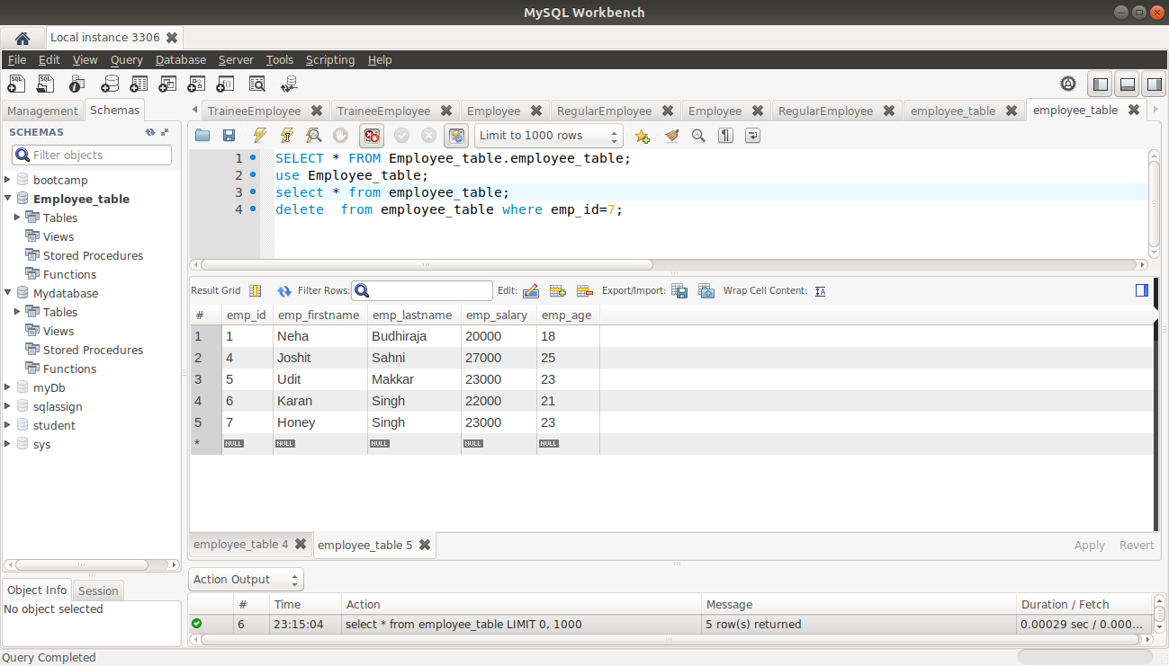

(After Deleting)

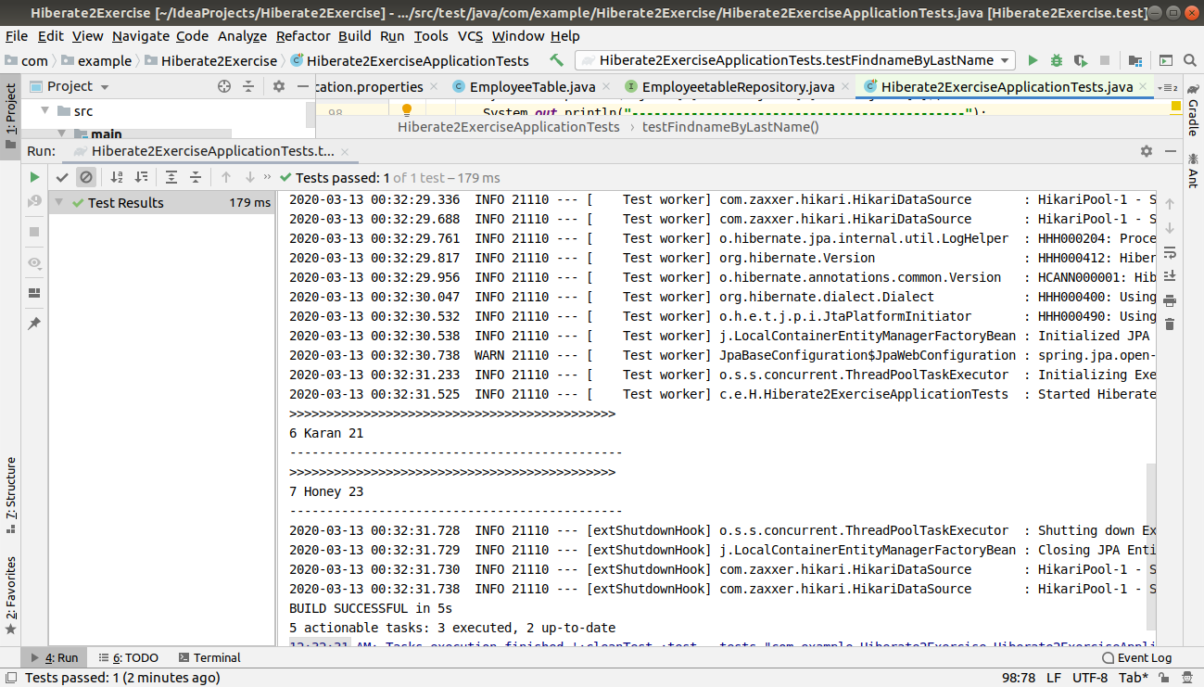

2) Delete all employees with age greater than 45(Should be passed as a parameter)

package com.example.Hiberate2Exercise;
import org.junit.jupiter.api.RepeatedTest;
import org.junit.jupiter.api.Test;
import org.springframework.beans.factory.annotation.Autowired;
import org.springframework.boot.test.context.SpringBootTest;
import org.springframework.data.domain.Sort;
import org.springframework.test.annotation.Rollback;
import org.springframework.transaction.annotation.Transactional;
import javax.persistence.Table;
import java.util.List;
@SpringBootTest
class Hiberate2ExerciseApplicationTests
{
@Autowired
EmployeetableRepository employeetableRepository;
@Test
void contextLoads() {
}
@Test
public void EmployeeCreate()
{
EmployeeTable employeeTable=new EmployeeTable();
employeeTable.setId(1);
employeeTable.setFirstName("Neha");
employeeTable.setLastName("Budhiraja");
employeeTable.setAge(18);
employeeTable.setSalary(20000);
EmployeeTable employeeTable1=new EmployeeTable();
employeeTable1.setId(2);
employeeTable1.setFirstName("Shreya");
employeeTable1.setLastName("Mago");
employeeTable1.setAge(40);
employeeTable1.setSalary(20000);
EmployeeTable employeeTable2=new EmployeeTable();
employeeTable2.setId(3);
employeeTable2.setFirstName("Akshita");
employeeTable2.setLastName("Tandon");
employeeTable2.setAge(30);
employeeTable2.setSalary(19000);
EmployeeTable employeeTable3=new EmployeeTable();
employeeTable3.setId(4);
employeeTable3.setFirstName("Joshit");
employeeTable3.setLastName("Sahni");
employeeTable3.setAge(25);
employeeTable3.setSalary(27000);
EmployeeTable employeeTable4=new EmployeeTable();
employeeTable4.setId(5);
employeeTable4.setFirstName("Udit");
employeeTable4.setLastName("Makkar");
employeeTable4.setAge(23);
employeeTable4.setSalary(23000);
EmployeeTable employeeTable5=new EmployeeTable();
employeeTable5.setId(6);
employeeTable5.setFirstName("Karan");
employeeTable5.setLastName("Singh");
employeeTable5.setAge(21);
employeeTable5.setSalary(22000);
EmployeeTable employeeTable6=new EmployeeTable();
employeeTable6.setId(7);
employeeTable6.setFirstName("Honey");
employeeTable6.setLastName("Singh");
employeeTable6.setAge(23);
employeeTable6.setSalary(23000);
employeetableRepository.save(employeeTable);
employeetableRepository.save(employeeTable1);
employeetableRepository.save(employeeTable2);
employeetableRepository.save(employeeTable3);
employeetableRepository.save(employeeTable4);
employeetableRepository.save(employeeTable5);
employeetableRepository.save(employeeTable6);
}

@Test
@Transactional
@Rollback(false)
public void deleteByAgeGreaterThan()
{
employeetableRepository.deleteEmployeeByAgeGreaterThan(25);
}
}

EmployeetableRepository.java

@Modifying
@Query(value = "delete from employee_table where emp_age>:age",nativeQuery = true)
void deleteEmployeeByAgeGreaterThan(@Param("age") int age);
}

(All the data in the database)
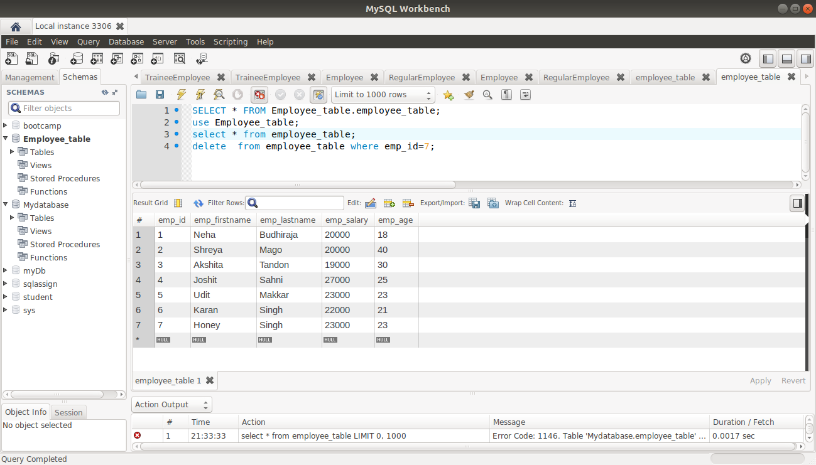

(After deleting the employees)

Inheritance Mapping:

1) Implement and demonstrate Single Table strategy.

Employee.java

package com.example.demoinheritancehibernate;
import javax.persistence.*;
@Entity
//@Inheritance(strategy = InheritanceType.JOINED)
//@Inheritance(strategy = InheritanceType.TABLE_PER_CLASS)
@Inheritance(strategy = InheritanceType.SINGLE_TABLE)
@DiscriminatorColumn(name = "Columnname",discriminatorType = DiscriminatorType.STRING)
public abstract class Employee {
private String name;
// @Embedded
// Address address;
@Id
private int id;
private int salary;
public Employee()
{
}
public Employee(String name, int id, int salary) {
this.name = name;
this.id = id;
this.salary = salary;
}
public String getName() {
return name;
}
public void setName(String name) {
this.name = name;
}
public int getId() {
return id;
}
public void setId(int id) {
this.id = id;
}
public int getSalary() {
return salary;
}
public void setSalary(int salary) {
this.salary = salary;
}
@Override
public String toString() {
return "Employee{" +
"name='" + name + '\'' +
", id=" + id +
", salary=" + salary +
'}';
}
}

RegularEmployee.java

package com.example.demoinheritancehibernate;
import javax.persistence.DiscriminatorValue;
import javax.persistence.Entity;
import javax.persistence.PrimaryKeyJoinColumn;
@Entity
//@PrimaryKeyJoinColumn(name = "id")
@DiscriminatorValue("Regular-employee")
public class RegularEmployee extends Employee
{
private String project;
public RegularEmployee()
{
}
public String getProject() {
return project;
}
public void setProject(String project) {
this.project = project;
}
@Override
public String toString() {
return "RegularEmployee{" +
"project='" + project + '\'' +
'}';
}
}

TraineeEmployee.java

package com.example.demoinheritancehibernate;
import javax.persistence.DiscriminatorValue;
import javax.persistence.Entity;
import javax.persistence.PrimaryKeyJoinColumn;
import javax.persistence.PrimaryKeyJoinColumns;
@Entity
//@PrimaryKeyJoinColumn(name = "id")
@DiscriminatorValue("Trainee-employee")
public class TraineeEmployee extends Employee
{
private int score;
public TraineeEmployee()
{
}
public int getScore() {
return score;
}
public void setScore(int score) {
this.score = score;
}
public TraineeEmployee(int score) {
this.score = score;
}
@Override
public String toString() {
return "TraineeEmployee{" +
"score=" + score +
'}';
}
}
EmployeeRepository Interface

package com.example.demoinheritancehibernate;
import org.springframework.data.repository.CrudRepository;
public interface Employeerepository extends CrudRepository<Employee,Integer>
{
}

DemoinheritancehibernateApplicationTests

package com.example.demoinheritancehibernate;
import org.junit.jupiter.api.Test;
import org.springframework.beans.factory.annotation.Autowired;
import org.springframework.boot.test.context.SpringBootTest;
@SpringBootTest
class DemoinheritancehibernateApplicationTests
{
@Autowired
Employeerepository employeerepository;
@Test
void contextLoads() {
}
@Test
public void testEmployeeCreate()
{
TraineeEmployee traineeEmployee=new TraineeEmployee();
traineeEmployee.setId(1);
traineeEmployee.setScore(29);
traineeEmployee.setName("Neha");
traineeEmployee.setSalary(10000);
TraineeEmployee traineeEmployee1=new TraineeEmployee();
traineeEmployee1.setId(2);
traineeEmployee1.setScore(20);
traineeEmployee1.setName("Akshita");
traineeEmployee1.setSalary(12000);
//traineeEmployee.setAddress(new Address(1,"West"));
RegularEmployee regularEmployee=new RegularEmployee();
regularEmployee.setId(3);
regularEmployee.setProject("Tatasky");
regularEmployee.setName("Shreya");
regularEmployee.setSalary(17000);
RegularEmployee regularEmployee1=new RegularEmployee();
regularEmployee1.setId(4);
regularEmployee1.setProject("Voot");
regularEmployee1.setName("Nisha");
regularEmployee1.setSalary(14000);
//regularEmployee.setAddress(new Address(2,"Ramesh nagar"));
employeerepository.save(traineeEmployee);
employeerepository.save(traineeEmployee1);
employeerepository.save(regularEmployee);
employeerepository.save(regularEmployee1);
System.out.println(employeerepository.findById(1));
System.out.println(employeerepository.findById(2));
}}

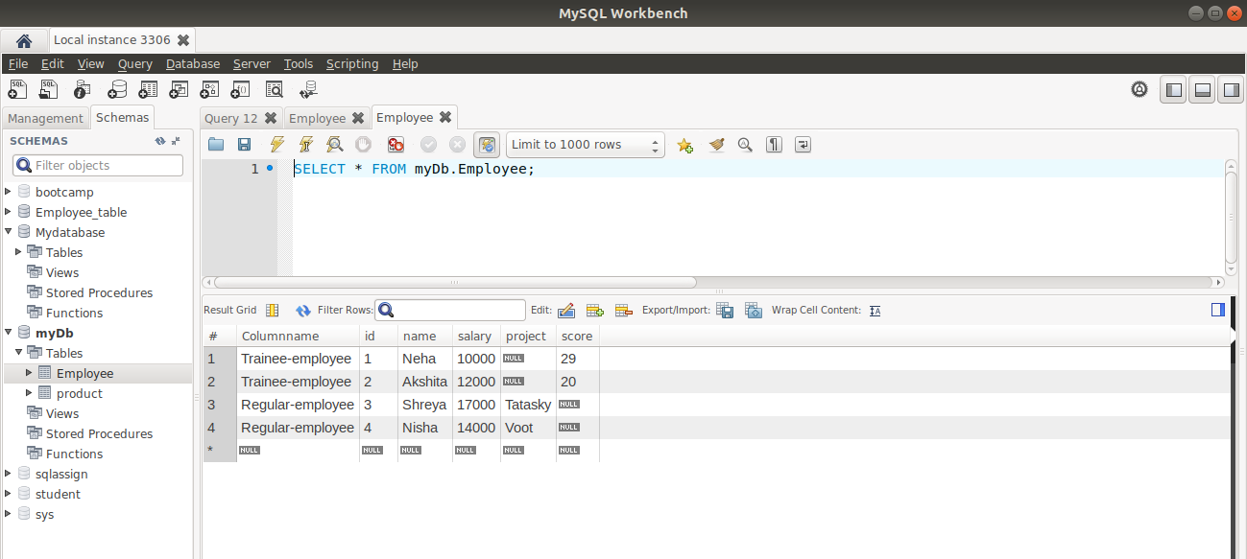
(One table will be formed)

2) Implement and demonstrate Table-per-class strategy.

package com.example.demoinheritancehibernate;
import javax.persistence.*;
@Entity

@Inheritance(strategy = InheritanceType.TABLE_PER_CLASS)
public abstract class Employee {
private String name;
// @Embedded
// Address address;
@Id
private int id;
private int salary;
public Employee()
{
}
public Employee(String name, int id, int salary) {
this.name = name;
this.id = id;
this.salary = salary;
}
public String getName() {
return name;
}
public void setName(String name) {
this.name = name;
}
public int getId() {
return id;
}
public void setId(int id) {
this.id = id;
}
public int getSalary() {
return salary;
}
public void setSalary(int salary) {
this.salary = salary;
}
@Override
public String toString() {
return "Employee{" +
"name='" + name + '\'' +
", id=" + id +
", salary=" + salary +
'}';
}
}

(Three tables will be formed: Employee, TraineeEmployee,RegularEmployee)

(Employee Table)

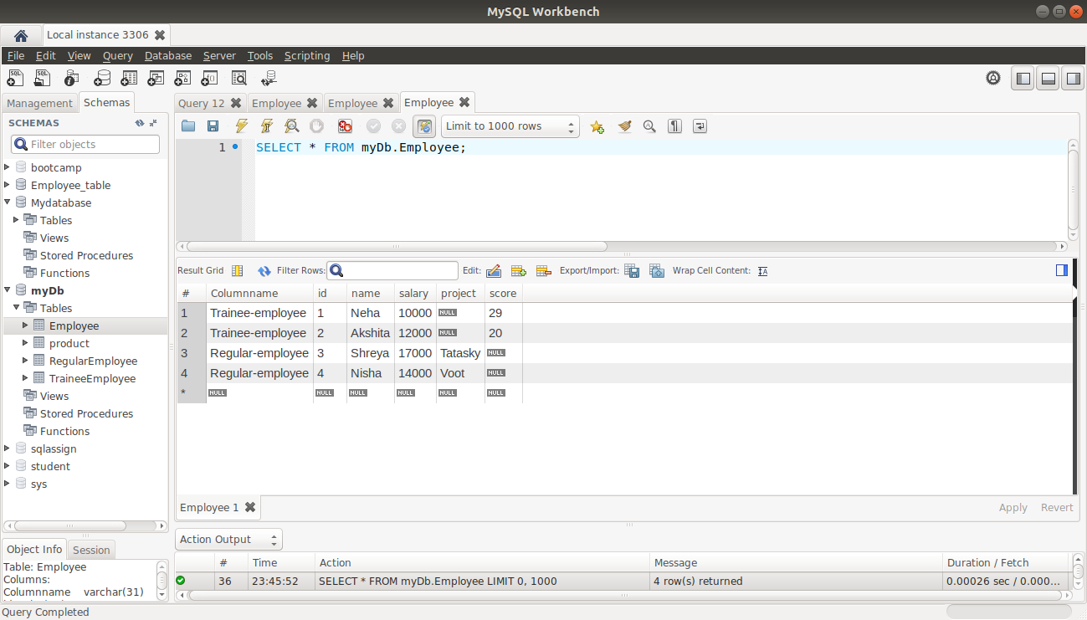
(RegularEmployee Table)

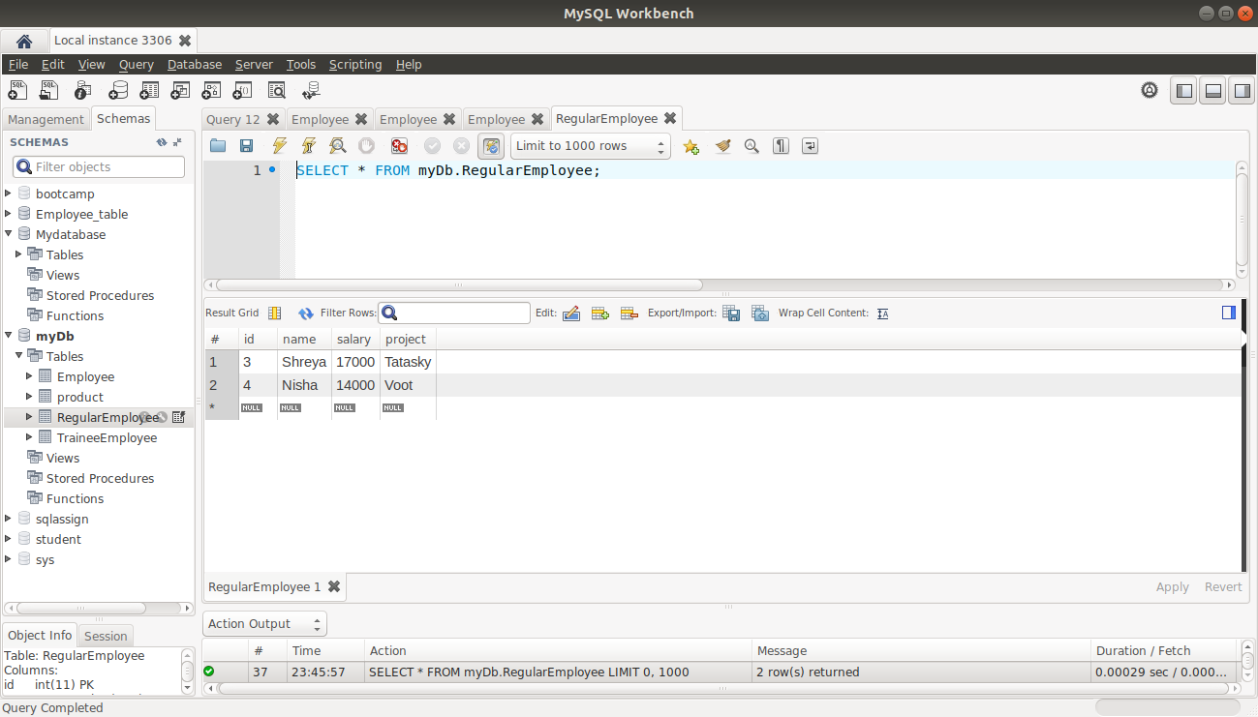

(TraineeEmployee Table)

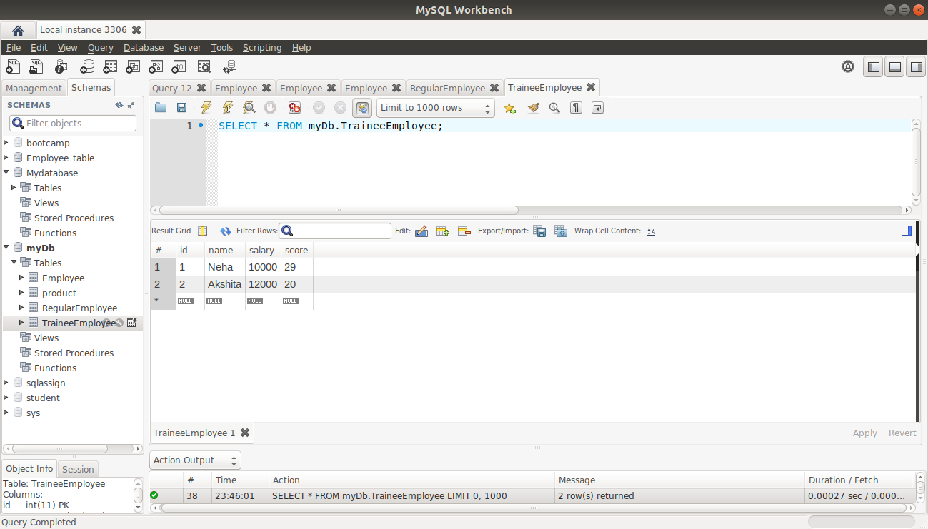

3) Implement and demonstrate joined strategy.

Employee.java

package com.example.demoinheritancehibernate;
import javax.persistence.*;
@Entity
@Inheritance(strategy = InheritanceType.JOINED)
//@Inheritance(strategy = InheritanceType.TABLE_PER_CLASS)
//@Inheritance(strategy = InheritanceType.SINGLE_TABLE)
//@DiscriminatorColumn(name = "Columnname",discriminatorType = DiscriminatorType.STRING)
public abstract class Employee {
private String name;
// @Embedded
// Address address;
@Id
private int id;
private int salary;
public Employee()
{
}
public Employee(String name, int id, int salary) {
this.name = name;
this.id = id;
this.salary = salary;
}
public String getName() {
return name;
}
public void setName(String name) {
this.name = name;
}
public int getId() {
return id;
}
public void setId(int id) {
this.id = id;
}
public int getSalary() {
return salary;
}
public void setSalary(int salary) {
this.salary = salary;
}
@Override
public String toString() {
return "Employee{" +
"name='" + name + '\'' +
", id=" + id +
", salary=" + salary +
'}';
}
}

RegularEmployee.java

package com.example.demoinheritancehibernate;
import javax.persistence.DiscriminatorValue;
import javax.persistence.Entity;
import javax.persistence.PrimaryKeyJoinColumn;
@Entity
@PrimaryKeyJoinColumn(name = "id")
//@DiscriminatorValue("Regular-employee")
public class RegularEmployee extends Employee
{
private String project;
public RegularEmployee()
{
}
public String getProject() {
return project;
}
public void setProject(String project) {
this.project = project;
}
@Override
public String toString() {
return "RegularEmployee{" +
"project='" + project + '\'' +
'}';
}
}
TraineeEmployee.java

package com.example.demoinheritancehibernate;
import javax.persistence.DiscriminatorValue;
import javax.persistence.Entity;
import javax.persistence.PrimaryKeyJoinColumn;
import javax.persistence.PrimaryKeyJoinColumns;
@Entity
@PrimaryKeyJoinColumn(name = "id")
//@DiscriminatorValue("Trainee-employee")
public class TraineeEmployee extends Employee
{
private int score;
public TraineeEmployee()
{
}
public int getScore() {
return score;
}
public void setScore(int score) {
this.score = score;
}
public TraineeEmployee(int score) {
this.score = score;
}
@Override
public String toString() {
return "TraineeEmployee{" +
"score=" + score +
'}';
}
}
(Three tables will be created)
(EmployeeTable)
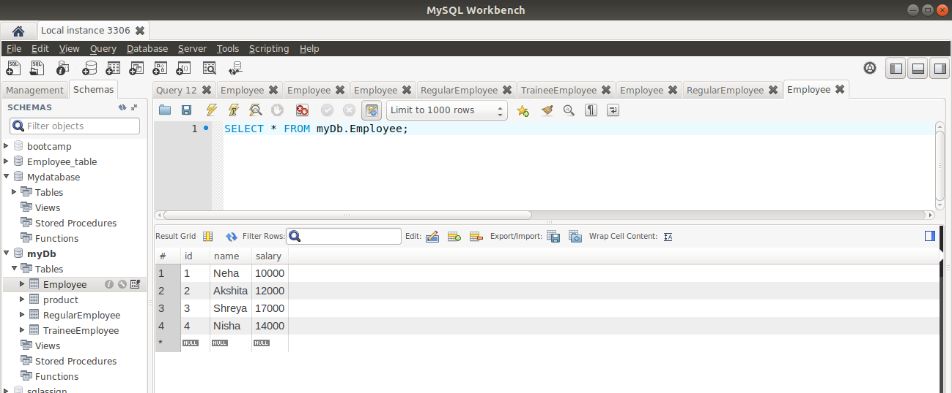

(RegularEmployee Table)

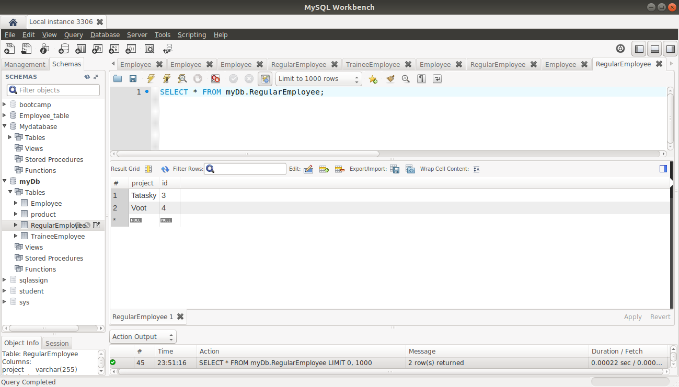

(TraineeEmployee Table)

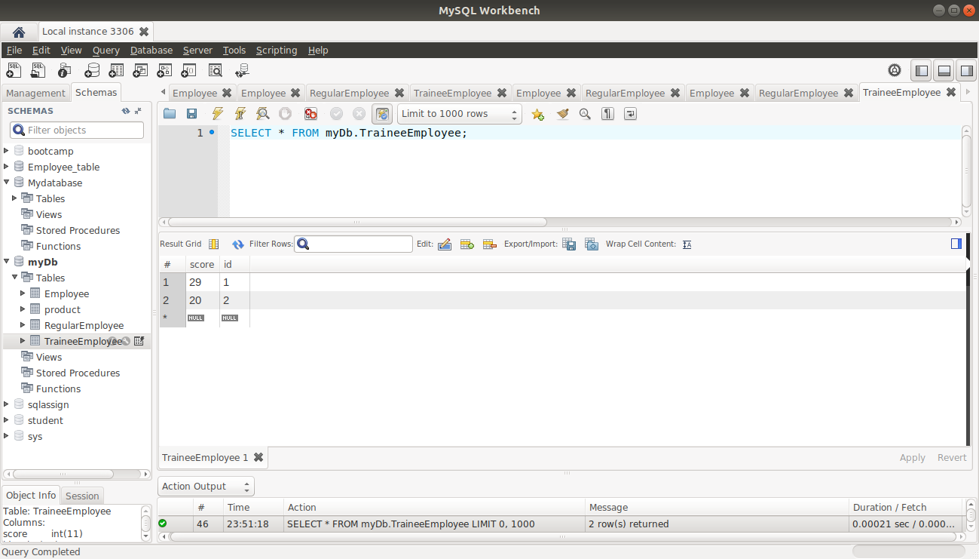

Component Mapping:

1) Implement and demonstrate Embedded mapping using employee table having following fields: id, firstName, lastName, age, basicSalary, bonusSalary, taxAmount, specialAllowanceSalary.

Employee.java

package com.example.demoinheritancehibernate;
import javax.persistence.*;
@Entity
///@Inheritance(strategy = InheritanceType.JOINED)
//@Inheritance(strategy = InheritanceType.TABLE_PER_CLASS)
//@Inheritance(strategy = InheritanceType.SINGLE_TABLE)
//@DiscriminatorColumn(name = "Columnname",discriminatorType = DiscriminatorType.STRING)
public abstract class Employee {
@Embedded
Salary salary;
@Id
private int id;
private String Firstname;
private String Lastname;
private int age;
public Employee()
{
}
public Employee(Salary salary, int id, String firstname, String lastname, int age) {
this.salary = salary;
this.id = id;
Firstname = firstname;
Lastname = lastname;
this.age = age;
}
public Salary getSalary() {
return salary;
}
public void setSalary(Salary salary) {
this.salary = salary;
}
public int getId() {
return id;
}
public void setId(int id) {
this.id = id;
}
public String getFirstname() {
return Firstname;
}
public void setFirstname(String firstname) {
Firstname = firstname;
}
public String getLastname() {
return Lastname;
}
public void setLastname(String lastname) {
Lastname = lastname;
}
public int getAge() {
return age;
}
public void setAge(int age) {
this.age = age;
}
@Override
public String toString() {
return "Employee{" +
", salary=" + salary +
", id=" + id +
", Firstname='" + Firstname + '\'' +
", Lastname='" + Lastname + '\'' +
", age=" + age +
'}';
}
}
Salary.java

package com.example.demoinheritancehibernate;
import javax.persistence.Embeddable;
@Embeddable
public class Salary{
private int basicSalary;
private int bonusSalary;
private int taxAmount;
private int specialAllowanceSalary;
public Salary()
{
}
public Salary(int basicSalary, int bonusSalary, int taxAmount, int specialAllowanceSalary) {
this.basicSalary = basicSalary;
this.bonusSalary = bonusSalary;
this.taxAmount = taxAmount;
this.specialAllowanceSalary = specialAllowanceSalary;
}
public int getBasicSalary() {
return basicSalary;
}
public void setBasicSalary(int basicSalary) {
this.basicSalary = basicSalary;
}
public int getBonusSalary() {
return bonusSalary;
}
public void setBonusSalary(int bonusSalary) {
this.bonusSalary = bonusSalary;
}
public int getTaxAmount() {
return taxAmount;
}
public void setTaxAmount(int taxAmount) {
this.taxAmount = taxAmount;
}
public int getSpecialAllowanceSalary() {
return specialAllowanceSalary;
}
public void setSpecialAllowanceSalary(int specialAllowanceSalary) {
this.specialAllowanceSalary = specialAllowanceSalary;
}
@Override
public String toString() {
return "Salary{" +
"basicSalary=" + basicSalary +
", bonusSalary=" + bonusSalary +
", taxAmount=" + taxAmount +
", specialAllowanceSalary=" + specialAllowanceSalary +
'}';
}
}

DemoinheritancehibernateApplication Tests

package com.example.demoinheritancehibernate;
import org.junit.jupiter.api.Test;
import org.springframework.beans.factory.annotation.Autowired;
import org.springframework.boot.test.context.SpringBootTest;
@SpringBootTest
class DemoinheritancehibernateApplicationTests
{
@Autowired
Employeerepository employeerepository;
@Test
void contextLoads() {
}
@Test
public void testEmployeeCreate()
{
TraineeEmployee traineeEmployee=new TraineeEmployee();
traineeEmployee.setId(1);
traineeEmployee.setFirstname("Neha");
traineeEmployee.setLastname("Budhiraja");
traineeEmployee.setAge(23);
traineeEmployee.setScore(79);
traineeEmployee.setSalary(new Salary(20000,32111,6544,7654));
TraineeEmployee traineeEmployee1=new TraineeEmployee();
traineeEmployee1.setId(2);
traineeEmployee1.setFirstname("Akshita");
traineeEmployee1.setLastname("Tandon");
traineeEmployee1.setAge(22);
traineeEmployee1.setScore(70);
traineeEmployee1.setSalary(new Salary(19000,2345,7654,2345));
//traineeEmployee.setAddress(new Address(1,"West"));
RegularEmployee regularEmployee=new RegularEmployee();
regularEmployee.setId(3);
regularEmployee.setFirstname("Shreya");
regularEmployee.setLastname("Mago");
regularEmployee.setAge(23);
regularEmployee.setProject("Tatasky");
regularEmployee.setSalary(new Salary(15000,2343,32433,7654));
RegularEmployee regularEmployee1=new RegularEmployee();
regularEmployee1.setId(4);
regularEmployee1.setFirstname("Joshit");
regularEmployee1.setLastname("Sahni");
regularEmployee1.setAge(23);
regularEmployee1.setProject("Voot");
regularEmployee1.setSalary(new Salary(17000,2349,3243,7000));
//regularEmployee.setAddress(new Address(2,"Ramesh nagar"));
employeerepository.save(traineeEmployee);
employeerepository.save(traineeEmployee1);
employeerepository.save(regularEmployee);
employeerepository.save(regularEmployee1);
// System.out.println(employeerepository.findById(1));
// System.out.println(employeerepository.findById(2));
}
}

