HIBERNATE PART-3 EXERCISE

1) Create a class Address for Author with instance variables streetNumber, location, State.

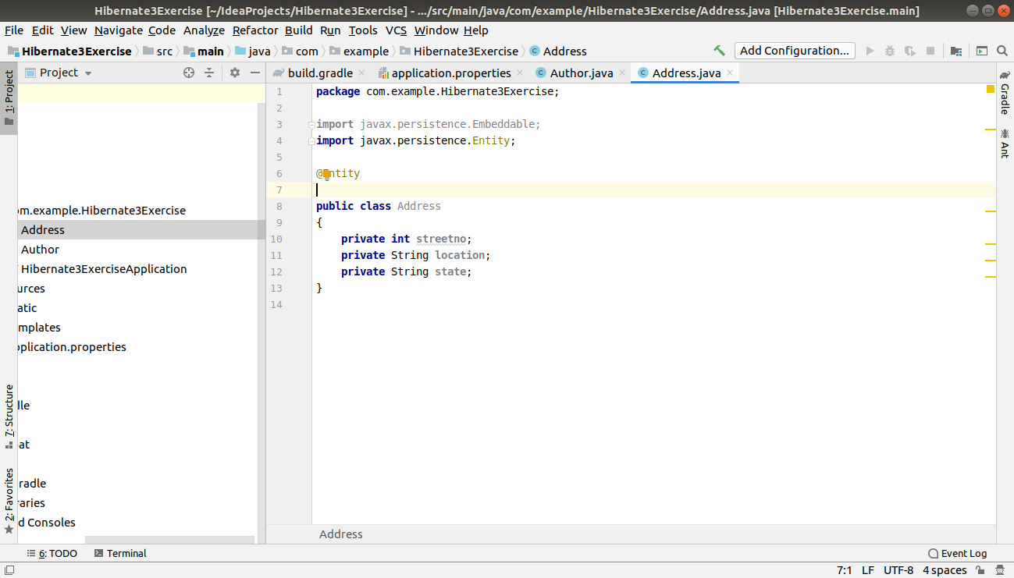
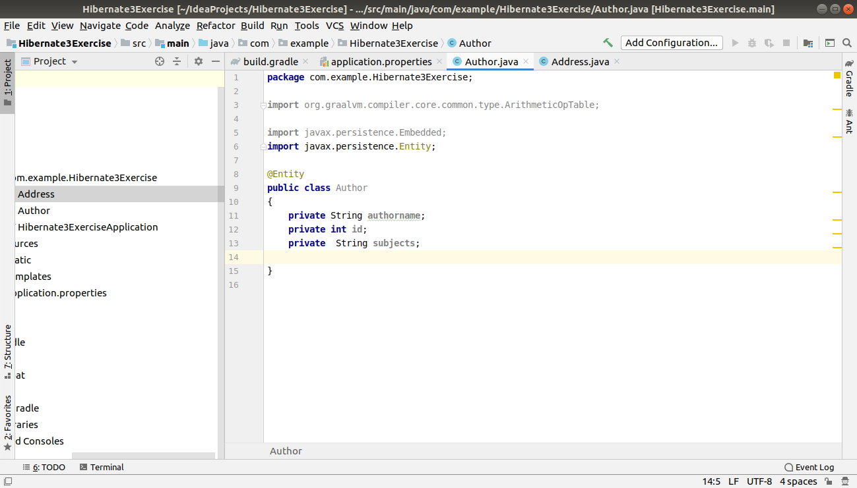

2) Create instance variable of Address class inside Author class and save it as embedded object.

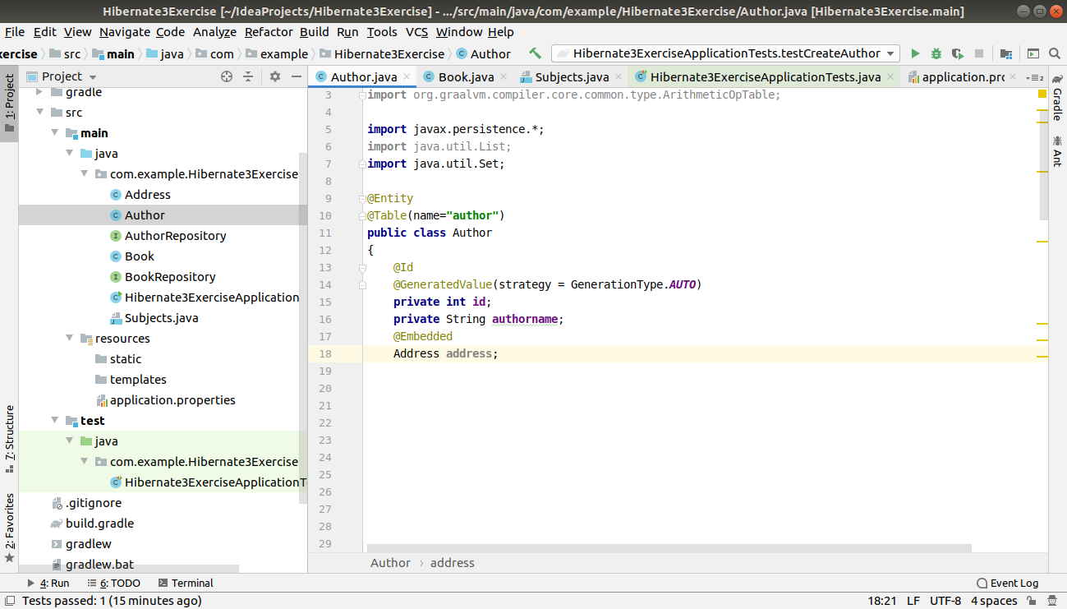
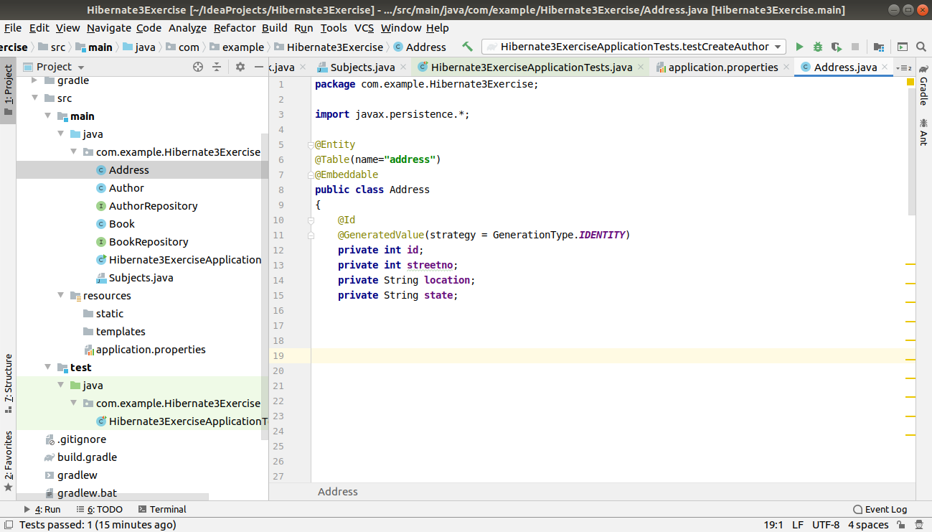

3) Introduce a List of subjects for author.Persist 3 subjects for each author.

Author.java

package com.example.Hibernate3Exercise;
import org.graalvm.compiler.core.common.type.ArithmeticOpTable;
import javax.persistence.*;
import java.util.List;
import java.util.Set;
@Entity
@Table(name="author")
public class Author
{
@Id
@GeneratedValue(strategy = GenerationType.IDENTITY)
private int id;
private String authorname;
@OneToMany(mappedBy = "author",cascade = CascadeType.ALL)
private Set<Address> address;
@OneToMany(mappedBy = "author",cascade = CascadeType.ALL)
private Set<Subjects> subjects;
public int getId() {
return id;
}
public void setId(int id) {
this.id = id;
}
public String getAuthorname() {
return authorname;
}
public void setAuthorname(String authorname) {
this.authorname = authorname;
}
public Set<Address> getAddress() {
return address;
}
public void setAddress(Set<Address> address) {
this.address = address;
}
public Set<Subjects> getSubjects() {
return subjects;
}
public void setSubjects(Set<Subjects> subjects) {
this.subjects = subjects;
}
}

Subjects.java

package com.example.Hibernate3Exercise;
import javax.persistence.*;
@Entity
@Table(name="subjects")
public class Subjects
{
@Id
@GeneratedValue(strategy = GenerationType.IDENTITY)
private int id;
private String subjects;
@ManyToOne
@JoinColumn(name="author_id")
private Author author;
public int getId() {
return id;
}
public void setId(int id) {
this.id = id;
}
public String getSubjects() {
return subjects;
}
public void setSubjects(String subjects) {
this.subjects = subjects;
}
public Author getAuthor() {
return author;
}
public void setAuthor(Author author) {
this.author = author;
}
}

Address.java

package com.example.Hibernate3Exercise;
import javax.persistence.*;
@Entity
@Table(name="address")
public class Address
{
@Id
@GeneratedValue(strategy = GenerationType.IDENTITY)
private int id;
private int streetno;
private String location;
private String state;
@ManyToOne
@JoinColumn(name = "author_id")
Author author;
public int getId() {
return id;
}
public void setId(int id) {
this.id = id;
}
public int getStreetno() {
return streetno;
}
public void setStreetno(int streetno) {
this.streetno = streetno;
}
public String getLocation() {
return location;
}
public void setLocation(String location) {
this.location = location;
}
public String getState() {
return state;
}
public void setState(String state) {
this.state = state;
}
public Author getAuthor() {
return author;
}
public void setAuthor(Author author) {
this.author = author;
}
}

AuthorRepository Interface
package com.example.Hibernate3Exercise;
import org.springframework.data.repository.CrudRepository;
public interface AuthorRepository extends CrudRepository<Author,Integer> {
}

Hibernate3ExerciseTests

package com.example.Hibernate3Exercise;
import org.junit.jupiter.api.Test;
import org.springframework.beans.factory.annotation.Autowired;
import org.springframework.boot.test.context.SpringBootTest;
import java.util.*;
@SpringBootTest
class Hibernate3ExerciseApplicationTests
{
@Autowired
AuthorRepository authorRepository;
@Test
void contextLoads() {
}
@Test
public void testCreateAuthor()
{
Author author=new Author();
author.setAuthorname("Ravinder Singh");
Set<Subjects> subjectsSet=new HashSet<>();
Subjects subjects=new Subjects();
subjects.setSubjects("Love-Stories");
subjects.setAuthor(author);
Subjects subjects1=new Subjects();
subjects1.setSubjects("Fiction-stories");
subjects1.setAuthor(author);
Subjects subjects2=new Subjects();
subjects2.setSubjects("Non-Fiction-stories");
subjects2.setAuthor(author);
subjectsSet.add(subjects);
subjectsSet.add(subjects1);
subjectsSet.add(subjects2);
Set<Address> addressSet=new HashSet<>();
Address address=new Address();
address.setStreetno(112);
address.setLocation("Patel-nagar");
address.setState("Delhi");
address.setAuthor(author);
Address address1=new Address();
address1.setStreetno(114);
address1.setLocation("Ramesh-nagar");
address1.setState("Delhi");
address1.setAuthor(author);
addressSet.add(address);
addressSet.add(address1);
author.setAddress(addressSet);
author.setSubjects(subjectsSet);
authorRepository.save(author);
}
}
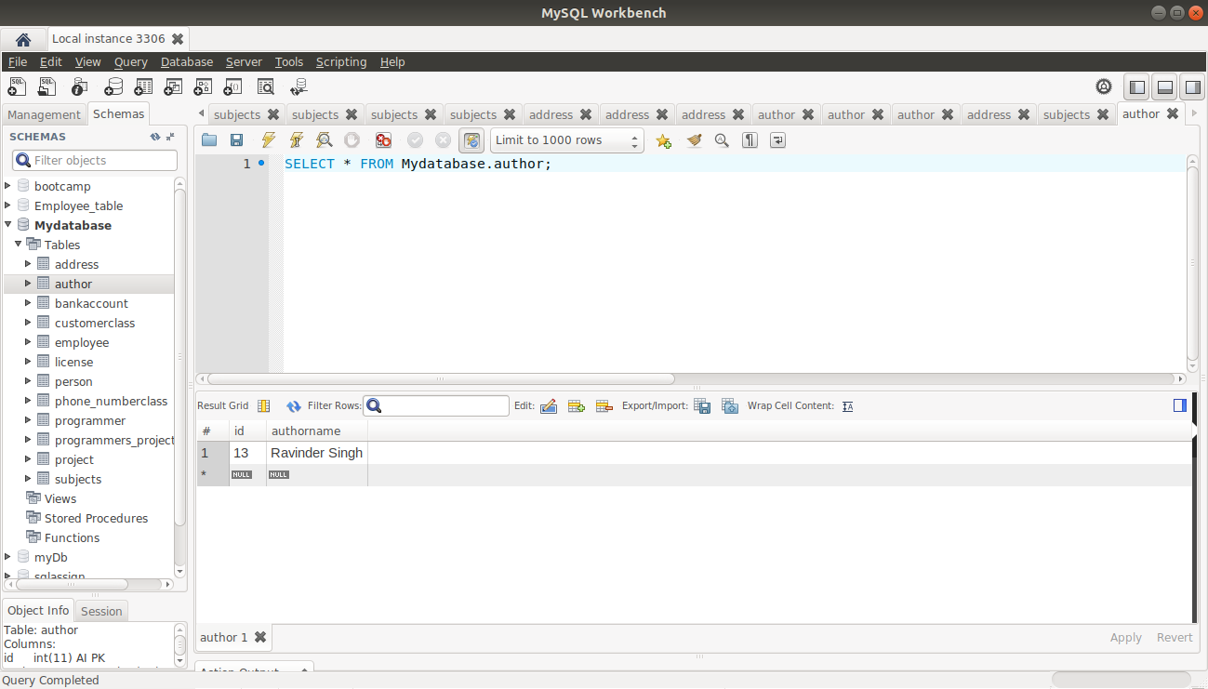

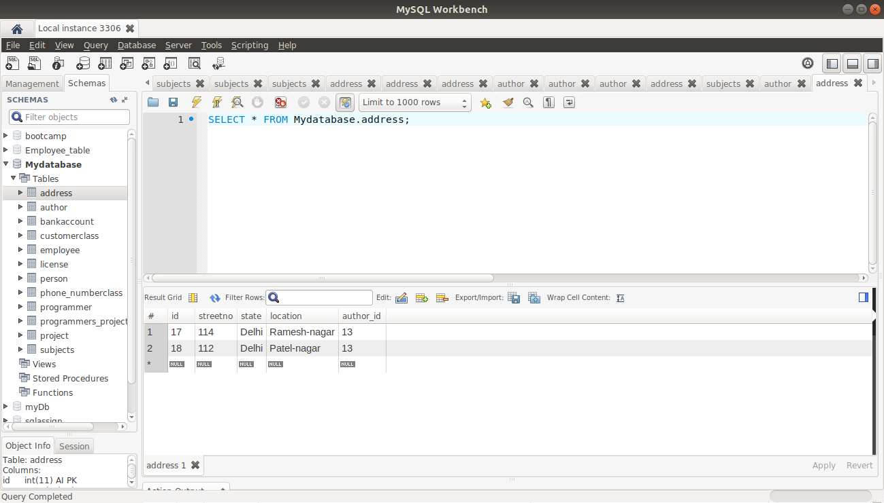

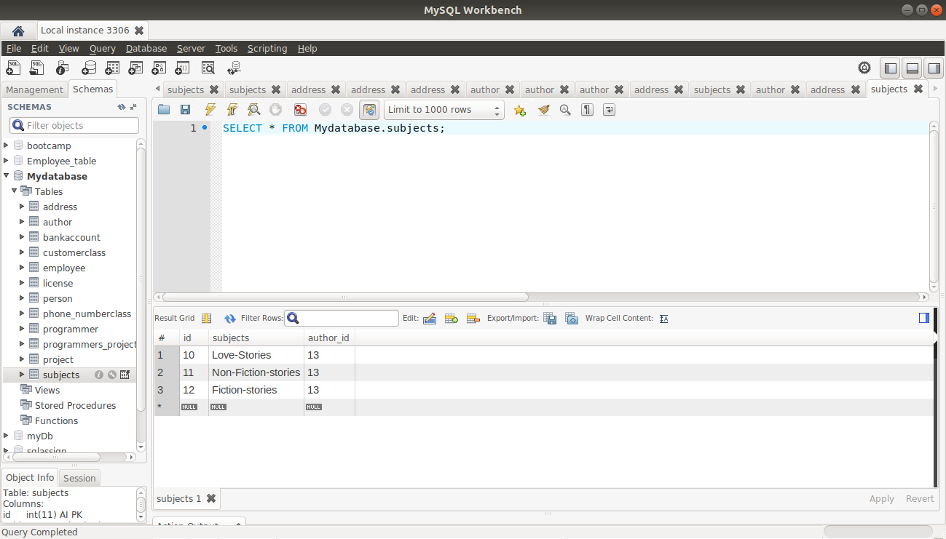

4) Create an Entity book with an instance variable bookName.

Book.java

package com.example.Hibernate3Exercise;
import javax.persistence.*;
@Entity
@Table(name="book")
public class Book
{
@Id
@GeneratedValue(strategy = GenerationType.IDENTITY)
private int id;
private String bookname;
@ManyToOne
@JoinColumn(name="author_id")
Author author;
public int getId() {
return id;
}
public void setId(int id) {
this.id = id;
}
public String getBookname() {
return bookname;
}
public void setBookname(String bookname) {
this.bookname = bookname;
}
public Author getAuthor() {
return author;
}
public void setAuthor(Author author) {
this.author = author;
}
}

5) Implement One to One mapping between Author and Book.

Book.java

package com.example.Hibernate3Exercise;
import javax.persistence.*;
@Entity
@Table(name="book")
public class Book
{
@Id
@GeneratedValue(strategy = GenerationType.IDENTITY)
private int id;
private String bookname;
@OneToOne(cascade = CascadeType.ALL)
@JoinColumn(name="author_id")
private Author author;
public int getId() {
return id;
}
public void setId(int id) {
this.id = id;
}
public String getBookname() {
return bookname;
}
public void setBookname(String bookname) {
this.bookname = bookname;
}
public Author getAuthor() {
return author;
}
public void setAuthor(Author author) {
this.author = author;
}
}
Author.java

package com.example.Hibernate3Exercise;
import org.graalvm.compiler.core.common.type.ArithmeticOpTable;
import javax.persistence.*;
import java.util.List;
import java.util.Set;
@Entity
@Table(name="author")
public class Author
{
@Id
@GeneratedValue(strategy = GenerationType.IDENTITY)
private int id;
private String authorname;
@OneToOne(mappedBy = "author")
private Book book;
public int getId() {
return id;
}
public void setId(int id) {
this.id = id;
}
public String getAuthorname() {
return authorname;
}
public void setAuthorname(String authorname) {
this.authorname = authorname;
}
public Book getBook() {
return book;
}
public void setBook(Book book) {
this.book = book;
}
}

BookRepository Interface
package com.example.Hibernate3Exercise;
import org.springframework.data.repository.CrudRepository;
public interface BookRepository extends CrudRepository<Book,Integer>
{
}
HibernateExercise3Tests
package com.example.Hibernate3Exercise;
import org.junit.jupiter.api.Test;
import org.springframework.beans.factory.annotation.Autowired;
import org.springframework.boot.test.context.SpringBootTest;
import java.util.*;
@SpringBootTest
class Hibernate3ExerciseApplicationTests
{
@Autowired
BookRepository bookRepository;
@Test
void contextLoads() {
}
@Test
public void testCreateAuthor()
{
Author author=new Author();
author.setAuthorname("Ravinder Singh");
Book book=new Book();
book.setBookname("Love Story");
book.setAuthor(author);
bookRepository.save(book);
}

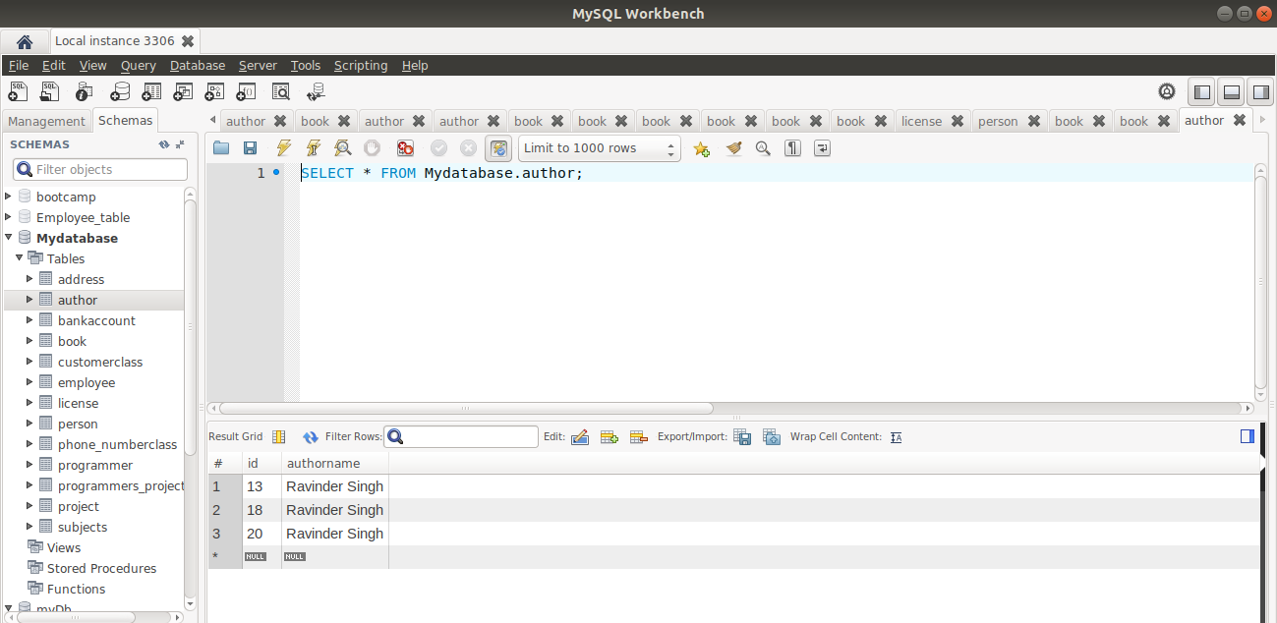

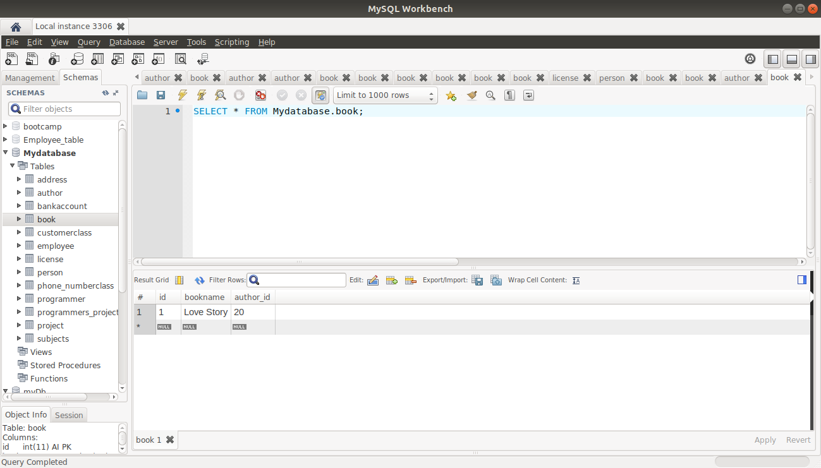

6) Implement One to Many Mapping between Author and Book(Unidirectional, BiDirectional and without additional table ) and implement cascade save.

Bidirectional mapping

Author.java

package com.example.Hibernate3Exercise;
import org.graalvm.compiler.core.common.type.ArithmeticOpTable;
import javax.persistence.*;
import java.util.List;
import java.util.Set;
@Entity
@Table(name="author")
public class Author
{
@Id
@GeneratedValue(strategy = GenerationType.IDENTITY)
private int id;
private String authorname;
@OneToMany(mappedBy = "author",cascade = CascadeType.ALL,fetch = FetchType.EAGER)
private Set<Book> book;
public Set<Book> getBook() {
return book;
}
public void setBook(Set<Book> book) {
this.book = book;
}
public int getId() {
return id;
}
public void setId(int id) {
this.id = id;
}
public String getAuthorname() {
return authorname;
}
public void setAuthorname(String authorname) {
this.authorname = authorname;
}

Book.java

package com.example.Hibernate3Exercise;
import javax.persistence.*;
@Entity
@Table(name="book")
public class Book
{
@Id
@GeneratedValue(strategy = GenerationType.IDENTITY)
private int id;
private String bookname;
@ManyToOne
@JoinColumn(name="author_id")
private Author author;
public int getId() {
return id;
}
public void setId(int id) {
this.id = id;
}
public String getBookname() {
return bookname;
}
public void setBookname(String bookname) {
this.bookname = bookname;
}
public Author getAuthor() {
return author;
}
public void setAuthor(Author author) {
this.author = author;
}
}

Hibernate3ExerciseApplication test

package com.example.Hibernate3Exercise;
import org.junit.jupiter.api.Test;
import org.springframework.beans.factory.annotation.Autowired;
import org.springframework.boot.test.context.SpringBootTest;
import java.util.*;
@SpringBootTest
class Hibernate3ExerciseApplicationTests
{
@Autowired
AuthorRepository authorRepository;

@Test
void contextLoads() {
}
@Test
public void testCreateAuthor()
{
Author author=new Author();
author.setAuthorname("Ravinder Singh");
Set<Book>bookSet=new HashSet<>();
Book book=new Book();
book.setBookname("Computer-Science");
book.setAuthor(author);
Book book1=new Book();
book1.setBookname("Chemistry");
book1.setAuthor(author);
Book book2=new Book();
book2.setBookname("Physics");
book2.setAuthor(author);
bookSet.add(book);
bookSet.add(book1);
bookSet.add(book2);
author.setBook(bookSet);
authorRepository.save(author);
}

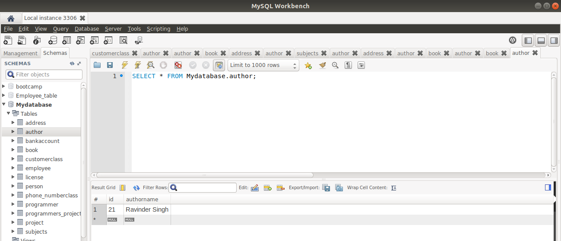

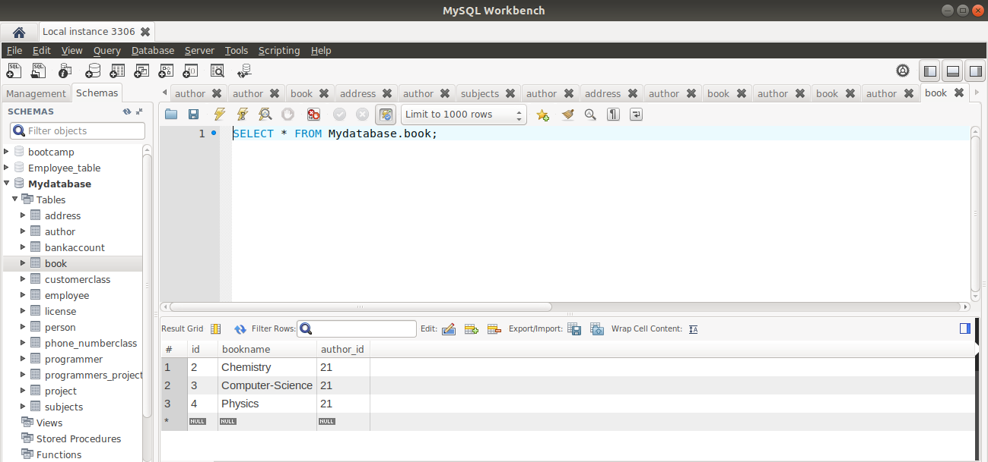

Unidirectional mapping

(It will implement another table on its own that is author_book table)

Author.java

import org.graalvm.compiler.core.common.type.ArithmeticOpTable;
import javax.persistence.*;
import java.util.List;
import java.util.Set;
@Entity
@Table(name="author")
public class Author
{
@Id
@GeneratedValue(strategy = GenerationType.IDENTITY)
private int id;
private String authorname;
@OneToMany(cascade = CascadeType.ALL,fetch = FetchType.EAGER)
private Set<Book> books;
public Set<Book> getBook() {
return books;
}
public void setBook(Set<Book> books) {
this.books = books;
}
public int getId() {
return id;
}
public void setId(int id) {
this.id = id;
}
public String getAuthorname() {
return authorname;
}
public void setAuthorname(String authorname) {
this.authorname = authorname;
}
@Override
public String toString() {
return "Author{" +
"id=" + id +
", authorname='" + authorname + '\'' +
'}';
}

Book.java

import javax.persistence.*;
import java.util.Set;
@Entity
@Table(name="book")
public class Book
{
@Id
@GeneratedValue(strategy = GenerationType.IDENTITY)
private int id;
private String bookname;
public int getId() {
return id;
}
public void setId(int id) {
this.id = id;
}
public String getBookname() {
return bookname;
}
public void setBookname(String bookname) {
this.bookname = bookname;
}
@Override
public String toString() {
return "Book{" +
"id=" + id +
", bookname='" + bookname + '\'' +
'}';
}

Tests

import org.junit.jupiter.api.Test;
import org.springframework.beans.factory.annotation.Autowired;
import org.springframework.boot.test.context.SpringBootTest;
import java.util.*;
@SpringBootTest
class Hibernate3ExerciseApplicationTests
{
@Autowired
AuthorRepository authorRepository;
BookRepository bookRepository;
@Test
void contextLoads() {
}
@Test
public void testCreateAuthor()
{
Author author=new Author();
author.setAuthorname("Chetan Bhagat");
Set<Book>bookSet=new HashSet<>();
Book book=new Book();
book.setBookname("Physics");
bookSet.add(book);
Book book1=new Book();
book1.setBookname("Chemistry");
bookSet.add(book1);
author.setBook(bookSet);
authorRepository.save(author);
}

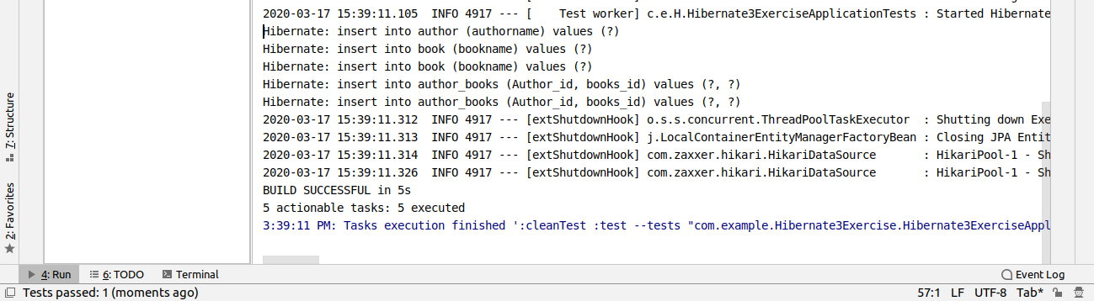

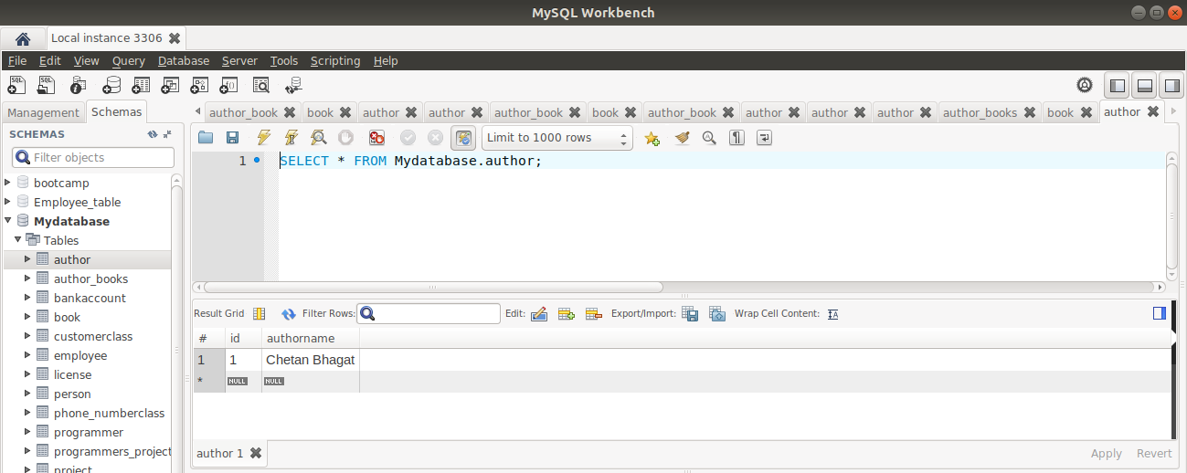

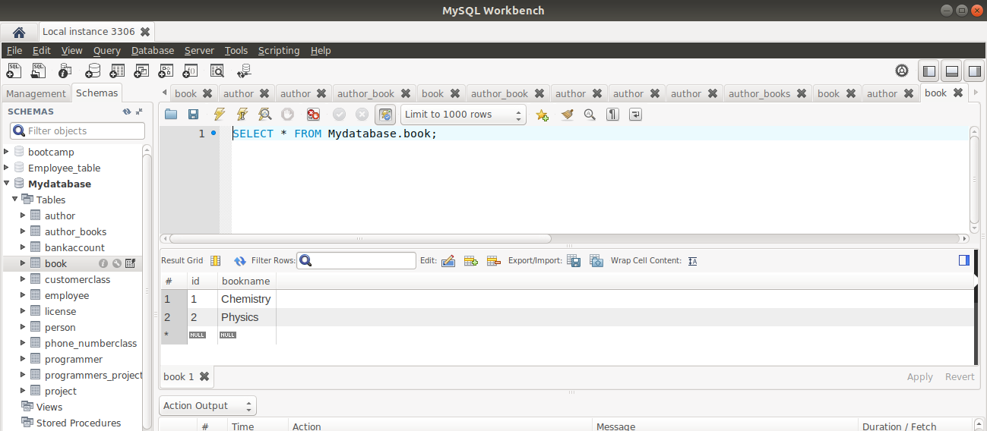

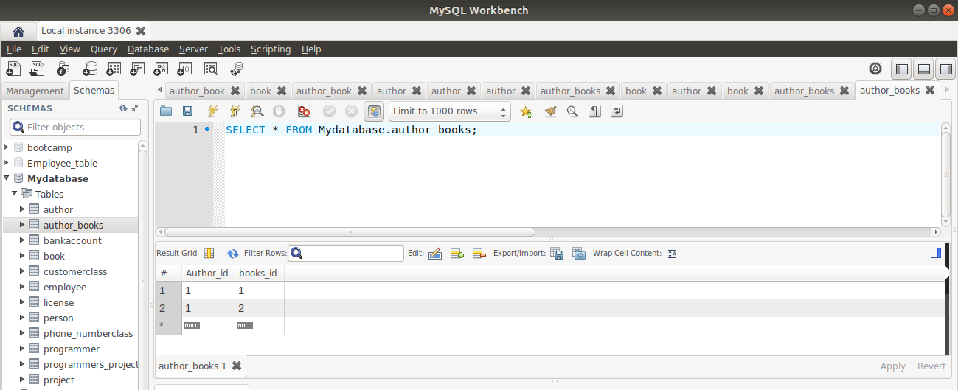

7) Implement Many to Many Mapping between Author and Book.

Author.java

import org.graalvm.compiler.core.common.type.ArithmeticOpTable;
import javax.persistence.*;
import java.util.List;
import java.util.Set;
@Entity
@Table(name="author")
public class Author
{
@Id
@GeneratedValue(strategy = GenerationType.IDENTITY)
private int id;
private String authorname;
@ManyToMany(cascade=CascadeType.ALL,fetch = FetchType.EAGER)
@JoinTable(name="author_book",joinColumns = @JoinColumn(name="author_id",referencedColumnName = "id")
,inverseJoinColumns = @JoinColumn(name = "book_id",referencedColumnName = "id"))
private Set<Book> books;
public Set<Book> getBook() {
return books;
}
public void setBook(Set<Book> books) {
this.books = books;
}
public int getId() {
return id;
}
public void setId(int id) {
this.id = id;
}
public String getAuthorname() {
return authorname;
}
public void setAuthorname(String authorname) {
this.authorname = authorname;
}
@Override
public String toString() {
return "Author{" +
"id=" + id +
", authorname='" + authorname + '\'' +
'}';
}

Book .java

import javax.persistence.*;
import java.util.Set;
@Entity
@Table(name="book")
public class Book
{
@Id
@GeneratedValue(strategy = GenerationType.IDENTITY)
private int id;
private String bookname;
@ManyToMany(mappedBy = "books")
public Set<Author> authorSet;
public Set<Author> getAuthorSet() {
return authorSet;
}
public void setAuthorSet(Set<Author> authorSet) {
this.authorSet = authorSet;
}
public int getId() {
return id;
}
public void setId(int id) {
this.id = id;
}
public String getBookname() {
return bookname;
}
public void setBookname(String bookname) {
this.bookname = bookname;
}
@Override
public String toString() {
return "Book{" +
"id=" + id +
", bookname='" + bookname + '\'' +
'}';
}

Tests
import org.junit.jupiter.api.Test;
import org.springframework.beans.factory.annotation.Autowired;
import org.springframework.boot.test.context.SpringBootTest;
import java.util.*;
@SpringBootTest
class Hibernate3ExerciseApplicationTests
{
@Autowired
AuthorRepository authorRepository;

@Test
void contextLoads() {
}
@Test
public void testCreateAuthor()
{

Author author=new Author();
author.setAuthorname("Chetan Bhagat");
Set<Book>bookSet=new HashSet<>();
Book book=new Book();
book.setBookname("Physics");
bookSet.add(book);
Book book1=new Book();
book1.setBookname("Chemistry");
bookSet.add(book1);
author.setBook(bookSet);
authorRepository.save(author);
}

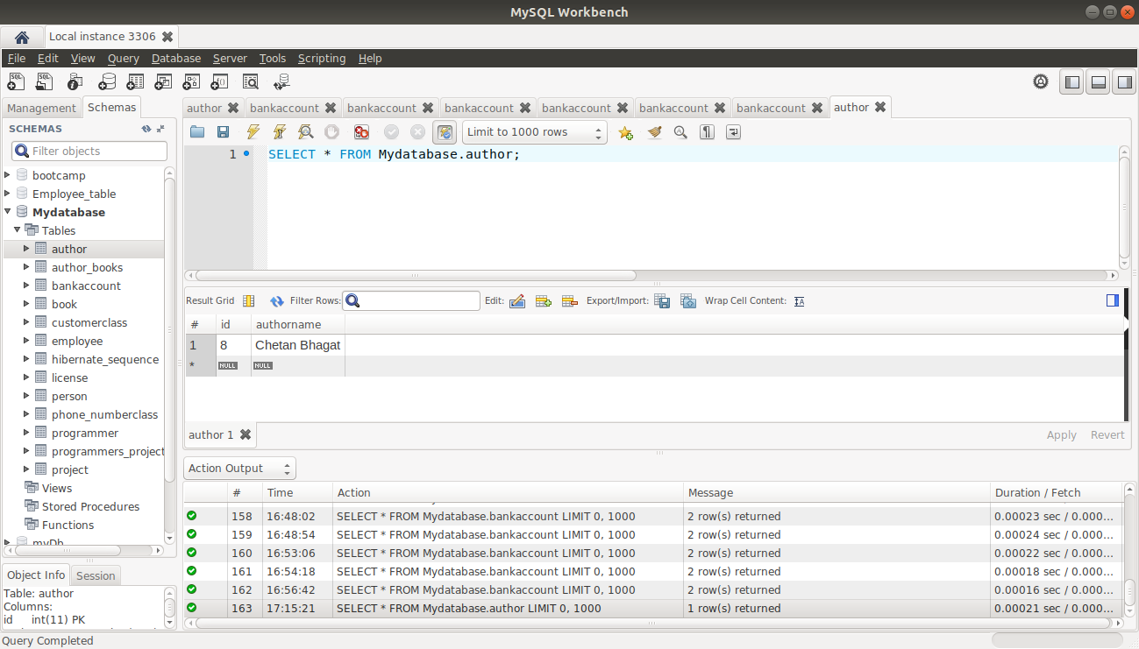

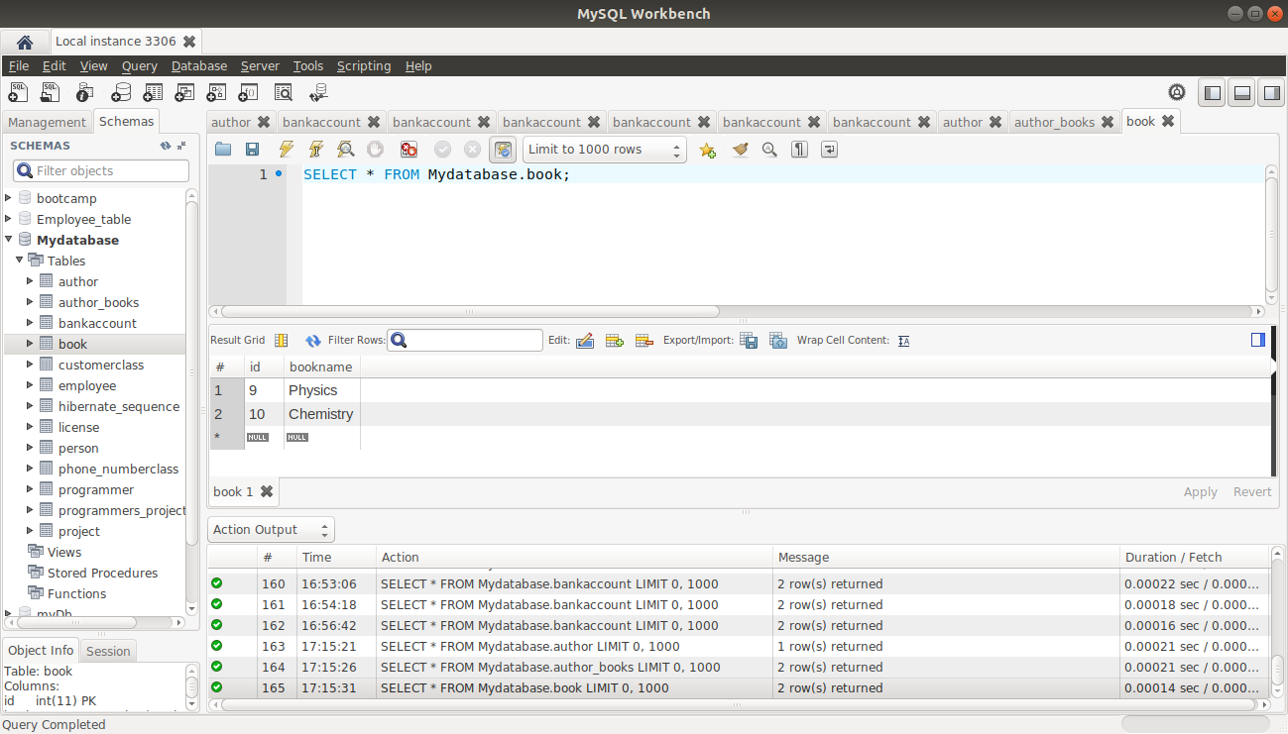

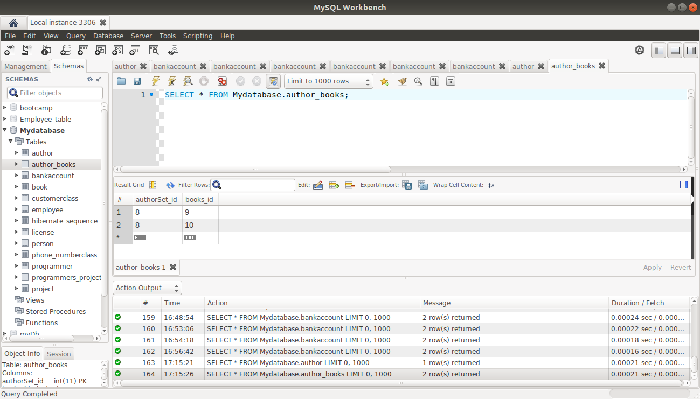

8) Which method on the session object can be used to remove an object from the cache?

Evict method is used to remove an object from the cache.

(When evicted)

BankAccount.java

package com.example.TrnsactionManagement;
import javax.persistence.Entity;
import javax.persistence.Id;
import javax.persistence.Table;
@Entity
@Table(name="bankaccount")
public class BankAccount
{
@Id
private int accno;
private String firstname;
private String lastname;
private int bal;
public int getAccno() {
return accno;
}
public void setAccno(int accno) {
this.accno = accno;
}
public String getFirstname() {
return firstname;
}
public void setFirstname(String firstname) {
this.firstname = firstname;
}
public String getLastname() {
return lastname;
}
public void setLastname(String lastname) {
this.lastname = lastname;
}
public int getBal() {
return bal;
}
public void setBal(int bal) {
this.bal = bal;
}
@Override
public String toString() {
return "BankAccount{" +
"accno=" + accno +
", firstname='" + firstname + '\'' +
", lastname='" + lastname + '\'' +
", bal=" + bal +
'}';
}
}
BankAccountRepository Interface

package com.example.TrnsactionManagement;
import org.springframework.data.repository.CrudRepository;
public interface BankAccountRepository extends CrudRepository<BankAccount,Integer>
{
}
BankSccount Service.java

package com.example.TrnsactionManagement;
public interface BankAccountService
{
void transfer(int amount);
}

BankAccountServiiceImpl

package com.example.TrnsactionManagement;
import org.springframework.beans.factory.annotation.Autowired;
import org.springframework.stereotype.Service;
@Service
public class BankAccountServiceImpl implements BankAccountService
{
@Autowired
BankAccountRepository repository;
@Override
public void transfer(int amount)
{
BankAccount obamaaccount=repository.findById(1).get();
obamaaccount.setBal(obamaaccount.getBal()-amount);
repository.save(obamaaccount);
BankAccount trumpaccount=repository.findById(2).get();
trumpaccount.setBal(trumpaccount.getBal()+amount);
repository.save(trumpaccount);
}
}

Test
package com.example.TrnsactionManagement;
import org.hibernate.Session;
import org.junit.jupiter.api.Test;
import org.springframework.beans.factory.annotation.Autowired;
import org.springframework.boot.test.context.SpringBootTest;
import org.springframework.transaction.annotation.Transactional;
import javax.persistence.EntityManager;
import java.util.Optional;
@SpringBootTest
class TrnsactionManagementApplicationTests
{
@Autowired
BankAccountService service;
@Autowired
BankAccountRepository bankAccountRepository;
@Autowired
EntityManager entityManager;
@Test
void contextLoads() {
}
@Test
public void testTransfer()
{
service.transfer(500);
}
@Test
@Transactional
public void testCaching()
{
Session session=entityManager.unwrap(Session.class);
BankAccount bankAccount = bankAccountRepository.findById(1).get();
bankAccountRepository.findById(1);
session.evict(bankAccount);
bankAccountRepository.findById(1);
}
}

(When eviceted, the data is deleted from the cache and it runs again for the data and taken the data from the database.)
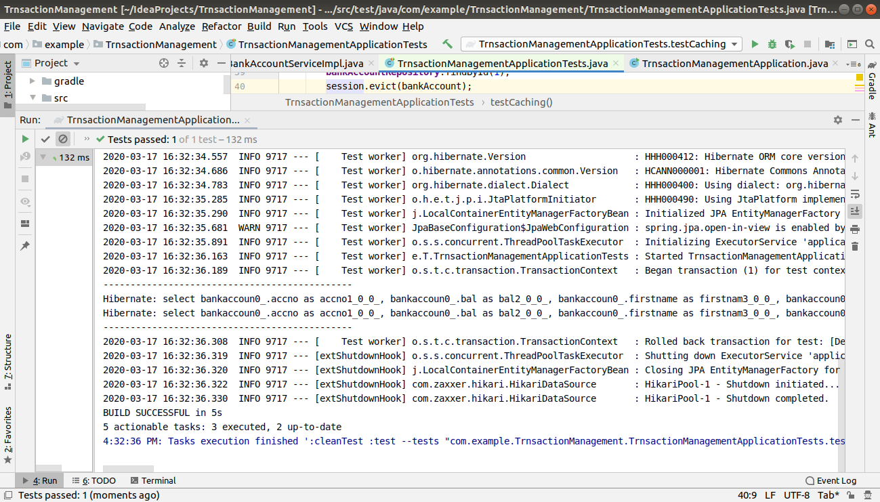

(When evict is not there it will run only one time as it is not deleted from the cache)

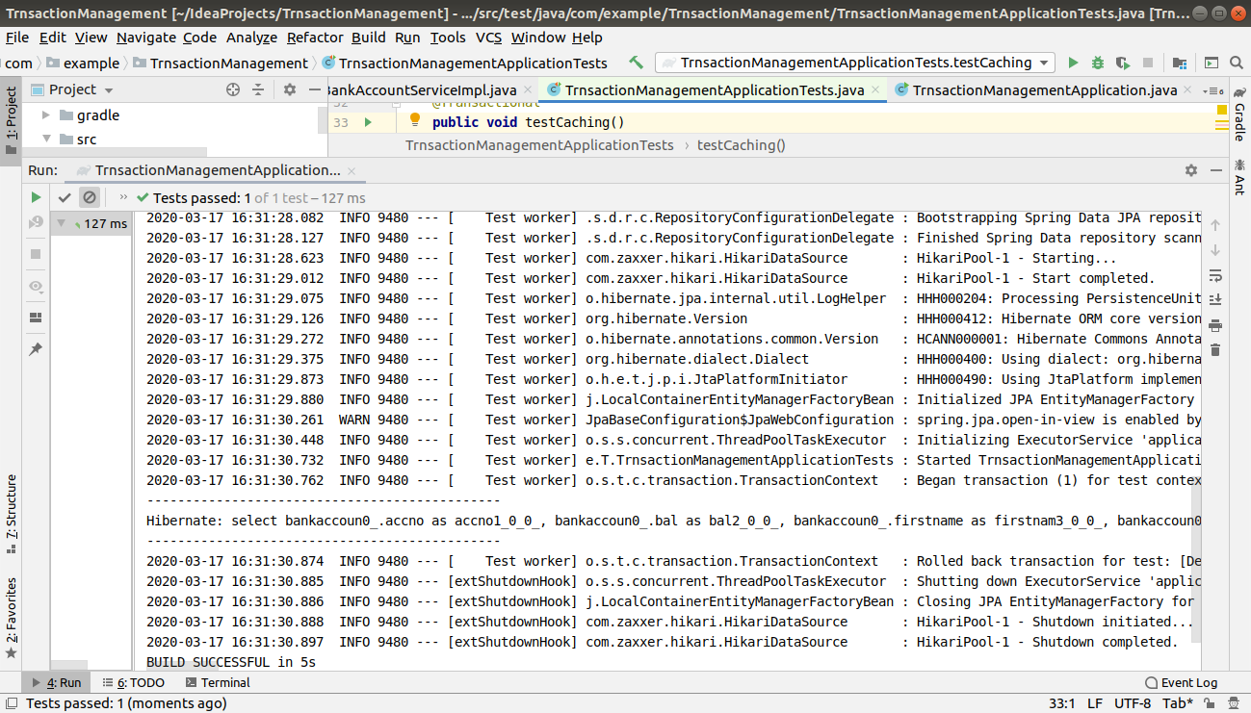

9) What does @transactional annotation do?

Everything in the method will be commiteed once,if not then it would roll back.

(Actual balance)

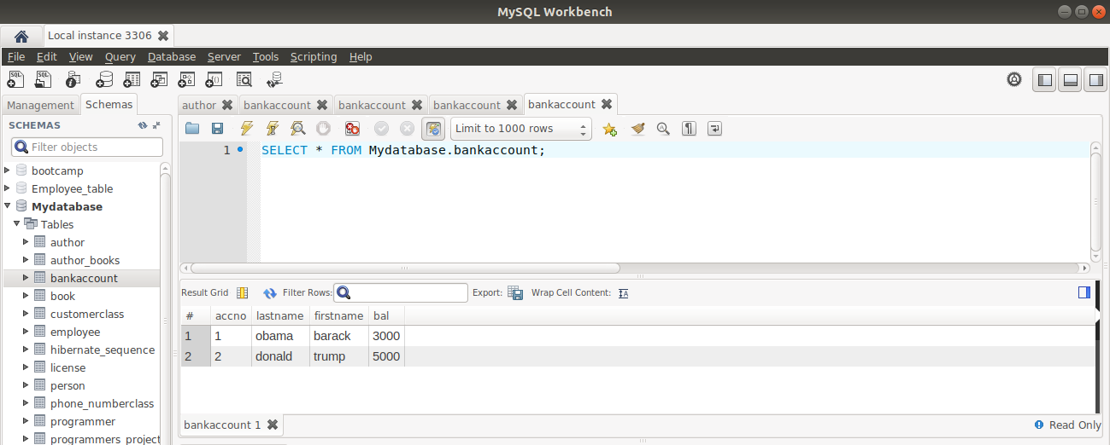

Before using Transaction annotation
- If one transaction throws an exception , then also it would deduct the balance as it wont be rollbacked.

@Test
public void testTransfer()
{
service.transfer(500);
}
@Override
public void transfer(int amount)
{
BankAccount obamaaccount=repository.findById(1).get();
obamaaccount.setBal(obamaaccount.getBal()-amount);
repository.save(obamaaccount);
if(true)
{
throw new RuntimeException();
}
BankAccount trumpaccount=repository.findById(2).get();
trumpaccount.setBal(trumpaccount.getBal()+amount);
repository.save(trumpaccount);
}

(The balance changed instead of throwing an exception)
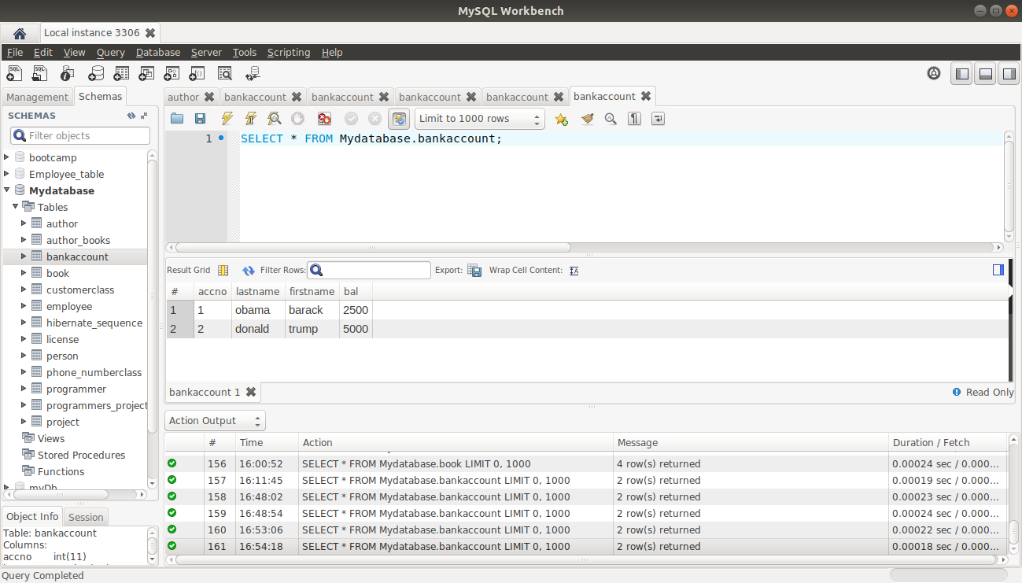

After @Transactional everything will be committed or will be rollback

- If one trandaction fails, the no transaction would be allowed to run and the parent transaction would also be rollbacked as in @transactional either whole of the trnsaction would run or neither of them

@Test
@Transactional
public void testTransfer()
{
service.transfer(500);
}
@Test
@Transactional
public void testCaching()
{
System.out.println("----------------------------------------------");
Session session=entityManager.unwrap(Session.class);
BankAccount bankAccount = bankAccountRepository.findById(1).get();
bankAccountRepository.findById(1);
session.evict(bankAccount);
bankAccountRepository.findById(1);
System.out.println("----------------------------------------------");
}

(The balance remained same ,as the first transaction throws an exception , but it would not reflect the balance)

