SPRING FUNDAMENTAL EXERCISE

1) Write a program to demonstrate Tightly Coupled code.

BinarySearch.java

package com.example.demo;
import org.springframework.beans.factory.annotation.Autowired;
import org.springframework.stereotype.Component;
@Component
public class BinarySearch
{
// @Autowired
//private SortAlgorithm sortAlgorithm;
/* public BinarySearch(SortAlgorithm sortAlgorithm)
{
super();
this.sortAlgorithm=sortAlgorithm;
}*/
public int BinarySearch(int[] numbers, int numberTosearch)
{
BubbleSort bubbleSort=new BubbleSort();
int []result=bubbleSort.sort(numbers);
QuickSort quickSort=new QuickSort();
int[]result1=quickSort.sort(numbers);
//int[] sortedNumbers= sortAlgorithm.sort(numbers);
// System.out.println(sortAlgorithm);
return 3;
}
}
Tightly coupled.java

package com.example.demo;
import org.springframework.boot.autoconfigure.SpringBootApplication;
import org.springframework.boot.SpringApplication;
import org.springframework.boot.autoconfigure.SpringBootApplication;
import org.springframework.context.ApplicationContext;
@SpringBootApplication
public class TightlyCoupled
{
public static void main(String[] args)
{
BinarySearch binarySearch=new BinarySearch();
int result=binarySearch.BinarySearch(new int[]{1,2,3,4},3);
System.out.println(result);
//ApplicationContext applicationContext = SpringApplication.run(DemoApplication.class, args);
}
}

BubbleSort.java

package com.example.demo;
import org.springframework.stereotype.Component;

public class BubbleSort
{
public int[] sort(int [] numbers)
{
return numbers;
}
}
QuickSort.java

package com.example.demo;
import org.springframework.context.annotation.Primary;
import org.springframework.stereotype.Component;

public class QuickSort
{
public int[] sort(int [] numbers)
{
//QuickSort logic
return numbers;
}
}
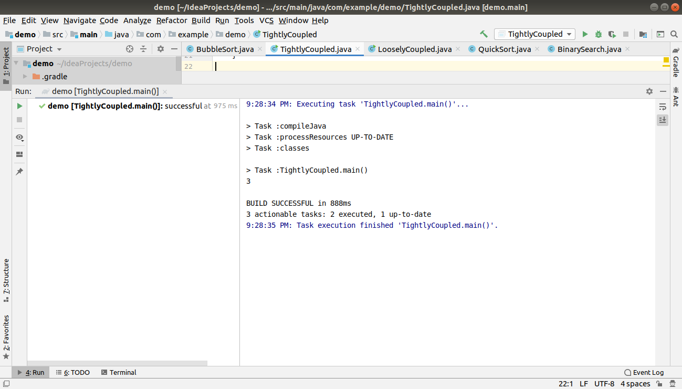
2) Write a program to demonstrate Loosely Coupled code.

BubbleSort.java

package com.example.demo;
public class BubbleSort implements SortAlgorithm
{
public int[] sort(int [] numbers)
{
return numbers;
}
}
QuickSort.java

package com.example.demo;
public class QuickSort implements SortAlgorithm
{
public int[] sort(int [] numbers)
{
//QuickSort logic
return numbers;
}
}

BinarySearch.java

package com.example.demo;
public class BinarySearch
{
private SortAlgorithm sortAlgorithm;
public BinarySearch(SortAlgorithm sortAlgorithm)
{

this.sortAlgorithm=sortAlgorithm;
}
public int BinarySearch(int[] numbers, int numberTosearch)
{
int[] sortedNumbers= sortAlgorithm.sort(numbers);
System.out.println(sortAlgorithm);
return 3;
}
}

Interface SortAlgorithm

package com.example.demo;
public interface SortAlgorithm
{
public int[] sort(int [] numbers);
}
LooselyCoupled.java(main)

package com.example.demo;
import org.springframework.boot.autoconfigure.SpringBootApplication;
import org.springframework.boot.SpringApplication;
import org.springframework.boot.autoconfigure.SpringBootApplication;
import org.springframework.context.ApplicationContext;
@SpringBootApplication
public class LooselyCoupled
{
public static void main(String[] args) {
// BinarySearch binarySearch=new BinarySearch(new BubbleSort());
BinarySearch binarySearch=new BinarySearch(new QuickSort());
int result=binarySearch.BinarySearch(new int[]{1,2,3,4},3);
System.out.println(result);
}
}
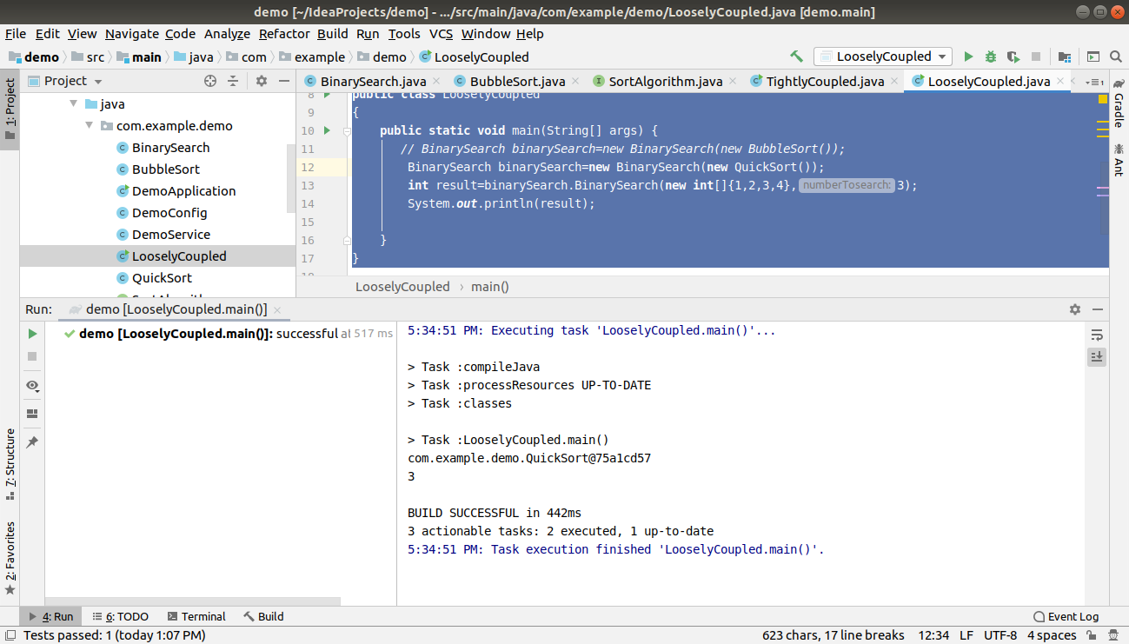

3) Use @Compenent and @Autowired annotations to in Loosely Coupled code for dependency management

BubbleSort.java
package com.example.demo;
import org.springframework.stereotype.Component;
@Component
public class BubbleSort implements SortAlgorithm
{
public int[] sort(int [] numbers)
{
return numbers;
}
}
BinarySearch.java
package com.example.demo;
import org.springframework.beans.factory.annotation.Autowired;
import org.springframework.stereotype.Component;
@Component
public class BinarySearch
{
@Autowired
private SortAlgorithm sortAlgorithm;
public BinarySearch(SortAlgorithm sortAlgorithm)
{
super();
this.sortAlgorithm=sortAlgorithm;
}
public int BinarySearch(int[] numbers, int numberTosearch)
{
int[] sortedNumbers= sortAlgorithm.sort(numbers);
System.out.println(sortAlgorithm);
return 3;
}
}
LooselyCoupled.java

package com.example.demo;
import org.springframework.boot.autoconfigure.SpringBootApplication;
import org.springframework.boot.SpringApplication;
import org.springframework.boot.autoconfigure.SpringBootApplication;
import org.springframework.context.ApplicationContext;
@SpringBootApplication
public class LooselyCoupled
{
public static void main(String[] args) {
// BinarySearch binarySearch=new BinarySearch(new BubbleSort());
//BinarySearch binarySearch=new BinarySearch(new QuickSort());
ApplicationContext applicationContext = SpringApplication.run(DemoApplication.class, args);
BinarySearch binarySearch=applicationContext.getBean(BinarySearch.class);
int result=binarySearch.BinarySearch(new int[]{1,2,3,4},3);
System.out.println(result);
}
}
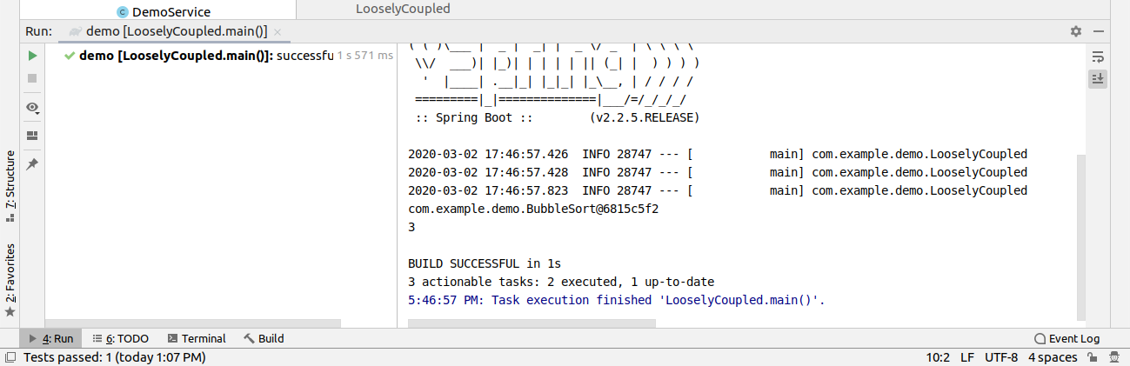
4) Get a Spring Bean from application context and display its properties.

package com.example.demo;
import org.springframework.boot.autoconfigure.SpringBootApplication;
import org.springframework.boot.SpringApplication;
import org.springframework.boot.autoconfigure.SpringBootApplication;
import org.springframework.context.ApplicationContext;
@SpringBootApplication
public class LooselyCoupled {
public static void main(String[] args) {
// BinarySearch binarySearch=new BinarySearch(new BubbleSort());
//BinarySearch binarySearch=new BinarySearch(new QuickSort());
ApplicationContext applicationContext = SpringApplication.run(DemoApplication.class, args);
for (String name : applicationContext.getBeanDefinitionNames()) {
System.out.println(name);
}
BinarySearch binarySearch = applicationContext.getBean(BinarySearch.class);
int result = binarySearch.BinarySearch(new int[]{1, 2, 3, 4},3);
System.out.println(result);
}
}
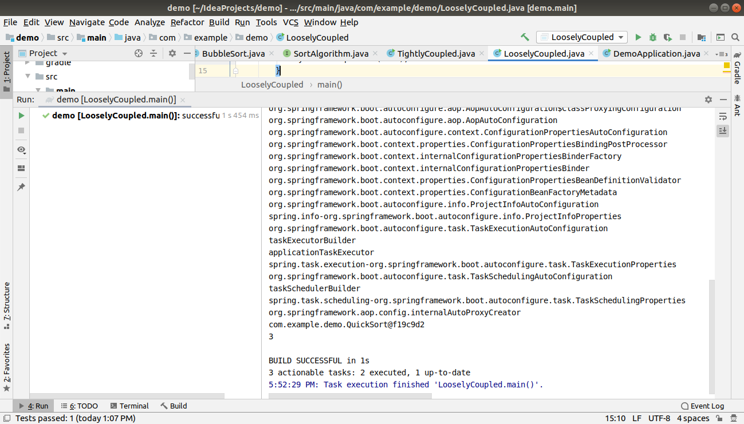

5) Demonstrate how you will resolve ambiguity while autowiring bean (Hint : @Primary)

BubbleSort.java
package com.example.demo;
import org.springframework.stereotype.Component;
@Component
public class BubbleSort implements SortAlgorithm
{
public int[] sort(int [] numbers)
{
return numbers;
}
}

QuickSort.java
package com.example.demo;
import org.springframework.context.annotation.Primary;
import org.springframework.stereotype.Component;
@Component
@Primary
public class QuickSort implements SortAlgorithm
{
public int[] sort(int [] numbers)
{
//QuickSort logic
return numbers;
}
}
BinarySearch.java
package com.example.demo;
import org.springframework.beans.factory.annotation.Autowired;
import org.springframework.stereotype.Component;
@Component
public class BinarySearch
{
@Autowired
private SortAlgorithm sortAlgorithm;
public BinarySearch(SortAlgorithm sortAlgorithm)
{
super();
this.sortAlgorithm=sortAlgorithm;
}
public int BinarySearch(int[] numbers, int numberTosearch)
{
int[] sortedNumbers= sortAlgorithm.sort(numbers);
System.out.println(sortAlgorithm);
return 3;
}
}
Interface SortAlgorithm

package com.example.demo;
public interface SortAlgorithm
{
public int[] sort(int [] numbers);
}
LooselyCoupled.java(main)

package com.example.demo;
import org.springframework.boot.autoconfigure.SpringBootApplication;
import org.springframework.boot.SpringApplication;
import org.springframework.boot.autoconfigure.SpringBootApplication;
import org.springframework.context.ApplicationContext;
@SpringBootApplication
public class LooselyCoupled
{
public static void main(String[] args) {
// BinarySearch binarySearch=new BinarySearch(new BubbleSort());
//BinarySearch binarySearch=new BinarySearch(new QuickSort());
ApplicationContext applicationContext = SpringApplication.run(DemoApplication.class, args);
BinarySearch binarySearch=applicationContext.getBean(BinarySearch.class);
int result=binarySearch.BinarySearch(new int[]{1,2,3,4},3);
System.out.println(result);
}
}
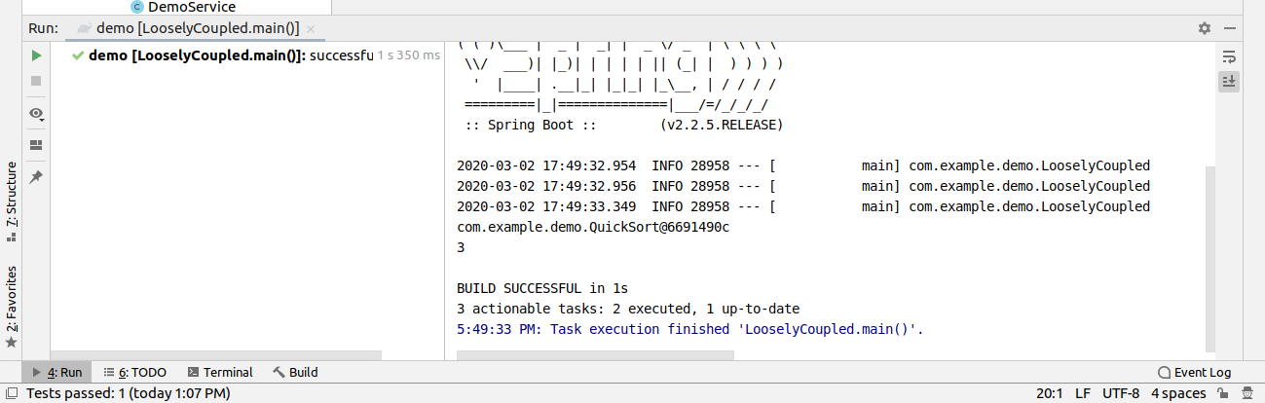
6) Perform Constructor Injection in a Spring Bean

Alpha.java

package com.example.demo1;
import org.springframework.beans.factory.annotation.Autowired;
import org.springframework.stereotype.Component;
@Component
public class Alpha
{
private Beta beta;
@Autowired
Alpha(Beta b)
{
this.beta=b;
}
public void calling()
{
System.out.println("Apha calling beta..");
beta.receiver();
}
}

Beta.java

package com.example.demo1;
import org.springframework.stereotype.Component;
@Component
public class Beta
{
public void receiver()
{
System.out.println("In beta..");
}
}
MainClass.java

package com.example.demo1;
import com.example.demo.DemoApplication;
import org.springframework.boot.SpringApplication;
import org.springframework.boot.autoconfigure.SpringBootApplication;
import org.springframework.context.ApplicationContext;
@SpringBootApplication
public class MainClass
{
public static void main(String[] args) {
ApplicationContext applicationContext= SpringApplication.run(MainClass.class, args);
Alpha alpha=applicationContext.getBean(Alpha.class);
alpha.calling();
}
}
