REST SERVICES PART 2

Internationalization
- Add support for Internationalization in your application allowing messages to be shown in English, German and Swedish, keeping English as default.

Internationalization.java

package com.example.RestServicesSpringBoot2;
import org.springframework.beans.factory.annotation.Autowired;
import org.springframework.context.MessageSource;
import org.springframework.context.i18n.LocaleContextHolder;
import org.springframework.web.bind.annotation.GetMapping;
import org.springframework.web.bind.annotation.RestController;
@RestController
public class Internationalization
{
@Autowired
private MessageSource messageSource;
@GetMapping("/helloworld")
public String helloworld()
{
return "Heelo International";
}
@GetMapping("/users/international")
public String EmployeeInternationalization()
{
//return "hello string";
return messageSource.getMessage("good.morning.message", null, LocaleContextHolder.getLocale());
}
}

RestServicesSpringBoot2.java

package com.example.RestServicesSpringBoot2;
import org.springframework.boot.SpringApplication;
import org.springframework.boot.autoconfigure.SpringBootApplication;
import org.springframework.context.annotation.Bean;
import org.springframework.web.servlet.LocaleResolver;
import org.springframework.web.servlet.i18n.AcceptHeaderLocaleResolver;
import java.util.Locale;
@SpringBootApplication
public class RestServicesSpringBoot2Application {
public static void main(String[] args) {
SpringApplication.run(RestServicesSpringBoot2Application.class, args);
}
@Bean
public LocaleResolver localeResolver()
{
AcceptHeaderLocaleResolver localeResolver=new AcceptHeaderLocaleResolver();
localeResolver.setDefaultLocale(Locale.US);
return localeResolver;
}

}
messasges.properties
good.morning.message=Good morning
messages_de.properties
good.morning.message=Guten Morgen

messages_sv.properties
good.morning.message=god morgon

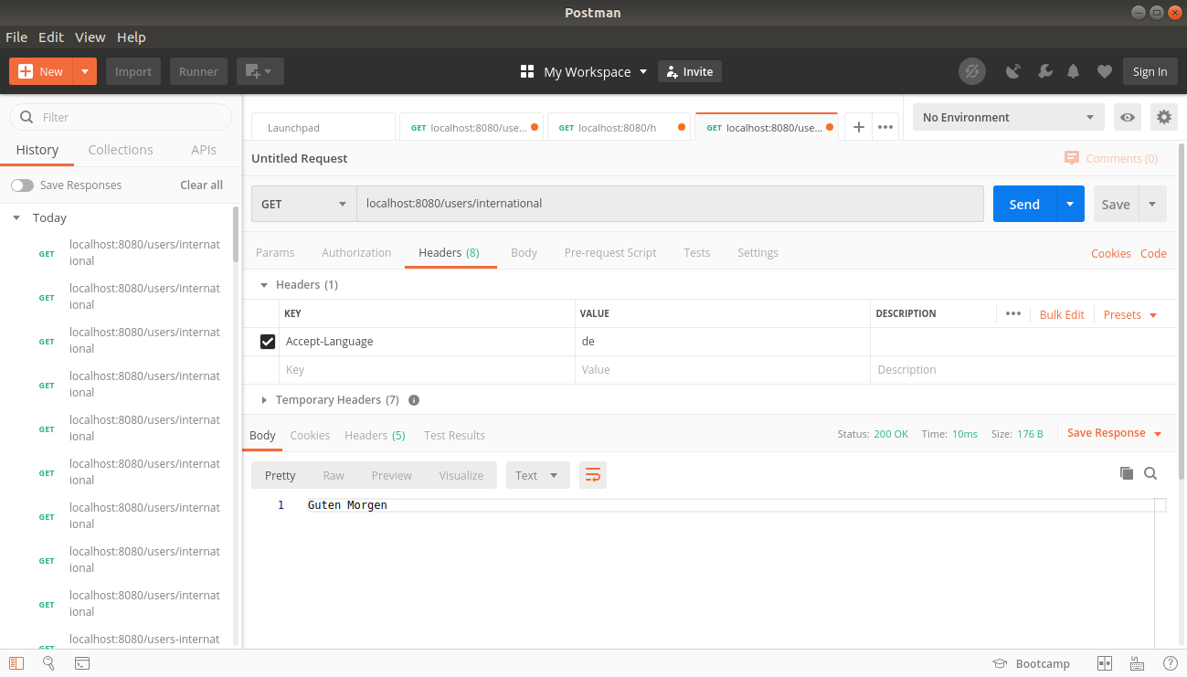
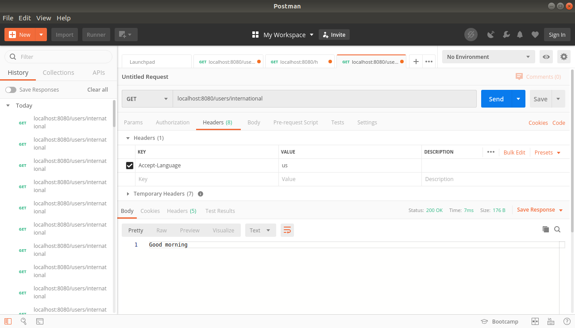
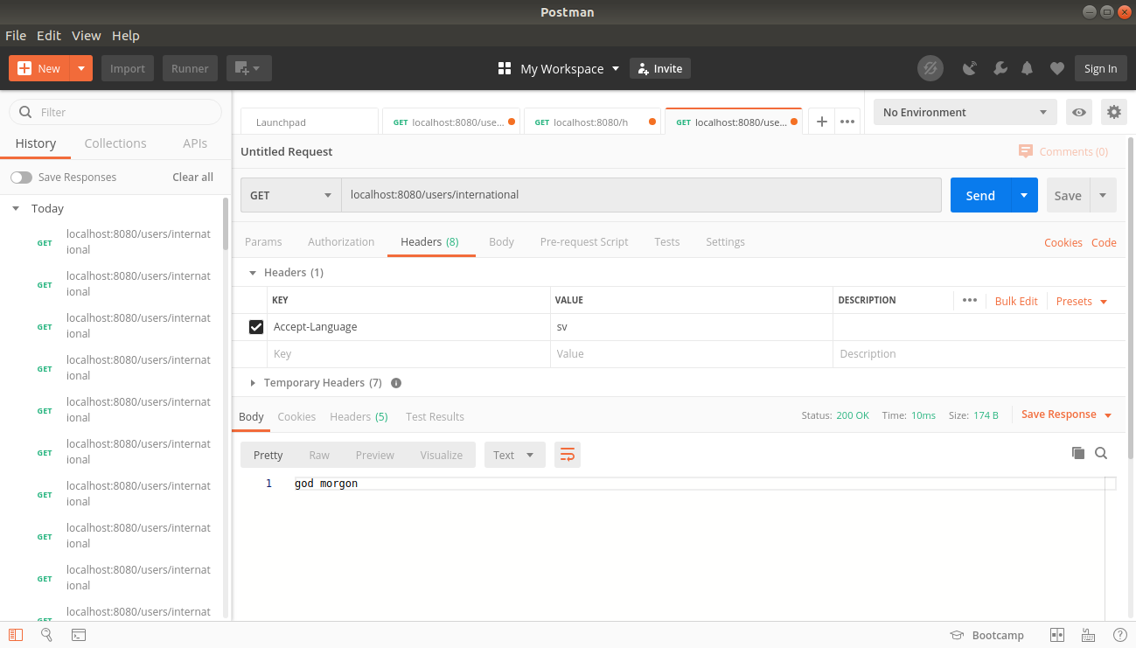

- Create a GET request which takes "username" as param and shows a localized message "Hello Username". (Use parameters in message properties)

In message.properties add
hello.message=hello {0}

message_de.properties
hello.message=hallo {0}

messages_sv.properties

hello.message=hej {0}

Helloworldinternationalization.java

package com.example.RestfulServices.hello;
import org.springframework.beans.factory.annotation.Autowired;
import org.springframework.context.MessageSource;
import org.springframework.context.i18n.LocaleContextHolder;
import org.springframework.web.bind.annotation.GetMapping;
import org.springframework.web.bind.annotation.PathVariable;
import org.springframework.web.bind.annotation.RequestHeader;
import org.springframework.web.bind.annotation.RestController;
import java.util.Locale;
@RestController
public class HeeloworldInternationalization
{
@Autowired
private MessageSource messageSource;
@GetMapping("/helloworld1")
public String helloworld() {
return "Heelo International";
}
@GetMapping("/users-international/{username}")
public String EmployeeInternationalization(@PathVariable String username)
{
String message=messageSource.getMessage("hello.message", new String[]{username}, LocaleContextHolder.getLocale());
return message;
}
}

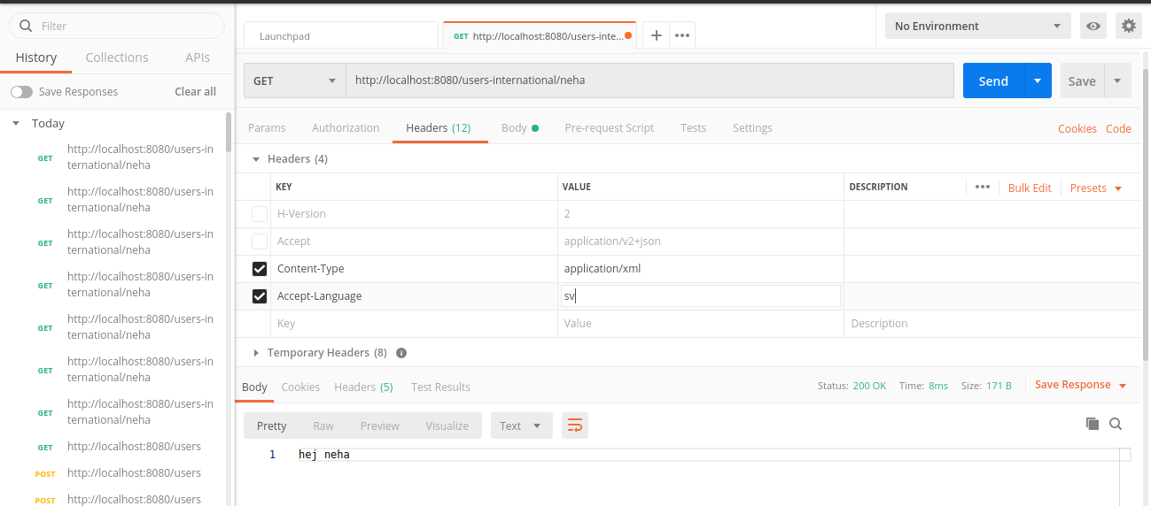

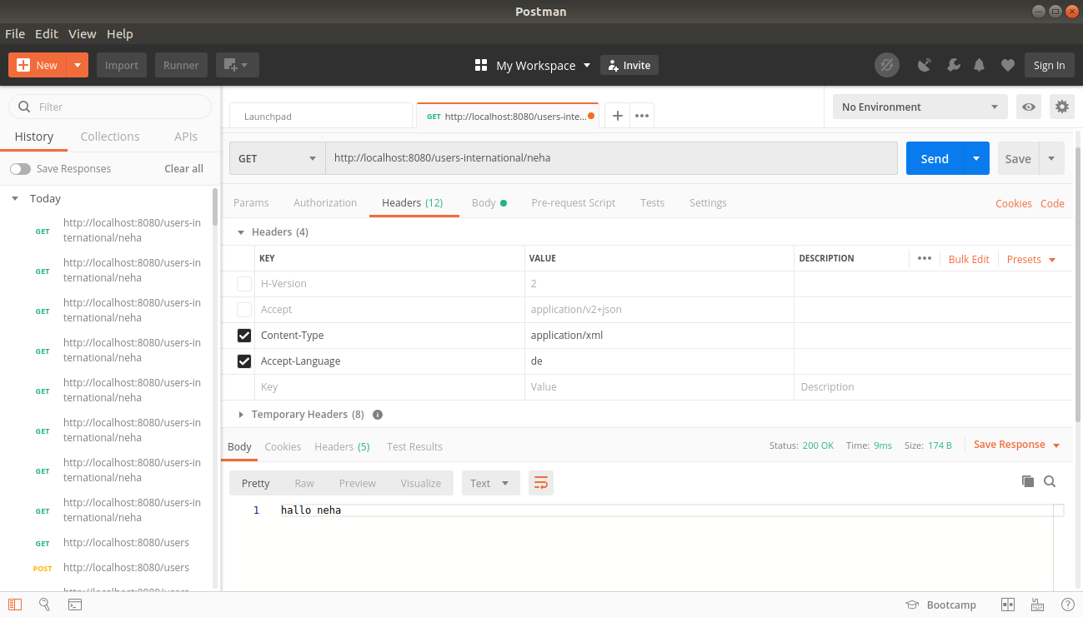

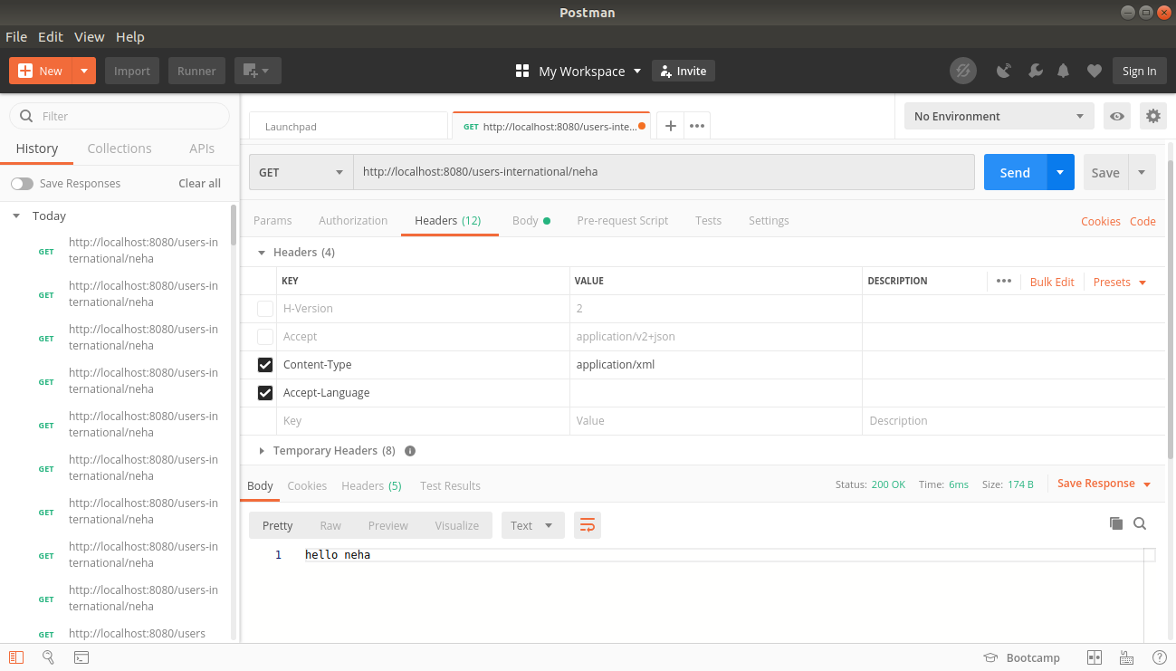

*Content Negotiation
3. Create POST Method to create user details which can accept XML for user creation.

EmployeeResource.java
Firstly, add dependency of jackson xml format in build.gradle
compile group: 'com.fasterxml.jackson.dataformat', name: 'jackson-dataformat-xml', version: '2.10.2

(Post Method)

@PostMapping(value = "/users",consumes = "application/xml")
// @ApiModelProperty(notes = "Method to Create the new user in the list of already created employees")
public ResponseEntity<Object> CreateUser( @Valid @RequestBody Employee employee)
{
Employee SavedUser=service.save(employee);
URI location= ServletUriComponentsBuilder.fromCurrentRequest()
.path("/{id}").
buildAndExpand(SavedUser.getId()).toUri();
return ResponseEntity.created(location).build();
}

// Created an Employee using post method in XML format//

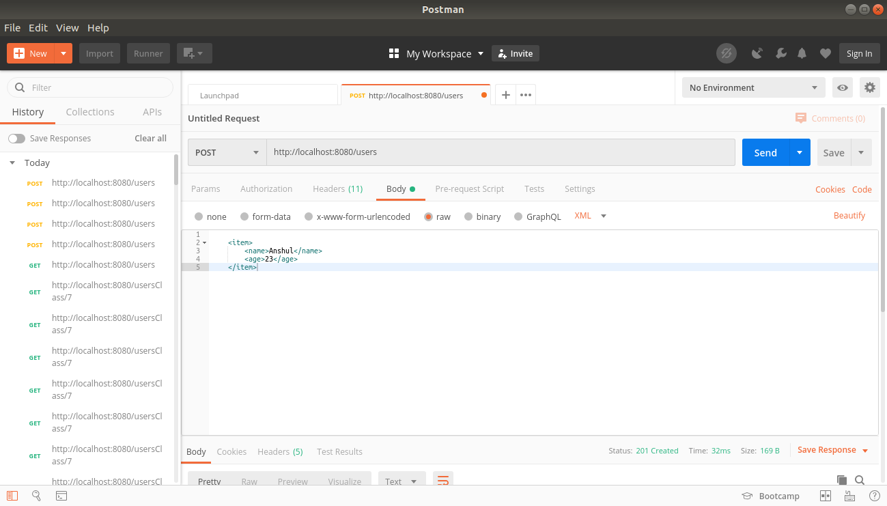
//The new Employee added in the list//

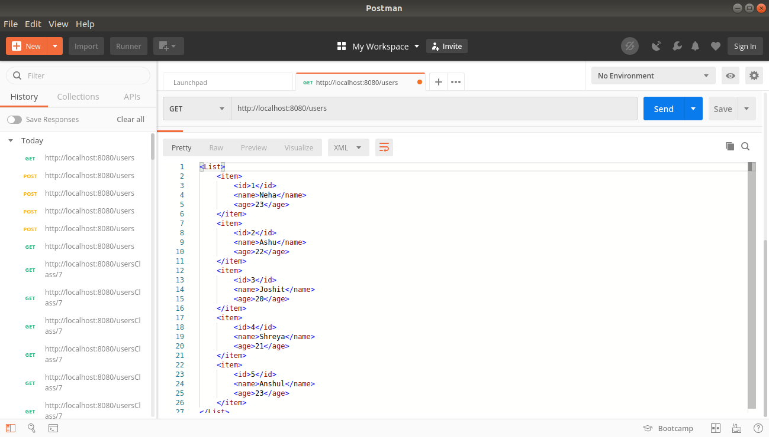

4. Create GET Method to fetch the list of users in XML format.
(Get Method)
package com.example.RestfulServices.user;
import io.swagger.annotations.*;
import org.springframework.beans.factory.annotation.Autowired;
import org.springframework.http.HttpStatus;
import org.springframework.http.ResponseEntity;
import org.springframework.web.bind.annotation.*;
import org.springframework.web.servlet.support.ServletUriComponentsBuilder;
import javax.validation.Valid;
import java.net.URI;
import java.nio.file.attribute.UserPrincipalNotFoundException;
import java.util.List;

@Api(value = "Employee resource class")
@RestController

public class EmployeeResource
{
@Autowired
private EmployeeDaoService service;
@ApiOperation(value="Method to retrieve the list of already created employees.")
@GetMapping(value = "/users",produces = "application/xml")

public List<Employee> retrieveAllUsers()
{
return service.findAll();
}
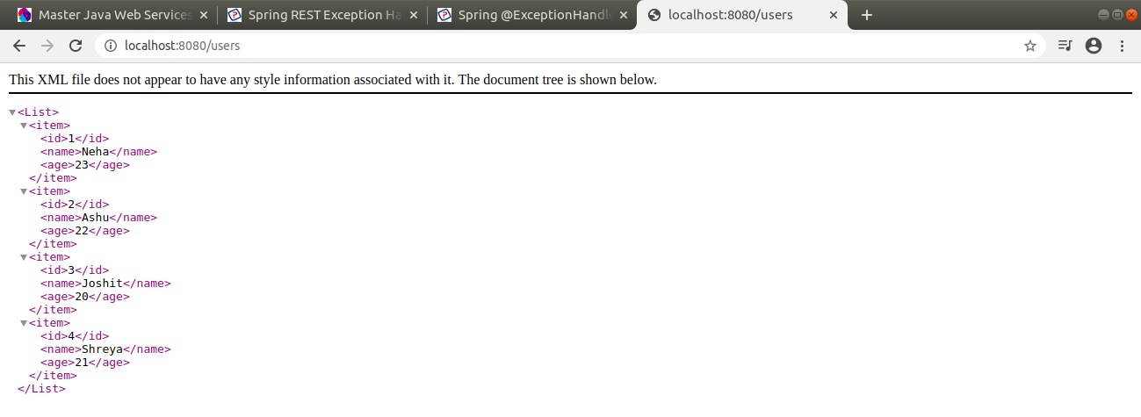

*Swagger
5. Configure swagger plugin and create document of following methods:
- Get details of User using GET request.
- Save details of the user using POST request.
- Delete a user using DELETE request.
Build.gradle

plugins {
id 'org.springframework.boot' version '2.2.5.RELEASE'
id 'io.spring.dependency-management' version '1.0.9.RELEASE'
id 'java'
}
group = 'com.example'
version = '0.0.1-SNAPSHOT'
sourceCompatibility = '1.8'
configurations {
developmentOnly
runtimeClasspath {
extendsFrom developmentOnly
}
}
repositories {
mavenCentral()
}
dependencies {
compile group: 'io.springfox', name: 'springfox-swagger-ui', version: '2.3.1'
compile group: 'io.springfox', name: 'springfox-swagger2', version: '2.3.1'
implementation 'org.springframework.boot:spring-boot-starter-web'
runtime 'org.springframework.boot:spring-boot-devtools'

runtimeOnly 'com.h2database:h2'
compile group: 'com.fasterxml.jackson.dataformat', name: 'jackson-dataformat-xml',version:'2.10.3'
testImplementation('org.springframework.boot:spring-boot-starter-test') {
exclude group: 'org.junit.vintage', module: 'junit-vintage-engine'
}
}
test {
useJUnitPlatform()

}

SWAGGER IMPLEMENTATION
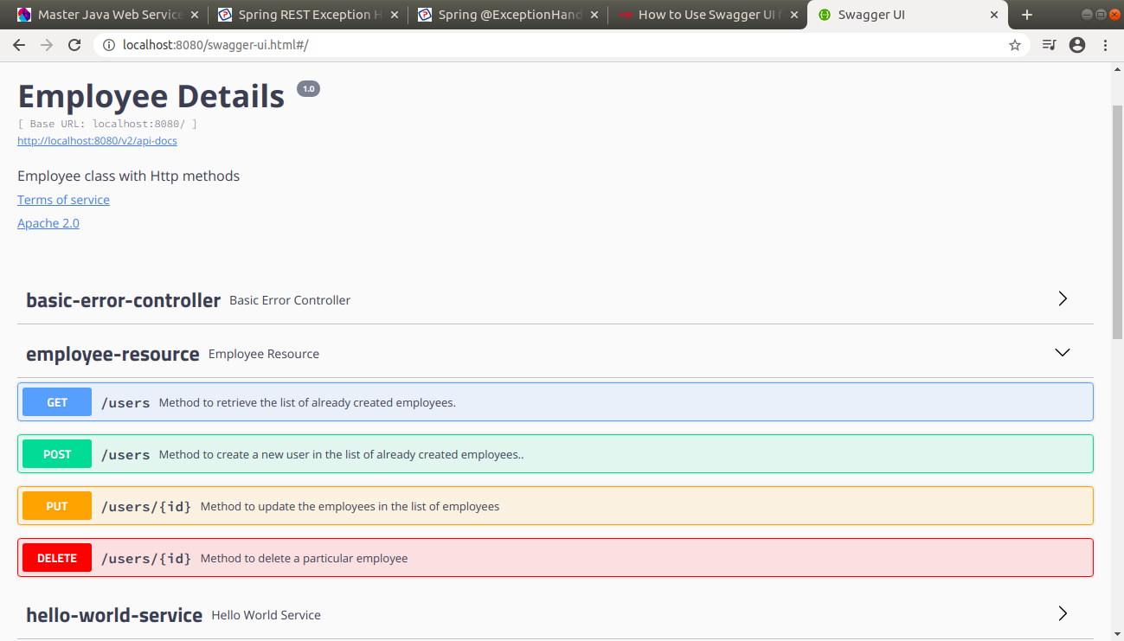

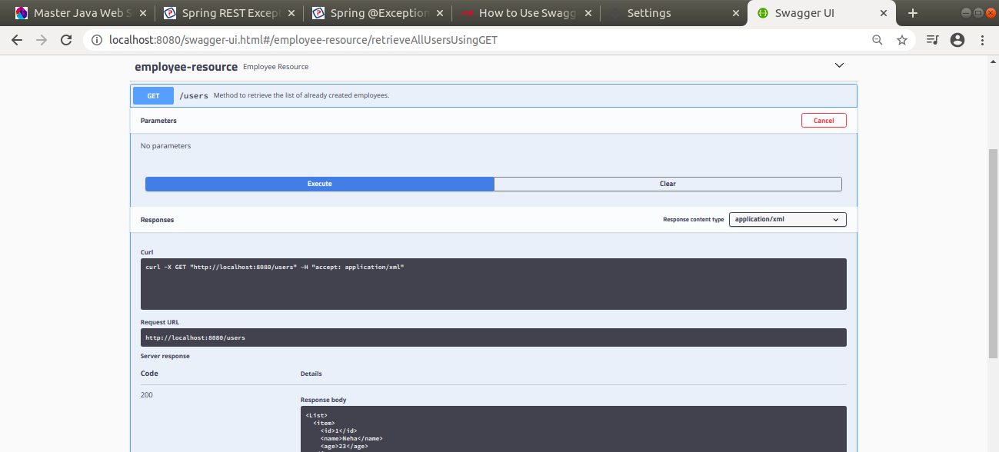
GET METHOD USING SWAGGER

POST METHOD USING SWAGGER (WHEN DETAILS ADDED)

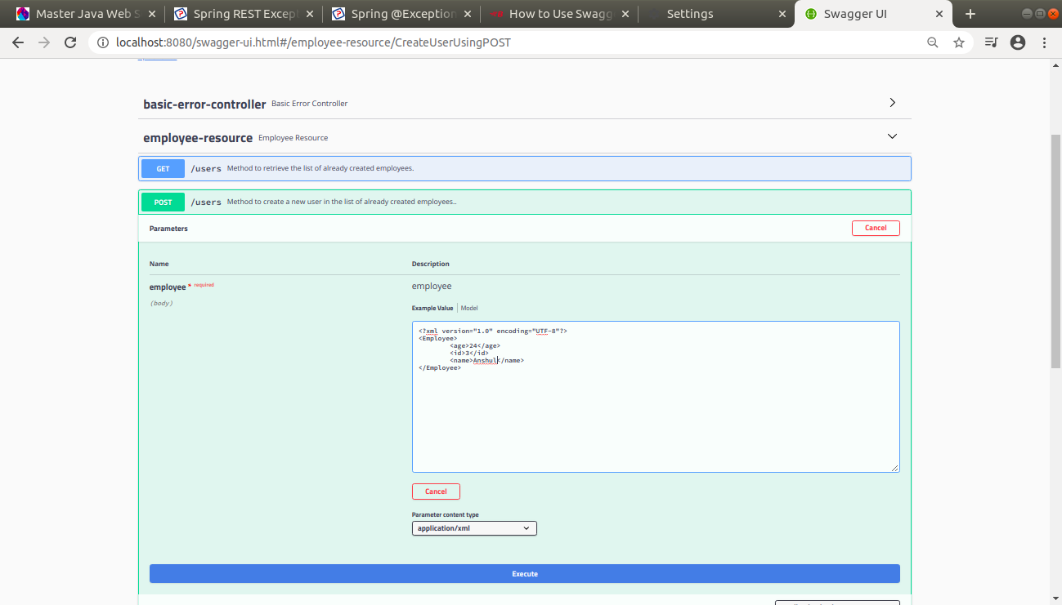
AFTER ADDING THE EMPLOYEE, THE USER IS ADDED

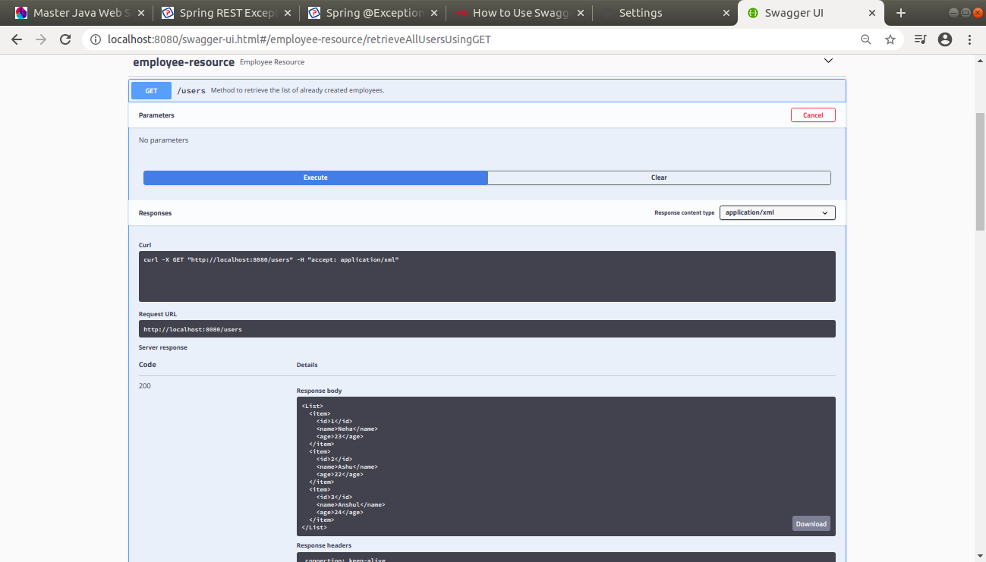

DELETING USING SWAGGER

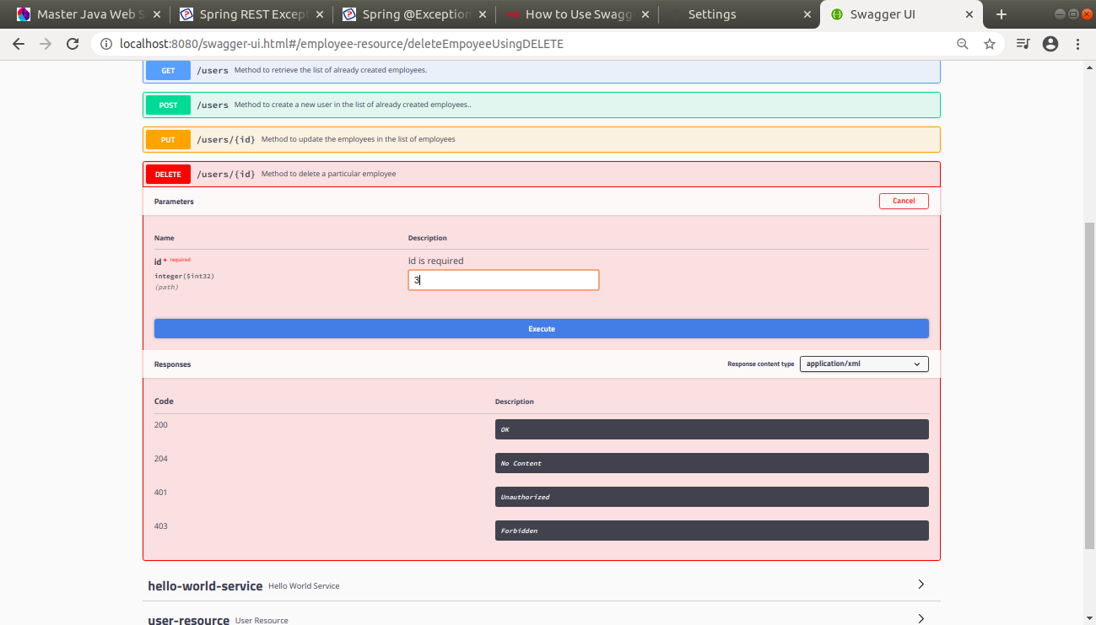

AFTER DELETING THE EMPLOYEE THE USER IS DELETED FROM THE LIST
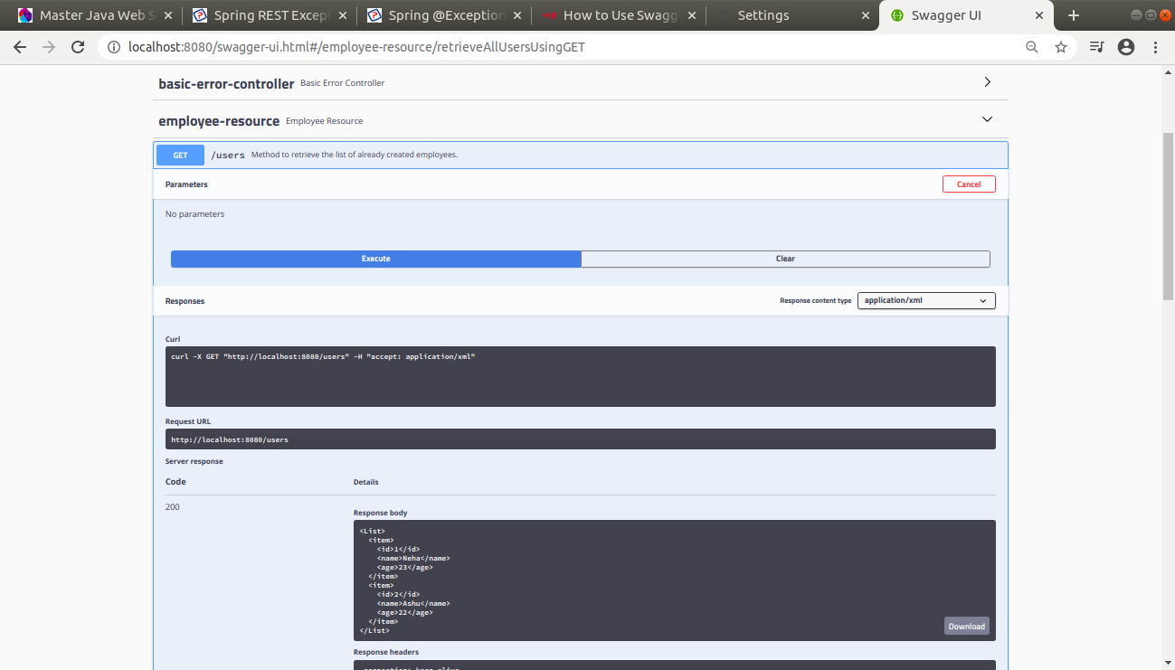

7. In swagger documentation, add the description of each class and URI so that in swagger UI the purpose of class and URI is clear.

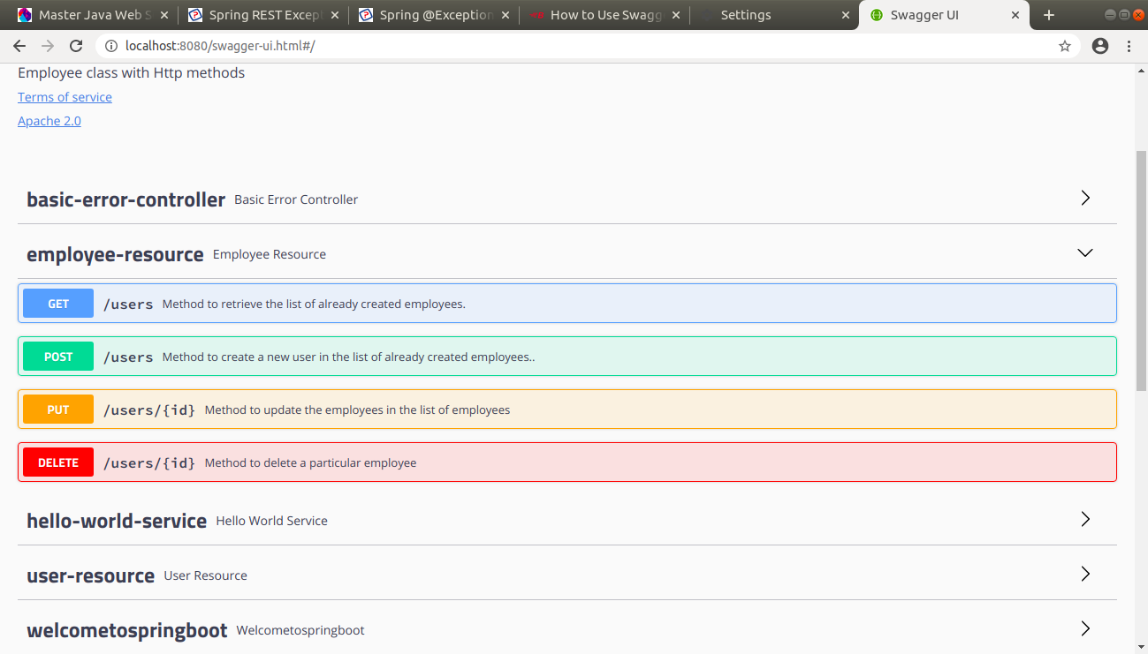

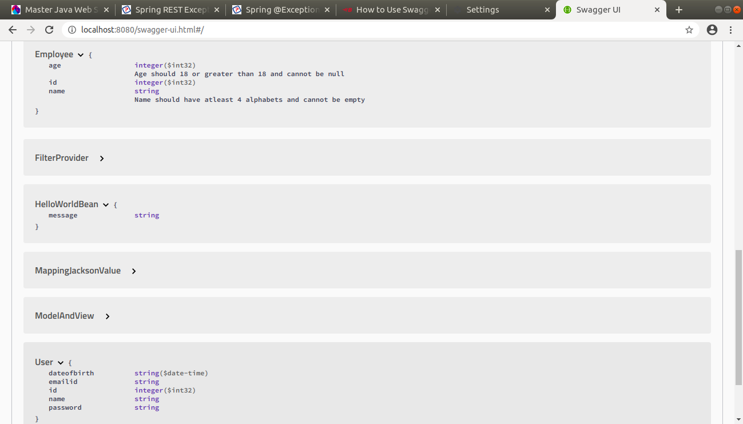
*Static and Dynamic filtering
8. Create API which saves details of User (along with the password) but on successfully saving returns only non-critical data. (Use static filtering)

User.java

package com.example.RestfulServices.hello;
import com.fasterxml.jackson.annotation.JsonFilter;
import com.fasterxml.jackson.annotation.JsonIgnore;
import com.fasterxml.jackson.annotation.JsonIgnoreProperties;
import java.util.Date;
@JsonIgnoreProperties(value={"password","emailid"})
//@JsonFilter("Filtering")
public class User
{
private int id;
String name;
private Date dateofbirth;
//@JsonIgnore
private String password;
private String emailid;
public User()
{
}
public User(int id, String name, Date dateofbirth, String password, String emailid) {
this.id = id;
this.name = name;
this.dateofbirth = dateofbirth;
this.password = password;
this.emailid = emailid;
}
public int getId() {
return id;
}
public void setId(int id) {
this.id = id;
}
public String getName() {
return name;
}
public void setName(String name) {
this.name = name;
}
public Date getDateofbirth() {
return dateofbirth;
}
public void setDateofbirth(Date dateofbirth) {
this.dateofbirth = dateofbirth;
}
public String getPassword() {
return password;
}
public void setPassword(String password) {
this.password = password;
}
public String getEmailid() {
return emailid;
}
public void setEmailid(String emailid) {
this.emailid = emailid;
}
@Override
public String toString() {
return "User{" +
"id=" + id +
", name='" + name + '\'' +
", dateofbirth=" + dateofbirth +
", password='" + password + '\'' +
", emailid='" + emailid + '\'' +
'}';
}
}
UserResource.java
package com.example.RestfulServices.hello;
import com.example.RestfulServices.user.Employee;
import com.example.RestfulServices.user.EmployeeDaoService;
import com.example.RestfulServices.user.UserNotFoundException;
import com.fasterxml.jackson.annotation.JsonFilter;
import com.fasterxml.jackson.databind.ser.FilterProvider;
import com.fasterxml.jackson.databind.ser.impl.SimpleBeanPropertyFilter;
import com.fasterxml.jackson.databind.ser.impl.SimpleFilterProvider;
import io.swagger.annotations.*;
import org.springframework.beans.factory.annotation.Autowired;
import org.springframework.http.ResponseEntity;
import org.springframework.http.converter.json.MappingJacksonValue;
import org.springframework.web.bind.annotation.*;
import org.springframework.web.servlet.support.ServletUriComponentsBuilder;
import javax.validation.Valid;
import javax.validation.constraints.AssertTrue;
import java.net.URI;
import java.util.ArrayList;
import java.util.Arrays;
import java.util.Date;
import java.util.List;
@RestController
public class UserResource
{
@Autowired
private UserDaoService userDaoService;
@ApiOperation(value="Method to retrieve the list of already created employees.")
@GetMapping(value = "/usersmodel")

public List<User> retrieveAllUsers()
{

return userDaoService.findAll();
}
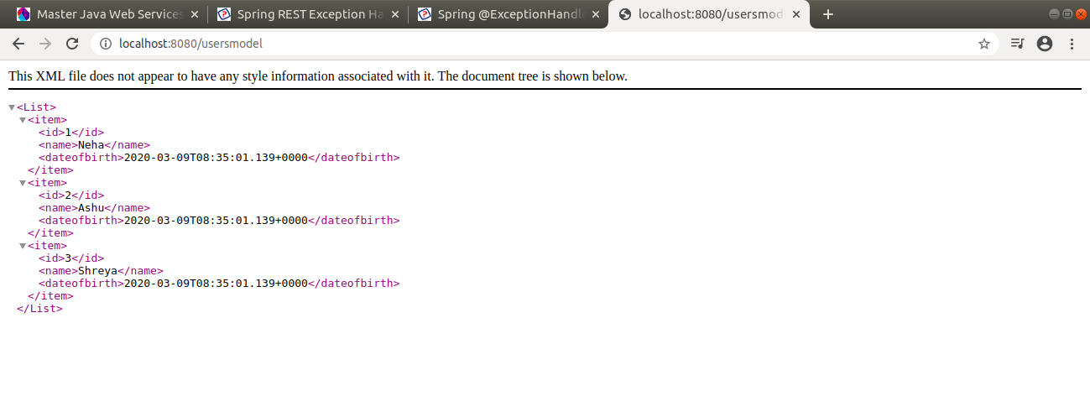

9. Create another API that does the same by using Dynamic Filtering.

User.java

package com.example.RestfulServices.hello;
import com.fasterxml.jackson.annotation.JsonFilter;
import com.fasterxml.jackson.annotation.JsonIgnore;
import com.fasterxml.jackson.annotation.JsonIgnoreProperties;
import java.util.Date;
@JsonIgnoreProperties(value={"password","emailid"})
//@JsonFilter("Filtering")
public class User
{
private int id;
String name;
private Date dateofbirth;
//@JsonIgnore
private String password;
private String emailid;
public User()
{
}
public User(int id, String name, Date dateofbirth, String password, String emailid) {
this.id = id;
this.name = name;
this.dateofbirth = dateofbirth;
this.password = password;
this.emailid = emailid;
}
public int getId() {
return id;
}
public void setId(int id) {
this.id = id;
}
public String getName() {
return name;
}
public void setName(String name) {
this.name = name;
}
public Date getDateofbirth() {
return dateofbirth;
}
public void setDateofbirth(Date dateofbirth) {
this.dateofbirth = dateofbirth;
}
public String getPassword() {
return password;
}
public void setPassword(String password) {
this.password = password;
}
public String getEmailid() {
return emailid;
}
public void setEmailid(String emailid) {
this.emailid = emailid;
}
@Override
public String toString() {
return "User{" +
"id=" + id +
", name='" + name + '\'' +
", dateofbirth=" + dateofbirth +
", password='" + password + '\'' +
", emailid='" + emailid + '\'' +
'}';
}
}
UserResource.java

package com.example.RestfulServices.hello;
import com.example.RestfulServices.user.Employee;
import com.example.RestfulServices.user.EmployeeDaoService;
import com.example.RestfulServices.user.UserNotFoundException;
import com.fasterxml.jackson.annotation.JsonFilter;
import com.fasterxml.jackson.databind.ser.FilterProvider;
import com.fasterxml.jackson.databind.ser.impl.SimpleBeanPropertyFilter;
import com.fasterxml.jackson.databind.ser.impl.SimpleFilterProvider;
import io.swagger.annotations.*;
import org.springframework.beans.factory.annotation.Autowired;
import org.springframework.http.ResponseEntity;
import org.springframework.http.converter.json.MappingJacksonValue;
import org.springframework.web.bind.annotation.*;
import org.springframework.web.servlet.support.ServletUriComponentsBuilder;
import javax.validation.Valid;
import javax.validation.constraints.AssertTrue;
import java.net.URI;
import java.util.ArrayList;
import java.util.Arrays;
import java.util.Date;
import java.util.List;
@RestController
public class UserResource
{
@Autowired
private UserDaoService userDaoService;
@ApiOperation(value="Method to retrieve the list of already created employees.")
@GetMapping(value = "/usersmodel")
public MappingJacksonValue retrieveAllUsers()
{
List<User> users=userDaoService.findAll();
SimpleBeanPropertyFilter filter=SimpleBeanPropertyFilter.filterOutAllExcept("id","name","dateofbirth");
FilterProvider filterProvider=new SimpleFilterProvider().addFilter("Filtering",filter);
MappingJacksonValue mappingJacksonValue=new MappingJacksonValue(users);
mappingJacksonValue.setFilters(filterProvider);
return mappingJacksonValue;

}
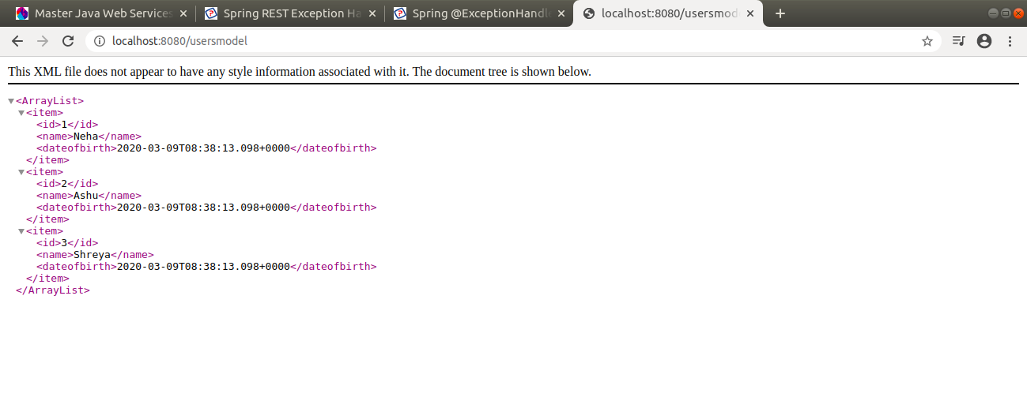

*Versioning Restful APIs
10. Create 2 API for showing user details. The first api should return only basic details of the user and the other API should return more/enhanced details of the user,
Now apply versioning using the following methods:
- MimeType Versioning
- Request Parameter versioning
- URI versioning
- Custom Header Versioning

URI VERSIONING

Userdetails.java

package com.example.Versioning;
import java.util.Date;
public class UserDetails
{
private int id;
private String name;
private Date dateofbirth;
private String password;
private String emailid;
private String address;
public UserDetails()
{
}
public UserDetails(int id, String name, Date dateofbirth,
String password, String emailid, String address) {
this.id = id;
this.name = name;
this.dateofbirth = dateofbirth;
this.password = password;
this.emailid = emailid;
this.address = address;
}
public int getId() {
return id;
}
public void setId(int id) {
this.id = id;
}
public String getName() {
return name;
}
public void setName(String name) {
this.name = name;
}
public Date getDateofbirth() {
return dateofbirth;
}
public void setDateofbirth(Date dateofbirth) {
this.dateofbirth = dateofbirth;
}
public String getPassword() {
return password;
}
public void setPassword(String password) {
this.password = password;
}
public String getEmailid() {
return emailid;
}
public void setEmailid(String emailid) {
this.emailid = emailid;
}
public String getAddress() {
return address;
}
public void setAddress(String address) {
this.address = address;
}
}
UserdetailsNew.java

package com.example.Versioning;
import java.util.Date;
public class UserDetailsNew
{
private Nameclass name;
private AddressClass address;
private int id;
private Date dateofbirth;
private String emailid;
private String password;
public UserDetailsNew()
{
}
public UserDetailsNew(Nameclass name, AddressClass address,
int id, Date dateofbirth, String emailid, String password) {
this.name = name;
this.address = address;
this.id = id;
this.dateofbirth = dateofbirth;
this.emailid = emailid;
this.password = password;
}
public Nameclass getName() {
return name;
}
public void setName(Nameclass name) {
this.name = name;
}
public AddressClass getAddress() {
return address;
}
public void setAddress(AddressClass address) {
this.address = address;
}
public int getId() {
return id;
}
public void setId(int id) {
this.id = id;
}
public Date getDateofbirth() {
return dateofbirth;
}
public void setDateofbirth(Date dateofbirth) {
this.dateofbirth = dateofbirth;
}
public String getEmailid() {
return emailid;
}
public void setEmailid(String emailid) {
this.emailid = emailid;
}
public String getPassword() {
return password;
}
public void setPassword(String password) {
this.password = password;
}
}
Nameclass.java

package com.example.Versioning;
public class Nameclass
{
private String firstname;
private String lastname;
public Nameclass()
{
}
public Nameclass(String firstname, String lastname) {
this.firstname = firstname;
this.lastname = lastname;
}
public String getFirstname() {
return firstname;
}
public void setFirstname(String firstname) {
this.firstname = firstname;
}
public String getLastname() {
return lastname;
}
public void setLastname(String lastname) {
this.lastname = lastname;
}
}
Addressclass.java

package com.example.Versioning;
public class AddressClass
{
private int housenumber;
private String street;
private String floor;
private int pincode;
public AddressClass()
{
}
public AddressClass(int housenumber, String street, String floor, int pincode) {
this.housenumber = housenumber;
this.street = street;
this.floor = floor;
this.pincode = pincode;
}
public int getHousenumber() {
return housenumber;
}
public void setHousenumber(int housenumber) {
this.housenumber = housenumber;
}
public String getStreet() {
return street;
}
public void setStreet(String street) {
this.street = street;
}
public String getFloor() {
return floor;
}
public void setFloor(String floor) {
this.floor = floor;
}
public int getPincode() {
return pincode;
}
public void setPincode(int pincode) {
this.pincode = pincode;
}
}
VersioningController.java

package com.example.Versioning;
import org.springframework.web.bind.annotation.GetMapping;
import org.springframework.web.bind.annotation.RestController;
import java.util.Date;
@RestController
public class VersioningController
{
@GetMapping("/userdetails1")
public UserDetails userDetails()
{
return new UserDetails(1,"Neha",new Date(),"neha@123","neha@gmail.com","Patel nagar");
}
@GetMapping("/userdetails2")
public UserDetailsNew userDetailsNew()
{
return new UserDetailsNew((new Nameclass("Neha","Budhiraja")) ,(new AddressClass(116,"Patel-Nagar","Second-Floor",110008)),1,
new Date(),"neha@gmail.com","neha@123");
}
}

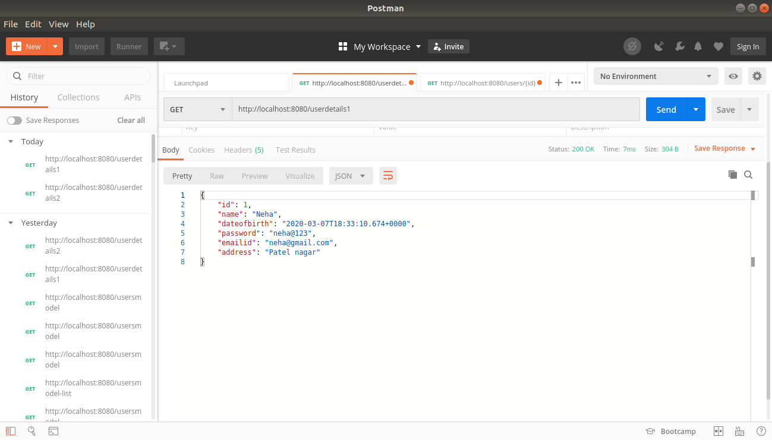
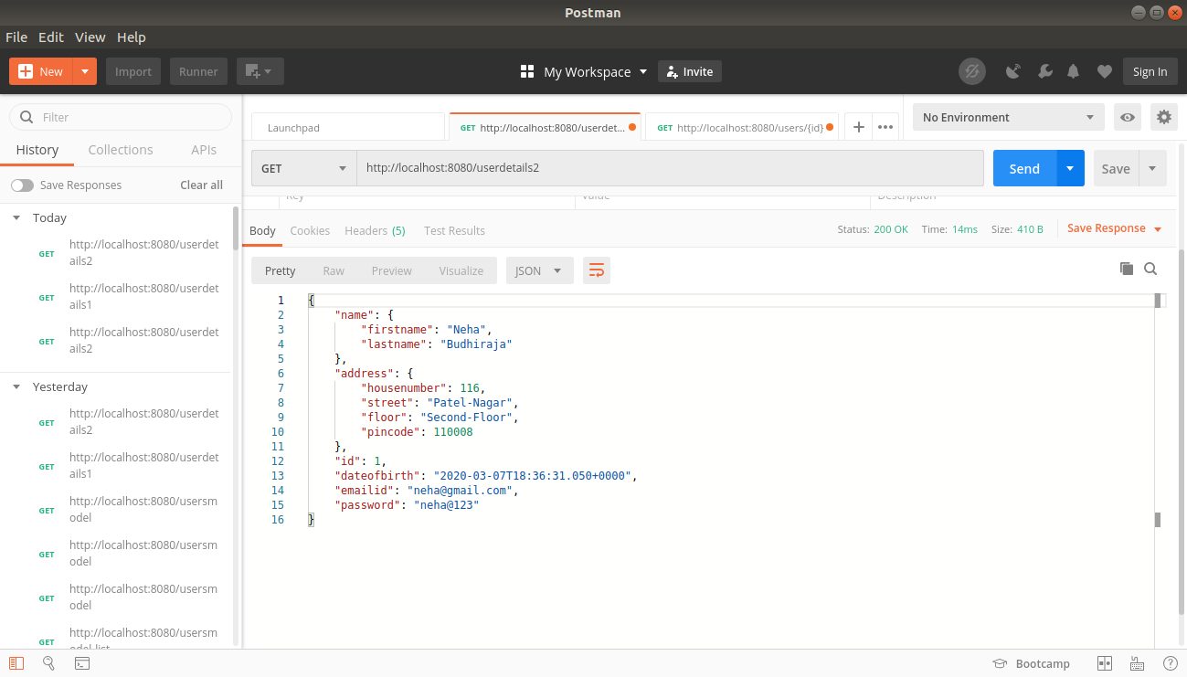

REQUEST PARAMETER VERSIONING

VersioningController.java

package com.example.Versioning;
import org.springframework.web.bind.annotation.GetMapping;
import org.springframework.web.bind.annotation.RestController;
import java.util.Date;
@RestController
public class VersioningController
{
@GetMapping(value="/userdetails",params="version=1")
public UserDetails userDetails()
{
return new UserDetails(1,"Neha",new Date(),"neha@123","neha@gmail.com","Patel nagar");
}
@GetMapping(value = "/userdetails",params = "version=2")
public UserDetailsNew userDetailsNew()
{
return new UserDetailsNew((new Nameclass("Neha","Budhiraja")) ,(new AddressClass(116,"Patel-Nagar","Second-Floor",110008)),1,
new Date(),"neha@gmail.com","neha@123");
}
}
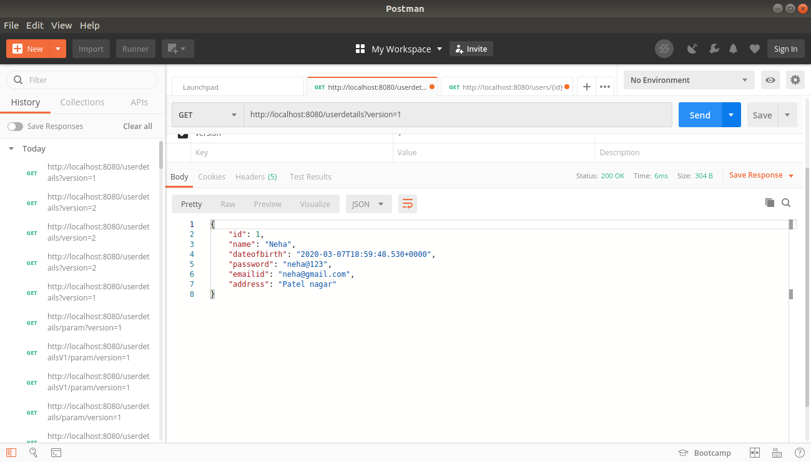

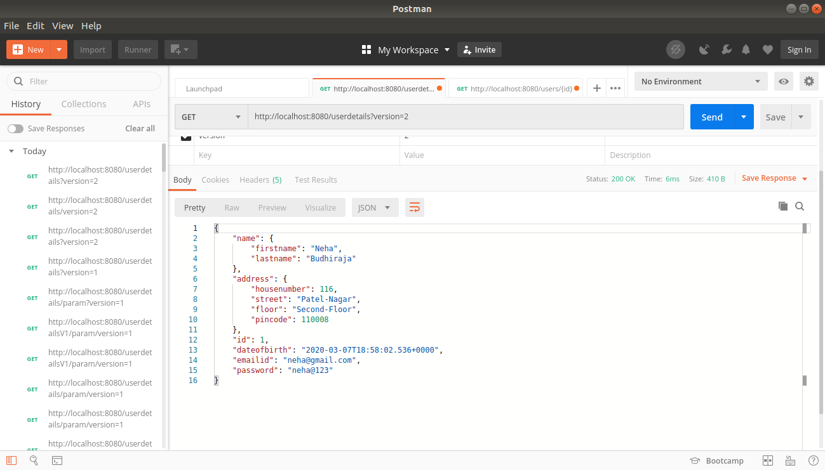

HEADER VERSIONING

VersioningController.java

package com.example.Versioning;
import org.springframework.web.bind.annotation.GetMapping;
import org.springframework.web.bind.annotation.RestController;
import java.util.Date;
@RestController
public class VersioningController
{
@GetMapping(value="/userdetails/header",headers="H-version=1")
public UserDetails userDetails()
{
return new UserDetails(1,"Neha",new Date(),"neha@123","neha@gmail.com","Patel nagar");
}
@GetMapping(value = "/userdetails/header",headers = "H-version=2")
public UserDetailsNew userDetailsNew()
{
return new UserDetailsNew((new Nameclass("Neha","Budhiraja")) ,(new AddressClass(116,"Patel-Nagar","Second-Floor",110008)),1,
new Date(),"neha@gmail.com","neha@123");
}
}
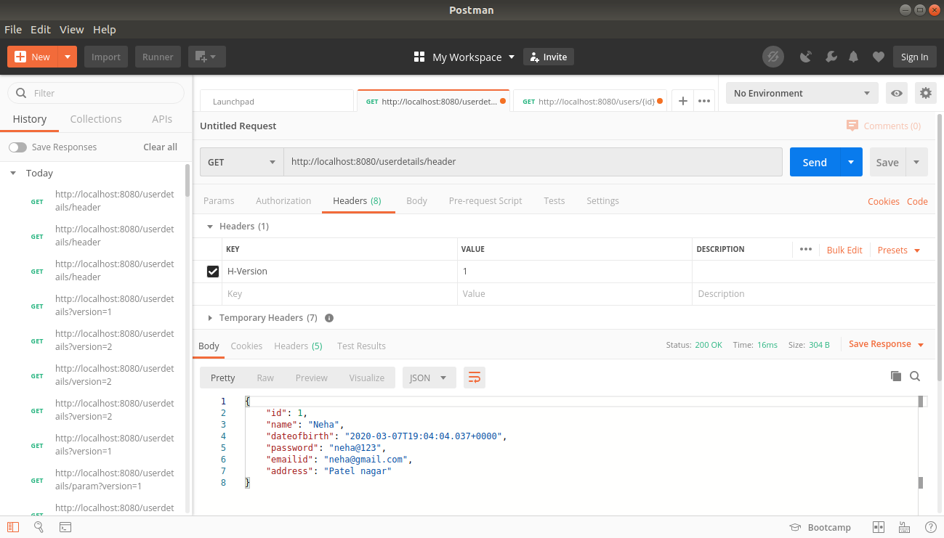

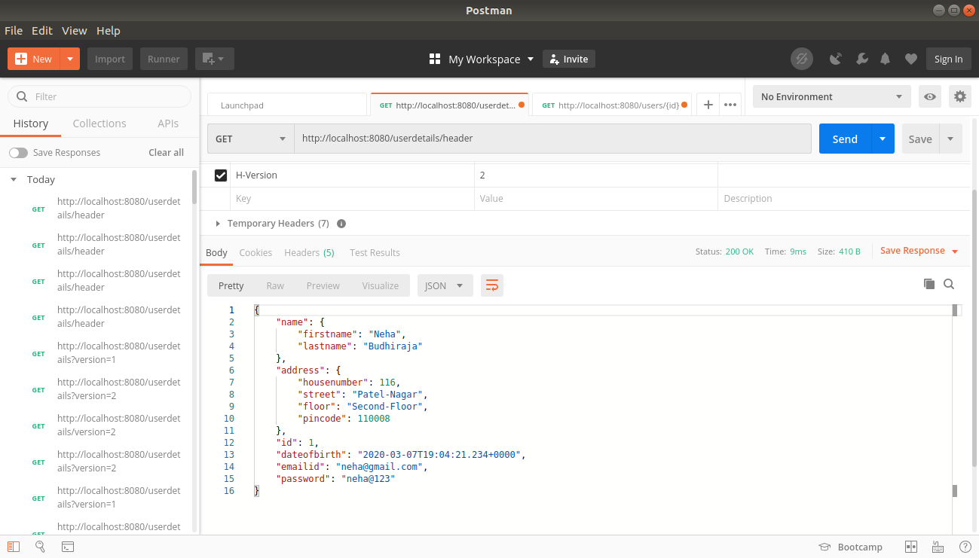

MIME TYPE VERSIONING

package com.example.Versioning;
import org.springframework.web.bind.annotation.GetMapping;
import org.springframework.web.bind.annotation.RestController;
import java.util.Date;
@RestController
public class VersioningController
{
@GetMapping(value="/userdetails/produces",produces="application/v1+json")
public UserDetails userDetails()
{
return new UserDetails(1,"Neha",new Date(),"neha@123","neha@gmail.com","Patel nagar");
}
@GetMapping(value = "/userdetails/produces",produces = "application/v2+json")
public UserDetailsNew userDetailsNew()
{
return new UserDetailsNew((new Nameclass("Neha","Budhiraja")) ,(new AddressClass(116,"Patel-Nagar","Second-Floor",110008)),1,
new Date(),"neha@gmail.com","neha@123");
}
}
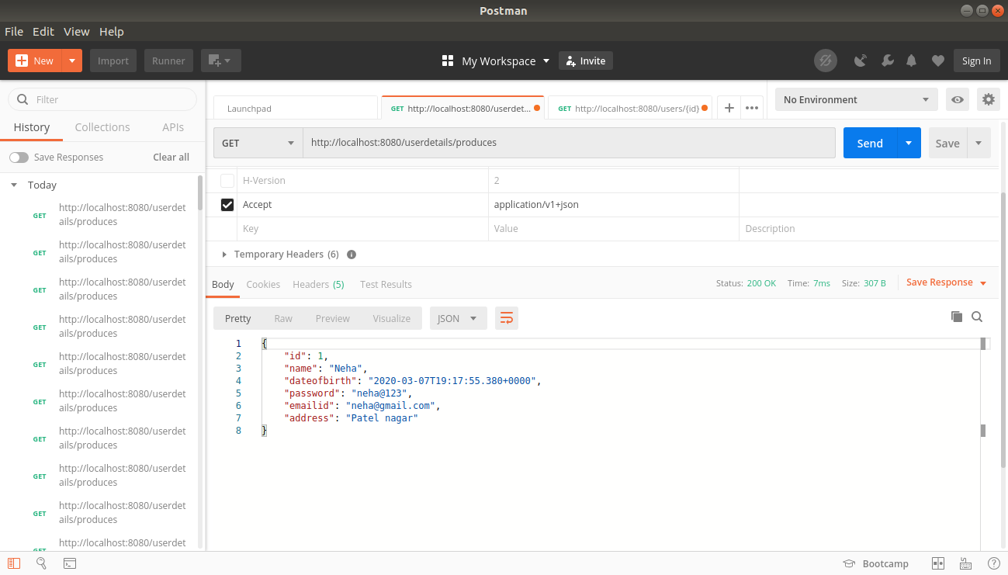
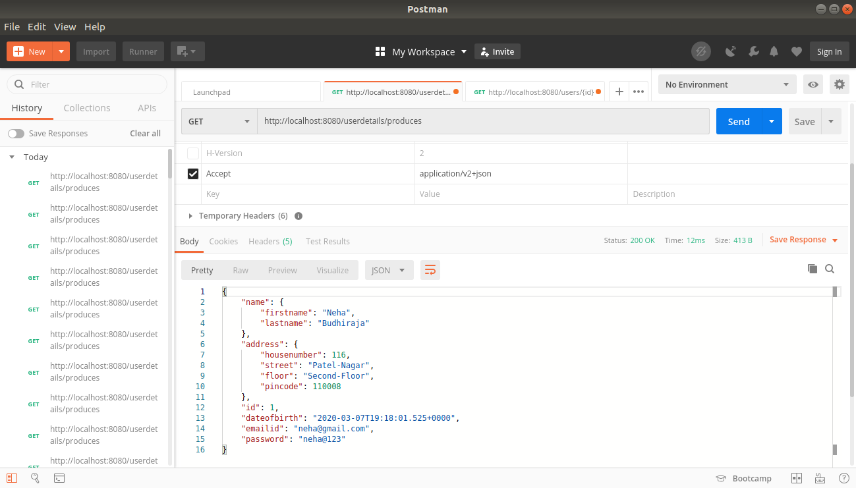

11) Hateoas Creation

First add the dependancy in build.gradle file

implementation 'org.springframework.boot:spring-boot-starter-hateoas'

EmployeeResource.java

package com.example.RestfulServices.user;
import org.hibernate.annotations.common.reflection.XMethod;
import org.springframework.beans.factory.annotation.Autowired;
import org.springframework.hateoas.EntityModel;
import static org.springframework.hateoas.server.mvc.WebMvcLinkBuilder.*;
import static org.springframework.hateoas.server.mvc.WebMvcLinkBuilder.*;
import org.springframework.hateoas.server.mvc.WebMvcLinkBuilder;
import org.springframework.hateoas.server.mvc.WebMvcLinkBuilderDslKt;
import org.springframework.http.HttpStatus;
import org.springframework.http.ResponseEntity;
import org.springframework.web.bind.annotation.*;
import org.springframework.web.servlet.support.ServletUriComponentsBuilder;
import javax.validation.Valid;
import java.net.URI;
import java.nio.file.attribute.UserPrincipalNotFoundException;
import java.util.List;

@RestController
public class EmployeeResource
{
@Autowired
private EmployeeDaoService service;
@GetMapping(value = "/users",produces = "application/xml")
public List<Employee> retrieveAllUsers()
{
return service.findAll();
}
@GetMapping("/users/{id}")
public EntityModel<Employee> retrieveuser(@PathVariable int id)
{
Employee employee= service.findOne(id);
if(employee==null)
{
throw new UserNotFoundException("id-" +id);
}
EntityModel<Employee> resource=new EntityModel<Employee>(employee);
WebMvcLinkBuilder linkTo=linkTo(methodOn(this.getClass()).retrieveAllUsers());
resource.add(linkTo.withRel("Find-all-users"));

return resource;
}
