JAVA8 FUNDAMENTALS

- Write the following a functional interface and implement it using lambda:
* First number is greater than second number or not Parameter (int ,int ) Return boolean

package com.company;
import org.w3c.dom.ls.LSOutput;
interface Greatest
{
boolean check(int a, int b);
}
public class GreaterNumber {
public static void main(String[] args) {
Greatest greatest = (a, b) -> a > b;
System.out.println(greatest.check(2,4));
}
}
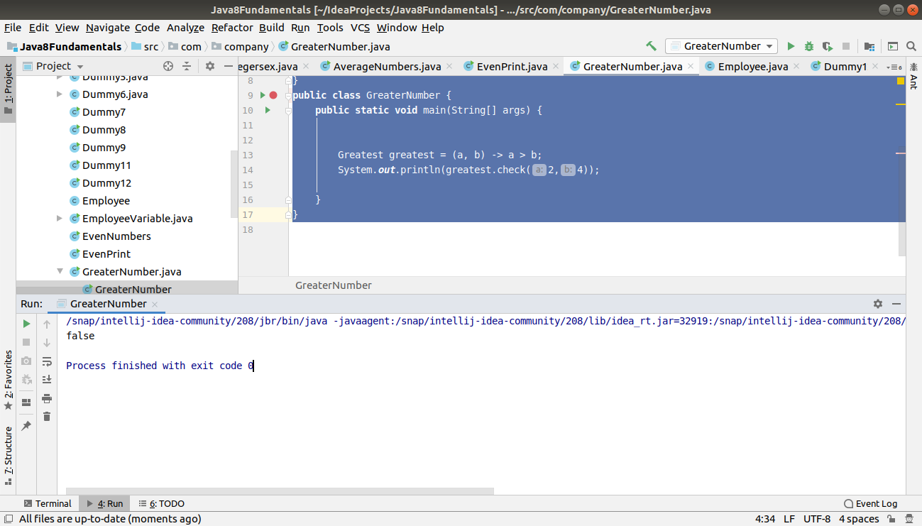

*Increment the number by 1 and return incremented value Parameter (int) Return int

package com.company;
interface Increment
{
int checkvalue(int a);
}
public class IncrementValue
{
public static void main(String[] args)
{
Increment inc=a -> a+1;
System.out.println(inc.checkvalue(3));
}
}

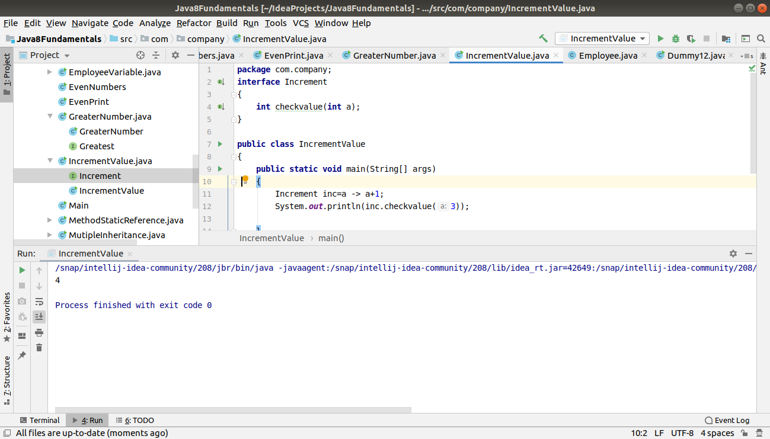

* Concatination of 2 string Parameter (String , String ) Return (String)

package com.company;
interface Concatenation
{
String checkconcat(String a, String b);
}
public class ConcatString {
public static void main(String[] args) {
Concatenation concatenation = (a, b) -> a + b;
System.out.println(concatenation.checkconcat("Hello","World"));
}
}
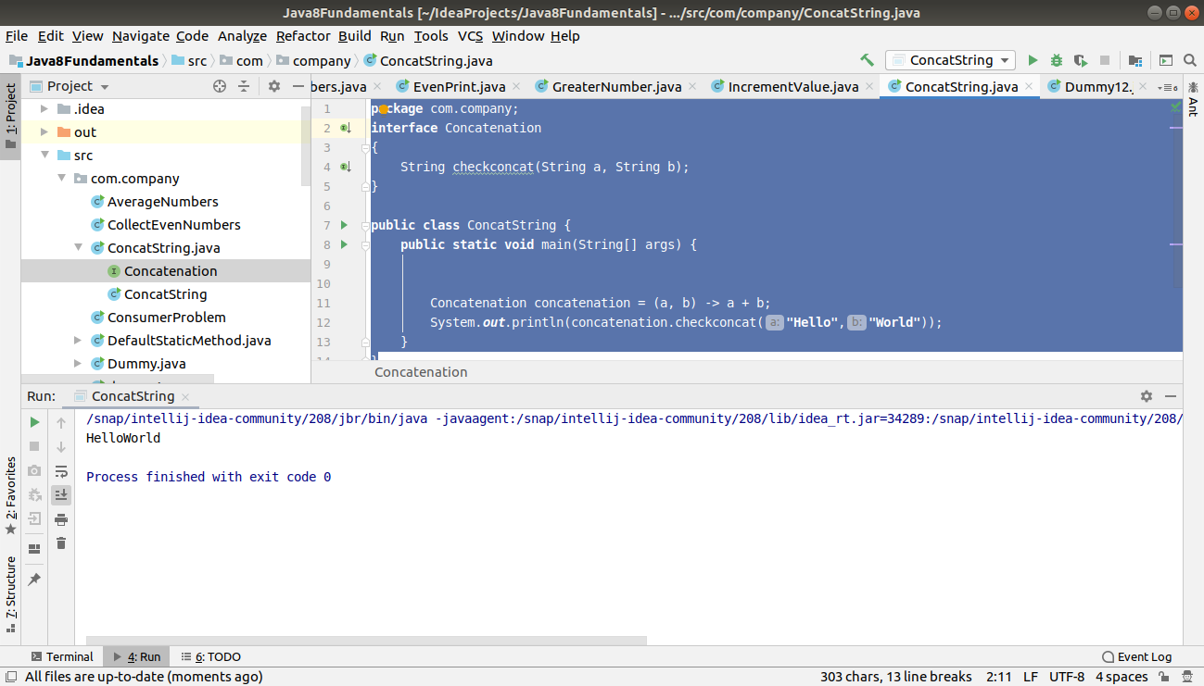

*Convert a string to uppercase and return .Parameter (String) Return (String)

package com.company;
interface LowerCase
{
String convertlower(String a);
}
public class StringLower
{
public static void main(String[] args)
{
LowerCase lowerCase=a -> a.toLowerCase();
System.out.println(lowerCase.convertlower("HELLO"));
}
}
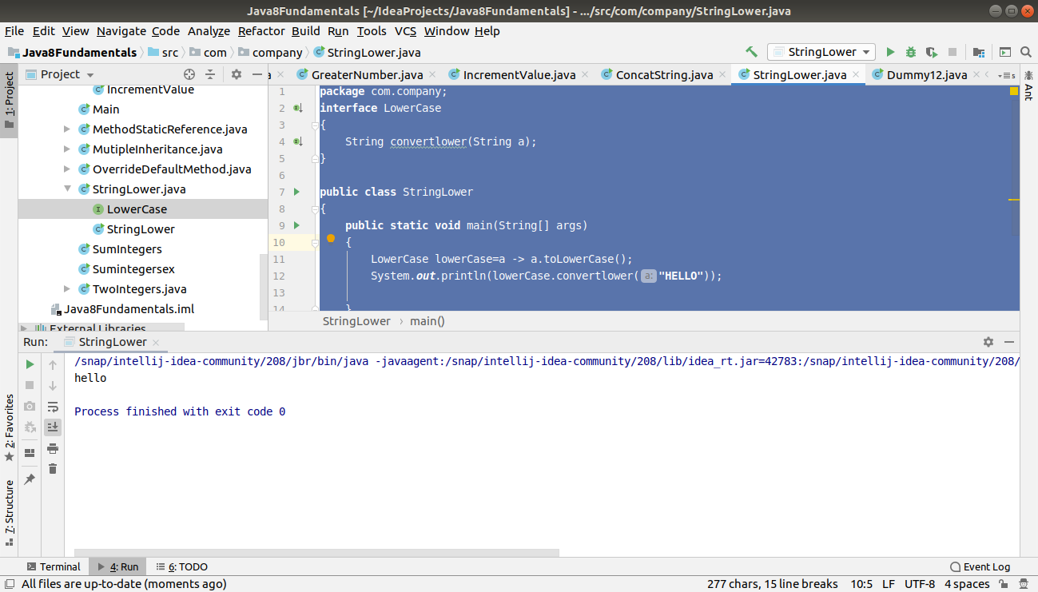

2. Create a functional interface whose method takes 2 integers and return one integer.

package com.company;
interface OneInteger
{
int add(int a,int b);
}
public class TwoIntegers
{
public static void main(String[] args) {
OneInteger one=(a,b)->a+b;
System.out.println("The sum of numbers is: " +one.add(2,4));
}
}
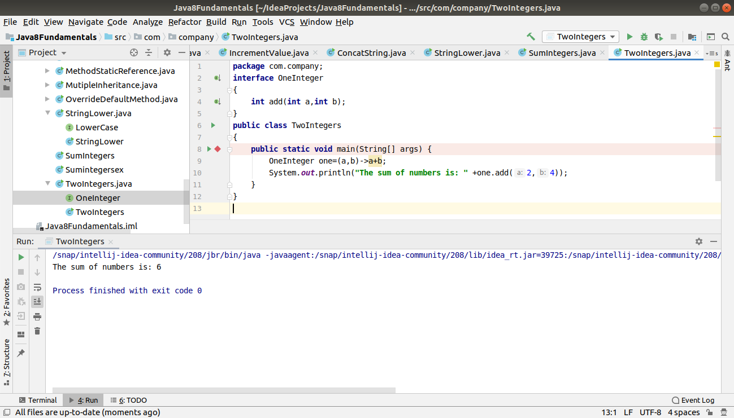

3. Using (instance) Method reference create and apply add and subtract method and using (Static) Method reference create and apply multiplication method for the functional interface created.

package com.company;
interface MethodStatic
{
void display(int a,int b);
}
public class MethodStaticReference
{
public void add(int a,int b)

{
System.out.println("The sum if two integers are: " +(a+b));
}
public void subtract(int a, int b)
{
System.out.println("The subtraction of two integers are: " +(a-b));
}
public static void multiplication(int a,int b)
{
System.out.println("The multiplication of two numbers is: " +(a*b));
}
public static void main(String[] args)
{
MethodStatic methodinstance=new MethodStaticReference()::add;
methodinstance.display(3,4);
MethodStatic methodinstance1=new MethodStaticReference()::subtract;
methodinstance1.display(5,4);
MethodStatic methodStatic=MethodStaticReference::multiplication;
methodStatic.display(4,5);
}
}
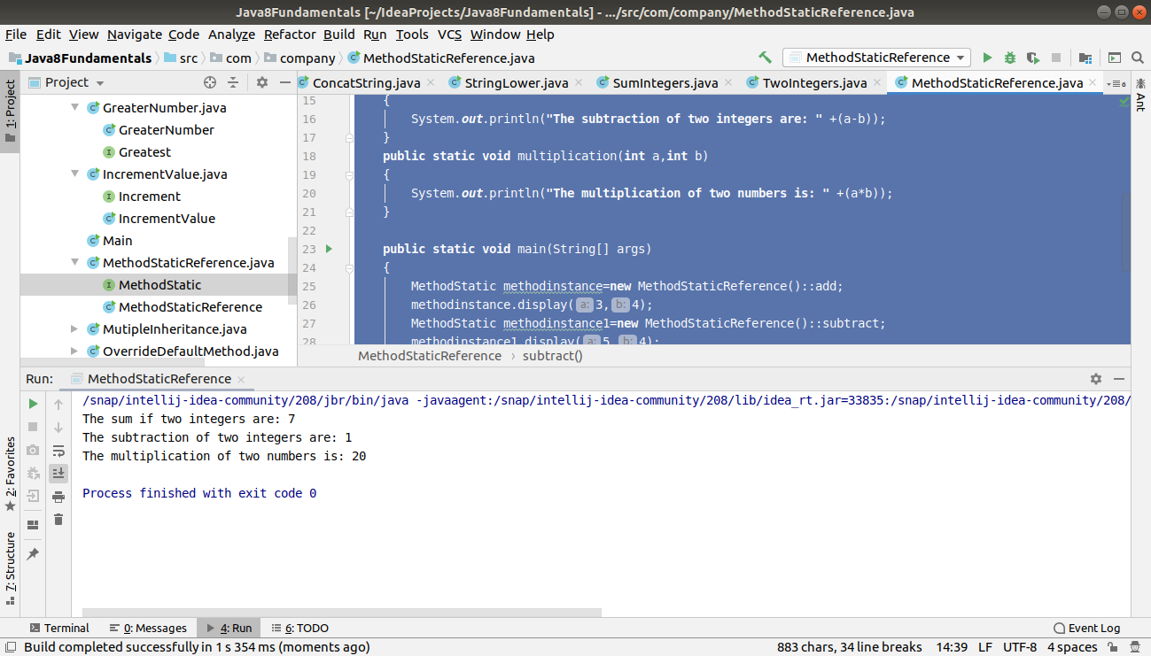

4.Create an Employee Class with instance variables (String) name, (Integer)age, (String)city and get the instance of the Class using constructor reference

package com.company;
interface EmployeeClass
{
EmployeeVariable display(String name, int age,String city);
}
public class EmployeeVariable
{
String name;
int age;
String city;
public String getName() {
return name;
}
public int getAge() {
return age;
}
public void setAge(int age) {
this.age = age;
}
public void setName(String name) {
this.name = name;
}
public String getCity()
{
return city;
}
public void setCity(String city)
{
this.city=city;
}
public String toString()
{
return "Name: "+ this.name +" | Age: "+ this.age +" | City: "+this.city;
}
EmployeeVariable(String name,int age,String city)
{
this.name=name;
this.age=age;
this.city=city;
}
public static void main(String[] args)
{
EmployeeVariable emp1,emp2;
EmployeeClass obj1=EmployeeVariable::new;
emp1=obj1.display("Neha",23,"Delhi");
emp2=obj1.display("Ashu",22,"Hyderabad");
System.out.println(emp1);
System.out.println(emp2);
}
}

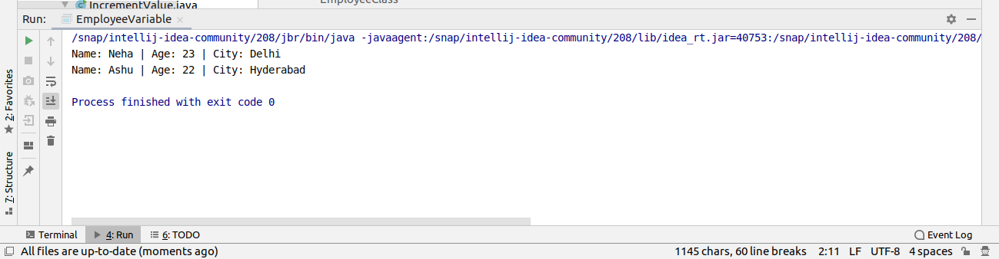

5. Implement following functional interfaces from java.util.function using lambdas:

(1) Consumer

(2) Supplier

(3) Predicate

(4) Function

package com.company;
import java.util.Arrays;
import java.util.List;
import java.util.function.Consumer;
import java.util.function.Function;
import java.util.function.Predicate;
import java.util.function.Supplier;
public class ConsumerProblem
{
public static void main(String[] args) {
List<Integer> list = Arrays.asList(1, 2, 3, 4, 5);
//It accepts the value but will not return anything//
System.out.println("Using Consumer Interface..");
Consumer consumer = (e) ->
{
System.out.println(e);
};
consumer.accept(list);
Supplier<String> supplier = () -> {
return "Hello,this is supplier";
};
Predicate<Integer> predicate=(e)->
{
return e%2==0;
};
Function<Integer,Integer> function=(e)->
{
return e*5;
};
System.out.println("Using Supplier Interface: ");
System.out.println(supplier.get());
System.out.println("Using Predicate Interface: ");
System.out.println(predicate.test(3));
System.out.println("Using Function Interface: ");
System.out.println(function.apply(7));
}
}

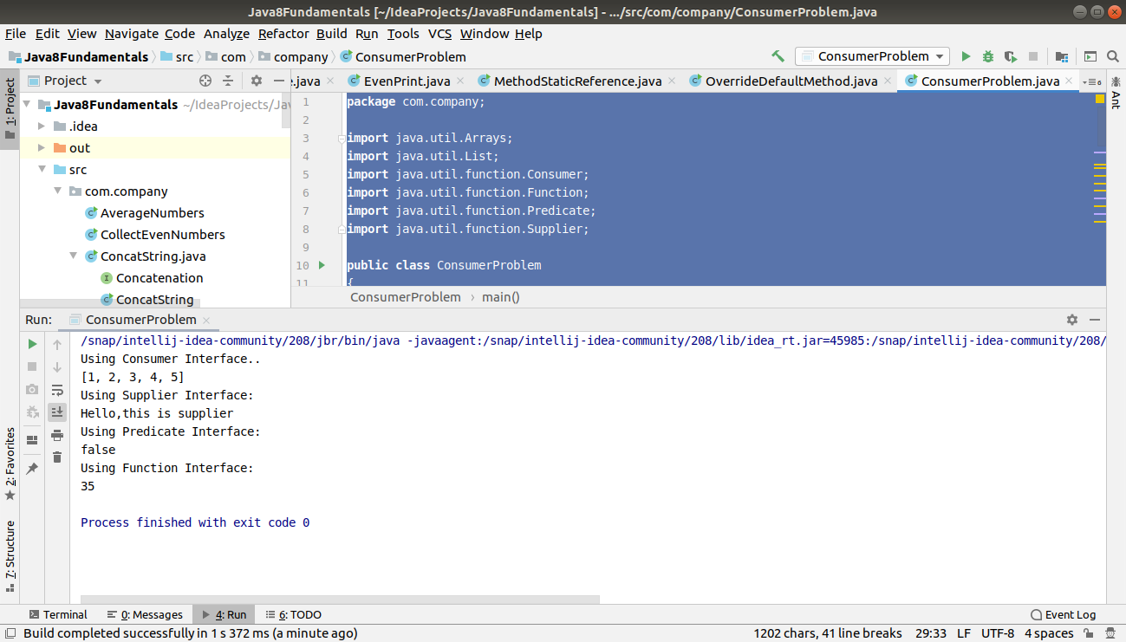

6. Create and access default and static method of an interface.

package com.company;
interface DefaultStatic
{
static void display()
{
System.out.println("This is a static block in an interface");
}
default void print()
{
System.out.println("This is a default method in an interface");
}
}
public class DefaultStaticMethod implements DefaultStatic{
public static void main(String[] args) {
DefaultStatic.display();
DefaultStatic defaultStatic=new DefaultStaticMethod();
defaultStatic.print();
}
}
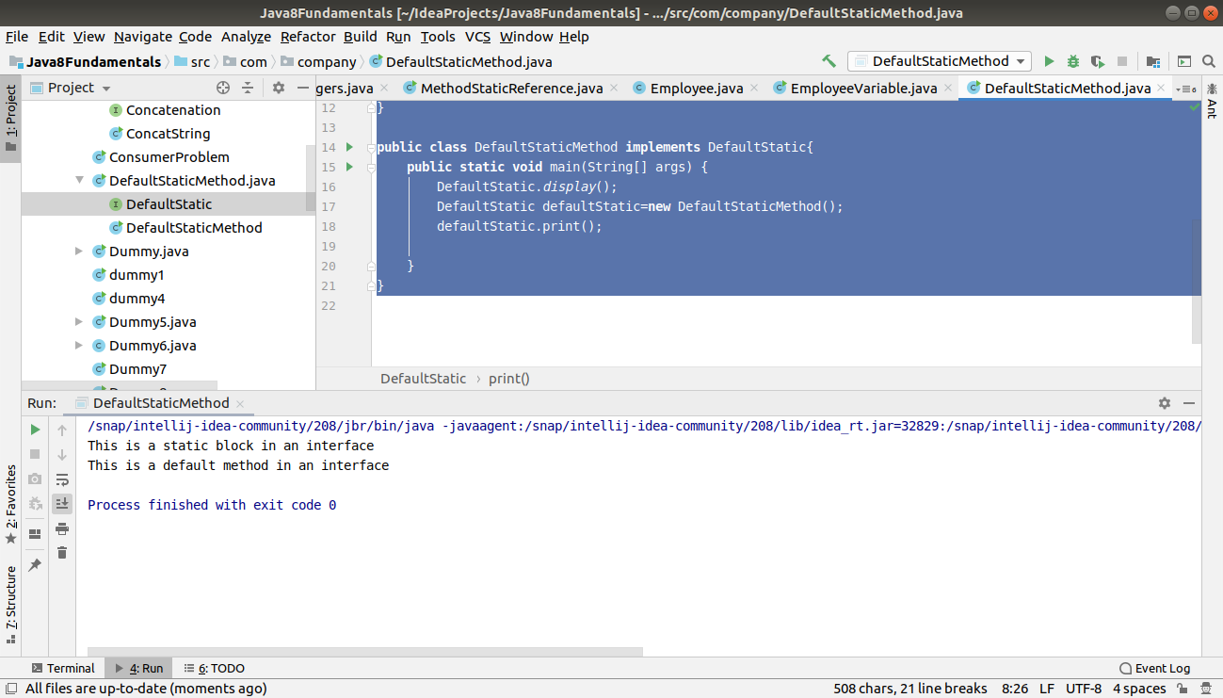

7. Override the default method of the interface.

package com.company;
interface DefaultMethod
{
default void display()
{
System.out.println("In the default method of an interface");
}
}
class Overridemethod implements DefaultMethod
{
@Override
public void display() {
System.out.println("This display method is overriden");
}
}
public class OverrideDefaultMethod {
public static void main(String[] args)
{
Overridemethod overridemethod=new Overridemethod();
overridemethod.display();
}
}
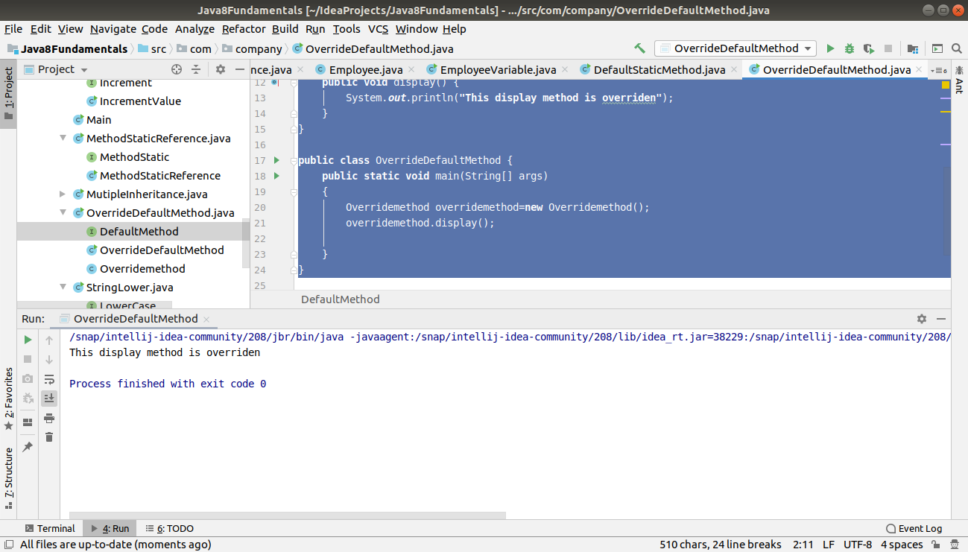

8. Implement multiple inheritance with default method inside interface.

package com.company;
interface Inheritance
{
default void display()
{
System.out.println("In the default method ");
}
}
interface child1 extends Inheritance
{
default void display() {
System.out.println("In the default method of child1");
}
}
interface child2 extends Inheritance
{
default void display() {
System.out.println("In the default method of child2");
}
}
public class MutipleInheritance implements child1,child2
{
@Override
public void display()
{
child1.super.display();
child2.super.display();
System.out.println("In the Main method of display");
}
public static void main(String[] args)
{
MutipleInheritance mutipleInheritance=new MutipleInheritance();
mutipleInheritance.display();
}
}
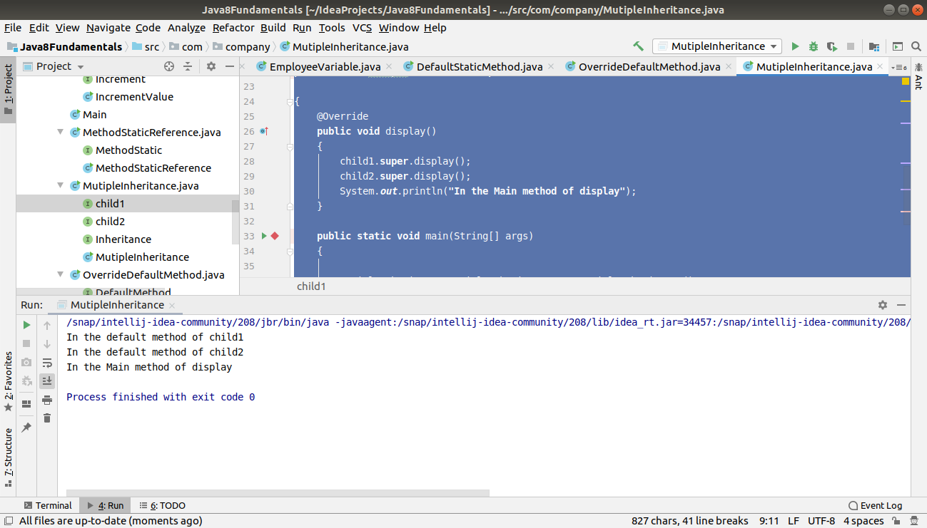

9.Collect all the even numbers from an integer list.

package com.company;
import java.util.Arrays;
import java.util.List;
import java.util.stream.Collectors;
public class CollectEvenNumbers
{
public static void main(String[] args) {
List<Integer> list= Arrays.asList(1,2,3,4,5,6,7,8,9,10);
System.out.println(
list
.stream()
.filter(e->e%2==0 )
.collect(Collectors.toList())
);
}
}
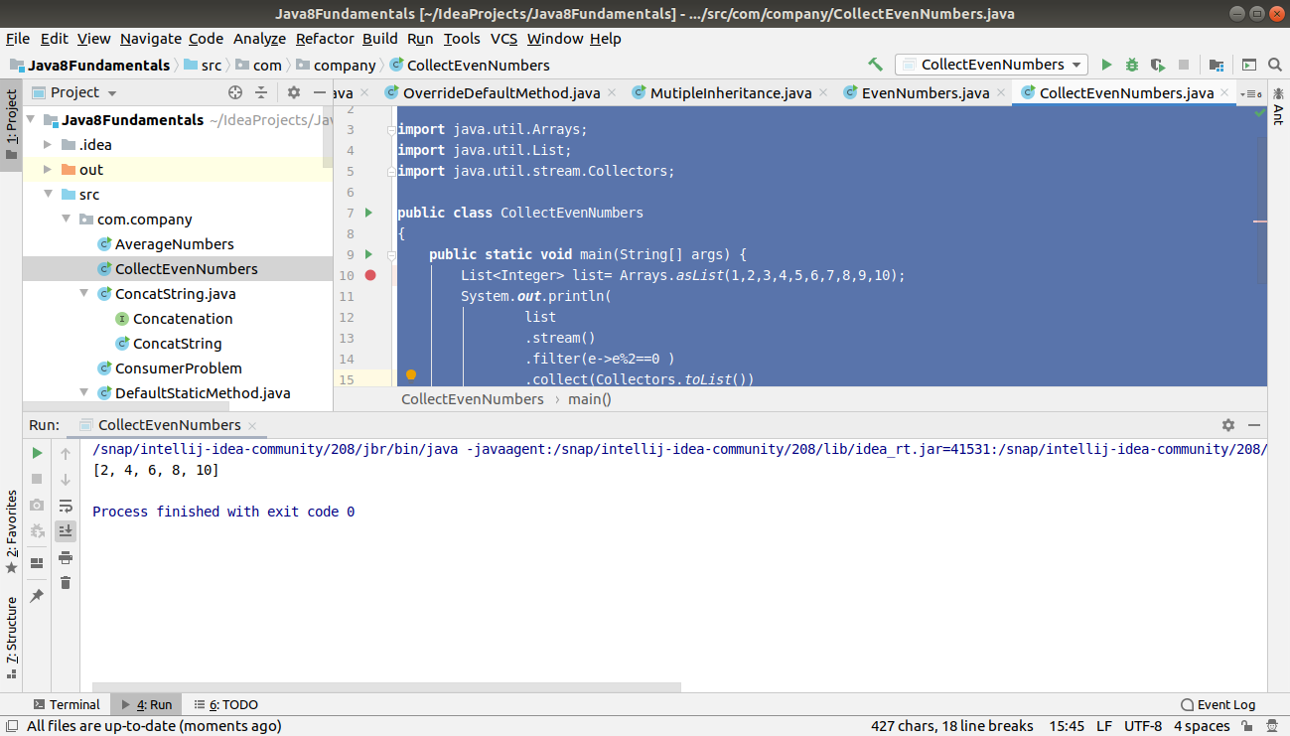

10. Sum all the numbers greater than 5 in the integer list.

package com.company;
import java.util.Arrays;
import java.util.List;
import java.util.stream.Collectors;
public class Sumintegersex
{
public static void main(String[] args) {
List<Integer> list= Arrays.asList(2,3,4,5,7,8,9,12,22);
System.out.println(
list
.stream()
.filter(e->e>5)
// .mapToInt(e->e)
//.sum()
.collect(Collectors.summingInt(e->e))
);
}
}
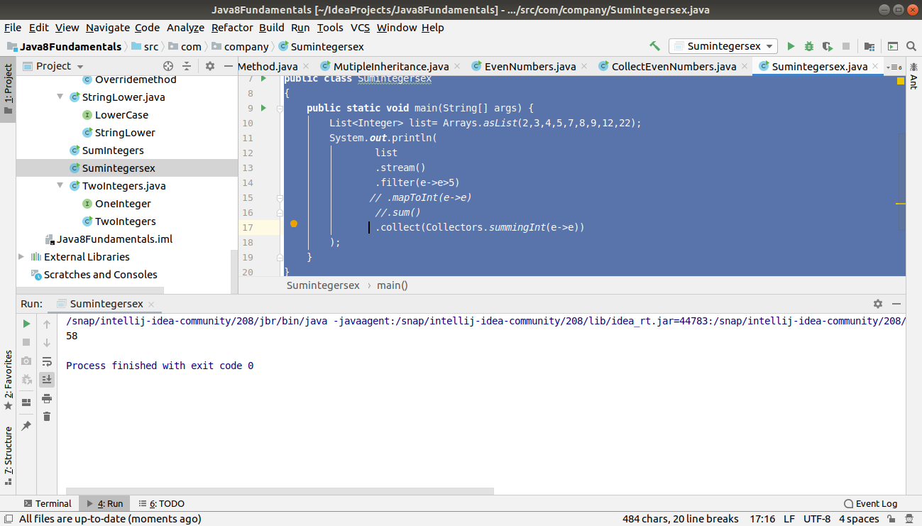

11. Find average of the number inside integer list after doubling it.

package com.company;
import java.util.Arrays;
import java.util.List;
public class AverageNumbers
{
public static void main(String[] args) {
List<Integer> list= Arrays.asList(2,3,4,6,8,9,10);
System.out.println(
list
.stream()
.map(e->e*2)
.mapToInt(e->e)
.average()
);
}
}
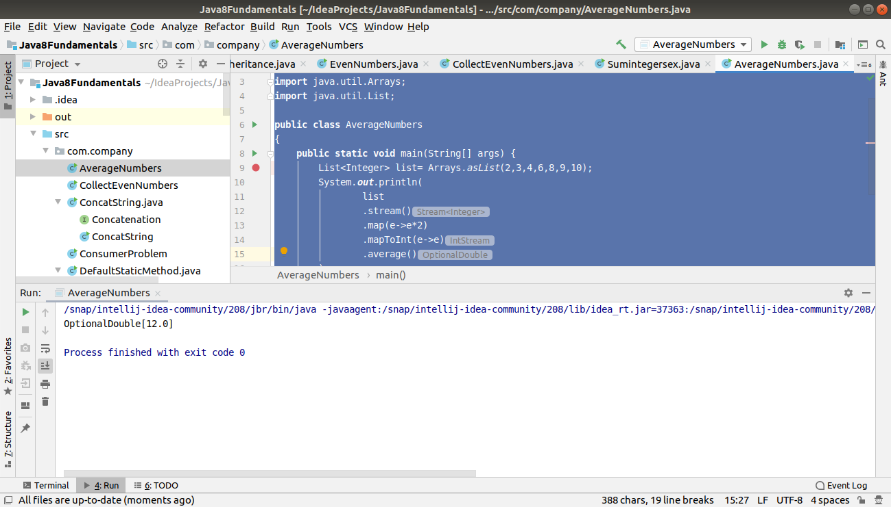

12. Find the first even number in the integer list which is greater than 3.

package com.company;
import java.util.Arrays;
import java.util.List;
public class EvenPrint
{
public static void main(String[] args) {
List<Integer> list= Arrays.asList(2,4,5,7,8,9,10,13);
System.out.println(
list
.stream()
.filter(e->e%2==0 && e>3)
.findFirst()
);
//.filter(e->e>3)
// .mapToInt(e->e)
//.forEach(System.out::println);
}
}

