GRADLE EXERCISE

1) Add a gradle dependency and its related repository url.

Steps:

Create a new Java gradle project and add mavenCentral as repository in build.gradle

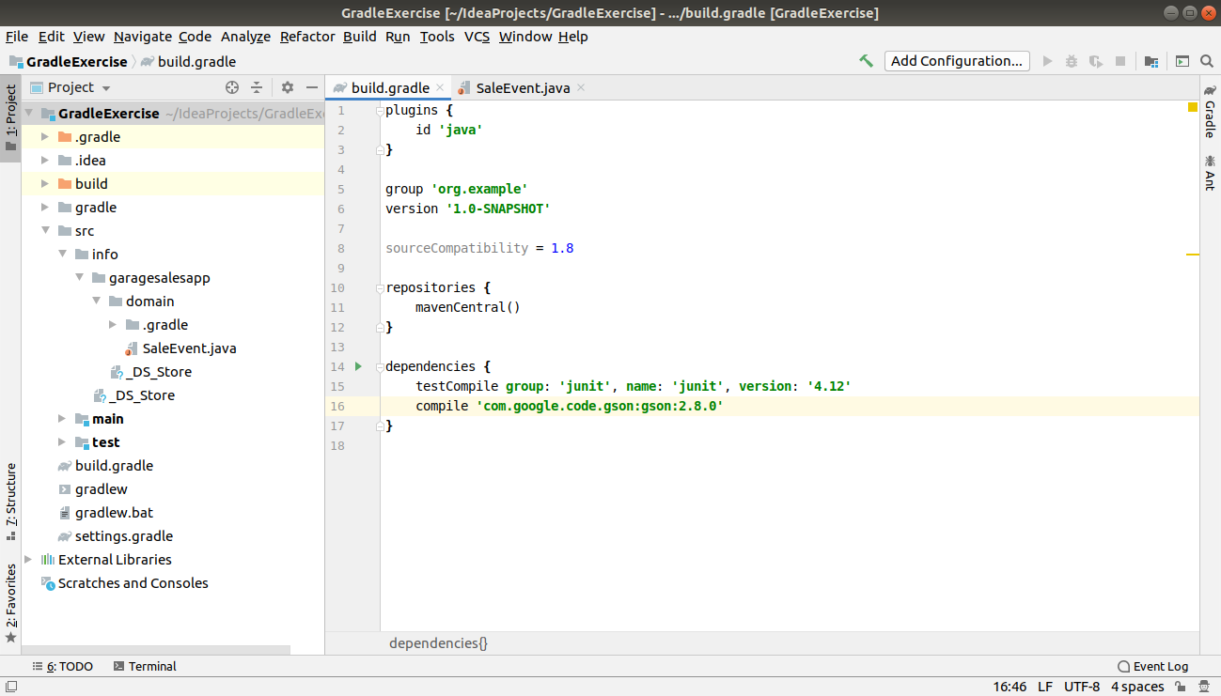

2) Using java plugin, make changes in the manifest to make the jar executable. Using java -jar JAR_NAME, the output should be printed as "Hello World"

Steps:

First Create a file Hello that prints “Hello world” in src/main/java
In the Manifest file add:

Main-Class: Hello
Then, add jar code in build.gradle

plugins {
id 'java'
}
group 'org.example'
version '1.0-SNAPSHOT'
sourceCompatibility = 1.8

repositories {
mavenCentral()
}
jar{
manifest
{
attributes 'Main-Class':'Hello'
}
}
dependencies {
testCompile group: 'junit', name: 'junit', version: '4.12'
compile 'com.google.code.gson:gson:2.8.0'
}

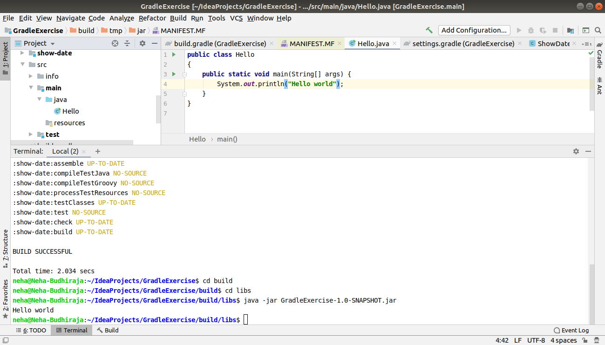

3) Differentiate between the different dependency scopes: compile, runtime, testCompile, testRuntime using different dependencies being defined in your build.gradle.

Compile : This is the default scope, used if none is specified. Compile dependencies are available in all classpaths of a project. It can be used when we have no special requirements for declaring a certain dependency.

Runtime : This scope indicates that the dependency is not required for compilation, but is for execution. It is in the runtime and test classpaths, but not the compile classpath. It can be used for dependencies that are not needed at compile time, like when we’re compiling against an API and only need the implementation of that API at runtime.

testCompile: testCompile is a group of dependencies that might be needed only for testing while compile is the group of dependencies that might be needed to build the application . The testCompile configuration contains the dependencies which are required to compile the tests of the project. This configuration contains the compiled classes of the project and the dependencies added to the compile configuration.
runCompile: The testRuntime contains the dependencies which are required when our tests are run. This configurations contains the dependencies added to compile, runtime, and testCompile configurations.
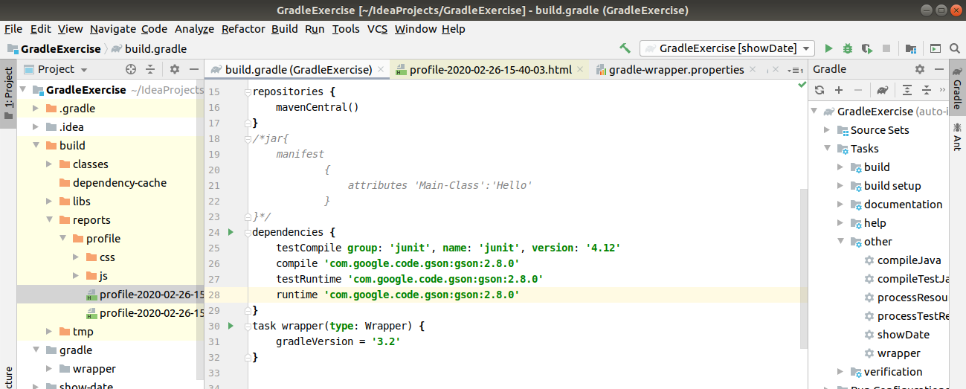
4) Create a custom plugin which contains a custom task which prints the current date-time. Using that plugin in your project, execute that task after the jar task executes.

Steps:

Create a package as showDate and paste it in the main project.
Add buildscript and pluggin in build.gradle file
Include show-date in settings.gradle

gradle.build

buildscript {
dependencies {
classpath files('show-date/build/libs/show-date-1.0-SNAPSHOT.jar')
}
}
plugins {
id 'java'
}
group 'org.example'
version '1.0-SNAPSHOT'
sourceCompatibility = 1.8
repositories {
mavenCentral()
}
dependencies {
testCompile group: 'junit', name: 'junit', version: '4.12'
compile 'com.google.code.gson:gson:2.8.0'
}
task wrapper(type: Wrapper) {
gradleVersion = '3.2'
}
apply plugin:'show-date-plugin'
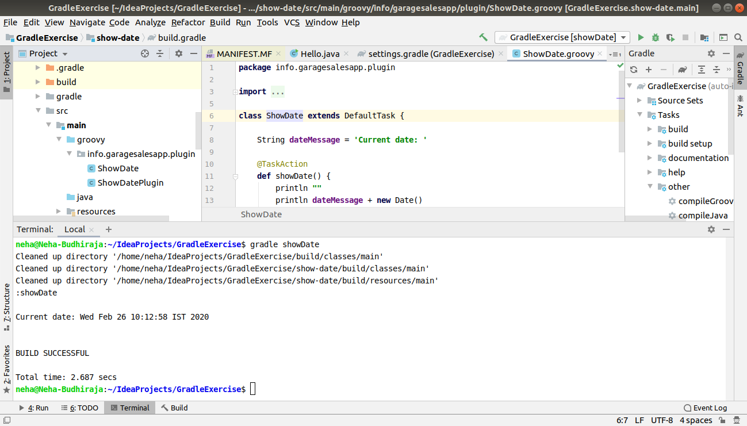

5) Instead of using default source set, use src/main/javaCode1, src/main/javaCode2 to be taken as code source. Make sure that the JAR created contains files from both the directories and not from src/main/java.

Steps:

Change the sourceSets in build.gradle file, as by default it takes src/main and then change the directory and run the command.
If the blue colour of the directory (JavaCode1 and JavaCoode2) appears then it is succesfull.

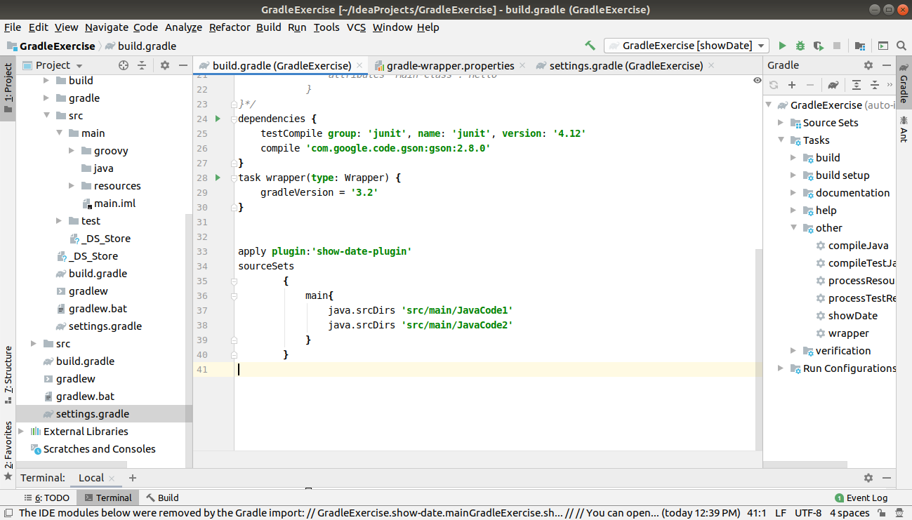
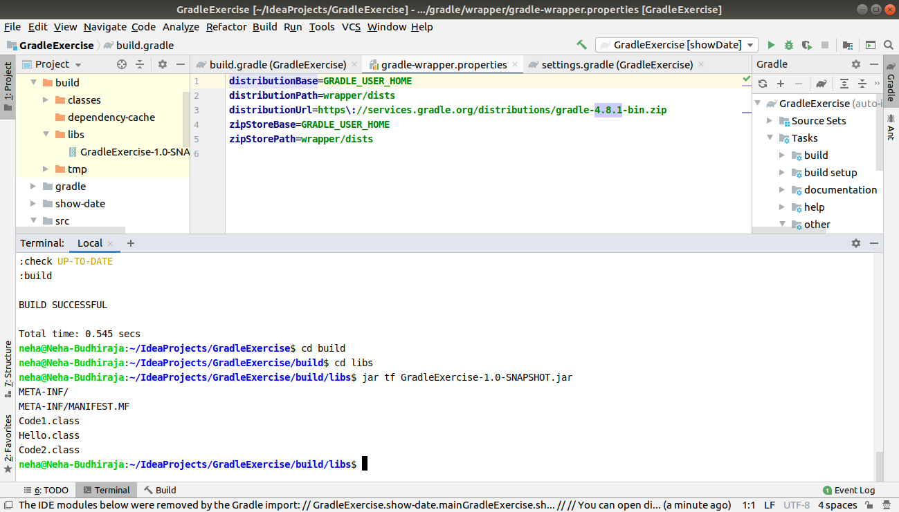

6) Override the Gradle Wrapper task to install a different version of gradle. Make sure that the task written in Q4 also executes with it.

Steps:

Override the wrapper task in build.gradle file
Change the gradle version of the current window by the command as-: gradle wrapper --gradle-version 3.2 and run the program
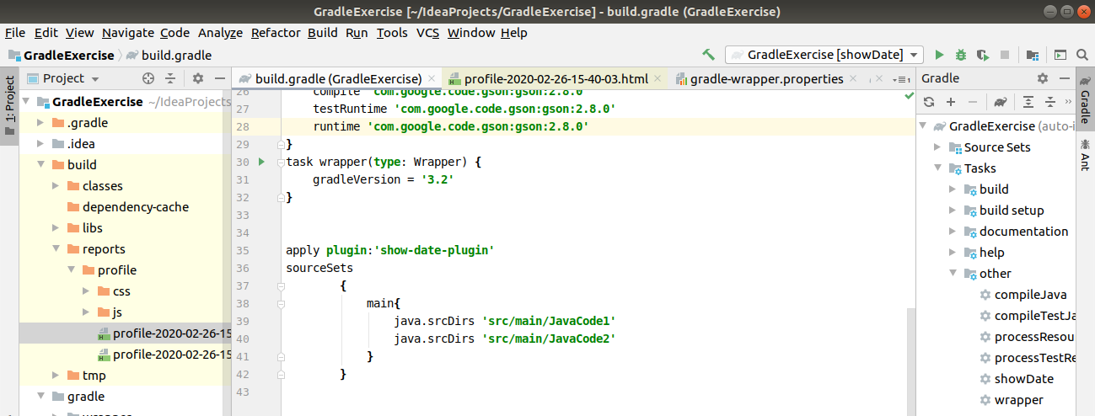

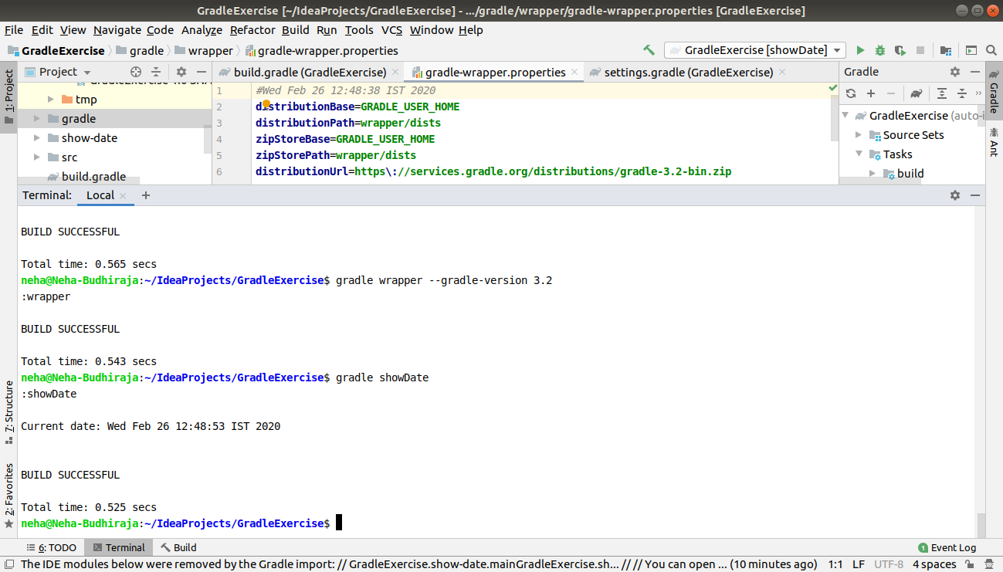

7) Run the gradle profile command and attach the resulting files.

Steps:

Type the command as gradle build –profile to generate the profile file(html format) in build/reports/profile/profile.html
And then open the html file in browser.
Profile will provide certain configurations for the runtime environment needed.

