SQL ASSIGNMENT

- Create Database

Query: create database sqlassign;
use sqlassign;

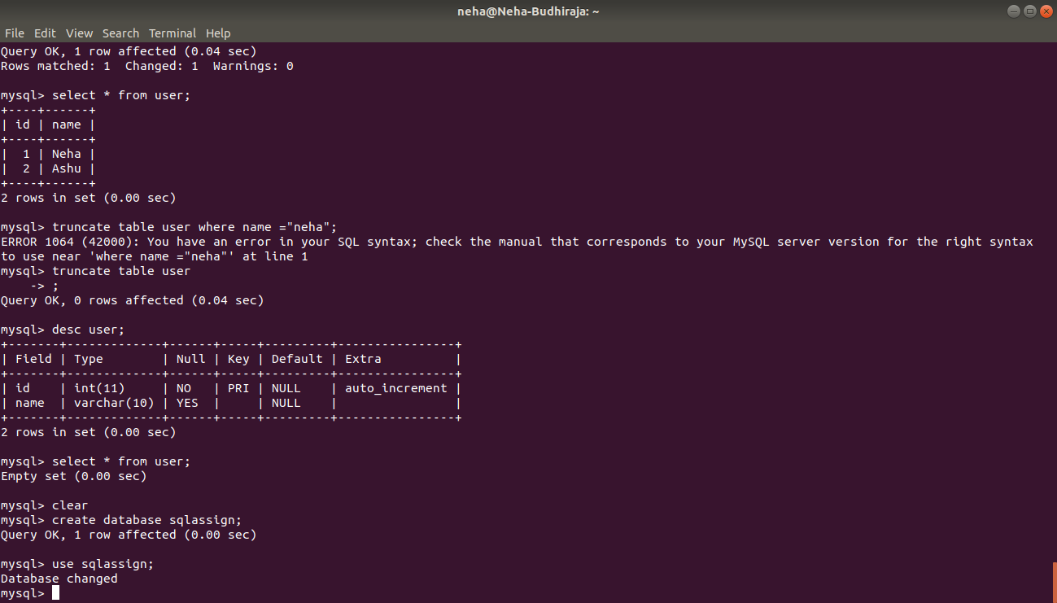

- Design Schema

Query: desc customer;
desc salesperson;
desc orders;

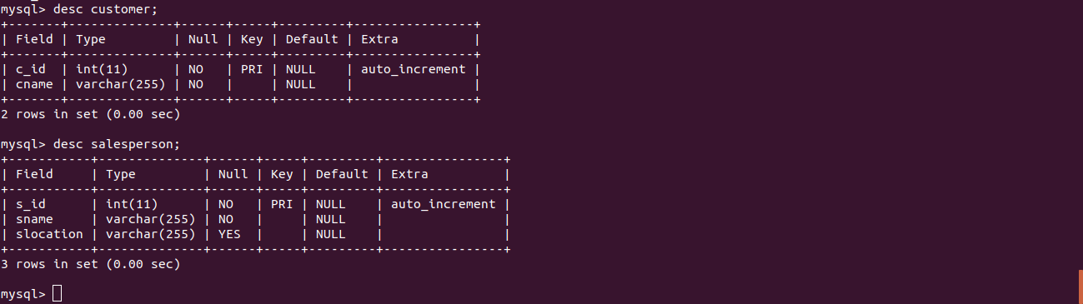
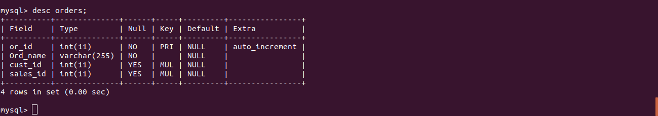

- Create tables

Query: create table customer
-> (
-> c_id int NOT NULL AUTO_INCREMENT,
-> cname varchar(255) NOT NULL,
-> primary key(c_id)
-> );

create table salesperson
-> (
-> s_id int NOT NULL AUTO_INCREMENT,
-> sname varchar(255) NOT NULL,
-> slocation varchar(255),
-> primary key(s_id)
-> );

create table orders
-> (
-> or_id int NOT NULL AUTO_INCREMENT,
-> Ord_name varchar(255) NOT NULL,
-> cust_id int,
-> sales_id int,
-> primary key(or_id),
-> FOREIGN KEY (cust_id) REFERENCES customer(c_id),
-> FOREIGN KEY (sales_id) REFERENCES salesperson(s_id)
-> );

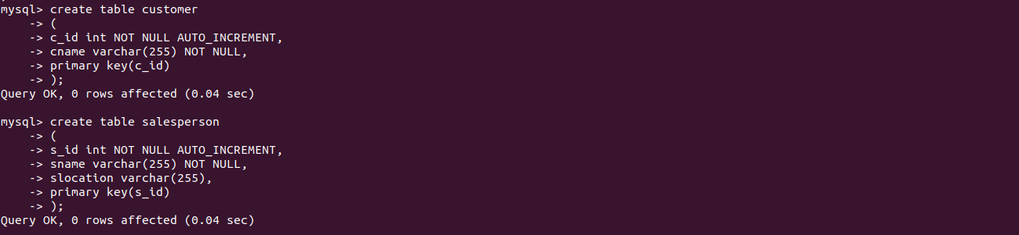
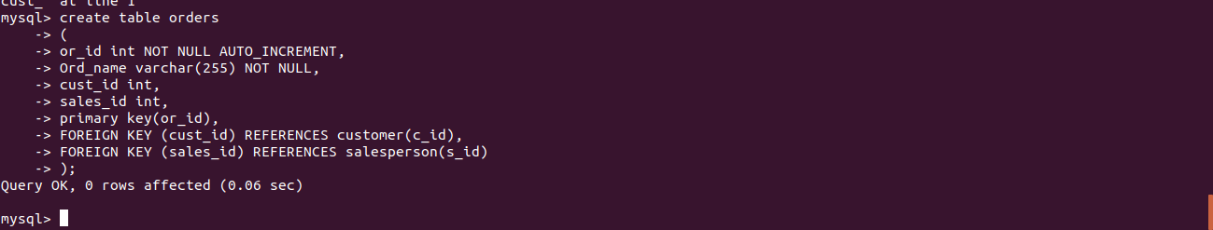

- Insert sample data

Query: insert into customer(c_id, cname) values (1,"Neha");
insert into salesperson(s_id, sname,slocation) values (2,"Anshul","Mumbai");
insert into orders(or_id,Ord_name,cust_id,sales_id) values(3,"MAC",3,3);

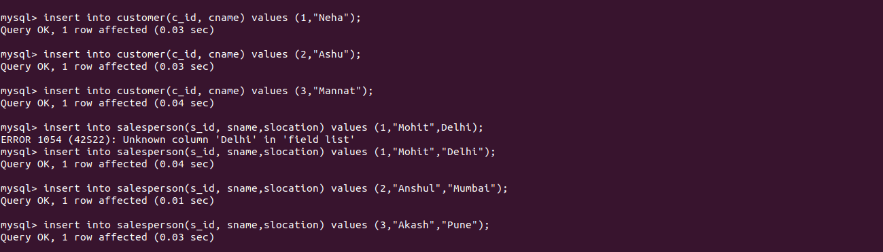
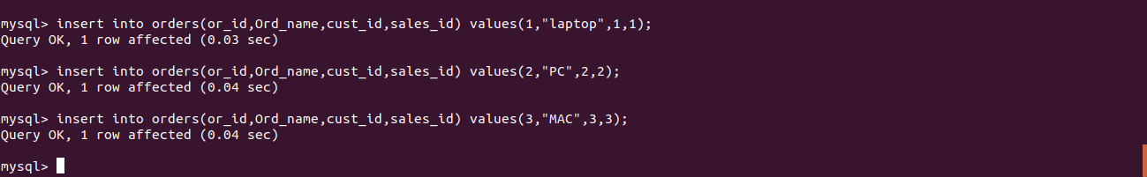
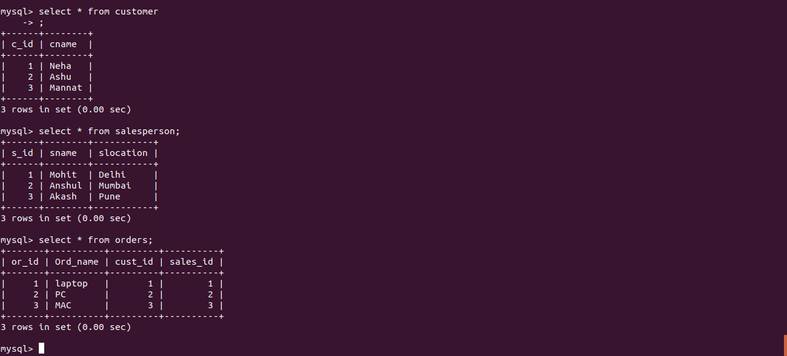

- Find the sales person have multiple orders

Query: select s.sname from salesperson s where (select count(*) from orders o where s.s_id=o.sales_id)>1;
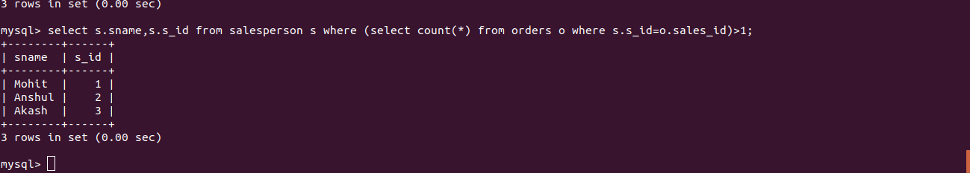

- Find the all sales person details along with order details

Query: select s.sname,s.s_id ,o.or_id,o.ord_name from salesperson s, orders o where s.s_id= o.sales_id;

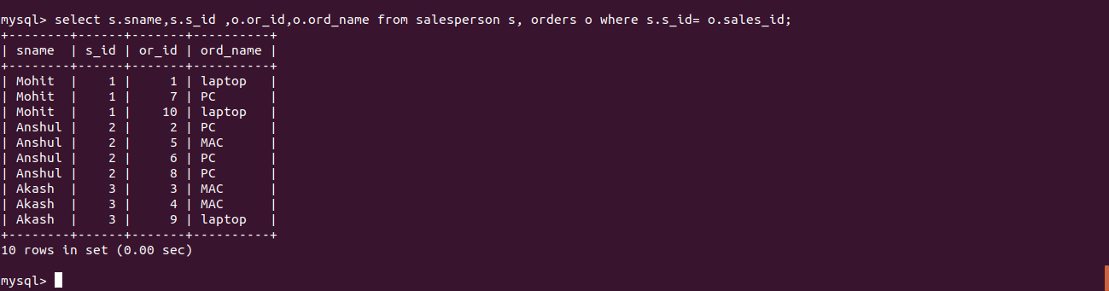

- Create index

Query: create index index2 on orders(or_id,sales_id);

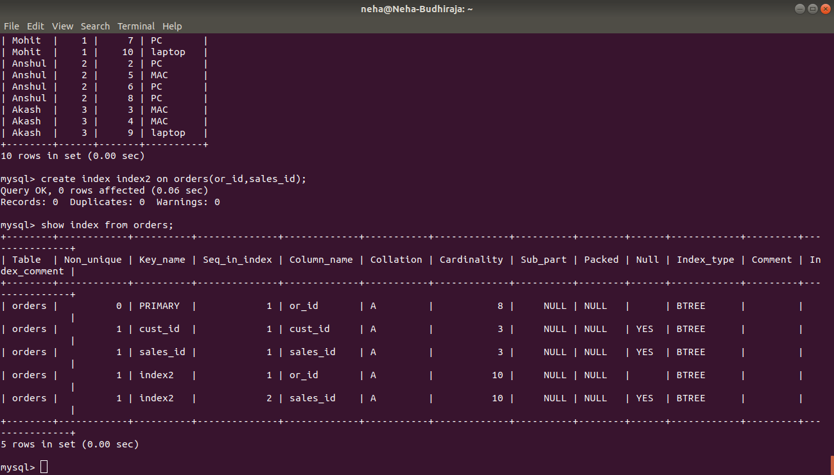

- How to show index on a table

Query: show index from orders;

- Find the order number, sale person name, along with the customer to whom that order belongs to

Query: select s.sname, o.or_id,c.cname from salesperson s,customer c, orders o where o.sales_id=s.s_id and o.cust_id=c.c_id;

