Java assignment1

Q1. Write a program to replace a substring inside a string with other string ?

package com.company;

public class Main {

public static void main(String[] args) {
String sentence="hello world";
System.out.println(sentence);
System.out.println(sentence.replaceAll("hello","world"));

}
}
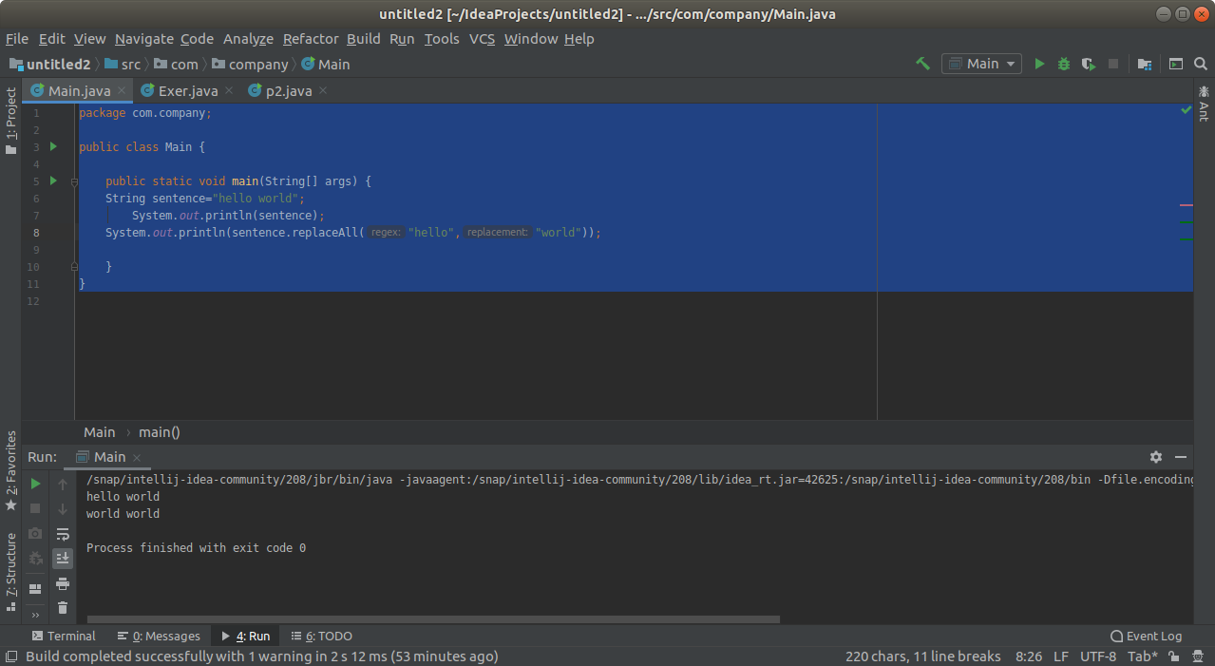
Q2. Write a program to find the number of occurrences of the duplicate words in a string and print them ?

package com.company;

import java.util.Scanner;

public class Main {

public static void main(String[] args)
{
Scanner sc= new Scanner(System.in);
System.out.println("Enter the string");
String word=sc.nextLine();
word=word.toLowerCase();
String[] sentence = word.split(" ");
for (int i = 0; i < sentence.length; i++)
{
int count = 1;
for (int j = i + 1; j < sentence.length; j++)
{
if (sentence[i].equals(sentence[j]))
{
count = count + 1;
sentence[j] = "0";

}
}
if ( count>1 && sentence[i] != "0") {
System.out.println(sentence[i] + "--" + count);

}
}
}

}
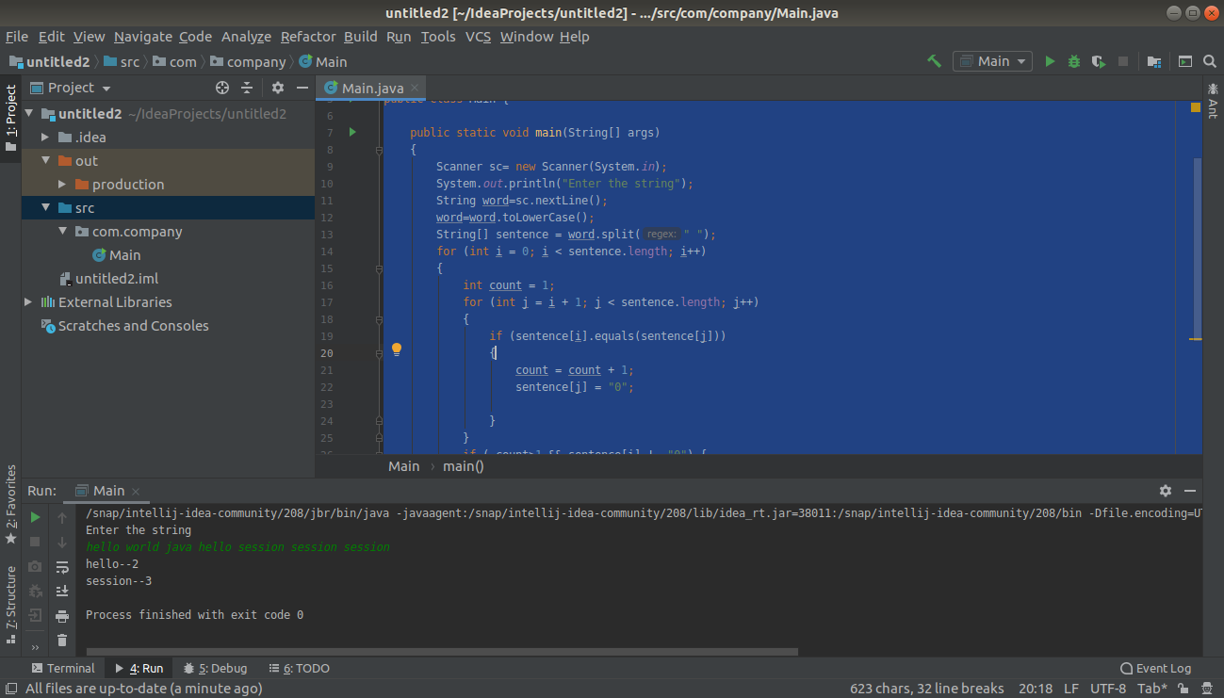

Q3. Write a program to find the number of occurrences of a character in a string without using loop?

package com.company;

import java.util.Scanner;

public class Exercise {
private static long countOccurrences(String str, char ch)
{
return str.length() - str.replace(String.valueOf(ch), "").length();
}

public static void main(String[] args)
{
System.out.println("Enter the string: ");
Scanner sc=new Scanner(System.in);
String str=sc.nextLine().toLowerCase();
System.out.println("Enter the character to find the number of occurence: ");
Scanner sc1=new Scanner(System.in);
char ch=sc1.nextLine().charAt(0);
System.out.println("Character " + ch + " occurs " + countOccurrences(str, ch) + " times.");
}

}

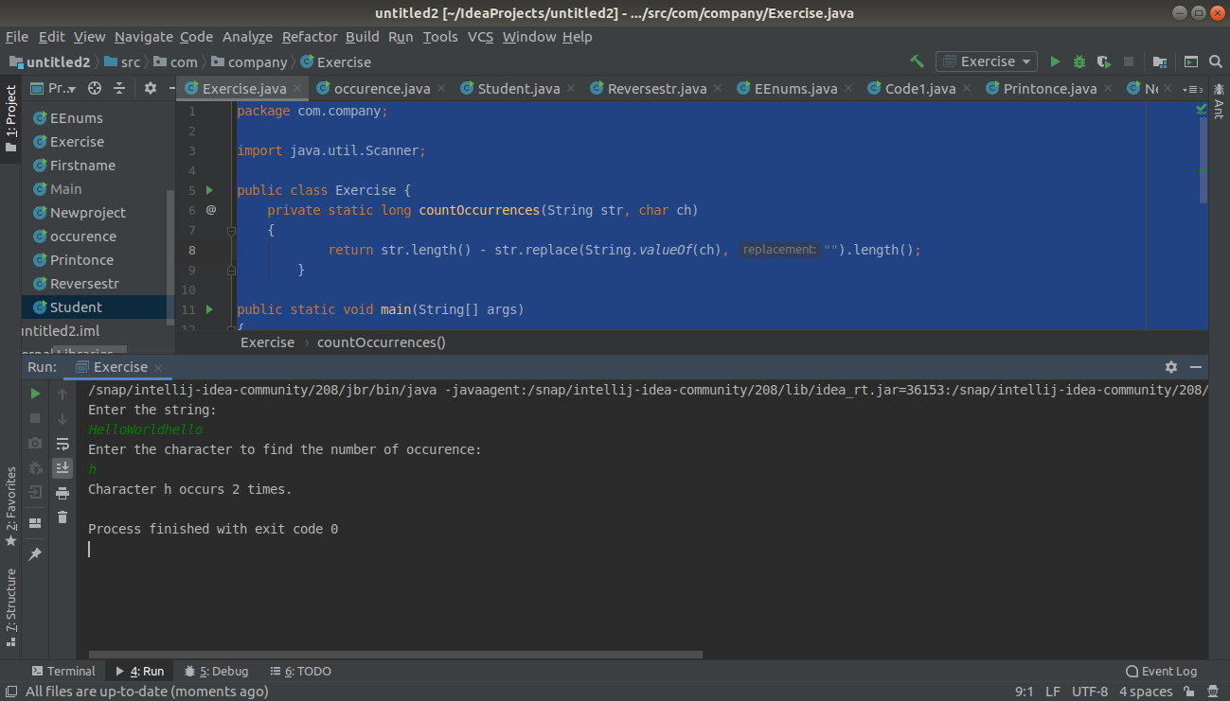

Q4. Calculate the number & Percentage Of Lowercase Letters,Uppercase Letters, Digits And Other Special Characters In A String

package com.company;

import java.text.DecimalFormat;
import java.util.Scanner;

public class occurence {
public static void main(String[] args)
{
Scanner sc=new Scanner(System.in);
sc.useDelimiter("\\s\\s");
System.out.println("Enter the string");
String data=sc.nextLine();
char[] charArray=data.toCharArray();
int upper=0;
int lower=0;
int digit=0;
int others=0;
int totalChars=data.length();
for(int i=0;i<data.length();i++)
{
if(Character.isUpperCase(charArray[i]))
{
upper++;

}
else if (Character.isLowerCase(charArray[i]))
{
lower++;
}
else if(Character.isDigit(charArray[i]))
{
digit++;

}
else
{
others++;
}
}
double upperCaseLetterPercentage = (upper * 100) / totalChars;
double lowerCaseLetterPercentage = (lower * 100) / totalChars;
double digitsPercentage = (digit * 100) / totalChars;
double otherCharPercentage = (others * 100) / totalChars;

DecimalFormat format = new DecimalFormat("##.##");
System.out.println("Uppercase letters are " + format.format(upperCaseLetterPercentage) + "% ");
System.out.println("Lowercase letters are " + format.format(lowerCaseLetterPercentage) + "%");
System.out.println("Digits Are " + format.format(digitsPercentage) + "%");
System.out.println("Other Characters Are " + format.format(otherCharPercentage) + "%");

}

}
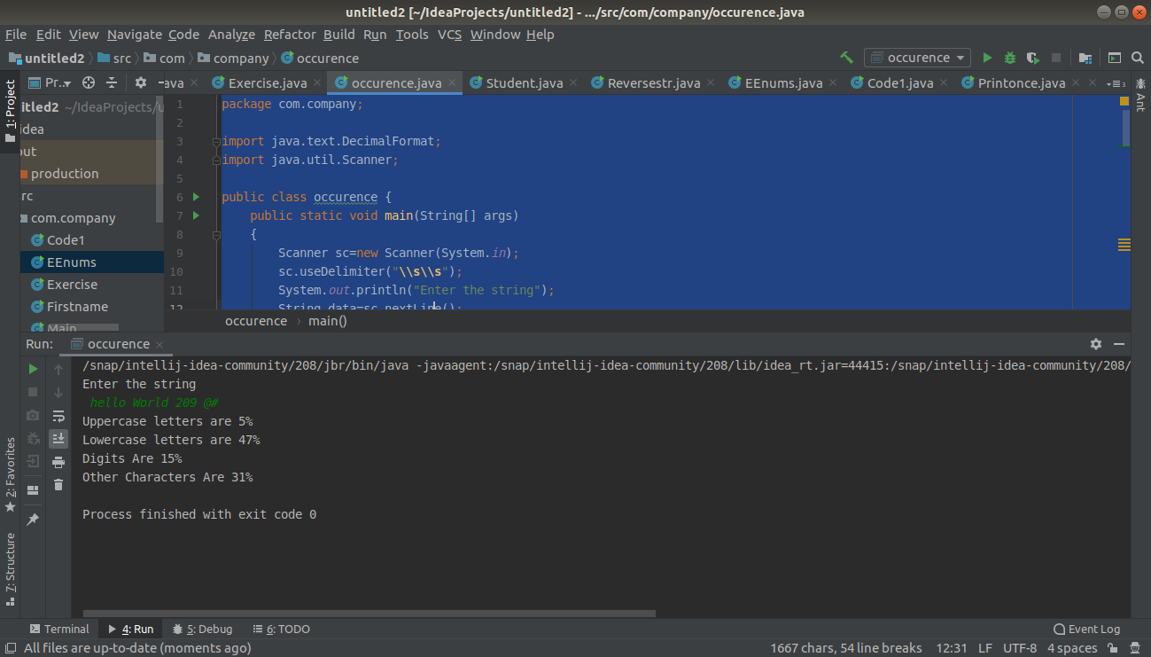

Q5. Find common elements between two arrays.

package com.company;

public class Code1 {
public static void main(String[] args)
{
int[] numArray1 = {1, 4, 5};
int[] numArray2 = {6, 1, 8, 34, 5};

for (int i = 0; i < numArray1.length; i++)
{
for (int j = 0; j < numArray2.length; j++)
{
if (numArray1[i] == numArray2[j]) {
System.out.println("The common elements are: " +numArray1[i]);
break;

}
}
}
}
}

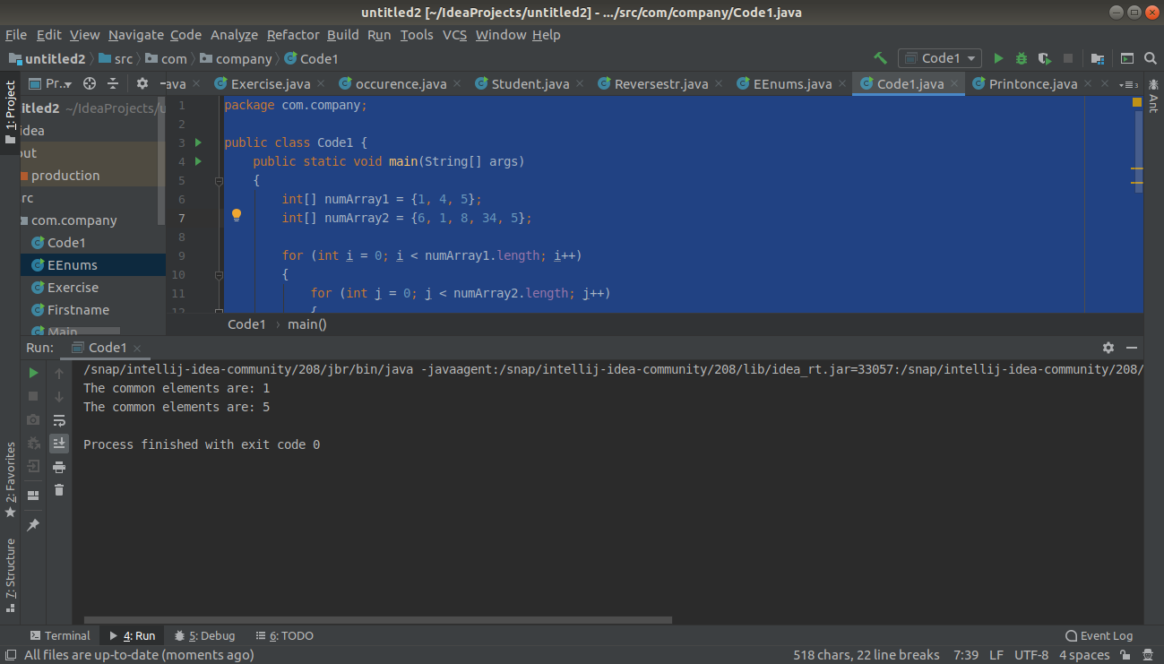

Q6. There is an array with every element repeated twice except one. Find that element

package com.company;

public class Newproject {
public static void findUsingXOR(int [] a){
if(a.length==0)
return;
int xor = a[0];
for (int i = 1; i <a.length ; i++) {
xor ^= a[i];
}
System.out.println("Element appear only once in array -> " + xor);
}

public static void main(String[] args) {
int [] a = { 1,2,3,4,4,3,2};
findUsingXOR(a);
}
}
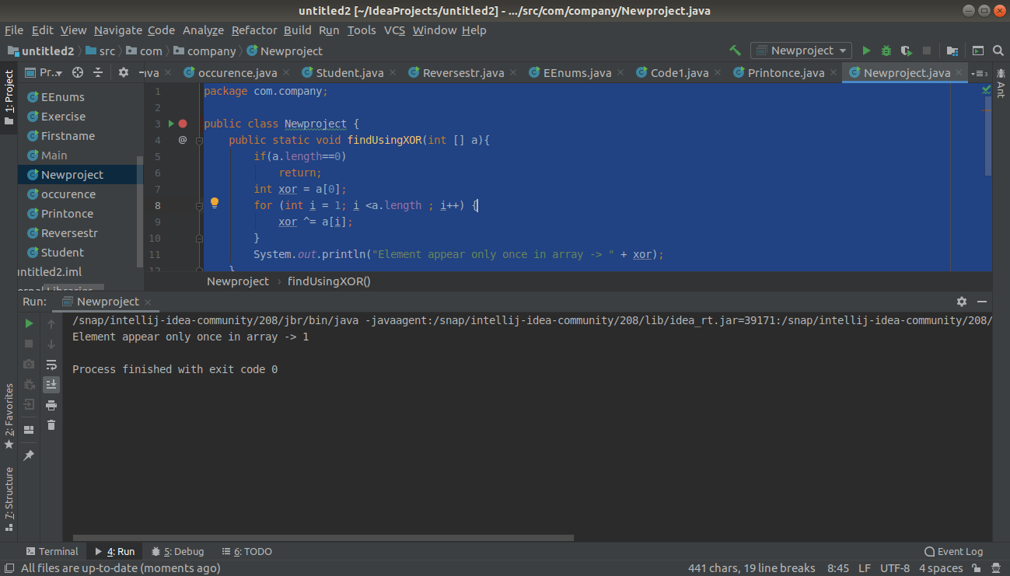

Q7. Write a program to print your Firstname,LastName & age using static block,static method & static variable respectively

package com.company;

public class Student {
static String Fname = "Ashu";
static String Lname="Budhiraja";
static int Age = 23;

static void change() {
Fname = "Neha";
}
static
{
Fname = "Savita";
Lname = "Budhiraja";
Age= 23;

}

void display() {
System.out.println(Fname + " " + Lname + " " +Age + " ");
}

public static void main(String[] args)
{
System.out.println(Student.Fname);
System.out.println(Student.Lname);
System.out.println(Student.Age);

Student.change();
Student s1=new Student();
s1.display();
}
}
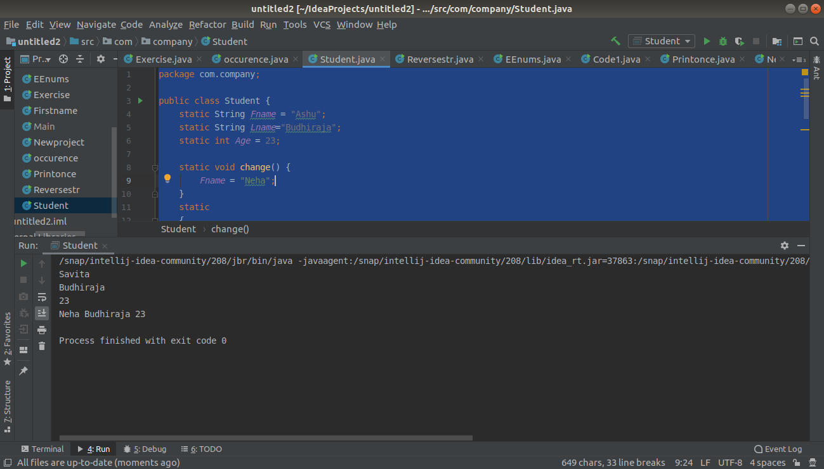

Q8. Write a program to reverse a string and remove character from index 4 to index 9 from the reversed string using String Buffer

import java.util.Scanner;

public class Reversestr {
public static void main(String args[]) {
StringBuffer sbuffer = new StringBuffer();
Scanner input = new Scanner(System.in);
System.out.println("Enter a string");
sbuffer.append(input.nextLine());
System.out.println("Reverse string is: ");
System.out.println(sbuffer.reverse());
sbuffer.delete(4, 9);
System.out.println("After deletion = " + sbuffer);
}
}
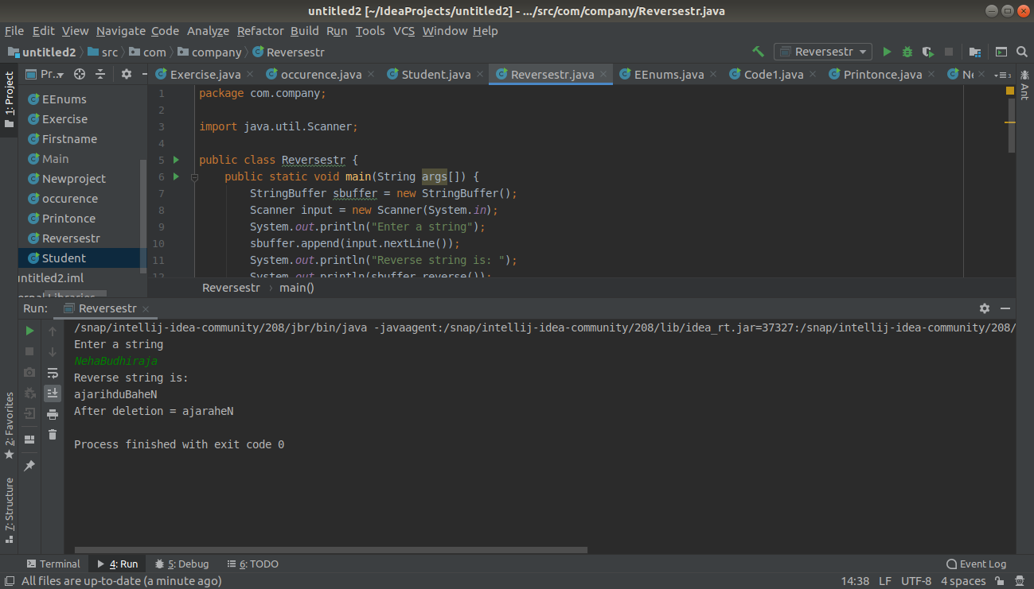
Q9.Write a program to display values of enums using a constructor & getPrice() method (Example display house & their prices)

package com.company;

public class EEnums
{
enum House
{
Flat(900),
Bunglow(2),
Multistorey(50),
kutcha(15),
pakka(12);
private int price;
House(int p)
{
price = p;
}
int getPrice()
{
return price;
}
}
public static void main(String args[])
{
System.out.println("All House prices:");
for (House h : House.values())
System.out.println(h + " costs " + h.getPrice() + " lakhs.");
}
}
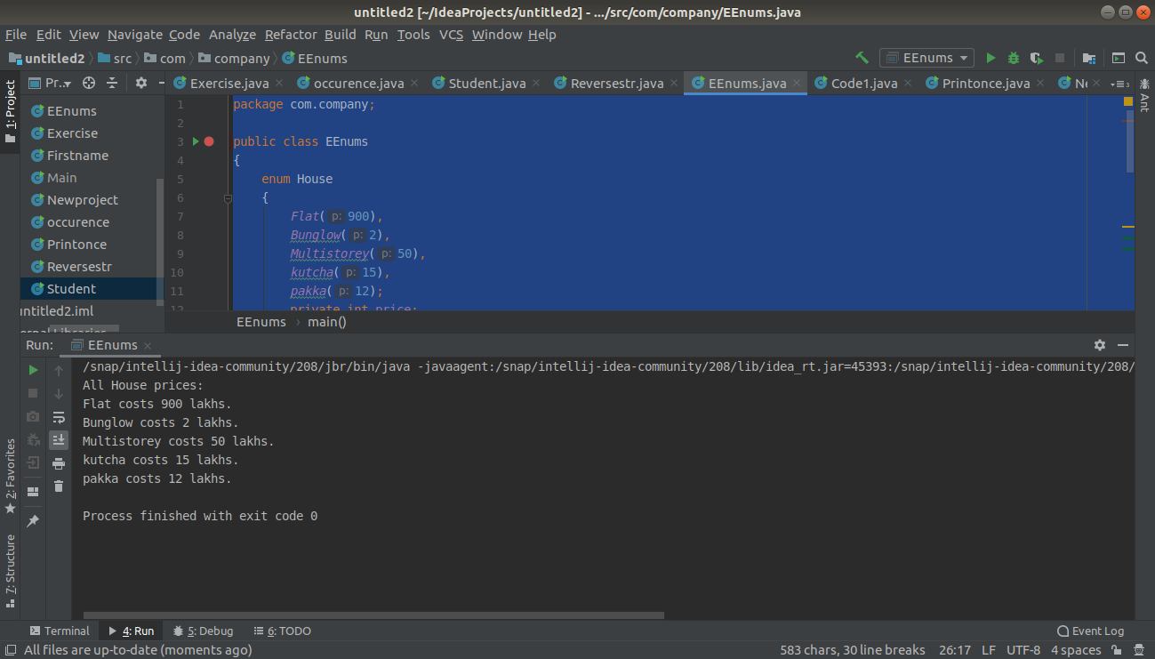

Q10.Write a single program for following operation using overloading
A) Adding 2 integer number
B) Adding 2 double
C) multiplying 2 float
D) multiplying 2 int
E) concate 2 string
F) Concate 3 String

package com.company;

public class Overloadingop
{
int sum(int a, int b)
{
return a+b;
//System.out.println("The sum of two integer numbers is :");
}
double sum(double a,double b)
{
//System.out.println("The sum of two double numbers is :");
return a+b;
}
int multiply(int a,int b)
{
//System.out.println("The multiplication of two integer numbers is :");
return (a*b);
}
float multiply (float a,float b)
{
//System.out.println("The multiplication of two float numbers is :");
return (a*b);

}
String concat(String a, String b)
{
//System.out.println("The concatenation of two strings are :");
return a+b;
}
String concat(String a, String b, String c)
{
//System.out.println("The concatenation of three strings are :");
return a+b+c;
}

public static void main(String[] args)
{
Overloadingop over=new Overloadingop();
System.out.println("The sum of two integer numbers is:");
System.out.println(over.sum(2,3));
System.out.println("The sum of two double numbers is:");
System.out.println(over.sum(2.5,3.9));
System.out.println("The multiplication of two integer numbers is:");
System.out.println(over.multiply(3,4));
System.out.println("The multiplication of two floating numbers is:");
System.out.println(over.multiply(2.3f, 2.4f));
System.out.println("The concatenation of two strings is:");
System.out.println(over.concat("Neha","Budhiraja"));
System.out.println("The concatenation of three strings is:");
System.out.println(over.concat("Neha","Ashu","Budhiraja"));

}
}
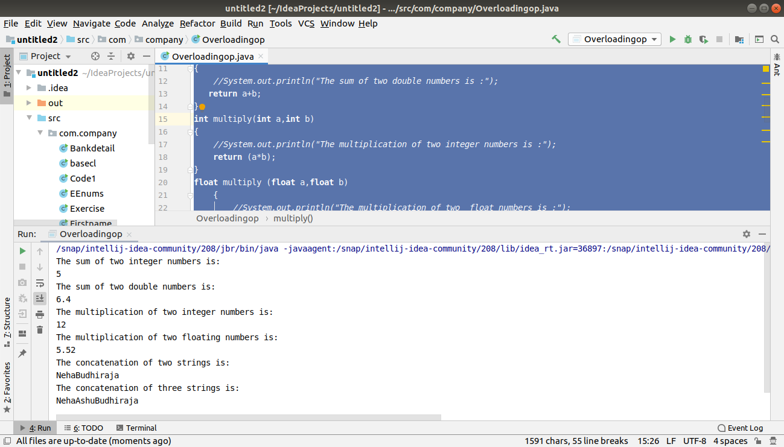

Q11.Create 3 sub class of bank SBI,BOI,ICICI all 4 should have method called getDetails which provide there specific details like rateofinterest etc,print details of every banks

package com.company;
public class Bankdetail
{
public class Bank
{
int getRateOfInterest()
{
return 0;
}
}
class SBI extends Bank
{
int getRateOfInterest()
{
return 7;
}
}
class ICICI extends Bank
{
int getRateOfInterest()
{
return 9;
}
}
class BOI extends Bank
{
int getRateOfInterest()
{
return 10;
}
}
public static void main(String[] args)
{
Bankdetail.SBI s=new Bankdetail().new SBI();
System.out.println("SBI Rate of Interest: "+s.getRateOfInterest());
Bankdetail.ICICI i=new Bankdetail().new ICICI();
System.out.println("The Rate of Interest of ICICI bank is: " +i.getRateOfInterest());
Bankdetail.BOI b=new Bankdetail().new BOI();
System.out.println("The Rate of Interest of BOI bank is: " +b.getRateOfInterest());
}
}
