JAVA ASSIGNMENT FUNDAMENTAL 2

1. Create Java classes having suitable attributes for Library management system.Use OOPs concepts in your design.Also try to use interfaces and abstract classes.

interface customer_operations{
public void add(String customer_name,String customer_address,Books books);
public void display();
public void checkout(int date_of_issue,int date_of_return);
}
abstract class books_operations{

public abstract void add(String book_name, String book_author, String book_publisher);
public abstract void delete(String book_name);
public abstract void display();
public abstract void submit(String book_name);
}
class Books extends books_operations{
private String book_name;
private String book_author;
private String book_publisher;

@Override
public void add(String book_name, String book_author, String book_publisher) {

}

@Override
public void delete(String book_name) {

}

@Override
public void display() {

}

@Override
public void submit(String book_name) {

}
}
class Customers implements customer_operations{
private String customer_name;
private String customer_address;
private int date_of_issue;
private int date_of_return;

@Override
public void add(String customer_name, String customer_address, Books books) {

}

@Override
public void display() {

}

@Override
public void checkout(int date_of_issue, int date_of_return) {

}
}
public class Library {
public static void main(String[] args) {
}
}

2. WAP to sorting string without using string Methods?.

package com.company;
import org.w3c.dom.ls.LSOutput;
import java.sql.SQLOutput;
import java.util.Scanner;
public class Sortstring {
public static void main(String[] args) {
Scanner scanner = new Scanner(System.in);
System.out.println("Enter a string");
String userInput = scanner.nextLine();
char[] charArray = userInput.toCharArray();
for (int i = 0; i < charArray.length; i++) {
for (int j = i + 1; j < charArray.length; j++) {
if (Character.toLowerCase(charArray[j]) < Character.toLowerCase(charArray[i])) {
swapChars(i, j, charArray);
}
}
}
System.out.println("Sorted string is:" + String.valueOf(charArray));
}
public static void swapChars(int i, int j, char[] charArray) {
char temp = charArray[i];
charArray[i] = charArray[j];
charArray[j] = temp;
}
}
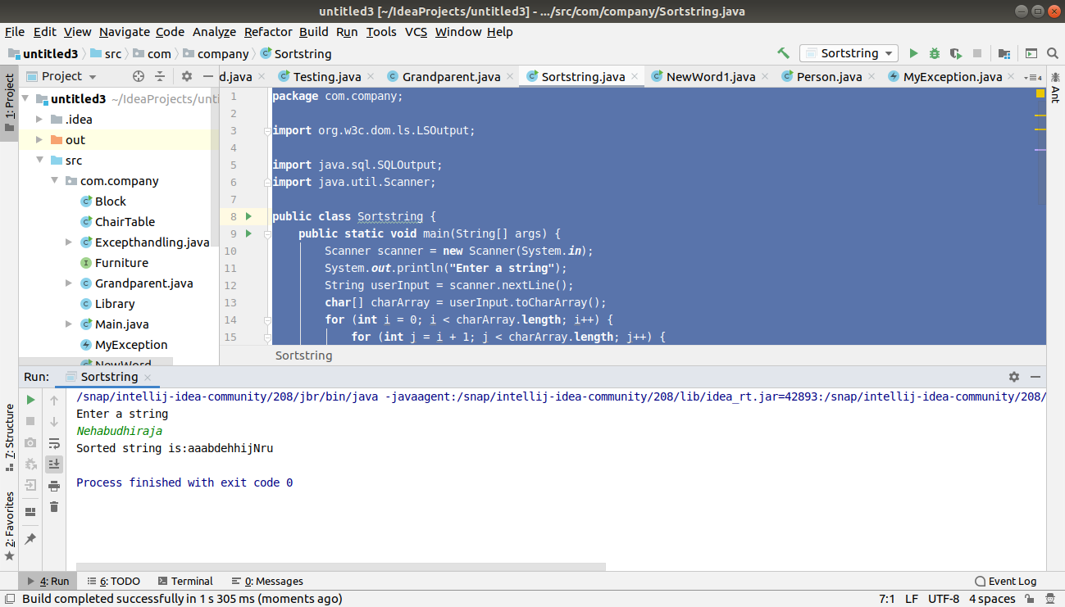
3. WAP to produce NoClassDefFoundError and ClassNotFoundException exception.

package com.company;
class JavaException
{
void show()
{
System.out.println("Hello exception");
}
}
public class Excepthandling {
public static void main(String[] args)
{
JavaException java=new JavaException();
java.show();
try
{
Class.forName("JavaException");
}
catch (ClassNotFoundException ex)
{
ex.printStackTrace();
}
}
}
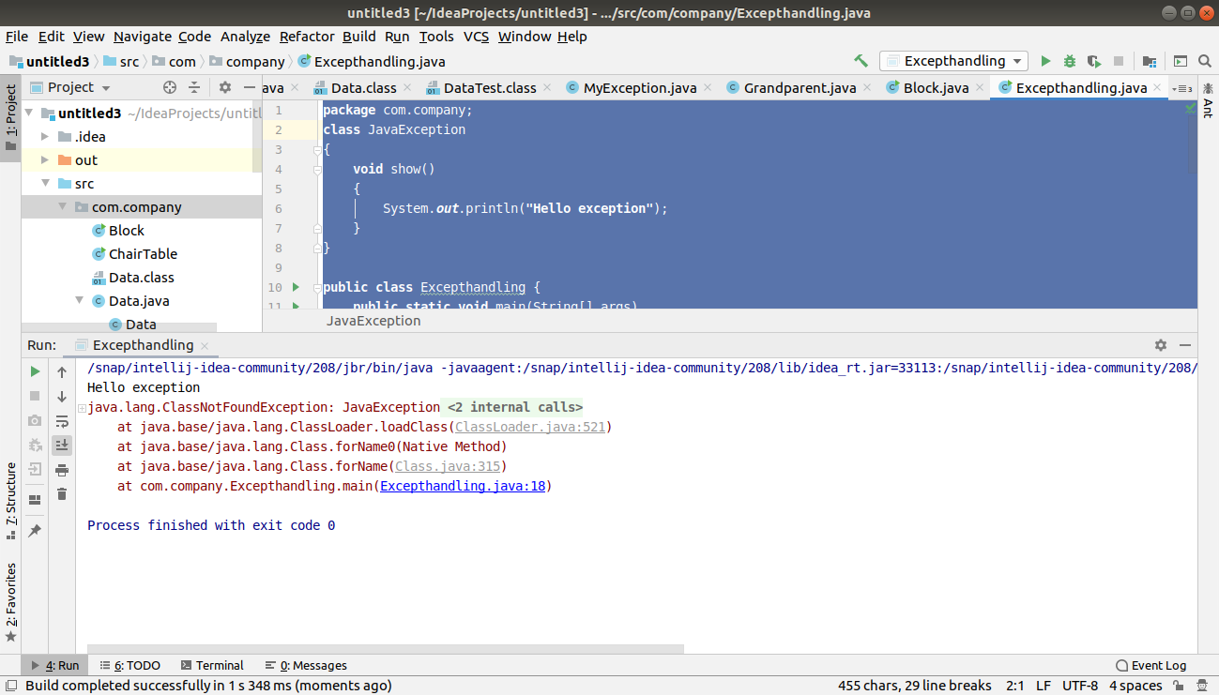

class Data
{
private int id;

public int getId() {
return id;
}
public void setId(int id)
{
this.id=id;

}
}
public class DataSet
{
public static void main(String[] args)
{
Data data=new Data();
data.setId(10);
System.out.println("Data ID = " +data.getId());

}
}

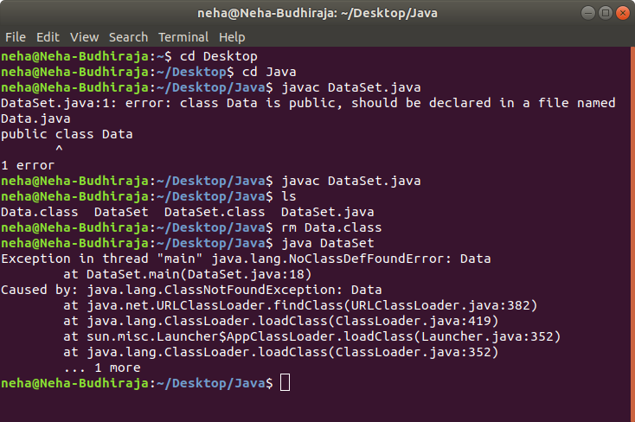

4. WAP to create singleton class.

package com.company;
public class SingleClass {
private static SingleClass singleton_instance = null;
public String str;
private SingleClass() {
str = "This is the Singleton Class, You can make only one object";
}
public static SingleClass getInstance() {
if (singleton_instance == null)
singleton_instance = new SingleClass();
return singleton_instance;
}
public static void main(String[] args)
{
SingleClass x=SingleClass.getInstance();
System.out.println(x);
SingleClass y=SingleClass.getInstance();
System.out.println(y);
System.out.println("String of x is:" +x.str);
System.out.println("String of y is:" +y.str);
}
}
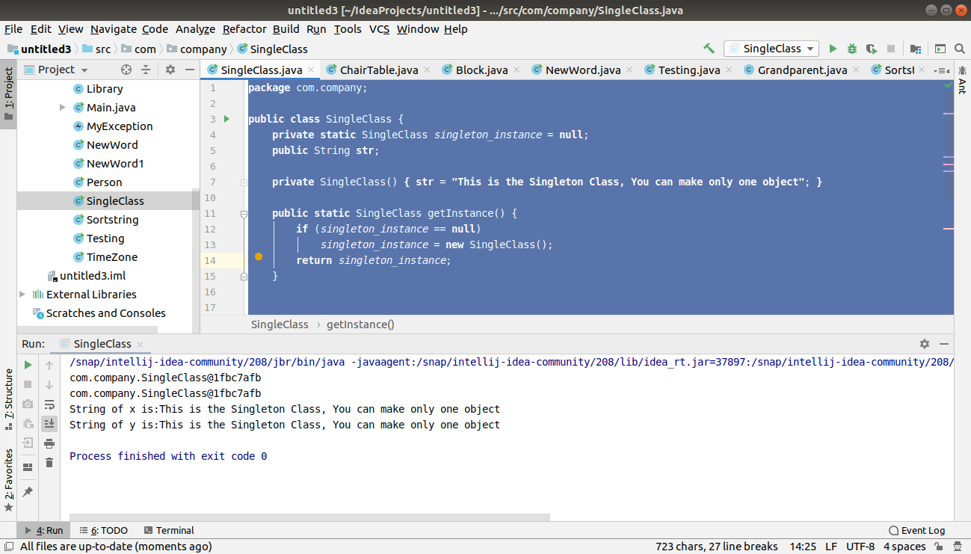

5. WAP to show object cloning in java using cloneable and copy constructor both.

package com.company;
public class Person implements Cloneable
{
int rollno;
String name;
Person(int rollno,String name){
this.rollno=rollno;
this.name=name;
}
Person(Person s) {
rollno = s.rollno;
name = s.name;
}
public Object clone()throws CloneNotSupportedException{
return super.clone();
}
public static void main(String args[]){
try{
Person s1=new Person(101,"Ashu");
Person s3=new Person(102,"Neha");
Person s2=(Person) s1.clone();
Person s4=new Person(s3);
System.out.println("Using cloning: ");
System.out.println(s1.rollno+" "+s1.name);
System.out.println(s2.rollno+" "+s2.name);
System.out.println("Using copy constructor: ");
System.out.println(s3.rollno+" "+s3.name);
System.out.println(s4.rollno+" "+s4.name);
}catch(CloneNotSupportedException c)
{
}
}
}
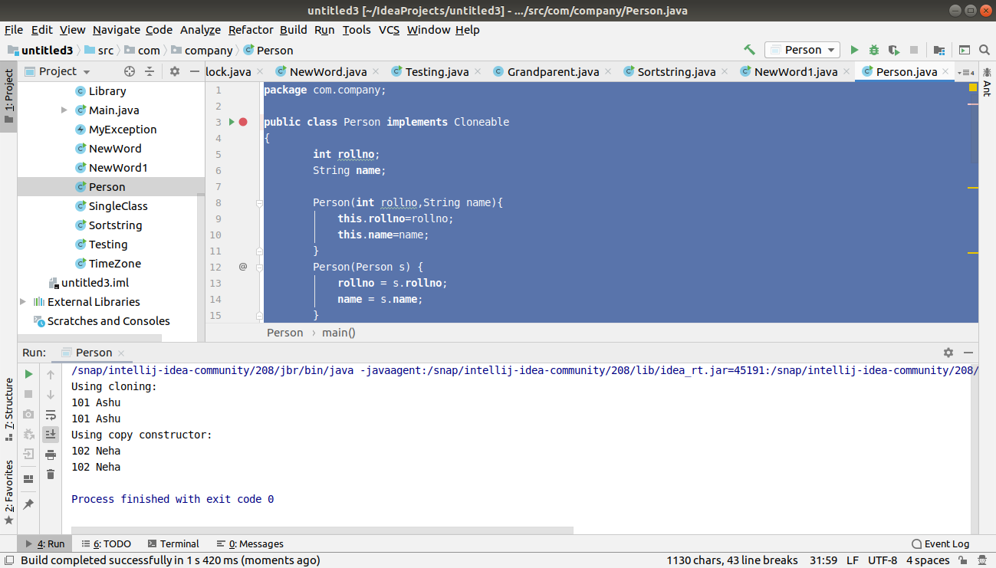

6. WAP showing try, multi-catch and finally blocks.

package com.company;
public class Block
{
public static void main(String[] args)
{
try {
int a[] = new int[4];
System.out.println(a[8]);
}
catch(ArithmeticException e)
{
System.out.println("Arithmetic Exception occurs");
}
catch(ArrayIndexOutOfBoundsException e)
{
System.out.println("ArrayIndexOutOfBounds Exception occurs");
}
catch(Exception e)
{
System.out.println("Parent Exception occurs");
}
finally
{
System.out.println("Finally block is always executed");
}
System.out.println("rest of the code");
}
}

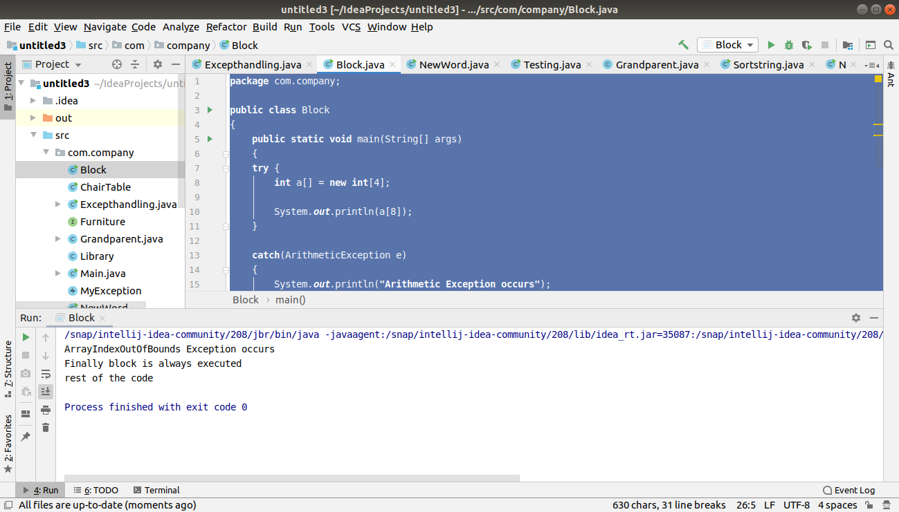

7. WAP to convert seconds into days, hours, minutes and seconds.

package com.company;
import java.util.Scanner;
public class TimeZone
{
public static void main(String[] args)
{
int n;
System.out.println("Enter the input in seconds");
Scanner sc=new Scanner(System.in);
n=sc.nextInt();
int day = n / (24 * 3600);
n = n % (24 * 3600);
int hour = n / 3600;
n %= 3600;
int minutes = n / 60 ;
n %= 60;
int seconds = n;
System.out.println( day + " " + "days " + hour + " " + "hours " + minutes + " " + "minutes " + seconds + " " + "seconds ");
}
}
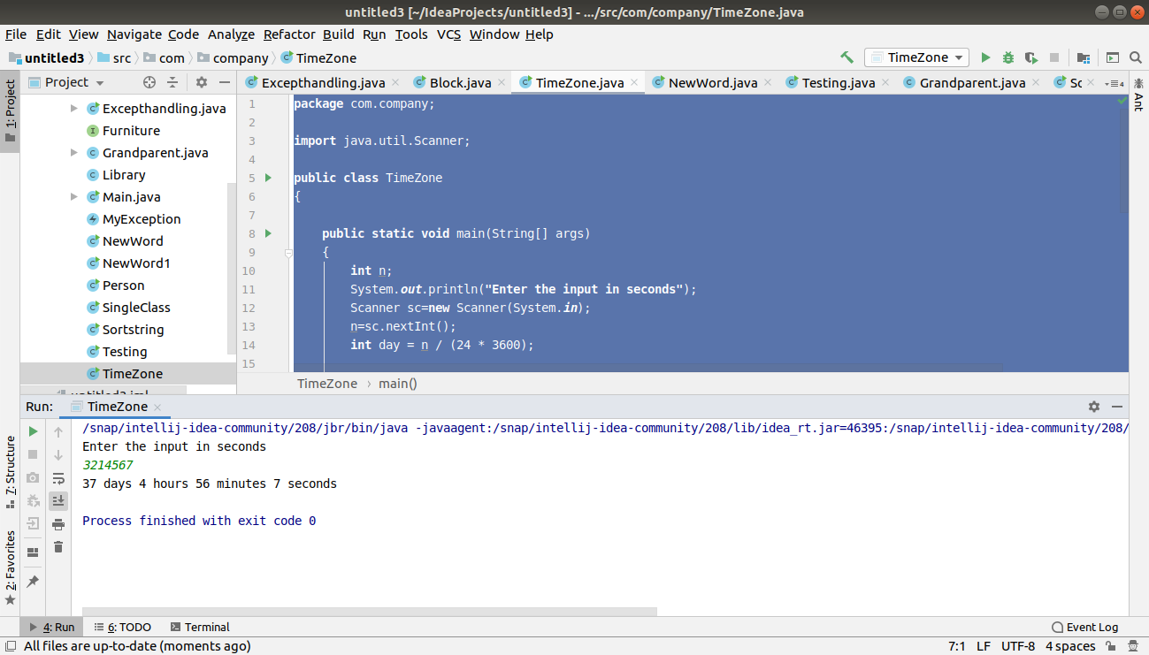

8. WAP to read words from the keyboard until the word done is entered. For each word except done, report whether its first character is equal to its last character. For the required loop, use a
a)while statement

package com.company;
import java.util.Scanner;
public class NewWord {
public static void main(String[] args)
{
Scanner keyboard = new Scanner(System.in);
System.out.println("Enter a word");
String word = keyboard.next();
while (!word.equals("done")) {
if (word.charAt(0) == word.charAt(word.length() - 1))
{
System.out.println("First and last character are equals for the word: " + word);
} else
{
System.out.println("First and last character are NOT equals for the word: " + word);
}
word = keyboard.next();
}
}
}
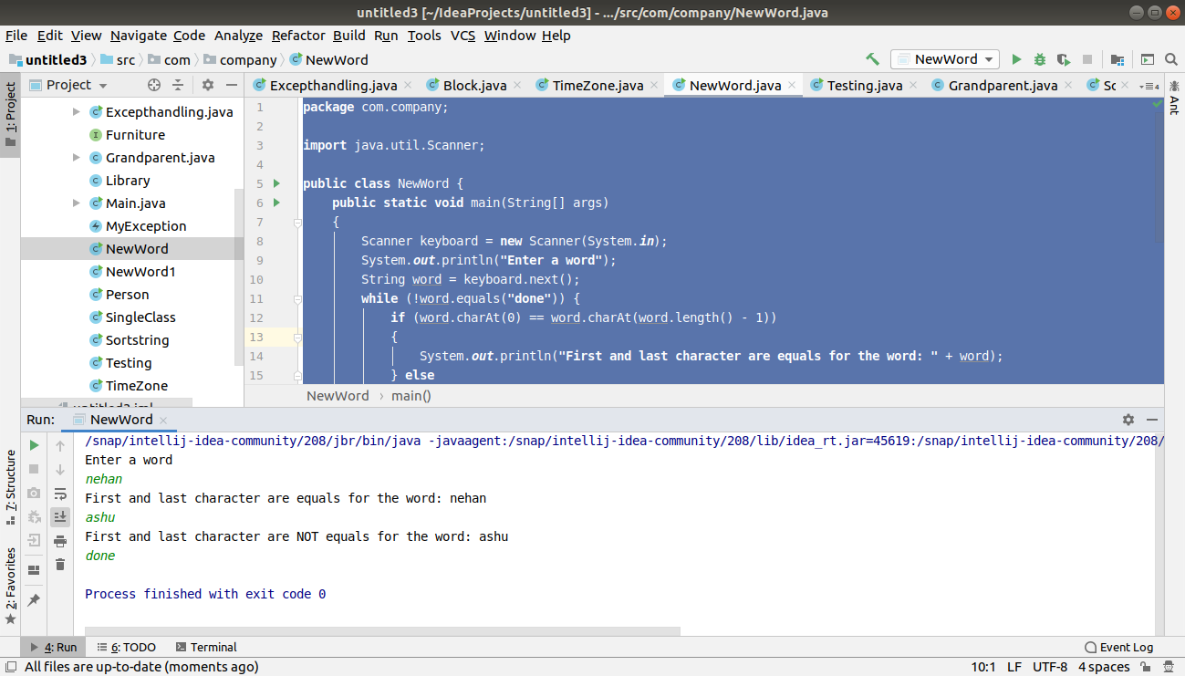
b)do-while statement

package com.company;
import java.util.Scanner;
public class NewWord1
{
public static void main(String[] args)
{
Scanner keyboard=new Scanner(System.in);
System.out.println("Enter a word");
String word=keyboard.nextLine();
do {
if(word.charAt(0)==word.charAt(word.length()-1))
{
System.out.println("First and the last Characters are equal for the word: " +word);
}
else
{
System.out.println("First and last characters are NOT equal for the word: " +word);
}
word=keyboard.nextLine();
}
while (!word.equals("done"));
}
}
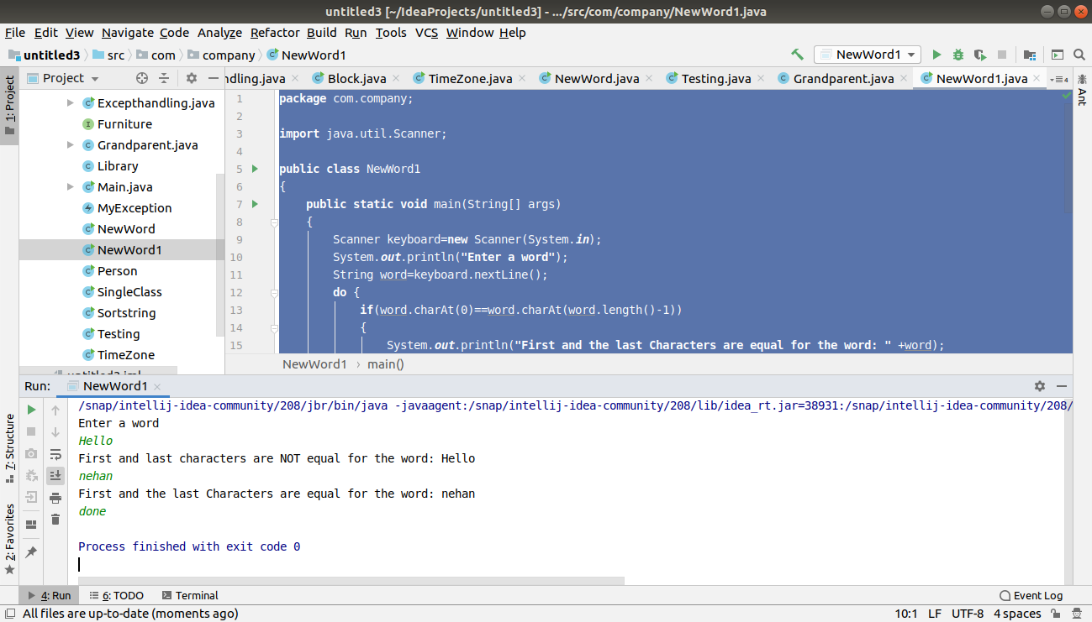

9. Design classes having attributes for furniture where there are wooden chairs and tables, metal chairs and tables. There are stress and fire tests for each products.

package com.company;
import java.util.Scanner;
public class ChairTable
{
public abstract class Chair implements Furniture {
public abstract String chairType();
}
public abstract class Table implements Furniture {
public abstract String tableType();
}
public class MetalChair extends Chair {
@Override
public void stressTest() {
System.out.println("This is the stress test for metal chair");
}
@Override
public void fireTest() {
System.out.println("This is the fire test for metal chair");
}
@Override
public String chairType() {
String s = "This is a Metal Chair";
return s;
}
public class Woodenchair extends Chair {
@Override
public void fireTest() {
System.out.println("This is the fire test for wooden chair");
}
@Override
public void stressTest() {
System.out.println("This is the stress test for wooden chair");
}
@Override
public String chairType() {
String s = "This is a wooden chair";
return s;
}
}
}
public class MetalTable extends Table {
@Override
public void stressTest() {
System.out.println("This is the stress test for metal table");
}
@Override
public void fireTest() {
System.out.println("This is the fire test for metal table");
}
@Override
public String tableType() {
String s = "This is a Metal Table";
return s;
}
public class WoodenTable extends Table {
@Override
public void fireTest() {
System.out.println("This is the fire test for wooden table");
}
@Override
public void stressTest() {
System.out.println("This is the stress test for wooden table");
}
@Override
public String tableType() {
String s = "This is a wooden table";
return s;
}
}
}
public static void main(String[] args) {
ChairTable.MetalChair mc = new ChairTable().new MetalChair();
ChairTable.MetalChair.Woodenchair wc = new ChairTable().new MetalChair().new Woodenchair();
// ChairTable.MetalChair.Woodenchair.MetalTable tc = new ChairTable().new MetalChair().new Woodenchair().new M
//ChairTable.MetalChair.Woodenchair wt = new ChairTable().new MetalChair().new Woodenchair();
ChairTable.MetalTable mt= new ChairTable().new MetalTable();
ChairTable.MetalTable.WoodenTable wt= new ChairTable().new MetalTable().new WoodenTable();
mc.chairType();
mc.fireTest();
mc.stressTest();
wc.chairType();
wc.fireTest();
wc.stressTest();
mt.tableType();
mt.fireTest();
mt.stressTest();
wt.tableType();
wt.fireTest();
wt.stressTest();
}
}
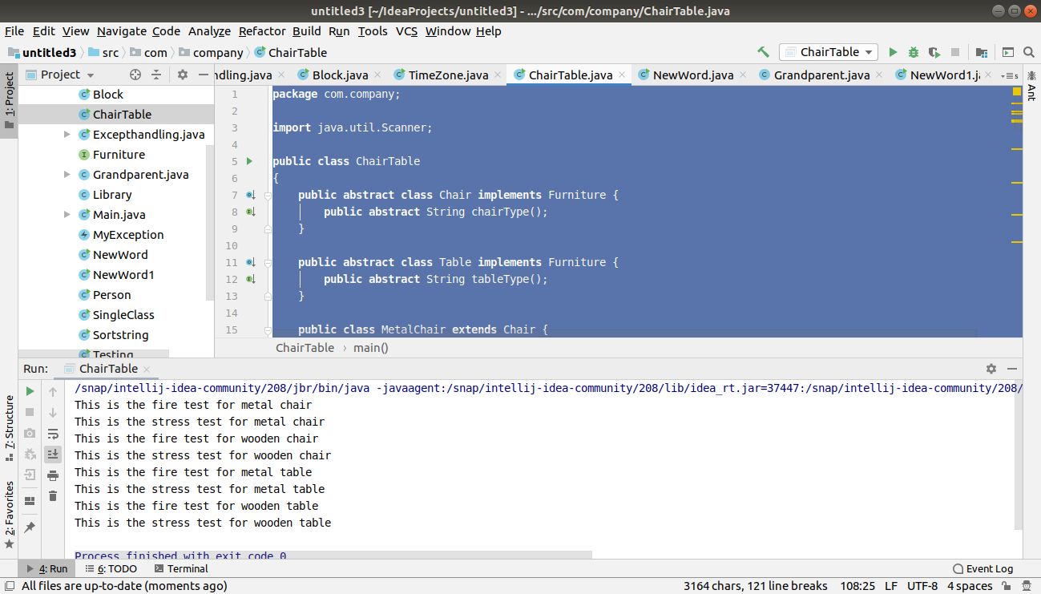

10. Design classes having attributes and method(only skeleton) for a coffee shop. There are three different actors in our scenario and i have listed the different actions they do also below

* Customer
- Pays the cash to the cashier and places his order, get a token number back
- Waits for the intimation that order for his token is ready
- Upon intimation/notification he collects the coffee and enjoys his drink
( Assumption: Customer waits till the coffee is done, he wont timeout and cancel the order. Customer always likes the drink served. Exceptions like he not liking his coffee, he getting wrong coffee are not considered to keep the design simple.)

* Cashier
- Takes an order and payment from the customer
- Upon payment, creates an order and places it into the order queue
- Intimates the customer that he has to wait for his token and gives him his token
( Assumption: Token returned to the customer is the order id. Order queue is unlimited. With a simple modification, we can design for a limited queue size)

* Barista
- Gets the next order from the queue
- Prepares the coffee
- Places the coffee in the completed order queue
- Places a notification that order for token is ready

class Customer{
public int TokenNumber;
public String order;
private int payment;

public int getTokenNumber() {
return 0;
}
public void waitForCoffee() {}
public void collectCoffee(){}
public void payPayment(){}
public void placeOrder(){}
}
class Cashier{
private String order;
private String getOrder(){
return null;
}
public void receivePayment(){}
public void notify(Customer c1){}

}class Barista{
public void prepareCoffee(){}
public void placeCoffee(){}
public void notify(Customer c1){}
}
public class CoffeeShop {
public static void main(String[] args) {

}
}

11. Convert the following code so that it uses nested while statements instead of for statements:

int s = 0;
int t = 1;
for (int i = 0; i < 10; i++)
{
s = s + i;
for (int j = i; j > 0; j−−)
{
t = t * (j - i);
}
s = s * t;
System.out.println("T is " + t);
}
System.out.println("S is " + s);

package com.company;
public class Testing
{
public static void main(String[] args)
{
int s = 0;
int t = 1;
int i=0;

while(i<10)
{
s = s + i;
int j=i;
while(j>0)
{
t = t * (j - i);
j--;
}
s = s * t;
i++;
System.out.println("T is " + t);
}
System.out.println("S is " + s);
}
}
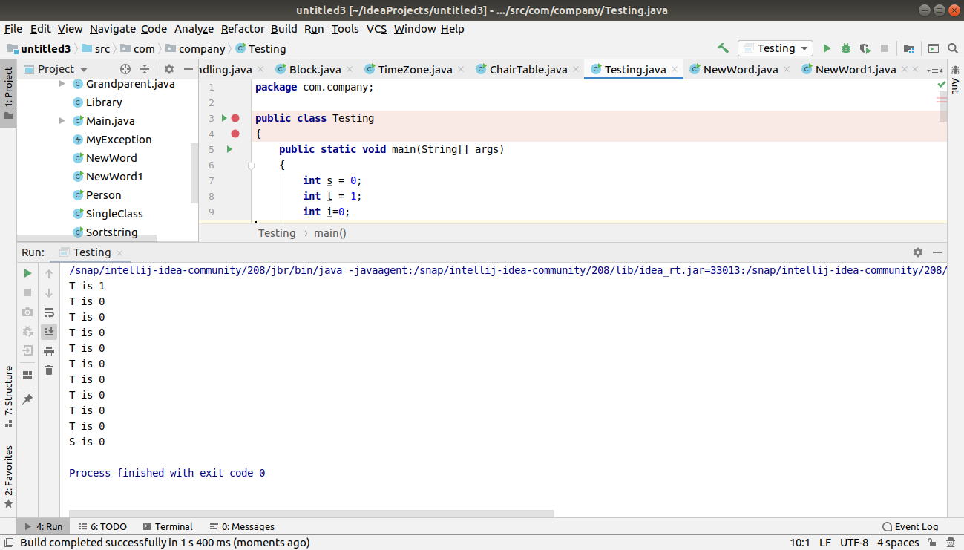

12.What will be the output on new Child(); ?

class Parent extends Grandparent {

{
System.out.println("instance - parent");
}

public Parent() {
System.out.println("constructor - parent");
}

static {
System.out.println("static - parent");
}
}

class Grandparent {

static {
System.out.println("static - grandparent");
}

{
System.out.println("instance - grandparent");
}

public Grandparent() {
System.out.println("constructor - grandparent");
}
}

class Child extends Parent {

public Child() {
System.out.println("constructor - child");
}

static {
System.out.println("static - child");
}

{
System.out.println("instance - child");
}
}

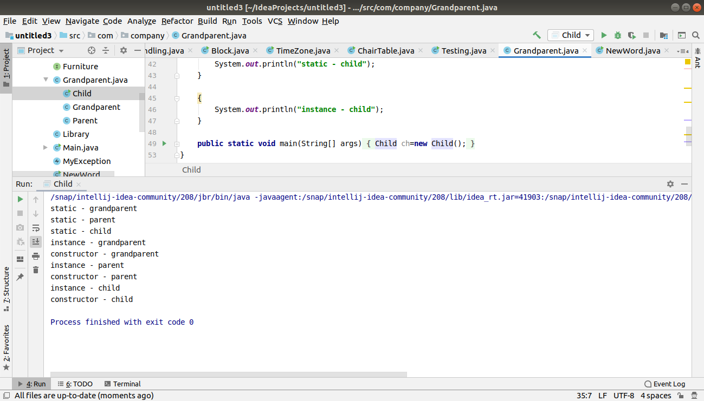

Q13. Create a custom exception that do not have any stack trace.

package com.company;
public class MyException extends Exception {
public MyException(String str) {
super(str);
}
public Throwable fillInStackTrace() {

return this;
}
public static void main(String[] args) {
try {
throw new MyException("Java custom exception");
} catch (MyException e) {
System.out.println("Caught Custom exception");
System.out.println(e.getMessage());
//System.out.println(e.getStackTraceString());
e.printStackTrace();
}
}
}

