Q1. Given this array: `[3,62,234,7,23,74,23,76,92]`, Using arrow function, create an array of the numbers greater than `70`.

Ans:

let points=[3,62,234,7,23,74,23,76,92];
let highScore=points.filter((n)=>
{
return n>70;
})
console.log(highScore);

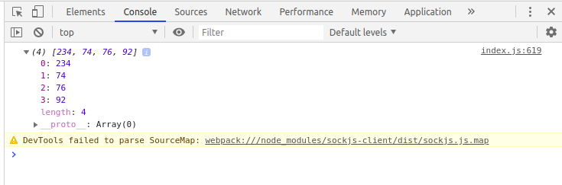

Q2.

<ul>
<li data-time="5:17">Flexbox Video</li>
<li data-time="8:22">Flexbox Video</li>
<li data-time="3:34">Redux Video</li>
<li data-time="5:23">Flexbox Video</li>
<li data-time="7:12">Flexbox Video</li>
<li data-time="7:24">Redux Video</li>
<li data-time="6:46">Flexbox Video</li>
<li data-time="4:45">Flexbox Video</li>
<li data-time="4:40">Flexbox Video</li>
<li data-time="7:58">Redux Video</li>
<li data-time="11:51">Flexbox Video</li>
<li data-time="9:13">Flexbox Video</li>
<li data-time="5:50">Flexbox Video</li>
<li data-time="5:52">Redux Video</li>
<li data-time="5:49">Flexbox Video</li>
<li data-time="8:57">Flexbox Video</li>
<li data-time="11:29">Flexbox Video</li>
<li data-time="3:07">Flexbox Video</li>
<li data-time="5:59">Redux Video</li>
<li data-time="3:31">Flexbox Video</li>
</ul>

a. Select all the list items on the page and convert to array.

Index.html

<!DOCTYPE html>
<html>
<head>
<title>ExampleJs</title>
</head>
<body>

<body>
<ul id="List">
<li data-time="5:17">Flexbox Video</li>
<li data-time="8:22">Flexbox Video</li>
<li data-time="3:34">Redux Video</li>
<li data-time="5:23">Flexbox Video</li>
<li data-time="7:12">Flexbox Video</li>
<li data-time="7:24">Redux Video</li>
<li data-time="6:46">Flexbox Video</li>
<li data-time="4:45">Flexbox Video</li>
<li data-time="4:40">Flexbox Video</li>
<li data-time="7:58">Redux Video</li>
<li data-time="11:51">Flexbox Video</li>
<li data-time="9:13">Flexbox Video</li>
<li data-time="5:50">Flexbox Video</li>
<li data-time="5:52">Redux Video</li>
<li data-time="5:49">Flexbox Video</li>
<li data-time="8:57">Flexbox Video</li>
<li data-time="11:29">Flexbox Video</li>
<li data-time="3:07">Flexbox Video</li>
<li data-time="5:59">Redux Video</li>
<li data-time="3:31">Flexbox Video</li>
</ul>

<script src="./bundle.js">

</script>
</body>
</html>

Convert.js

let array=[];
let lists=document.getElementById("List").getElementsByTagName("li");
for(var i=0;i<lists.length;i++)
{
array.push(lists[i].innerHTML);
}
export{array};

index.js

import{array} from './Convert.js';
console.log(array);

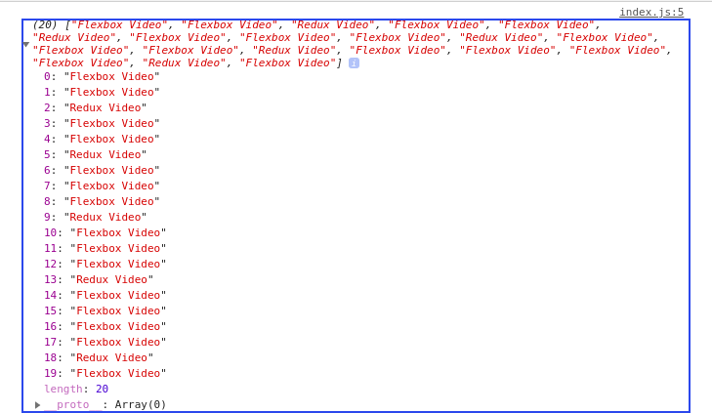

b. Filter for only the elements that contain the word 'flexbox'

Convert.js

console.log("Array containing only Flexbox word");
let flexBoxArray=array.filter((a)=>a.toLowerCase().includes("flexbox"));
export{flexBoxArray};

index.js

import{flexBoxArray} from './Convert.js';
console.log(flexBoxArray);

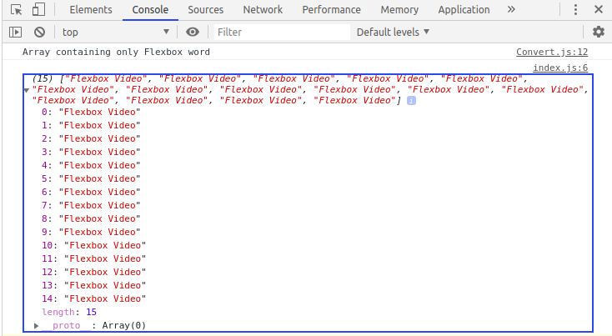

c. Map down to a list of time strings

Convert.js

console.log("Map down to the list of strings..")
let arrayTime=[];
for(var i=0;i<lists.length;i++)
{
arrayTime.push(lists[i].getAttribute("data-time"));
}

export{arrayTime};

index.js

import{arrayTime} from './Convert.js';

console.log(arrayTime);

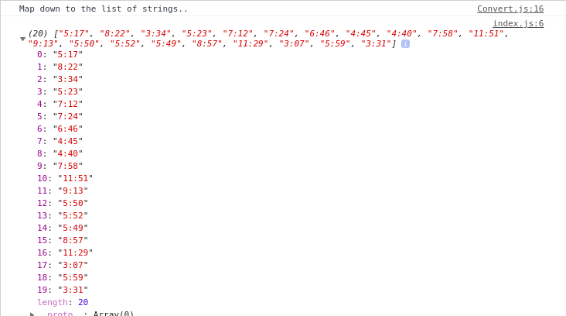

d. Map to an array of seconds

Convert.js

console.log("Map down to array of seconds!");
let arraySecond = [];
arraySecond = arrayTime.map((a) => a.split(":")).map((a) => ((a[0] * 60) + (a[1])));
export{arraySecond};

index.js

import{arraySecond} from './Convert.js';
console.log(arraySecond);

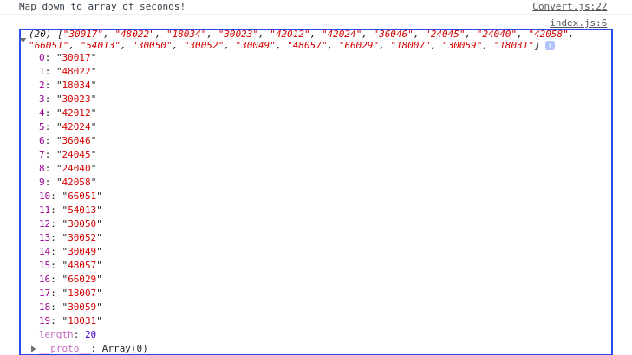

e. Reduce to get total using .filter and .map

Convert.js

console.log("Total time using filter and map!")
let totalTime;
totalTime=arraySecond.reduce((a,b)=>a+b);

export{totalTime};

index.js

import{totalTime} from './Convert.js';
console.log(totalTime);

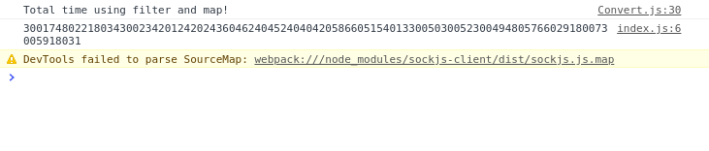

Q3. Create a markup template using string literal

const song = {
name: 'Dying to live',
artist: 'Tupac',
featuring: 'Biggie Smalls'
};

Result:
"<div class="song">
<p>
Dying to live — Tupac
(Featuring Biggie Smalls)
</p>
</div>
“

Song.js

const song = {
name: 'Dying to live',
artist: 'Tupac',
featuring: 'Biggie Smalls'
};

const markup=
`
<div class="song">
<p>
${song.name} - ${song.artist}
(Featuring ${song.featuring})
</p>
</div>

`
document.getElementById("block").innerHTML=markup;
export {markup};

index.html

<!DOCTYPE html>
<html>
<head>
<title>ExampleJs</title>
</head>
<body>

<body>

<div id="block">
<p>

</p>
</div>
<script src="./bundle.js">

</script>
</body>
</html>

index.js

import{markup} from './Song.js'
console.log(markup);

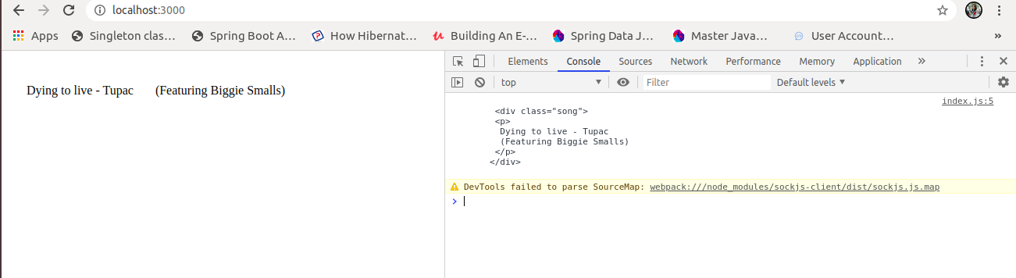

Q4. Extract all keys inside address object from user object using destructuring ?

const user = {
firstName: ‘Sahil’,
lastName: ‘Dua’,
Address: {
Line1: ‘address line 1’,
Line2: ‘address line 2’,
State: ‘Delhi’,
Pin: 110085,
Country: ‘India’,
City: ‘New Delhi’,
},
phoneNo: 9999999999
}

index.js

const user = {
firstName: 'Sahil',
lastName: 'Dua',
Address: {
Line1: 'address line 1',
Line2: 'address line 2',
State: 'Delhi',
Pin: 110085,
Country: 'India',
City: 'New Delhi',
},
phoneNo: 9999999999
}

let{Address}=user;
console.log("Address of user is",Address);

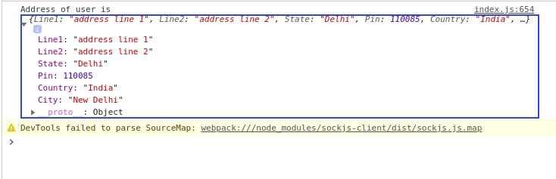

Q5. Filter unique array members using Set.

let numbers=[2,3,4,5,5,5,6,8,9,2,6];
let numSet=new Set(numbers);

for(let element of numSet.values())
{
console.log(element);
}

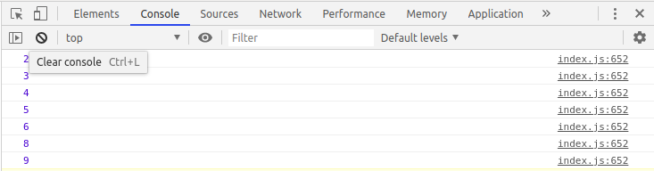

Q6. Find the possible combinations of a string and store them in a MAP?

Q7. Write a program to implement inheritance upto 3 classes.The Class must public variables and static functions.

class Animal
{
constructor(name,height)
{
this.name=name;
this.height=height;
}
hello()
{
console.log(`Hi I am ${this.name} from animal class`);
}
static sound()
{
return "Wohooooooo";
}

}
class Lion extends Animal
{
constructor(name,height,fur)
{
super(name,height);
this.fur=fur;
}
hello()
{
console.log(`Hi I am ${this.name} from Lion class`);
}
static sound()
{
return "Wohooooo Lion"
}
}

class Tiger extends Lion
{

constructor(name,height,fur,color)
{
super(name,height,fur)

this.color=color;

}
hello()
{
console.log(`Hi I am ${this.name} from tiger class`);
}
static colour()
{
return "Yellow";
}
}
let king=new Animal("Animal",6.5);
console.log(king);
king.hello();
let lion=new Lion("Lion",5.5,"White fur");
console.log(lion);
lion.hello();
let tiger=new Tiger("Tiger",7.6,"Yellow fur","Yellow-Black");
console.log(tiger);
tiger.hello();
let staticMethod=Tiger.colour();
console.log(staticMethod);
let staticMethodLion=Lion.sound();
console.log(staticMethodLion);
let staticMethodAnimal=Animal.sound();
console.log(staticMethodAnimal);

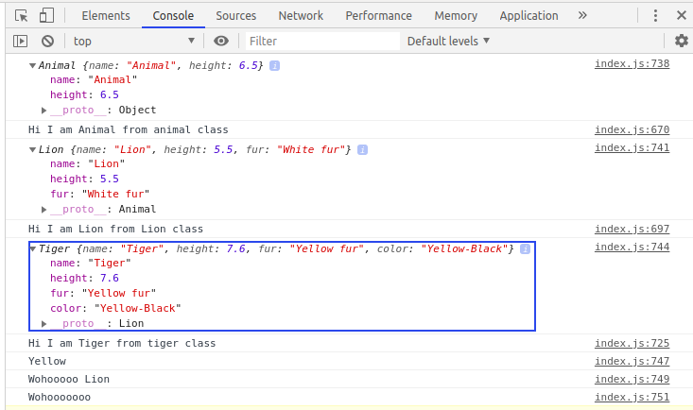

Q8. Write a program to implement a class having static functions

class Calculator
{

static add(a,b)
{
return a+b;
}
static addFunction()
{
return "Add called";
}
static multiply(a,b)
{
return a*b;
}
static multiplyFunction()
{
return "Multiply called!";
}

}

let calAdd= Calculator.add(3,5);
console.log(calAdd);
let staticFunctionAdd=Calculator.addFunction();
console.log(staticFunctionAdd);

let calMultiply=Calculator.multiply(4,6);
console.log(calMultiply);
let staticFunctionMul=Calculator.multiplyFunction();
console.log(staticFunctionMul);

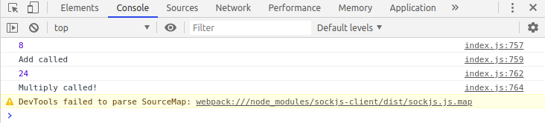

Q9. Import a module containing the constants and method for calculating area of circle, rectangle, cylinder.

Area.js

let circle=function(radius)
{
this.radius=radius;
this.area= function()
{
return Math.PI*this.radius*this.radius;
}
}
let rectangle=function(length, breadth)
{
this.length=length;
this.breadth=breadth;
this.area=function()
{
return length*breadth
}
}
let cylinder=function(diameter,height)
{
this.diameter=diameter;
this.height=height;
this.area=function()
{
return ((Math.PI * (this.diameter * this.diameter) / 4)*2)+(this.height*(this.Math.PI*this.diameter));
}
}

export function circle(radius)
{

return Math.PI*radius*radius;
}

export function rectangle(length,breadth)
{
return length*breadth;
}

export function cylinder(diameter,height)
{

return ((Math.PI * (diameter * diameter) / 4)*2)+(height*(Math.PI*diameter));
}

index.js

const lib=require('./Area.js')

console.log(lib.circle(5));
console.log(lib.rectangle(10,5));
console.log(lib.cylinder(4,6));

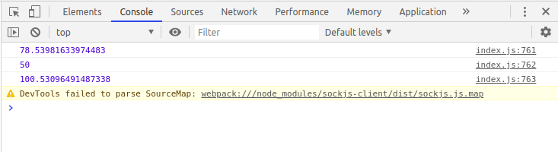

Q10. Import a module for filtering unique elements in an array.

Filtering.js

let numbers=[1,2,3,4,5,6,7,5,4,2,1];
let numbersSet=new Set(numbers);
for(let element of numbersSet.values())
{
console.log(element);
}

export{numbersSet};

index.js

import{numbersSet} from './Filtering.js'
console.log(numbersSet);

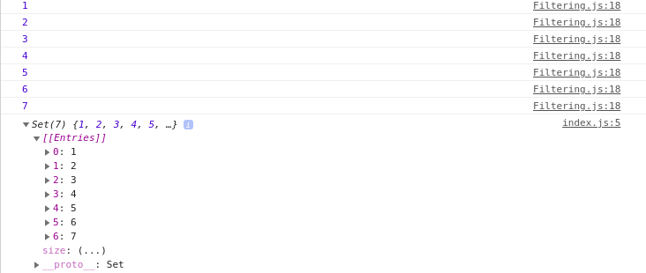

Q11. Write a program to flatten a nested array to single level using arrow functions.

index.js

var arrays = [["6"], ["12"], ["25"], ["25"], ["18"], ["22"], ["10"], ["0"], ["15"]];
console.log(arrays);
arrays = arrays.reduce((a, b) => a.concat(b), []);
console.log(arrays);

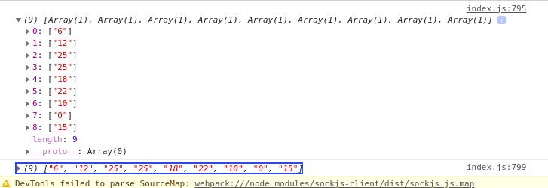

Q12. Implement a singly linked list in es6 and implement addFirst() addLast(), length(), getFirst(), getLast(). (without using array)

LinkList.js

class Node{
constructor(data,next=null){
this.data=data;
this.next=next;
}
}

class LinkedList{
constructor(){
this.head=null;
}

addFirst(data){
let newNode = new Node(data);
// The pointer next is assigned head pointer so that both pointers now point at the same node.
newNode.next = this.head;
// As we are inserting at the beginning the head pointer needs to now point at the newNode.

this.head = newNode;
// return this.head;
}
addLast(data){
let newNode = new Node(data);
// When head = null i.e. the list is empty, then head itself will point to the newNode.
if(!this.head){
this.head = newNode;
//return this.head;
}
// Else, traverse the list to find the tail (the tail node will initially be pointing at null), and update the tail's next pointer.
let tail = this.head;
while(tail.next !== null){
tail = tail.next;
}
tail.next = newNode;
// return this.head;
}
lengthOfList(){

var count=1;
let tail = this.head;
while(tail.next !== null){
tail=tail.next;
count+=1;
}

return count;
}
getLast(){

let tail = this.head;
while(tail.next != null)
tail=tail.next;

return tail.data;

}

getFirst(){
return this.head.data;
}
}
function dothis(){
let list=new LinkedList();
list.addFirst(5);
list.addFirst(7);
list.addFirst(8);
list.addLast(9);
console.log(list);
console.log("First",list.getFirst());
console.log("Last",list.getLast());
console.log("Length",list.lengthOfList());

}

export {dothis}

index.js

import{dothis} from './LinkList.js'
console.log(dothis());

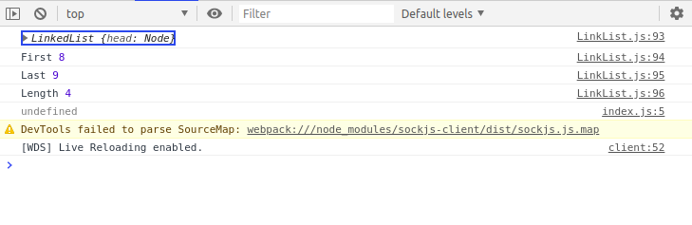

Q13. Implement Map and Set using Es6

//SET//

let setImpl=new Set();
setImpl.add(4);
setImpl.add("Neha");
setImpl.add({x:6,y:7});
console.log(setImpl);
console.log(setImpl.size);

let numbersSet=[2,4,5,6,3,1,8,9,1];
let numberFilter=new Set(numbersSet);
for(let element of numberFilter.values())
{
console.log(element);
}

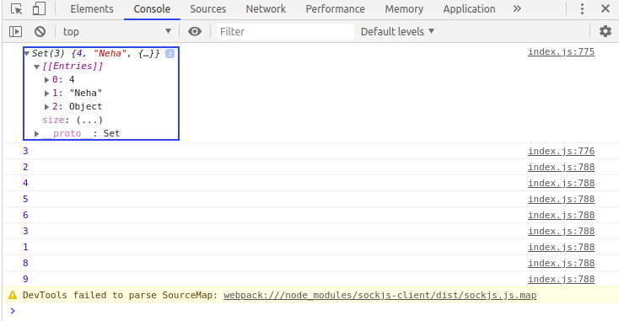

//Map//

let mapImpl=new Map();
let key_one="String Key 1";
let key_two="String Key 2";
let key_three={a:'key',b:20};
let key_four=function()
{
return "I am in function";
}
mapImpl.set(key_one,'Returning value from String key 1');
mapImpl.set(key_two,'Returning value from String Key 2');
mapImpl.set(key_three,"Returning value from key value pair")
mapImpl.set(key_four,"Returning value from function");
console.log(mapImpl);

let arrays=[[1,"One"],[2,"Two"],[3,"Three"],[4,"Four"]];
let arrayMap=new Map(arrays);
console.log(arrayMap);
for(let [key,value] of arrayMap.entries())
{
console.log(`${key} point to ${value}`);
}

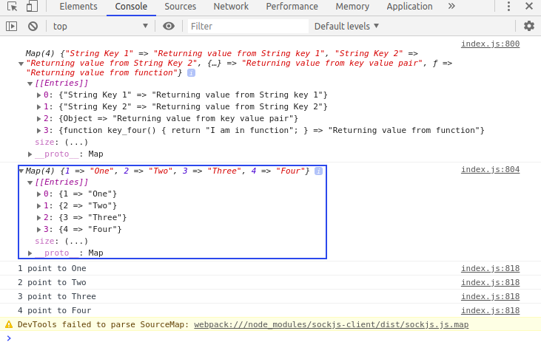

Q14. Implementation of stack (using linked list)

function stackUsingLL(){
//Node defination
let Node = function(elm){
this.element = elm;
this.next = null;
}

//To keep track of the size
let length = 0;

//To keep track of the list
let head = null;

//Push data in the stack
this.push = function(elm){
//Create a new node
let node = new Node(elm),
current;

//Add the new node at the top
current = head;
node.next = current;
head = node;

length++;
}

//Pop the item from the stack
this.pop = function(){
let current = head;

//If there is item then remove it
//and make the next element as the first
if(current){
let elm = current.element;
current = current.next;
head = current;
length--;
return elm;
}

return null;
}

//Return the first element in the stack
this.peek = function(){
if(head){
return head.element;
}

return null;
}

//Convert the stack to an array
this.toArray = function(){
let arr = [];
let current = head;
while(current){
arr.push(current.element);
current = current.next;
}

return arr;
}

//Check if stack is empty
this.isEmpty = function(){
return length === 0;
}

//Return the size of the stack
this.size = function(){
return length;
}

//Clear the stack
this.clear = function(){
head = null;
length = 0;
}

}
let stack = new stackUsingLL(); //creating new instance of Stack
stack.push(1);
stack.push(2);
stack.push(3);
console.log(stack.peek());

console.log(stack.isEmpty());
console.log(stack.size());
console.log(stack.pop());
console.log(stack.toArray());
console.log(stack.size());
stack.clear(); //clear the stack
console.log(stack.isEmpty());

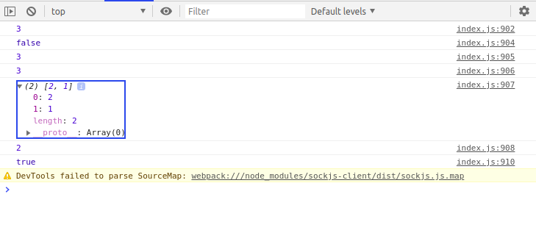

Extra Question from Udemy

Q1)

class Instrument {
constructor(name, type) {
this.name = name;
this.type = type;
}
}
class Guitar extends Instrument {
describe() {
return `I'm a ${this.name} from the ${this.type} family.`;
}
}
let fender = new Guitar("Fender", "strings");
console.log(fender.describe());
console.log(fender);

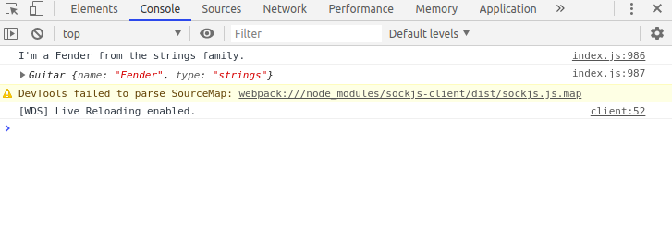

Q2)

function Vehicle(make, year, color) {
this.make = make;
this.year = year;
this.color = color;
this.bio = () => `A ${this.color} ${this.make} made in ${this.year}.`;
}
let s = new Vehicle("Tesla", 2017);
s.color = "black";
console.log(s.bio());
console.log(s);

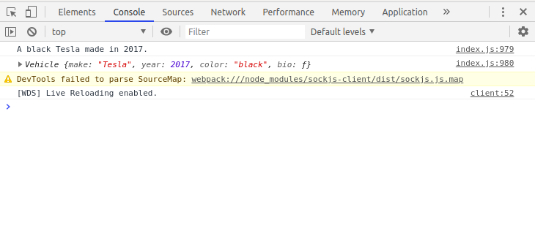

Q3)

const contains = (word, letter) => {
let letters = word.split("");
let letter_set = new Set(letters);
return letter_set.has(letter);
};
let true_check = contains("west", "e");
let false_check = contains("north", "e");
console.log(true_check);
console.log(false_check);

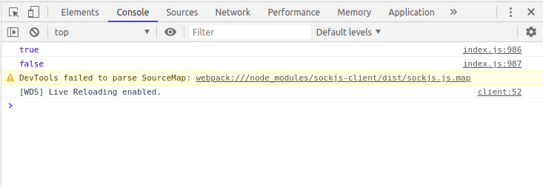

Q4)

let string = 'supercalifragilisticexpialidocious';
const countLetter = (word, orig_letter) => {
let letters = new Map();
for (let i = 0; i < word.length; i++) {
let letter = word[i];
if (!letters.has(letter)) {
letters.set(letter, 1);
} else {
letters.set(letter, letters.get(letter) + 1);
}
}
return letters.get(orig_letter);
};
let a_count = countLetter(string, 'a');
let x_count = countLetter(string, 'x');
console.log(a_count);
console.log(x_count);

