Collections Assignment

1) Write Java code to define List . Insert 5 floating point numbers in List, and using an iterator, find the sum of the numbers in List.
package com.company;
import java.util.ArrayList;
import java.util.Iterator;
public class ListExample
{
public static void main(String[] args)
{
ArrayList<Double> list =new ArrayList<>();
list.add(3.4);
list.add(2.4);
list.add(4.5);
list.add(3.7);
list.add(5.5);
System.out.println(list);
//System.out.println("The sum of elements are: ");
Iterator itr= list.iterator();
{
double sum = 0;
while(itr.hasNext())
{
double num= (double) itr.next();
sum= sum + num;
}
System.out.println("The sum of elements are: " +sum);
}
}
}
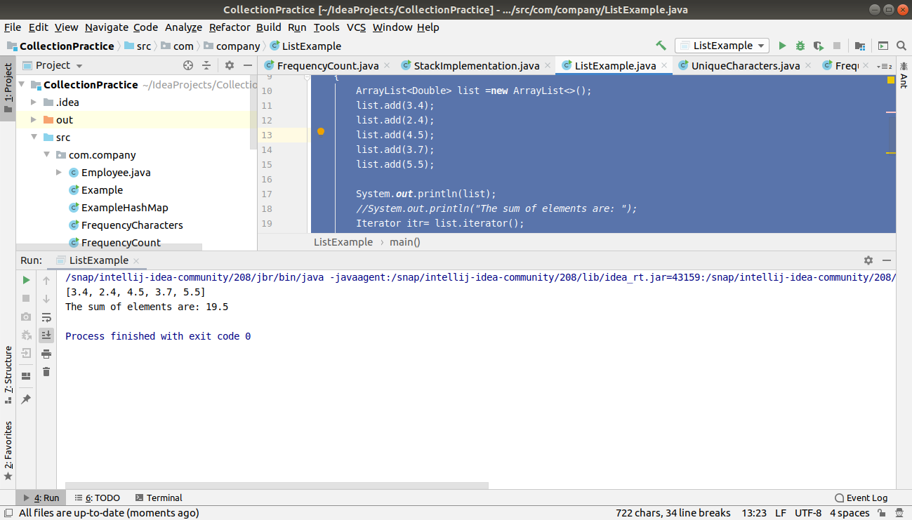

2) Write a method that takes a string and returns the number of unique characters in the string.

package com.company;
import java.util.HashSet;
import java.util.Scanner;
public class UniqueCharacters {
public static void main(String[] args) throws Exception {
Scanner sc = new Scanner(System.in);
System.out.println("Please enter the string: ");
String input = sc.nextLine();
System.out.println("The unique characters are: " + isUnique(input));
}
private static int isUnique(String input) {
char[]array=input.toCharArray();
HashSet<Character> hashSet = new HashSet<Character>();
for(int i=0;i<array.length;i++)
{
hashSet.add(array[i]);
}
return hashSet.size();
}
}
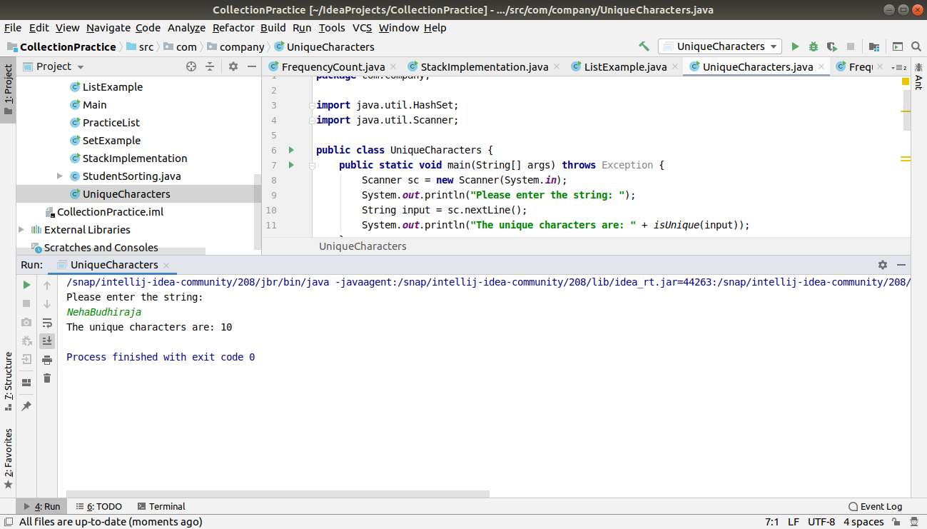

3) Write a method that takes a string and print the number of occurrence of each character characters in the string.

package com.company;
import java.util.HashMap;
import java.util.Scanner;
public class FrequencyCharacters {
public static void Frequencycount(String input) {
HashMap<Character, Integer> frequency = new HashMap<Character, Integer>();
char[] charArray = input.toCharArray();
for (char ch : charArray) {
if (frequency.containsKey(ch)) {
frequency.put(ch, frequency.get(ch) + 1);
} else
{
frequency.put(ch, 1);
}
}
System.out.println("Input string is: " + input + " has occurence as: " + frequency);
}
public static void main(String[] args) {
Scanner sc = new Scanner(System.in);
System.out.println("Please enter the string: ");
String input = sc.nextLine();
String output=input.toLowerCase();
Frequencycount(output);
}
}
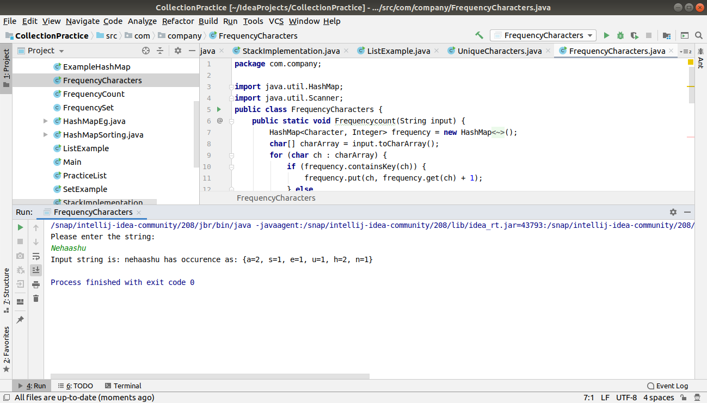
4) Write a program to sort HashMap by value.

package com.company;
import java.util.*;
class SortMap implements Comparator<Map.Entry<Integer,String>> {
@Override
public int compare(Map.Entry<Integer, String> integerStringEntry, Map.Entry<Integer, String> t1) {
return integerStringEntry.getValue().compareTo(t1.getValue());
}
}
public class HashMapSorting {
public static void main(String[] args) {
HashMap<Integer, String> hmap = new HashMap<Integer, String>();
hmap.put(1, "D");
hmap.put(5, "A");
hmap.put(7, "H");
hmap.put(10, "C");
hmap.put(9, "T");
System.out.println("Before Sorting: ");
for (Map.Entry<Integer, String> entry : hmap.entrySet()) {
int key = entry.getKey();
String value = entry.getValue();
System.out.println(key + ": " + value);
}
System.out.println("After sorting...");
List<Map.Entry<Integer, String>> lists = new ArrayList<Map.Entry<Integer, String>>(hmap.entrySet());
Collections.sort(lists, new SortMap());
//System.out.println("After sorting");
System.out.println(lists);
}
}
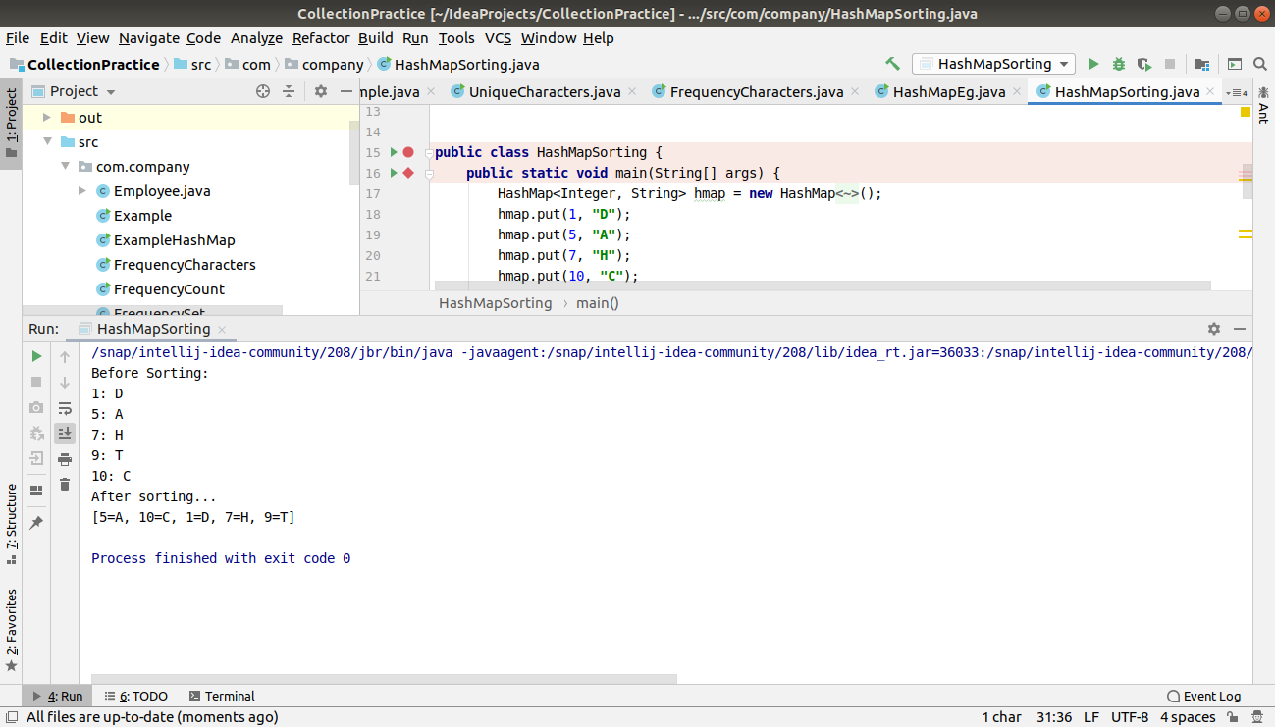
5) Write a program to sort Employee objects based on highest salary using Comparator. Employee class{ Double Age; Double Salary; String Name

package com.company;
import java.util.*;
import java.util.Collection;
import java.util.Collections;
import java.util.List;
public class Employee
{
private double salary;
private double age;
private String name;
public Employee(double salary,double age,String name)
{
this.salary=salary;
this.name=name;
this.age=age;
}
public double getAge() {
return age;
}
public double getSalary() {
return salary;
}
public String getName() {
return name;
}
public void setAge(double age) {
this.age = age;
}
public void setSalary(double salary) {
this.salary = salary;
}
public void setName(String name) {
this.name = name;
}
@Override
public String toString() {
return "Employee{" +
"salary=" + salary +
", age=" + age +
", name='" + name + '\'' +
'}';
}
}
class DoubleLengthComparator implements Comparator<Employee> {
@Override
public int compare(Employee employee, Employee t1) {
if(employee.getSalary()>t1.getSalary())
{
return -1;
}
else if(employee.getSalary()<t1.getSalary())
{
return 1;
}
return 0;
}
}
class HighestSalary {
public static void main(String[] args) {
Employee e1 = new Employee(15000, 23, "Neha");
Employee e2 = new Employee(13000, 27, "Ashu");
Employee e3 = new Employee(12000, 21, "Nisha");
Employee e4 = new Employee(16000, 20, "Shreya");
Employee e5 = new Employee(18000, 27, "Akshita");
List<Employee> employees = new ArrayList<Employee>();
employees.add(e1);
employees.add(e2);
employees.add(e3);
employees.add(e4);
employees.add(e5);
System.out.println("Before Sorting");
System.out.println(employees);
System.out.println("\n");
Collections.sort(employees,new DoubleLengthComparator());
System.out.println("After Sorting");
System.out.println(employees);
}
}
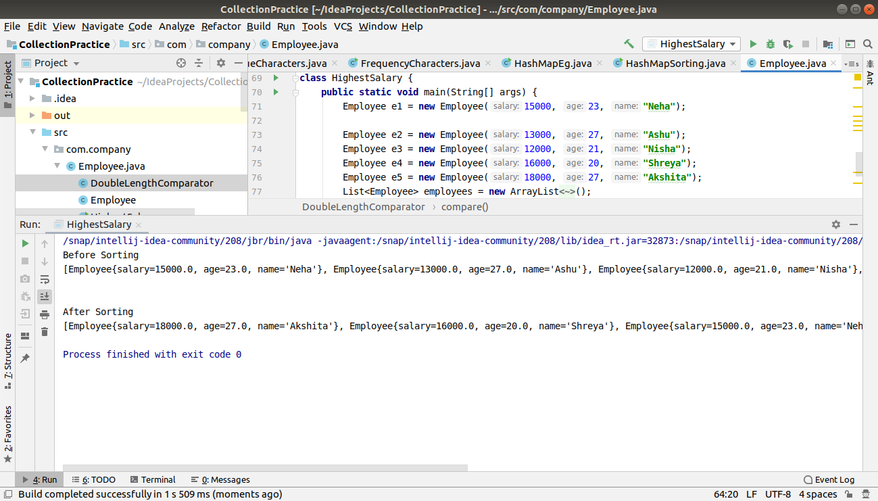
6) Write a program to sort the Student objects based on Score , if the score are same then sort on First Name . Class Student{ String Name; Double Score; Double Age

package com.company;
import java.util.ArrayList;
import java.util.Collections;
import java.util.Comparator;
import java.util.List;
public class StudentSorting
{
private String name;
private double score;
double age;
public StudentSorting(String name,double score,double age)
{
this.name=name;
this.score=score;
this.age=age;
}
public void setName(String name) {
this.name = name;
}
public String getName() {
return name;
}
public void setAge(double age) {
this.age = age;
}
public double getAge() {
return age;
}
public double getScore() {
return score;
}
public void setScore(double score) {
this.score = score;
}
@Override
public String toString() {
return "StudentSorting{" +
"name='" + name + '\'' +
", score=" + score +
", age=" + age +
'}';
}
}
class HighestScore implements Comparator<StudentSorting> {
@Override
public int compare(StudentSorting studentSorting, StudentSorting t1) {
if (studentSorting.getScore() > t1.getScore()) {
return 1;
} else if (studentSorting.getScore() < t1.getScore()) {
return -1;
} else {
return (studentSorting.getName().compareTo(t1.getName()));
}
}
}
class SalaryStudent
{
public static void main(String[] args)
{
StudentSorting s1=new StudentSorting("Neha",56,23);
StudentSorting s2=new StudentSorting("Pradyut",46,22);
StudentSorting s3=new StudentSorting("Nisha",46,21);
StudentSorting s4=new StudentSorting("Udit",52,20);
StudentSorting s5=new StudentSorting("Shreya",32,25);
List<StudentSorting> lists=new ArrayList<StudentSorting>();
lists.add(s1);
lists.add(s2);
lists.add(s3);
lists.add(s4);
lists.add(s5);
System.out.println("Before sorting...");
System.out.println(lists);
System.out.println("After Sorting...");
Collections.sort(lists,new HighestScore());
System.out.println(lists);
}
}
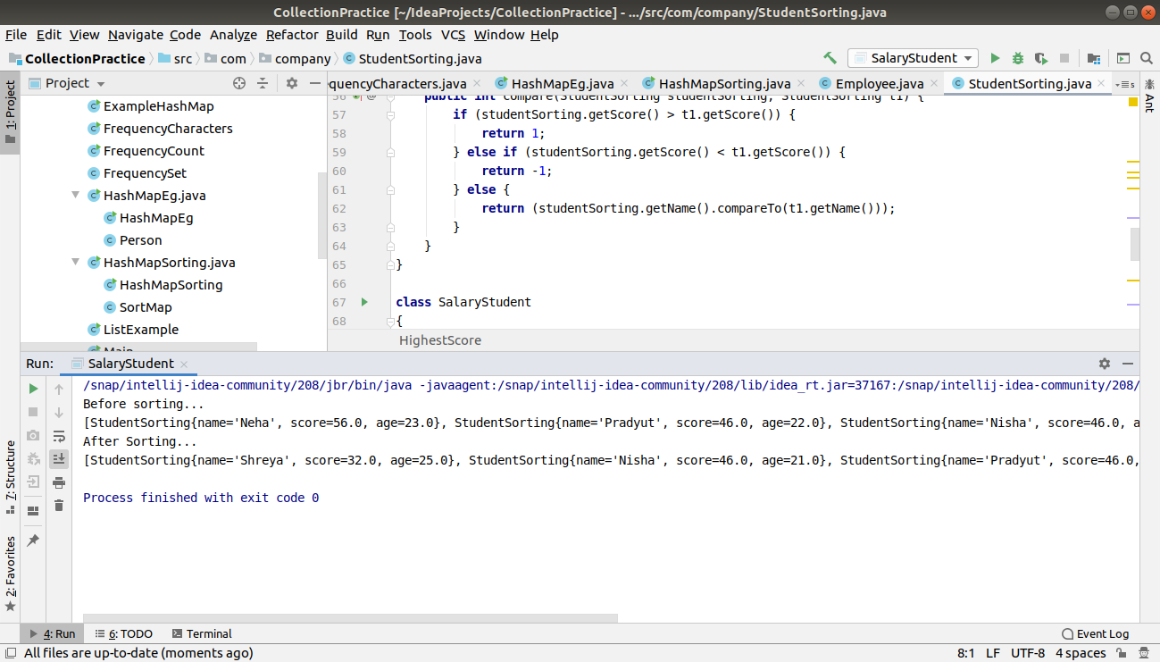
7) Print the elements of an array in the decreasing frequency if 2 numbers have same frequency then print the one which came first.

package com.company;
import java.util.*;
public class FrequencyCount
{
public static void SortByFrequency(int[] input)
{
Map<Integer, Integer> hmap = new LinkedHashMap<>();
for (int i = 0; i < input.length; i++) {
if (hmap.containsKey(input[i])) {
hmap.put(input[i], hmap.get(input[i])+1);
} else {
hmap.put(input[i], 1);
}
}
ArrayList<Map.Entry<Integer, Integer>> list = new ArrayList<Map.Entry<Integer, Integer>>(hmap.entrySet());
Collections.sort(list, new Comparator<Map.Entry<Integer, Integer>>() {
@Override
public int compare(Map.Entry<Integer, Integer> integerIntegerEntry, Map.Entry<Integer, Integer> t1) {
return integerIntegerEntry.getValue().compareTo(t1.getValue());
}
});
System.out.println("Array before sorting:" + Arrays.toString(input));
//System.out.println(input);
System.out.println("Elements in descending order: ");
for (Map.Entry<Integer, Integer> entry : list) {
int frequency = entry.getValue();
while (frequency >= 1) {
System.out.print(entry.getKey() + " ");
frequency--;
}
}
}
public static void main(String[] args)
{
int output[]={2,3,4,1,2,3,1,4,6,6,6,6,2};
SortByFrequency(output);
}
}
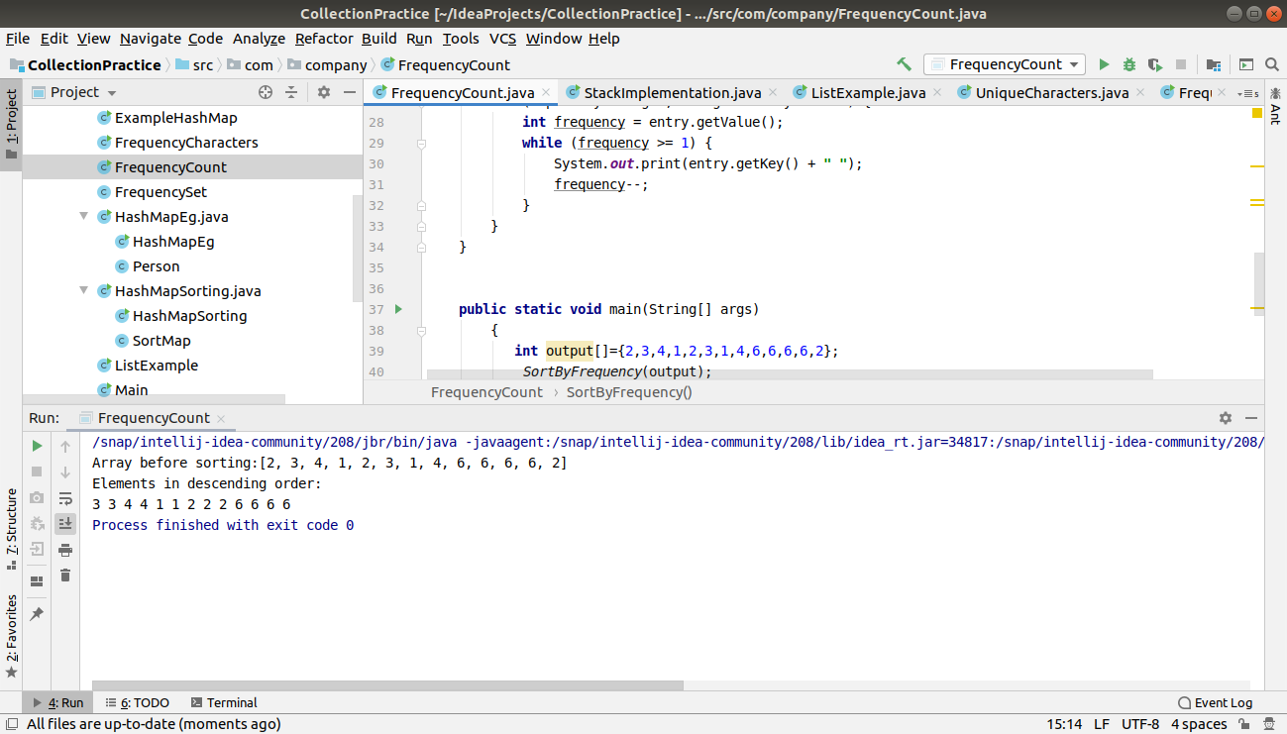
8) Design a Data Structure SpecialStack that supports all the stack operations like push(), pop(), isEmpty(), isFull() and an additional operation getMin() which should return minimum element from the SpecialStack. (Expected complexity O(1))
package com.company;
import java.util.Stack;
public class StackImplementation extends Stack<Integer>
{
Stack<Integer> auxstack=new Stack<>();
void push(int x) {
if (isEmpty() == true) {
super.push(x);
auxstack.push(x);
} else {
super.push(x);
int y = auxstack.pop();
auxstack.push(y);
if (x < y) {
auxstack.push(x);
} else {
auxstack.push(y);
}
}
}
public Integer pop(int x)
{
int x1=super.pop();
auxstack.pop();
return x1;
}
public void isFull()
{
if(super.size()>super.capacity())
{
System.out.println("Stack is full");
}
}
int getMin()
{
int x=auxstack.pop();
auxstack.push(x);
return x;
}
public static void main(String[] args) {
StackImplementation stack=new StackImplementation();
stack.push(30);
stack.push(20);
stack.push(40);
stack.push(5);
stack.pop(5);
System.out.println("The minimum element:" +stack.getMin());
stack.push(1);
System.out.println("The minimum element after adding:" +stack.getMin());
}
}

