MULTITHREADING ASSIGNMENT

1. Name of method in Thread class to pause execution?

package com.company;
public class TestSleepMethod extends Thread
{
public void run()
{
for (int i = 1; i < 5; i++)
{
try
{
Thread.sleep(300);
} catch (InterruptedException e) {
System.out.println(e);
}
System.out.println(i);
}
}
public static void main(String[] args)
{
TestSleepMethod t1=new TestSleepMethod();
TestSleepMethod t2=new TestSleepMethod();
t1.start();
t2.start();
}
}
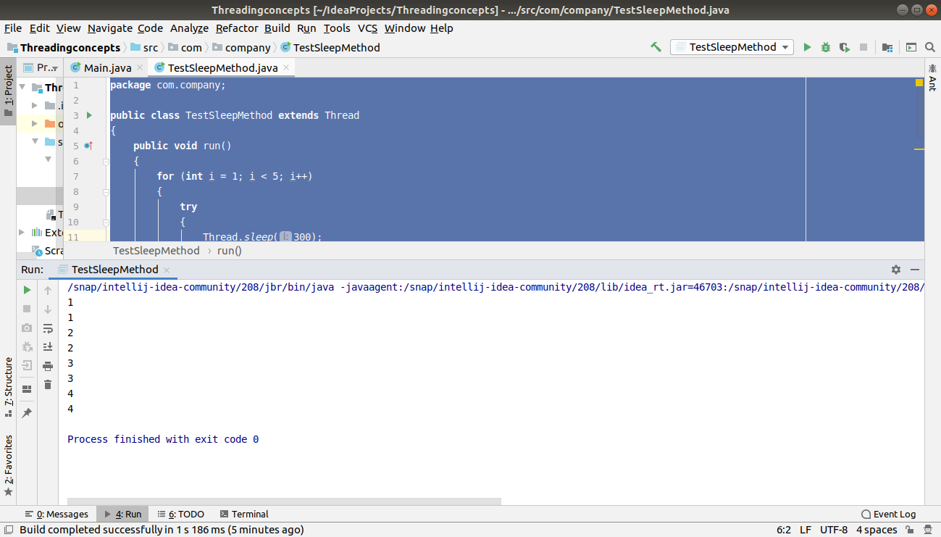

2. Role of "volatile" keyword.

package com.company;
import java.util.Scanner;
public class Processor extends Thread
{
private volatile boolean running =true;
public void run()
{
while(running)
{
System.out.println("Running");
try
{
Thread.sleep(20);
}
catch(InterruptedException e)
{
e.printStackTrace();
}
}
}
public void shutdown()
{
running=false;
}
public static void main(String[] args)
{
Processor pr=new Processor();
pr.start();
new Scanner(System.in).nextLine();
pr.shutdown();
}
}
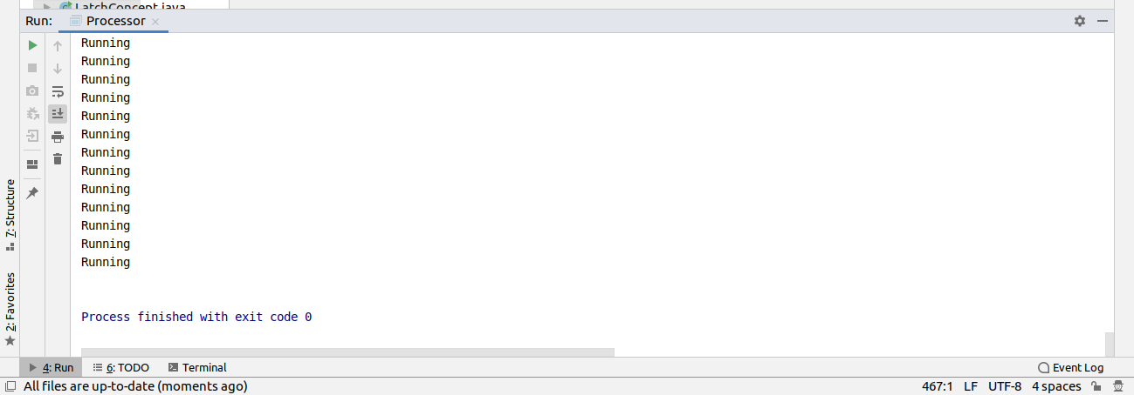

3. Write a program to create a thread using Thread class and Runnable interface each.

(Extending Thread class)

package com.company;
public class ExtendingThread extends Thread
{
public void run()
{
for(int i=0;i<5;i++)
{
System.out.println("Hello: " +i);
try
{
Thread.sleep(150);
}catch(InterruptedException e)
{
System.out.println(e);
e.printStackTrace();
}
}
}
public static void main(String[] args)
{
ExtendingThread ex=new ExtendingThread();
ex.start();
ExtendingThread ex2=new ExtendingThread();
ex2.start();
}
}
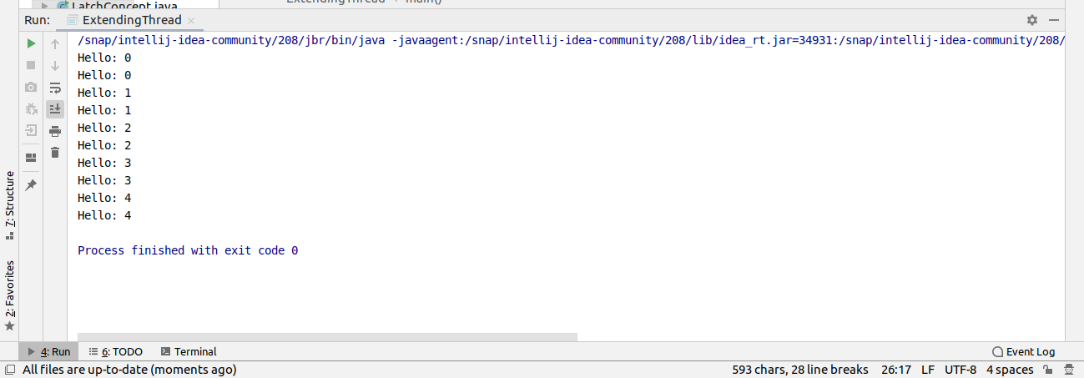

(Implementing Runnable Interface)

package com.company;
public class RunnableInterface implements Runnable
{
@Override
public void run()
{
for(int i=0;i<5;i++)
{
System.out.println("Hello Hi: " +i);
try
{
Thread.sleep(100);
}catch(InterruptedException e)
{
System.out.println(e);
e.printStackTrace();
}
}
}
public static void main(String[] args)
{
Thread rn=new Thread(new RunnableInterface());
rn.start();
}
}
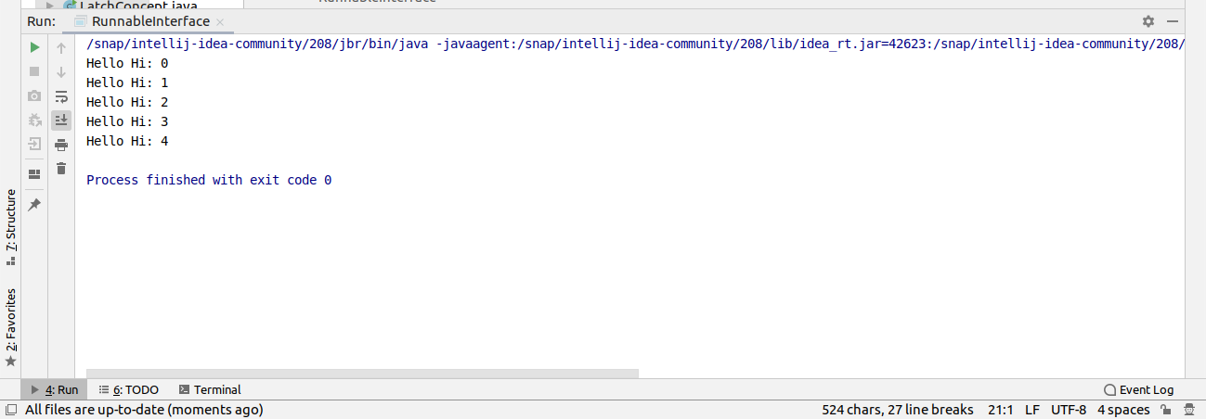
4.Write a program using synchronization block and synchronization method

(Synchronized block)

package com.company;
public class SynchronizedBlockNew
{
void printTable(int n){
synchronized(this){//synchronized block
for(int i=1;i<=5;i++){
System.out.println(n*i);
try{
Thread.sleep(400);
}catch(Exception e){System.out.println(e);}
}
}
}//end of the method
}
class MyThread1 extends Thread{
SynchronizedBlockNew t;
MyThread1(SynchronizedBlockNew t){
this.t=t;
}
public void run(){
t.printTable(5);
}
}
class MyThread2 extends Thread{
SynchronizedBlockNew t;
MyThread2(SynchronizedBlockNew t){
this.t=t;
}
public void run(){
t.printTable(100);
}
}
class TestSynchronizedBlock1{
public static void main(String args[]){
SynchronizedBlockNew obj = new SynchronizedBlockNew();
SynchronizedBlockNew obj1=new SynchronizedBlockNew();
MyThread1 t1=new MyThread1(obj);
MyThread2 t2=new MyThread2(obj1);
t1.start();
t2.start();
}
}
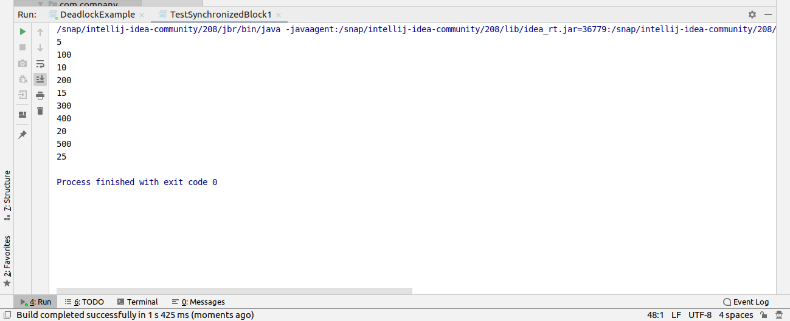

(Sychronized method)

package com.company;
public class SynchronizedMethodNew implements Runnable
{
private static int count=0;
public static synchronized void increment(){
count++;
}
public void display(){
System.out.println("Count is "+count);
}
@Override
public void run() {
for(int i=0;i<1000;i++){
increment();
}
}
}
class ExperimentMethod{
public static void main(String[] args) {
SynchronizedMethodNew inc=new SynchronizedMethodNew();
Thread t1=new Thread(new SynchronizedMethodNew());
Thread t2=new Thread(new SynchronizedMethodNew());
t1.start();
t2.start();
try {
t1.join();
t2.join();
} catch (InterruptedException e) {
e.printStackTrace();
}
inc.display();
}
}
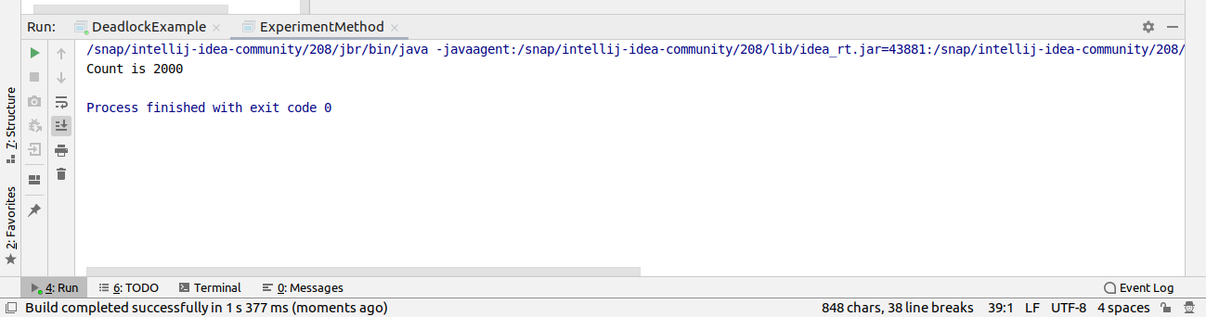

5.Write a program to create a Thread pool of 2 threads where one Thread will print even numbers and other will print odd numbers.

package com.company;
import java.util.concurrent.Executor;
import java.util.concurrent.ExecutorService;
import java.util.concurrent.Executors;
import java.util.concurrent.TimeUnit;
public class Even implements Runnable
{
@Override
public void run()
{
System.out.println("Even Number");
for(int i=1;i<10;i++)
{
if(i%2==0)
{
System.out.println("Even number " +i+ ",");
}
}
}
}
class Odd implements Runnable
{
@Override
public void run()
{
System.out.println("Odd number");
for(int i=1;i<10;i++)
{
if(i%2!=0)
{
System.out.println("Odd number " +i+ ",");
}
}
}
}
class OddEven
{
public static void main(String[] args)
{
ExecutorService executorService= Executors.newFixedThreadPool(2);
executorService.submit(new Even());
executorService.submit(new Odd());
executorService.shutdown();
try
{
executorService.awaitTermination(1, TimeUnit.DAYS);
} catch (InterruptedException e)
{
}
System.out.println("All tasks completed.");
}
}
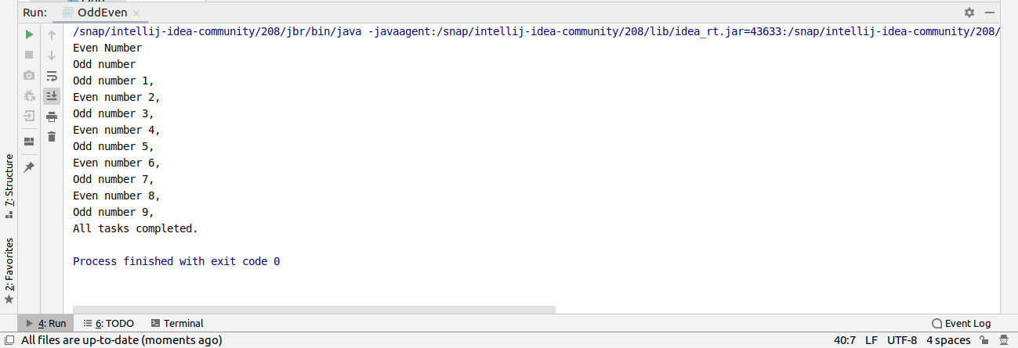

6.Write a program to demonstrate wait and notify methods.

package com.company;
import java.util.Scanner;
public class ProducerConsumer {
public void Producer() throws InterruptedException {
synchronized (this) {
System.out.println("Producer thread runnung...");
wait();
System.out.println("Resumed from it...");
}
}
public void Consumer() throws InterruptedException {
Scanner scanner = new Scanner(System.in);
Thread.sleep(2000);
synchronized (this) {
System.out.println("waiting for return key...");
scanner.nextLine();
System.out.println("Return key pressed...");
notify();
Thread.sleep(5000);
}
}
}
class Threadexample
{
public static void main(String[] args) throws InterruptedException {
final ProducerConsumer pc=new ProducerConsumer();
Thread thread=new Thread(new Runnable() {
@Override
public void run() {
try
{
pc.Producer();
} catch(InterruptedException e)
{
e.printStackTrace();
}
}
});
Thread thread2=new Thread(new Runnable() {
@Override
public void run()
{
try
{
pc.Consumer();
}
catch(InterruptedException e)
{
e.printStackTrace();
}
}
});
thread.start();
thread2.start();
// thread.join();
//thread2.join();
}
}
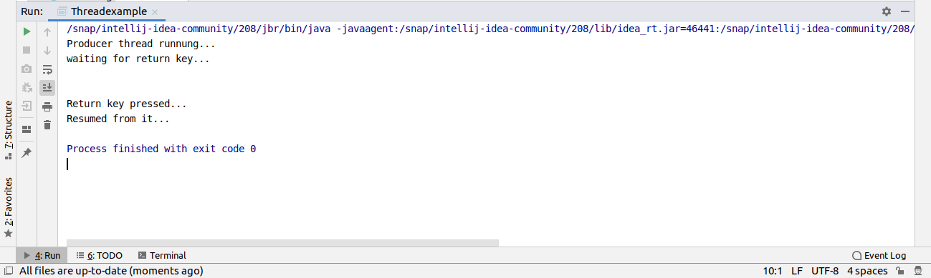

7. Write a program to demonstrate sleep and join methods.

package com.company;
public class SleepJoin implements Runnable
{
static int counter = 0;
@Override
public void run() {
try {
Thread.sleep(5000);
System.out.println("Running Thread");
} catch (InterruptedException e) {
e.printStackTrace();
}
}
}
class MethodSleepJoin
{
public static void main(String[] args) {
Thread t1=new Thread(new SleepJoin());
Thread t2=new Thread(new SleepJoin());
t1.start();
t2.start();
try {
t1.join();
t2.join();
} catch (InterruptedException e) {
e.printStackTrace();
}
System.out.println("Main Ended");
}
}
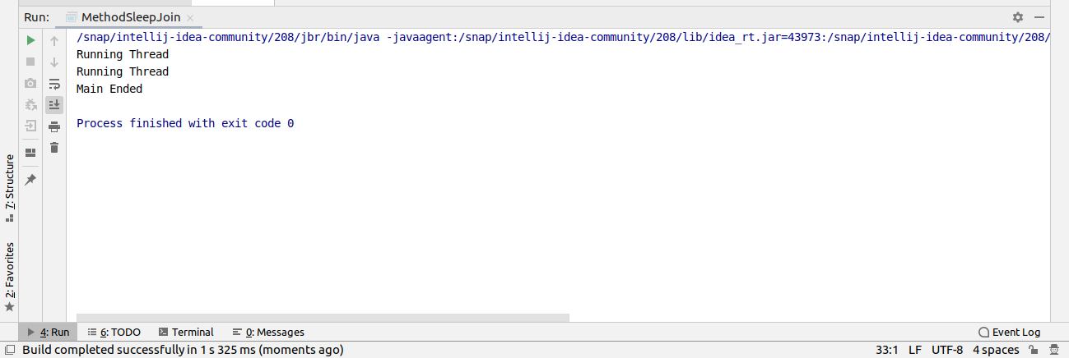

8. Run a task with the help of callable and store it's result in the Future.

package com.company;
import java.io.IOException;
import java.util.Random;
import java.util.concurrent.*;
public class CallableFuture
{
public static void main(String[] args)
{
ExecutorService executor= Executors.newCachedThreadPool();
Future<Integer> future=executor.submit(new Callable<Integer>()
{
@Override
public Integer call() throws Exception {
Random random = new Random();
int duration = random.nextInt(3000);
if (duration > 1500) {
throw new IOException("Sleeping has been too long");
}
System.out.println("Starting....");
try {
Thread.sleep(duration);
} catch (InterruptedException e) {
e.printStackTrace();
}
System.out.println("Finish....");
return duration;
}
});
executor.shutdown();
try
{
System.out.println("Result is: " +future.get());
}
catch(InterruptedException e)
{
e.printStackTrace();
}
catch (ExecutionException e)
{
e.getStackTrace();
//System.out.println(e.getMessage());
}
}
}
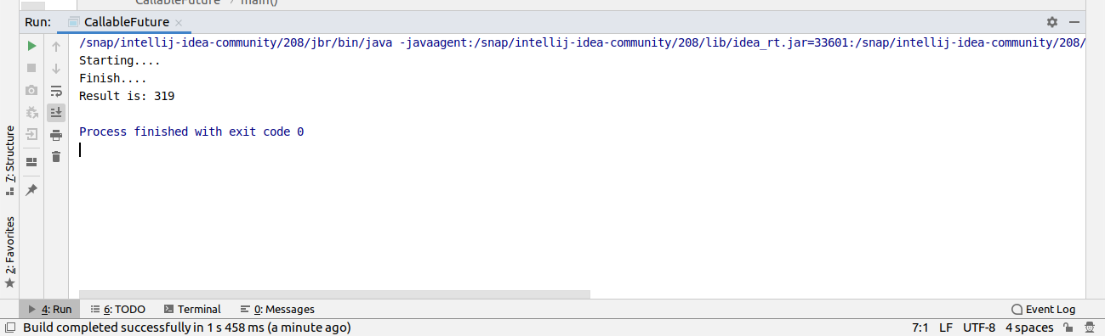

9.Write a program to demonstrate the use of semaphore

package com.company;
import java.util.concurrent.Semaphore;
class Shared{
static int count=0;
}
public class SemaphoreUse extends Thread
{
Semaphore sem;
public String threadName;
SemaphoreUse(Semaphore sem,String threadName)
{
super(threadName);
this.sem=sem;
this.threadName=threadName;
}
@Override
public void run() {
if(this.getName().equals("A")){
System.out.println("waiting for lock for "+threadName);
try {
sem.acquire();
} catch (InterruptedException e) {
e.printStackTrace();
}
for(int i=0;i<5;i++){
Shared.count++;
System.out.println("the value of shared resource is "+Shared.count+" in "+threadName);
}
System.out.println("lock acquired for "+threadName);
try {
Thread.sleep(1000);
} catch (InterruptedException e) {
e.printStackTrace();
}
sem.release();
System.out.println("lock is released by "+threadName);
}
if(this.getName().equals("B")){
System.out.println("waiting for lock for "+threadName);
try {
sem.acquire();
} catch (InterruptedException e) {
e.printStackTrace();
}
for(int i=0;i<5;i++){
Shared.count--;
System.out.println("the value of shared resource is "+Shared.count+" in"+threadName);
}
System.out.println("lock acquired for "+threadName);
try {
Thread.sleep(1000);
} catch (InterruptedException e) {
e.printStackTrace();
}
sem.release();
System.out.println("lock is released by "+threadName);
}
}
}
class SemaphoreDemo {
public static void main(String[] args) {
Semaphore sem=new Semaphore(1);
SemaphoreUse test1=new SemaphoreUse(sem,"A");
SemaphoreUse test2=new SemaphoreUse(sem,"B");
test1.start();
test2.start();
try {
test1.join();
test2.join();
} catch (InterruptedException e) {
e.printStackTrace();
}
System.out.println("Value of shared resources is "+Shared.count);
}
}
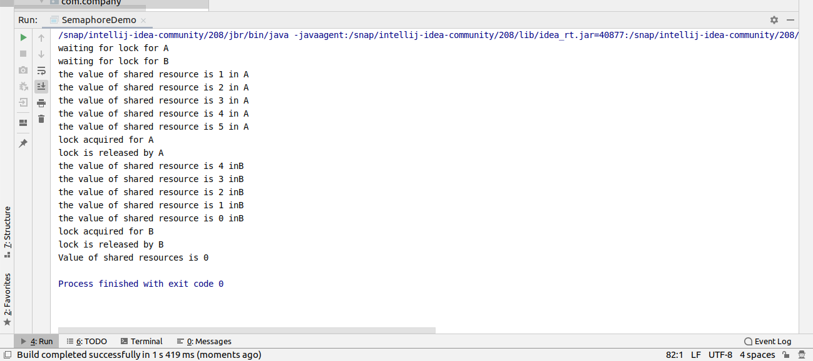

10. Write a program to demonstrate the use of CountDownLatch

package com.company;
import java.util.concurrent.CountDownLatch;
public class LatchConcept
{
public static void main(String[] args) throws InterruptedException
{
CountDownLatch latch = new CountDownLatch(4);
Worker worker1 = new Worker(500, latch, "WORKER-1");
Worker worker2 = new Worker(500, latch, "WORKER-2");
Worker worker3 = new Worker(500, latch, "WORKER-3");
Worker worker4 = new Worker(500, latch, "WORKER-4");
worker1.start();
worker2.start();
worker3.start();
worker4.start();
latch.await();
System.out.println(Thread.currentThread().getName() + " has finished");
}
}
class Worker extends Thread
{
private int delay;
private CountDownLatch latch;
public Worker(int delay,CountDownLatch latch,String name)
{
super(name);
this.delay=delay;
this.latch=latch;
}
@Override
public void run() {
try
{
Thread.sleep(1000);
latch.countDown();
System.out.println(Thread.currentThread().getName()
+ " finished");
}catch(InterruptedException e)
{
e.printStackTrace();
}
}
}
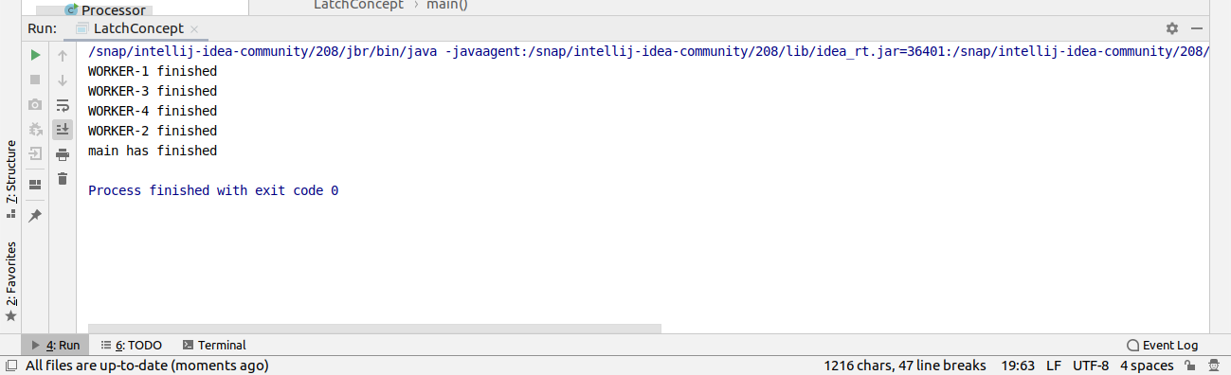

11 . Write a program which creates deadlock between 2 threads

package com.company;
class DeadlockClass
{
public synchronized void test1(DeadlockClass s2)
{
System.out.println("test1-begin");
try {
Thread.sleep(1000);
} catch (InterruptedException e) {
e.printStackTrace();
}
s2.test2(this);
System.out.println("test1-end");
}
public synchronized void test2(DeadlockClass s1)
{
System.out.println("test2-begin");
try {
Thread.sleep(1000);
} catch (InterruptedException e) {
e.printStackTrace();
}
s1.test1(this);
System.out.println("test2-end");
}
}
class Thread4 extends Thread
{
private DeadlockClass s1;
private DeadlockClass s2;
public Thread4(DeadlockClass s1, DeadlockClass s2)
{
this.s1 = s1;
this.s2 = s2;
}
@Override
public void run()
{
s1.test1(s2);
}
}
class Thread5 extends Thread
{
private DeadlockClass s1;
private DeadlockClass s2;
public Thread5(DeadlockClass s1, DeadlockClass s2)
{
this.s1 = s1;
this.s2 = s2;
}
@Override
public void run()
{
s2.test2(s1);
}
}
class DeadlockExample
{
public static void main(String[] args)
{
DeadlockClass s1 = new DeadlockClass();
DeadlockClass s2 = new DeadlockClass();
Thread4 t1 = new Thread4(s1, s2);
t1.start();
Thread5 t2 = new Thread5(s1, s2);
t2.start();
try {
Thread.sleep(2000);
} catch (InterruptedException e) {
e.printStackTrace();
}
}
}
