Neha Cathrin A

1BM19CS099

Lab Program 1:

Develop a Java program that prints all real solutions to the quadratic equation ax2 +bx+c = 0.

Read in a, b, c and use the quadratic formula. If the discriminate b2-4ac is negative, display a message stating that there are no real solutions.

import java.util.*;

class quadratic

{

public static void main(String args[])

{

Scanner sc=new Scanner(System.in);

int a,b,c;

double d,r1,r2;

System.out.println("enter values of a b and c in a quadratic equation");

a=sc.nextInt();

b=sc.nextInt();

c=sc.nextInt();

d=b*b-(4*a*c);

if(d<0)

System.out.println("no real solution");

else

{

d=Math.sqrt(d);

r1=(-b+d)/(2.0*a);

r2=(-b-d)/(2.0*a);

System.out.println("roots are real ");

System.out.println(" roots of the equation are "+r1+" and "+r2);

}

}

}

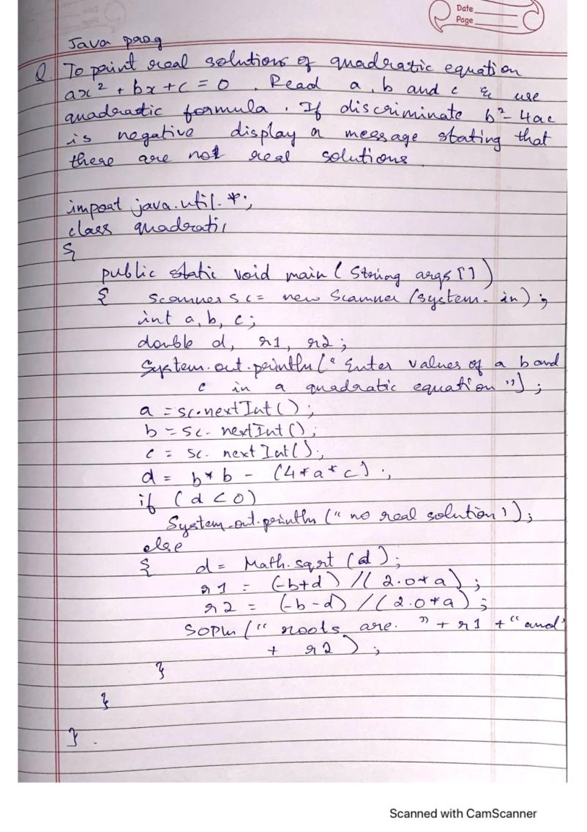

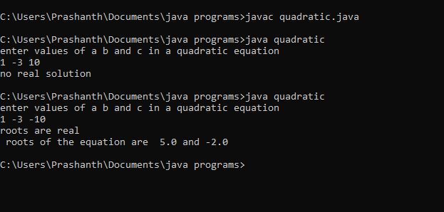

Lab Program 2:

Develop a Java program to create a class Student with members usn, name, an array

credits and an array marks. Include methods to accept and display details and a method to

calculate SGPA of a student.

import java.util.*;

class student

{

String usn,name;

static int credits[];

static double marks[];

void input(int n)

{

Scanner sc=new Scanner(System.in);

System.out.println("enter usn and name ");

usn=sc.nextLine();

name=sc.nextLine();

System.out.println("enter marks along with credits");

for(int i=0;i<n;i++)

{

marks[i]=sc.nextDouble();

credits[i]=sc.nextInt();

System.out.println();

}

}

double calculate(int n)

{

int c,cred=0;

double tot,total=0.0;

for(int i=0;i<n;i++)

{

tot=marks[i];

if(tot>=90)

c=10;

else if(tot>=80)

c=9;

else if(tot>=70)

c=8;

else if(tot>=60)

c=7;

else if(tot>=50)

c=6;

else if(tot>=40)

c=4;

else

c=0;

total=total+(c*credits[i]);

cred=cred+credits[i];

}

total=total/cred;

return(total);

}

void display(int n,float total)

{

System.out.println("name of student : "+name);

System.out.println("usn of student : "+usn);

System.out.println("marks of student along with credits of course");

for(int i=0;i<n;i++)

{

System.out.println(marks[i]+" "+credits[i]);

}

System.out.println("sgpa of student : "+total);

}

public static void main(String args[])

{

Scanner sc=new Scanner(System.in);

student obj=new student();

System.out.println("enter no of course ");

int n=sc.nextInt();

credits=new int[n];

marks=new double[n];

obj.input(n);

double total=obj.calculate(n);

float res=(float)total;

obj.display(n,res);

}

}

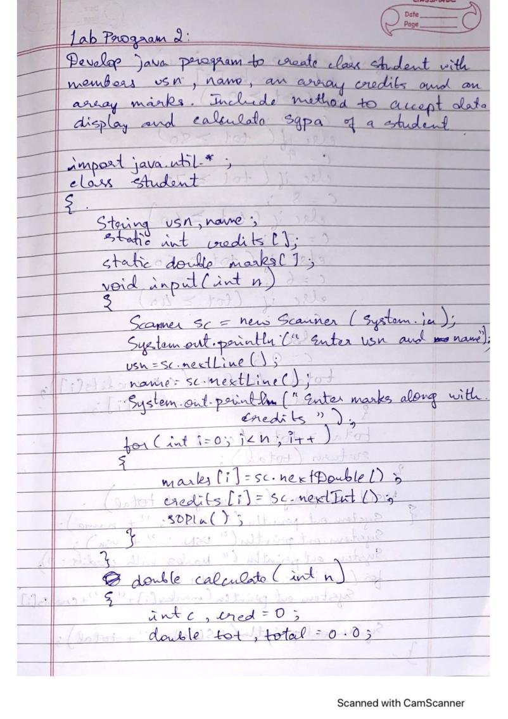

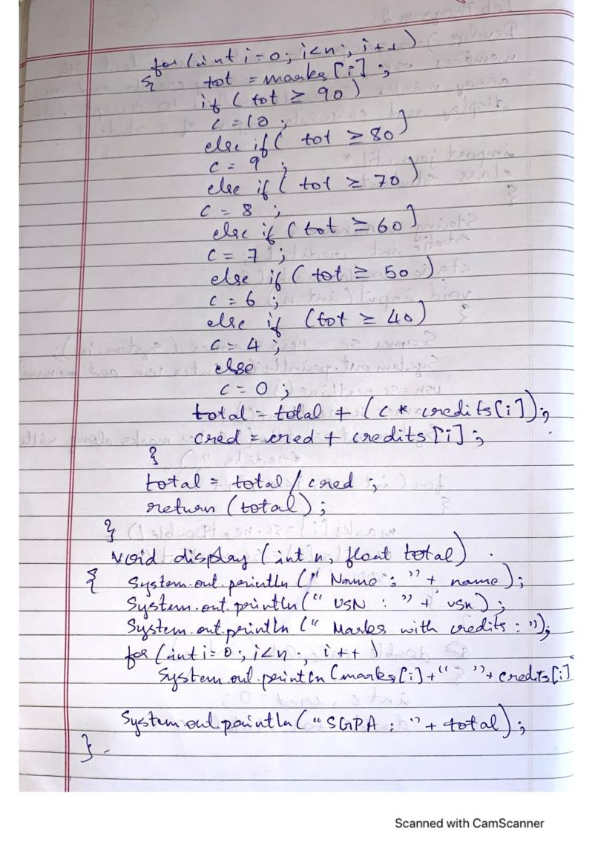

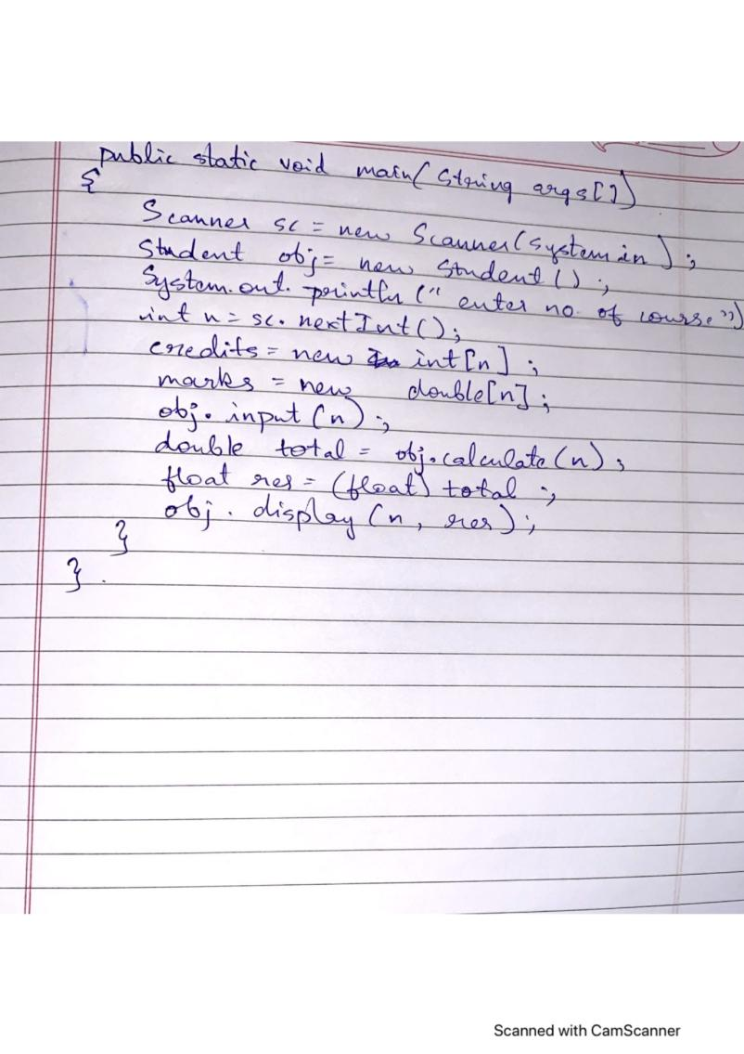

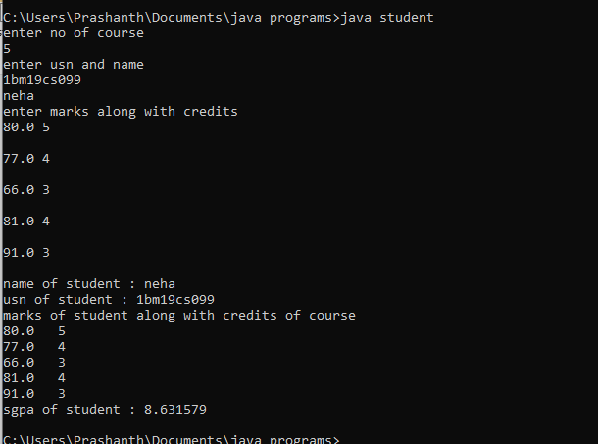

Lab Program - 3

Create a class Book which contains four members: name, author, price,

num_pages. Include a constructor to set the values for the members. Include

methods to set and get the details of the objects. Include a toString( ) method

that could display the complete details of the book. Develop a Java program to

create n book objects.

import java.util.*;

class book

{

String name,author;

int price,num_pages;

book(String nam,String a,int p,int nno)

{

name=nam;

author=a;

price=p;

num_pages=no;

}

static String accept_name()

{

Scanner sc=new Scanner(System.in);

System.out.println("enter name of the book");

return(sc.nextLine());

}

static String accept_author()

{

Scanner sc=new Scanner(System.in);

System.out.println("enter name of the author");

return(sc.nextLine());

}

static int accept_price()

{

Scanner sc=new Scanner(System.in);

System.out.println("enter price of the book");

return(sc.nextInt());

}

static int accept_pages()

{

Scanner sc=new Scanner(System.in);

System.out.println("enter no of pages of the book");

return(sc.nextInt());

}

public String toString()

{

return("name : "+name+"\n author : "+author+"\n price : "+price+"\n no of pages : "+num_pages);

}

public static void main(String args[])

{

Scanner sc=new Scanner(System.in);

int n;

System.out.println("enter value of n");

n=sc.nextInt();

String nam,a;

int p,no;

book []obj=new book[n];

for(int i=0;i<n;i++)

{

nam=accept_name();

a=accept_author();

p=accept_price();

no=accept_pages();

obj[i]=new book(nam,a,p,no);

}

int x=1;

for(int i=0;i<n;i++)

{

System.out.println("BOOK "+(x++));

System.out.println(obj[i]);

}

}

}

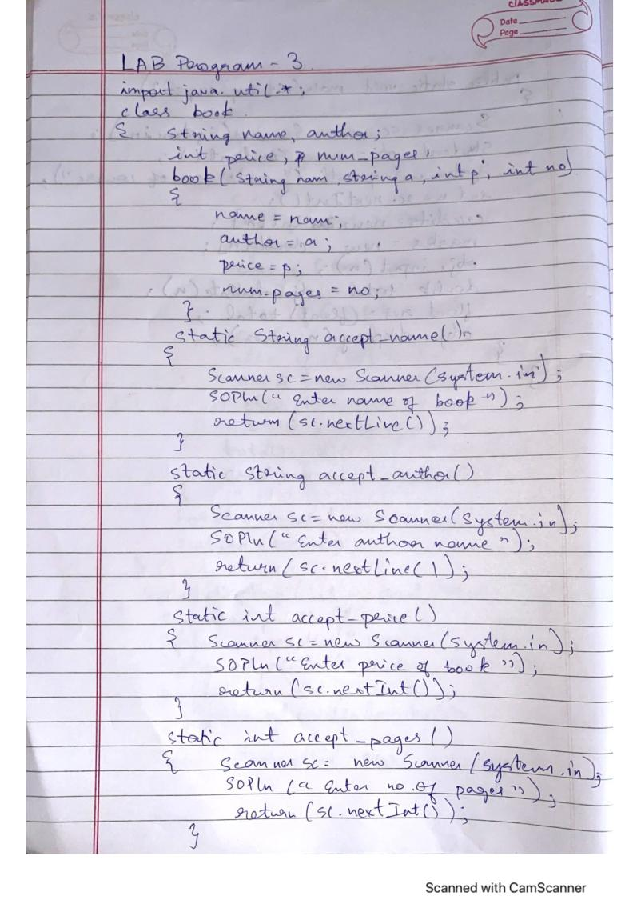

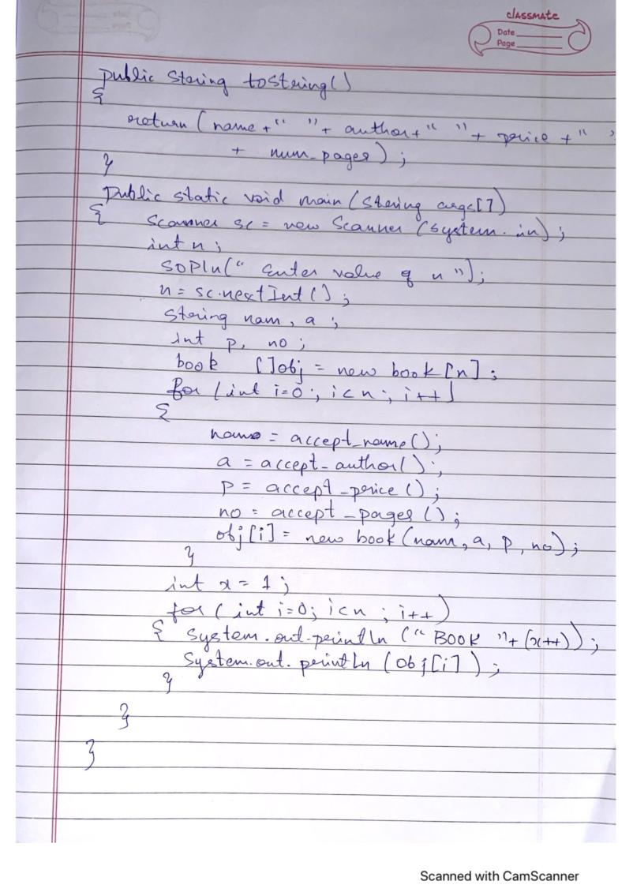

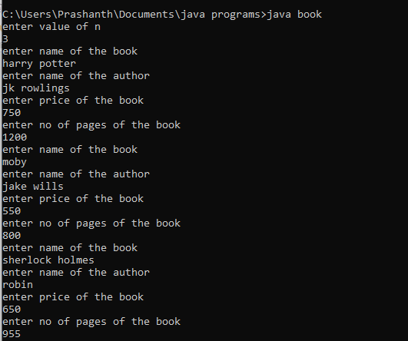

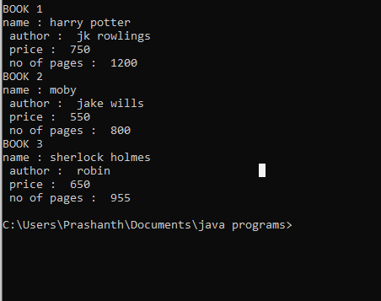

Lab Program 4:

Develop a Java program to create an abstract class named Shape that contains two integers and

an empty method named printArea( ). Provide three classes named Rectangle, Triangle and

Circle such that each one of the classes extends the class Shape. Each one of the classes contain

only the method printArea( ) that prints the area of the given shape.

/*Develop a Java program to create an abstract class named Shape that contains two integers and

an empty method named printArea( ). Provide three classes named Rectangle, Triangle and

Circle such that each one of the classes extends the class Shape. Each one of the classes contain

only the method printArea( ) that prints the area of the given shape.*/

import java.util.*;

abstract class shape

{

int a,b;

abstract void printArea();

}

class rectangle extends shape

{

float area_rec;

void printArea()

{

area_rec=a*b;

System.out.println("area of rectangle = "+area_rec);

}

}

class triangle extends shape

{

float area_tri;

void printArea()

{

area_tri=0.5f*a*b;

System.out.println("area of triangle = "+area_tri);

}

}

class circle extends shape

{

float area_cir;

void printArea()

{

area_cir=3.14f*a*a;

System.out.println("area of circle = "+area_cir);

}

}

class area_shapes

{

public static void main(String args[])

{

Scanner sc=new Scanner(System.in);

rectangle a1=new rectangle();

System.out.println("enter length and breath of rectangle");

a1.a=sc.nextInt();

a1.b=sc.nextInt();

a1.printArea();

triangle a2=new triangle();

System.out.println("enter base and height of triangle");

a2.a=sc.nextInt();

a2.b=sc.nextInt();

a2.printArea();

circle a3=new circle();

System.out.println("enter radius of circle");

a3.a=sc.nextInt();

a3.printArea();

}

}

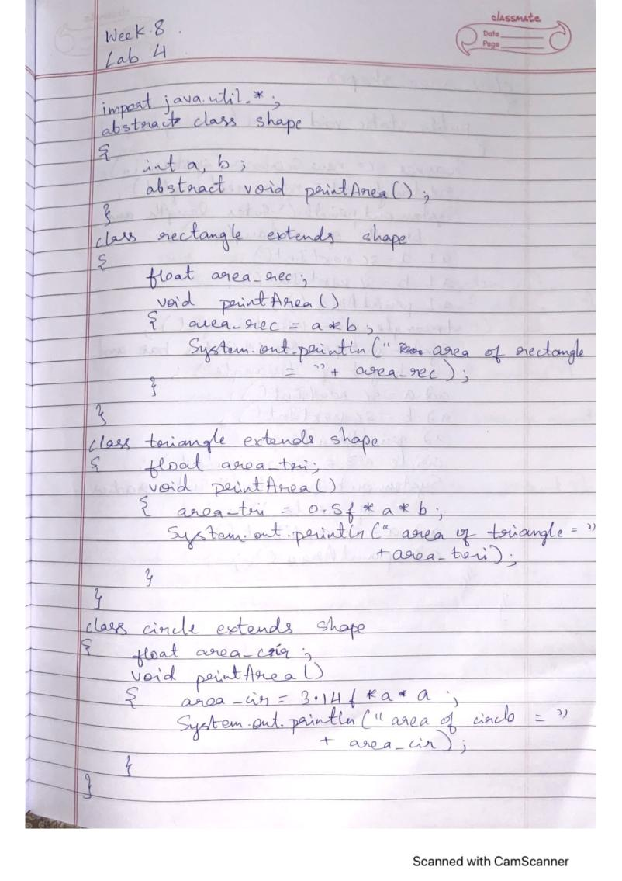

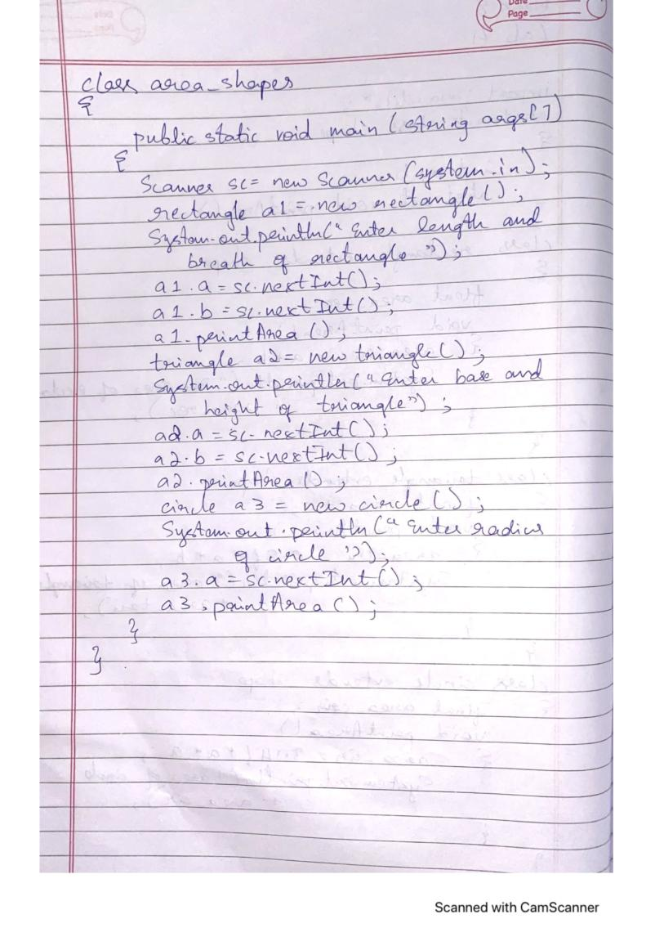

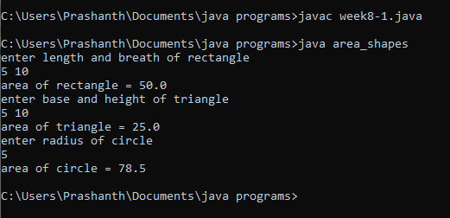

Lab Program 5:

Develop a Java program to create a class Bank that maintains two kinds of account for its

customers, one called savings account and the other current account. The savings account

provides compound interest and withdrawal facilities but no cheque book facility. The current

account provides cheque book facility but no interest. Current account holders should also

maintain a minimum balance and if the balance falls below this level, a service charge is

imposed. Create a class Account that stores customer name, account number and type of

account. From this derive the classes Curr-acct and Sav-acct to make them more specific to

their requirements. Include the necessary methods in order to achieve the following tasks: •

Accept deposit from customer and update the balance. • Display the balance. • Compute and

deposit interest • Permit withdrawal and update the balance • Check for the minimum balance,

impose penalty if necessary and update the balance

import java.util.*;

class account

{

String cust_name;

long acc_no;

double balance;

int type_acc;

void input()

{

Scanner sc=new Scanner(System.in);

System.out.println("-----enter account details-----");

System.out.println("enter customer name ");

cust_name=sc.nextLine();

System.out.println("enter customer account number");

acc_no=sc.nextLong();

System.out.println("enter customer's account type 1.savings account 2.current account");

type_acc=sc.nextInt();

System.out.println("enter customer's balance amount in account");

balance=sc.nextDouble();

}

void display()

{

System.out.println("-----customer's account details-----");

System.out.println("customer name\t"+cust_name);

System.out.println("customer account number\t"+acc_no);

System.out.println("customer's account type\t"+type_acc);

System.out.println("customer's balance amount in account\t"+balance);

}

void deposit()

{

Scanner sc=new Scanner(System.in);

double amt;

System.out.println("enter amount to be deposited ");

amt=sc.nextDouble();

balance=balance+amt;

System.out.println("customer's balance amount in account\t"+balance);

}

}

class Sav_acct extends account

{

double interest;

void compute_interest()

{

Scanner sc=new Scanner(System.in);

int rate,time;

System.out.println("enter rate and time period ");

rate=sc.nextInt();

time=sc.nextInt();

interest=balance*Math.pow(1+rate/100.0,time)-balance;

System.out.println("compound interest = "+interest);

balance=balance+interest;

System.out.println("customer's balance amount in account\t"+balance);

}

void withdrawal()

{

Scanner sc=new Scanner(System.in);

double with;

System.out.println("enter amount to be withdrawn");

with=sc.nextDouble();

if(with>balance)

System.out.println("withdrawal not possible due to insufficiant balance");

else

{

balance=balance-with;

System.out.println("customer's balance amount in account\t"+balance);

}

}

void check()

{

double penalty;

if(balance<2000.0)

{

penalty=200.0;

balance=balance - penalty;

System.out.println("balance amount lesser than minimum balance");

System.out.println("penalty of Rs.200");

System.out.println("customer's balance amount in account\t"+balance);

}

}

}

class Curr_acct extends account

{

void withdrawal()

{

Scanner sc=new Scanner(System.in);

double with;

System.out.println("enter amount to be withdrawn");

with=sc.nextDouble();

if(with>balance)

System.out.println("withdrawal not possible due to insufficiant balance");

else

{

balance=balance-with;

System.out.println("customer's balance amount in account\t"+balance);

}

}

void check()

{

double penalty;

if(balance<2000.0)

{

penalty=200.0;

balance=balance - penalty;

System.out.println("balance amount lesser than minimum balance");

System.out.println("penalty of Rs.200");

System.out.println("customer's balance amount in account\t"+balance);

}

else

System.out.println(" balance amount greater than minimum balance \n no penalty");

}

}

class bank

{

public static void main(String args[])

{

Sav_acct o1=new Sav_acct();

Curr_acct o2=new Curr_acct();

Scanner sc=new Scanner(System.in);

System.out.println("enter customer's account type 1.savings account 2.current account");

int ch=sc.nextInt();

int n=0;

if(ch==1)

{

o1.input();

o1.display();

while(n!=3)

{

System.out.println("enter 1.deposit 2.withdrawal 3.exit");

n=sc.nextInt();

if(n==1)

o1.deposit();

if(n==2)

o1.withdrawal();

}

o1.compute_interest();

o1.check();

}

else if(ch==2)

{

o2.input();

o2.display();

while(n!=3)

{

System.out.println("enter 1.deposit 2.withdrawal 3.exit");

n=sc.nextInt();

if(n==1)

o2.deposit();

if(n==2)

o2.withdrawal();

}

o2.check();

}

else

System.out.println("invalid choice");

}

}

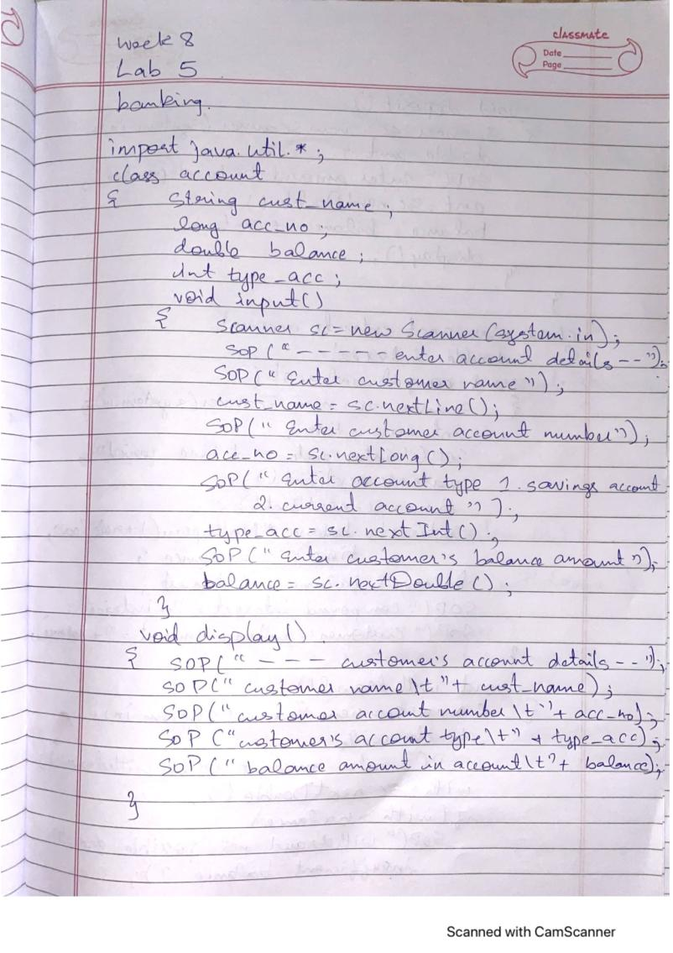

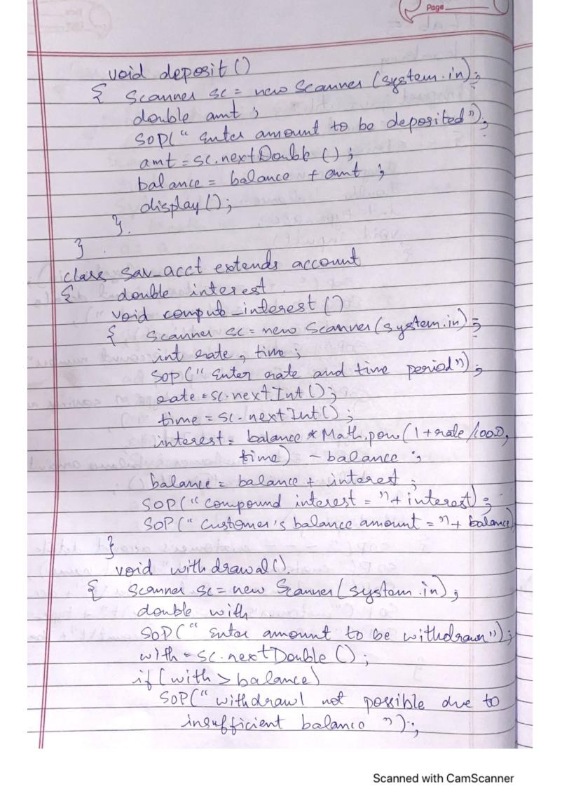

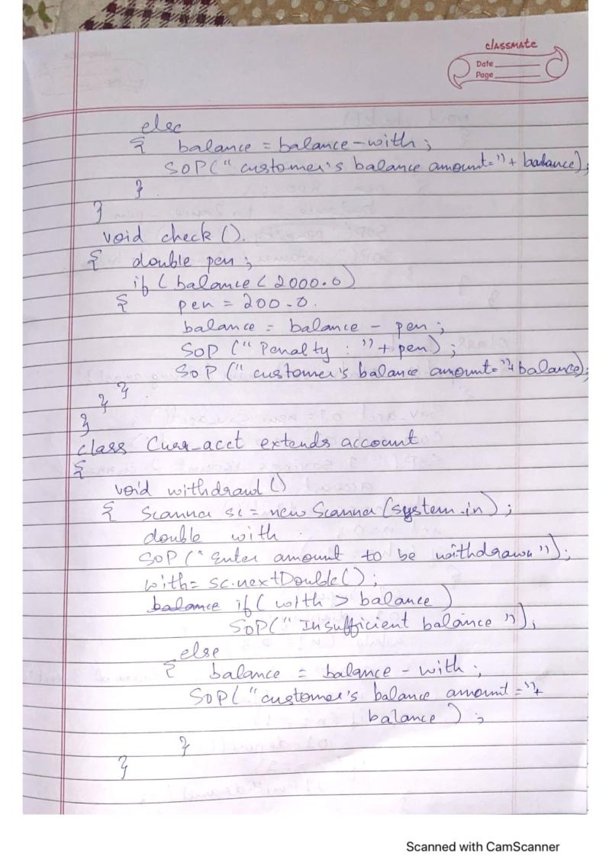

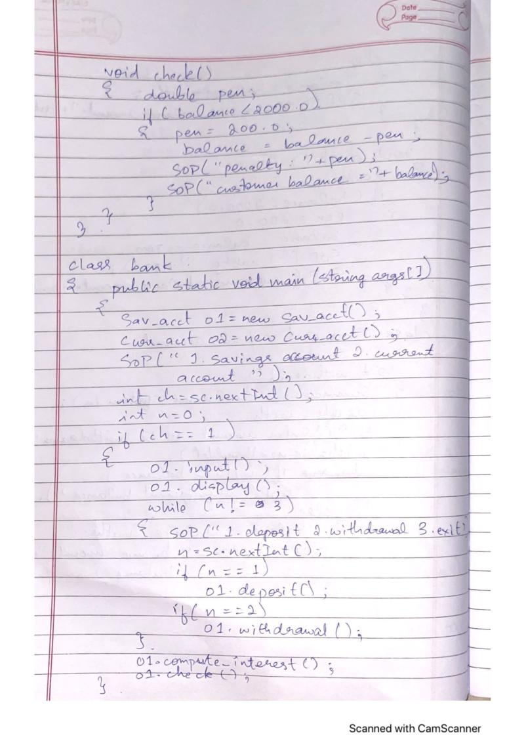

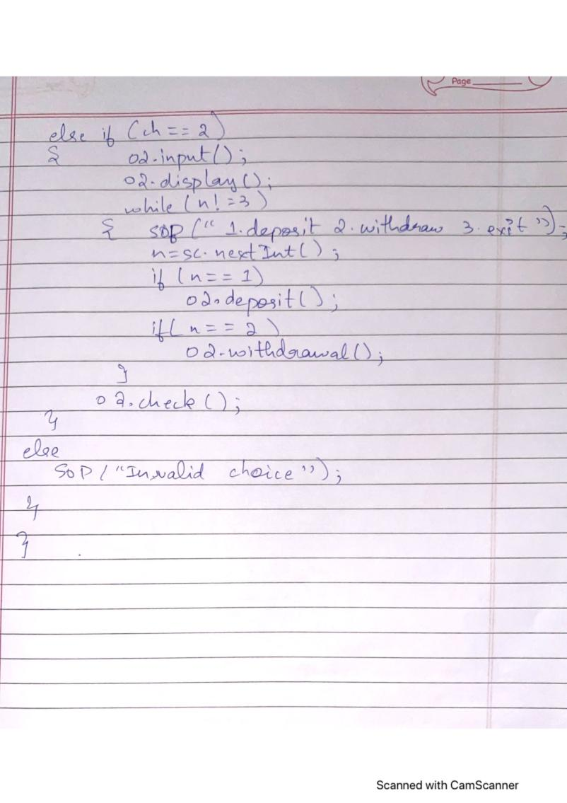

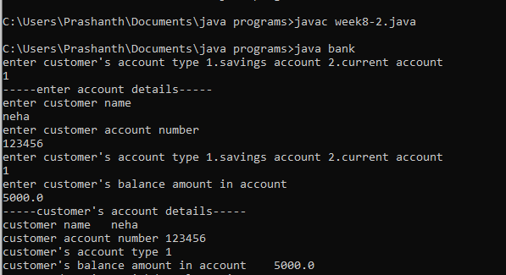

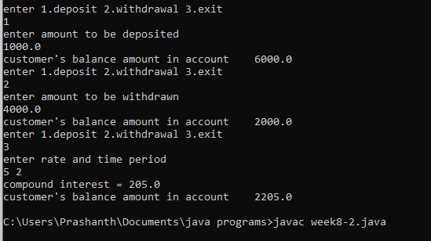

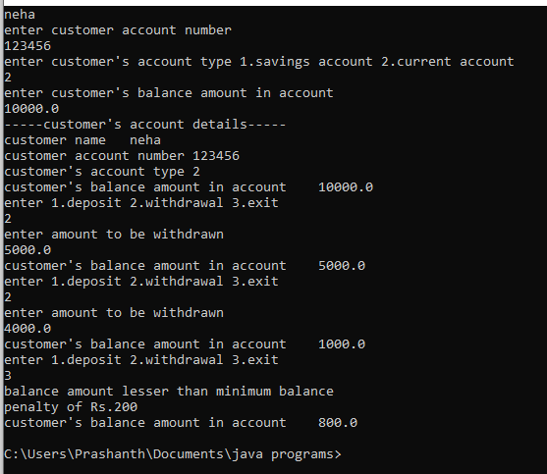

Lab Program 6:

Create a package CIE which has two classes- Student and Internals. The

class Personal has members like usn, name, sem. The class Internals has an

array that stores the internal marks scored in five courses of the current

semester of the student. Create another package SEE which has the class

External which is a derived class of Student. This class has an array that

stores the SEE marks scored in five courses of the current semester of the

student. Import the two packages in a file that declares the final marks of n

students in all five courses.

package CIE;

import java.util.*;

public class Student

{

public String usn,name;

public int sem;

public void input()

{

Scanner sc=new Scanner(System.in);

System.out.println("---enter student details---");

System.out.print("name : ");

name= sc.nextLine();

System.out.print("usn : ");

usn=sc.nextLine();

System.out.print("sem : ");

sem=sc.nextInt();

System.out.println();

}

public void display()

{

System.out.println("---student details---");

System.out.println("name : "+name);

System.out.println("usn : "+usn);

System.out.println("sem : "+sem);

}

}

package SEE;

import CIE.*;

import java.util.*;

public class External extends CIE.Student

{

public int see_marks[]=new int[5];

public void input()

{

Scanner sc=new Scanner(System.in);

System.out.println("enter see marks in 5 courses :");

for(int i=0;i<5;i++)

see_marks[i]=sc.nextInt();

}

public void display()

{

System.out.println("see marks : ");

for(int i=0;i<5;i++)

System.out.print(see_marks[i]+" ");

System.out.println();

}

}

package CIE;

import java.util.*;

public class Internals

{

public int cie_marks[]=new int[5];

public void input()

{

Scanner sc=new Scanner(System.in);

System.out.println("enter cie marks in 5 courses :");

for(int i=0;i<5;i++)

cie_marks[i]=sc.nextInt();

}

public void display()

{

System.out.println("cie marks : ");

for(int i=0;i<5;i++)

System.out.print(cie_marks[i]+" ");

System.out.println();

}

}

import CIE.*;

import SEE.*;

import java.util.*;

class main

{

int final_marks[]=new int[5];

public static void main(String args[])

{

Scanner sc=new Scanner(System.in);

System.out.println("enter no of students ");

int n=sc.nextInt();

CIE.Student []o1=new CIE.Student[n];

CIE.Internals []o2=new CIE.Internals[n];

SEE.External []o3=new SEE.External[n];

main []obj=new main[n];

for(int i=0;i<n;i++)

{

o1[i]=new CIE.Student();

o2[i]=new CIE.Internals();

o3[i]=new SEE.External();

obj[i]=new main();

o1[i].input();

o2[i].input();

o3[i].input();

for(int j=0;j<5;j++)

obj[i].final_marks[j]=o2[i].cie_marks[j]+(o3[i].see_marks[j]/2);

}

for(int i=0;i<n;i++)

{

o1[i].display();

o2[i].display();

o3[i].display();

System.out.println("final marks in 5 courses");

for(int j=0;j<5;j++)

System.out.print(obj[i].final_marks[j]+" ");

System.out.println();

}

}

}

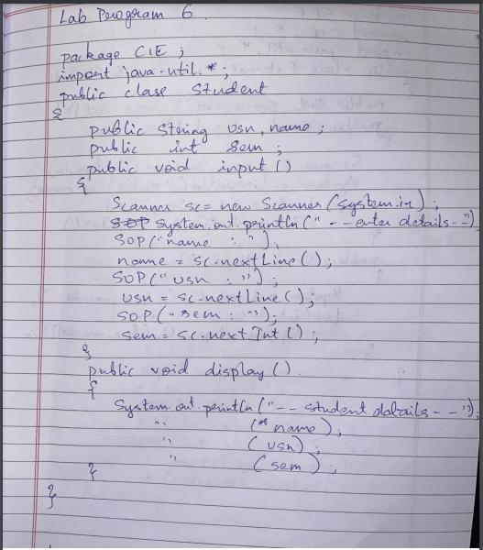

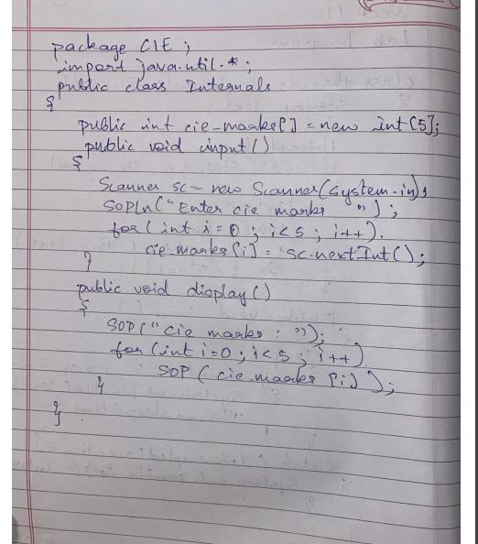

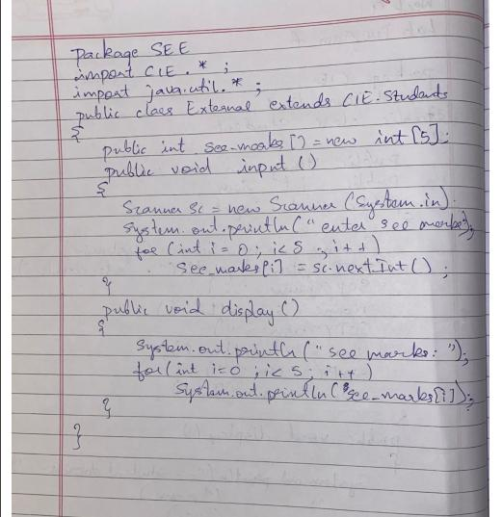

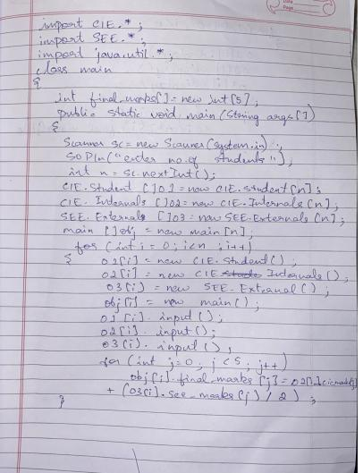

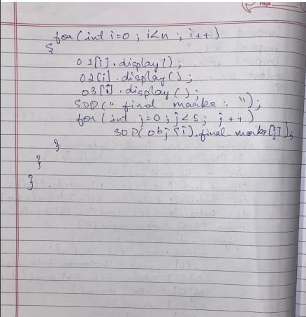

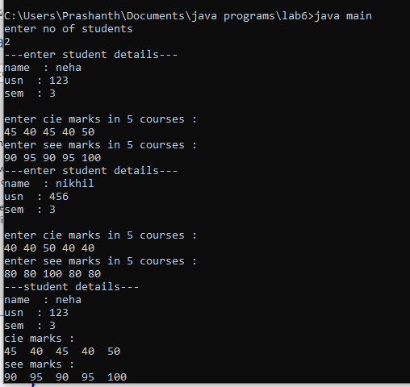

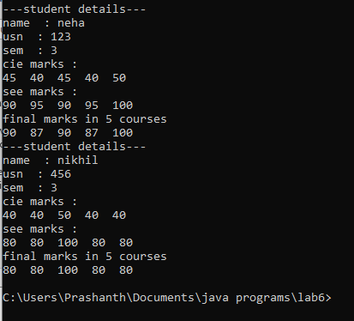

Lab Program 7:

class Gen<T1, T2>

{

T1 ob1;

T2 ob2;

Gen(T1 o1, T2 o2)

{

ob1 = o1;

ob2 = o2;

}

void showTypes()

{

System.out.println("Type of T1 is " +ob1.getClass().getName());

System.out.println("Type of T2 is " +ob2.getClass().getName());

}

T1 getob1() {

return ob1;

}

T2 getob2() {

return ob2;

}

}

class demo

{

public static void main(String args[])

{

Gen<Integer, String> obj = new Gen<Integer, String>(100, "hello!");

obj.showTypes();

int v = obj.getob1();

System.out.println("T1 value: " + v);

String str = obj.getob2();

System.out.println("T2 value: " + str);

}

}

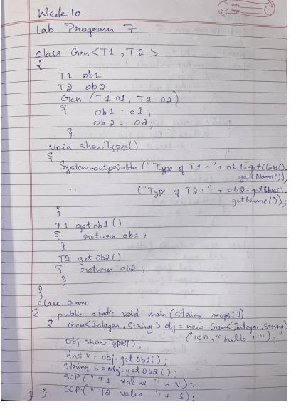

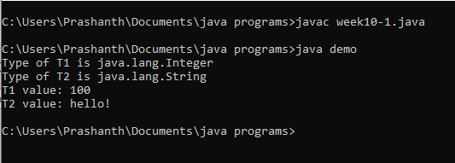

Lab Program 8:

/*Write a program that demonstrates handling of exceptions in inheritance tree. Create a base class

called “Father” and derived class called “Son” which extends the base class. In Father class,

implement a constructor which takes the age and throws the exception Wrong Age( ) when the input

age=father’s age.*/

/*import java.util.*;

class F_Ex extends Exception

{

public String toString()

{

return ("Father's age is less than 0");

}

}

class S_Ex extends Exception

{

int a;

S_Ex(int age)

{

a=age;

}

public String toString()

{

if(a<0)

return ("Son's age is less than 0");

else

return ("Son's age is more than father's age");

}

}

class father

{

public int age_f;

father(int a)

{

age_f=a;

}

void ex1() throws F_Ex

{

if(age_f<0)

throw new F_Ex();

}

}

class son extends father

{

public int age_s;

son(int a,int b)

{

super(a);

age_s=b;

}

void ex2() throws S_Ex

{

if(age_s<0 || age_s>age_f)

throw new S_Ex(age_s);

}

}

class fatherson

{

public static void main(String args[])

{

Scanner sc=new Scanner(System.in);

System.out.print("Enter father's age: ");

int a=sc.nextInt();

System.out.print("Enter son's age: ");

int b=sc.nextInt();

son s=new son(a,b);

try

{

s.ex1();

}

catch(F_Ex e)

{

System.out.println(e);

}

try

{

s.ex2();

}

catch(S_Ex e)

{

System.out.println(e);

}

}

}*/

import java.util.Scanner;

class WrongAge extends Exception{

int age;

WrongAge(int x)

{

age=x;

}

public String toString()

{

return "AGE OF SON="+age+" IS ENTERED INCORRECTLY";

}

}

class father

{

int a;

father(int x)

{

a=x;

}

}

class son extends father{

int age;

son(int fage,int sage){

super(fage);

age=sage;

}

void compute() throws WrongAge{

if(age>=a)

{

throw new WrongAge(age);

}

else{

System.out.println("THE AGES ARE ENTERED CORECTLY");

System.out.println("FATHER'S AGE="+a+"\t"+"SON'S AGE="+age);

}

}

}

class expmain

{

public static void main(String args[])

{

Scanner s=new Scanner(System.in);

System.out.println("ENTER FATHER'S AGE");

int f=s.nextInt();

System.out.println("ENTER SON'S AGE");

int so=s.nextInt();

son ss=new son(f,so);

try{

ss.compute();

}catch(WrongAge e)

{

System.out.println(e);

}

}

}

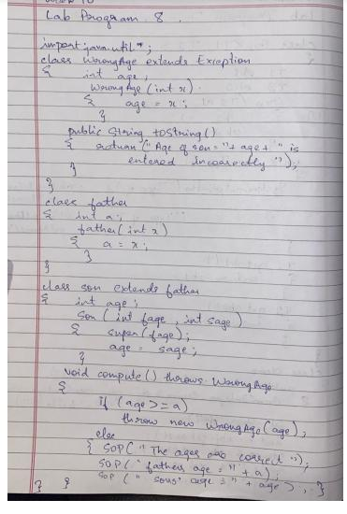

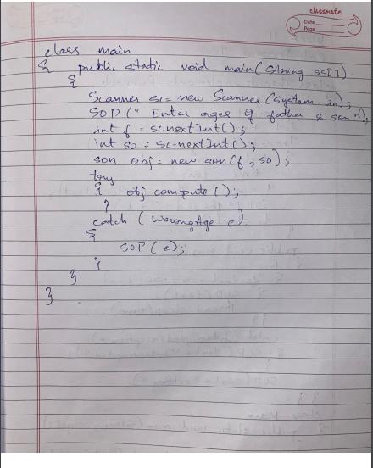

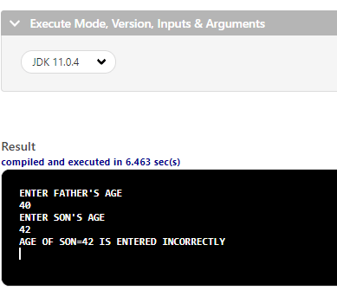

Lab Program 9:

class Threads implements Runnable {

String text;

Thread t;

int time;

Threads(String threadname,int tm) {

text= threadname;

time=tm;

t = new Thread(this, text);

System.out.println("thread:"+ t);

t.start();

}

public void run() {

try {

for(int i = 5; i > 0; i--) {

System.out.println(text);

Thread.sleep(time);

}

} catch (InterruptedException e) {

System.out.println(text + "Interrupted");

}

System.out.println(text + " exiting.");

}

}

class Main {

public static void main(String args[]) {

Threads t1=new Threads("BMS COLLEGE OF ENGINEERING",10000);

Threads t2=new Threads("CSE",2000);

}

}

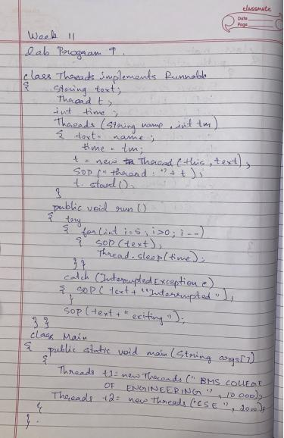

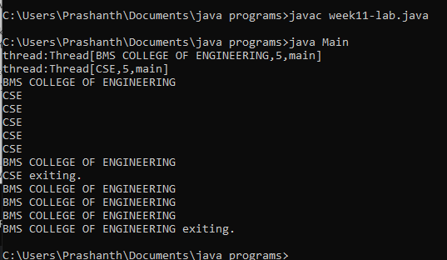

Lab Program 10:

/*Write a program that creates a user interface to perform integer divisions. The user enters two

numbers in the text fields, Num1 and Num2. The division of Num1 and Num2 is displayed in the

Result field when the Divide button is clicked. If Num1 or Num2 were not an integer, the program

would throw a NumberFormatException. If Num2 were Zero, the program would throw an

Arithmetic Exception Display the exception in a message dialog box.*/

import java.awt.*;

import java.awt.event.*;

import javax.swing.*;

public class integerdivision extends Frame implements ActionListener

{

TextField n1,n2,res;

Label ln1,ln2,lres;

Button b;

public integerdivision()

{

setLayout(new FlowLayout());

Label ln1=new Label("NUMBER 1",Label.RIGHT);

Label ln2=new Label("NUMBER 2",Label.RIGHT);

Label lres=new Label("RESULT",Label.RIGHT);

n1=new TextField(12);

n2=new TextField(8);

res=new TextField(10);

b=new Button("DIVISION");

add(ln1);

add(n1);

add(ln2);

add(n2);

add(b);

add(lres);

add(res);

b.addActionListener(this);

addWindowListener(new WindowAdapter1());

}

public void actionPerformed(ActionEvent ae)

{

if(ae.getSource()==b)

{

try{

int num1=Integer.parseInt(n1.getText());

int num2=Integer.parseInt(n2.getText());

int num3=num1/num2;

res.setText(String.valueOf(num3));

}

catch(NumberFormatException e )

{

JOptionPane.showMessageDialog(this,e,"ERROR", JOptionPane.ERROR_MESSAGE);

}

catch(ArithmeticException a)

{

JOptionPane.showMessageDialog(this,a,"DIVISION BY ZERO ERROR", JOptionPane.ERROR_MESSAGE);

}

}

}

public static void main(String args[])

{

integerdivision i=new integerdivision();

i.setSize(new Dimension(400,400));

i.setTitle("INTEGER DIVISION OF TWO NUMBERSs");

i.setVisible(true);

}

class WindowAdapter1 extends WindowAdapter{

public void windowClosing(WindowEvent we)

{

System.exit(0);

}

}

}

