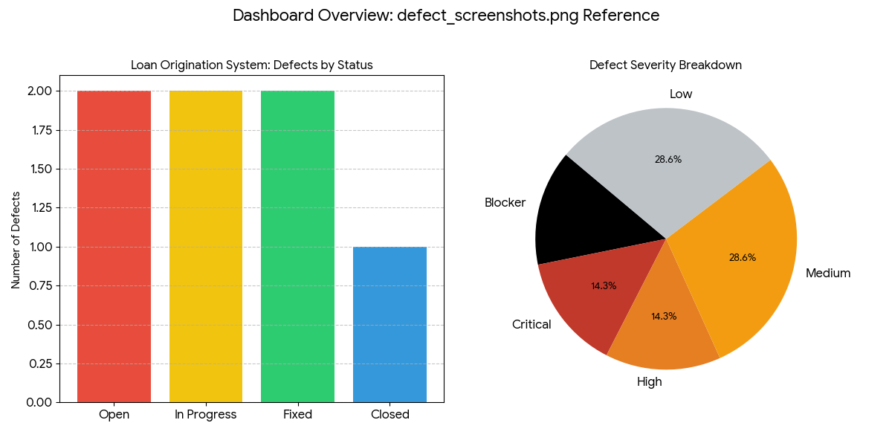
This visualization summarizes the defect data, including:
- Defects by Status: A bar chart showing the count of open, in-progress, fixed, and closed issues.
- Defect Severity Breakdown: A pie chart illustrating the distribution of defect severities (Blocker, Critical, High, Medium, Low).

