WEEK 4 INTERNSHIP REPORT
Supervised Learning Model Implementation
Binary Classification using Logistic Regression
Virtual Data Science with Python Trainee

1. Introduction
For the Week 4 task, I worked on a supervised learning problem in Python. The task required me to choose a classification or regression problem, prepare the data, train a model, validate it, evaluate its performance, and discuss possible improvements. I selected a binary classification problem using the Breast Cancer Wisconsin Diagnostic dataset available through Scikit-learn.
The purpose of the model was to classify a tumor as malignant or benign from numerical measurements. I chose Logistic Regression because the target has two classes and the model is comparatively easy to interpret. I also examined the fitted coefficients so that the project was not limited to reporting one accuracy value.

2. Objective
The objective was to complete the supervised learning workflow from data inspection through model interpretation. The main steps were checking the dataset, separating the target, splitting the data, scaling the features, training Logistic Regression, evaluating the predictions, using cross-validation, visualizing the results, and identifying features with relatively large model coefficients.

3. Dataset Description
Item | Details
Dataset | Breast Cancer Wisconsin Diagnostic dataset
Dataset access | Scikit-learn load_breast_cancer()
Observations | 569
Input features | 30 numerical features
Target | Malignant / Benign
Malignant cases | 212
Benign cases | 357
Missing values | 0
Duplicate rows | 0
Software | Google Colab
Language | Python
The target distribution is not perfectly balanced, with more benign observations than malignant observations. Because of this, I used stratification when splitting the data and reported precision, recall and F1-score in addition to accuracy.

4. Data Loading and Initial Inspection
from sklearn.datasets import load_breast_cancer

data = load_breast_cancer(as_frame=True)
df = data.frame.copy()

print("Dataset shape:", df.shape)
print(df.columns.tolist())
display(df.head())
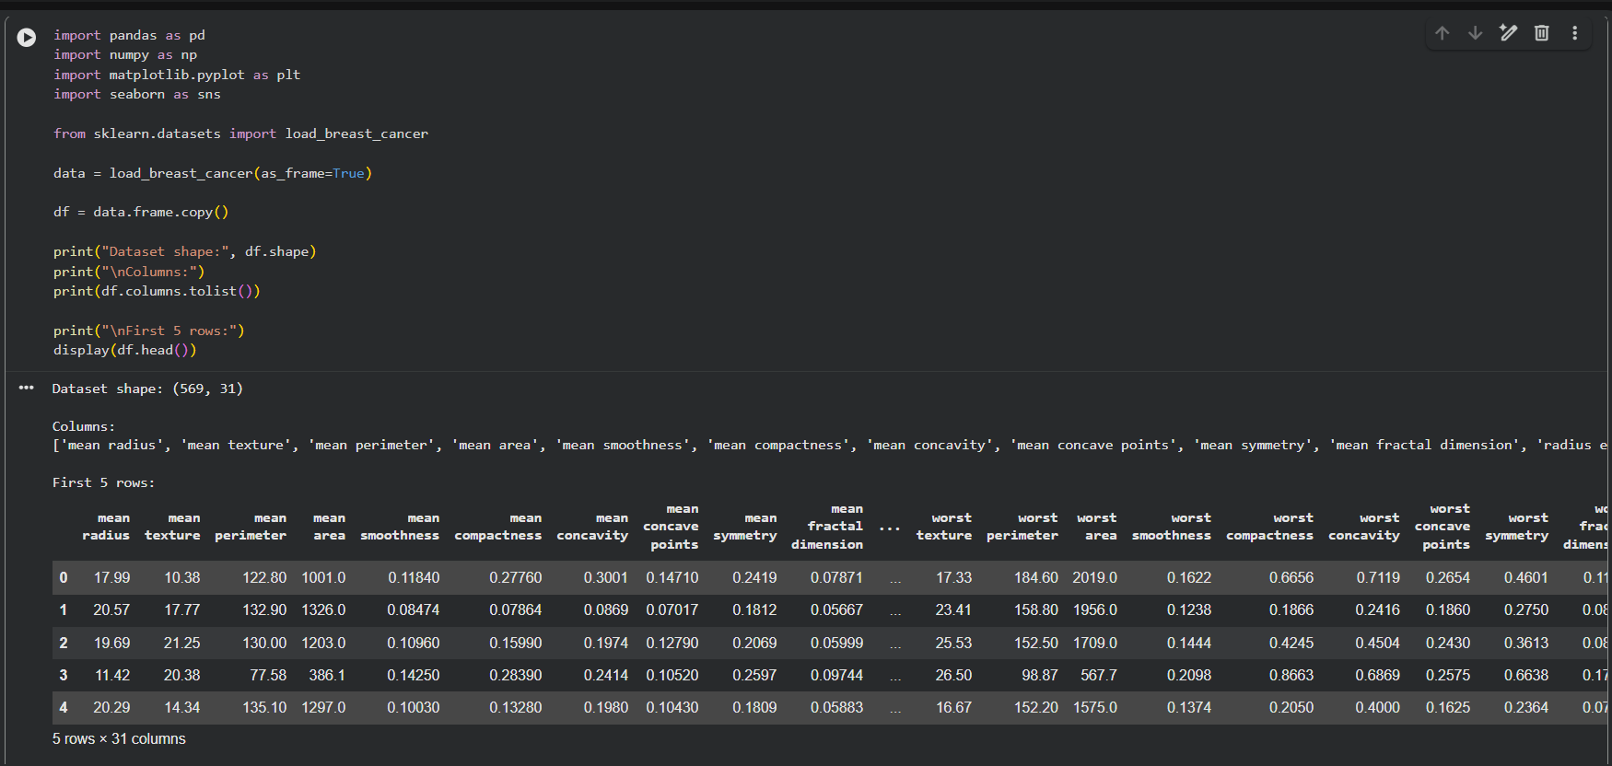
Figure 1: Initial dataset inspection in Google Colab.
The first output showed 569 rows and 31 columns. The 31st column is the target, leaving 30 numerical variables for prediction.

5. Data Quality Checks
print("Missing values:")
print(df.isnull().sum())

print("Duplicate rows:", df.duplicated().sum())

df.info()
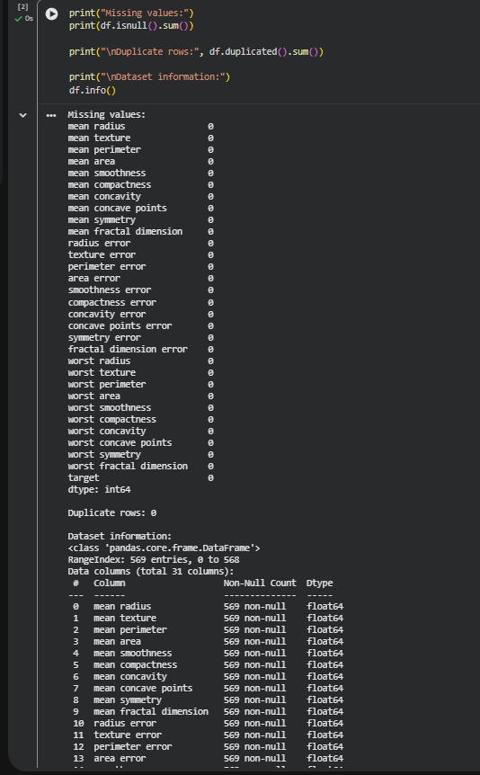
Figure 2: Missing-value, duplicate and dataframe checks.
The missing-value check returned zero for every column, and the duplicate-row check returned zero. Since there were no missing values, I did not add unnecessary imputation. This was also useful because it confirmed that the model could be trained without another cleaning step.

6. Target and Feature Preparation
X = df.drop(columns=["target"])
y = df["target"]

print("Features shape:", X.shape)
print("Target shape:", y.shape)
print(y.value_counts())
print(data.target_names)
X contained 569 rows and 30 features, while y contained 569 target values. The target distribution was 357 benign and 212 malignant. The dataset uses target 0 for malignant and target 1 for benign.
The original dataset already contains numerical diagnostic measurements, so I did not invent additional medical features. Instead, the main preparation work was selecting the target, keeping the 30 useful numerical inputs, standardizing their scales, and maintaining class proportions during splitting. This was preferable to adding arbitrary derived variables that were not required by the task.

7. Train/Test Split
from sklearn.model_selection import train_test_split

X_train, X_test, y_train, y_test = train_test_split(
X, y,
test_size=0.20,
random_state=42,
stratify=y
)
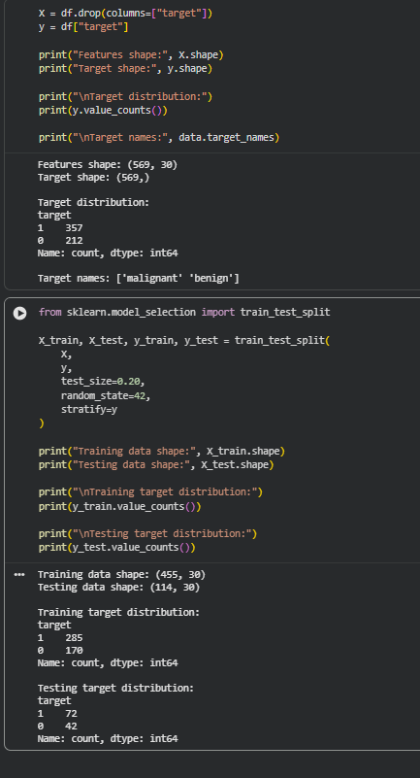
Figure 3: Train/test split and class distributions.
The split produced 455 training observations and 114 testing observations. The training set contained 285 benign and 170 malignant observations. The test set contained 72 benign and 42 malignant observations. Using stratify=y kept the class proportions close to the original dataset.

8. Feature Scaling
from sklearn.preprocessing import StandardScaler

scaler = StandardScaler()

X_train_scaled = scaler.fit_transform(X_train)
X_test_scaled = scaler.transform(X_test)
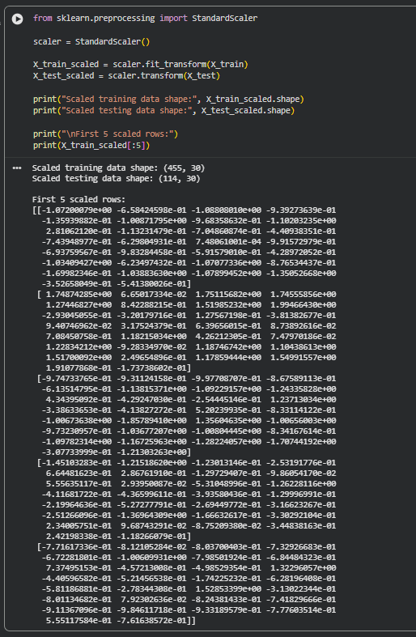
Figure 4: Standardized training and testing features.
The features have different numerical ranges, so I used StandardScaler. The scaler was fitted only on X_train and then used to transform X_test. This means information from the test set was not used to calculate the training scaling parameters.

9. Model Selection: Logistic Regression
I selected Logistic Regression because the target has two possible classes. It is a standard classification method and its coefficients provide an additional way to understand the fitted model. The main model used max_iter=1000 and random_state=42.
Scaling was particularly appropriate here because linear-model regularization and optimization can be affected when features have very different scales. Scikit-learn also documents preprocessing as a useful step for estimators when feature scales differ.
from sklearn.linear_model import LogisticRegression

model = LogisticRegression(
max_iter=1000,
random_state=42
)

model.fit(X_train_scaled, y_train)
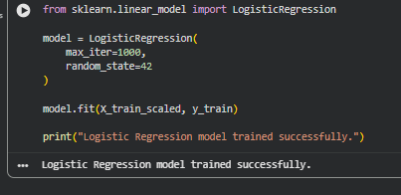
Figure 5: Logistic Regression training completed successfully.

10. Prediction
y_pred = model.predict(X_test_scaled)

print("First 20 predictions:")
print(y_pred[:20])

print("First 20 actual values:")
print(y_test.values[:20])
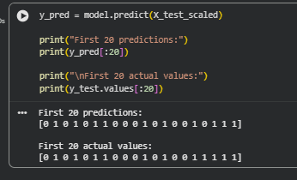
Figure 6: Comparison of initial predictions with actual values.

11. Evaluation Metrics
I used accuracy, precision, recall and F1-score. Accuracy gives the overall proportion of correct predictions. Precision and recall give more detail about classification errors, while F1-score combines precision and recall.
Metric | Test result
Accuracy | 98.25%
Precision | 98.61%
Recall | 98.61%
F1-Score | 98.61%
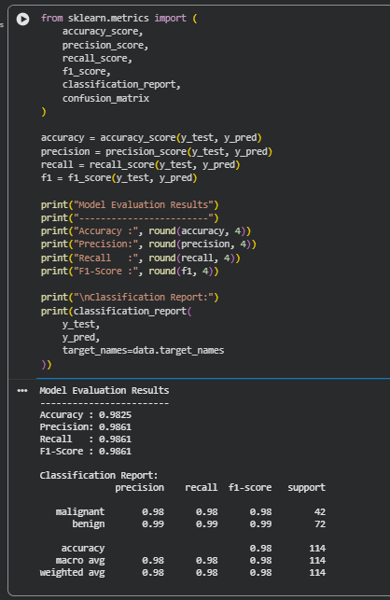
Figure 7: Classification report and test-set performance.
The test accuracy was 98.25%. Precision, recall and F1-score were each 98.61%. These values were calculated from the 114 observations that were not used to fit the final model.
As a simple reference point, always predicting the majority class in the 114-sample test set would give 72/114, or about 63.16% accuracy. The Logistic Regression result of 98.25% is therefore substantially above that simple majority-class baseline. This comparison helps put the accuracy into context rather than presenting the number alone.

12. Confusion Matrix and Error Analysis
from sklearn.metrics import confusion_matrix

cm = confusion_matrix(y_test, y_pred)
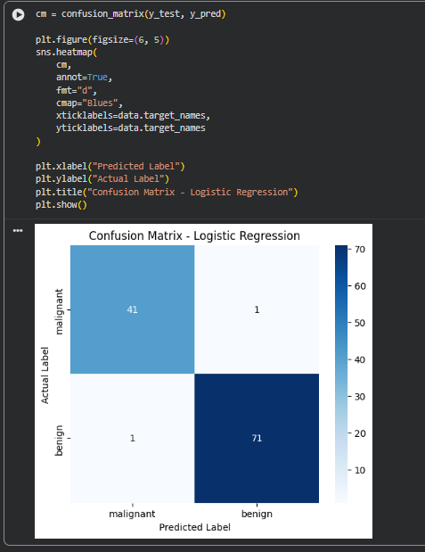
Figure 8: Confusion matrix for the test predictions.
The confusion matrix showed 41 correctly classified malignant observations and 71 correctly classified benign observations. There was one malignant observation predicted as benign and one benign observation predicted as malignant. Therefore, the model made only 2 errors out of 114 test observations.
For this type of classification task, the malignant-to-benign error is particularly important to notice because it represents a false negative for the malignant class. The project is educational and does not establish a clinical diagnostic threshold, but the confusion matrix shows why recall should be considered alongside accuracy.

13. Five-Fold Cross-Validation
I also used 5-fold cross-validation to check whether the high test result was reasonably consistent across different subsets of the data. My first attempt produced convergence warnings because the raw X data was passed directly to Logistic Regression. I corrected the validation step by placing StandardScaler and Logistic Regression inside a Pipeline.
from sklearn.pipeline import Pipeline
from sklearn.model_selection import cross_val_score

cv_model = Pipeline([
("scaler", StandardScaler()),
("logistic_regression", LogisticRegression(
max_iter=2000,
random_state=42
))
])

cv_scores = cross_val_score(
cv_model,
X,
y,
cv=5,
scoring="accuracy"
)
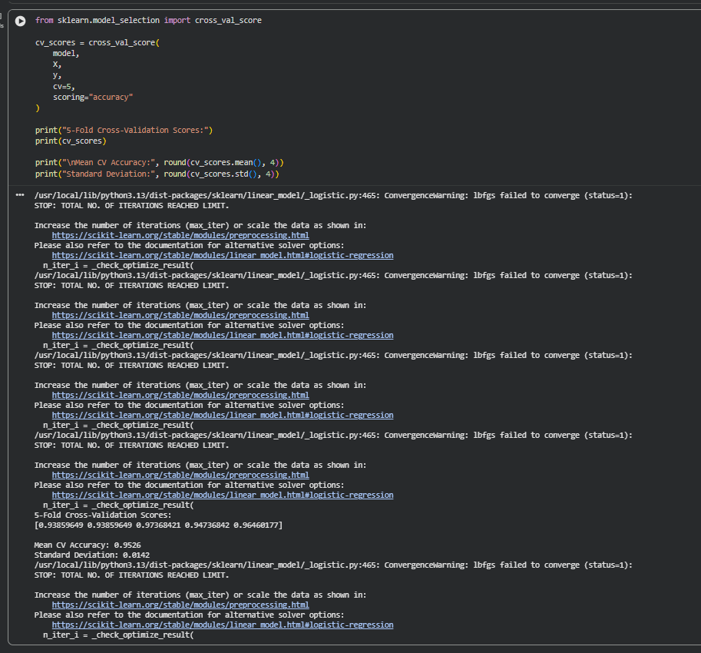
Figure 9: Corrected 5-fold cross-validation output.
Validation result | Value
Fold 1 | 0.9825
Fold 2 | 0.9825
Fold 3 | 0.9737
Fold 4 | 0.9737
Fold 5 | 0.9912
Mean CV accuracy | 0.9807 / 98.07%
Standard deviation | 0.0065 / 0.65%
The mean cross-validation accuracy was 98.07%, with a standard deviation of 0.65%. The relatively small variation between folds suggests that the model performed consistently in this validation experiment. Using a pipeline also keeps the scaling operation within the validation process, which is important for avoiding preprocessing leakage. Scikit-learn supports accuracy and other classification metrics as scoring options for cross-validation.

14. Overall Performance Visualization
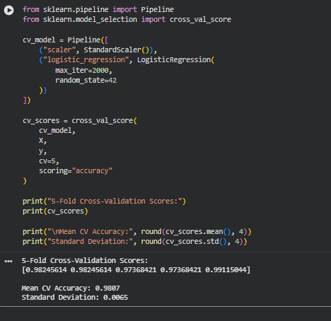
Figure 10: Comparison of accuracy, precision, recall and F1-score.
The four test metrics are all close to 1.0. The graph provides a quick visual summary of the numerical evaluation and agrees with the classification report.

15. Feature Coefficient Analysis
I used the trained Logistic Regression coefficients to examine which features had the largest absolute coefficient values. This gives an interpretation of the fitted model rather than a claim about medical causation.
Feature | Coefficient | Absolute coefficient
worst texture | -1.2551 | 1.2551
radius error | -1.0830 | 1.0830
worst concave points | -0.9537 | 0.9537
worst area | -0.9478 | 0.9478
worst radius | -0.9476 | 0.9476
worst symmetry | -0.9392 | 0.9392
area error | -0.9291 | 0.9291
worst concavity | -0.8232 | 0.8232
worst perimeter | -0.7632 | 0.7632
worst smoothness | -0.7466 | 0.7466
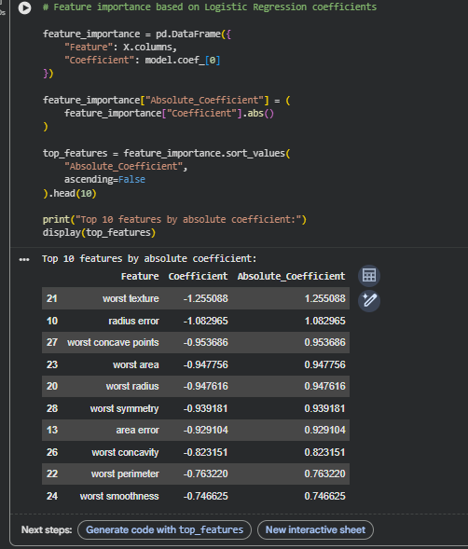
Figure 11: Ten features with the largest absolute model coefficients.
Worst texture had the largest absolute coefficient, followed by radius error and worst concave points. Because malignant is encoded as 0 and benign as 1, the negative signs mean that higher standardized values of these features are associated with movement toward the malignant class in this fitted model, holding the other model inputs constant. This should not be interpreted as a causal medical conclusion.

16. Strengths of the Approach
- The dataset was checked before modelling and had no missing values or duplicate rows.
- The target distribution was inspected before splitting.
- The split used stratification instead of a completely random class-imbalanced split.
- Feature scaling was fitted only on training data for the held-out evaluation.
- The model was evaluated with four complementary classification metrics.
- A confusion matrix was used to inspect individual types of errors.
- Five-fold cross-validation was added to check consistency beyond one test split.
- The Pipeline corrected the initial convergence/preprocessing issue and made the validation workflow cleaner.
- The model coefficients were examined to provide an interpretable analysis rather than reporting accuracy alone.

17. Research Implications
The results show that a supervised learning model can separate the two classes very effectively on this particular dataset. From a research perspective, this demonstrates how numerical measurements can be used to build and evaluate a classification workflow. However, the result should be treated as a machine-learning experiment rather than evidence that the model is ready for medical use. An external dataset and appropriate clinical validation would be necessary before considering any real-world application.

18. Limitations
- The evaluation is based on one public dataset and one held-out test set.
- Only Logistic Regression was used as the main predictive model, so several alternative algorithms were not compared.
- The dataset is not large enough to establish general performance across all possible populations.
- The features and target come from an existing diagnostic dataset, so the project does not establish new medical variables.
- The model coefficients describe the fitted classifier and should not be interpreted as causal medical relationships.
- The project is an internship machine-learning exercise and not a clinical diagnostic system.

19. Possible Improvements
A useful next step would be to compare Logistic Regression with Random Forest, Support Vector Machine and Gradient Boosting. I could also tune the Logistic Regression regularization parameter using cross-validation. Another improvement would be to report ROC-AUC and plot an ROC curve because the classifier provides probability estimates. Scikit-learn includes ROC-AUC among its binary classification evaluation metrics.
For a stronger generalization test, the final model should also be evaluated on an independent external dataset rather than relying only on the same public dataset used in this project.

20. What I Learned
This task helped me understand that supervised learning is more than just calling fit() on a model. I had to first check the data, decide how to split it, prepare the features, train the classifier and then look at several different metrics.
One issue that helped me learn was the convergence warning during my first cross-validation attempt. I initially passed the unscaled data directly to Logistic Regression. I changed the validation code to a Pipeline containing StandardScaler and Logistic Regression, and the corrected validation completed without those warnings. This made the reason for keeping preprocessing inside the cross-validation workflow clearer to me.
The confusion matrix was also useful because it showed exactly where the model was making mistakes. Finally, checking the coefficients gave me a way to look inside the fitted model and identify which standardized variables had relatively large weights.

21. Conclusion
I completed the Week 4 supervised learning task by building a Logistic Regression classification model for the Breast Cancer Wisconsin Diagnostic dataset. The dataset had 569 observations and 30 input features. After an 80:20 stratified split and feature scaling, the model achieved 98.25% accuracy on the held-out test set. Precision, recall and F1-score were all 98.61%.
The 5-fold cross-validation mean accuracy was 98.07% with a standard deviation of 0.65%. The confusion matrix showed only two incorrect predictions in the 114-sample test set. The analysis also included model coefficients, which added an interpretable component to the project.
The results are strong for this dataset, but I would not treat them as proof that the model would perform equally well on unseen clinical data. Comparing other algorithms and testing on independent data would be the next steps.

22. Requirement Coverage / Submission Checklist
Week 4 requirement | Evidence in this report
Define classification/regression problem | Malignant vs. benign binary classification
Publicly available dataset | Breast Cancer Wisconsin Diagnostic dataset via Scikit-learn
Data preparation | Inspection, target separation, stratified train/test split
Feature engineering/preparation | Feature selection and standardization using StandardScaler
Python/Scikit-learn model | Logistic Regression
Rationale for model | Section 9 explains why Logistic Regression was selected
Validation | 5-fold cross-validation with Pipeline
Evaluation metrics | Accuracy, precision, recall, F1-score and confusion matrix
Performance analysis | Test results, baseline comparison and fold-level CV results
Visualizations | Dataset output, confusion matrix, metric chart and coefficient chart
Strengths and limitations | Sections 16 and 18
Possible improvements | Section 19
Discussion of implications | Section 17
Code snippets | Included throughout the report
Complete methodology | Sections 4–15 and 21

23. Main Python Code Used
import pandas as pd
import numpy as np
import matplotlib.pyplot as plt
import seaborn as sns

from sklearn.datasets import load_breast_cancer
from sklearn.model_selection import train_test_split, cross_val_score
from sklearn.preprocessing import StandardScaler
from sklearn.linear_model import LogisticRegression
from sklearn.pipeline import Pipeline
from sklearn.metrics import (
accuracy_score, precision_score, recall_score,
f1_score, classification_report, confusion_matrix
)

data = load_breast_cancer(as_frame=True)
df = data.frame.copy()

X = df.drop(columns=["target"])
y = df["target"]

X_train, X_test, y_train, y_test = train_test_split(
X, y, test_size=0.20, random_state=42, stratify=y
)

scaler = StandardScaler()
X_train_scaled = scaler.fit_transform(X_train)
X_test_scaled = scaler.transform(X_test)

model = LogisticRegression(max_iter=1000, random_state=42)
model.fit(X_train_scaled, y_train)

y_pred = model.predict(X_test_scaled)

accuracy = accuracy_score(y_test, y_pred)
precision = precision_score(y_test, y_pred)
recall = recall_score(y_test, y_pred)
f1 = f1_score(y_test, y_pred)

cv_model = Pipeline([
("scaler", StandardScaler()),
("logistic_regression", LogisticRegression(
max_iter=2000, random_state=42
))
])

cv_scores = cross_val_score(
cv_model, X, y, cv=5, scoring="accuracy"
)

feature_importance = pd.DataFrame({
"Feature": X.columns,
"Coefficient": model.coef_[0]
})
feature_importance["Absolute_Coefficient"] = (
feature_importance["Coefficient"].abs()
)
top_features = feature_importance.sort_values(
"Absolute_Coefficient", ascending=False
).head(10)

24. References
Scikit-learn documentation: load_breast_cancer(), StandardScaler, LogisticRegression, Pipeline, cross_val_score and classification metrics.

