WEEK 2
Exploratory Data Analysis and Visualization
Titanic Passenger Dataset

Final Report

Python • Pandas • Matplotlib • Seaborn

Dataset carried forward from Week 1: titanic_cleaned.csv

Report Control and Scope
Deliverable | Week 2 – Exploratory Data Analysis and Visualization
Dataset | titanic_cleaned.csv, carried forward from Week 1
Records analyzed | 891
Tools | Google Colab, Python, Pandas, Matplotlib, Seaborn
Analysis type | Descriptive exploratory data analysis
Main outcome | Survived
This report uses the cleaned dataset produced for the previous week. The purpose of Week 2 is not to repeat the cleaning process, but to use the cleaned data to investigate patterns, compare groups, and communicate findings through statistics and visualizations.

1. Introduction and Objective
In this task, I explored the cleaned Titanic passenger dataset to understand which variables show the clearest differences in observed survival. I used numerical summaries first and then used visualizations to make the main patterns easier to compare.
The analysis focuses on survival by gender and passenger class, age-group comparisons, fare behaviour, family-size feature creation, and relationships between numerical variables. I also checked the data again after creating the derived variables so that the final results were based on a consistent dataset.
I treated the results as descriptive findings. In particular, a difference in survival rate is reported as an association in the dataset rather than as proof that a single variable caused the outcome.

2. Dataset and Tools Used
The Week 1 cleaned dataset contains 891 passenger records. The main fields used in this analysis are Pclass, Survived, Sex, Age, SibSp, Parch, Fare, and the encoded embarkation fields. The cleaned file was loaded into Google Colab using Pandas.
import pandas as pd
import matplotlib.pyplot as plt
import seaborn as sns
df = pd.read_csv("titanic_cleaned.csv")
df.head()
No new external dataset version was introduced for this analysis. Keeping the same cleaned file from Week 1 makes the Week 1 → Week 2 workflow traceable.

3. EDA Approach
I followed the analysis in the following order:
- Inspect the cleaned data and establish the number of records and key variables.
- Calculate baseline statistics such as survival rate, mean age, median age, mean fare, and median fare.
- Compare survival rates by gender and passenger class.
- Combine gender and class to check whether the broad patterns remain within smaller groups.
- Create AgeGroup and compare survival rates while keeping group sizes visible.
- Create FamilySize from SibSp and Parch for possible family-based comparisons.
- Examine the relationship between age and fare using correlation and a correlation matrix.
- Perform a final missing-value check after the EDA transformations.
- Interpret the results with attention to subgroup size, skewness, and the difference between association and causation.

4. Initial Data Exploration
The cleaned dataset contains 891 passengers. The overall observed survival rate was 38.38%. The mean age was 29.36 years and the median was 28.00 years. The mean fare was 32.20 and the median was 14.45.
Measure | Value | What it tells us
Records | 891 | Total observations used
Overall survival | 38.38% | Baseline survival proportion
Mean age | 29.36 | Average passenger age
Median age | 28.00 | Middle passenger age
Mean fare | 32.20 | Average recorded fare
Median fare | 14.45 | Middle recorded fare
Age–fare correlation | 0.0967 | Very weak positive linear relationship
The gap between the mean and median fare is notable. Because the mean is much higher than the median, the fare variable is positively skewed; a smaller number of higher fares pull the average upward.

5. Survival Analysis
The overall survival rate of 38.38% provides the baseline for the subgroup comparisons below. The main question in this part of the EDA was whether survival rates changed noticeably across passenger groups.

5.1 Survival by Gender
Female passengers had an observed survival rate of 74.20%, while male passengers had an observed survival rate of 18.89%. The difference is large and is one of the clearest patterns in the dataset.

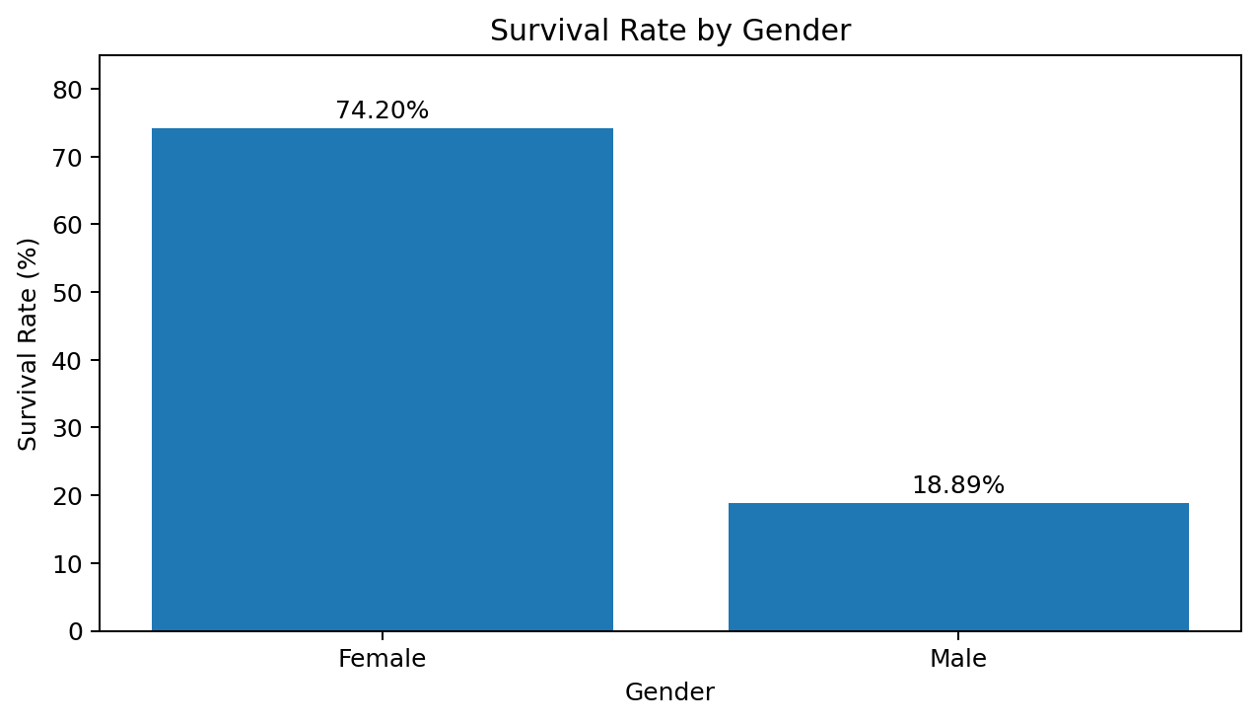
Figure 1. Observed survival rate by gender.
gender_survival = df.groupby("Sex")["Survived"].mean() * 100
print(gender_survival)
The visualization makes the size of the difference immediately visible. This is an observed association, not a causal conclusion. Passenger class and other characteristics may also be related to the result.

5.2 Survival by Passenger Class
The observed survival rate decreased across passenger classes: 62.96% for first class, 47.28% for second class, and 24.24% for third class.
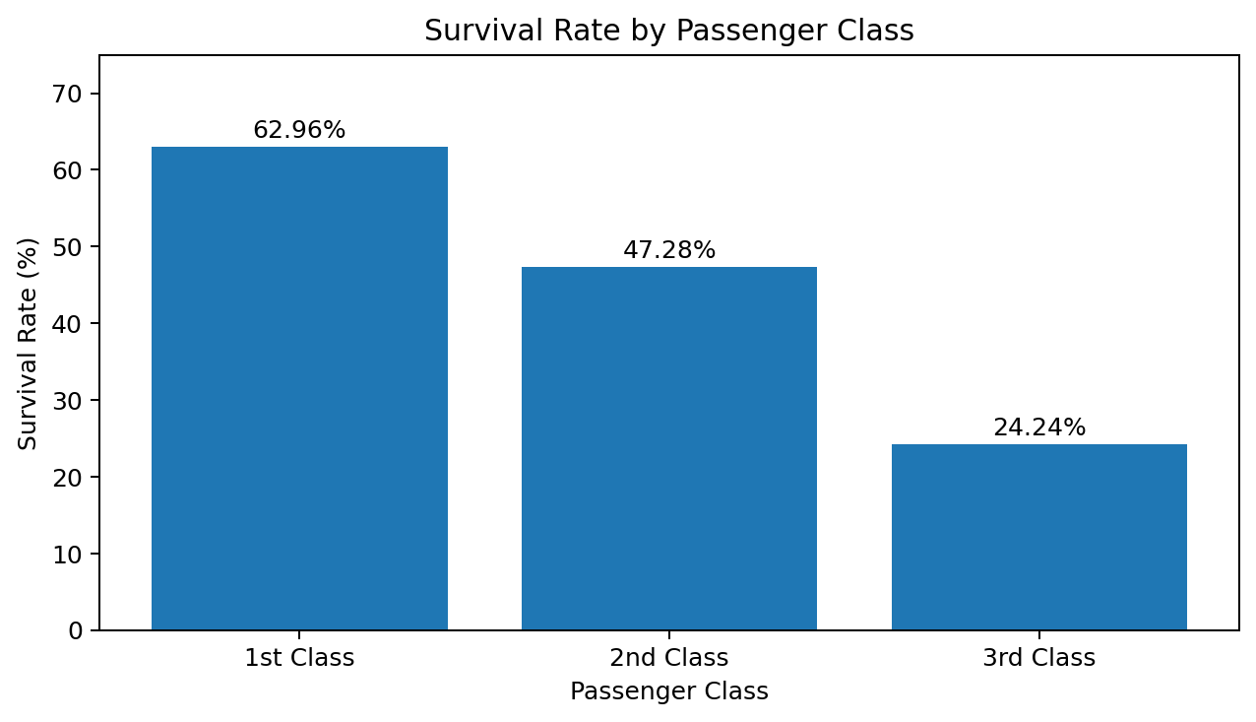
Figure 2. Observed survival rate by passenger class.
class_survival = df.groupby("Pclass")["Survived"].mean() * 100
print(class_survival)
The pattern is consistent across the three classes and shows a substantial difference between first and third class. The result describes an association within this dataset rather than a causal effect.

5.3 Survival by Passenger Class and Gender
Combining two variables gives more detail than looking at either one separately. The observed subgroup survival rates were 36.89% for first-class males, 96.81% for first-class females, 15.74% for second-class males, 92.11% for second-class females, 13.54% for third-class males, and 50.00% for third-class females.
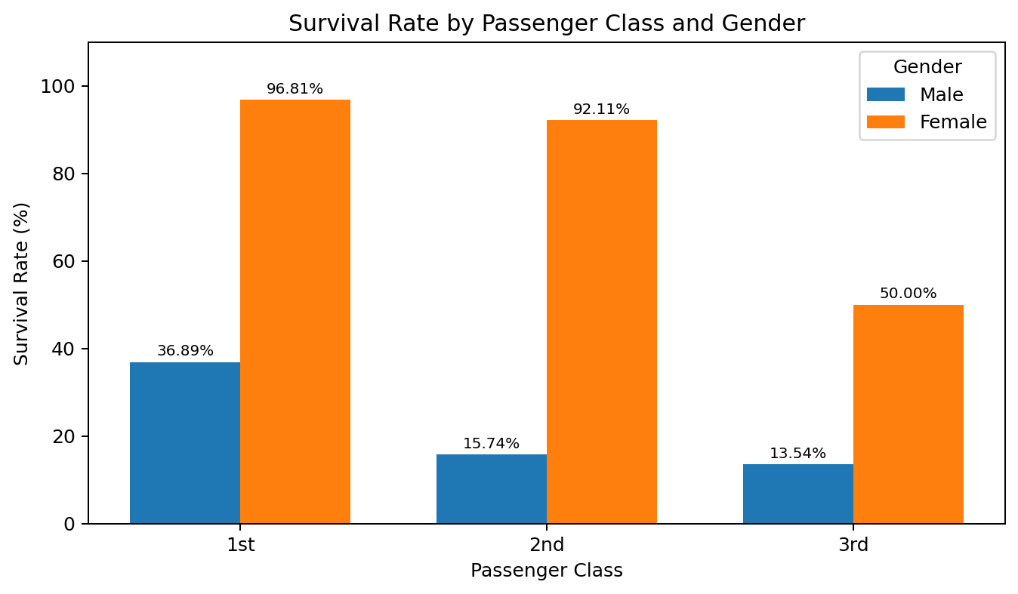
Figure 3. Observed survival rate by passenger class and gender.
gender_class_survival = (
df.groupby(["Pclass", "Sex"])["Survived"]
.mean()
.mul(100)
)
print(gender_class_survival)
Female passengers had higher observed survival rates than male passengers within every passenger class. This comparison is useful because it shows that the gender difference is not limited to only one class.

6. Age Analysis
Age was examined as both a numerical variable and through grouped categories. The mean age was 29.36 years and the median was 28.00 years.
For exploratory comparison, I divided passengers into five age groups. These boundaries were selected to create interpretable groups for comparison and are not intended to represent statistically or medically defined categories.
df["AgeGroup"] = pd.cut(
df["Age"],
bins=[0, 12, 17, 34, 59, 100],
labels=["Child", "Teenager", "Adult", "Middle-aged", "Senior"],
include_lowest=True
)

6.1 Survival by Age Group
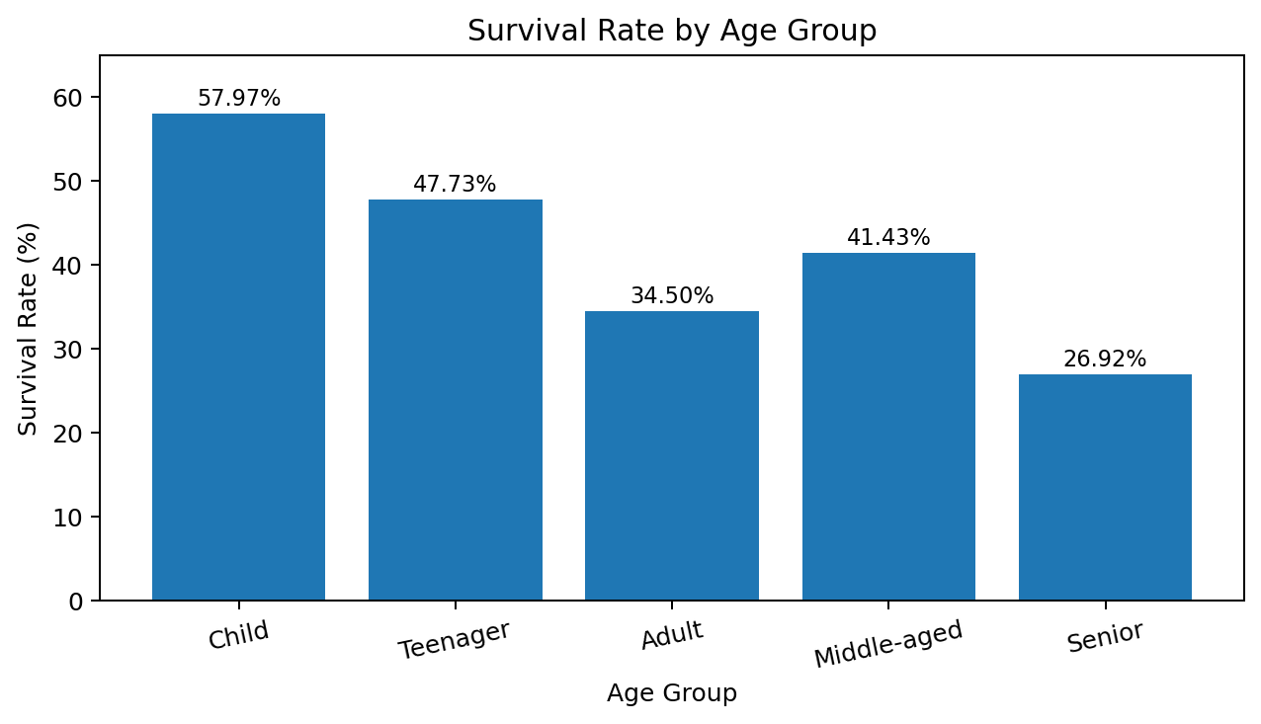
Figure 4. Observed survival rate by age group.
Age group | Passenger count | Survival rate
Child | 69 | 57.97%
Teenager | 44 | 47.73%
Adult | 542 | 34.50%
Middle-aged | 210 | 41.43%
Senior | 26 | 26.92%
Children had the highest observed survival rate at 57.97%, while seniors had the lowest at 26.92%. The senior result needs caution because the group contains only 26 passengers. In comparison, the adult group contains 542 passengers. This is why the group sizes are reported alongside the percentages.

7. Fare Analysis
The fare variable has a mean of 32.20 and a median of 14.45. The higher mean compared with the median indicates a positively skewed distribution. The median therefore gives a better indication of a typical passenger's fare than the mean alone.
print(df["Fare"].describe())
This interpretation is connected to the Week 1 preprocessing decision to investigate high fare values rather than automatically delete them. A high fare is not necessarily an error; it can represent a genuine difference between passengers.

8. Age and Fare Relationship
The Pearson correlation between age and fare was 0.0967. This is a very weak positive linear relationship. The result suggests that age does not have a strong linear association with fare in this dataset.
correlation = df["Age"].corr(df["Fare"])
print(f"Age-Fare correlation: {correlation:.4f}")
A weak correlation should not be interpreted as proof that the variables are completely unrelated. It means that a strong linear relationship was not observed.

9. Family Size Feature
I created FamilySize by combining SibSp and Parch and adding one for the passenger themselves. The purpose was to create a single, more interpretable measure of the recorded family group size.
df["FamilySize"] = df["SibSp"] + df["Parch"] + 1
The transformation is useful for further grouped analysis. The supplied Week 2 evidence contains the transformation and the final missing-value check, but it does not contain a completed FamilySize survival table or chart. Therefore, this report does not invent a FamilySize survival result.

10. Correlation Analysis
A correlation matrix was used to examine linear relationships among the numerical variables in the cleaned dataset.
correlation_matrix = df.corr(numeric_only=True)
plt.figure(figsize=(10, 7))
sns.heatmap(correlation_matrix, annot=True, fmt=".2f")
plt.title("Correlation Heatmap")
plt.show()
The heatmap is useful as an exploratory screening tool. Correlation can identify relationships worth investigating, but it does not establish causation.

11. Final Data Quality Check
After creating AgeGroup and FamilySize, I checked the main variables affected by the EDA transformations. The final output showed zero missing values in all four checked variables.
Variable | Missing values
Age | 0
Fare | 0
FamilySize | 0
AgeGroup | 0
print(df[["Age", "Fare", "FamilySize", "AgeGroup"]].isnull().sum())
This provides a reproducibility check: the derived variables used in the report did not introduce additional missing values in the fields checked.

12. Summary of Main Findings
Analysis | Observed result | Interpretation
Overall survival | 38.38% | Fewer than half of the passengers survived.
Gender | Female 74.20%; Male 18.89% | Large observed difference between the two groups.
Passenger class | 1st 62.96%; 2nd 47.28%; 3rd 24.24% | Observed survival decreased across class.
Age group | Child 57.97%; Senior 26.92% | Rates differ, but group size must be considered.
Age | Mean 29.36; Median 28.00 | Mean and median are relatively close.
Fare | Mean 32.20; Median 14.45 | Difference suggests positive skewness.
Age–fare relationship | r = 0.0967 | Very weak positive linear association.
Final quality check | 0 missing in checked variables | No missing values introduced in the checked transformations.

13. Critical Interpretation and Limitations
The strongest patterns in this EDA are the differences in survival by gender and passenger class. These differences are visible in both the numerical summaries and the charts.
The age-group analysis shows why percentages should be interpreted together with sample size. The senior group has the lowest observed survival rate, but it contains only 26 passengers. The adult group contains 542 passengers.
The fare analysis demonstrates why more than one summary statistic is useful. Reporting only the mean would hide the fact that the median is much lower.
This analysis is descriptive rather than causal. Correlation measures linear association, some subgroups are relatively small, and the AgeGroup boundaries were chosen for exploratory comparison. The findings therefore identify patterns worth investigating rather than proving why those patterns occurred.

14. Reflection and What I Learned
The main lesson from this task was that EDA is more than producing graphs. Numerical summaries helped identify which differences were worth discussing, while visualizations made the direction and size of those differences easier to compare.
I also learned the importance of keeping subgroup size visible. The senior age group is a useful example because it has only 26 observations. Without the passenger count, it would be easy to overinterpret the 26.92% survival rate.
Another useful point was the difference between correlation and causation. The age–fare correlation of 0.0967 indicates that a strong linear relationship was not observed; it does not prove that the variables can never be related.
I carried forward the Week 1 practice of documenting decisions with evidence. In this report, the main findings are supported by the actual counts and percentages available from the notebook, the assumptions behind AgeGroup are stated, and the final transformation check is reported explicitly.

15. Traceability to Week 1
Week 2 begins from the cleaned dataset created in Week 1. Week 1 focused on acquisition, cleaning, missing-value handling, duplicate checking, outlier investigation, and preprocessing. Week 2 uses that cleaned output to investigate patterns without repeating the cleaning process.
The fare discussion is directly connected to the Week 1 decision to investigate high-fare values rather than automatically remove them. In Week 2, the mean–median difference is used as evidence that fare is skewed, while high values are not automatically treated as errors.
This keeps the two submissions distinct: Week 1 explains how the dataset was prepared, while Week 2 explains what can be learned from the prepared dataset.

16. Conclusion
The Week 2 EDA identified clear differences in observed survival across gender and passenger class. Age groups also showed differences, although subgroup size needs to be considered when interpreting the percentages.
The fare results showed a positively skewed distribution because the mean of 32.20 is much higher than the median of 14.45. The age–fare correlation of 0.0967 indicated only a very weak positive linear relationship.
Overall, the analysis demonstrates how descriptive statistics, grouped aggregation, feature creation, and visualization can be combined to explore a dataset. The results provide useful exploratory evidence, but they should not be treated as causal conclusions.

Appendix A. Core Python Code
# Load cleaned dataset
import pandas as pd
import matplotlib.pyplot as plt
import seaborn as sns
df = pd.read_csv("titanic_cleaned.csv")
# Survival by gender
gender_survival = df.groupby("Sex")["Survived"].mean() * 100
# Survival by passenger class
class_survival = df.groupby("Pclass")["Survived"].mean() * 100
# Family size
df["FamilySize"] = df["SibSp"] + df["Parch"] + 1
# Age groups
df["AgeGroup"] = pd.cut(
df["Age"],
bins=[0, 12, 17, 34, 59, 100],
labels=["Child", "Teenager", "Adult", "Middle-aged", "Senior"],
include_lowest=True
)
# Age-group survival
age_group_analysis = df.groupby(
"AgeGroup", observed=False
)["Survived"].agg(
PassengerCount="count",
SurvivalRate="mean"
)
age_group_analysis["SurvivalRate"] *= 100
# Age-Fare correlation
correlation = df["Age"].corr(df["Fare"])
# Final check
print(df[["Age", "Fare", "FamilySize", "AgeGroup"]].isnull().sum())

