Week 5: Deep Learning Application in Data Science
Fashion-MNIST Image Classification using a Convolutional Neural Network
Virtual Data Science with Python Internship
Framework: TensorFlow / Keras | Problem: Multi-class image classification

1. Introduction
This project applies deep learning to image classification using the Fashion-MNIST dataset. A Convolutional Neural Network (CNN) was designed, trained and evaluated using TensorFlow and Keras. The workflow covers data inspection, preprocessing, model design, training, validation, test evaluation, error analysis and model saving.

2. Problem Statement
The objective is to predict which of ten clothing and accessory categories an input 28 × 28 grayscale image belongs to. The classes are T-shirt/top, Trouser, Pullover, Dress, Coat, Sandal, Shirt, Sneaker, Bag and Ankle boot. This is a supervised multi-class classification problem.

3. Objectives
- Prepare the Fashion-MNIST image data for deep learning.
- Design and justify a CNN architecture.
- Train and validate the model.
- Evaluate performance on unseen test data.
- Use accuracy, precision, recall, F1-score and a confusion matrix.
- Analyse incorrect predictions and confidence.
- Discuss overfitting, limitations and future improvements.

4. Dataset and Initial Inspection
Fashion-MNIST was loaded with TensorFlow/Keras. The training set contains 60,000 images and the test set contains 10,000 images. Each image is 28 × 28 pixels with one grayscale channel. There are ten classes, and the training distribution is balanced with 6,000 images per class.
Item | Value
Training images | 60,000
Test images | 10,000
Image size | 28 × 28
Classes | 10
Training images/class | 6,000
Original pixel range | 0–255
Data type | uint8
Sample images were inspected visually and the labels matched the expected Fashion-MNIST categories. The original pixel range was 0 to 255.

5. Preprocessing
Pixel values were converted to float32 and divided by 255, producing a range of 0.0 to 1.0. An explicit channel dimension was then added for CNN input.
X_train = X_train.astype("float32") / 255.0
X_test = X_test.astype("float32") / 255.0
X_train = X_train[..., np.newaxis]
X_test = X_test[..., np.newaxis]
The resulting shapes were (60000, 28, 28, 1) for training and (10000, 28, 28, 1) for testing.

6. CNN Architecture
A CNN was selected because convolutional layers can learn local image features such as edges, shapes and textures. The model used two convolutional blocks followed by a dense classification section.
Layer | Configuration | Purpose
Input | 28 × 28 × 1 | Accepts grayscale image
Conv2D | 32 filters, 3×3, ReLU | Learns low-level patterns
MaxPooling | 2×2 | Reduces spatial size
Conv2D | 64 filters, 3×3, ReLU | Learns more complex patterns
MaxPooling | 2×2 | Further reduction
Flatten | 1,600 values | Creates feature vector
Dense | 128, ReLU | Higher-level learning
Dropout | 0.30 | Helps reduce overfitting
Output | 10, Softmax | Class probabilities
The model contained 225,034 trainable parameters.
model = models.Sequential([
layers.Input(shape=(28, 28, 1)),
layers.Conv2D(32, (3, 3), activation="relu"),
layers.MaxPooling2D((2, 2)),
layers.Conv2D(64, (3, 3), activation="relu"),
layers.MaxPooling2D((2, 2)),
layers.Flatten(),
layers.Dense(128, activation="relu"),
layers.Dropout(0.3),
layers.Dense(10, activation="softmax")
])
The model was compiled with Adam, sparse categorical cross-entropy and accuracy.
model.compile(
optimizer="adam",
loss="sparse_categorical_crossentropy",
metrics=["accuracy"]
)

7. Training Procedure
The model was trained for 10 epochs with batch size 64. A 10% validation split was used to monitor performance on data not used for weight updates.
history = model.fit(
X_train, y_train,
epochs=10,
batch_size=64,
validation_split=0.1,
verbose=1
)

8. Training Results
Epoch | Train Acc. | Val. Acc. | Train Loss | Val. Loss
1 | 79.80% | 86.65% | 0.5591 | 0.3635
2 | 86.81% | 87.18% | 0.3641 | 0.3339
3 | 88.50% | 88.67% | 0.3144 | 0.2973
4 | 89.41% | 88.82% | 0.2878 | 0.2876
5 | 90.17% | 90.28% | 0.2641 | 0.2593
6 | 90.88% | 90.62% | 0.2455 | 0.2561
7 | 91.61% | 90.90% | 0.2256 | 0.2440
8 | 92.05% | 90.78% | 0.2125 | 0.2509
9 | 92.60% | 91.93% | 0.1988 | 0.2318
10 | 93.04% | 91.10% | 0.1859 | 0.2525
Training accuracy increased from 79.80% to 93.04%. The highest validation accuracy was 91.93% at epoch 9, followed by 91.10% at epoch 10. Validation loss reached its lowest value of 0.2318 at epoch 9 and then increased to 0.2525 at epoch 10. This indicates mild overfitting near the end of training.
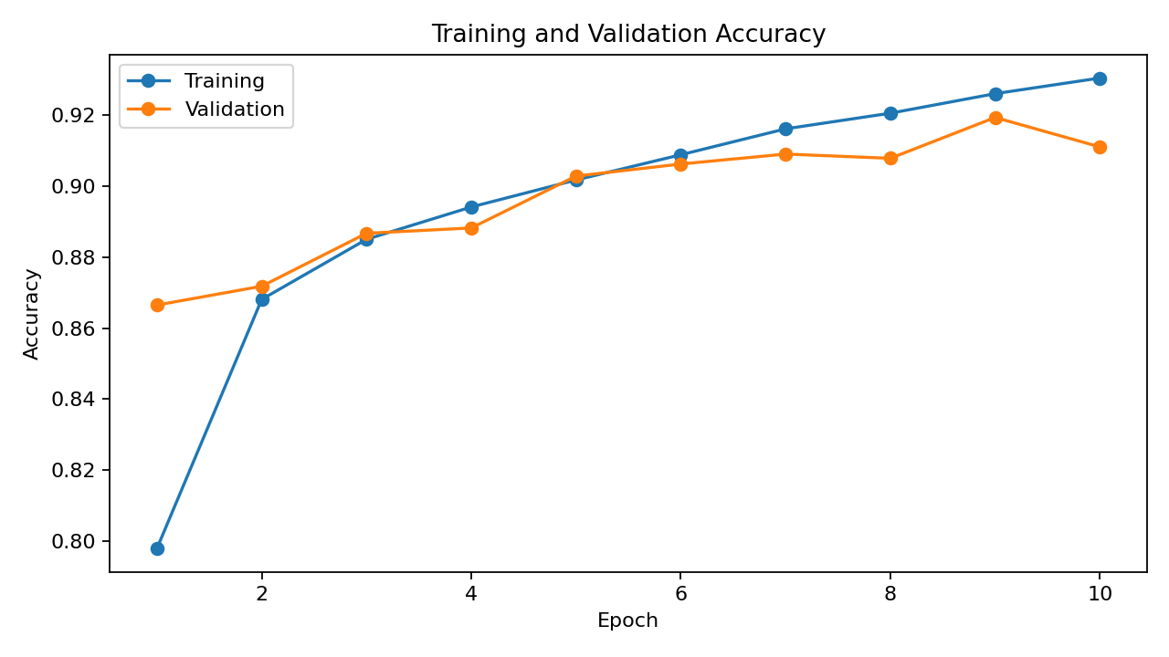
Figure 1. Training and validation accuracy.
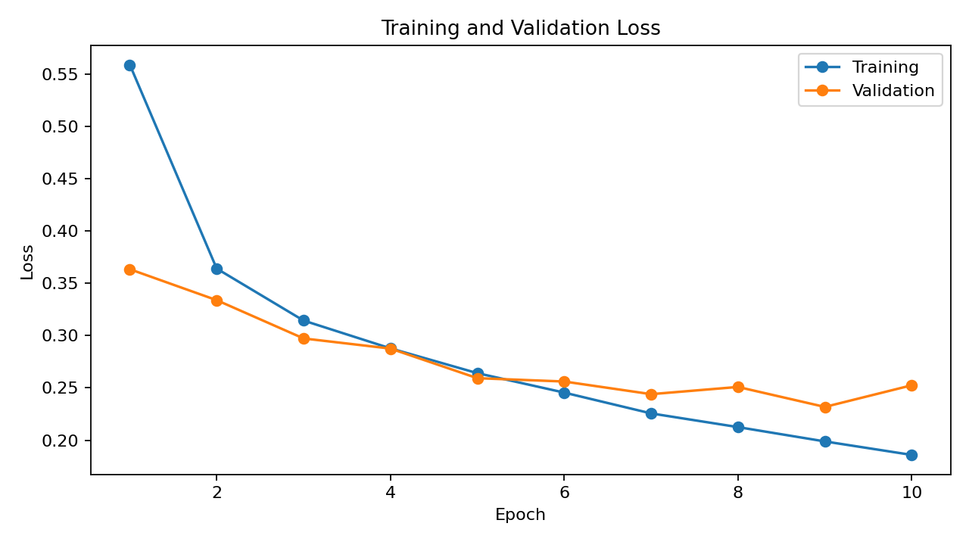
Figure 2. Training and validation loss.

9. Test Evaluation
The trained model was evaluated on the separate 10,000-image test set. Test loss was 0.2652 and test accuracy was 90.51%. The model made 9,051 correct predictions and 949 incorrect predictions.
Metric | Result
Test loss | 0.2652
Test accuracy | 90.51%
Correct predictions | 9,051
Incorrect predictions | 949

10. Classification Report
The overall classification report showed accuracy of about 91%, macro-average F1 of 0.90 and weighted-average F1 of 0.90.
Class | Precision | Recall | F1 | Support
T-shirt/top | 0.81 | 0.91 | 0.86 | 1,000
Trouser | 0.99 | 0.98 | 0.99 | 1,000
Pullover | 0.82 | 0.88 | 0.85 | 1,000
Dress | 0.92 | 0.91 | 0.92 | 1,000
Coat | 0.85 | 0.85 | 0.85 | 1,000
Sandal | 0.98 | 0.97 | 0.98 | 1,000
Shirt | 0.79 | 0.64 | 0.71 | 1,000
Sneaker | 0.92 | 0.99 | 0.95 | 1,000
Bag | 0.98 | 0.97 | 0.98 | 1,000
Ankle boot | 0.99 | 0.94 | 0.96 | 1,000
The strongest results were obtained for Trouser, Sandal, Bag, Sneaker and Ankle boot. Shirt was the weakest class, with recall 0.64 and F1-score 0.71.
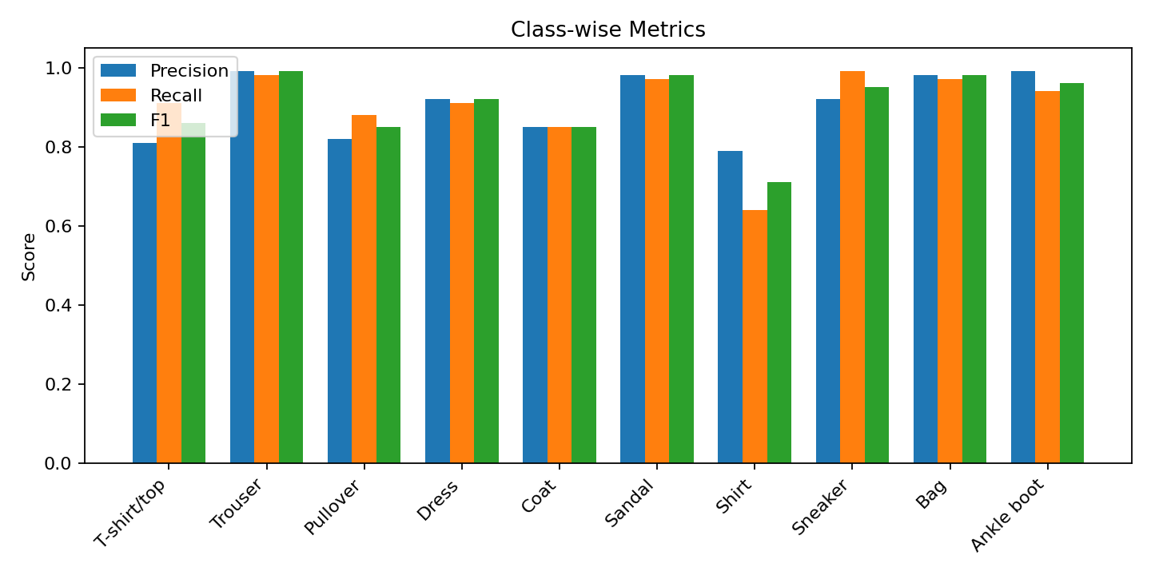
Figure 3. Class-wise precision, recall and F1-score.

11. Confusion Matrix and Error Analysis
The confusion matrix showed strong performance for distinctive classes such as Sneaker and Trouser. Sneaker had 990 correct predictions out of 1,000, while Trouser had 983.
Shirt was the most difficult category: only 637 of 1,000 Shirt images were correctly classified. The main confusions were Shirt predicted as T-shirt/top (167), Pullover (90) and Coat (73). These errors are understandable because these upper-body garments have similar shapes in low-resolution grayscale images.
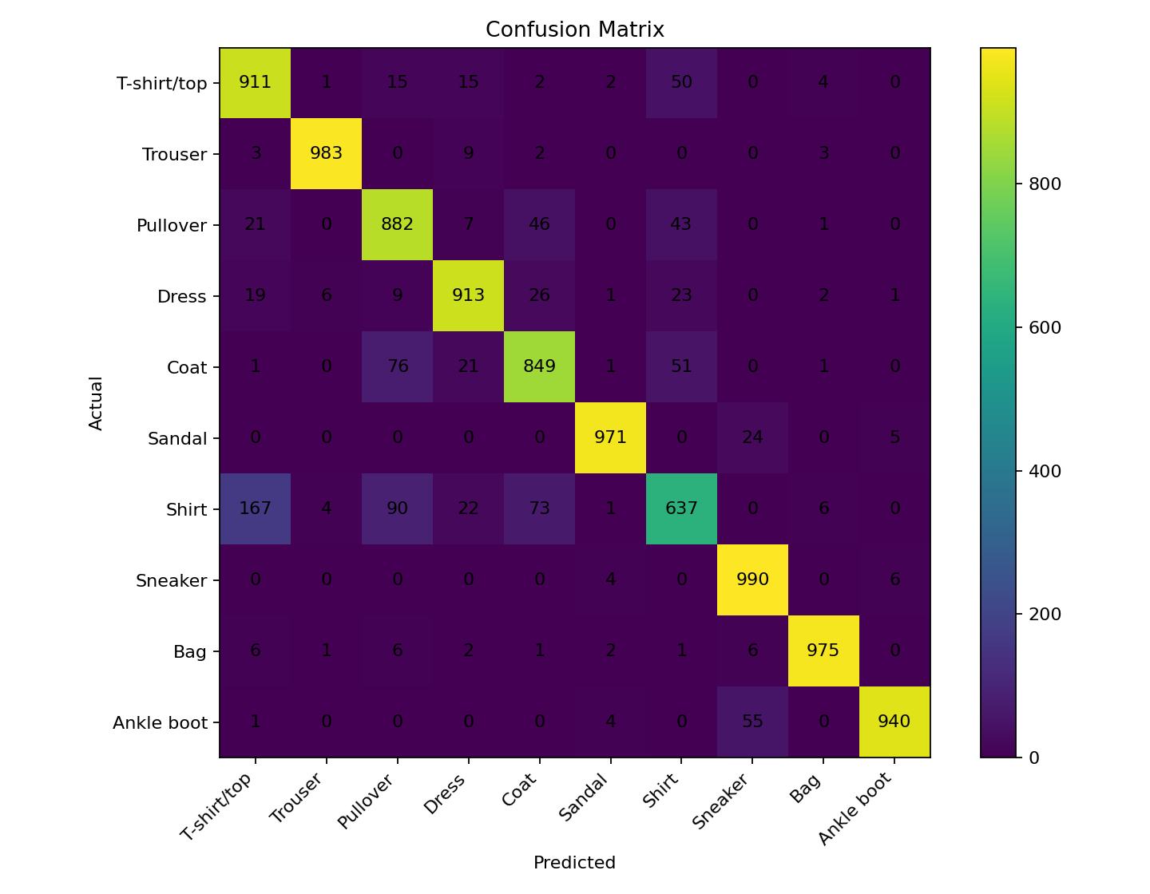
Figure 4. Confusion matrix for the 10,000 test images.

12. Incorrect Predictions and Confidence
The project inspected 12 incorrectly classified test images. The examples included Shirt/T-shirt-top, Sandal/Sneaker, Ankle boot/Sandal and several Dress/Coat/Pullover/Shirt confusions. This visual inspection supported the numerical error analysis.
A separate confidence visualization showed that several correct predictions had very high confidence, while an ambiguous Shirt image was predicted as T-shirt/top with only 48.7% confidence. This suggests that the model can express lower confidence when visual evidence is less distinctive.

13. Challenges and Critical Analysis
- Upper-body clothing classes are visually similar and account for many errors.
- The 28 × 28 grayscale format limits fine visual detail.
- Training accuracy continued to increase while validation performance fluctuated slightly near the end.
- The model performs differently across classes even though the training data are balanced.
- Dropout and convolutional feature learning were used to improve generalization.

14. Strengths
- CNN architecture is appropriate for image data.
- Training and test data were kept separate.
- The training process included validation monitoring.
- Multiple evaluation metrics were reported.
- Confusion-matrix and example-based error analysis were performed.
- The trained model was saved for reproducibility.

15. Limitations
- Results are specific to Fashion-MNIST and should not be assumed to transfer directly to real-world images.
- Only one main CNN architecture was evaluated.
- The training run used a fixed ten-epoch configuration rather than exhaustive tuning.
- The model still has noticeable difficulty with Shirt and other visually similar classes.

16. Possible Improvements
- Use early stopping based on validation loss or accuracy.
- Apply suitable image augmentation.
- Tune filters, dropout, learning rate and batch size.
- Compare deeper CNNs or transfer-learning approaches.
- Investigate class-specific techniques for improving Shirt recognition.

17. Model Saving
The trained model was saved successfully as fashion_mnist_cnn.keras and the file existence was verified in Colab.
model.save("fashion_mnist_cnn.keras")
print(os.path.exists("fashion_mnist_cnn.keras"))

18. Main Python Workflow
from tensorflow.keras.datasets import fashion_mnist
from tensorflow.keras import layers, models
from sklearn.metrics import confusion_matrix, classification_report
(X_train, y_train), (X_test, y_test) = fashion_mnist.load_data()
X_train = X_train.astype("float32") / 255.0
X_test = X_test.astype("float32") / 255.0
X_train = X_train[..., np.newaxis]
X_test = X_test[..., np.newaxis]
model = models.Sequential([
layers.Input(shape=(28, 28, 1)),
layers.Conv2D(32, (3, 3), activation="relu"),
layers.MaxPooling2D((2, 2)),
layers.Conv2D(64, (3, 3), activation="relu"),
layers.MaxPooling2D((2, 2)),
layers.Flatten(),
layers.Dense(128, activation="relu"),
layers.Dropout(0.3),
layers.Dense(10, activation="softmax")
])
model.compile(optimizer="adam",
loss="sparse_categorical_crossentropy",
metrics=["accuracy"])
history = model.fit(X_train, y_train,
epochs=10, batch_size=64,
validation_split=0.1)
test_loss, test_accuracy = model.evaluate(X_test, y_test)
y_pred_prob = model.predict(X_test)
y_pred = np.argmax(y_pred_prob, axis=1)
print(classification_report(
y_test, y_pred, target_names=class_names
))
model.save("fashion_mnist_cnn.keras")

19. Key Findings
- Training accuracy: 93.04%.
- Best validation accuracy: 91.93% at epoch 9.
- Test accuracy: 90.51%.
- Correct test predictions: 9,051 out of 10,000.
- Macro F1-score: 0.90.
- Shirt was the most difficult class with recall 0.64 and F1-score 0.71.
- Sneaker and Trouser were among the strongest classes.
- The final training curves suggest mild overfitting near epoch 10.

20. Learning Reflection
This project helped me understand how a deep learning workflow handles image data differently from traditional machine-learning workflows. The CNN learns visual features directly through convolutional layers rather than requiring manual image feature extraction. I also learned why validation and test evaluation need to be separated and why a confusion matrix can reveal important class-specific weaknesses that a single accuracy value cannot show.

21. Conclusion
The project successfully implemented a complete deep learning workflow using a CNN on Fashion-MNIST. The final model achieved 90.51% test accuracy on 10,000 unseen images. The combination of training curves, class-level metrics, confusion matrix, incorrect examples and confidence analysis provided a detailed evaluation of the model. The main weakness was confusion among visually similar upper-body categories, especially Shirt. Future work could use augmentation, early stopping, hyperparameter tuning or deeper architectures to improve generalization.

22. Week 5 Requirement Coverage
Requirement | Evidence
Public deep-learning dataset | Fashion-MNIST
Problem definition | 10-class image classification
Neural-network architecture | CNN with two convolutional blocks
Training and evaluation | Sections 7–12
Metrics and figures | Accuracy, precision, recall, F1, curves, confusion matrix
Critical analysis | Sections 11–16
Code examples | Section 18
Challenges/overfitting | Sections 8 and 13
Improvements | Section 16

23. Personal Project Notes
I treated this as a practical experiment rather than trying to optimize the model endlessly. My first focus was getting the data pipeline working correctly, then I checked the model behaviour using validation results and the separate test set. The final 90.51% test accuracy is useful, but the class-level results were more informative because they showed where the model was actually struggling.
One result that stood out to me was the Shirt class. The model got many of these images wrong even though the overall accuracy was above 90%. Looking at the confusion matrix made the reason clearer: Shirt images were often classified as T-shirt/top, Pullover or Coat. This was a useful reminder that a single accuracy number does not describe every part of a classification problem.
I also noticed that the training accuracy kept increasing while the validation result did not improve at the same rate near the end. If I continued the experiment, I would try early stopping and a small amount of suitable data augmentation instead of simply increasing the number of epochs.

24. References
- TensorFlow/Keras documentation for Fashion-MNIST and CNN layers.
- TensorFlow/Keras model-training documentation.
- Scikit-learn documentation for classification metrics and confusion matrices.

25. Final Results at a Glance
Measure | Actual result from Colab
Training accuracy | 93.04%
Best validation accuracy | 91.93% (Epoch 9)
Test accuracy | 90.51%
Test loss | 0.2652
Correct test predictions | 9,051 / 10,000
Incorrect test predictions | 949 / 10,000
Macro F1-score | 0.90
Weakest class | Shirt (F1 = 0.71; recall = 0.64)
Model parameters | 225,034

