WEEK 6 INTEGRATIVE CAPSTONE PROJECT
Customer Churn Analysis and Prediction Using Python
End-to-End Data Science Pipeline with Supervised Learning and Customer Segmentation

Project item | Details
Dataset | IBM Telco Customer Churn dataset
Original size | 7,043 rows × 21 columns
Cleaned size | 7,032 rows × 20 modeling columns
Supervised models | Logistic Regression and Random Forest
Unsupervised method | K-Means clustering
Best clustering k | 2 (silhouette = 0.4256)
Main modeling finding | Random Forest gives substantially higher churn recall

1. Executive Summary
For this project, I worked through the full Data Science with Python process using a telecommunications customer churn dataset. I started with the raw public data, cleaned it, explored the main patterns, trained two classification models, checked their performance and then added customer segmentation using K-Means.
After cleaning, 7,032 customer records remained. The overall churn rate was 26.58%. Exploratory analysis showed particularly large differences by contract type, payment method, internet service, tenure, monthly charges and technical support.
Logistic Regression achieved 80.53% accuracy, 65.15% precision, 57.49% recall, 61.08% F1-score and 0.8361 ROC-AUC. Random Forest achieved 76.40% accuracy, 54.04% precision, 75.13% recall, 62.86% F1-score and 0.8360 ROC-AUC. Cross-validation showed the same trade-off: Logistic Regression was stronger in accuracy and precision, while Random Forest was stronger in recall and F1-score.
K-Means clustering used tenure, MonthlyCharges and NumServices. Two clusters gave the highest silhouette score of 0.4256. The segmentation identified a longer-tenure, higher-service group and a shorter-tenure, lower-service group.

2. Problem Statement
The main idea was to understand which customer details were related to churn, see how well I could predict churn, and then divide customers into a few useful groups.

3. Objectives
- Acquire and inspect a public churn dataset.
- Clean inconsistent data and prepare variables for modeling.
- Perform EDA and identify important churn patterns.
- Build Logistic Regression and Random Forest classifiers.
- Evaluate models with accuracy, precision, recall, F1-score, ROC-AUC and confusion matrices.
- Use five-fold stratified cross-validation.
- Apply K-Means segmentation without using Churn to form the clusters.
- Interpret findings and provide practical recommendations.

4. Dataset and Data Acquisition
I used the IBM Telco Customer Churn dataset. It contains customer demographic details, account information, subscribed services, billing information and the Churn target. I loaded the CSV directly with pandas.
Source: IBM public GitHub repository: https://github.com/IBM/telco-customer-churn-on-icp4d/blob/master/data/Telco-Customer-Churn.csv

5. Data Cleaning
The raw file had 7,043 rows and 21 columns. At first, the missing-value check did not show any missing values. However, TotalCharges was stored as an object, so I converted it to numeric. That revealed 11 blank values. I removed those 11 rows and also removed customerID because it is only an identifier.
Check | Result
Original dataset | 7,043 × 21
Invalid TotalCharges after conversion | 11
Final dataset | 7,032 × 20
Duplicate rows | 0
Churn = No | 5,163 (73.42%)
Churn = Yes | 1,869 (26.58%)

6. Exploratory Data Analysis
The numerical summary showed mean tenure of 32.42 months, mean MonthlyCharges of 64.79 and mean TotalCharges of 2,283.30. The target was imbalanced, so accuracy was not treated as the only meaningful metric.

6.1 Contract Type
Month-to-month customers had 42.71% churn, compared with 11.28% for one-year contracts and 2.85% for two-year contracts.
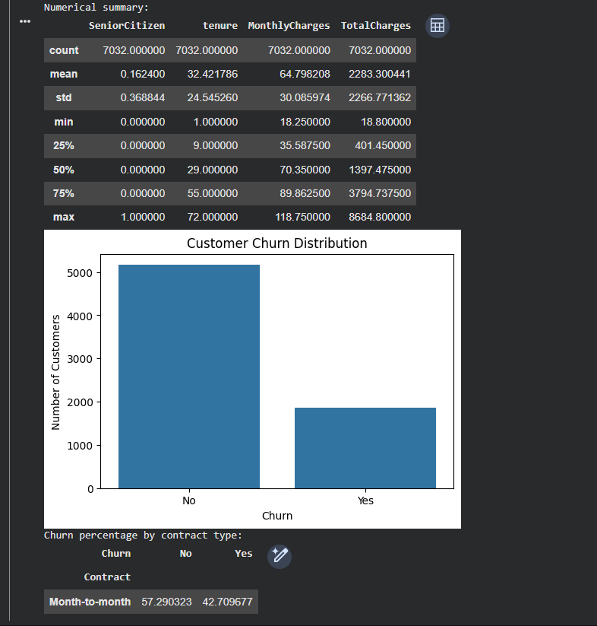
Figure 1. Churn rate by contract type.

6.2 Internet Service, Tenure and Monthly Charges
Fiber optic customers had 41.89% churn, compared with 18.38% for DSL and 7.43% for customers with no internet service. Churned customers were more concentrated at lower tenure values, and their MonthlyCharges median was visibly higher.
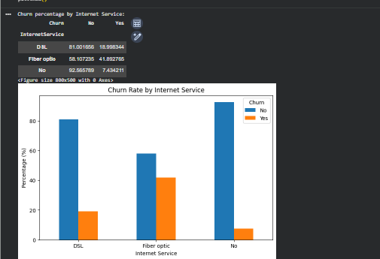
Figure 2. Internet service, tenure and monthly charges.

6.3 Payment, Billing and Support
Electronic check customers had 45.29% churn. Paperless billing customers had 33.59% churn versus 16.38% without paperless billing. Customers without tech support had 41.65% churn versus 15.20% with tech support.
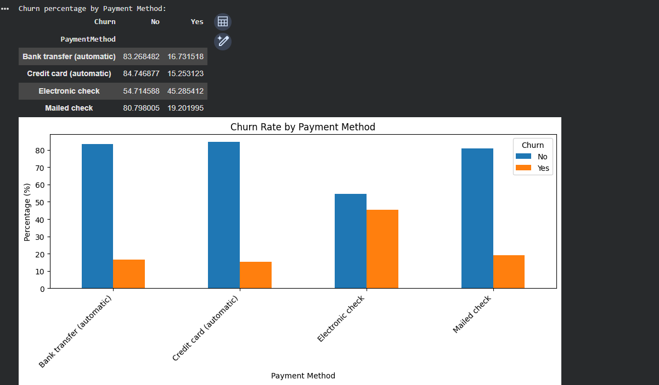
Figure 3. Churn rate by payment method.
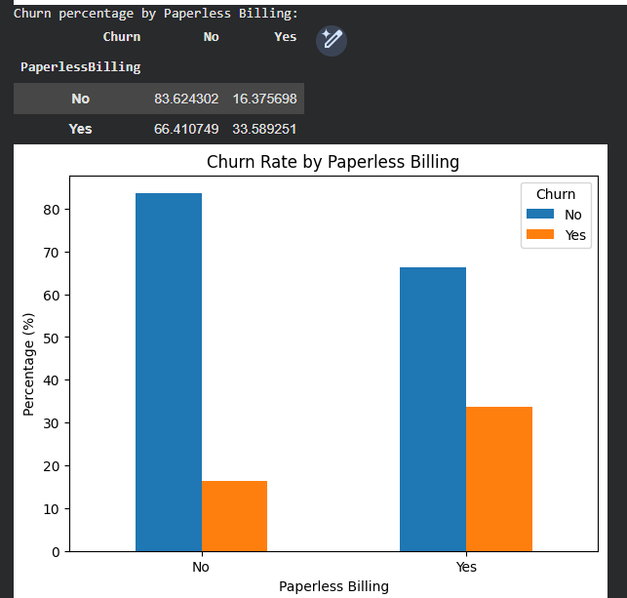
Figure 4. Churn rate by paperless billing.
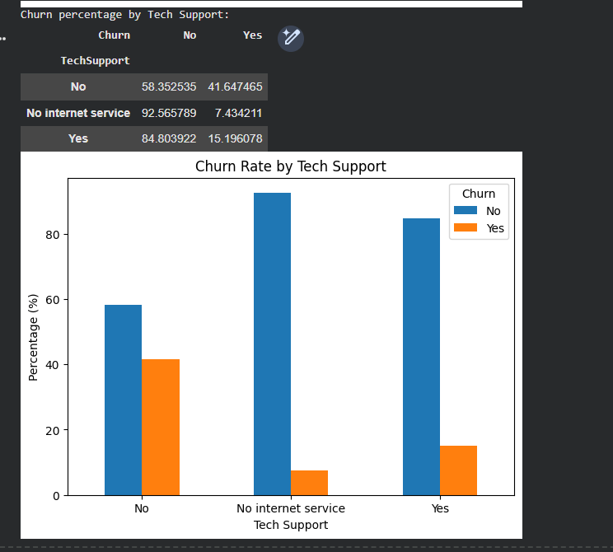
Figure 5. Churn rate by tech support.
These are associations in the dataset, not proof of causation.

7. Feature Engineering and Data Preparation
Churn was mapped to 0/1. Categorical predictors were one-hot encoded with drop_first=True, producing 30 model features. The data was split 80/20 using random_state=42 and stratify=y. Training contained 5,625 records and testing contained 1,407. Numerical variables were standardized for Logistic Regression using a scaler fitted only on the training set.

8. Logistic Regression
I used Logistic Regression first as a simple baseline for the binary churn problem.
Metric | Test result
Accuracy | 80.53%
Precision | 65.15%
Recall | 57.49%
F1-score | 61.08%
ROC-AUC | 83.61%
Its confusion matrix contained 918 true negatives, 215 true positives, 115 false positives and 159 false negatives. The 57.49% churn recall shows that many actual churners were missed.
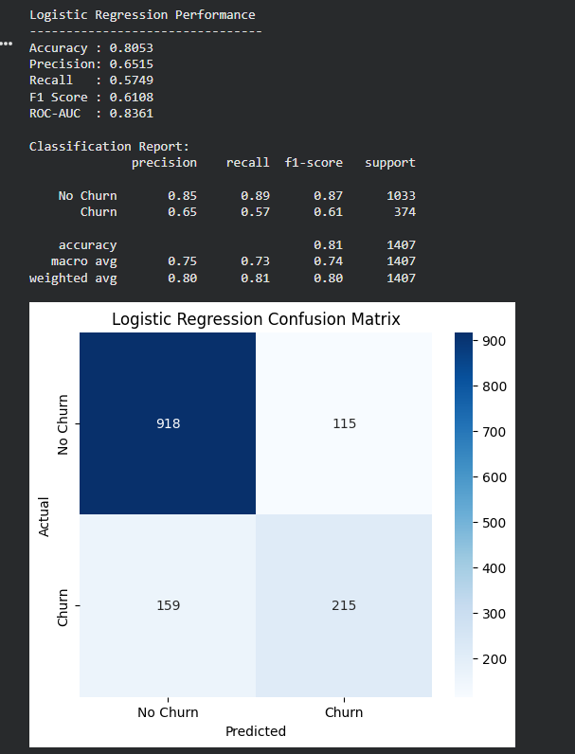
Figure 6. Logistic Regression evaluation.

9. Random Forest
Random Forest was selected as a nonlinear comparison model. The model used 300 trees, max_depth=10, min_samples_split=5, random_state=42 and class_weight='balanced'.
Metric | Test result
Accuracy | 76.40%
Precision | 54.04%
Recall | 75.13%
F1-score | 62.86%
ROC-AUC | 83.60%
The confusion matrix contained 794 true negatives, 281 true positives, 239 false positives and 93 false negatives. The major advantage was substantially higher churn recall.
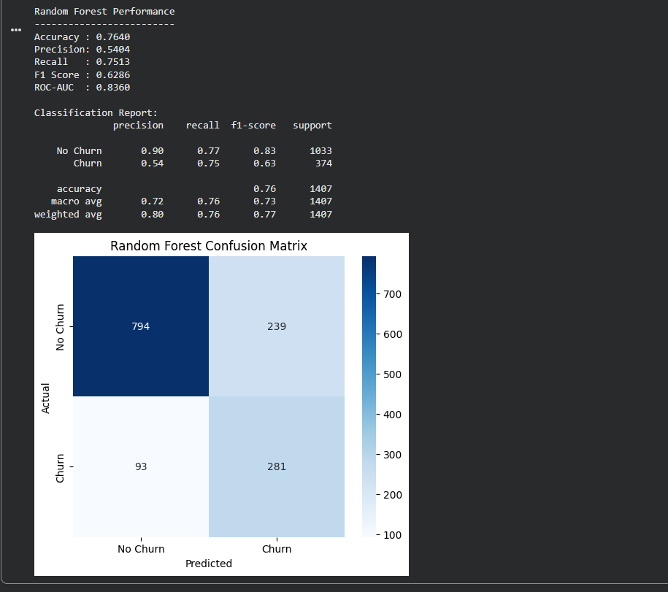
Figure 7. Random Forest evaluation.

10. Model Comparison
Metric | Logistic Regression | Random Forest
Accuracy | 0.8053 | 0.7640
Precision | 0.6515 | 0.5404
Recall | 0.5749 | 0.7513
F1-score | 0.6108 | 0.6286
ROC-AUC | 0.8361 | 0.8360
The results were quite different. Logistic Regression had better accuracy and precision, while Random Forest found more of the customers who actually churned and had the slightly better F1-score. If the main goal is to catch more possible churners, I would prefer the Random Forest result.
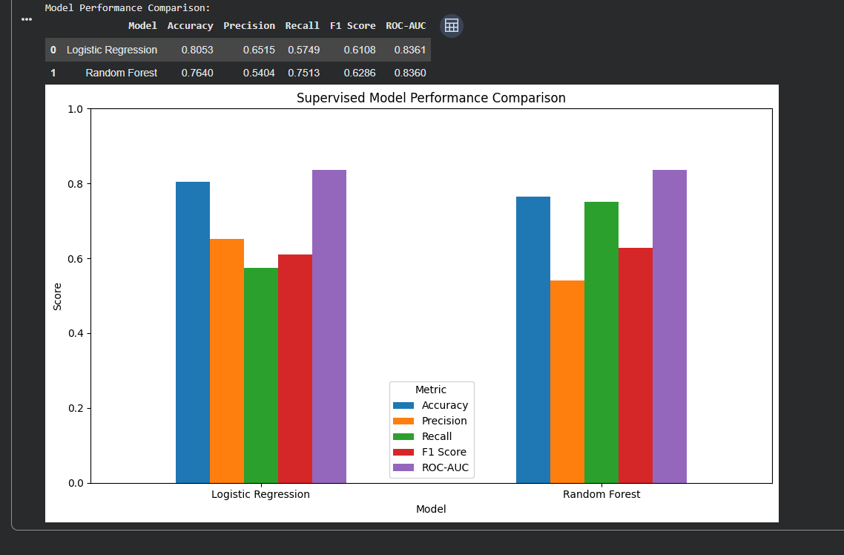
Figure 8. Model performance comparison.

11. Five-Fold Cross-Validation
Metric | Logistic Regression | Random Forest
Accuracy | 0.8028 | 0.7776
Precision | 0.6558 | 0.5636
Recall | 0.5452 | 0.7244
F1-score | 0.5952 | 0.6339
ROC-AUC | 0.8461 | 0.8463
Cross-validation supports the same trade-off observed on the held-out test set.
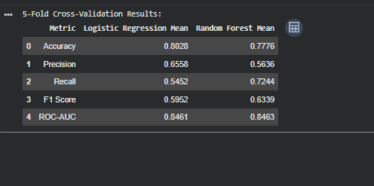
Figure 9. Five-fold cross-validation output.

12. ROC-AUC Analysis
The test ROC-AUC values were almost identical: 0.8361 for Logistic Regression and 0.8360 for Random Forest. The ROC curves therefore overlap closely. This means the models have similar overall ranking ability even though their default classification behavior differs.
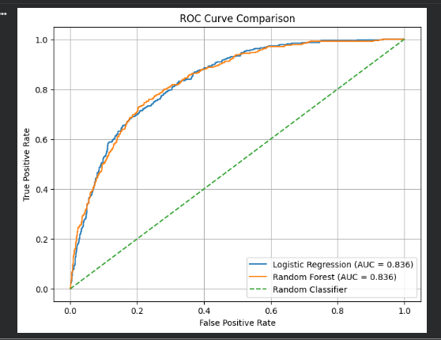
Figure 10. ROC curve comparison.

13. Random Forest Feature Importance
The strongest Random Forest feature was tenure, followed by TotalCharges, two-year contract, MonthlyCharges, fiber-optic internet service and electronic check.
Rank | Feature | Importance
1 | tenure | 0.1791
2 | TotalCharges | 0.1438
3 | Contract_Two year | 0.1064
4 | MonthlyCharges | 0.1053
5 | InternetService_Fiber optic | 0.0648
6 | PaymentMethod_Electronic check | 0.0494
7 | Contract_One year | 0.0430
8 | OnlineSecurity_Yes | 0.0334
9 | TechSupport_Yes | 0.0230
10 | PaperlessBilling_Yes | 0.0178
Feature importance indicates model usefulness, not causal influence.
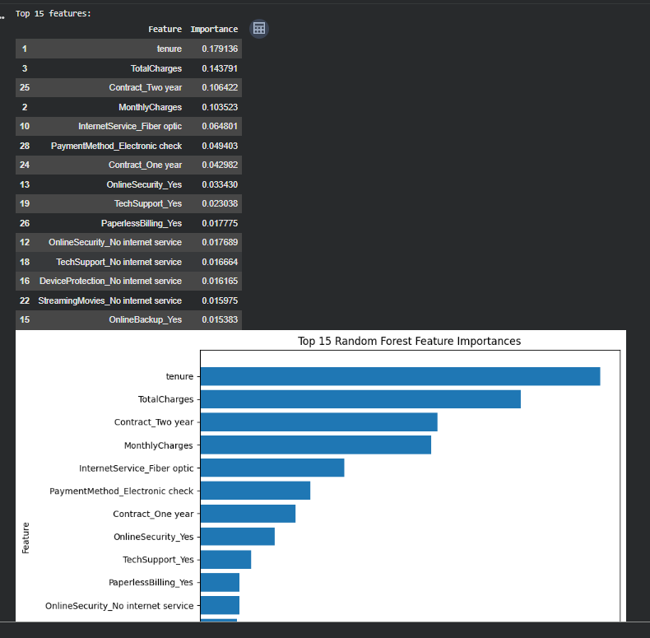
Figure 11. Top Random Forest feature importances.

14. Unsupervised Learning – K-Means
K-Means clustering was performed without using Churn as an input. The features were tenure, MonthlyCharges and NumServices. All three were standardized.
k | Silhouette score
2 | 0.4256
3 | 0.4056
4 | 0.4211
5 | 0.3834
6 | 0.3948
7 | 0.3799
8 | 0.3658
The highest silhouette score was at k=2, so I used two clusters for the final segmentation.
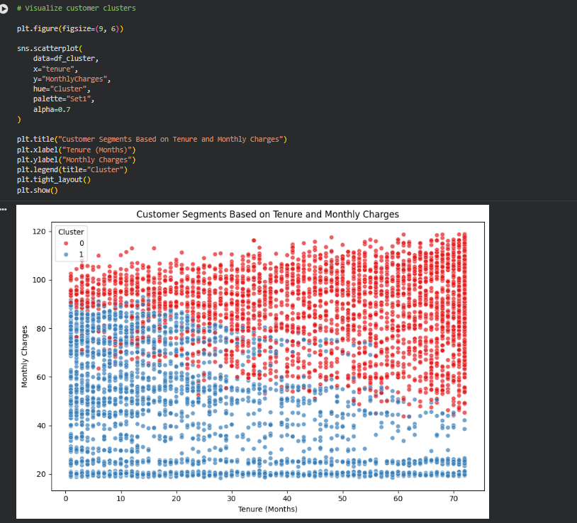
Figure 12. Customer segments based on tenure and monthly charges.

15. Customer Segment Profiles
Cluster | Customers | Avg tenure | Avg monthly charges | Avg services | Churn rate
0 | 3,147 | 46.61 | 89.47 | 5.28 | 24.21%
1 | 3,885 | 20.93 | 44.82 | 1.81 | 28.49%
Cluster 0 represents longer-tenure, higher-service customers. Cluster 1 represents shorter-tenure, lower-service customers. Cluster 1 has somewhat higher observed churn. The difference is not large enough to claim that the clusters themselves explain churn.
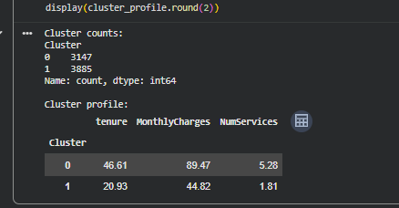
Figure 13. K-Means cluster profile output.

16. Business Insights and Recommendations
- Prioritize month-to-month customers for retention outreach because this group had 42.71% churn.
- Pay particular attention to electronic-check customers, who had 45.29% churn.
- Investigate the experience of fiber-optic customers, who had 41.89% churn.
- Consider proactive support for customers without tech support, who had 41.65% churn.
- Use tenure as an important risk indicator because it was the strongest Random Forest feature.
- For retention campaigns where missed churners are costly, consider the Random Forest model because its churn recall was 75.13% on the test set and 72.44% in cross-validation.
- Use Logistic Regression when accuracy, precision and straightforward interpretation are more important.
- Use the K-Means segments for customer profiling rather than treating them as direct explanations of churn.

17. Limitations
- The results come from one public dataset and may not generalize to every telecom setting.
- The target is imbalanced, so accuracy alone can hide missed churn cases.
- External validation on a different dataset was not performed.
- Random Forest feature importance is not causal evidence.
- The clustering uses only three features and therefore provides intentionally simple customer profiles.
- The analysis is observational and does not prove that business actions cause churn changes.

18. Possible Improvements
- Perform systematic hyperparameter tuning using stratified cross-validation.
- Compare additional ensemble methods.
- Tune the classification threshold according to the cost of missed churners versus false alerts.
- Calibrate predicted probabilities for risk scoring.
- Use SHAP or similar explainability methods for customer-level explanations.
- Validate the model on a separate future period or external dataset.
- Test richer clustering features and hierarchical clustering.

19. Reflection
The main practical lesson was that a complete data science workflow involves more than fitting a model. TotalCharges appeared complete in the initial missing-value check but revealed 11 invalid values after numeric conversion. This showed why data-type validation matters.
Another lesson was that accuracy alone was not enough. Logistic Regression had better accuracy, but Random Forest found many more actual churners. This made the model choice dependent on the purpose of the system rather than one headline score.
The clustering stage also separated prediction from segmentation. Churn was not used to create the clusters, so the segments could be analyzed independently and then compared with churn afterward.

20. End-to-End Methodology
Stage | Completed work
Data acquisition | Loaded public IBM Telco Customer Churn CSV
Cleaning | Converted TotalCharges; removed 11 invalid rows; removed customerID
EDA | Analyzed churn, contract, internet, tenure, charges, payment, billing and support
Feature engineering | Binary target and one-hot encoding
Split | 80/20 stratified train/test split
Scaling | Training-only StandardScaler for Logistic Regression
Supervised models | Logistic Regression and Random Forest
Evaluation | Accuracy, precision, recall, F1, ROC-AUC, confusion matrices and ROC curves
Validation | Five-fold stratified cross-validation
Interpretation | Random Forest feature importance
Unsupervised model | K-Means customer segmentation
Outputs | Processed CSV and saved model files
For the clustering part, I kept Churn out of the clustering features. I wanted the clusters to represent customer characteristics first and then compare the churn rates afterward. The two clusters were simple, but they gave me a useful way to describe the customer base.
I also noticed that the two models did not give the same kind of result. Logistic Regression had the higher accuracy, but Random Forest had much better recall for the churn class. This helped me understand why checking several evaluation metrics is important for an imbalanced classification problem.
While doing the notebook, one thing I did not expect was the TotalCharges issue. The first missing-value output showed zero missing values, but after I converted TotalCharges to numeric, 11 rows became missing. I removed those rows rather than filling them with an estimated value.

A Few Notes From My Work

21. Conclusion
Overall, this project took the data from the original CSV through cleaning, EDA, prediction, validation and customer segmentation.
The most important modeling result is the trade-off between the two classifiers. Logistic Regression is stronger in accuracy and precision, while Random Forest identifies a substantially larger share of actual churners and has a slightly better F1-score. For a retention-focused use case, Random Forest is therefore a reasonable operating choice when recall is prioritized.
The project also shows why business interpretation matters. Contract type, tenure, payment method, internet service, monthly charges and technical support all show useful associations with churn, but the analysis does not establish causality.

22. References
IBM. Telco Customer Churn dataset. Public GitHub repository.
Scikit-learn documentation for LogisticRegression, RandomForestClassifier, KMeans, StandardScaler and evaluation metrics.
Pandas documentation for data loading, cleaning and one-hot encoding.

