1. **Imagine you have a table claim including 3 columns: claim(customer_id, claim_datetime, claim_amount). Write a query to only return the last claim record for each customer. Hint: One customer may claim multiple times, so only select the latest claim record.**

**Answer 1:**

The Sql Query for the above question is as follows:

SELECT Customer_Id, claim_DateTime, claim_Amount

FROM claim x where claim_DateTime >= ALL (SELECT claim_DateTime FROM claim WHERE Customer_Id = x.Customer_Id AND claim_DateTime > 0);

To demonstrate the result of the above query, I have used mysql Workbench. I have input dummy data into the given columns in the schema claim. The following is the screenshot of the data and the result of the query:

This is the table claim,

The original table contains multiple record claims for customer with ID 400 and 401. The query will return only the latest claim record for each customer. For example, the result displays the latest record for 400, 401 and 20001.

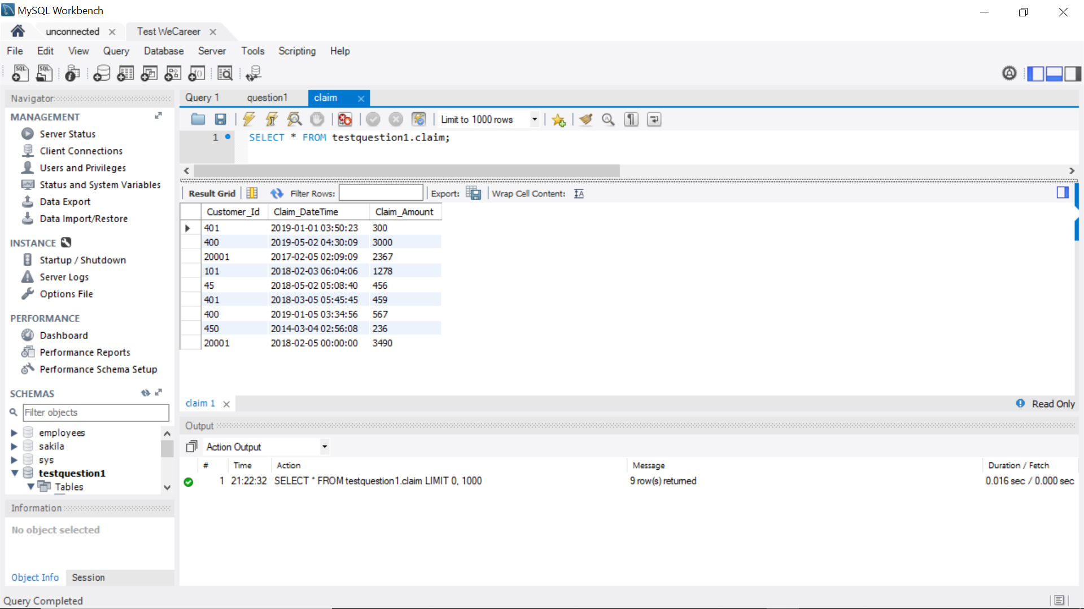

The result of the query is,

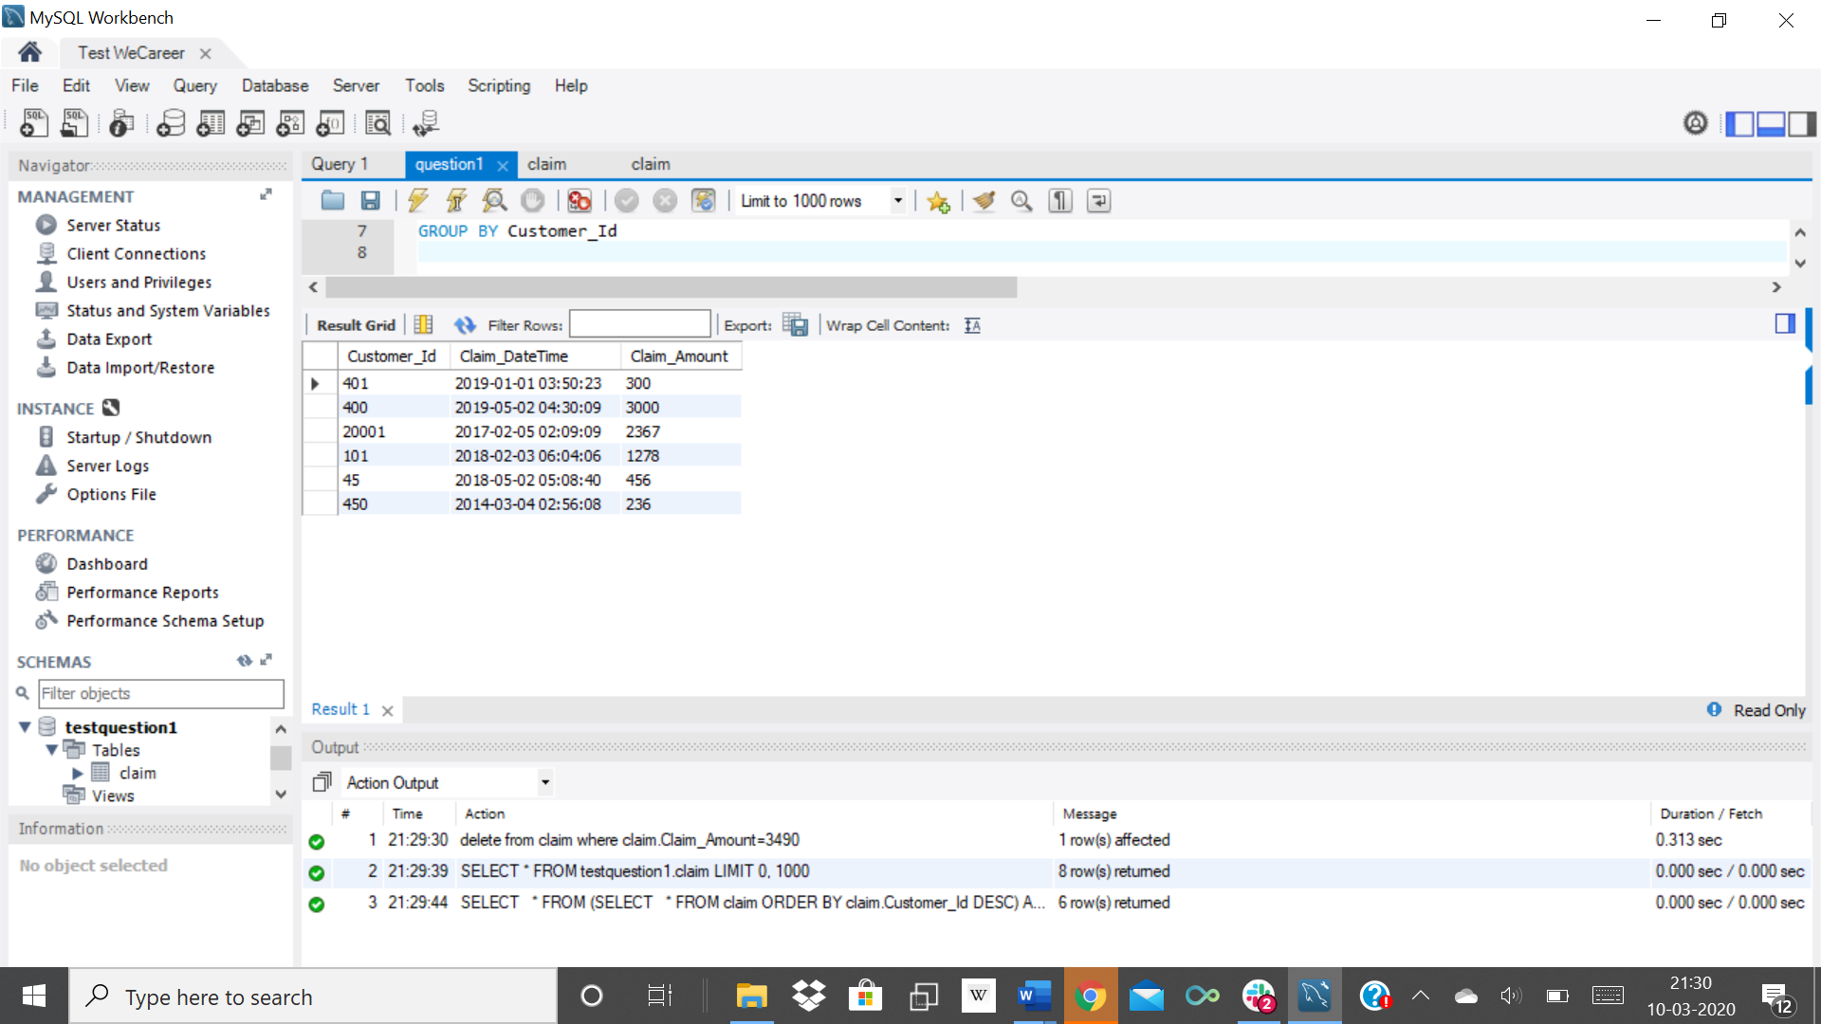

1. **Write a query to output the province where customers have the highest average balance.**

customer_contact_info

|  |  |  |
| --- | --- | --- |
| account_number | postal_code | province |
| 283285 | M2N2A2 | ON |
| 973525 | V5A4A6 | BC |
| 736823 | B6N8M3 | NS |
| 160186 | T1K4X5 | AB |
| 384623 | L6A3C5 | ON |
| .... | | |

customer_status

|  |  |  |  |
| --- | --- | --- | --- |
| account_number | status | balance | credit_limit |
| 51088 | OPEN | 3050 | 5000 |
| 28590 | OPEN | 234 | 10000 |
| 974824 | CLOSED | 0 | 8000 |
| 869173 | OPEN | 2007 | 7500 |
| 929023 | OPEN | 2500 | 20000 |
| .... | | | |

**Answer 2:**

The sql query for the above question is as follows:

SELECT customer_contact_info.province, AVG(customer_status.balance) AS Average_Balance

FROM customer_contact_info, customer_status

where customer_status.status='OPEN' AND customer_contact_info.account_number=customer_status.account_number

GROUP BY customer_contact_info.province

ORDER BY Average_balance DESC

LIMIT 1;

To demonstrate the result of the above query, I have used mysql Workbench. I have input dummy data into the given columns in the schema claim. The following is the screenshot of the data and the result of the query:

The table customer_contact_info is,

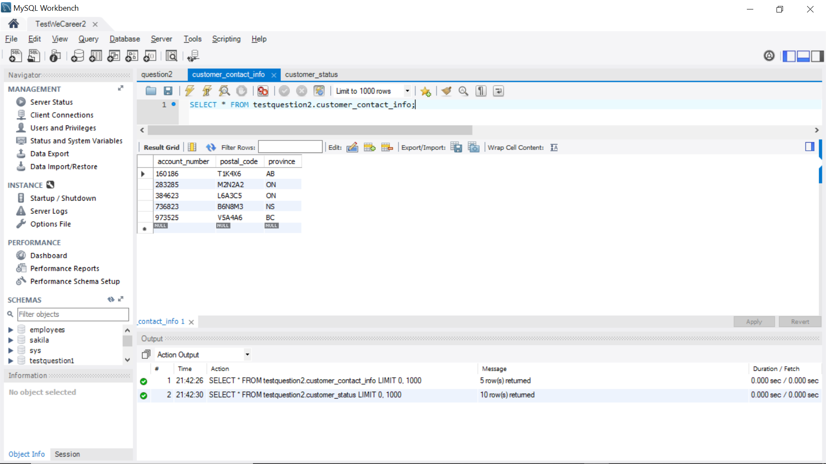

The table customer_status is,

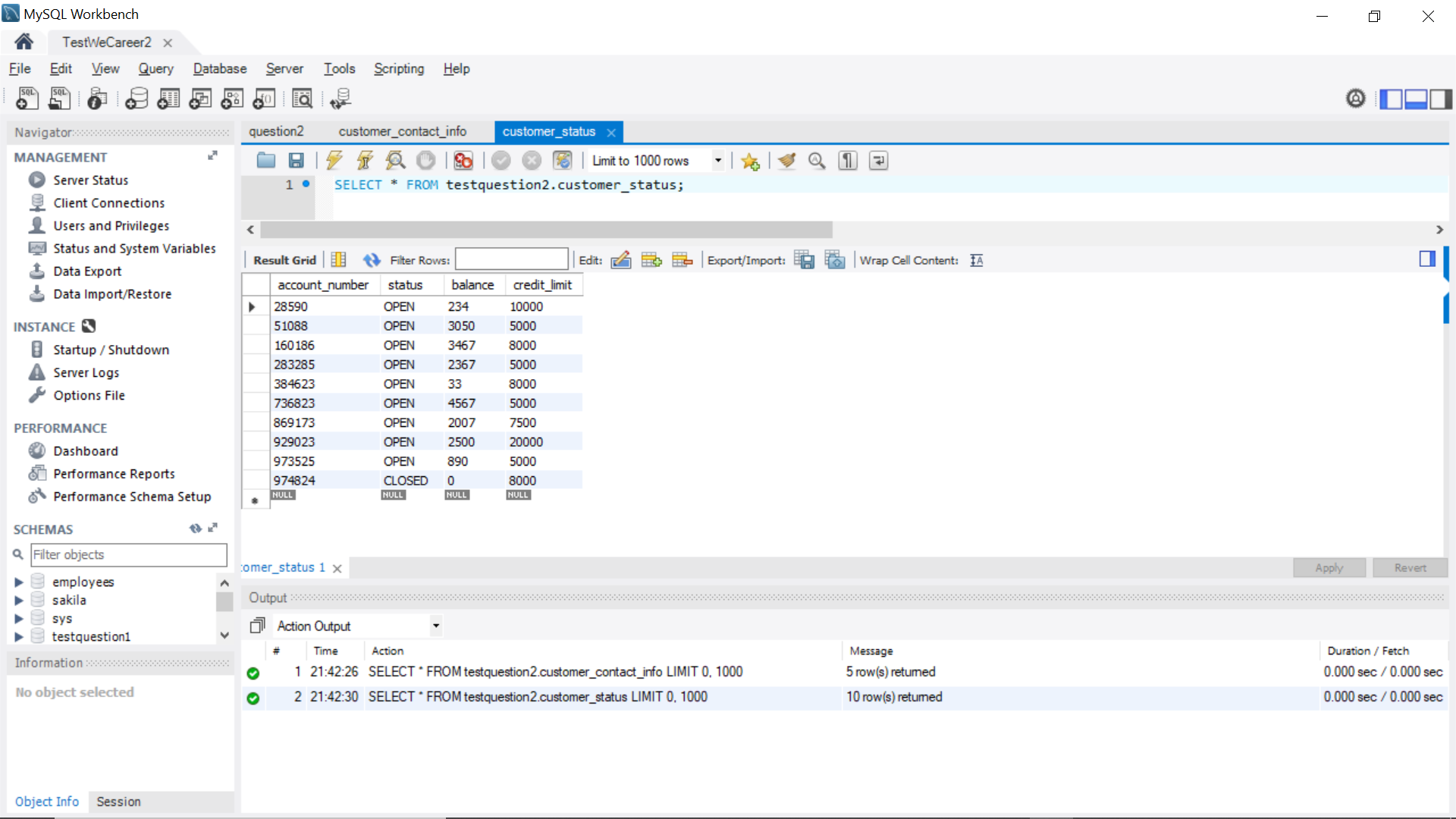

To better demonstrate the result of the query, I have added some values in the tables with the same account number. Before seeing the final result of the query, the following is the result showing the average balance amount for each province,

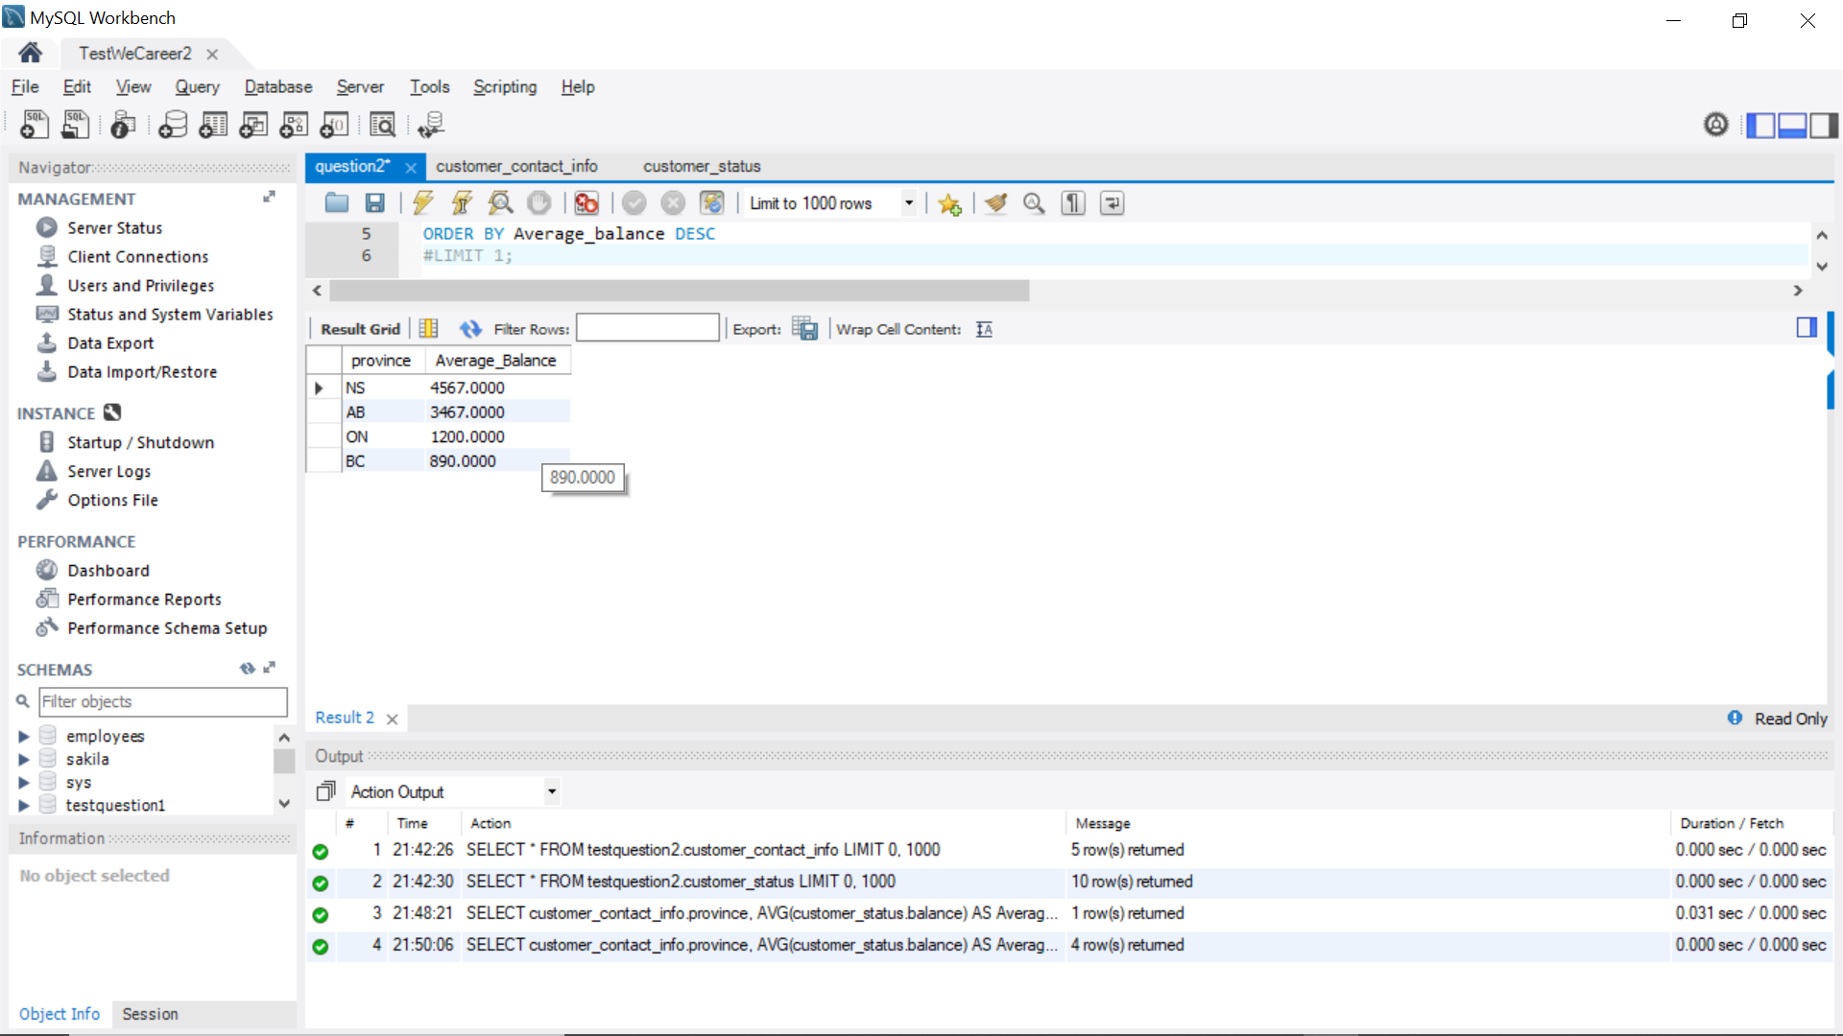

The final result is,

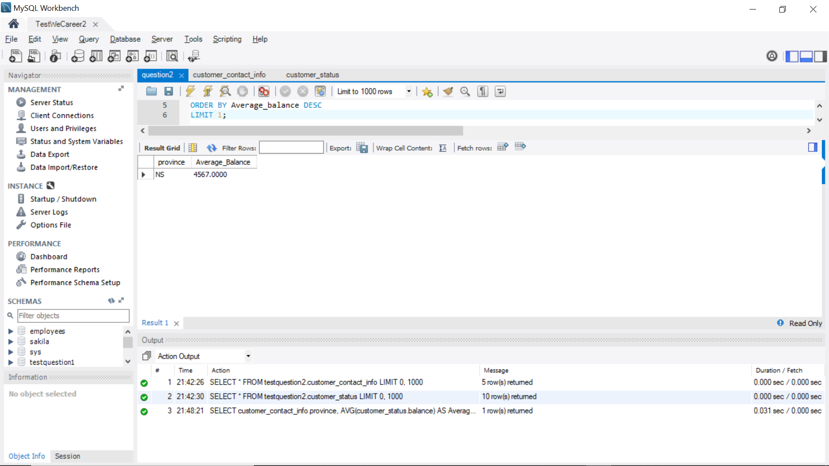

So, Nova Scotia has the highest average balance amount according to my dummy values in the table.

1. **Write a query based on 4 tabs to list the names of supervisors for the crew on the flight to Copenhagen (destination= CPH) on March 4, 2013. Note:**

* **Supervisors live in the same state as the employees they supervise.**
* **There is one supervisor for each state and job category. Therefore, to find the supervisor for employee, you need to make sure that supervisor's state = employee' state and supervisor's job category = employee's job category.**
* **Table flight_schedule and payroll_master only contain information for the crew**
* **Table staff_master contains information for the crew and supervisors**
* **job_code with the same first 2 characters belong to the same job category, for example, jobcode TA2 and TA3 are under job category TA. Hint: use substring(jobcode ,1,2)=jobcategory**

flight_schedule

|  |  |  |  |
| --- | --- | --- | --- |
| emp_id | date | destination | flight_number |
| 1269 | 04MAR2013 | YYZ | 182 |
| 1739 | 04MAR2013 | LHR | 219 |
| 1478 | 04MAR2013 | LHR | 219 |
| 1130 | 04MAR2013 | LHR | 219 |
| 1125 | 04MAR2013 | LHR | 219 |
| .... | | | |

staff_master

|  |  |  |  |  |
| --- | --- | --- | --- | --- |
| emp_id | last_name | first_name | state | phone |
| 1919 | ADAMS | GERALD | CT | 203/781-1255 |
| 1653 | ALEXANDER | SUSAN | CT | 203/675-7715 |
| 1400 | APPLE | TROY | NY | 212/586-0808 |
| 1350 | ARTHUR | BARBARA | NY | 718/383-1549 |
| 1401 | AVERY | JERRY | NJ | 201/732-8787 |
| .... | | | | |

payroll_master

|  |  |  |  |  |  |
| --- | --- | --- | --- | --- | --- |
| emp_id | gender | date_of_birth | date_of_hire | job_code | salary |
| 1919 | M | 16SEP1968 | 07JUN1995 | TA2 | $48,126 |
| 1653 | F | 19OCT1972 | 12AUG1998 | ME2 | $49,151 |
| 1400 | M | 08NOV1975 | 19OCT1998 | ME1 | $41,677 |
| 1350 | F | 04SEP1973 | 01AUG1998 | FA3 | $46,040 |
| 1401 | M | 16DEC1958 | 21NOV1993 | TA3 | $54,351 |
| .... | | | | | |

supervisors

|  |  |  |
| --- | --- | --- |
| emp_id | state | job_category |
| 1677 | CT | BC |
| 1834 | NY | BC |
| 1431 | CT | FA |
| 1433 | NJ | FA |
| 1983 | NY | FA |
| .... | | |

**Answer 3:**

Before executing the final query, I first converted the job_code in payroll_master to display the job_category by stripping away the numbers at the end of the job_category.

The query and result for that is:

Update payroll_master

Set job_category = SUBSTRING(job_code, 1, 2)

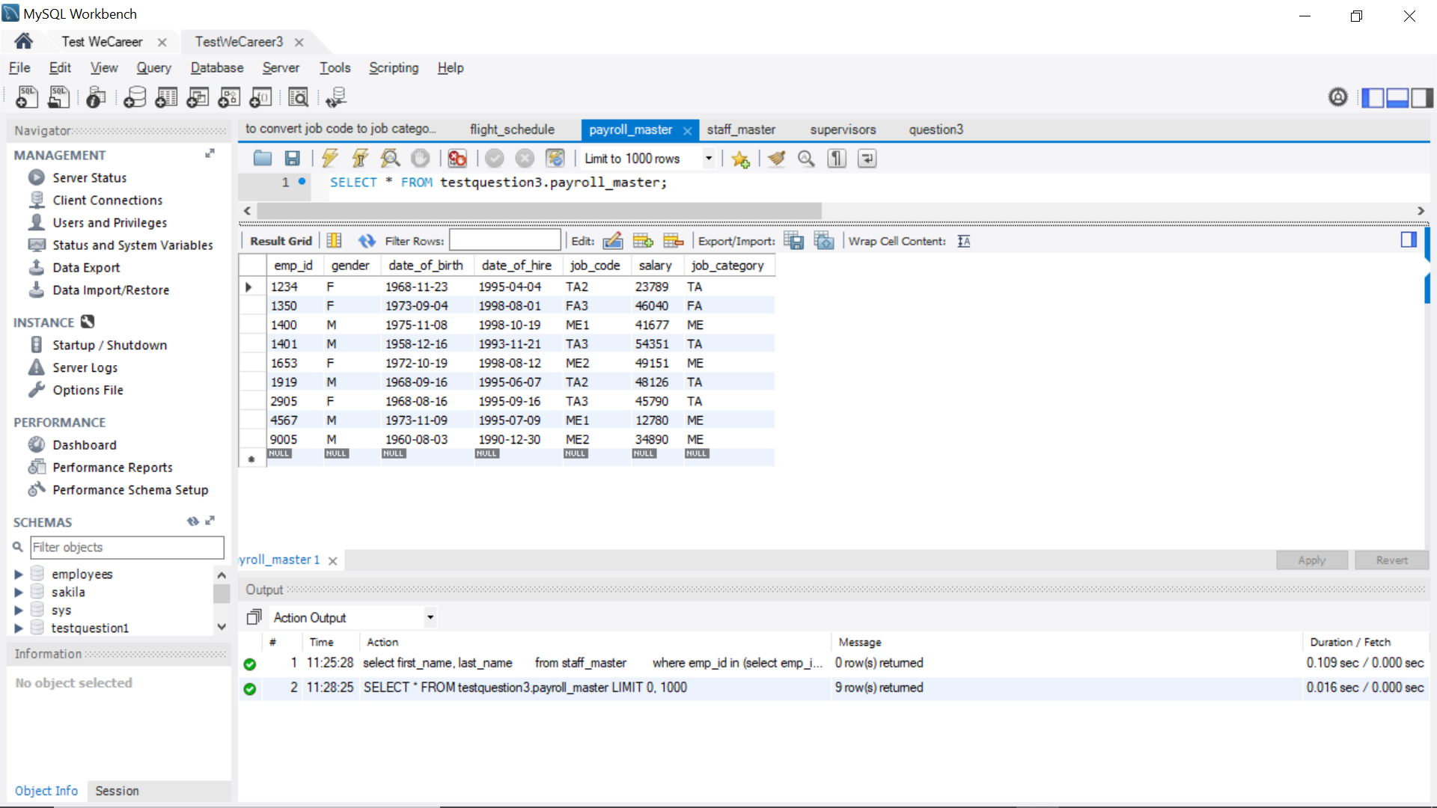

The query to get the names of supervisors for the crew on the flight to Copenhagen is:

select first_name, last_name

from staff_master

where emp_id in

(select emp_id

from supervisors,

(select job_category, state

from staff_master,

payroll_master

where staff_master.emp_id=payroll_master.emp_id and staff_master.emp_id in

(select emp_id

from flight_schedule

where destination='CPH' and date='2013-03-04')) as c

where supervisors.job_category=c.job_category

and supervisors.state=c.state);

To demonstrate the result of the above query, I have used mysql Workbench. I have input dummy data into the given columns in the schema claim. The following is the screenshot of the data and the result of the query:

The 4 tables are:

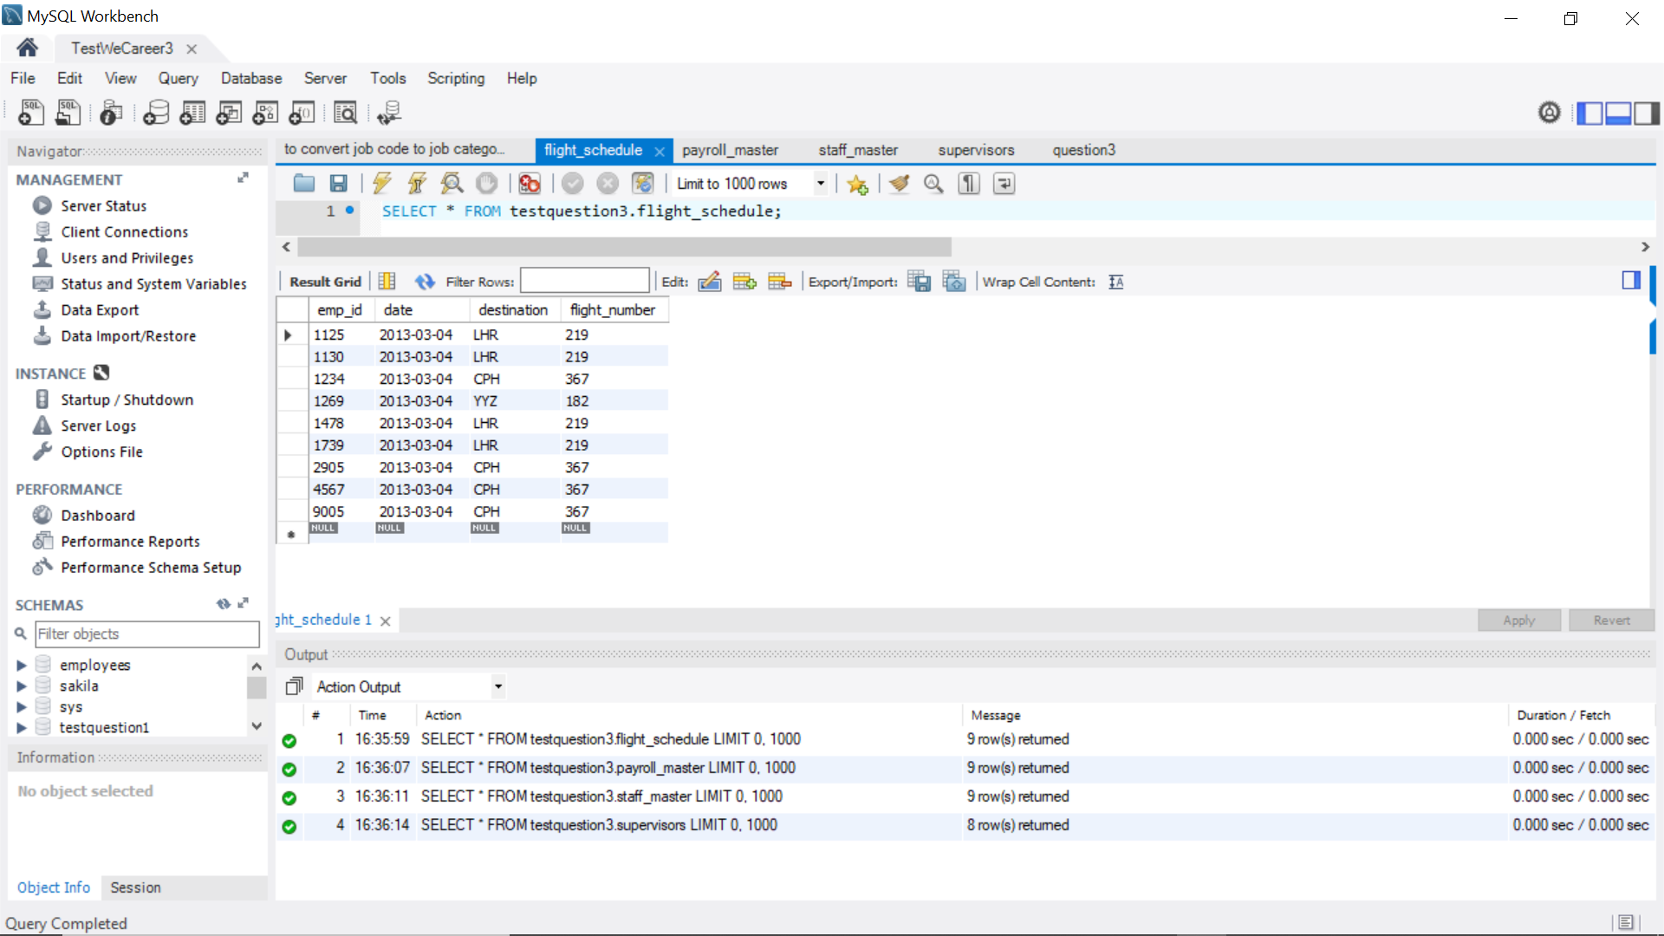 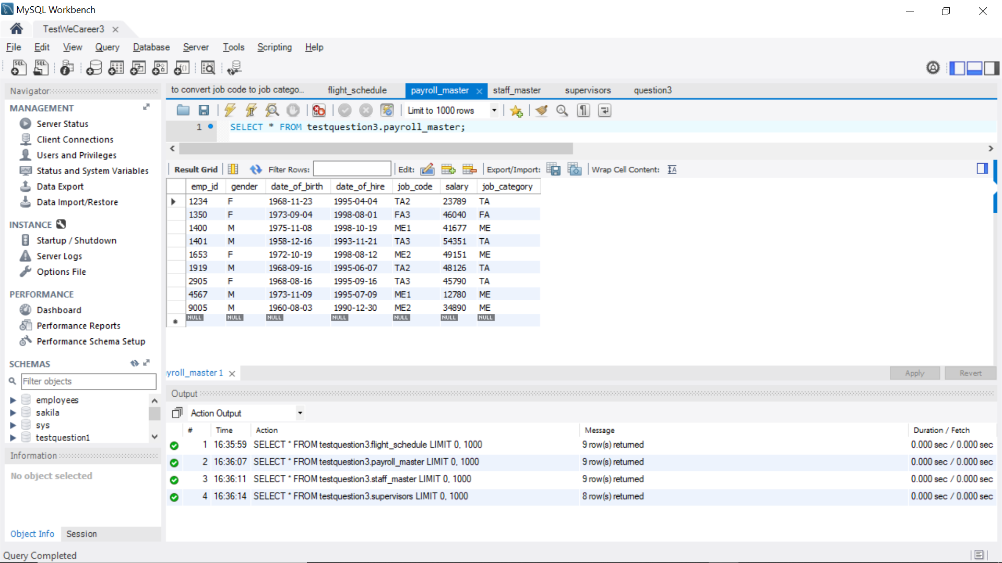

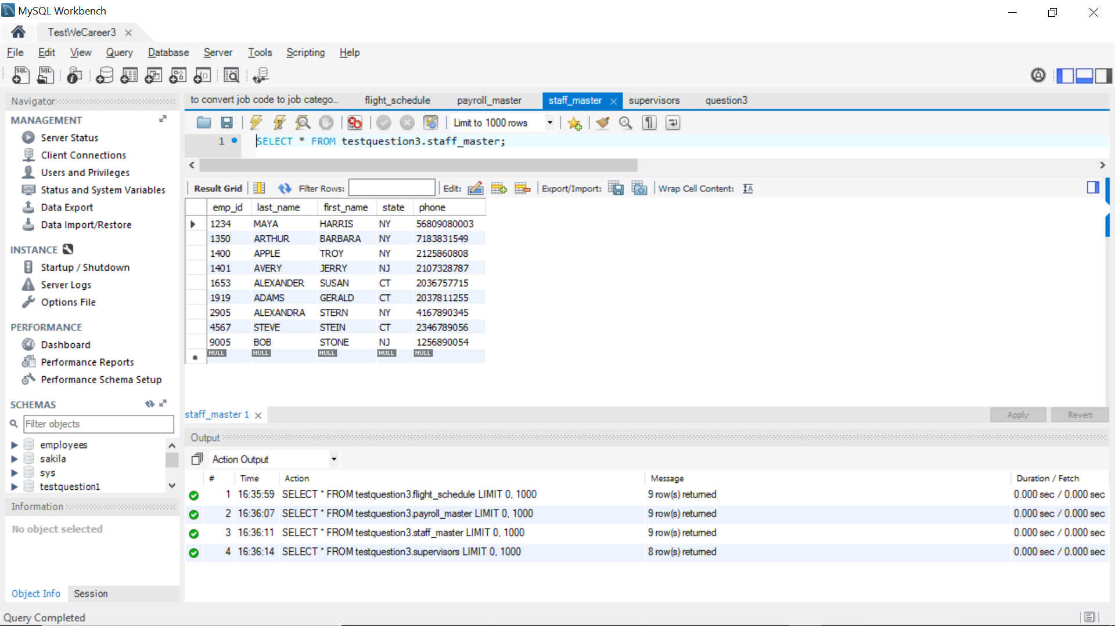 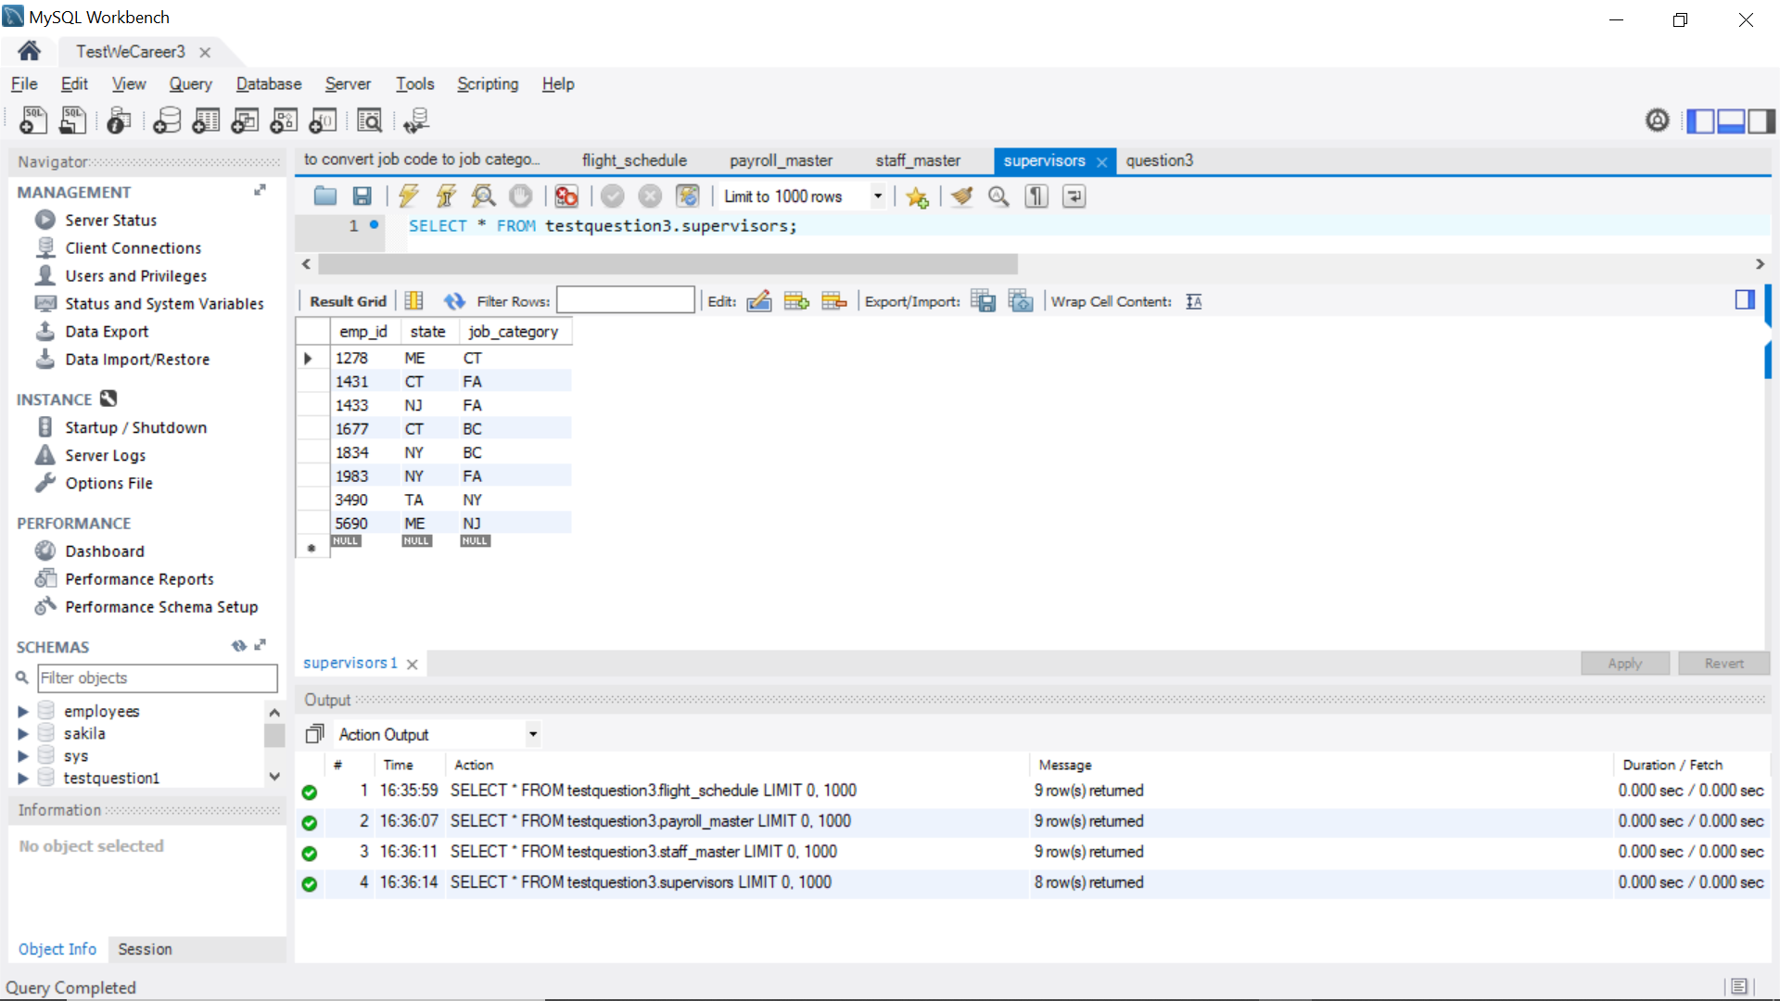

1. **Background information:**

* You are a manager at a company that markets various products and services and that is looking to diversify.
* You receive some information that indicates magazine publishing may be interesting.
* You are considering developing a new magazine but are not sure how profitable it might be.

**Things to consider:**

* Defining the target market
* Competition (# of competitors, fragmentation, brand name)
* Build off of core competencies
* Barriers to entry
* Business cycle stage
* Method of measuring viability
* Opportunity cost

**Understand economics and profit drivers of publishing business:**

* Revenue: subscriptions, newsstand sales, advertising, customer lists, Internet
* Cost: printing, distribution, content development, marketing/promotions

**Through some initial research you have been able to determine the following:**

* Charge $25 for an annual subscription of 50 issues
* Ignore newsstand sales for now
* Generate $1 in advertising revenue per issue for each subscription
* Printing and distribution costs are $1 per copy per issue
* Content development costs run $1 million per year
* Ignore marketing expenses for now

How much profit will you generate in a year from one incremental subscription?

How many subscriptions do we need to sell to break even?

Let’s consider marketing costs. Your company has expertise in direct mail solicitation so you decide to use that method to market your magazine. Each piece of mail costs $.50. You are able to achieve a 2% response rate. How much does it cost you to sign up a subscriber?

How will this affect your breakeven calculation?

What can we do to make this venture better?

**Answer 4:**

1. Profit generated in one incremental subscription:

$25 for one subscription of 50 issues,

$1 in advertising 1 issue for each subscription. Therefore, for 50 issues the advertising revenue generated would be $1 X 50 = $50

So, total $75 revenue generated.

Cost for printing and distribution: $1 per issue

So, cost for printing and distribution of 50 issues: $1 X 50 = $50

**Therefore, profit generated = $75 - $50 = $25**

**Therefore, the profit generated for each incremental subscription is $25.**

1. Content development costs are $1 million yearly.

Profit generated by 1 subscription is $25.

**Therefore, number of subscriptions that are needed to be sold to break-even are:**

**$1 million / $25 = 40,000 subscriptions.**

1. Each piece of mail costs $0.50

Consider that we mailed the offer to 50 people.

So, the mail cost will be: $0.50 X 50 = $25

The response rate is 2%.

So, out of 50 people, 2% will respond. Therefore, (50 X 2% = 1) 1 person would sign up.

**Hence, cost to sign up 1 subscriber is $25.**

1. Effect of marketing cost in the break-even calculation,

In addition to printing, distribution costs, the marketing cost will also be added now.

Therefore, total cost = $50 + $25 = $75

$25 for one subscription of 50 issues,

$1 in advertising 1 issue for each subscription. Therefore, for 50 issues the advertising revenue generated would be $1 X 50 = $50

So, total $75 revenue generated.

**Hence, now after adding the marketing costs, the profit generated is $75- %75 = $0.**

**So, there is no profit generation.**

1. In order to make this venture better, the following things can be made possible:

* Increase the rate of annual subscriptions
* Increase the revenue generated by advertising
* Increase the response rate. (out of 50 people, only 1 person signs up. That’s not a very good response rate)
* Facilitate subscription renewals
* Reduce the cost for paid advertising
* Give a month of free trial of the subscription and then offer a lifetime subscription