1. Write an Android program to read 5 numbers and print the sum of all

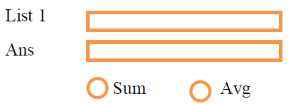

import java.util.Scanner;

public class Main {

public static void main(String[] args) {

Scanner scanner = new Scanner(System.in);

int sum = 0;

System.out.println("Enter 5 numbers:");

for (int i = 0; i < 5; i++) {

System.out.print("Number " + (i + 1) + ": ");

int num = scanner.nextInt();

sum += num;

}

System.out.println("Sum of the numbers is: " + sum);

}

}