Step by Step Git-Hub to Rstudio

1. Log into your Github Account

2. Create a Repo

3. Open Repo

4. Click Clone or Download

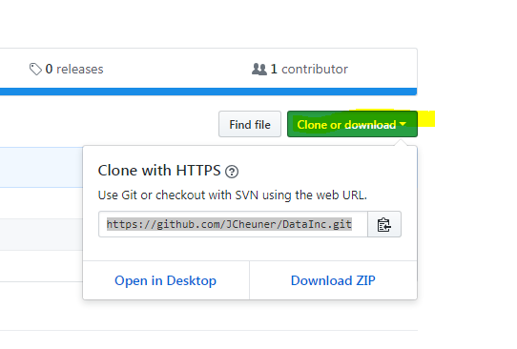

5, Copy the link.

6. Open R-Studio

7. Click on File

8. New project

9. Click on Version Control

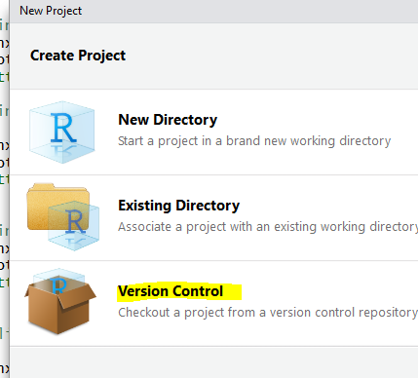

10. Click on the Git

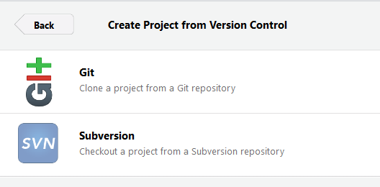

11. Copy the Link into the Repository URL

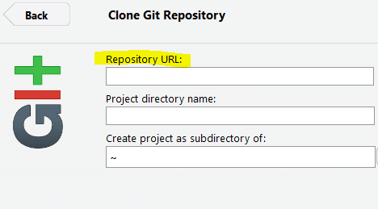

12. Click Create Project