Week 2: Exploratory Data Analysis (EDA)
Data Science Internship Task Report
Dataset: UCI/scikit-learn Wine recognition dataset; analysis uses the supplied cleaned_wine_dataset.csv. Observations: 178; chemical predictors: 13; target: wine_class with three classes.

1. Objective
The objective is to understand the structure, quality, distributions, and relationships in the wine chemical-measurement dataset. Descriptive statistics and visualizations are used to identify patterns and potential outliers. An initial hypothesis test assesses whether mean alcohol content differs across wine classes.

2. Dataset and data quality
The dataset has 178 observations, 13 numeric chemical predictors, and one categorical target (wine_class). The supplied cleaned file contains no missing cells and no duplicate rows. Class distribution is class_0 = 59, class_1 = 71, and class_2 = 48. Class proportions are not identical, so stratification is useful for later modeling.
Quality check | Result
Rows / columns | 178 / 14
Numeric predictors | 13
Missing cells | 0
Duplicate rows | 0
Target classes | class_0: 59, class_1: 71, class_2: 48

3. Descriptive statistics
The table summarizes selected features. Mean and median describe central tendency; standard deviation, range, and quartiles describe spread. Predictor scales vary considerably: proline is measured in hundreds while hue is near one, so scale-aware methods may require standardization.
Feature | Mean | Median | Std. dev. | Min | Max
alcohol | 13.001 | 13.050 | 0.812 | 11.030 | 14.830
malic_acid | 2.336 | 1.865 | 1.117 | 0.740 | 5.800
color_intensity | 5.058 | 4.690 | 2.318 | 1.280 | 13.000
proline | 746.893 | 673.500 | 314.907 | 278.000 | 1680.000
flavanoids | 2.029 | 2.135 | 0.999 | 0.340 | 5.080
hue | 0.957 | 0.965 | 0.229 | 0.480 | 1.710

4. Visual analysis and interpretation
Figure 1 — Alcohol distribution by class. The class distributions overlap but are centered at different levels. Class_0 has the highest sample mean alcohol, class_1 the lowest, and class_2 lies between them. This pattern motivates a formal group comparison.
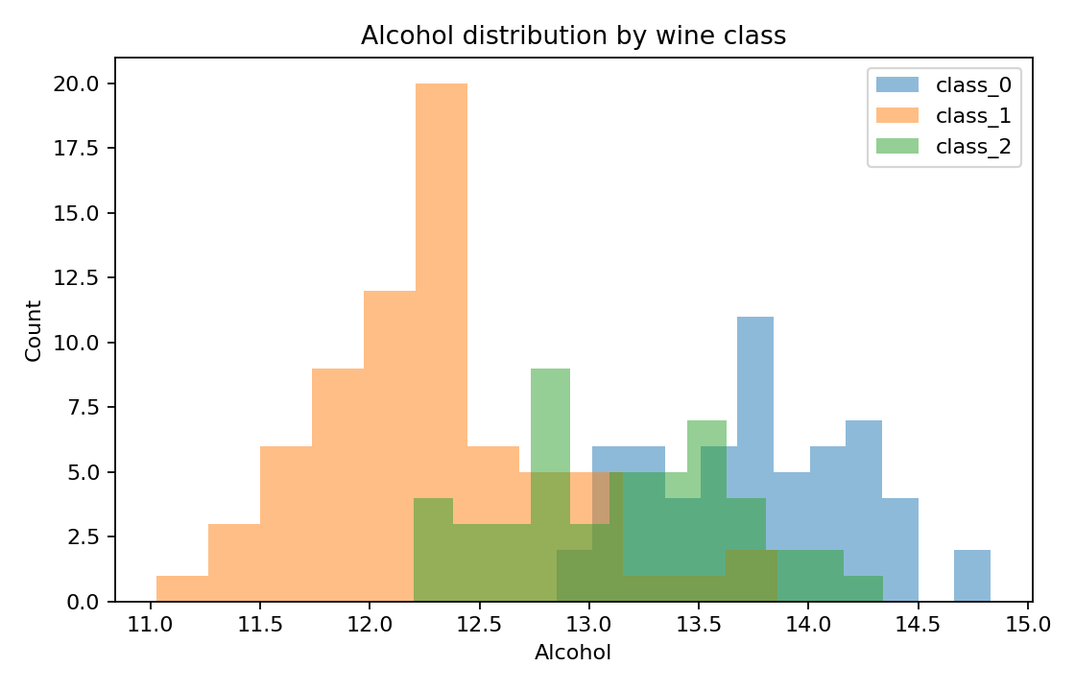
Figure 2 — Color intensity box plots. The distributions differ across classes and show within-class variability. Points outside the whiskers, where present, are potential statistical outliers rather than automatically erroneous observations.
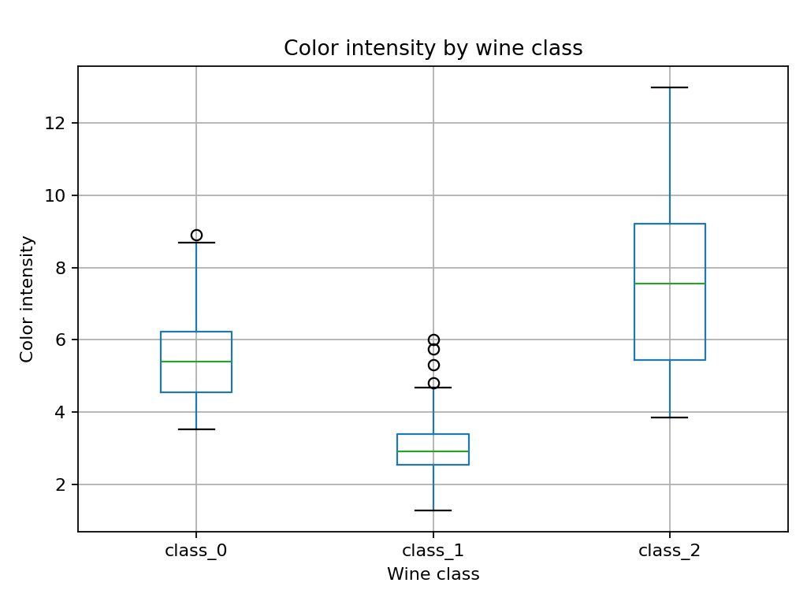
Figure 3 — Alcohol versus proline. The scatter plot shows that the two measurements vary across classes and may help distinguish class membership. Visual separation is not a causal relationship and does not alone establish predictive performance.
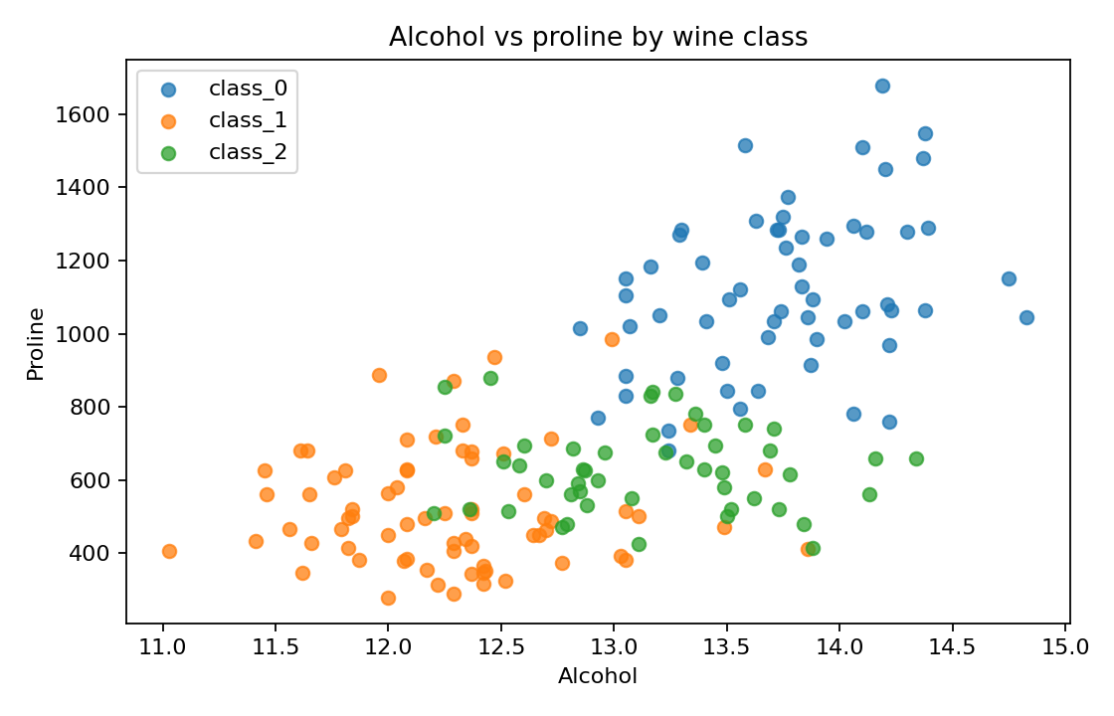
Figure 4 — Pearson correlation heat map. Some chemical features are correlated, indicating that they may contain overlapping information. Correlation describes linear association; it does not prove causation. The target label is excluded from this heat map because it is categorical.
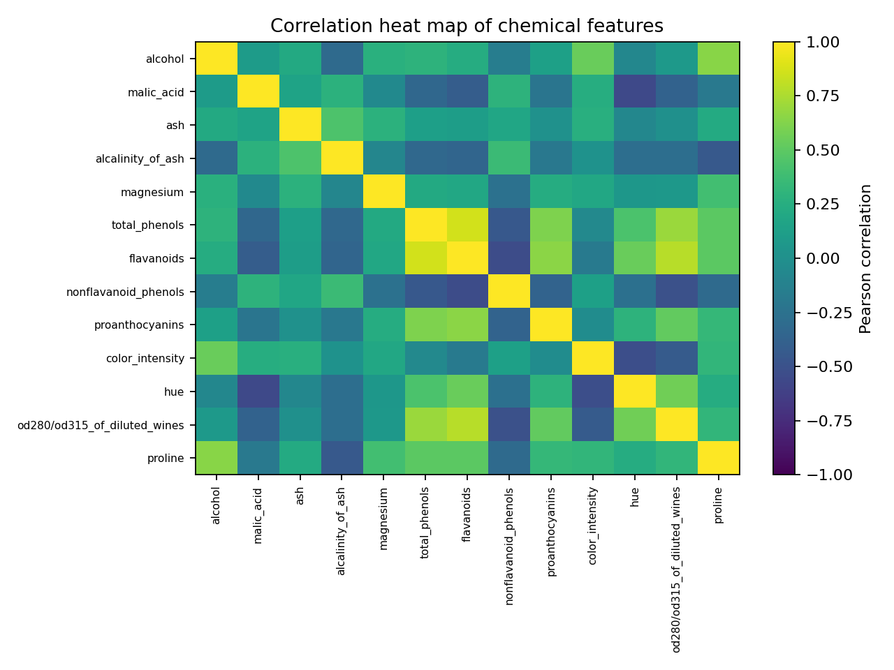

5. Outlier screening
Potential outliers were screened using the 1.5 × IQR rule for each numeric predictor. This rule flags values below Q1 − 1.5×IQR or above Q3 + 1.5×IQR. Such flags are not proof of data errors. The previous preprocessing report also retained flagged measurements because the values are scientific measurements and there was no evidence that they were data-entry mistakes. No observations were removed for this EDA.
Feature | IQR outlier flags
alcohol | 0
malic_acid | 3
ash | 3
alcalinity_of_ash | 4
magnesium | 4
total_phenols | 0
flavanoids | 0
nonflavanoid_phenols | 0
proanthocyanins | 2
color_intensity | 4
hue | 1
od280/od315_of_diluted_wines | 0
proline | 0

6. Initial hypothesis test
Research question: Is average alcohol content the same for all three wine classes? H0: the population mean alcohol content is equal across classes. H1: at least one class mean differs. A one-way ANOVA produced F = 135.078 and p = 3.320e-36.
Because p < 0.05, reject H0 at the 5%% significance level. The data provide evidence that mean alcohol content is not equal across all three classes. This omnibus test does not identify which pairs differ; post-hoc comparisons with a multiple-testing correction would be needed. ANOVA assumes independent observations, approximately normal within-group residuals, and similar group variances; these assumptions should be checked before strong inferential claims.
Wine class | n | Mean alcohol | Std. dev.
class_0 | 59 | 13.745 | 0.462
class_1 | 71 | 12.279 | 0.538
class_2 | 48 | 13.154 | 0.530

7. Conclusions, assumptions, and limitations
The dataset is complete and contains no exact duplicate rows. Visualizations show class-related variation in alcohol and color intensity and correlations among some predictors. ANOVA indicates a statistically significant difference in mean alcohol across classes. The analysis is exploratory: a significant p-value does not measure practical importance, and repeated testing of many features can increase false-positive risk. Results apply to this benchmark dataset and should not automatically be generalized to all wines. The notebook contains the code to reproduce the summaries, plots, outlier screen, and test.

8. Reproducibility and source
Run Week2_EDA_Wine_Dataset.ipynb with cleaned_wine_dataset.csv in the same directory. Required packages: pandas, numpy, matplotlib, scipy, and Jupyter. Dataset references: UCI Machine Learning Repository Wine dataset; scikit-learn load_wine documentation.

