Dridex
Introduction
Dridex is a type of malware that can communicate with external servers as part of its malicious activity. Network traffic generated during such activity can contain useful information that helps security analysts is=dentify suspicious communication.
In this task, the provided Dridex-related network traffic was analyzed using Wireshark to understand the communication patterns and identify potentially useful indicators. Based on the observations from the traffic analysis, Suricata detection rules were created and tested using the captured PCAP files. Docker was used to run Suricata in a controlled environment and replay the captured traffic for detection testing.
This task provided a practical understanding of how network traffic analysis, detection rules, and offline PCAP replay can be combined as part of a basic network security monitoring and detection workflow.
OBJECTIVE
The main objective of this task is to analyze Dridex-related network traffic and understand the indicators that could be used for network-based detection.
The task focused on:
- Analyzing the provided Dridex PCAP files using Wireshark.
- Identifying suspicious network communication and relevant TLS certificate indicators.
- Creating Suricata rules based on the observations from the traffic analysis.
- Validating the Suricata rules and replaying the PCAP files for offline detection.
- Running Suricata using Docker to create a controlled and reproducible testing environment.
- Reviewing the generated alerts and correlating the with the original Wireshark findings.
- Documenting the analysis, detection results and limitations.

TOOLS AND ENVIRONMENT
The task was performed in an Ubuntu-based analysis environment using the following tools and technologies:
Wireshark: Used to inspect the PCAP files, analyze network communication, and examine TLS handshake and certificate information.
Suricata: Used to create and test network detection signature based on the indicators identified during traffic analysis.
Docker: Used to run Suricata in an isolated and reproducible environment for offline PCAP replay.
PCAP files: Provided the captured network traffic used for analysis and detection testing.
Ubuntu 24.04: Used as the primary analysis environment.
Suricata 7.0.3: Installed on the Ubuntu host for rule development and validation.
Suricata 8.0.7: Used trough the jasonish/suricata Docker image for PCAP replay.
PCAP ANALYSIS METHODOLOGY
The provided Dridex infection traffic was available in five PCAP files. The analysis was performed using Wireshark to understand the network communication and identify potentially useful indicators for detection.
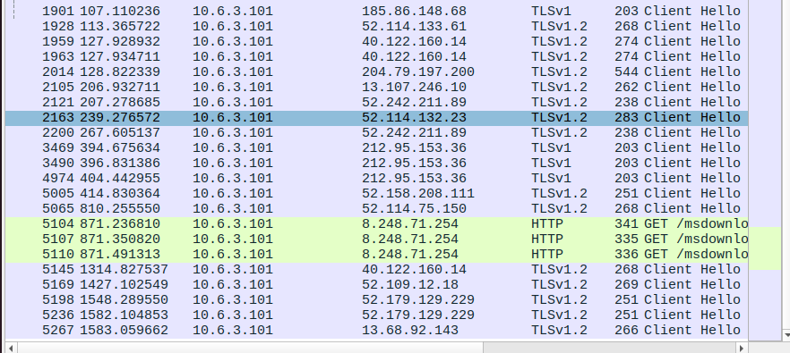
Figure 1: Initial Wireshark filtering of HTTP and TLS ClientHello traffic.
The analysis followed the same general process for each PCAP:
- Load the PCAP in Wireshark
Each PCAP file was opened in Wireshark to examine the captured network traffic.
- Identify relevant network traffic
HTTP requests and TLS handshake traffic were initially examined while excluding SSDP traffic to reduce unrelated network noise. The following filter was used:
(http.request or tls.handshake.type eq 1) and !(ssdp)
This helped focus the investigation on HTTP requests and TLS ClientHello messages.
- Identify external communication
The traffic was examined to identify communication between the internal host and external IP addresses. These connections were then investigated further.
- Inspect TLS certificates
For relevant TLS connections, certificate handshake messages were examined using:
tls.handshake.type == 11
TLS handshake type 11 corresponds to the Certificate message.
- Examine certificate information
The certificate information was inspected for fields such as issuer, organization common name, and other available metadata. The observed certificate values were recorded as candidate indicators for the respective PCAP.
- Record the findings
The internal host, external endpoints, and relevant certificate observations were documented for each PCAP. These observations were later used to develop the suricata detection rules.
The same investigation approach was applied across all five PCAPs so that the findings could be compared consistently before the detection signatures.
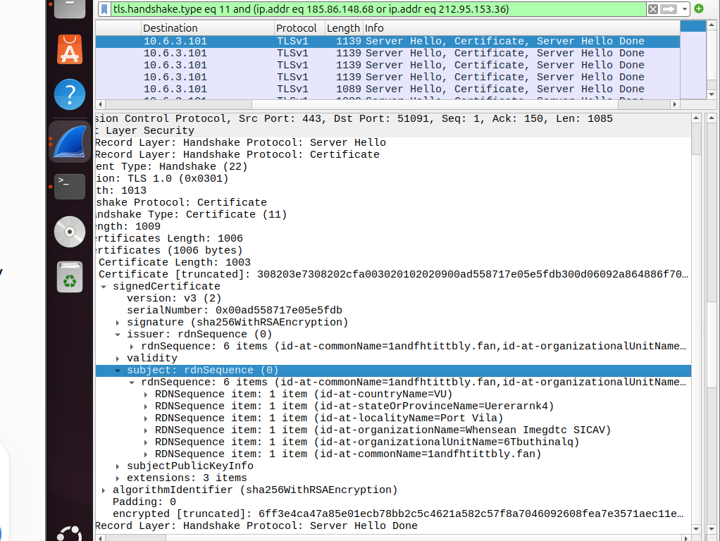
Figure 2: TLS Certificate packets identified during the investigation.
WIRESHARK FINDINGS
The five provided PCAP files were analyzed individually in Wireshark using the methodology described in the previous section. The analysis focused mainly on communication between the internal host and external endpoints involved in TLS traffic.
For each PCAP, the relevant TLS certificate messages were examined to identify certificate-related information such as issuer, organization, locality and common name where available. The observed values were recorded as candidate indicators for the corresponding capture.
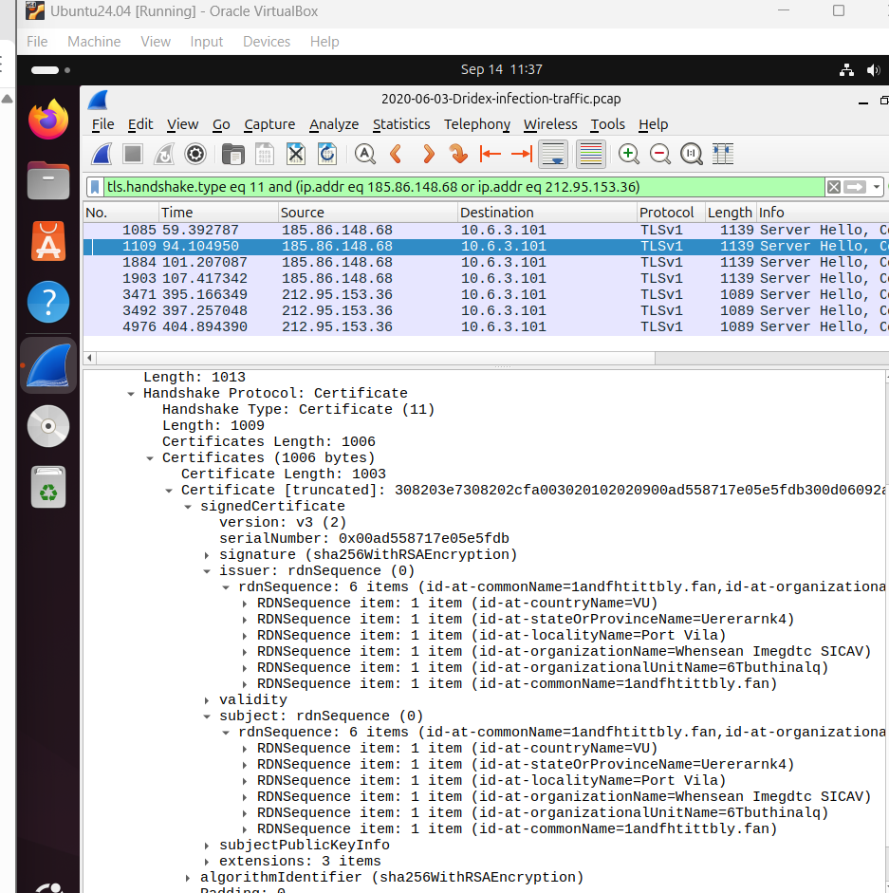
Figure 3: TLS certificate information and observed issuer.
Summary of Observed Network Indicators
PCAP | Internal Host | External Endpoint | Observed Certificate Indicator
PCAP 1 | 10.6.3.101 | 185.86.148.68 | Whensean Imegdtc SICAV
PCAP 1 | 10.6.3.101 | 212.95.153.36 | Msorest KGaA
PCAP 2 | 10.9.24.101 | 151.236.219.181 | Wemadd Hixhach GmBH
PCAP 2 | 10.9.24.101 | 62.98.109.30 | Hedanpr S.p.a.
PCAP 3 | 10.9.29.101 | 67.79.105.174 | Massol SE
PCAP 3 | 10.9.29.101 | 144.202.31.138 | Hedanpr S.p.a.
PCAP 4 | 10.10.5.101 | 85.114.134.25 | Llinng Lovisq NL
PCAP 4 | 10.10.5.101 | 85.211.162.44 | Ointavi Tagate Unltd.
PCAP 5 | 10.10.7.101 | 177.87.70.3 | Mesureder S.p.a.
PCAP 5 | 10.10.7.101 | 188.250.8.142 | Icccodiso Icloneedb Oyj

The certificate values above were treated as candidate indicators observed in the traffic captures. They were not assumed to be universal indicators of Dridex activity.
TLS Certificate Analysis
TLS certificate messages were identified using the Wireshark filter.
tls.handshake.type == 11
The certificate information provided additional context about the external TLS connections. In several cases, the certificate organization or issuer values appeared unusual or randomly generated. These values were useful for creating capture specific detection signatures.
For example, in PCAP 5, the external endpoints 177.87.70.3 and 188.250.8.142 were associated with the certificate indicators Mesureder S.p.a and Icccodiso Icloneedb Oyj, respectively.
These observations were subsequently used as inputs for the Suricta rile development stage.
Interpretation and Limitations
The observed certificate information should be treated as network indicators rather than proof of malicious activity by itself. A certificate issuer, organization name, IP address, or country does not automatically make traffic malicious.
The indicators were therefore used in combination with the context of the provided Dridex infection PCAPs. Their primary purpose in this task was to demonstrate how observations made during network analysis can be converted into detection signatures and tested through offline traffic replay.
5.Suricata Rule Development
After analyzing the PCAP files in Wireshark, the observed certificate indicators were used to create Suricata signatures for network-based detection. The purpose of the rules was to identify TLS traffic containing the certificate issuer values during the analysis.
5.1 Rule Structure
A Suricata rule follows a general structure consisting of an action, protocol, traffic direction and rule options.
An example from the PCAP5 rules is:
alert tls any any -> any any (msg:"DRIDEX PCAP5 Suspicious TLS Certificate - Mesureder S.p.a."; tls.cert_issuer; content:"Mesureder S.p.a."; sid:1000006; rev:1;)
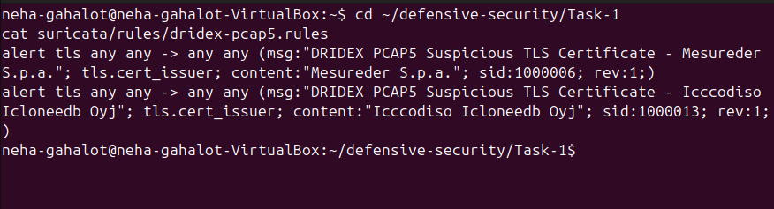
Figure 4: Suricata rules created from the TLS certificate indicators identified during PCAP analysis.
The main components of the rule are:
Component | Purpose
alert | Generates an alert when the rule matches the traffic.
tls | Specifies that the rule is intended for TLS traffic.
any any -> any any | Allows the rule to inspect traffic regardless of the source/destination IP address and port.
msg | Provides a readable description of the alert.
tls.cert_issuer | Selects the TLS certificate issuer field for inspection.
content | Specifies the certificate issuer string that should be matched.
sid | Provides a unique ID for the Suricata signature.
rev | Indicates the revision number of the rule.

5.2 Why tls.cert_issuer Was Used
The certificate issuer field was selected because the relevant indicators from TLS certificate information during the Wireshark investigation.
Instead of searching the complete packet for a text string, the rule targets the specifies TLS certificate field:
tls.cert_issuer;
The content keyword then specifies the value that should be matched.
For example:
tls.cert_issuer;
content: “Mesureder S.p.a.”;
This means that Suricata checks the TLS certificate issuer field for the specified value.
5.3 Rules Created
Separate rule files were created for the different PCAPs so that the indicators associated with each capture could be tested independently.
The rules included the following certificate indicators:
PCAP | Certificate Indicator | SID
PCAP 1 | Whensean imegdtc SICAV | 1000003
PCAP1 | Msorest KGaA | 1000007
PCAP 2 | Wemadd Hixhac GmBH | 1000008
PCAP 2 | Hedanpr S.p.a. | 1000009
PCAP 3 | Massol SE | 1000010
PCAP 3 | Hedanpr S.p.a. | 1000011
PCAP 4 | Llinng Lovisq NL | 1000005
PCAP 4 | Ointavi Tagate Unltd. | 1000012
PCAP 5 | Mesureder S.p.a. | 1000006
PCAP 5 | Iccodiso Icloneedb Oyj | 1000013
The rules were intentionally associated with the corresponding PCAP observations. These certificate values were treated as capture-specific indicators rather than universal Dridex signatures.
5.4 Rule Validation
Before replaying the PCAP files, the rules were checked using Suricata’s test mode.
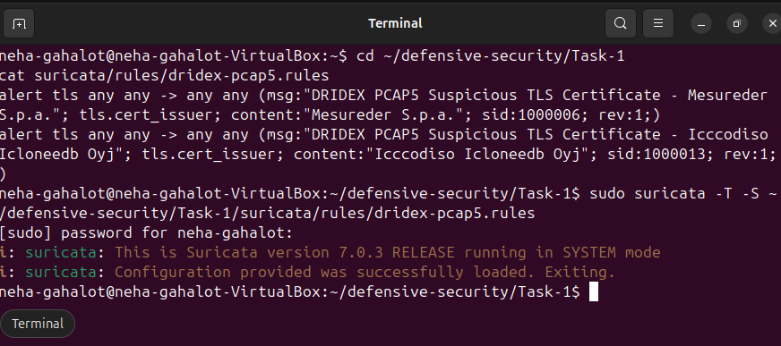
Figure 5: Successful validation of the Suricata PCAP5 rule file using test mode (-T).
For example:
sudo suricata -T -S ~/defensive-security/Task-1/suricata/rules/dridex-pcap5.rules
The -T options was used to verify that the Suricata configuration and rule syntax could be loaded successfully.
A successful validation confirmed that the rule file was syntactically valid and could be loaded by suricata. However, this test did not determine whether the rule would actually generate an alert. Actual detection was tested separately by replaying the PCAP through Suricata.
5.5 Detection Logic
The overall rule-development process was:
Wireshark observation -> TLS certificate indicator identified -> Select relevant certificate field -> Create Suricata signature -> Validate rule syntax ->Replay corresponding PCAP -> Check generated alerts
This allowed the observations made during manual network investigation to be converted into repeatable detection logic.
6.Docker -Based PCAP Replay
After creating and validating the Suricata rules, the next step was to test them against the actual PCAP files. Docker was used to run Suricata in a controlled environment and perform offline replay of the captured network traffic.
The purpose of this step was to check whether the Suricata rules created from the Wireshark findings could successfully detect the corresponding certificate indicators in the PCAP.
  - Docker Setup
The Docker environment used in three main directories:
Host Directory | Container Directory | Purpose
docker/pcaps | /pcaps | Contains the PCAP files to be analyzed
suricata/rules | /rules | Contains the Suricata rule files
docker/output | /output | Stores Suricata log’s and alerts

The PCAP and rule directories were mounted as read-only using :ro. This ensured that the original PCAP files and rule files were not modified by the container.
The basic workflow was:
Host PCAP -> Docker volume mount -> /pcaps inside container -> Suricata reads PCAP -> Suricata applies selected rule -> Alerts/logs written to /output -> Output available on host
  - Docker Replay Command
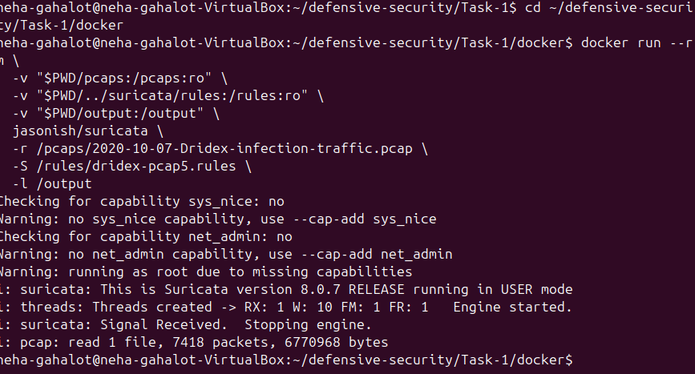
Figure 6: Offline replay of the PCAP through Suricata running in Docker.
For example, the PCAP5 traffic was replayed using:
docker run --rm \
-v "$PWD/pcaps:/pcaps:ro" \
-v "$PWD/../suricata/rules:/rules:ro" \
-v "$PWD/output:/output" \
jasonish/suricata \
-r /pcaps/2020-10-07-Dridex-infection-traffic.pcap \
-S /rules/dridex-pcap5.rules \
-l /output
6.3 Explanation of the Command
Command/Option | Purpose
docker run | Creates and starts a container from the specified Docker image.
--rm | Automatically removes the temporary container after it exits.
-v | Mounts a host directory inside the container.
$PWD | Represents the current working directory on the host.
:ro | Mounts the directory as read-only.
jasonish/suricata | Docker image containing Suricata.
-r | Tells Suricata to read and analyze a PCAP file offline.
-S | Loads the specified Suricata rule file exclusively.
-l | Specifies the directory where Suricata should write its logs.

In this command:
/pcaps/2020-10-07-Dridex-infection-traffic.pcap
is the PCAP being analyzed, while:
/rules/dridex-pcap5.rules
Contains the two Suricata signatures created from the PCAP5 certificate indicators.
The output was written to:
/output
which was mapped to the host’s docker/output directory.
  - Replay Result
The Docker container successfully processed the PCAP. Suricata reported:
This is Suricata version 8.0.7 RELEASE
and later:
pcap: read 1 file, 7418 packets, 6770968 bytes
This shows that Suricata successfully read the complete PCAP file containing 7,418 packets.
The Docker environment also displayed capability warnings related to sys nice. These warnings did not prevent the offline replay from completing, the PCAP was successfully processed.
6.5 Alert Output
The replay generated alerts in Suricata’s fast.log. Since the output directory was reused during testing, the PCAP5 entries were isolated using the corresponding capture date before counting the alerts
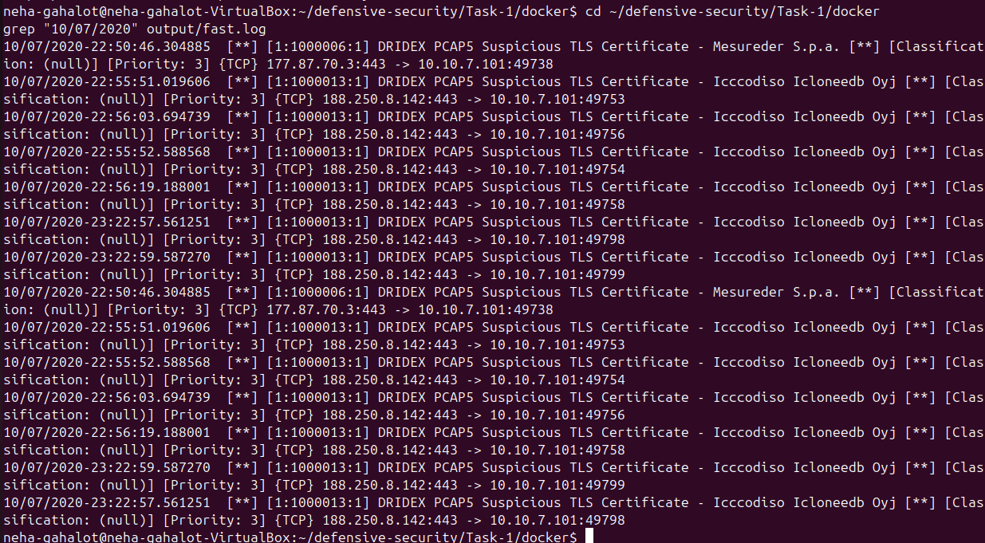
Figure 7: Suricata alerts generated during offline replay of the PCAP5 traffic.
Rule SID | Certificate Indicator | Alert Count
1000006 | Mesureder S.p.a. | 1
1000013 | Iccodiso Icoloneedb Oyj | 6
Total :7
The alerts showed communication from the observed external IP addresses to the internal host, for example:
177.87.70.3:443 -> 10.10.7.101:49738
and:
188.250.8.142:443 -> 10.10.7.101:49753
The important point is that these are Suricata alert matches, not a count of malicious packets. A single rule can generate multiple alerts when its condition is observed multiple times in traffic.
The PCAP5 replay therefore demonstrated that the Suricata rules successfully matched the certificate issuer indicators that had previously been identified during the Wireshark investigation.
  - Evidence files
The generated Suricata output was examined using:
docker/output/fast.log
A filtered copy of the PCAP5 alerts was also saved as:
docker/evidence/pcap5-fast.log
These files provided evidence that the rules were not only syntactically valid but also produced actual alerts when the corresponding PCAP traffic was replayed.
Overall, the Docker-based replay connected the previous stages of the task:
Wireshark analysis -> Certificate indicators identified -> Suricata rules created -> Rules validated -> PCAP replayed through Docker -> Suricata alerts generated
This provided a practical way to test the detectin logic against previously captured network traffic in a controlled environment.
- Detection Results
After the Suricata rules were created and validated, the corresponding PCAP files were replayed to check whether the certificate indicators identified during the Wireshark analysis could be detected automatically.
The results showed that the rules were able to match the certificate issuer values observed in the PCAP traffic.
  - PCAP5 Detection Result
During the replay of the PCAP5 file:
2020-10-07-Dridex-infection-traffic.pcap
Suricata processed:
7,418 packets
6,770,968 bytes
The two PCAP5 rules generated a total of 7 alerts.
SID | Certificate Indicator | Alerts generated
1000006 | Mesureder S.p.a. | 1
1000013 | Icccodiso Icloneedb Oyj | 6
Total: 7
The alerts were recorded in Suricata’s fast.log.
For example, one alert associated with SID 1000006 was:
[1:1000006:1] DRIDEX PCAP5 Suspicious TLS Certificate - Mesureder S.p.a.
{TCP} 177.87.70.3:443 -> 10.10.7.101:49738
Another alert associated with SID 1000013 was:
[1:1000013:1] DRIDEX PCAP5 Suspicious TLS Certificate - Icccodiso Icloneedb Oyj
{TCP} 188.250.8.142:443 -> 10.10.7.101:49753
These alerts show that the Suricata rules matched the TLS certificate issuer values that had previously been identified during the Wireshark investigation.
  - Interpretation of the Alerts
The Suricata alerts demonstrate that the detection rules were able to identify the selected certificate indicators during offline PCAP replay.
However, an alert should not be interpreted by itself as proof that the corresponding traffic is malicious. The rules were based on certificate issuer values observed in the supplied captures, so they should be treated as capture-specific indicators rather than universal Dridex signatures.
For example, the rule:
tls.cert_issuer;
content:"Mesureder S.p.a.";
detects the specified issuer value in the TLS certificate field. It does not independently determine whether the connection is malicious.
This distinction is important because a network detection rule can produce:
True positives – the rule matches relevant suspicious activity.
False positives – the rule matches legitimate traffic containing the same indicator.
False negatives – relevant activity exists but the rule does not detect it.
Therefore, the alerts should be investigated together with other network evidence such as the destination IP address, connection details, TLS information, and the original PCAP.
  - Detection Workflow
The complete detection workflow used in this task was:
PCAP traffic -> Wireshark investigation -> TLS certificate indicator identified -> Suricata rule created -> Rule syntax validated with -T -> PCAP replayed using -r -> Suricata evaluates the traffic ->Matching certificate indicator -> Alert generated in fast.log
This demonstrates how a manually identified network indicator can be converted into a repeatable detection rule and tested against captured traffic.
7.4 Result Summary
The testing successfully demonstrated the complete detection process for the analyzed PCAP5 traffic:
Stage | Result
PCAP analysis | Completed using Wireshark
Certificate indicators identified | Completed
Suricata rules created | Completed
Rule syntax validation | Successful
Docker-based PCAP replay | Successful
PCAP packets processed | 7418
Alerts generated | 7
Alert evidence | Fast.log and pcap5-fast.log

The result confirms that the created Suricata rules were able to match the certificate indicators observed in the corresponding PCAP during offline replay.
- Correlation & Validation
The Wireshark and Suricata results were correlated to verify that the indicators detected by Suricata were the same indicators identified during the manual traffic investigation.
The purpose of this step was to connect the complete detection chain
Wireshark finding
External IP address
TLS certificate
Certificate issuer
Suricata rule
SID
Suricata alert
  - Correlating the Certificate Indicator
For PCAP5, Wireshark identified the following certificate indicators:
External IP | Certificate Indicator | Suricata SID
177.87.70.3 | Mesureder S.p.a. | 1000006
188.250.8.142 | Icccodiso Icloneedb Oyj | 1000013
These values were then used in the Suricata rules.
For example, the Wireshark investigation identified:
177.87.70.3 -> TLS Certificate -> Issuer: Mesureder S.p.a.
The corresponding Suricata rule contained:
tls.cert_issuer;
content:"Mesureder S.p.a.";
During PCAP replay, Suricata generated an alert with SID 1000006 for traffic involving:
177.87.70.3:443 -> 10.10.7.101:49738
This provides a direct connection between the indicator observed manually in Wireshark and the automated Suricata detection.
  - Correlating the Second Indicator
The same process was followed for the second PCAP5 indicator.
188.250.8.142 -> TLS Certificate -> Issuer: Icccodiso Icloneedb Oyj
The Corresponding Suricata rule used:
tls.cert_issuer;
content:"Icccodiso Icloneedb Oyj.";
During replay, SID 1000013 generated six alerts involving the same external IP address:
188.250.8.142:443 -> 10.10.7.101:<ephemeral-port>
The destination port varied between connections, while the external destination service used port 443.

8.3 Validation of the Detection Process
The correlation confirmed that the detection process worked across multiple stages:
Validation Step | Result
Indicator identified in Wireshark | Successful
Indicator converted into Suricata rule | Successful
Rule syntax tested with -T | Successful
Corresponding PCAP replayed | Successful
Suricata matched the certificate indicator | Successful
Alert recorded in fast.log | Successful
Alert correlated with the observed IP and indicator | Successful

This validation demonstrates that the Suricata rules were based on actual observations from the PCAP rather than unrelated or randomly selected values.

8.4 Wireshark and Suricata: Different Roles
The two tools served different purposes during the investigation.
Wireshark was used for manual investigation. It helped inspect packets, identify relevant TLS communication, examine certificate information, and determine which indicators were worth testing.
Suricata was used for automated rule-based detection. Once the indicators were converted into signatures, Suricata could inspect the replayed traffic and generate alerts whenever the rule conditions were matched.
Therefore, the workflow can be summarized as:
Wireshark (manual investigation) -> Identify useful indicator -> Suricata (Automated detection) -> Alert -> Wireshark/Pcap (Further investigation and validation)
This shows how packet analysis and network intrusion detection can complement each other in a practical security monitoring workflow.
8.5 Important Limitation of the Correlation
The correlation confirms that the certificate indicators found in the PCAP were successfully detected by the corresponding rules. It does not prove that the certificate issuer values are universally associated with Dridex.
The rules were created specifically from the indicators observed in the supplied captures. Real-world detection would require additional indicators and validation across a larger and more diverse dataset to reduce the possibility of false positives and false negatives.

9. Limitations
Although the detection workflow successfully identified the certificate indicators observed in the supplied PCAP files, there are some limitations to the approach used in this task.

9.1 Capture-Specific Indicators
The Suricata rules were created using certificate issuer values observed in the provided PCAP files. Therefore, these values should be treated as capture-specific indicators rather than universal signatures for detecting Dridex.
A different sample of the same malware could use different certificates, infrastructure, or communication patterns.

9.2 Possible False Positives
The rules primarily match specific TLS certificate issuer values. A legitimate system could potentially use the same certificate issuer, which could cause an alert even when the traffic is not malicious.
For example, an issuer-based rule does not by itself provide enough context to determine whether a connection is malicious. Additional information such as the destination IP, domain, TLS characteristics, and other network indicators may be required for proper investigation.

9.3 Limited Dataset
The analysis was performed using the five supplied PCAP files. Since the dataset was limited, the results cannot be used to determine how well the rules would perform on a much larger or more diverse collection of network traffic.
Testing with additional benign and malicious traffic would provide a better understanding of the detection coverage and false-positive rate.

9.4 Certificate-Based Detection
The rules depend on TLS certificate information. If the certificate information is unavailable, changed, or different from the values observed in the analyzed captures, these rules may not generate an alert.
Therefore, certificate-based detection should normally be combined with other network indicators rather than being used as the only detection method.

9.5 Offline PCAP Replay
The testing performed in this task used previously captured network traffic rather than live network traffic.
Docker and Suricata were used to replay the PCAP files in a controlled environment. In a real monitoring environment, Suricata would typically process live network traffic or traffic collected from a monitoring interface, which introduces additional operational considerations.

9.6 Detection Does Not Equal Proof of Malicious Activity
A Suricata alert indicates that the conditions defined in a rule were matched. It does not, by itself, prove that the traffic is malicious.
For this reason, the generated alerts were correlated with the original Wireshark observations and the corresponding certificate and network information.
These limitations highlight the importance of combining automated detection with manual investigation and multiple indicators when analyzing suspicious network activity.
10. Conclusion
This task provided practical experience in analyzing malware-related network traffic and developing a basic network detection workflow.
The five provided Dridex-related PCAP files were investigated using Wireshark to understand the network communication and identify relevant TLS certificate indicators. The observed certificate issuer values were then converted into Suricata detection rules using the tls.cert_issuer and content keywords.
The rules were validated using Suricata's test mode and then tested through offline PCAP replay using Docker. The PCAP5 replay successfully processed 7,418 packets and generated seven alerts corresponding to the certificate indicators identified during the Wireshark analysis.
The results demonstrated the complete workflow:
PCAP Collection ->Wireshark Traffic Analysis -> TLS Certificate Investigation -> Indicator Identification -> Suricata Rule Development - >Rule Validation ->Docker-Based PCAP Replay ->Alert Generation ->Correlation and Validation
The task also demonstrated the different roles of Wireshark and Suricata. Wireshark was used for detailed manual investigation and identification of network indicators, while Suricata was used to automate the detection of selected indicators through rule-based signatures.
At the same time, the results showed that certificate-based rules should be treated as indicators rather than complete malware detection mechanisms. In a real-world environment, such rules would need to be combined with additional network indicators and further investigation to improve detection accuracy and reduce false positives.
Overall, the task provided a practical understanding of how network traffic analysis can be converted into repeatable detection logic and validated using offline captured traffic in a controlled environment.

