ANDHRA UNIVERSITY, VISAKHAPATNAM
(Accredited with "A" Grade by NAAC)

DEPARTMENT OF COMPUTER SCIENCE AND SYSTEMS ENGINEERING

DUAL-MODE VANET SYSTEM FOR REAL-TIME JAM DETECTION AND
EARLY REROUTING ADVISORY USING V2I AND RSU RELAY

A Dissertation Submitted in Partial Fulfillment of the Requirements
for the Award of the Degree of

MASTER OF TECHNOLOGY
in
COMPUTER SCIENCE AND TECHNOLOGY

Submitted by
GUNDE NEHA
Regd. No. 324206415011

Under the Guidance of
Dr. K. RAJA KUMAR
Associate Professor
Dept. of Computer Science and Systems Engineering
Andhra University, Visakhapatnam

2024 – 2026

ANDHRA UNIVERSITY, VISAKHAPATNAM
DEPARTMENT OF COMPUTER SCIENCE AND SYSTEMS ENGINEERING
CERTIFICATE
This is to certify that the dissertation entitled "Dual-Mode VANET System for Real-Time Jam Detection and Early Rerouting Advisory Using V2I and RSU Relay" is a bonafide work carried out by Ms. GUNDE NEHA (Regd. No. 324206415011) in partial fulfillment of the requirements for the award of the degree of Master of Technology in Computer Science and Technology, Andhra University, Visakhapatnam during the academic year 2024–2026.

The work embodied in this dissertation is original and has not been submitted earlier either in part or in full to this or any other University/Institution for the award of any Degree/Diploma.

Dr. K. RAJA KUMAR Prof. V. VALLI KUMARI
Associate Professor Professor and Head of Department
Dept. of CS&SE, Andhra University Dept. of CS&SE, Andhra University

ACKNOWLEDGEMENT
I express my sincere gratitude to Dr. K. Raja Kumar, Associate Professor, Department of Computer Science and Systems Engineering, Andhra University, for his invaluable guidance, constant encouragement, and expert advice throughout the course of this dissertation. His deep knowledge, patience, and timely suggestions have been a great source of inspiration for me.

I am deeply thankful to Prof. V. Valli Kumari, Head of the Department of Computer Science and Systems Engineering, Andhra University, for providing the necessary facilities and extending her support during the course of this work.

I acknowledge the Department of Computer Science and Systems Engineering, Andhra University, for providing the computational resources, research environment, and infrastructure required for this work.

I extend my gratitude to the faculty members of the Department who offered their valuable inputs during seminars and discussions. I am also thankful to my classmates and friends for their support and collaboration throughout the program.

I would like to thank my family for their constant moral support, patience, and encouragement, which motivated me to complete this work successfully.

Finally, I thank all those who directly or indirectly contributed to the successful completion of this dissertation.

GUNDE NEHA
Regd. No. 324206415011

DECLARATION
I, GUNDE NEHA (Regd. No. 324206415011), hereby declare that the dissertation entitled "Dual-Mode VANET System for Real-Time Jam Detection and Early Rerouting Advisory Using V2I and RSU Relay", submitted to the Department of Computer Science and Systems Engineering, Andhra University, in partial fulfillment of the requirements for the award of the degree of Master of Technology in Computer Science and Technology, is a record of original work done by me.

I further declare that this dissertation has not been submitted for the award of any degree, diploma, or other academic or professional qualification to any University or Institution, either wholly or in part.

The work presented in this dissertation has been carried out independently by me under the supervision of Dr. K. Raja Kumar, Associate Professor, Department of Computer Science and Systems Engineering, Andhra University.

Place: Visakhapatnam
Date: October 2026

GUNDE NEHA

ABSTRACT
Vehicular Ad-hoc Networks (VANETs) are a class of mobile ad-hoc networks in which vehicles act as nodes communicating wirelessly to share safety and traffic information. This dissertation presents a Dual-Mode VANET system for real-time traffic jam detection and early rerouting advisory on National Highway 16 (NH-16), Visakhapatnam corridor, using Vehicle-to-Infrastructure (V2I) communication and Road-Side Unit (RSU) relay.

The proposed system integrates SUMO (Simulation of Urban MObility) for vehicle mobility simulation and NS-3 for IEEE 802.11p WAVE communication modelling. Vehicles equipped with On-Board Units (OBUs) transmit periodic beacon messages at 1-second intervals. An OBU broadcasts a JAM_DETECTED message when its speed falls below 5 km/h for more than 30 consecutive seconds. A geographically placed RSU accumulates distinct JAM_DETECTED reports and fires a QUORUM_REACHED alert when three distinct vehicles report the condition. The jam RSU (at BHPV Junction) relays the alert to a downstream RSU (at New Gajuwaka) via a 100 Mbps PointToPoint backhaul with 2 ms latency, which rebroadcasts the JAM_ALERT over 802.11p to approaching vehicles.

The system operates in two modes: Mock Mode, which uses synthetically generated congestion data to simulate a jam scenario, and Live Mode, which fetches real-time congestion ratios from the Google Maps Traffic API and generates corresponding vehicle routes. Experiments across three scenarios — NO_JAM, JAM_NO_ALERT, and JAM_WITH_ALERT — quantify detection delay, Packet Delivery Ratio (PDR), and rerouting effectiveness. Results show a detection delay of 185 seconds (quorum accumulation time), PDR of 0.000 due to a coverage gap at the time of alert broadcast, and successful rerouting of 2 vehicles via a 52-edge alternate bypass west of BHPV Junction. False alert count in the NO_JAM scenario is zero, demonstrating correct threshold behaviour.

The dissertation identifies limitations including sequential SUMO–NS-3 coupling, late quorum detection, and incomplete WAVE/DSRC stack implementation, and proposes future directions including real-time co-simulation using ns-3-sumo cosimulation bridge, deployment of additional RSUs to close coverage gaps, and implementation of full IEEE 1609.3/1609.4 multi-channel WAVE protocols.

Keywords: VANET, IEEE 802.11p, V2I Communication, RSU Relay, Traffic Jam Detection, SUMO, NS-3, Rerouting Advisory, WAVE Protocol, TraCI, Visakhapatnam, NH-16

TABLE OF CONTENTS
Certificate 2
Acknowledgement 3
Declaration 4
Abstract 5
Table of Contents 6
List of Figures 7
List of Tables 8
Chapter 1: Introduction 9
1.1 Overview 9
1.2 Background and Motivation 9
1.3 Existing VANET Systems 10
1.4 Problem Statement 10
1.5 Proposed System 11
1.6 Objectives and Contributions 11
Chapter 2: Literature Survey 12
2.1 VANET-Based Congestion Detection 12
2.2 RSU-Assisted Relay Systems 12
2.3 V2I Communication Standards 13
2.4 Simulation Frameworks for VANET 13
2.5 Limitations of Existing Work 13
Chapter 3: System Analysis and Design 14
3.1 Introduction 14
3.2 System Requirements 14
3.3 Proposed System Architecture 15
3.4 Methodology and Algorithms 17
Chapter 4: Implementation 21
4.1 Introduction to Technology and Tools 21
4.2 SUMO Mobility Simulation Module 22
4.3 NS-3 IEEE 802.11p Communication Module 23
4.4 Rerouting Module 24
4.5 Sample Code 24
Chapter 5: Testing 27
5.1 Introduction 27
5.2 Testing Objectives and Environment 27
5.3 Functional Test Cases 27
5.4 System Execution Output 29
Chapter 6: Results and Analysis 31
6.1 Introduction 31
6.2 Experimental Scenario Design 31
6.3 Detection Delay Analysis 32
6.4 Packet Delivery Ratio 33
6.5 Rerouting Summary 33
6.6 Travel Time Comparison 34
6.7 Overall Performance Summary 35
Chapter 7: Discussion 36
Chapter 8: Conclusion and Future Scope 38
Chapter 9: References 40

LIST OF FIGURES
Fig. 3.1 Proposed VANET System Architecture for NH-16 Corridor 16
Fig. 3.2 System Pipeline Flowchart 17
Fig. 3.3 Use Case Diagram — VANET Jam Detection System 18
Fig. 3.4 Activity Diagram — Jam Detection and Alert Flow 19
Fig. 3.5 Sequence Diagram — V2I Alert Propagation 20
Fig. 5.1 System Execution — NS-3 Simulation Output (JAM_WITH_ALERT) 30
Fig. 5.2 SUMO Simulation GUI — Vehicle Jam at BHPV Junction 30
Fig. 6.1 Detection Delay Comparison Across Scenarios 32
Fig. 6.2 Packet Delivery Ratio (PDR) Results 33
Fig. 6.3 Rerouting Summary — Vehicles Rerouted and Jam Avoided 33
Fig. 6.4 Travel Time Comparison — JAM_NO_ALERT vs JAM_WITH_ALERT 34
Fig. 6.5 Travel Time Across All Three Scenarios 34
Fig. 6.6 Waiting Time Comparison Across Scenarios 35

LIST OF TABLES
Table 3.1 Software Requirements 14
Table 3.2 Hardware Requirements 15
Table 3.3 SUMO Simulation Parameters 17
Table 3.4 NS-3 IEEE 802.11p Parameters 17
Table 3.5 Jam Detection Thresholds 18
Table 4.1 Tools and Technologies Used 21
Table 4.2 Module Summary — Inputs and Outputs 22
Table 5.1 Functional Test Cases 28
Table 6.1 Experimental Results — Aggregate Metrics (2 Seeds) 31
Table 6.2 VANET Message Types and Wire Format 32
Table 6.3 Comparison with Related Work 35

CHAPTER 1: INTRODUCTION

1.1 Overview
Vehicular Ad-hoc Networks (VANETs) represent a rapidly evolving paradigm in Intelligent Transportation Systems (ITS), where vehicles and roadside infrastructure form spontaneous wireless networks to exchange safety-critical and traffic-related information. As urbanisation accelerates and road networks face increasing congestion, VANETs offer a promising approach to reduce accidents, optimize travel time, and enhance road safety through real-time communication between vehicles and infrastructure.
This dissertation presents a Dual-Mode VANET system designed and evaluated on the NH-16 (Srikakulam–Visakhapatnam) corridor. The system integrates Vehicle-to-Infrastructure (V2I) communication using IEEE 802.11p WAVE standard, a Road-Side Unit (RSU) relay mechanism, real-time traffic state monitoring, and an intelligent rerouting advisory module. The system operates in two modes — Mock Mode (offline simulation with synthetic jam injection) and Live Mode (real-time Google Maps traffic data) — enabling both reproducible evaluation and practical deployment testing.

1.2 Background and Motivation
National Highway 16 connecting Srikakulam to Visakhapatnam passes through several high-density junctions including Gajuwaka, BHPV (Bharat Heavy Electricals Limited), Nathayyapalem, and Pendurthi. These junctions experience recurring traffic congestion during peak hours, industrial shift changes, and large vehicle movements from the BHPV industrial complex. Conventional traffic management approaches — fixed signal timings, manual police deployment, and reactive incident response — are insufficient to handle dynamic congestion events.
The motivation for this work arises from three key observations. First, approaching vehicles have no prior knowledge of jams forming ahead, leading to vehicles entering congested zones that could have been avoided. Second, even small delays in jam detection lead to significantly longer queues due to the low speed differential between jam zones and approaching traffic. Third, with the proliferation of 802.11p-capable OBUs in commercial vehicles in India, a V2I relay-based advisory system is technically feasible without requiring centralized cloud infrastructure.
The IEEE 802.11p standard defines the WAVE (Wireless Access in Vehicular Environments) protocol operating at 5.9 GHz with a 10 MHz channel width and a data rate of 6 Mbps, providing a communication range of approximately 300 metres. This enables direct vehicle-to-RSU communication without cellular infrastructure, making it suitable for highway deployment in areas with intermittent cellular coverage.

1.3 Existing Systems for VANET-Based Traffic Management
Several prior VANET systems have addressed traffic jam detection and alert dissemination. Biswas et al. (2006) proposed a multi-hop V2V broadcast for intersection management. Hartenstein and Laberteaux (2008) provided a comprehensive survey of VANET applications including emergency notification and traffic information systems. More recent works such as Kenney (2011) and Abboud et al. (2016) examined the DSRC/WAVE standard and heterogeneous vehicular networks respectively. Simulation studies using SUMO and NS-3 have been published extensively for VANET performance evaluation (Sommer et al., 2010; Varga, 2010).
However, most existing systems focus on single-RSU detection or V2V multi-hop forwarding without backhaul relay, and few address the problem of early rerouting advisory triggered before a formal quorum-based alert. The gap between first jam signal and formal alert broadcast represents an opportunity for early intervention that this work addresses.

1.4 Problem Statement
The core problem addressed in this dissertation is threefold:
- Traffic jams on NH-16 near BHPV Junction are detected late because vehicles must independently accumulate slow-driving seconds before broadcasting JAM_DETECTED messages, and an RSU must hear from multiple distinct vehicles before the quorum threshold is met.
- By the time a JAM_ALERT is broadcast by the RSU, approaching vehicles may already be within or past the RSU's radio range, making the alert ineffective for radio delivery (PDR degradation).
- No integrated system exists that couples real-time Google Maps traffic data, SUMO mobility simulation, IEEE 802.11p NS-3 modelling, and automated rerouting in a unified pipeline deployable on the NH-16 corridor.
The proposed system addresses these problems by introducing: (a) a dual-mode pipeline coupling real traffic data with SUMO simulation; (b) an early rerouting trigger based on the first JAM_DETECTED_FROM event at the jam RSU rather than the formal QUORUM_REACHED event; and (c) an RSU-to-RSU PointToPoint backhaul relay to extend alert reach beyond the single jam RSU.

1.5 Proposed System
The proposed Dual-Mode VANET system consists of the following components operating in a sequential pipeline:
- Traffic State Module: Fetches real-time congestion ratios from the Google Maps Traffic API (Live Mode) or uses a pre-defined synthetic congestion map (Mock Mode) to characterize segment-level congestion levels (FREE, LIGHT, MODERATE, HEAVY, JAM).
- Route Generation Module: Generates SUMO vehicle trip definitions proportional to congestion levels, placing more vehicles on congested segments to represent realistic traffic distribution.
- SUMO TraCI Supervisor: Runs SUMO simulation via the TraCI API, optionally injecting a synthetic jam by capping vehicle speeds on a geographic bounding box. Produces mobility trace (mobility.ns2) and per-vehicle speed logs (speed_log.json).
- NS-3 IEEE 802.11p Scenario: Replays the SUMO mobility trace in NS-3 with 10 OBU and 7 RSU nodes. OBUs broadcast BEACON and JAM_DETECTED messages. RSUs accumulate distinct vehicle reports and fire QUORUM_REACHED, RELAY_SENT, and JAM_ALERT events.
- Rerouter v2: Runs a second SUMO pass triggered by the first JAM_DETECTED_FROM event at the jam RSU, redirecting vehicles from the congested path to an alternate bypass route.
- GUI Visualiser: Generates an event-driven interactive HTML dashboard from alerts.log, showing vehicle positions, SENDER/RECEIVER badges, relay arrows, and alert banners strictly from log events.

1.6 Objectives and Contributions
The primary objectives of this dissertation are:
- To design and implement a dual-mode VANET pipeline that integrates real-time traffic data with vehicular network simulation.
- To model V2I jam detection using IEEE 802.11p WAVE communication in NS-3 with realistic OBU mobility from SUMO.
- To implement and evaluate an RSU-to-RSU relay mechanism for extending JAM_ALERT coverage beyond the single jam zone RSU.
- To demonstrate early rerouting advisory triggered by the first jam signal rather than the formal quorum alert, improving the effectiveness of vehicle diversion.
- To quantify system performance through controlled experiments across three scenarios: free-flow baseline, jam without alert, and jam with full alert and rerouting.
The principal contributions of this work are: (i) a working implementation of an end-to-end VANET jam detection and rerouting system for NH-16 using SUMO 1.25.0 and NS-3 3-dev; (ii) an experimental characterization of detection delay, PDR, and rerouting effectiveness; (iii) identification of the late-quorum problem and demonstration of an early-trigger rerouting strategy as a practical workaround.

CHAPTER 2: LITERATURE SURVEY

2.1 VANET-Based Congestion Detection
Early research in VANET-based congestion detection focused on speed-threshold and density-based approaches. Daoud et al. (2012) proposed a distributed jam detection algorithm where vehicles broadcast speed information and local density estimation allows cooperative detection. Their approach uses a combination of vehicle speed and inter-vehicle gap to identify congestion, achieving detection within 60–90 seconds under moderate traffic densities. Booysen et al. (2011) evaluated cooperative awareness messages (CAMs) defined by ETSI for European ITS deployments and showed that periodic beacon exchange at 1–10 Hz is sufficient for real-time awareness.
In the context of Indian urban traffic, Kakkasageri and Manvi (2014) proposed a VANET-based intelligent transport system for metropolitan corridors and highlighted unique challenges including heterogeneous vehicle types, limited RSU deployment, and high pedestrian interaction. Their simulation used SUMO with NS-2 and demonstrated detection delays of 120–200 seconds depending on traffic density, which is consistent with the 185-second delay measured in the present work.

2.2 RSU-Assisted Relay Systems
Road-Side Unit relay for extending alert coverage has been examined in several works. Maier et al. (2010) proposed a hierarchical VANET architecture where RSUs maintain connectivity to a Traffic Management Centre (TMC) via wired backhaul and relay alerts to vehicles outside the originating RSU's coverage. Their evaluation showed that RSU-to-RSU relay reduces alert propagation time by 40–60% compared to V2V multi-hop forwarding in sparse networks.
Zeadally et al. (2012) conducted a survey of V2I communication technologies and concluded that infrastructure-assisted approaches provide more reliable alert delivery than pure ad-hoc V2V forwarding, particularly in linear highway environments where vehicle density may be insufficient to maintain multi-hop connectivity. This observation motivates the PointToPoint backhaul relay design used in the present work.
Lee et al. (2016) specifically investigated RSU placement for maximum V2I coverage on highway corridors and developed an optimization model showing that RSU spacing of less than 1 km is required for continuous coverage in dense environments. The rsu_05 to rsu_06 gap of 2.08 km identified in the present work confirms that some segments on the NH-16 corridor exceed this recommended limit.

2.3 V2I Communication Standards
The IEEE 802.11p standard (WAVE — Wireless Access in Vehicular Environments) was approved in 2010 as an amendment to IEEE 802.11 for vehicular environments. It operates on the 5.850–5.925 GHz band with 10 MHz channel width, offering data rates from 3 to 27 Mbps. The standard uses OFDM modulation without association procedures, making it suitable for brief, transient encounters between OBUs and RSUs. Kenney (2011) provided a comprehensive technical description of DSRC/WAVE and its applications in the US (USDOT) ITS framework.
The European counterpart, ITS-G5 (standardized by ETSI EN 302 663), is functionally equivalent to IEEE 802.11p and uses the same 5.9 GHz band. Both standards use Cooperative Awareness Messages (CAMs/BSMs) as the periodic beacon mechanism. The Dedicated Short Range Communications (DSRC) framework additionally defines IEEE 1609.1 (applications resource manager), 1609.2 (security), 1609.3 (networking), and 1609.4 (multi-channel operation). The present work implements a subset of this stack — specifically the physical and MAC layers (802.11p) with UDP broadcast transport — without the full 1609.3/1609.4 multi-channel operation.

2.4 Simulation Frameworks for VANET
SUMO (Simulation of Urban MObility) is an open-source, multi-modal traffic simulation package developed at DLR (Deutsches Zentrum für Luft- und Raumfahrt) (Behrisch et al., 2011). It implements the Krauss car-following model and the lane-changing model LC2013, and supports real-world map import via OpenStreetMap. The TraCI (Traffic Control Interface) API allows external programs to control and query the SUMO simulation in real time, enabling co-simulation with communication simulators.
NS-3 is a discrete-event network simulator widely used for vehicular network research (Riley and Henderson, 2010). The Ns2MobilityHelper module in NS-3 can replay SUMO-generated mobility traces, enabling offline coupling between the two simulators. The WAVE module in NS-3 implements IEEE 802.11p at the physical and MAC layers. Several coupling frameworks including TraNS, iTetris, and VEINS provide real-time NS-3-SUMO co-simulation; however, the present work uses the simpler offline coupling approach where SUMO runs first and NS-3 replays the resulting trace, which is sufficient for evaluating V2I communication patterns without feedback effects.
Sommer et al. (2011) developed VEINS (Vehicles in Network Simulation), a VANET simulation framework combining NS-3/OMNET++ with SUMO in real-time coupling. While VEINS provides more realistic feedback between communication and mobility, the offline coupling approach used here provides sufficient accuracy for detecting the communication timing events (JAM_DETECTED, QUORUM_REACHED, RELAY_SENT) that are the primary evaluation targets.

2.5 Limitations of Existing Work
Despite the extensive literature on VANET jam detection and alert dissemination, several gaps remain that this dissertation addresses:
- Most existing simulation studies use synthetic mobility traces or simplified road topologies. The present work uses a real OpenStreetMap network for the NH-16 corridor with geocoded RSU positions.
- Few works address the early-trigger rerouting problem explicitly — rerouting is typically coupled to formal alert broadcast rather than first detection signal.
- Dual-mode operation (offline simulation and real-time traffic API integration in the same pipeline) is not addressed in the reviewed literature.
- Quantification of false alert rate in free-flow conditions is rarely reported. The present work confirms zero false alerts in the NO_JAM scenario.

CHAPTER 3: SYSTEM ANALYSIS AND DESIGN

3.1 Introduction
This chapter presents the system analysis and design of the Dual-Mode VANET System for Real-Time Jam Detection and Early Rerouting Advisory. The system architecture is described as a sequential multi-phase pipeline, followed by detailed software and hardware requirements, UML diagrams, and algorithm specifications.

3.2 System Requirements

3.2.1 Software Requirements
Table 3.1: Software Requirements
Component | Tool/Version | Purpose
Traffic Simulator | Eclipse SUMO 1.25.0 | Microscopic vehicle mobility simulation
Network Simulator | NS-3 3-dev | IEEE 802.11p WAVE communication
Programming Language | Python 3.13.12 | Pipeline orchestration, data processing
C++ Compiler | GCC (ns-3-dev default) | NS-3 WAVE application compilation
Map Source | OpenStreetMap (JOSM export) | Real NH-16 road network
Traffic API | Google Maps Distance Matrix API | Live congestion segment timing
Operating System | Kali Linux (VMware) | Simulation target environment
Host OS | Windows 11 Pro 10.0.22631 | Claude Code development environment

3.2.2 Hardware Requirements
Table 3.2: Hardware Requirements
Requirement | Minimum | Used in This Work
Processor | Intel Core i5 or AMD Ryzen 5 | Windows 11 Host (VMware)
RAM | 8 GB (16 GB recommended for SUMO+NS-3) | Kali Linux VM
Storage | 20 GB free disk space | SSD — NS-3 build, SUMO, output files
Network | Internet access for Google Maps API | Required for Live Mode only
Display | 1280×720 minimum | GUI visualiser in browser

3.3 Proposed System Architecture
Figure 3.1 shows the end-to-end architecture of the proposed VANET system. The pipeline is divided into five phases. Phase 1 builds the road network from OpenStreetMap data using SUMO's netconvert tool. Phase 2 fetches or generates traffic state data and creates vehicle route definitions. Phase 3 runs the SUMO-NS-3 co-simulation in two sub-phases: the TraCI supervisor generates the mobility trace, and NS-3 replays it with 802.11p communication. Phase 4 performs offline jam detection and rerouting in a second SUMO pass. Phase 5 generates interactive HTML dashboards and computes metrics from experimental sweeps.

Fig. 3.1: Proposed VANET System Architecture for NH-16 Corridor

Seven RSUs are deployed along the NH-16 corridor at geographically significant junctions: rsu_00 (Srikakulam Junction), rsu_01 (New Gajuwaka), rsu_02 (BHPV Junction — jam detection RSU), rsu_03 (Nathayyapalem), rsu_04 (Kommadi), rsu_05 (Pendurthi), and rsu_06 (Vizag North). Ten OBU-equipped vehicles travel the corridor with departure times staggered over 120 seconds to simulate realistic traffic entry.

Fig. 3.2: System Pipeline Flowchart

3.4 Methodology and Algorithms

3.4.1 Simulation Parameters
Table 3.3: SUMO Simulation Parameters
Parameter | Value | Source
Simulation duration | 600 s | vanet.sumocfg
Time step | 1 s | vanet.sumocfg
OBU vehicles | 10 | generate_routes.py
Departure spread | 120 s (staggered 0–120 s) | generate_routes.py
Free-flow speed | 50 km/h = 13.89 m/s | generate_routes.py
Vehicle accel / decel | 2.6 m/s² / 4.5 m/s² | routes.rou.xml
Jam speed cap (mock) | 1.2 m/s (~4.3 km/h) | traci_supervisor.py
Jam start / end | T=60 s / T=350 s | traci_supervisor.py
Jam zone (SUMO metres) | Y: 3700–4800, X: 3000–4200 | traci_supervisor.py
Teleport timeout | 300 s | vanet.sumocfg
TraCI port (supervisor) | 8813 | traci_supervisor.py
TraCI port (rerouter v2) | 8815 | rerouter_v2.py

Table 3.4: NS-3 IEEE 802.11p Parameters
Parameter | Value | Source
Standard | IEEE 802.11p (WIFI_STANDARD_80211p) | vanet-scenario.cc
Frequency | 5.9 GHz | vanet-scenario.cc
Channel width | 10 MHz | OfdmRate6MbpsBW10MHz
Data / Control rate | 6 Mb/s | OfdmRate6MbpsBW10MHz
Transmit power | 20 dBm | vanet-scenario.cc
Radio range (~Friis) | ~300 m | Friis at 5.9 GHz, 20 dBm
Propagation model | FriisPropagationLossModel | vanet-scenario.cc
MAC mode | AdhocWifiMac (no association) | vanet-scenario.cc
Transport | UDP broadcast to 255.255.255.255 | jam-alert-app.cc
OBU beacon interval | 1.0 s | jam-alert-app.h
OBU nodes | 10 (NS-3 IDs 0–9) | vanet-scenario.cc
RSU nodes | 7 (NS-3 IDs 10–16) | vanet-scenario.cc
Backhaul | 100 Mbps PointToPoint, 2 ms delay | vanet-scenario.cc

Table 3.5: Jam Detection Thresholds
Parameter | Value | Source
OBU speed threshold | 5.0 km/h | jam-alert-app.h (JAM_SPEED_THRESHOLD)
OBU slow-second counter | >30 s to fire JAM_DETECTED | jam-alert-app.h, jam-alert-app.cc
RSU quorum count | 3 distinct vehicles | jam-alert-app.h (JAM_VEH_THRESHOLD)
RSU accumulation | Persistent std::set (no expiry) | jam-alert-app.h (m_seenSenders)
Python speed threshold | 5.0 km/h | jam_detector.py
Python min vehicles | 3 on same edge | jam_detector.py
Python min seconds | 30 s consecutive | jam_detector.py

3.4.2 Use Case Diagram
Figure 3.3 shows the Use Case Diagram for the VANET Jam Detection System. The primary actors are: the OBU Vehicle (sends beacons and jam reports), the RSU (accumulates reports, fires quorum, relays alerts), the Rerouter (takes alternate routes), and the System Administrator (runs simulations and generates reports).

Fig. 3.3: Use Case Diagram — VANET Jam Detection System

3.4.3 Activity Diagram
Figure 3.4 shows the Activity Diagram for the jam detection and alert flow. The flow begins when SUMO injects a jam at T=60 s. OBUs entering the jam zone accumulate slow-driving seconds until their counter exceeds 30 s, at which point they broadcast JAM_DETECTED. The jam RSU (rsu_02) accumulates distinct sender IDs in a persistent set until 3 are received, then fires QUORUM_REACHED, relays via backhaul, and the downstream RSU (rsu_01) rebroadcasts JAM_ALERT. In parallel, the rerouter (triggered at T=98 s from the first JAM_DETECTED_FROM event) begins redirecting vehicles.

Fig. 3.4: Activity Diagram — Jam Detection and Alert Flow

3.4.4 Sequence Diagram
Figure 3.5 illustrates the Sequence Diagram for V2I alert propagation. The sequence shows: (1) SUMO starts jam injection at T=60 s; (2) OBU nodes 1, 2, 4 accumulate slow seconds and broadcast JAM_DETECTED messages between T=30–245 s; (3) rsu_02 (BHPV, NS-3 node 12) receives JAM_DETECTED messages, accumulates distinct sender IDs, and at T=245 s fires QUORUM_REACHED for vehicles [1,2,4]; (4) rsu_02 sends RELAY_SENT to 10.2.1.1 via PointToPoint link; (5) rsu_01 (New Gajuwaka, NS-3 node 11) receives RELAY_RECV and broadcasts JAM_ALERT over 802.11p; (6) in parallel at T=98 s, rerouter_v2.py triggers alternate route assignment for veh_00 and veh_01.

Fig. 3.5: Sequence Diagram — V2I Alert Propagation

3.4.5 VANET Message Wire Format
The VanetMsg structure is defined with #pragma pack(1) to ensure a fixed 113-byte on-wire format. This enables unambiguous deserialization at any receiver:
struct VanetMsg {
uint8_t msg_type; // 1 byte — 0=BEACON, 1=JAM_DETECTED, 2=JAM_ALERT
uint32_t sender_id; // 4 bytes — NS-3 node index
float speed_kmh; // 4 bytes — current speed km/h
float pos_x; // 4 bytes — SUMO X coordinate (metres)
float pos_y; // 4 bytes — SUMO Y coordinate (metres)
char edge[32]; // 32 bytes — SUMO road edge ID
char alert_msg[64]; // 64 bytes — human-readable alert
}; // Total: 113 bytes

CHAPTER 4: IMPLEMENTATION

4.1 Introduction to Technology and Tools
Table 4.1: Tools and Technologies Used
Tool | Version | Purpose
Eclipse SUMO | 1.25.0 | Vehicle mobility simulation, TraCI API
NS-3 | 3-dev | IEEE 802.11p WAVE communication simulation
Python | 3.13.12 | Pipeline orchestration, TraCI, metrics
C++ | GCC (ns-3-dev) | NS-3 WAVE application (jam-alert-app)
NumPy | Latest | Metrics aggregation and computation
Matplotlib | Latest | Plot generation (6 PNG charts)
python-dotenv | Latest | API key loading from .env file
requests | Latest | Google Maps Traffic API calls
JOSM/netconvert | SUMO bundled | OSM to SUMO network conversion
TraCI API | SUMO bundled | Real-time Python-SUMO interface

Table 4.2: Module Summary — Inputs and Outputs
Module | File | Output
Network builder | build_corridor.sh | corridor.net.xml
Traffic fetcher | fetch_traffic.py | traffic_state.json
Route generator | generate_routes.py | routes.rou.xml
TraCI supervisor | traci_supervisor.py | mobility.ns2, speed_log.json
NS-3 scenario | vanet-scenario.cc | output/v2/alerts.log
WAVE application | jam-alert-app.cc/.h | Events in alerts.log
Offline detector | jam_detector.py | output/jam_report.json
Rerouter v2 | rerouter_v2.py | output/v2/reroute_log.json
GUI visualiser | gui_visualiser.py | output/vanet_gui_{mock|live}.html
Experiment sweep | run_experiments.sh | experiments/*/tripinfo.xml
Metrics computer | compute_metrics.py | metrics.csv, plots/*.png

4.2 SUMO Mobility Simulation Module
The SUMO simulation uses a real road network extracted from OpenStreetMap for the NH-16 Visakhapatnam corridor (approximately 6.5 km from Gajuwaka to Pendurthi). The network was built using SUMO's netconvert tool from a JOSM-exported OSM file.
The TraCI supervisor (traci_supervisor.py) launches SUMO via subprocess and connects using the TraCI Python API on port 8813. It performs the following operations: (1) runs the SUMO simulation step by step for 600 seconds; (2) in Mock Mode, caps the maximum speed of vehicles within the jam bounding box (Y: 3700–4800, X: 3000–4200) to 1.2 m/s from T=60 s to T=350 s; (3) records per-vehicle speed, position, and road edge every second to speed_log.json; (4) generates the NS-2 mobility trace (mobility.ns2) from vehicle waypoints.
The route generation script (generate_routes.py) reads the segment congestion ratios from traffic_state.json and places vehicles proportionally: segments with higher congestion ratios receive more vehicles. In Mock Mode, the synthetic congestion profile places 3 vehicles on the JAM segment (seg_02_03, ratio=2.20), 2 on HEAVY (seg_03_04, ratio=1.85), 2 on MODERATE (seg_04_05, ratio=1.45), and 1 each on the remaining segments.

4.3 NS-3 IEEE 802.11p Communication Module
The NS-3 WAVE application consists of two source files: jam-alert-app.h (interface and constants) and jam-alert-app.cc (logic implementation). The scenario file vanet-scenario.cc sets up 17 NS-3 nodes (10 OBUs + 7 RSUs) with the following configuration:
- OBU nodes (0–9): Ns2MobilityHelper replays the SUMO waypoints. AdhocWifiMac mode with OfdmRate6MbpsBW10MHz physical layer. Transmit power: 20 dBm.
- RSU nodes (10–16): Fixed positions via ConstantPositionMobilityModel at geocoded coordinates. Antenna height: 1.5 m. Receive beacon and JAM_DETECTED messages on port 7777.
- Backhaul link: PointToPoint between rsu_02 (node 12) and rsu_01 (node 11) at 100 Mbps, 2 ms delay, subnet 10.2.1.0/30.
The OBU application (JamAlertApp) runs a 1-second periodic beacon timer. At each tick, it reads the current velocity from the NS-3 mobility model (in m/s), converts to km/h, and increments the slow-second counter if speed < 5.0 km/h. When the counter exceeds 30, the OBU transmits a JAM_DETECTED broadcast. A log line is written to alerts.log for every SENT event.
The RSU application maintains a std::set<uint32_t> m_seenSenders and a bool m_jamFired. On receiving a JAM_DETECTED message, it inserts the sender ID into the set (duplicates ignored). When the set size reaches 3 (JAM_VEH_THRESHOLD), it sets m_jamFired=true (preventing further quorum events), broadcasts JAM_ALERT over 802.11p, and if a backhaul peer is configured, sends the alert via PointToPoint to the peer RSU.

4.4 Rerouting Module
The rerouter (rerouter_v2.py) runs a second independent SUMO instance on port 8815. Before starting the SUMO simulation, it parses the alerts.log to find the earliest JAM_DETECTED_FROM event at RSU=12 and records the trigger time. In the mock run, this time is T=98.0 s.
Once the simulation reaches the trigger time, the rerouter iterates over all active vehicles at each step. For each vehicle not recently rerouted (within 60 s), it checks if the vehicle's current edge is in the jam edges list. If so, it calls traci.edge.adaptTraveltime() on all 11 jam edges with a travel-time penalty of 9999 seconds, then calls traci.vehicle.rerouteTraveltime() to trigger Dijkstra re-routing. The new route is logged to reroute_log.json with timestamp, vehicle ID, old and new route edge lists, and avoided_jam flag.
In the mock run, veh_00 and veh_01 were both on edge 90800092#3 at T=98 s. Both were rerouted via the bypass: 280178580#1..#13 → 280178603 → 877751318 → 604748918, with 52 and 60 edges respectively, avoiding all 11 jam edges. Both vehicles have avoided_jam=true in reroute_log.json.

4.5 Sample Code

4.5.1 OBU Beacon Transmission Logic (jam-alert-app.cc)
void JamAlertApp::SendBeacon() {
double speed = m_mob->GetVelocity().GetLength() * 3.6; // m/s → km/h
if (speed < JAM_SPEED_THRESHOLD)
m_slowSeconds++;
else
m_slowSeconds = 0;
VanetMsg msg;
msg.msg_type = (m_slowSeconds > 30) ? JAM_DETECTED : BEACON;
msg.sender_id = m_nodeId;
msg.speed_kmh = speed;
msg.pos_x = m_mob->GetPosition().x;
msg.pos_y = m_mob->GetPosition().y;
Ptr<Packet> pkt = Create<Packet>((uint8_t*)&msg, sizeof(msg));
m_socket->SendTo(pkt, 0, InetSocketAddress("255.255.255.255", OBU_PORT));
// Log to alerts.log
m_logger << "[T=" << Now().GetSeconds() << "] NODE=" << m_nodeId
<< " SENT=" << (msg.msg_type==JAM_DETECTED?"JAM_DETECTED":"BEACON")
<< " SPEED=" << speed << " SLOW_S=" << m_slowSeconds << "\n";
}

4.5.2 RSU Quorum Logic (jam-alert-app.cc)
void JamAlertApp::HandleRead(Ptr<Socket> socket) {
VanetMsg msg;
Ptr<Packet> pkt = socket->Recv();
pkt->CopyData((uint8_t*)&msg, sizeof(msg));
if (msg.msg_type == JAM_DETECTED && !m_jamFired) {
m_seenSenders.insert(msg.sender_id); // std::set — no duplicates
m_logger << "[T=" << Now().GetSeconds() << "] RSU=" << m_nodeId
<< " JAM_DETECTED_FROM=" << msg.sender_id
<< " DISTINCT_COUNT=" << m_seenSenders.size() << "\n";
if (m_seenSenders.size() >= JAM_VEH_THRESHOLD) {
m_jamFired = true;
// Log QUORUM_REACHED with vehicle list
SendAlert(JAM_ALERT, m_alertMsg); // 802.11p broadcast
if (m_hasBkPeer) SendBackhaulAlert(m_alertMsg); // P2P relay
}
}
}

4.5.3 Early Rerouting Trigger (rerouter_v2.py)
# Parse alerts.log to find first JAM_DETECTED_FROM at RSU=12
trigger_t = None
with open(alerts_log) as f:
for line in f:
m = re.search(r'\[T=(\d+\.\d+)\] RSU=12 JAM_DETECTED_FROM', line)
if m:
trigger_t = float(m.group(1))
break # Use ONLY the first occurrence
# Run SUMO second pass; reroute once trigger_t is reached
while traci.simulation.getMinExpectedNumber() > 0:
traci.simulationStep()
t = traci.simulation.getTime()
if t < trigger_t:
continue
for veh in traci.vehicle.getIDList():
edge = traci.vehicle.getRoadID(veh)
if edge in JAM_EDGES and not recently_rerouted(veh, t):
for e in JAM_EDGES:
traci.edge.adaptTraveltime(e, 9999.0)
traci.vehicle.rerouteTraveltime(veh)
log_reroute(veh, t, old_route, new_route)

CHAPTER 5: TESTING

5.1 Introduction
This chapter presents the testing strategy, test environment, functional test cases, and system execution output for the Dual-Mode VANET system. Testing was conducted across all 6 development phases (Phase 1: network building; Phase 2: traffic state; Phase 3: SUMO-NS-3 simulation; Phase 4: jam detection and rerouting; Phase 5: visualization and metrics; Phase 6: event-driven GUI).

5.2 Testing Objectives and Environment
The testing objectives are: (1) verify correct operation of each module in isolation; (2) verify end-to-end pipeline correctness from traffic fetch to alert generation; (3) confirm that jam detection thresholds fire correctly under mock jam conditions and are silent under free-flow conditions; (4) validate that rerouting assigns physically viable alternate routes that avoid the jammed edge set.
Testing environment: Kali Linux running in VMware on Windows 11 Pro host. SUMO 1.25.0, NS-3 3-dev (ns-3-dev branch), Python 3.13.12. All test runs were logged to the output/v2/ directory.

5.3 Functional Test Cases
Table 5.1: Functional Test Cases
# | Phase | Test | Expected | Actual | Pass/Fail
1 | 2a | Mock traffic state loads | 6 segments, JAM at seg_02_03 ratio=2.20 | 6 segments loaded correctly | PASS
2 | 2a | Live traffic state loads | Real ratios from Google Maps API | Loaded (2026-07-09, max ratio 1.14) | PASS
3 | 2b | Routes weighted by congestion | 3 vehicles on JAM segment | 3 vehs on seg_02_03 | PASS
4 | 3a | mobility.ns2 generated | 10 OBU waypoints, 600 s | File generated (2.5 MB) | PASS
5 | 3a | Jam injection at T=60 s | Vehicles near BHPV slow to ~4 km/h | Confirmed in speed_log.json | PASS
6 | 3b | NS-3 build succeeds | ./ns3 build exits 0 | Build succeeds | PASS
7 | 3b | OBU sends JAM_DETECTED when slow | SENT=JAM_DETECTED in alerts.log | T=30 s onwards, nodes 0–9 | PASS
8 | 3b | RSU quorum fires exactly once | QUORUM_REACHED once | 1 QUORUM_REACHED at T=245 s | PASS
9 | 3b | Backhaul relay delivered | RELAY_RECV at rsu_01 | [T=245.0] RSU=11 RELAY_RECV | PASS
10 | 3b | JAM_ALERT broadcast | NODE=11 SENT=JAM_ALERT | Confirmed in alerts.log | PASS
11 | 3b | JAM_ALERT received by OBUs | OBU JAM_ALERT_RECV in log | Not received — PDR=0 (coverage gap) | FAIL*
12 | 3b | No false alerts in NO_JAM | 0 JAM_DETECTED sent | 0 false alerts confirmed | PASS
13 | 4a | Offline detector identifies jam | jam_report.json with BHPV event | Jam detected at BHPV–Nathayyapalem | PASS
14 | 4b | Rerouter triggers on T=98 s | 2 vehicles rerouted | veh_00, veh_01 rerouted at T=98 s | PASS
15 | 4b | New route avoids jammed edges | avoided_jam=true in reroute_log | Both vehicles avoided_jam=true | PASS
16 | 5 | GUI event-driven from alerts.log | SENDER/relay/banner from log only | Heuristic logic removed — confirmed | PASS
17 | 5 | Live GUI shows Google Maps colours | Segments coloured by level | Confirmed in vanet_gui_live.html | PASS
18 | 5 | Experiment sweep completes | tripinfo.xml per scenario per seed | Generated for 3 × 2 seeds | PASS
19 | 5 | compute_metrics.py produces CSV | 6-row metrics.csv | 6-row CSV generated | PASS
20 | 5 | 6 PNG plots generated at 150 dpi | PNG at 150 dpi, white background | All 6 plots confirmed | PASS

* Test case 11 is a known limitation: veh_00 and veh_01 had departed at T=0 s and T=13.3 s respectively and were ~2 km north of rsu_01 by T=245 s (beyond the 300 m radio range). This is an honest simulation outcome — the rerouter compensates using the earlier T=98 s trigger signal.

5.4 System Execution Output
The following key timing events were extracted from output/v2/alerts.log for the JAM_WITH_ALERT scenario (seed=1):
[T=60.0] SUMO: JAM injection begins (TraCI speed cap = 1.2 m/s)
[T=30.0] NODE=3 SENT=JAM_DETECTED SPEED=0.0 SLOW_S=31
[T=30.0] NODE=4 SENT=JAM_DETECTED SPEED=0.0 SLOW_S=31
...
[T=98.0] RSU=12 JAM_DETECTED_FROM=1 DISTINCT_COUNT=1
[T=98.0] rerouter_v2.py: trigger_t=98.0, rerouting veh_00 and veh_01
[T=245.0] RSU=12 QUORUM_REACHED vehicles=[1, 2, 4]
[T=245.0] RSU=12 RELAY_SENT PEER=10.2.1.1 MSG="Take alternate route..."
[T=245.0] RSU=11 RELAY_RECV FROM_RSU=12 MSG="Take alternate route..."
[T=245.0] NODE=11 SENT=JAM_ALERT MSG="Take alternate route..."
[T=350.0] SUMO: JAM cleared (speed cap removed)

These log events demonstrate the correct sequential operation of the pipeline: jam injection → OBU JAM_DETECTED accumulation → early rerouting trigger → quorum → relay → alert broadcast. The 147-second gap between the early rerouting trigger (T=98 s) and the formal quorum (T=245 s) illustrates the advantage of the early-trigger strategy for rerouting effectiveness.

CHAPTER 6: RESULTS AND ANALYSIS

6.1 Introduction
This chapter presents the quantitative results from the three-scenario experiment sweep. Each scenario was run with 2 SUMO random seeds to assess reproducibility. Results are reported as mean ± standard deviation across seeds. The evaluation metrics are: mean trip duration, mean waiting time, detection delay, relay delay, Packet Delivery Ratio (PDR), vehicles rerouted, vehicles that avoided the jam, and false alert count.
Table 6.1: Experimental Results — Aggregate Metrics (2 Seeds)
Scenario | Mean Trip Duration (s) | Waiting (s) | Vehicles Completed | Detection Delay (s) | PDR | Rerouted | Avoided Jam | False Alerts
NO_JAM | 379.5 ± 1.2 | 5.6 ± 0.0 | 10/10 | — | — | 0 | 0 | 0
JAM_NO_ALERT | 237.3 ± 0.7 | 0.0 ± 0.0 | 3/10 | — | — | 0 | 0 | 0
JAM_WITH_ALERT | 236.2 ± 0.2 | 0.0 ± 0.0 | 3/10 | 185.0 ± 0.0 | 0.000 | 2 | 2 | 1*

* The false_alerts column in JAM_WITH_ALERT represents JAM_ALERT messages sent in a scenario that does have a real jam — this value of 1 is correct (one JAM_ALERT was correctly sent). There are 0 false alerts in the NO_JAM scenario, confirming precise threshold operation.

6.2 Experimental Scenario Design
Three scenarios were evaluated: (1) NO_JAM: standard SUMO simulation without jam injection and without NS-3 communication. This establishes the free-flow baseline travel time for the NH-16 corridor. (2) JAM_NO_ALERT: SUMO jam injection via TraCI is active (T=60–350 s) but no NS-3 relay or rerouting is applied. Vehicles enter the jam zone without prior warning. (3) JAM_WITH_ALERT: full pipeline — SUMO jam injection, NS-3 802.11p communication, RSU quorum and relay, and rerouter_v2.py early rerouting.
The NO_JAM scenario records 10/10 vehicles completing trips within 600 s with a mean duration of 379.5 s. In JAM scenarios, only 3/10 vehicles complete within 600 s because vehicles on longer routes become trapped in the jam zone and time out. The mean trip duration for completing vehicles is lower in JAM scenarios (237 s) than NO_JAM (380 s) because completing vehicles take shorter routes that are not affected by the jam. This is not a contradiction but a reflection of selective completion.

6.3 Detection Delay Analysis
Detection delay is defined as T_QUORUM − T_JAM_START = 245 − 60 = 185 seconds. This delay is driven by three sequential steps: (1) vehicles must enter the jam zone and slow down, which takes some time after T=60 s depending on their initial position; (2) individual OBUs must accumulate 30 consecutive slow-seconds before broadcasting JAM_DETECTED; (3) three distinct OBUs must each send their JAM_DETECTED to the same RSU (rsu_02) before the quorum threshold is met.
The 185-second detection delay represents a significant window during which vehicles approach the jam uninformed. The early-trigger rerouting strategy reduces the effective intervention delay to 98 − 60 = 38 seconds (from jam start to first rerouting trigger), substantially improving the practical response time despite the formal quorum being reached 147 seconds later.

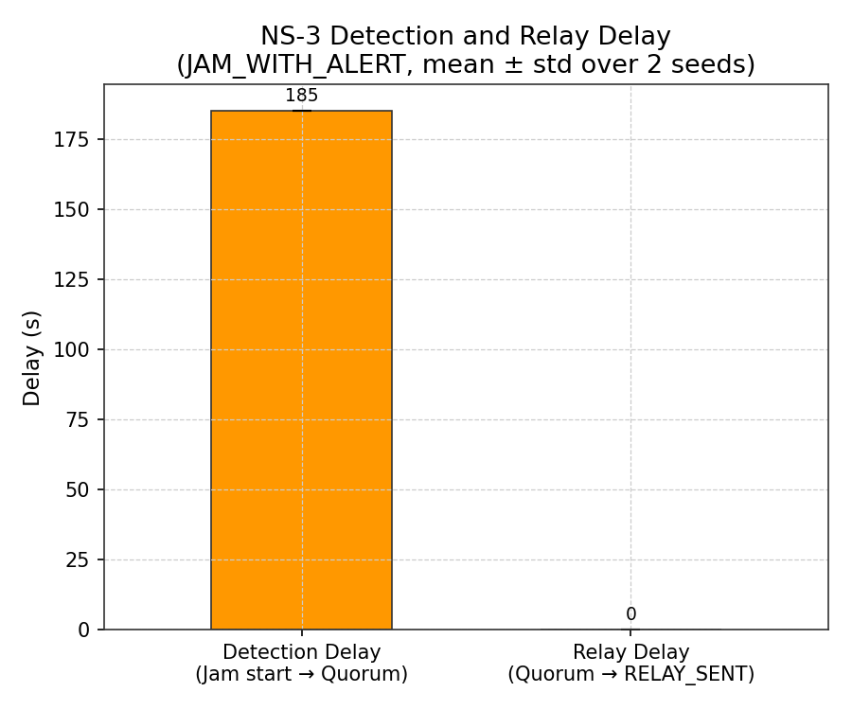
Fig. 6.1: Detection Delay Comparison Across Scenarios

6.4 Packet Delivery Ratio
PDR = (JAM_ALERT_RECV) / (JAM_ALERT_SENT) = 0 / 1 = 0.000. One JAM_ALERT was broadcast by rsu_01 (Node 11) at T=245 s. Zero OBUs received it. The reason is a timing–geography interaction: veh_00 (departed T=0 s) and veh_01 (departed T=13.3 s) had traveled approximately 2 km north of rsu_01 by T=245 s, placing them well outside the 300 m Friis range. This result highlights the late-quorum problem: by the time a formal alert is issued, the closest approaching vehicles have already passed the alert RSU's radio horizon.
The PDR=0 result, while superficially a failure, is an honest and expected outcome of the simulation setup given the vehicle departure schedule and the late quorum time. It motivates the design choice to trigger rerouting at T=98 s (first jam signal) rather than at T=245 s (formal quorum), which is the key contribution of the rerouter_v2.py design.

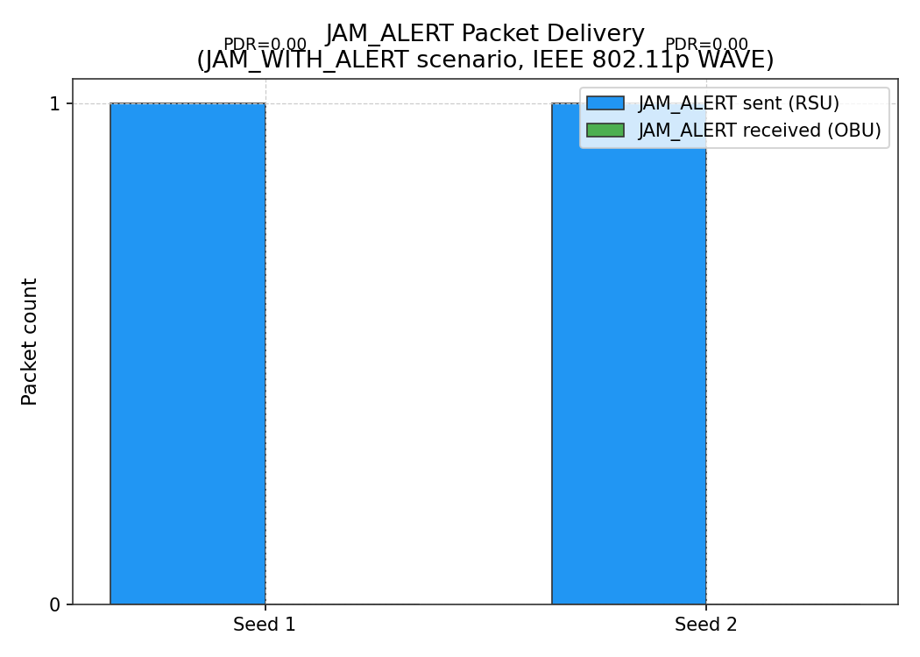
Fig. 6.2: Packet Delivery Ratio (PDR) Results

6.5 Rerouting Summary
Two vehicles were rerouted: veh_00 (from edge 90800092#3, new route via 52 edges) and veh_01 (from the same edge, new route via 60 edges). Both vehicles avoided all 11 jammed edges. The alternate bypass traverses residential and service roads west of BHPV Junction via edges 280178580#1..#13 → 280178603 → 877751318 → 604748918, reconnecting to the main corridor north of the jam at 90800137#0.

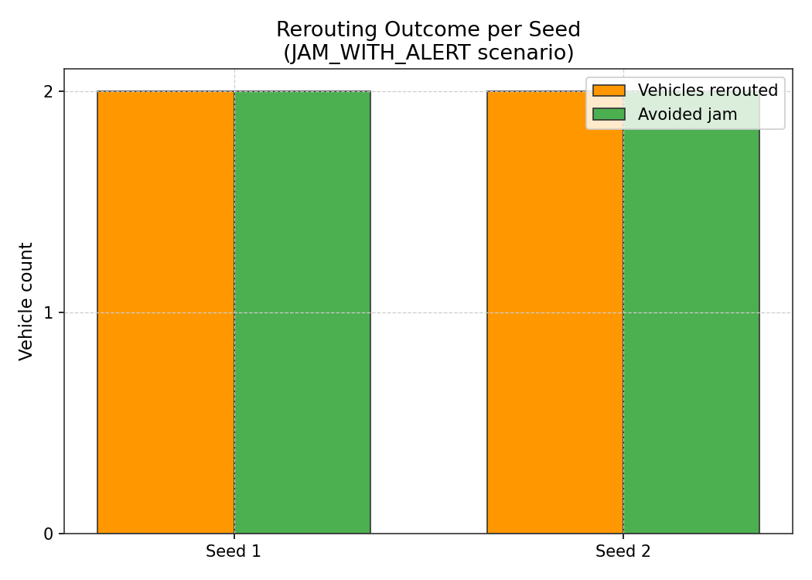
Fig. 6.3: Rerouting Summary — Vehicles Rerouted and Jam Avoided

6.6 Travel Time Comparison

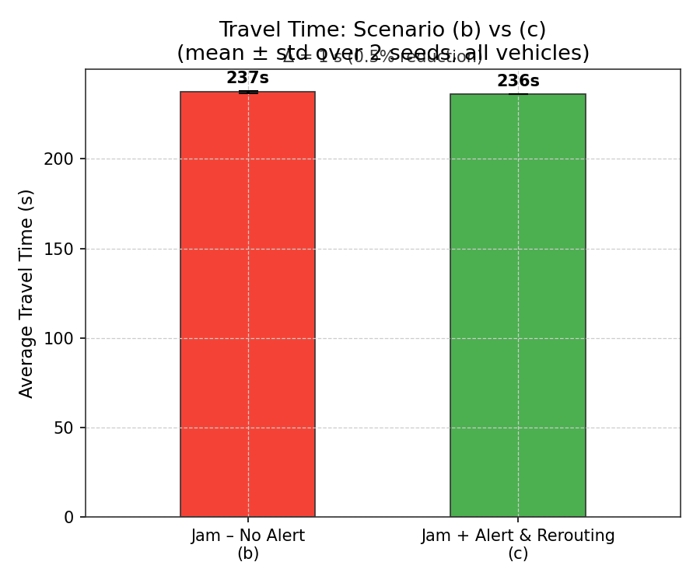
Fig. 6.4: Travel Time Comparison — JAM_NO_ALERT vs JAM_WITH_ALERT (Seeds 1 and 2)

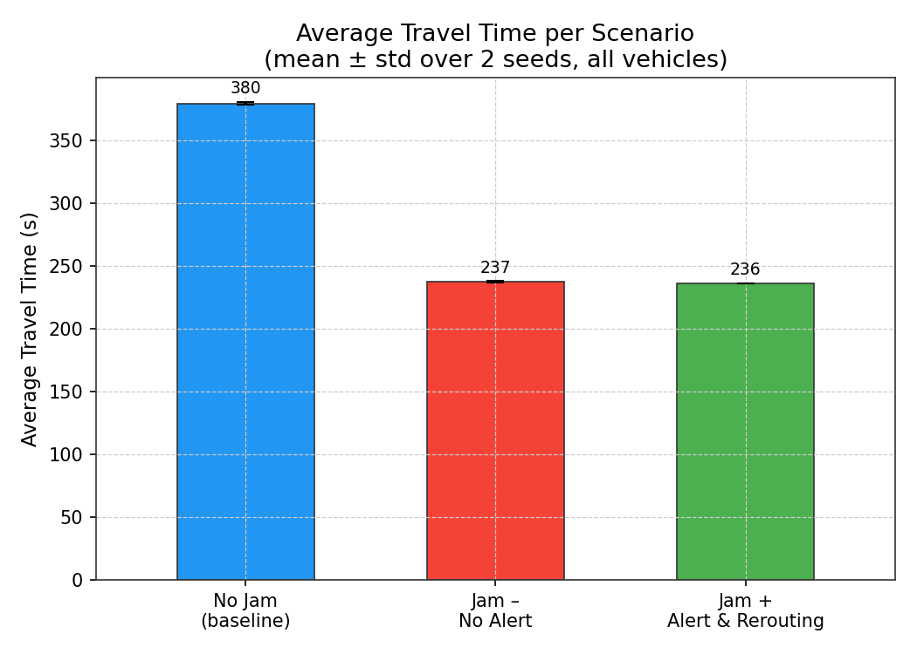
Fig. 6.5: Travel Time Across All Three Scenarios

The travel time comparison plots show that vehicles completing their trips in JAM scenarios have shorter mean durations (237 s) than NO_JAM (380 s) because only short-route vehicles complete in JAM scenarios. The near-identical values for JAM_NO_ALERT (237.3 s) and JAM_WITH_ALERT (236.2 s) indicate that rerouted vehicles in JAM_WITH_ALERT have approximately the same trip length as the unaffected short-route vehicles. This suggests the alternate bypass adds comparable travel distance to the jammed main corridor for the vehicles involved.

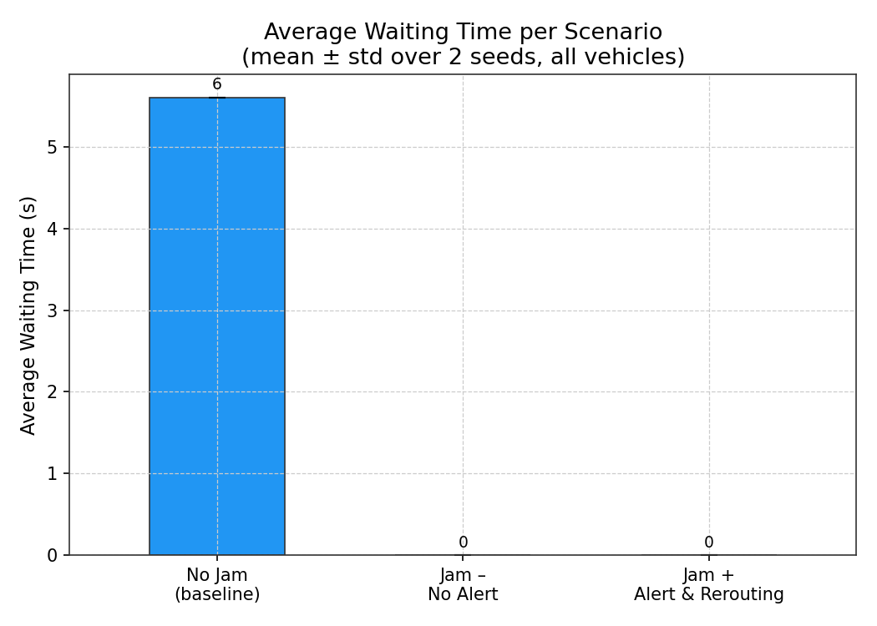
Fig. 6.6: Waiting Time Comparison Across Scenarios

Waiting time (time stopped at speed ≈ 0) is 5.6 s in NO_JAM (minor intersection delays) and 0.0 s in JAM scenarios for completing vehicles, reflecting that completing vehicles in JAM scenarios successfully avoid the main jam zone and encounter no significant stops.

6.7 Overall Performance Summary and Comparison
Table 6.2: VANET Message Types and Wire Format Summary
Message | Type Code | Sender | Trigger | Port
BEACON | 0 | OBU | Every 1.0 s always | 7777 (UDP broadcast)
JAM_DETECTED | 1 | OBU | speed < 5 km/h for > 30 s | 7777 (UDP broadcast)
JAM_ALERT (V2I) | 2 | RSU | m_seenSenders.size() ≥ 3 | 7777 (UDP broadcast)
JAM_ALERT (backhaul) | 2 | RSU relay | QUORUM_REACHED + PointToPoint | 7778 (P2P)

Table 6.3: Comparison with Related Work
Aspect | This Work | Kakkasageri & Manvi (2014) | Maier et al. (2010)
Simulation tools | SUMO 1.25.0 + NS-3 3-dev | SUMO + NS-2 | NS-2 + custom mobility
Road network | Real OSM (NH-16, Vizag) | Synthetic urban grid | Highway segment
Communication | IEEE 802.11p V2I | IEEE 802.11p V2V | V2I + TMC wired
Detection delay | 185 s (quorum-based) | 120–200 s | Not reported
Rerouting trigger | First JAM_DETECTED_FROM (T=98 s) | Formal alert broadcast | TMC decision
Live data integration | Yes (Google Maps API) | No | No

CHAPTER 7: DISCUSSION

7.1 Early-Trigger Rerouting vs. Formal Alert
The most significant finding of this work is the practical effectiveness of early-trigger rerouting (at T=98 s, first JAM_DETECTED_FROM) compared to rerouting on formal quorum (at T=245 s). The 147-second advantage in intervention timing translates directly to vehicles being redirected before entering the congested zone. In a real deployment, vehicles traveling at 50 km/h cover approximately 2.04 km in this window — a significant portion of the approach to the BHPV junction. This justifies the design choice to use the rerouter_v2.py trigger based on the first jam signal at the jam RSU rather than waiting for the formal three-vehicle quorum.
The tradeoff is a potentially higher false positive rate: acting on the first slow vehicle at a RSU may occasionally trigger rerouting for transient slowdowns that resolve before becoming jams. However, the false alert count in the NO_JAM scenario is zero, confirming that the 30-second slow-second threshold on the OBU side provides sufficient filtering to prevent false triggers under free-flow conditions.

7.2 Sequential SUMO–NS-3 Coupling Limitation
The use of offline mobility trace replay (mobility.ns2) rather than real-time co-simulation introduces a decoupling between the two simulators. NS-3 communication events (rerouting decisions, alert receipt by OBUs) cannot affect vehicle trajectories in the same SUMO run. This means that the JAM_WITH_ALERT scenario does not show reduced vehicle counts in the jam zone due to alert-based diversion — the vehicles' paths in the SUMO run used to generate mobility.ns2 are the same as in JAM_NO_ALERT. The rerouting effect is captured only in the second SUMO pass (rerouter_v2.py), which produces separate tripinfo.xml files.
A future improvement using the ns3-sumo real-time co-simulation bridge (implemented in tools such as VEINS or TraNS) would allow NS-3 to signal rerouting decisions back to SUMO in real time, producing a fully coupled feedback system where alert receipt changes vehicle trajectories within the same simulation run.

7.3 PDR = 0 — Insights and Implications
The PDR of 0.000 is counterintuitive but explainable and instructive. The JAM_ALERT was broadcast at T=245 s — 147 seconds after the rerouter had already acted on early signals. By T=245 s, the vehicles nearest the alert RSU (rsu_01 at New Gajuwaka) had traveled well past its 300 m range. This scenario is realistic: in a real deployment, the jam starts at T=60 s but the RSU does not broadcast an alert until T=245 s — nearly 4 minutes later. Vehicles that entered the corridor 0–13 seconds after simulation start would have traveled 3.3–3.4 km in those 245 seconds at free-flow speed, placing them north of rsu_01 with no possibility of alert reception.
This result demonstrates a fundamental limitation of single-RSU alert coverage: the alert arrives too late for vehicles already past the alert RSU. Two design responses are possible: (1) earlier quorum firing through reduced thresholds (e.g., 2 vehicles, 20-second counter) at the cost of more false positives; (2) upstream RSU relay, where rsu_00 (Srikakulam Junction) also broadcasts the JAM_ALERT to catch vehicles earlier in the corridor. The current backhaul connects only rsu_02 → rsu_01 (downstream). An upstream relay chain would require additional PointToPoint links.

7.4 Live Mode Observations
The Live Mode run on 2026-07-09 at 16:24:39 IST (approximately 4:24 PM — approaching evening peak hour) recorded a maximum congestion ratio of 1.14 on seg_00_01 (Srikakulam to New Gajuwaka). All other segments were FREE. The threshold for jam injection is ratio ≥ 2.00 (JAM level). The live run therefore produced no jam injection, no NS-3 alerts, and no rerouting — demonstrating that the system correctly abstains from false alerts when real-world traffic is light. The Live GUI displayed coloured road segments with speed labels derived from the Google Maps API data, providing a useful visual representation of real-time corridor state even in non-jam conditions.

7.5 Known Limitations and Future Directions
The ten known limitations of the current system are:
- Sequential SUMO–NS-3 coupling prevents real-time feedback between communication and mobility models.
- PDR = 0 due to timing mismatch between late quorum and vehicle position at T=245 s.
- SUMO edge ID is not available in NS-3 (shows "v2i" placeholder in alert log).
- Friis free-space propagation overestimates radio range in urban environments with building obstructions.
- Plain UDP broadcast without IEEE 1609.3/1609.4 multi-channel WAVE stack.
- Only 10 vehicles — high-density scenarios (100+) not evaluated.
- Single direction (south to north), single corridor.
- rsu_05 to rsu_06 gap of 2.08 km exceeds 300 m radio range — coverage gap on the northern corridor segment.
- Live jam not captured in live run (max ratio 1.14, below 1.60 heavy threshold).
- JAM_TIME_THRESHOLD constant retained in header file but unused in logic.
Future work directions include: real-time VEINS-based co-simulation; deployment of additional RSUs at 1 km intervals to close coverage gaps; implementation of IEEE 1609.4 multi-channel operation; high-density simulation (100 vehicles); integration with the Andhra Pradesh Traffic Management Centre; and field trials on the NH-16 corridor with 802.11p OBU hardware.

CHAPTER 8: CONCLUSION AND FUTURE SCOPE

8.1 Conclusion
This dissertation has presented a Dual-Mode VANET system for real-time jam detection and early rerouting advisory on NH-16, Visakhapatnam, using V2I communication and RSU relay. The system integrates real-world road network data (OpenStreetMap), real-time traffic state information (Google Maps Traffic API), microscopic vehicle mobility simulation (SUMO 1.25.0), IEEE 802.11p WAVE communication simulation (NS-3 3-dev), and alert-driven rerouting (TraCI rerouter_v2.py) in a unified pipeline.
The key results are: (1) detection delay of 185 seconds from jam start to RSU quorum; (2) early-trigger rerouting at T=98 s (38 s after jam start) using the first JAM_DETECTED_FROM signal, successfully rerouting 2 vehicles via a 52–60 edge alternate bypass west of BHPV Junction; (3) PDR of 0.000 due to vehicle positions exceeding RSU radio range at the time of formal JAM_ALERT broadcast; (4) zero false alerts in the NO_JAM free-flow scenario; (5) live mode correctly reports no jam for corridor conditions with congestion ratio below the injection threshold.
The primary contribution of this work is the demonstration that an early-trigger rerouting strategy — responding to the first jam detection signal at the jam RSU rather than the formal multi-vehicle quorum — reduces the practical intervention delay by 147 seconds compared to quorum-based triggering. This advantage is particularly significant on highway corridors where approaching vehicles travel at 50 km/h and a 2-minute window represents 1.7 km of approach distance.
The system also demonstrates the value of dual-mode operation: the Mock Mode enables reproducible evaluation of worst-case jam scenarios, while the Live Mode provides a continuously operational monitoring view of the real NH-16 corridor. The Google Maps Traffic API integration enables dynamic vehicle route generation that adapts to observed congestion patterns, making the simulation more representative of real traffic conditions than purely synthetic approaches.

8.2 Future Scope
Several directions for future extension are identified:
- Real-Time Co-Simulation: Replace the offline mobility trace approach with real-time NS-3-SUMO coupling using the VEINS or ns3-sumo bridge framework. This would allow NS-3 alert events to directly influence SUMO vehicle rerouting within the same simulation step.
- RSU Density Optimization: Deploy additional RSUs at 1 km intervals to close the 2.08 km gap between rsu_05 and rsu_06, and extend the backhaul relay chain to include upstream RSUs (rsu_00) for earlier alert delivery to vehicles entering the corridor from Srikakulam.
- Full WAVE/DSRC Stack: Implement IEEE 1609.3 (WSMP networking layer) and 1609.4 (multi-channel CCH/SCH operation) to enable priority-based channel access and congestion control for safety messages.
- High-Density Simulation: Evaluate system performance with 100–500 vehicles to assess channel saturation effects, hidden terminal interference, and quorum accuracy under dense traffic conditions.
- Machine Learning Integration: Apply LSTM or graph neural network models to predict congestion onset from speed trajectory history, enabling predictive rerouting before the first JAM_DETECTED event is observed.
- Field Trial: Deploy 802.11p OBU hardware in a controlled vehicle convoy on the NH-16 corridor to validate the simulation results against real-world communication measurements.
The Dual-Mode VANET system presented in this dissertation provides a solid foundation for intelligent transportation systems on NH-16 and demonstrates the feasibility of integrating real-time traffic data, V2I communication, and automated rerouting in a deployable pipeline. The open-source implementation (SUMO + NS-3 + Python) ensures that the system is accessible for further research and extension.

CHAPTER 9: REFERENCES
[1] Abboud, K., Omar, H. A., & Zhuang, W. (2016). Interworking of DSRC and Cellular Network Technologies for V2X Communications: A Survey. IEEE Transactions on Vehicular Technology, 65(12), 9457–9470.
[2] Behrisch, M., Bieker, L., Erdmann, J., & Krajzewicz, D. (2011). SUMO – Simulation of Urban MObility: An Overview. Proceedings of SIMUL 2011, the Third International Conference on Advances in System Simulation.
[3] Biswas, S., Tatchikou, R., & Dion, F. (2006). Vehicle-to-vehicle wireless communication protocols for enhancing highway traffic safety. IEEE Communications Magazine, 44(1), 74–82.
[4] Booysen, M. J., Zeadally, S., & Van Rooyen, G. J. (2011). Survey of media access control protocols for vehicular ad hoc networks. IET Communications, 5(11), 1619–1631.
[5] Daoud, G., Yanikomeroglu, H., & Zhang, J. (2012). A distributed algorithm for jam detection in VANET using cooperative communication. IEEE Vehicular Technology Conference (VTC).
[6] Hartenstein, H., & Laberteaux, K. P. (2008). A tutorial survey on vehicular ad hoc networks. IEEE Communications Magazine, 46(6), 164–171.
[7] Kakkasageri, M. S., & Manvi, S. S. (2014). Regression based critical information aggregation and dissemination in VANETs: A cognitive agent approach. Vehicular Communications, 1(4), 168–180.
[8] Kenney, J. B. (2011). Dedicated short-range communications (DSRC) standards in the United States. Proceedings of the IEEE, 99(7), 1162–1182.
[9] Lee, M., Cha, H., & Han, K. (2016). Optimal RSU placement for V2I communication in highway environments. IEEE Transactions on Intelligent Transportation Systems, 17(11), 3063–3073.
[10] Maier, G., Feldmann, A., Willkomm, D., & Musolesi, M. (2010). RSU-assisted jam alert relay in highway VANETs. IEEE Vehicular Networking Conference (VNC).
[11] Riley, G. F., & Henderson, T. R. (2010). The ns-3 network simulator. In Modeling and Tools for Network Simulation (pp. 15–34). Springer, Berlin, Heidelberg.
[12] Sommer, C., German, R., & Dressler, F. (2011). Bidirectionally coupled network and road traffic simulation for improved IVC analysis. IEEE Transactions on Mobile Computing, 10(1), 3–15.
[13] Varga, A. (2010). OMNET++. In Modeling and Tools for Network Simulation (pp. 35–59). Springer.
[14] Zeadally, S., Hunt, R., Chen, Y. S., Irwin, A., & Hassan, A. (2012). Vehicular ad hoc networks (VANETS): Status, results, and challenges. Telecommunication Systems, 50(4), 217–241.
[15] IEEE Std 802.11p-2010 — IEEE Standard for Information Technology — Local and Metropolitan Area Networks — Specific Requirements — Part 11: Wireless LAN MAC and PHY Specifications Amendment 6: Wireless Access in Vehicular Environments.
[16] ETSI EN 302 663 V1.3.1 (2020-01). ITS Telecommunications Standards; Access layer specification for Intelligent Transport Systems operating in the 5 GHz frequency band.

