ACEest Fitness — CI/CD Assignment
Student: Neha Gupta
BITS ID: 2024ht66038
Date: November 2025

1. Executive Summary
This report presents the complete CI/CD implementation for the ACEest Fitness web application. The application is a simple Flask-based REST API demonstrating automation through Continuous Integration (CI) and Continuous Deployment (CD) practices using tools like Jenkins, Docker, Kubernetes (Minikube), and SonarQube.

2. Architecture and Flow
The CI/CD flow integrates code development, automated testing, containerization, and deployment:
GitHub (source code) → Jenkins (CI pipeline) → Docker Hub (image registry) → Kubernetes (Minikube cluster) → Running Flask App.

3. Files Included
- ACEest_Fitness.py — Flask app entrypoint
- app/ — Flask application logic
- tests/ — Pytest test cases
- Dockerfile, .dockerignore — container build files
- Jenkinsfile — CI/CD pipeline configuration
- k8s/ — Kubernetes manifests for deployment and services
- README.md — detailed setup and execution guide
- Report.docx — this submission report

4. Validation and Results
Below are the key validation steps performed during the CI/CD workflow with corresponding screenshots.
✅ Step 1: Running pytest — All tests passed successfully.
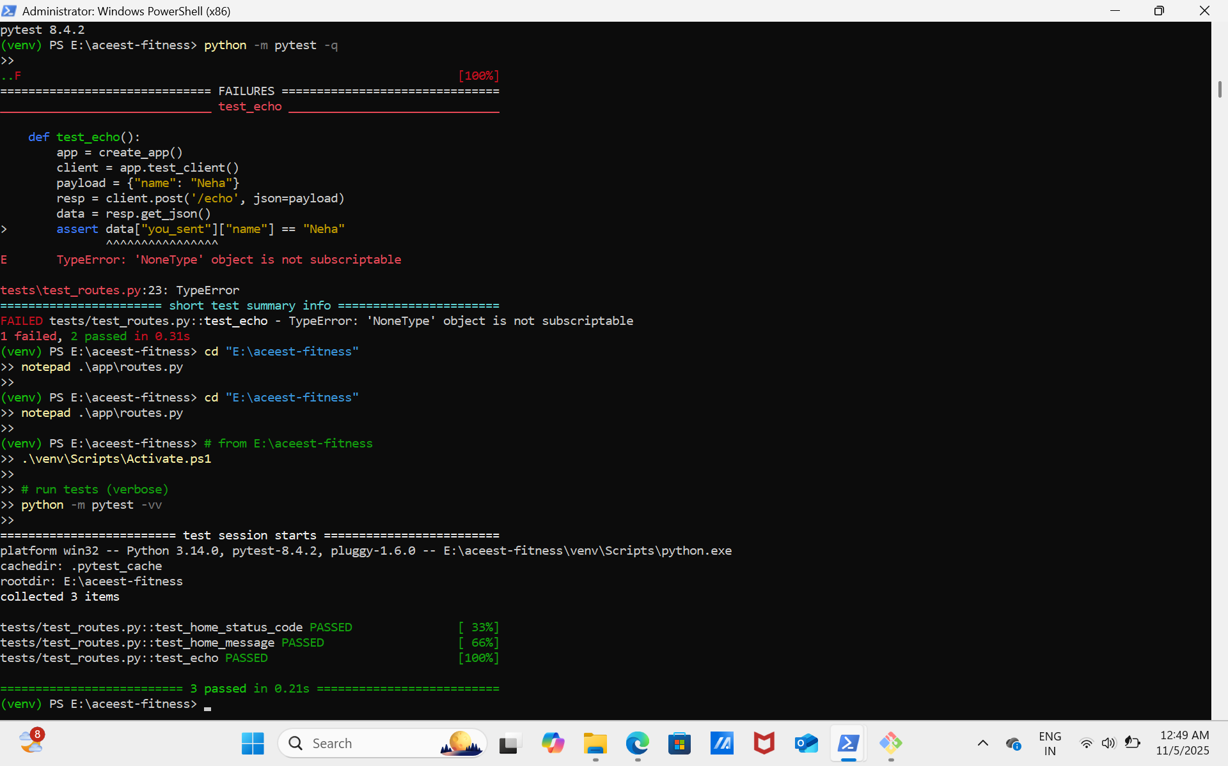

✅ Step 2: Docker image built successfully using Dockerfile.
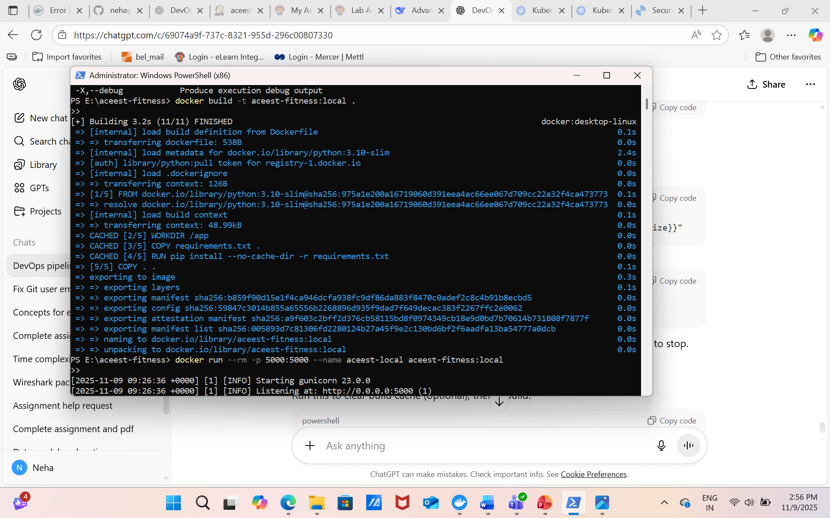

✅ Step 3: Image pushed to Docker Hub under the repository `aceest-fitness`.
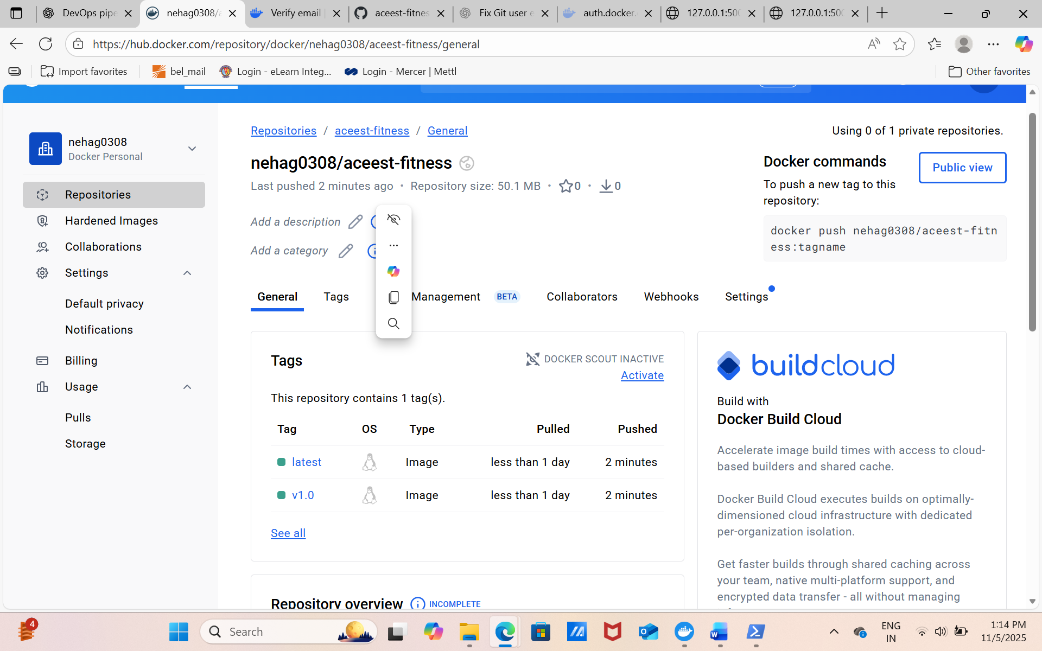

✅ Step 4: Minikube Kubernetes deployment created successfully and pods running.
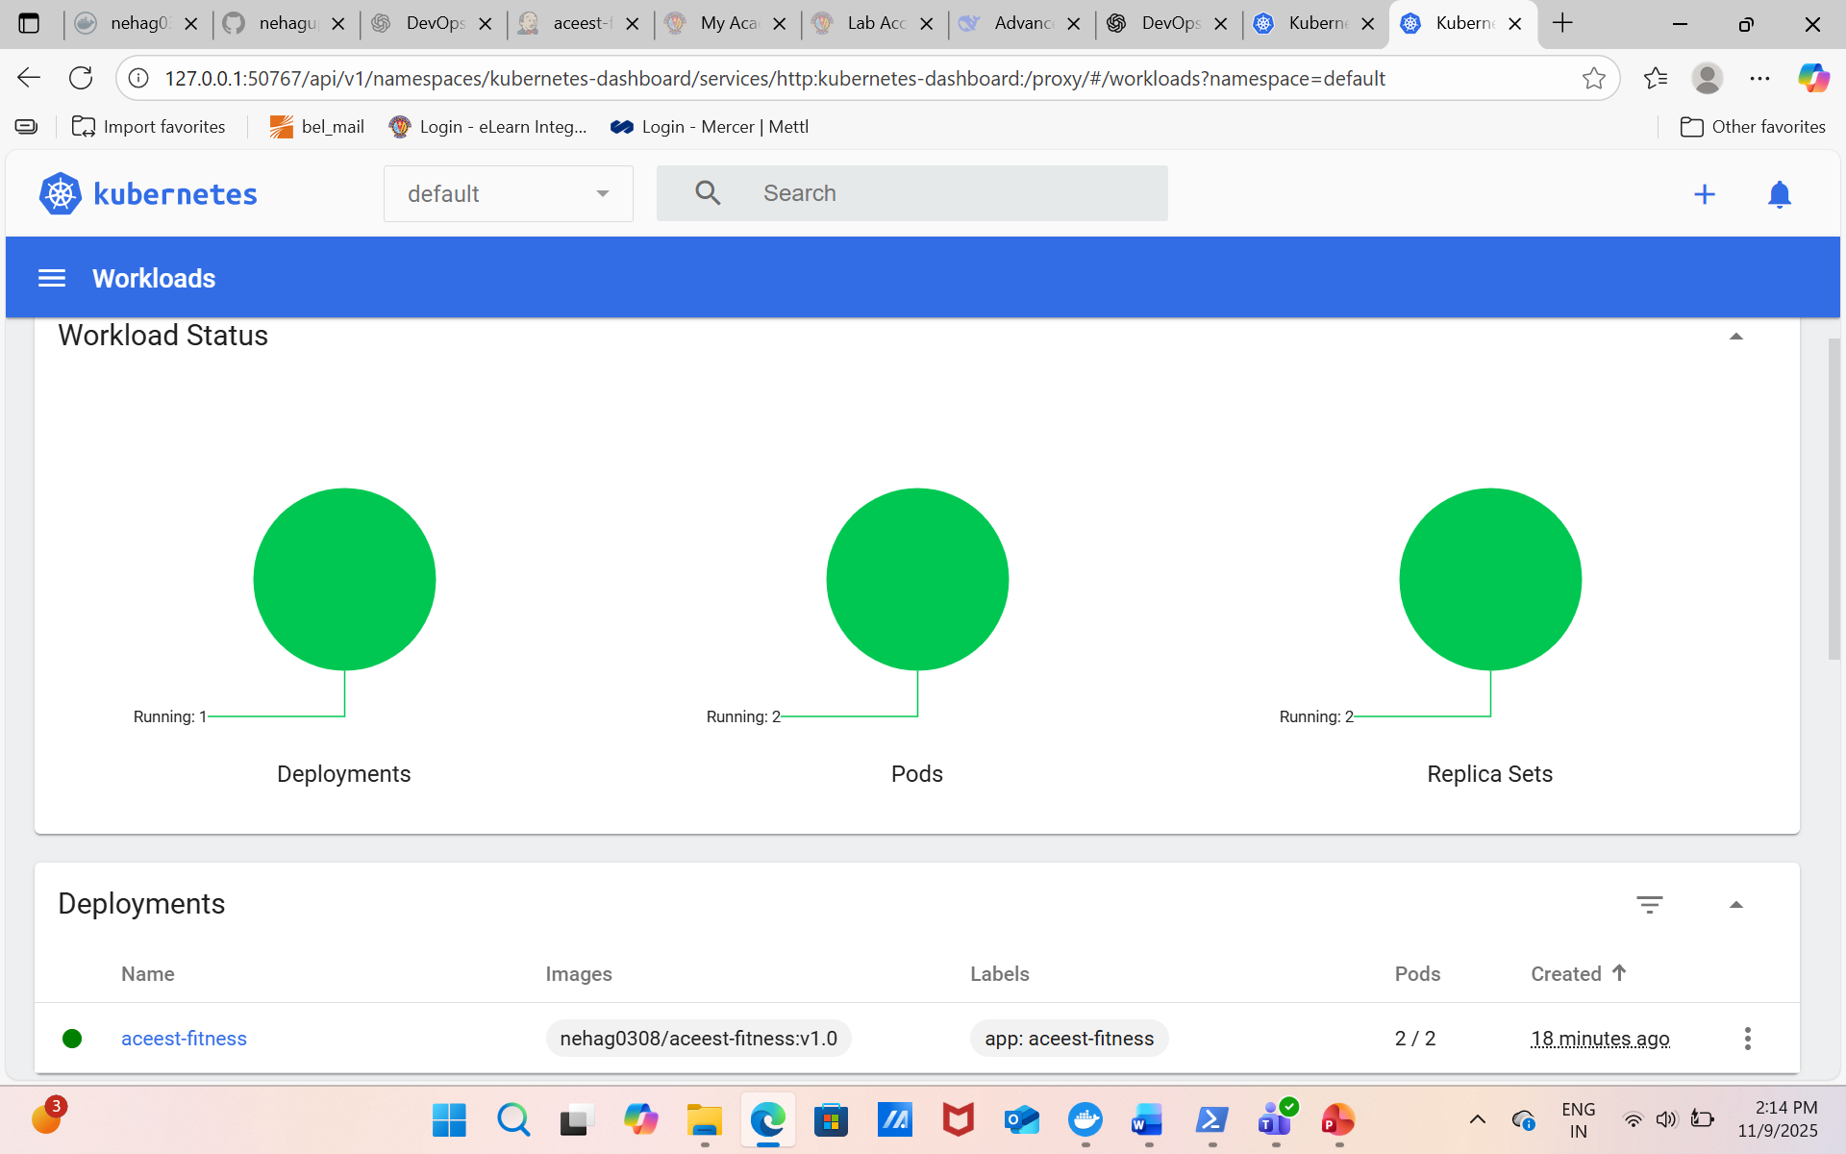

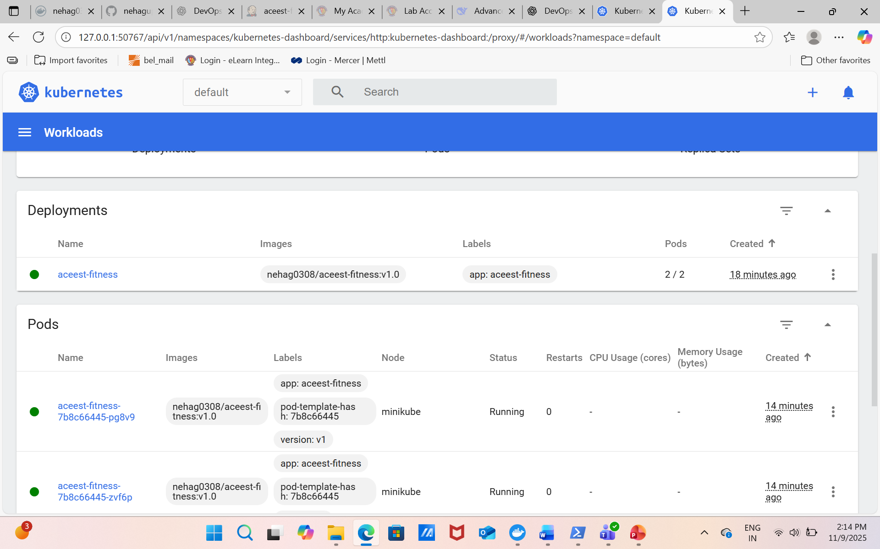

✅ Step 5: Service accessible externally through Minikube URL.
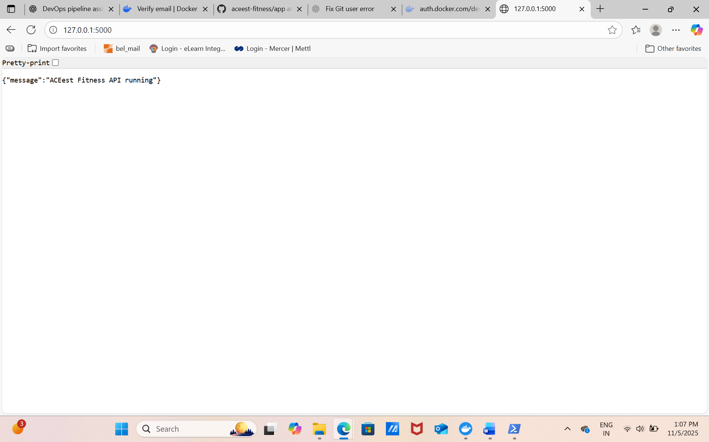

✅ Step 6: SonarQube code quality scan executed successfully with no major code smells.
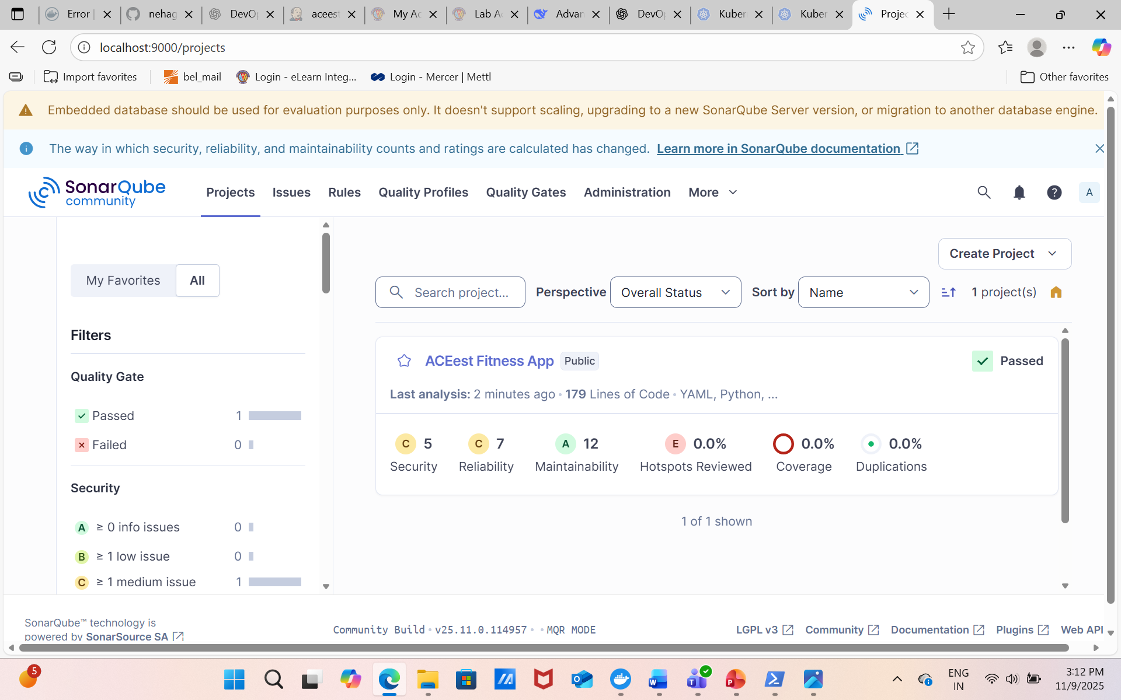

Jenkins pipeline console log
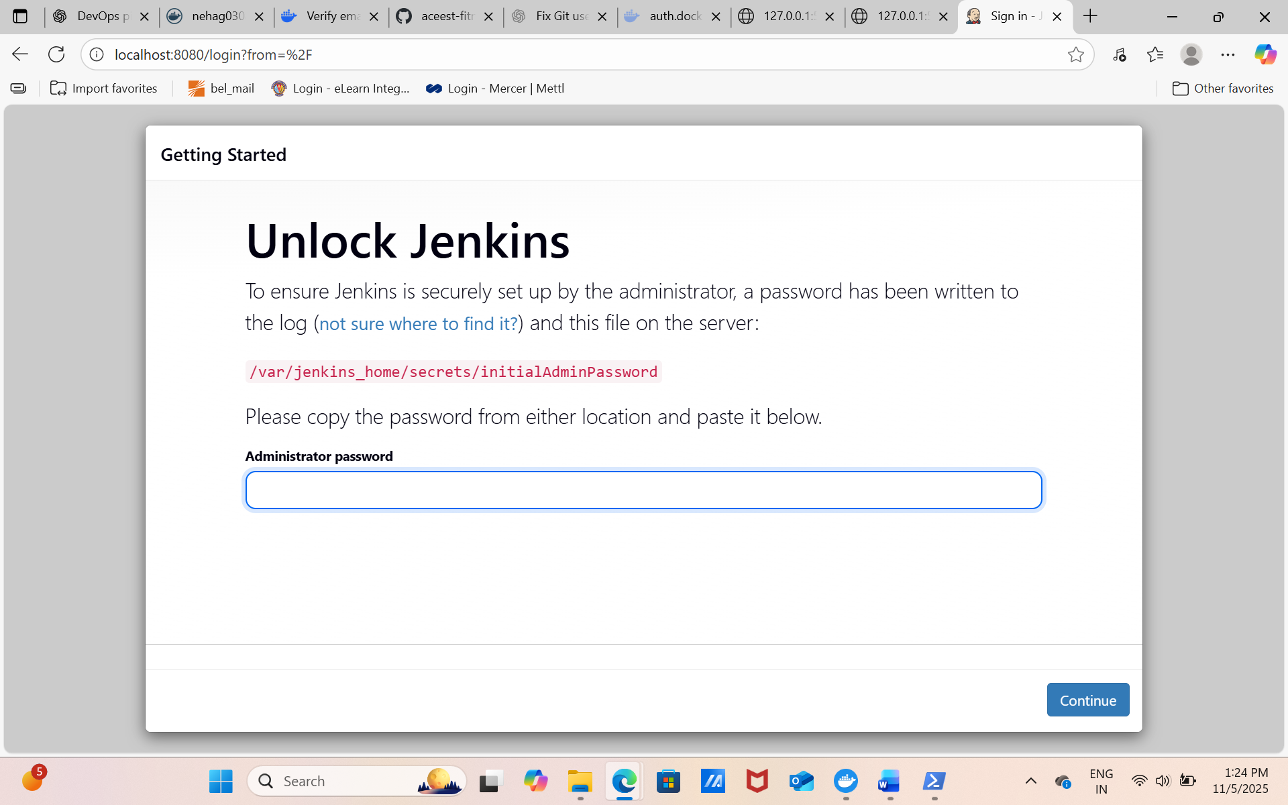
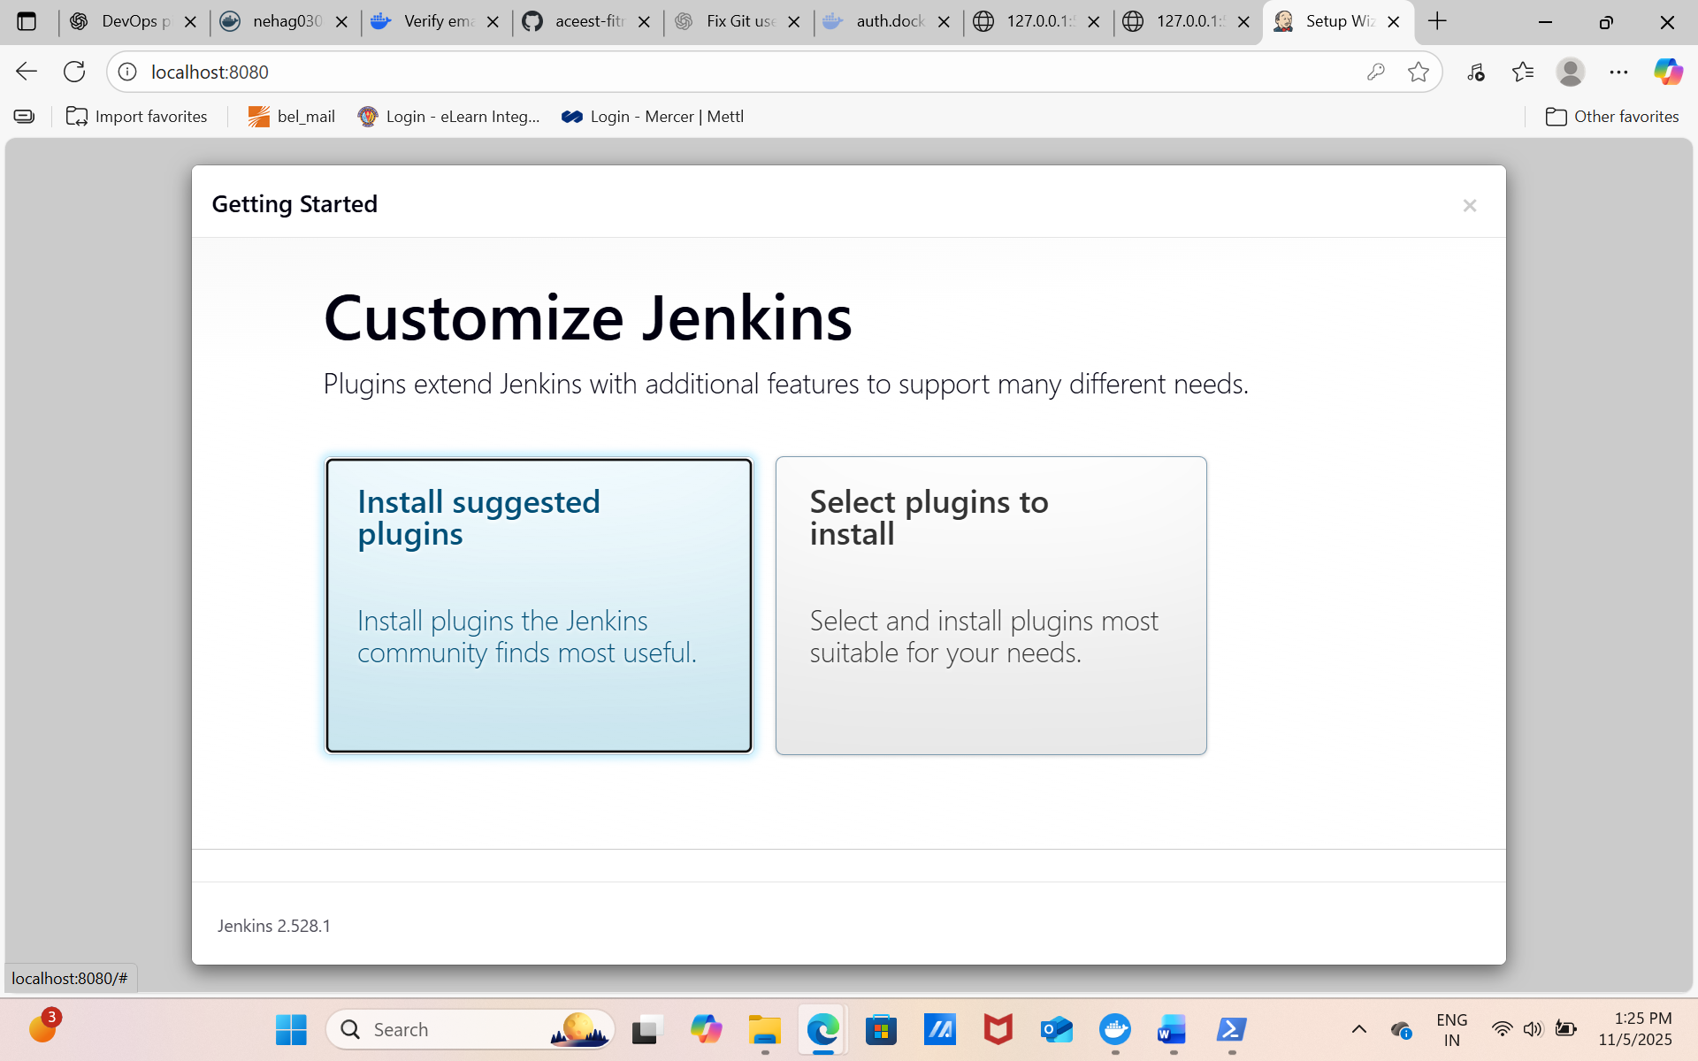
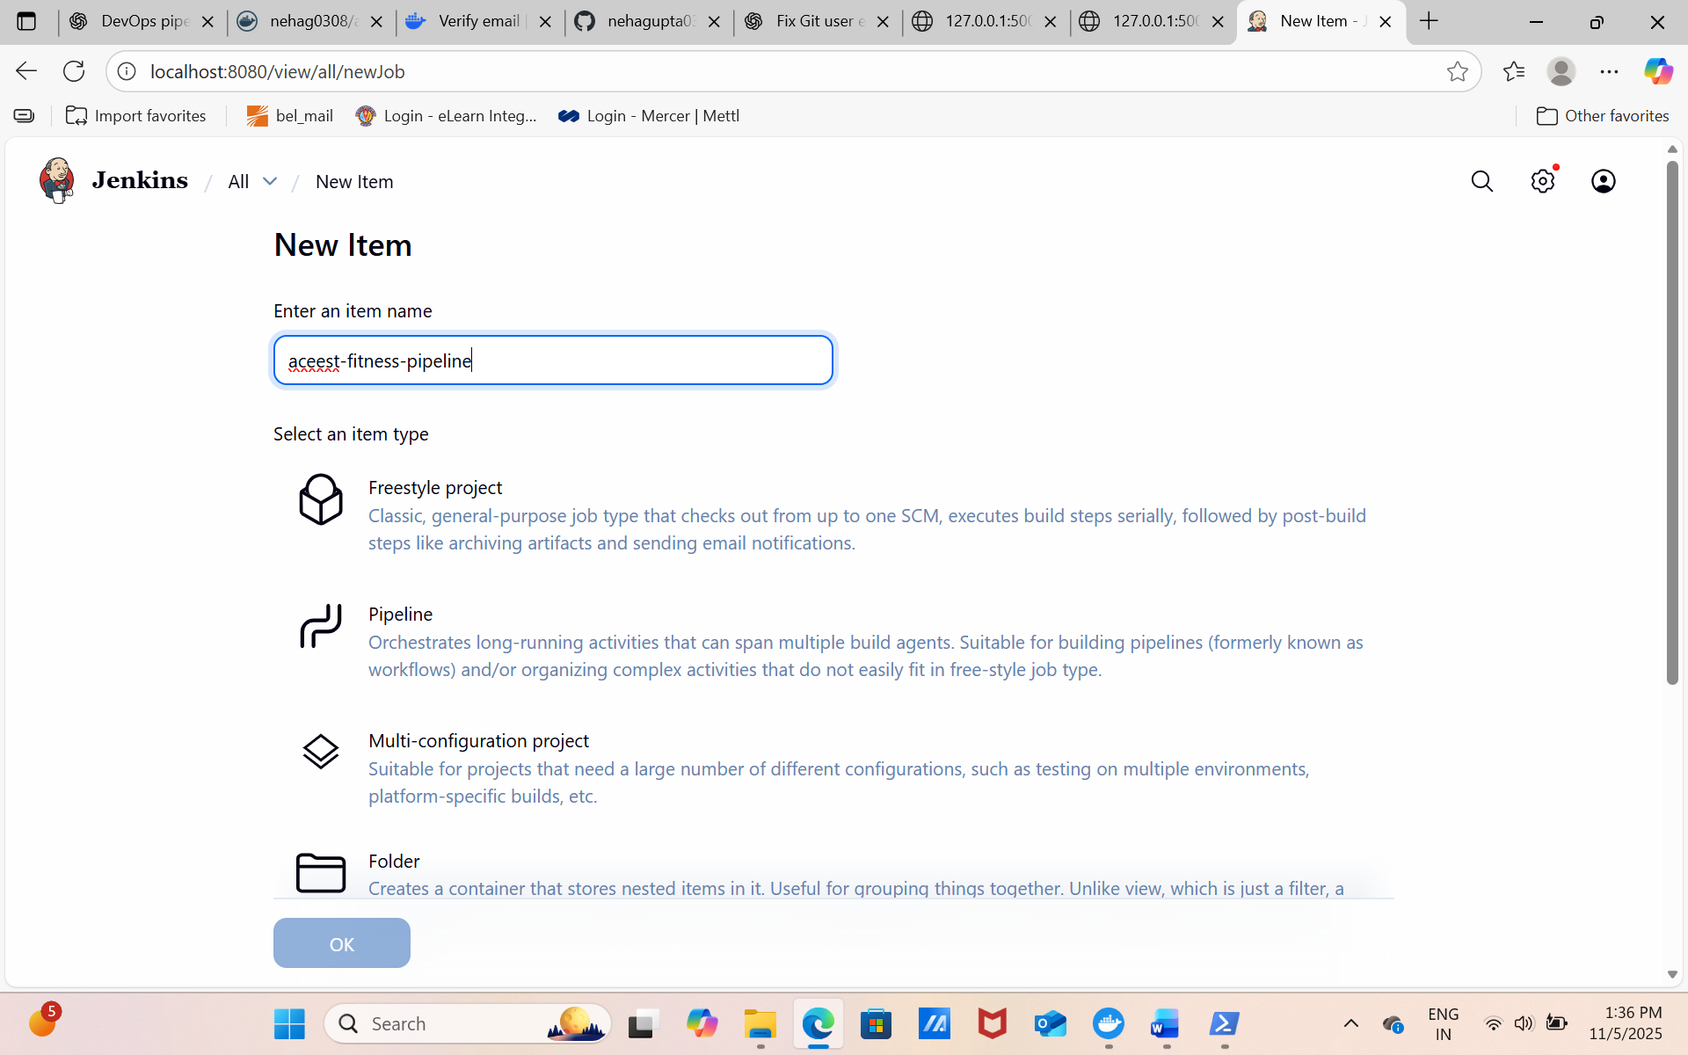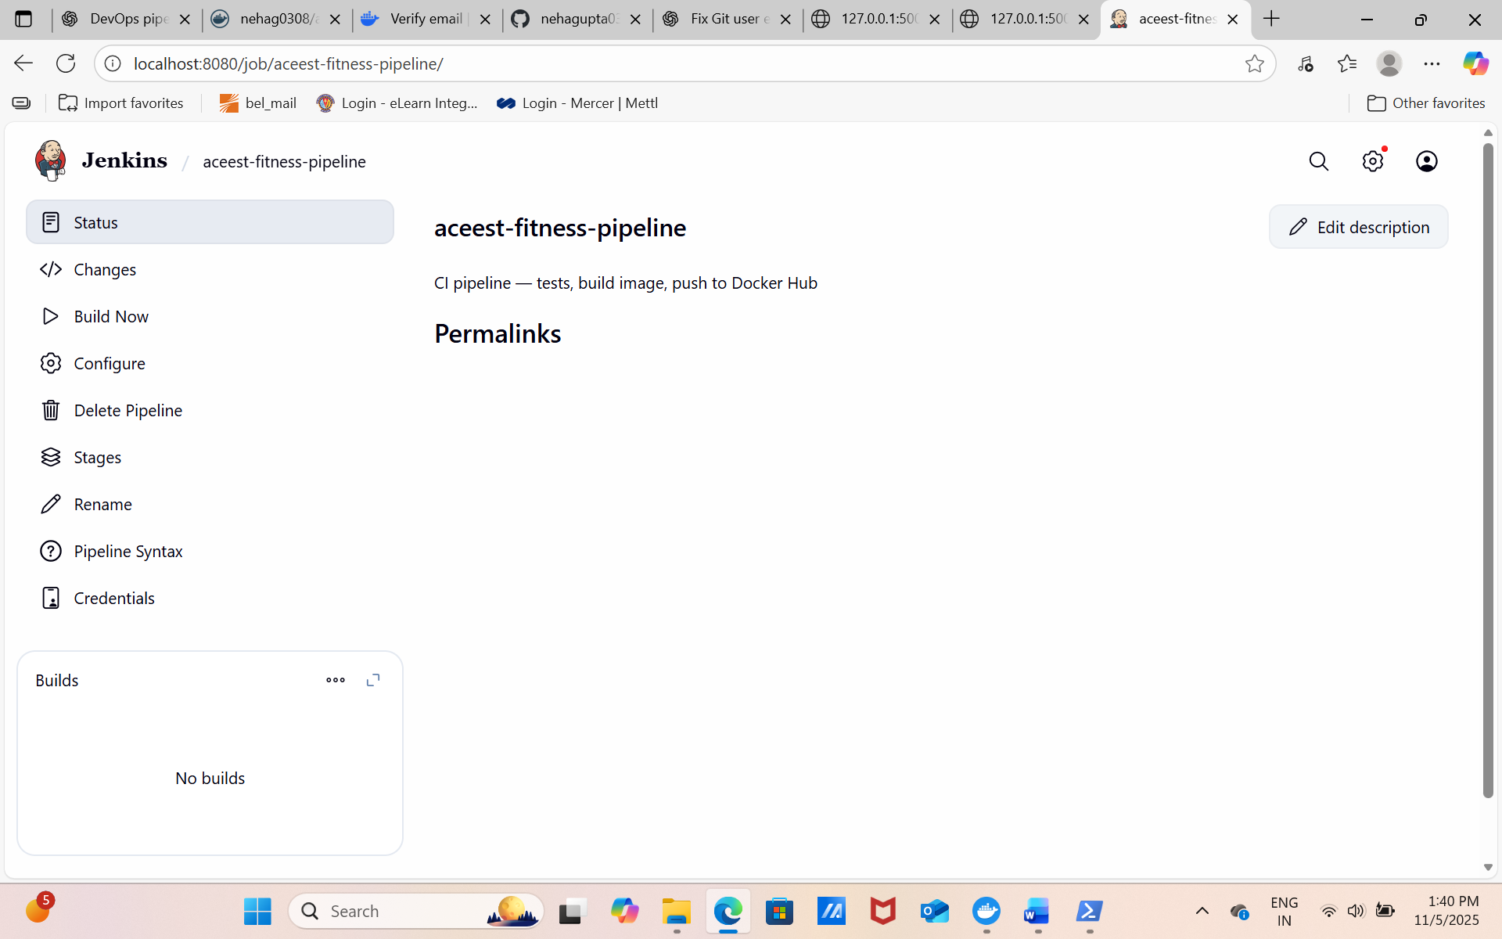

5. Deployment Strategies Demonstrated
- **Rolling Update:** Using `kubectl set image` to gradually replace running pods.
- **Blue-Green Deployment:** Two deployments (v1-blue and v2-green) switching via Service selector.
- **Canary Deployment:** Deploying 1 small pod to test new version before full rollout.

6. Challenges and Mitigations
- Jenkins inside Docker needed root privileges to use Docker CLI. Solved by running Jenkins as root.
- Docker Hub image push initially failed due to unverified email. Fixed by verifying account.
- Some Kubernetes pulls failed due to private image tags. Solved by using public repository or `imagePullSecrets`.

7. Step-by-Step Command Summary
All PowerShell commands for local testing and deployment are documented in README.md. In summary:
1. Setup venv and install requirements
2. Run pytest
3. Build Docker image
4. Push image to Docker Hub
5. Deploy using Minikube with kubectl apply

8. Conclusion
The ACEest Fitness project demonstrates a full CI/CD lifecycle using open-source DevOps tools. The system builds, tests, containerizes, and deploys a Flask application through automated stages. All stages were validated locally, and relevant screenshots are attached.
End of Report — Neha Gupta (2024ht66038)

