**AED FINAL PROJECT PROPOSAL DRAFT**

**TOPIC: PERSONAL LIFE MANAGEMENT SYSTEM**

In the fast pace life, individuals regularly neglect to track or maintain a balance in their routine life. The objective of this project is to empower a man to keep a beware of his work-health-daily schedule. Our smart application will give a drastically extraordinary approach in following of wellbeing, getting sorted out individual's every day work plan, monitoring his other day by day routine and in this manner giving valuable proposals to the individual. The recommendations and activities will be an aftereffect of the examination performed on information got from number of such individuals in the ecosystem.

Our smart application will dynamically maintain track of individual’s vital signs and medical reports. If the individual’s vital sign exceeds the optimum threshold the smart application will alert and dynamically send his medical condition to the doctor. The individual will get the suggestions reasonable to his wellbeing condition via this application.

The framework additionally includes a person's working hours, plan, leave adjusts and relying on these points of interest it will propose the individual how to deal with his calendar for instance when to take a break amid working hours, on the off chance that he needs to take an excursion etc.

We will try to include other aspects of individual’s routine for further analytics and enhancement.

The System Admin will be responsible for performing task like managing the network in an Ecosystem, managing the enterprises and their admins, managing people and view the analytics about different person and drafting a detailed recommendations to every individual based upon the results of the analytics performed.

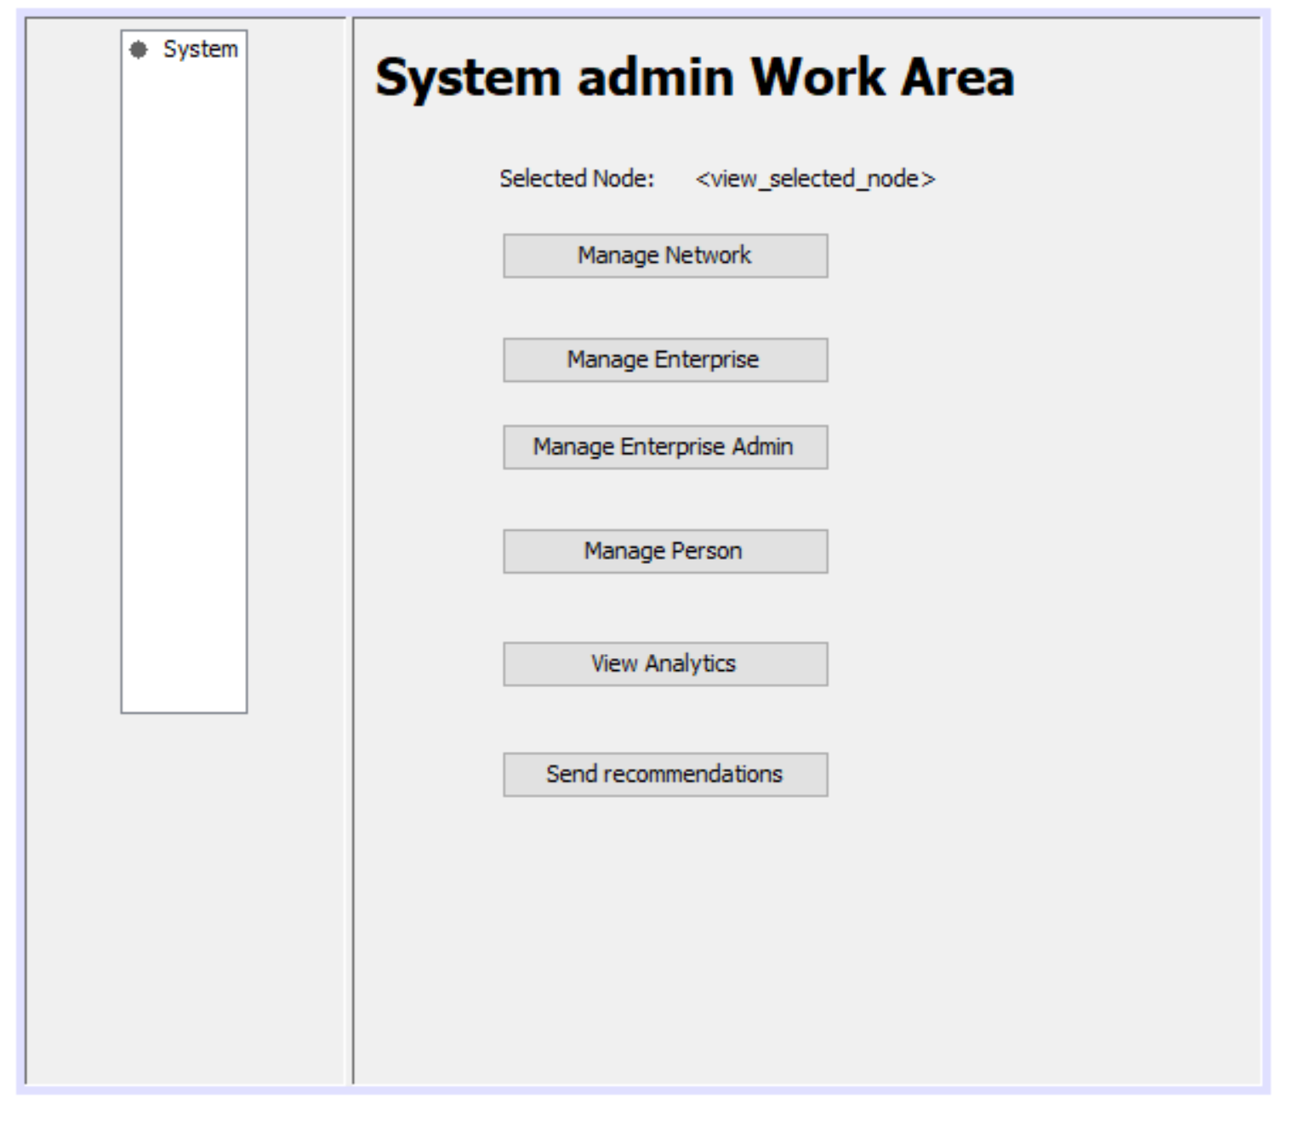

Each Enterprise will have their respective Admins which will perform the tasks such as managing the various organizations within the enterprise, managing the employees and assigning them to various roles and giving them their respective user account details.

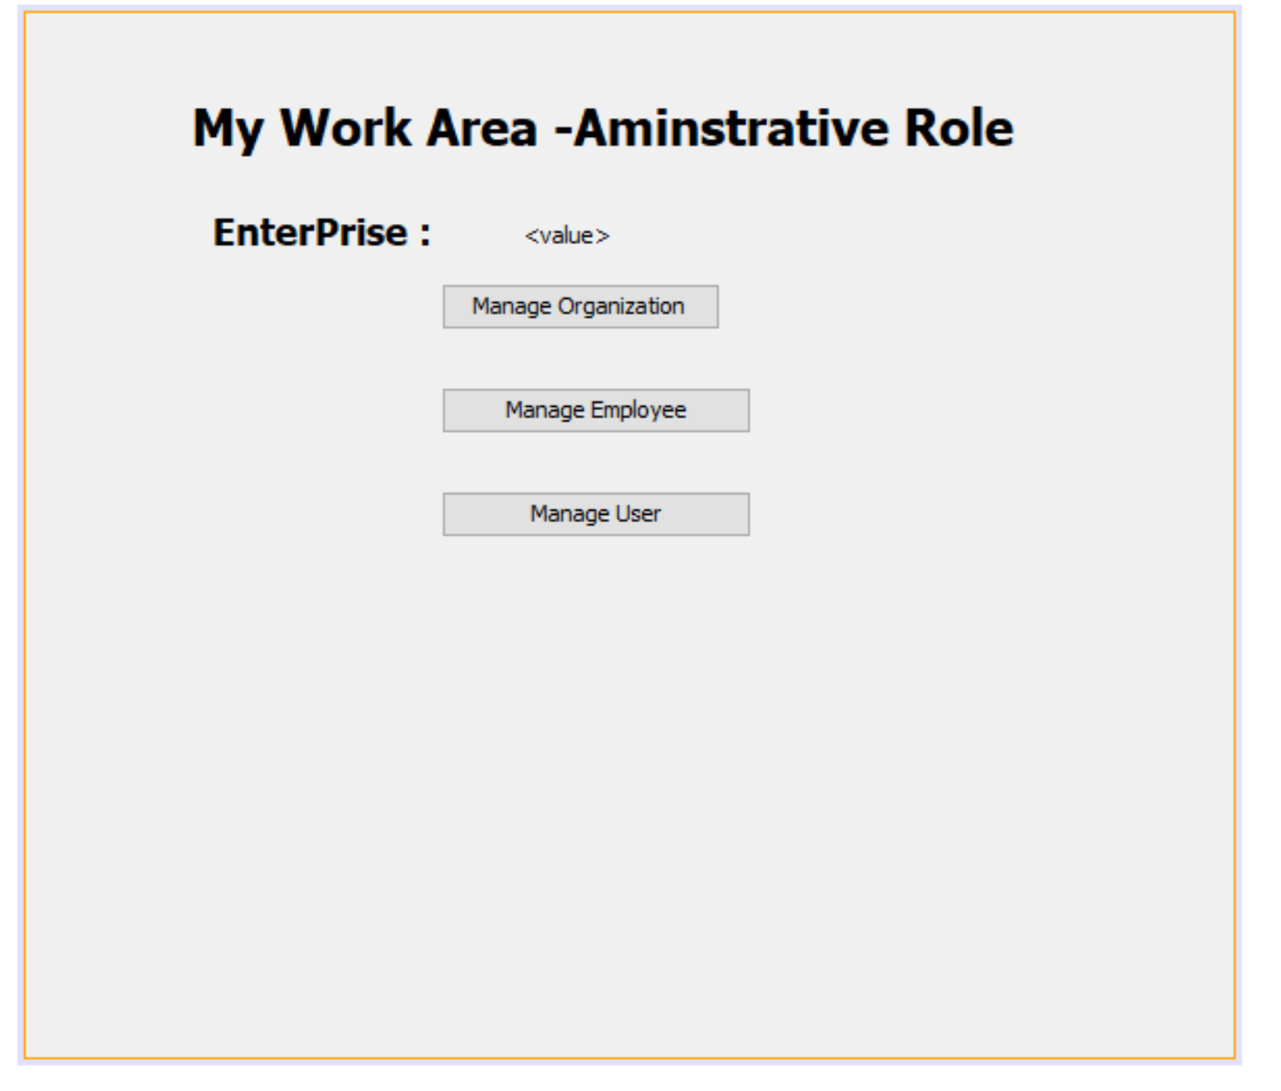

When a person login in his personal smart application device, He will see the following use-cases/features on MY PERSONAL TRACKER screen such as Health, Routine, Work and System Recommendations through which he will have access to monitor and manage his life.

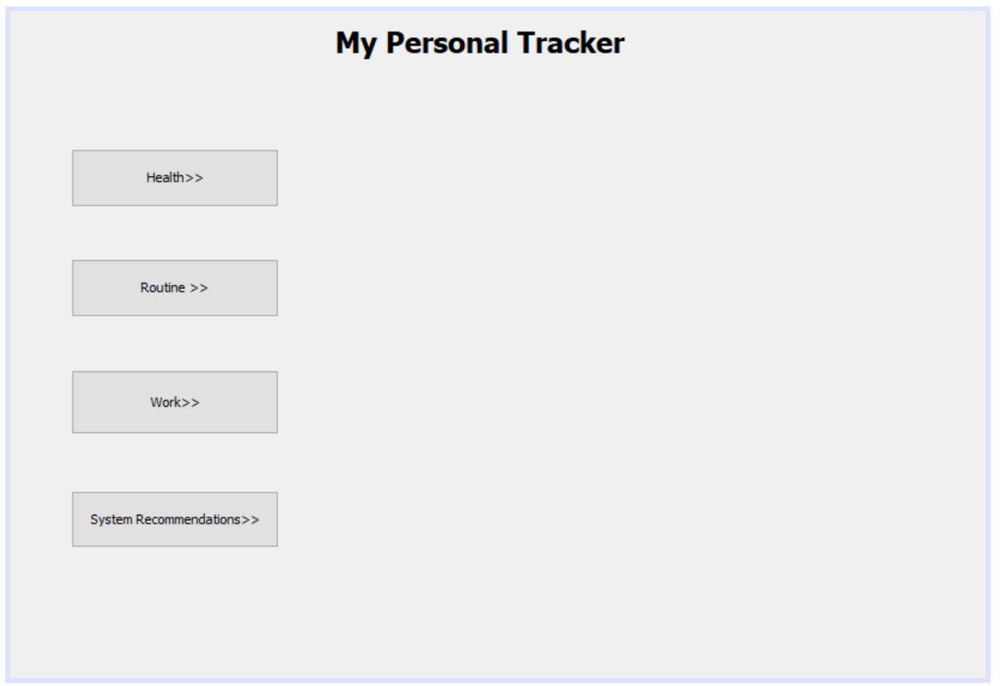

On-Click on the button Health, the person will be redirected to the MY HEALTH TRACKER screen which has use cases like capturing vital signs, viewing his vital signs, viewing his health report and managing his appointments with the Doctor.

The Capturing Vital Signs feature will allow the person to enter his vital sign details into the system.

View my vital sign history will allow the person to keep track on his previous vital sign history.

The person will be able to view his health report drafted by hospital enterprise’s organization by using view my health report button.

Manage my appointments feature will notify the person about his appointments with the doctor.

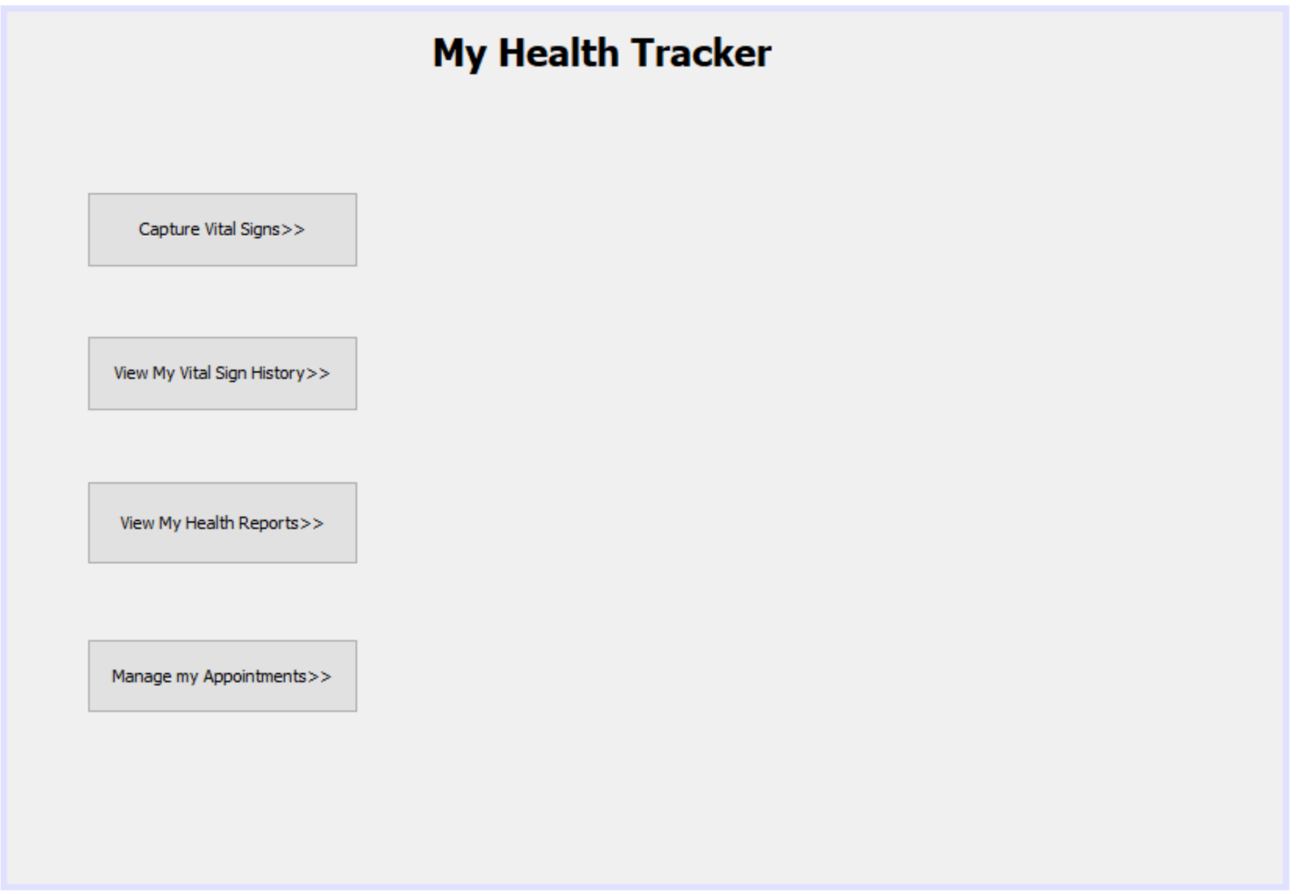

When the Doctor login in his work area, on selecting the patient(person) he will be able to view the person’s vital sign notification which the smart application device notifies the doctor when the person’s vital sign exceeds the normal vital sign threshold. If the vital sign notification is abnormal the doctor will flag alert to his lab assistant to which the lab assistant will set up appointment and draft report to the person. Doctor, Lab assistant and the person will be able to view the appointments. The doctor and lab assistant work area skeleton is shown below:

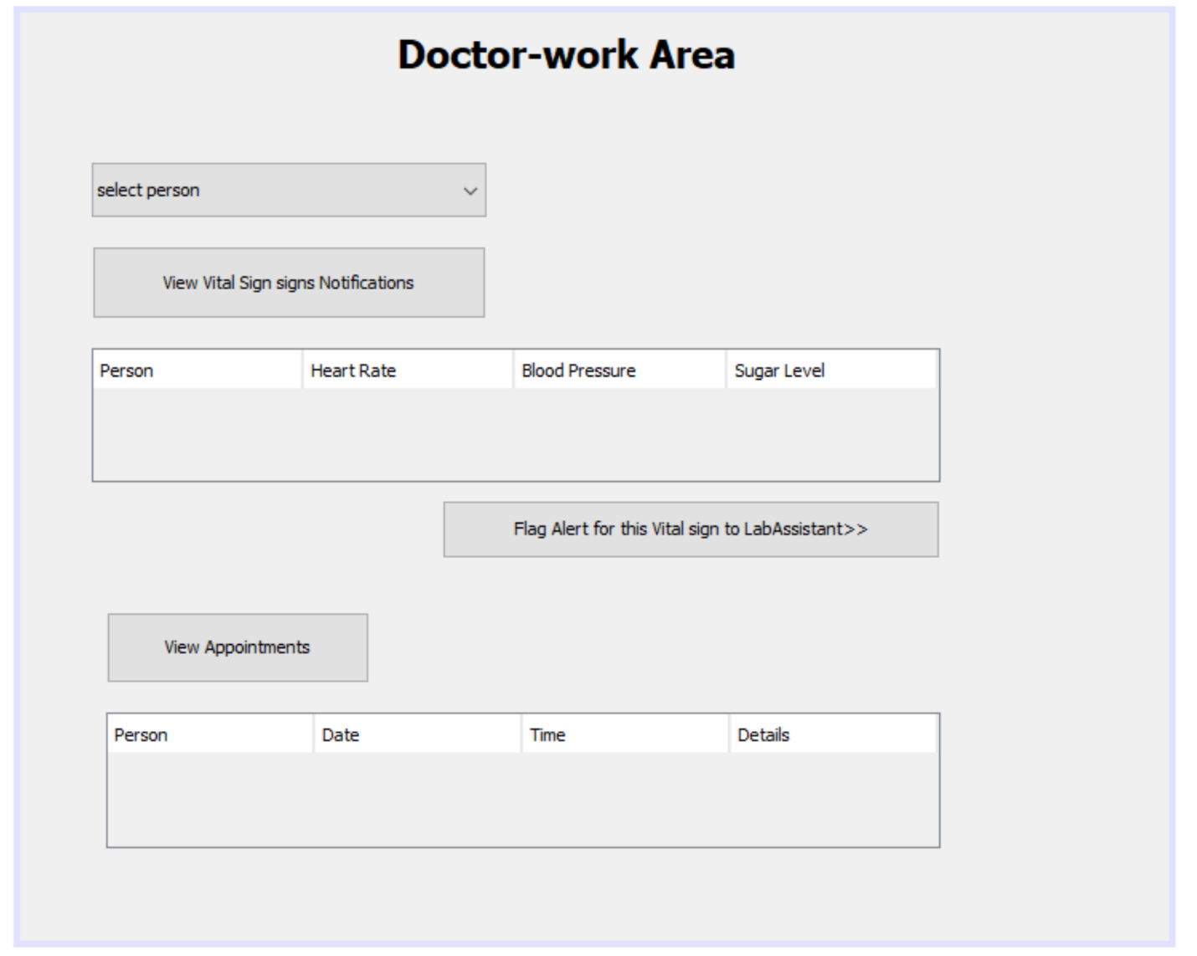

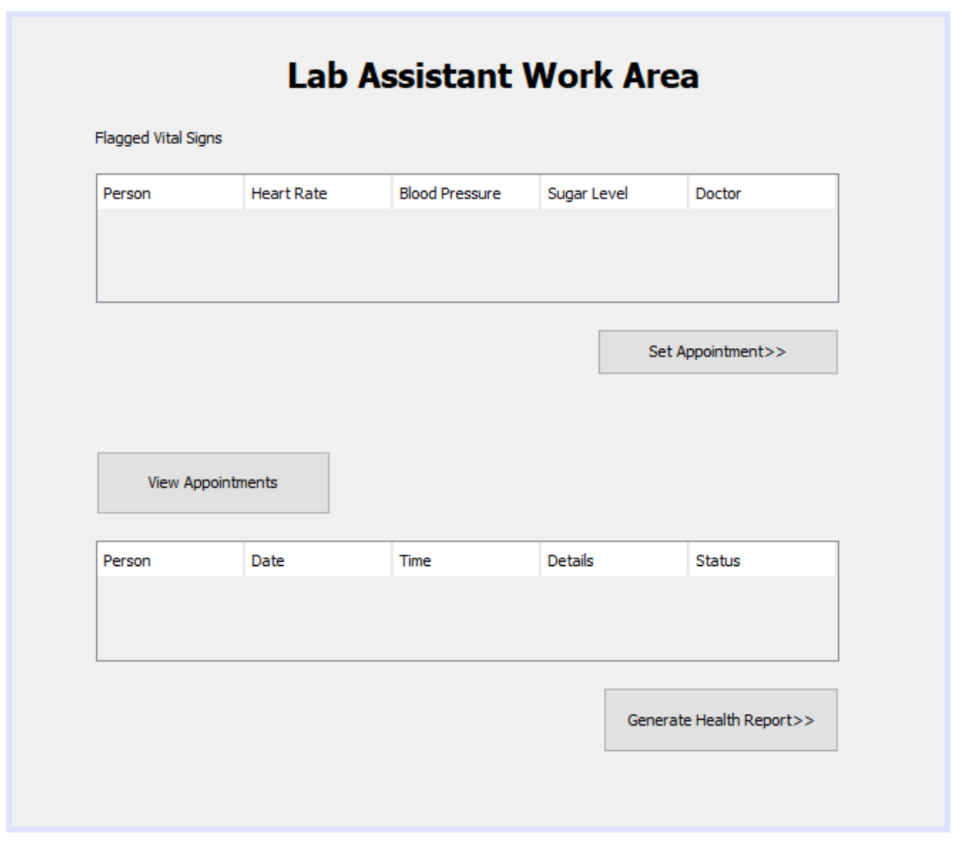

Another main feature of the smart application device is to track person’s routine activities. On-click on the Routine button, Person will be redirected to MY ROUTINE TRACKER which has features/use-cases like capturing person’s food consumption, capturing sleep hours, capturing his work-out and view his food-sleep-workout trends.

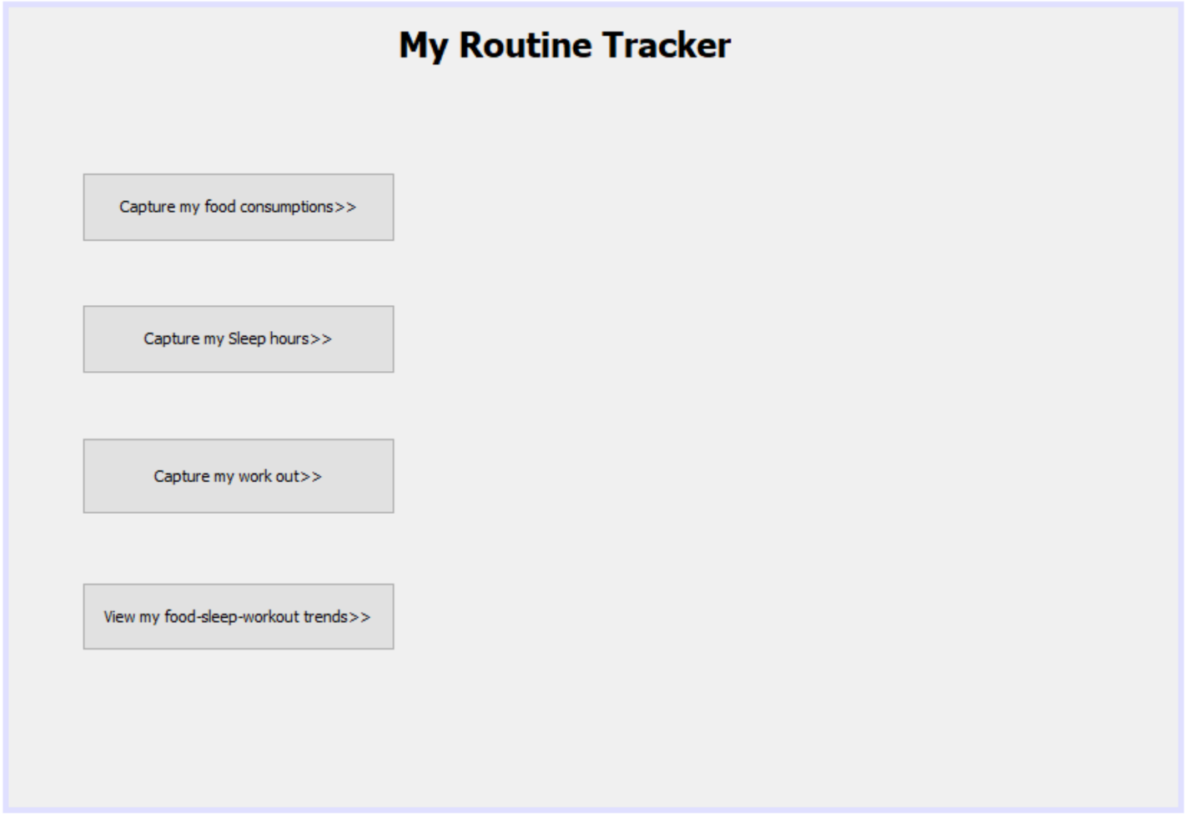

Capture my work-out feature will enable the person to record his start time and end time of his work out which will be useful in analysis about food-sleep-workout trend and which is also connected to his health.

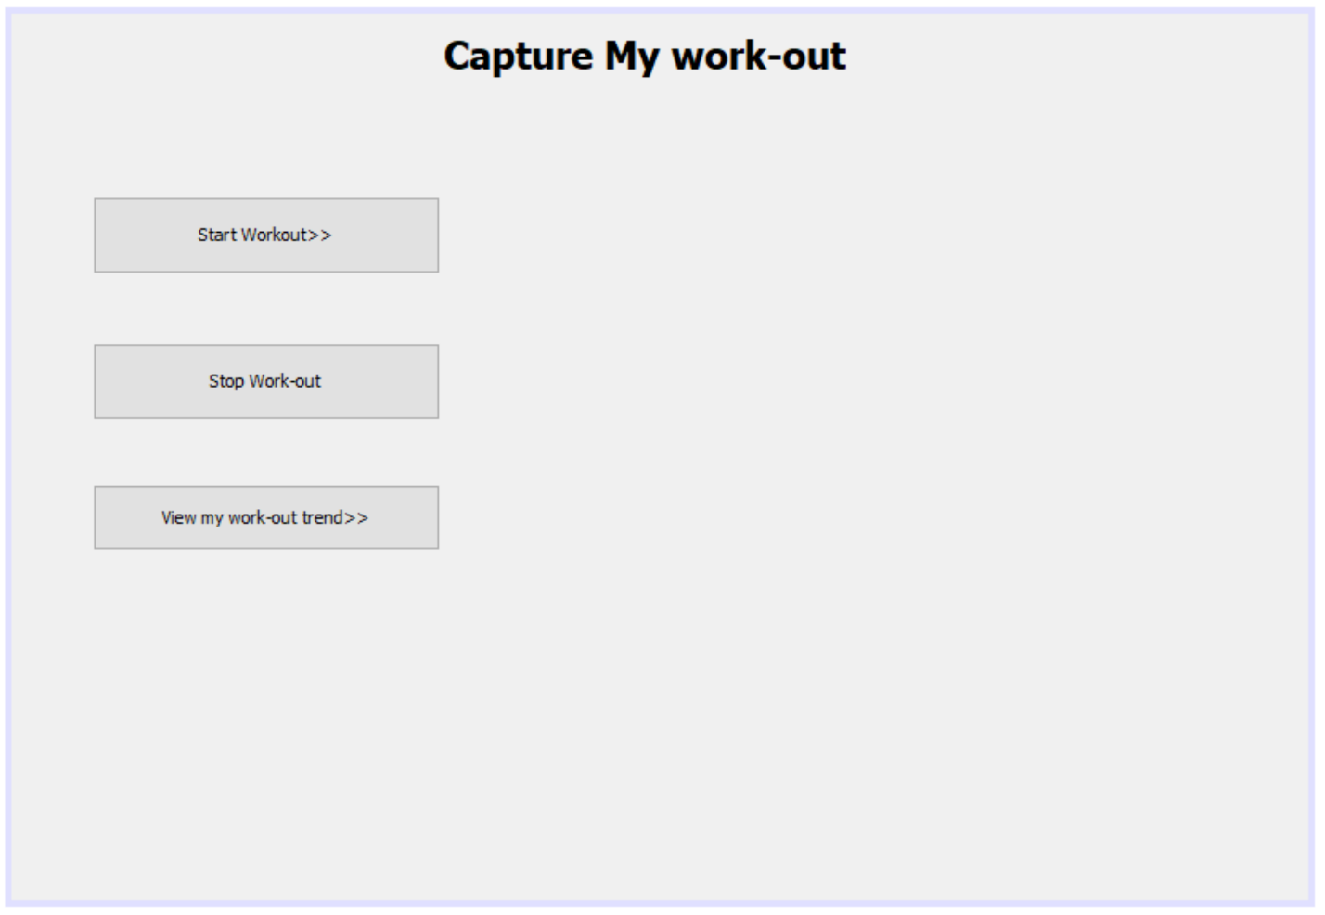

The Start work-out screen will enable the person to select which type of work-out an individual is doing and his vital sign will get captured in the smart application device which will be useful if incase the vital sign exceed normal threshold the doctor will be notified as specified in above use cases.

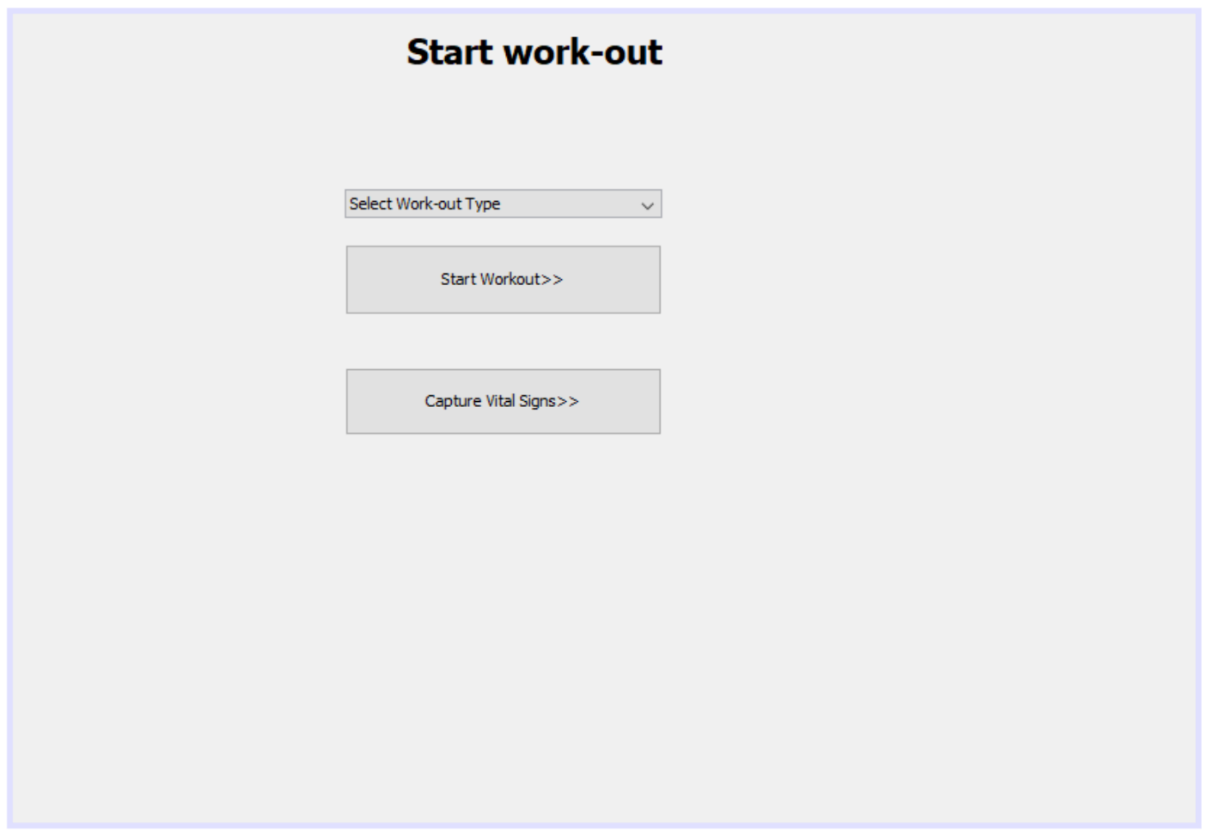

The Capturing my food consumption screen will have features like fill my diet chart for today and view my food consumption trend which will enable the person to keep check on his food consumption trend.

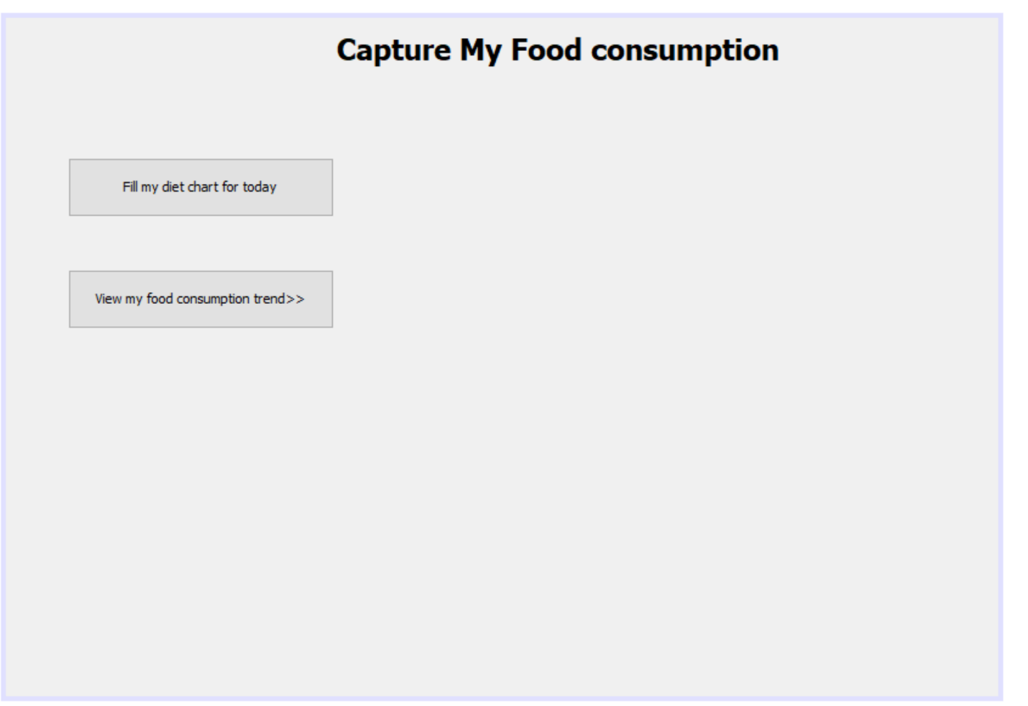

The capture my sleep hours feature will help the person to keep his food-sleep trend which will enable him to keep balance between his eating and sleeping habits.

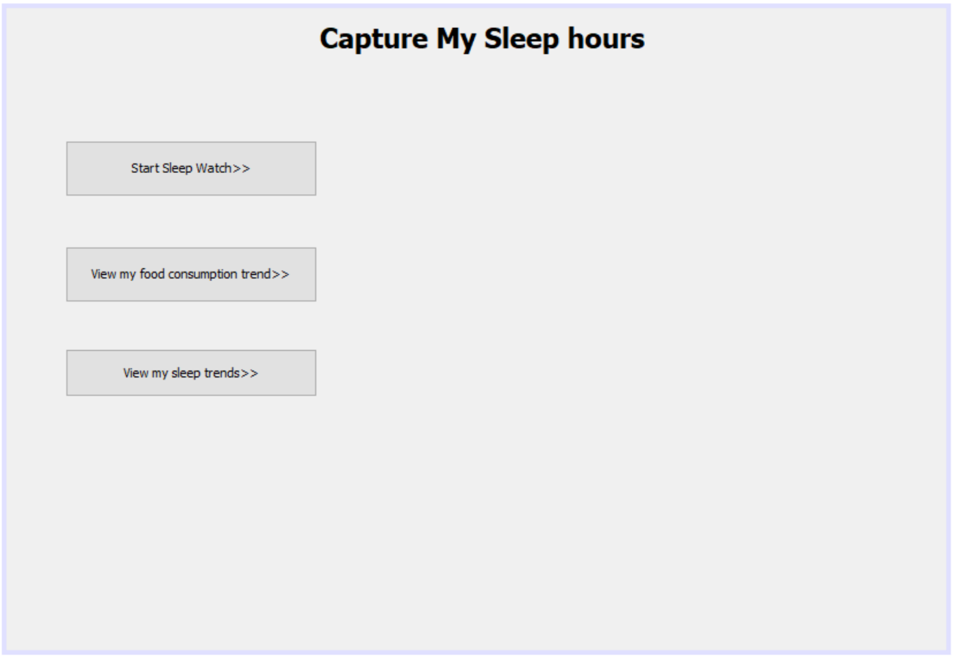

Another important feature of the SMART APPLICATION DEVICE is to enable the person to track his activities at his Work place. The person will be able to use features like manage his leaves, manage his working hours and view his work-leave trends.

The smart application will give recommendation to the person when he needs to take a break during his working hours, if his body needs break from work he can apply for leave if eligible etc.

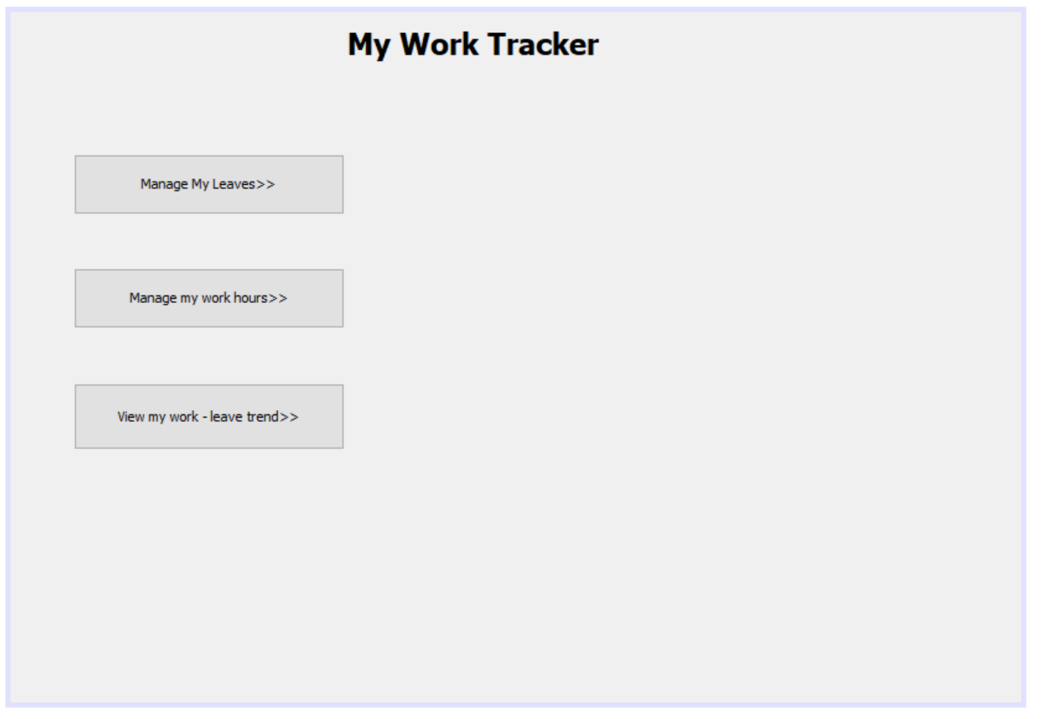

Manage my work hours screen has features like Fill my work efforts for the day and view my work hours for today which will enable the person to keep track on his working activities at work.

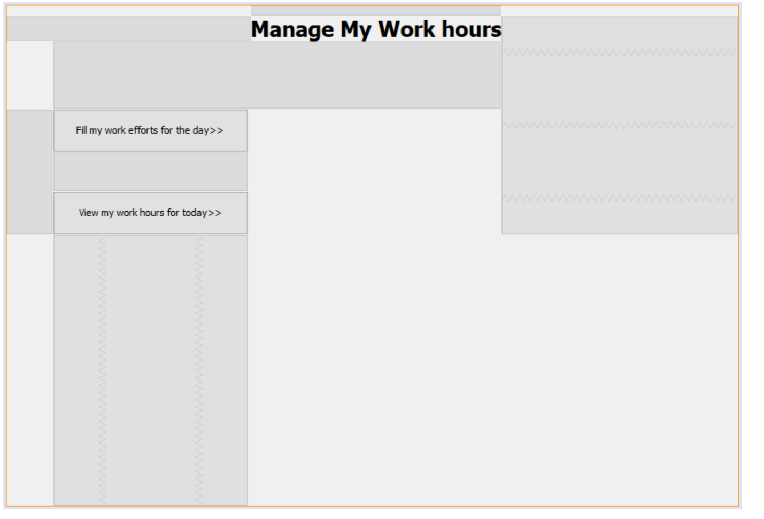

Manage My Leaves screen has features like fill my time sheet, view my time-sheet and request for leave.

The person can send leave request to his supervisor. The supervisor will be able to see the details of the person and the reason why he needs the leave and the supervisor will approve or reject his request.

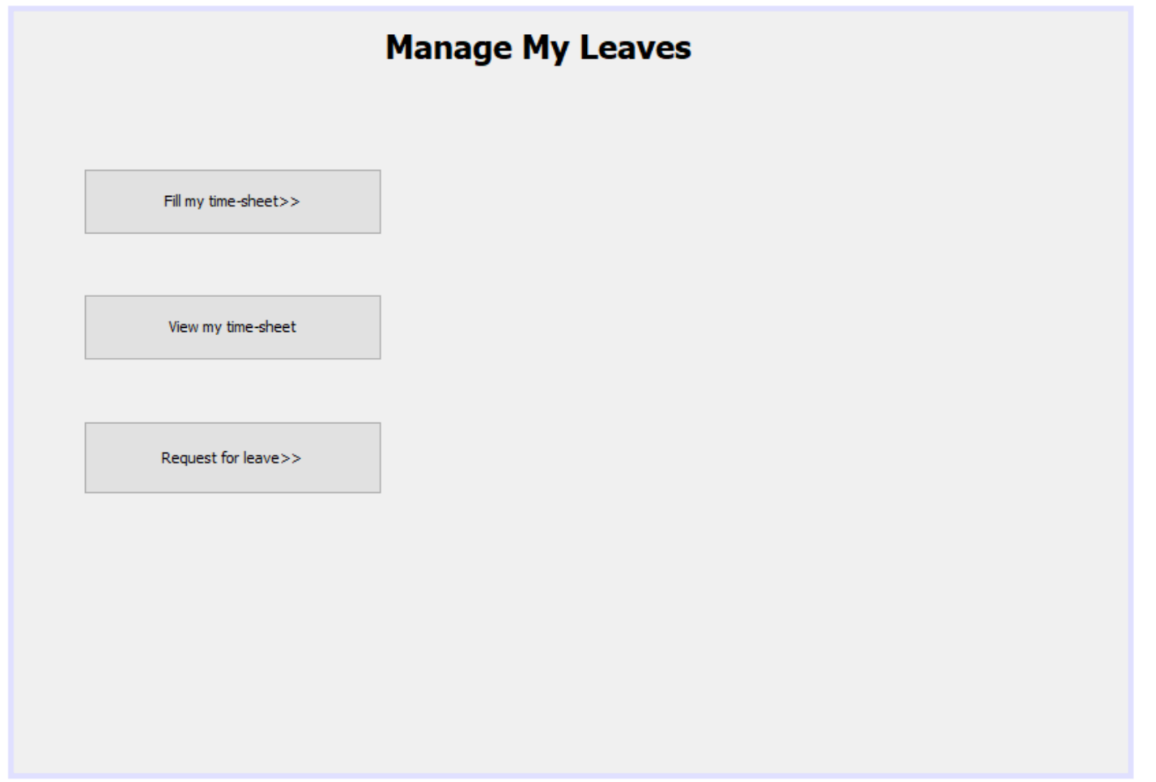

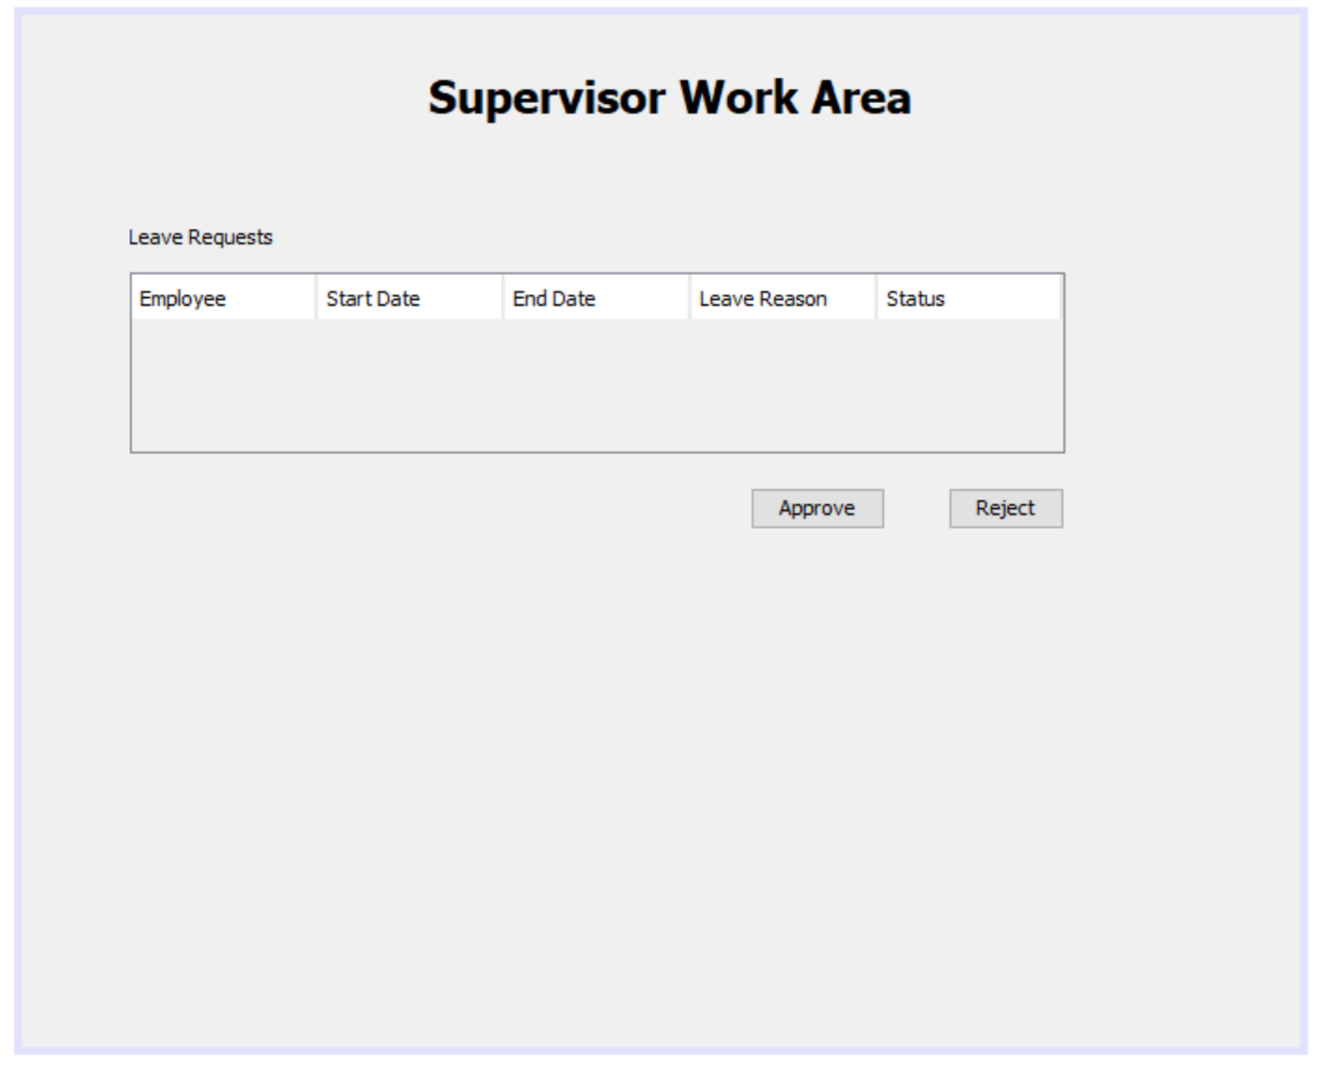

**Group Name:** ***Jaguar***

**Group Members:** Ankush Deora Moolchand (001822054)

Krish Pravin Jain (001881885)

Neha Hasmukh Jain (0012347437)