Kotak Ad Intelligence Studio
Amazon-Style Product Requirements Document
Date: 26 March 2026
Document status: Working draft
Audience: Product, engineering, creative operations, business stakeholders

1. Narrative Summary
Kotak Ad Intelligence Studio is being built as a structured creative production system that converts a marketing requirement into a review-ready short-form video ad. The system begins with requirement gathering, converts the requirement into a duration-fit script, creates a believable speaking persona and scene, generates a base video, applies the correct supers, appends the correct end slate, and exposes a final asset plus intermediate debug outputs for review.
The business need is clear: Kotak requires a faster, more repeatable, and more auditable way to create high-quality short-form ad creatives without rebuilding the creative process manually for every variation, RTB, audience segment, or format.
The current product focus is Air Plus 8-second performance and offer-led videos. The near-term goal is to harden the framework, improve realism and output reliability, and then extend the same system to Cashback Plus and longer 15-second offer videos.

2. Problem Statement
Today, short-form video production for card marketing is slow, manual, and difficult to scale across multiple offers, formats, and audiences. Message consistency breaks easily across script, visual execution, supers, and final packaging. Review teams also lack enough intermediate visibility to diagnose where a creative went wrong.
- Manual production cycles are too slow for iterative performance marketing.
- Offer emphasis can drift between brief, script, and final video.
- Visual execution can become generic, stiff, or off-brand without structured controls.
- Supers and end slate finishing often become manual post-production work instead of a repeatable system step.
- Without intermediate artifacts, debugging quality failures becomes guesswork.

3. Customer and User
- Primary users: brand marketing, product marketing, growth/performance marketing, creative review stakeholders.
- Secondary users: creative operations, engineering operators, internal QA reviewers.
- Primary customer need: move from requirement to reviewable video rapidly while preserving offer clarity, brand realism, and repeatability.

4. Product Vision
The target product is not just a prompt tool. It is a controllable brief-to-video framework. Every output should be traceable from business requirement to final render. The system should eventually support multiple products, multiple formats, multiple motion providers, and high-volume test execution while keeping message fidelity and brand consistency intact.

5. Goals
- Convert a campaign brief into a review-ready short-form video asset.
- Preserve the intended RTB from brief to script to final video.
- Generate believable direct-to-camera character-led creative, not generic talking heads.
- Automate supers, end slate, and delivery so finalization is part of the pipeline.
- Expose enough intermediate artifacts to support QA, debugging, and batch testing.
- Build a reusable framework that can be extended from Air Plus to Cashback Plus and beyond.

6. Non-Goals
- Media buying or campaign publishing.
- Long-form film or brand-film production workflows.
- Human-free creative approval.
- Cross-channel reporting and analytics beyond creative generation quality.

7. Scope of Current Build
- Requirement intake through brief input.
- Script generation with duration-fit constraints.
- Persona and backstory generation.
- Video prompt generation for point-to-camera flows.
- Video generation using swappable motion providers.
- Supers rendering with RTB-specific treatments.
- End slate append and finalization.
- Debug outputs for script, backstory, prompt, raw asset, final asset, and supers timing.
- Batch dry testing and selected end-to-end validation.

8. End-to-End Workflow
The product workflow should remain simple for stakeholders, while the underlying system remains controllable for operators.
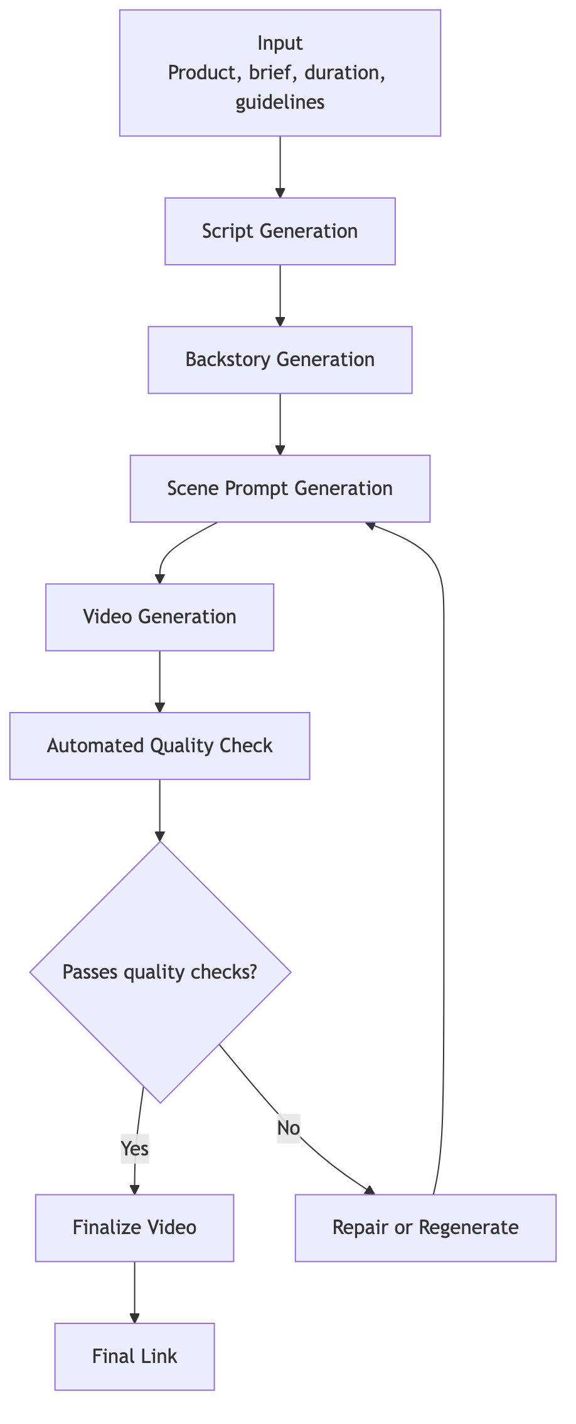
Figure 1. Brief-to-video workflow: requirement gathering to final asset
Step | Purpose
Requirement Gathering | Capture offer, audience, objective, platform, guardrails, and duration.
Creative Brief Input | Convert the business need into structured input for the system.
Script Generation | Generate a short spoken script that fits runtime and preserves the intended offer.
Persona and Scene Planning | Define the speaker, setting, wardrobe, movement, and emotional delivery.
Video Prompt Generation | Create the final scene-level motion prompt.
Video Generation | Generate the base speaking video.
Supers Application | Apply the correct RTB-specific on-screen treatment and timing.
End Slate Append | Append the correct branded end slate for the target format.
Delivery and Review | Expose final asset plus intermediate artifacts for QA and stakeholder review.

9. Functional Requirements

9.1 Requirement Input
The system must accept product, brief, duration, video type, and optional guidelines.

9.2 Scripting Agent
The system must generate an 8-second or 15-second spoken script that fits runtime, reflects the brief, and preserves the intended RTB or offer.

9.3 Persona and Backstory Agent
The system must define a believable speaking character, including city, profession, setting, wardrobe, body language, and speaking energy.

9.4 Prompt Generation Layer
The system must generate a final motion prompt with explicit constraints for camera setup, lighting, realism, script fidelity, speaking behavior, exclusions, and ending behavior.

9.5 Motion Generation Layer
The system must route generation through a selectable motion provider while preserving the same business-level workflow and asset contract.

9.6 Supers Engine
The system must map the RTB to the correct super treatment, render it in the right position, and apply timing rules that match the spoken line or chosen fast mode.

9.7 Finalization
The system must stabilize the base render, mix audio where required, append the correct end slate, and produce a final reviewable export.

9.8 Debug and Review Outputs
The system must expose script output, backstory, final motion prompt, raw video, final video, and supers debug metadata for review.

10. Quality Bar
- Direct-to-camera performance with visible on-camera speaking.
- Natural Indian English delivery with clear script fidelity.
- Photographic realism, not painterly or synthetic-looking humans.
- Premium travel or category-appropriate brand world.
- No unwanted transitions, scene resets, or effect-heavy rendering.
- Correct supers placement and readable finalization.
- Consistent end slate packaging.

11. Current Status of Build
Area | Status
Brief to script | Built and active
Backstory generation | Built and active
Prompt generation | Built and active
Air Plus 8-second end-to-end flow | Working beta
Supers system | Built with RTB-specific treatments
Portrait Air Plus end slate | Replaced and active
Batch dry testing | Completed at 20-case level
Fresh end-to-end Air Plus video set | Completed for curated 5-case set
Alternate motion-provider path | Integrated and under active evaluation
Cashback Plus framework extension | Not yet executed at full validation level
Current overall status: working beta with strong internal review readiness, but not yet fully hardened for large-scale unattended execution.

12. Errors Identified and What Has Been Fixed
This section exists to separate operational truth from aspirational design. It captures the concrete issues found in testing and the fixes already shipped.
Issue | Observed Problem | Status | Fix Shipped / Current Action
Stale retries corrupted active jobs | Older provider callbacks could mutate newer retries and create impossible poll states. | Fixed | Run-token isolation and retry fencing were added to the job lifecycle.
Fallback waits could hang indefinitely | Provider fallback subscriptions could remain in running state too long. | Fixed | Timeout guards and bounded subscribe policies were added.
Wrong backend routing for alternate motion flow | The alternate provider path initially hit the wrong API route and then an unavailable infrastructure path. | Fixed | The flow was rerouted to the correct fal-backed path.
Script drift from brief-stated offer | Some briefs were collapsing back to default travel-rewards language instead of preserving the requested RTB. | Partially fixed | Brief-offer preservation and RTB anchoring were tightened; a few edge RTBs still need work.
Prompts lacked strong direct-to-camera and acting constraints | Generated performances could become generic, stiff, or voiceover-like. | Fixed / ongoing | Direct-to-camera, on-camera speaking, acting beats, body-language, and delivery constraints were strengthened.
Age drift outside target band | Generated personas were not consistently constrained to the intended age band. | Fixed | Age range was constrained to 25–38 for the current short-form flow.
Cartoonish or plastic-looking humans | Some renders looked synthetic, over-smoothed, or beauty-filtered. | Partially fixed | Negative realism constraints were added; realism remains an active quality focus.
Raw clips ended badly or transitioned awkwardly | The model tail could introduce end transitions or visual instability. | Fixed | Raw-tail stabilization and same-shot ending controls were added.
Supers overlapped unsafe UI zones | Lower overlays were too low for Meta-safe composition. | Fixed | Supers were raised and reworked into lower-third brand treatments.
Supers look inconsistent across RTBs | Different RTBs used mixed styles and inconsistent visual hierarchy. | Partially fixed | Backend red-band lower-third treatments were created for key Air Plus RTBs; final polish is still pending.
End slate asset mismatch | The old portrait Air Plus end slate no longer matched the latest desired asset. | Fixed | The portrait Air Plus end slate was replaced with the new supplied asset.
Background music/noise in raw renders | Base generations could include unwanted ambience or score. | Fixed / ongoing | Prompt-level audio constraints were added to prefer clean voice-only raw generation; final music tuning remains open.
Alternate provider returned frozen or non-compliant clips | A completed job could still be unusable due to still-frame output, script drift, or poor realism. | Identified; prompt tightened | Verbatim script lock, single-shot rules, motion-validity rules, and photographic realism rules were added; rerun validation is in progress.

13. Open Issues
- Some supporting-fact RTBs still soften or collapse in edge briefs.
- Visual realism and natural motion are improved but not yet consistently reliable.
- Alternate motion-provider outputs can still fail creatively even when the job completes technically.
- Large-batch unattended execution is not yet hardened enough for full trust.
- Audio finishing and music behavior still need tighter product-level controls.

14. Success Metrics
- RTB survives from brief to script to final video.
- Base video is reviewable without heavy manual correction.
- Supers are correct, readable, and placed safely.
- End slate is appended consistently for the correct format.
- Test batches can run at scale with low operational intervention.
- The same framework can be ported from Air Plus to Cashback Plus with controlled product-level changes.

15. Sprint 2 Plan
Sprint 2 is focused on hardening the current 8-second framework before expanding scope.
- Finalise supers and end slate.
- Fix visual realism.
- Fix background music.
- A/B test with different models and different prompt variants.
- Build adapts with the same face across other dimensions.
- Test with around 200 test cases.
- Once the framework is complete, adapt the same flow for Cashback Plus Card with changes in brand world, product information, target audience, brand look and feel, supers, and end slates. Validate the flow from brief to video with 50 test cases.
- Air Plus and Cashback Plus 8-second bumper videos live on everyday@gro.care.

16. Sprint 3 Plan
Sprint 3 expands the framework into longer offer-led creative after the 8-second foundation is stable.
- Build and validate 15-second offer videos, first for Air Plus and then for Cashback Plus.
- Focus specifically on the scripting agent, because longer videos require stronger structure and message pacing.
- Test with around 200 test cases.
- Air Plus and Cashback Plus offer videos live on everyday@gro.care.

17. Risks and Dependencies
- Motion-provider quality and latency remain the biggest external dependency.
- Model compliance with exact script fidelity is not guaranteed and requires active QA gates.
- Realism issues can persist even when generation succeeds technically.
- Scaling to 200+ test cases requires stronger automation, rejection logic, and reporting discipline.
- Cross-product extension to Cashback Plus depends on clean separation of brand world, product facts, audience assumptions, supers, and end-slate assets.

18. Recommendation
The project should be treated as a strong working beta moving toward a repeatable creative operating system. The next two sprints should focus on hardening quality and repeatability, not just generating more videos. If the system is stabilized on realism, script fidelity, supers finishing, and high-volume testing, it can become a reusable engine for both Air Plus and Cashback Plus across short-form offer creatives.

