Playwright Training Guide for Employee Portal
Author: Neha Jadav
Support: neha.jadav@gmail.com
Version: 1.1.0
This guide teaches Playwright from scratch for QA testing using the Employee Portal app. Each module includes step-by-step instructions, a working script snippet, and snapshot guidance. It ends with exercises and a 50-question quiz.

Quick Start
1) Install dependencies: npm install
2) Start the app: npm run dev
3) Open: http://127.0.0.1:3000/
Test accounts: admin/admin123 (admin), viewer/viewer123 (viewer)

Contents
- 1. Modules with Scripts and Snapshots
- 2. Exercises (Easy)
- 3. Exercises (Medium)
- 4. Exercises (Hard)
- 5. Step-by-step Walkthroughs with Answers
- 6. Architecture
- 7. Files and Their Uses
- 8. Version Management
- 9. Bug Fixes
- 10. External Topics
- 11. Quiz (50 Questions)
- 12. Answer Key

1. Modules with Scripts and Snapshots

Module 1: Playwright Basics
Steps:
- Install Playwright and browsers.
- Run the sample test suite.
- Open the HTML report.
Script:
npm install
npx playwright install
npm test
npx playwright show-report
Snapshot: No snapshot required.

Module 2: Locators and Assertions
Steps:
- Open login page.
- Assert that the username field is visible.
- Assert that the login button is enabled.
Script:
const { test, expect } = require('@playwright/test');
test('login page has fields', async ({ page }) => {
await page.goto('/');
await expect(page.locator('[data-testid=login-username]')).toBeVisible();
await expect(page.locator('[data-testid=login-submit]')).toBeEnabled();
});
Snapshot: Capture login page screenshot: docs/login.png

Module 3: Authentication Flow
Steps:
- Fill admin credentials.
- Submit login form.
- Assert redirect to /employees.
Script:
test('admin login', async ({ page }) => {
await page.goto('/');
await page.fill('[data-testid=login-username]', 'admin');
await page.fill('[data-testid=login-password]', 'admin123');
await page.click('[data-testid=login-submit]');
await expect(page).toHaveURL(/\/employees/);
});
Snapshot: Capture employees list screenshot: docs/employees.png

Module 4: Form Validation
Steps:
- Leave fields empty and attempt submit.
- Assert required validation message.
- Fix fields and resubmit.
Script:
test('form validation', async ({ page }) => {
// login first
await page.goto('/');
await page.fill('[data-testid=login-username]', 'admin');
await page.fill('[data-testid=login-password]', 'admin123');
await page.click('[data-testid=login-submit]');
await page.click('[data-testid=form-submit]');
await expect(page.locator('[data-testid=form-error]')).toContainText('required');
});
Snapshot: Optional: capture validation error state.

Module 5: Table Sorting and Filtering
Steps:
- Search for E1001.
- Toggle sort on Name.
- Filter by Status = Inactive.
Script:
test('search and filter', async ({ page }) => {
await page.goto('/');
await page.fill('[data-testid=login-username]', 'admin');
await page.fill('[data-testid=login-password]', 'admin123');
await page.click('[data-testid=login-submit]');
await page.fill('[data-testid=search]', 'E1001');
await expect(page.locator('[data-testid=row-E1001]')).toBeVisible();
await page.selectOption('[data-testid=status-filter]', 'Inactive');
await expect(page.locator('[data-testid=result-meta]')).toBeVisible();
});
Snapshot: Capture filtered table screenshot.

Module 6: Role-based Access
Steps:
- Login as viewer.
- Verify create/bulk actions are disabled.
- Attempt submit and check error.
Script:
test('viewer restrictions', async ({ page }) => {
await page.goto('/');
await page.fill('[data-testid=login-username]', 'viewer');
await page.fill('[data-testid=login-password]', 'viewer123');
await page.click('[data-testid=login-submit]');
await expect(page.locator('[data-testid=form-submit]')).toBeDisabled();
await expect(page.locator('[data-testid=bulk-delete]')).toBeDisabled();
});
Snapshot: Capture disabled controls.

Module 7: CRUD Workflow
Steps:
- Create employee.
- Edit employee.
- Delete employee and confirm removal.
Script:
test('create/edit/delete', async ({ page }) => {
await page.goto('/');
await page.fill('[data-testid=login-username]', 'admin');
await page.fill('[data-testid=login-password]', 'admin123');
await page.click('[data-testid=login-submit]');
const id = 'E' + Date.now().toString().slice(-6);
await page.fill('[data-testid=emp-id]', id);
await page.fill('[data-testid=emp-name]', 'Test User');
await page.fill('[data-testid=emp-email]', id.toLowerCase() + '@example.com');
await page.fill('[data-testid=emp-dept]', 'QA');
await page.fill('[data-testid=emp-role]', 'Tester');
await page.click('[data-testid=form-submit]');
await page.fill('[data-testid=search]', id);
await page.click('[data-testid=edit-' + id + ']');
await page.fill('[data-testid=emp-name]', 'Updated');
await page.click('[data-testid=form-submit]');
page.once('dialog', d => d.accept());
await page.click('[data-testid=delete-' + id + ']');
});
Snapshot: Capture success message after create.

Module 8: Employee Detail Page
Steps:
- Open employee detail page from list.
- Verify details.
- Edit fields and save.
Script:
test('detail page', async ({ page }) => {
await page.goto('/');
await page.fill('[data-testid=login-username]', 'admin');
await page.fill('[data-testid=login-password]', 'admin123');
await page.click('[data-testid=login-submit]');
await page.click('[data-testid=employee-link-E1001]');
await expect(page.locator('[data-testid=details]')).toContainText('E1001');
});
Snapshot: Capture employee detail page: docs/employee.png

Module 9: QA Failure and Delay
Steps:
- Enable QA fail toggle.
- Trigger a search.
- Verify error state.
- Set delay and confirm loading.
Script:
test('qa toggles', async ({ page }) => {
await page.goto('/');
await page.fill('[data-testid=login-username]', 'admin');
await page.fill('[data-testid=login-password]', 'admin123');
await page.click('[data-testid=login-submit]');
await page.check('[data-testid=qa-fail]');
await page.click('[data-testid=qa-save]');
await page.fill('[data-testid=search]', 'E1001');
await expect(page.locator('[data-testid=table-error]')).toContainText('Failed');
});
Snapshot: Capture error message state.

Module 10: Debugging and Reports
Steps:
- Run tests in headed mode.
- Use UI mode to inspect steps.
- Open HTML report.
Script:
npm run test:headed
npm run test:ui
npx playwright show-report
Snapshot: Optional: capture Playwright report.
Snapshot: Login page
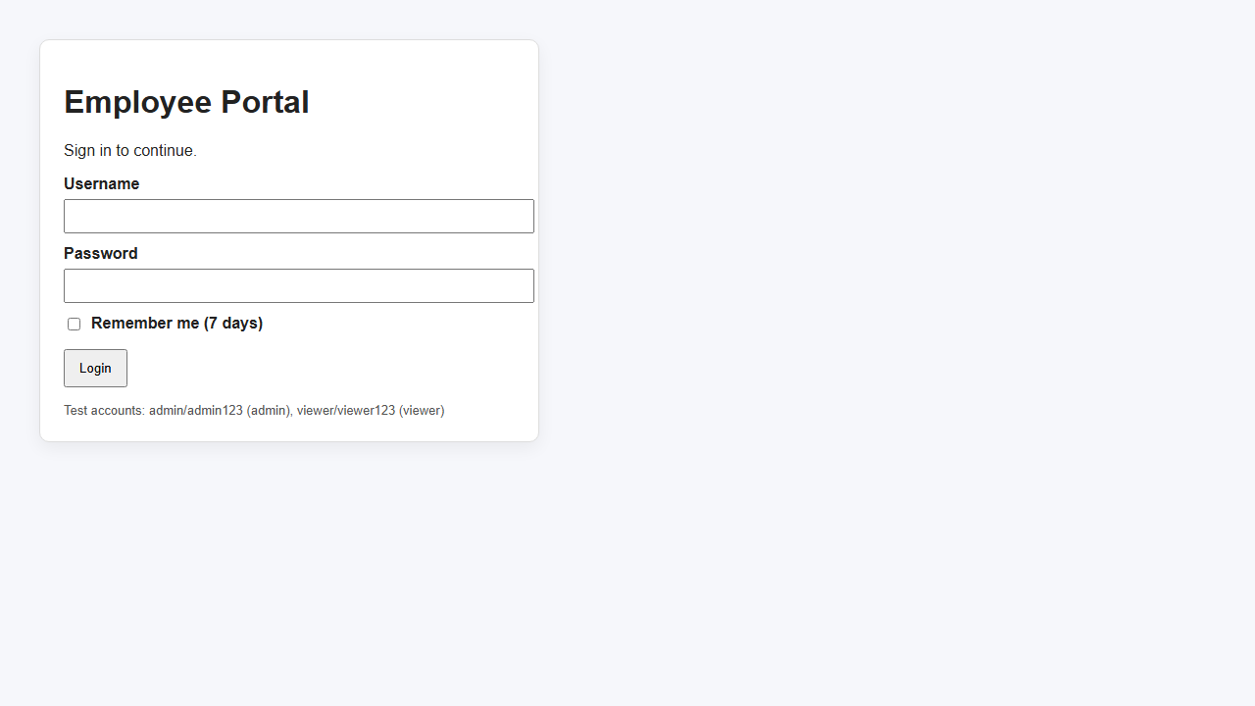
Snapshot: Employees list
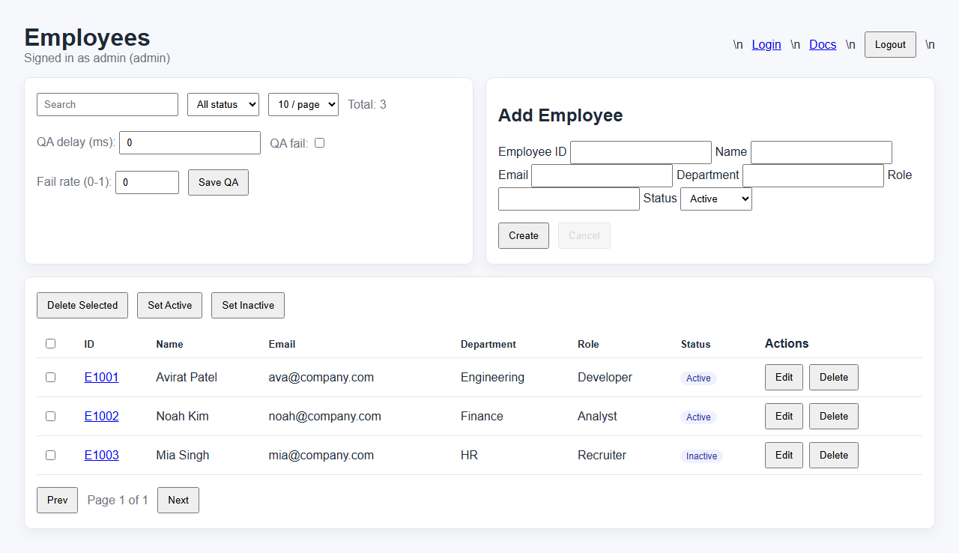
Snapshot: Employee detail
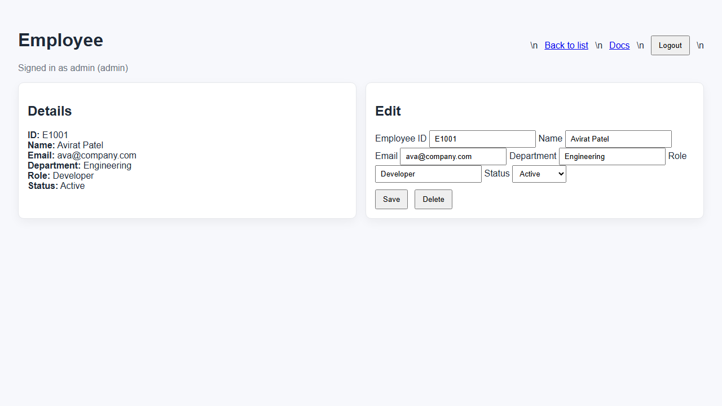

2. Exercises (Easy)

E1: Verify Login Page Loads
Goal: Confirm the login UI renders and has required fields.
Steps:
- Open the app at /
- Check username and password inputs
- Confirm the Login button is visible
Expected: All elements are visible.
Answer/Verification: Use data-testid selectors: login-username, login-password, login-submit.

E2: Successful Admin Login
Goal: Log in as admin and reach the Employees page.
Steps:
- Fill admin/admin123
- Click Login
- Wait for /employees URL
Expected: User info displays admin role.
Answer/Verification: Expect URL /employees and user-info contains admin.

E3: Failed Login
Goal: Show error for invalid credentials.
Steps:
- Fill admin/wrong
- Click Login
- Check error text
Expected: Error message is displayed.
Answer/Verification: login-error contains 'Invalid'.

3. Exercises (Medium)

M1: Create Employee
Goal: Create a new employee record.
Steps:
- Login as admin
- Fill the form with a unique ID
- Click Create
- Search for the new ID
Expected: New employee appears in the table.
Answer/Verification: form-success shows 'created'; row-<id> exists.

4. Exercises (Hard)

H1: Bulk Status Update
Goal: Select multiple employees and set status.
Steps:
- Select two rows
- Click Set Inactive
- Verify status pills
Expected: Selected employees become Inactive.
Answer/Verification: Statuses reflect Inactive.

5. Step-by-step Walkthroughs with Answers
Walkthrough 1: Login and Verify Dashboard
- Open the app at http://127.0.0.1:3000/
- Fill admin/admin123
- Click Login
- Verify /employees URL and user-info text
Answer/Verification: user-info contains 'admin' and URL is /employees.

6. Architecture
- Node/Express backend serving API and static HTML.
- In-memory sessions with cookies.
- Employee data stored in backend/data/employees.json.
- UI pages in backend/public.

7. Files and Their Uses
- backend/server.js - Express server and API routes
- backend/public/login.html - login page
- backend/public/employees.html - employees list + CRUD
- backend/public/employee.html - employee detail
- backend/public/docs.html - in-app documentation
- tests/* - Playwright tests
- playwright.config.js - Playwright configuration
- docs/*.png - screenshots

8. Version Management
- Use semantic versioning: MAJOR.MINOR.PATCH.
- Update package.json version on releases.
- Record changes in CHANGELOG.md.
- Tag releases in Git if using version control.

9. Bug Fixes
- Populated empty login.html and employees.html files to avoid blank pages.
- Added 404 fallback to avoid empty responses.
- Added QA toggles to simulate failures and latency.

10. External Topics to Learn
- JavaScript basics (variables, functions, arrays)
- Async/await and Promises
- HTTP basics (GET/POST, status codes)
- Selectors and accessibility (ARIA roles)
- Git basics (commit, branch)
- CI basics (GitHub Actions)
- Test design patterns (page object model)

11. Quiz (50 Questions)
1. What command runs Playwright tests?
- A) npm test
- B) npm run dev
- C) node server.js
- D) npm start
2. Which selector is most stable?
- A) data-testid
- B) text selector
- C) CSS by class
- D) XPath
3. What does page.goto() do?
- A) Navigate to a URL
- B) Click an element
- C) Wait for network idle
- D) Fill a form
4. How do you assert a URL in Playwright?
- A) expect(page).toHaveURL()
- B) expect(url).toBe()
- C) page.assertUrl()
- D) page.checkUrl()
5. Which function checks element visibility?
- A) toBeVisible
- B) toShow
- C) isVisibleSync
- D) checkVisible
6. What is the default test runner package?
- A) @playwright/test
- B) playwright-core
- C) jest
- D) mocha
7. What is a fixture?
- A) Reusable test context
- B) An API route
- C) A browser binary
- D) A CLI flag
8. Which command opens Playwright UI mode?
- A) npm run test:ui
- B) npm run dev
- C) npm start
- D) playwright open
9. What does expect().toContainText do?
- A) Checks substring
- B) Checks equality only
- C) Checks visibility only
- D) Checks URL
10. How do you handle dialogs?
- A) page.once('dialog', cb)
- B) page.alert()
- C) page.dialog()
- D) browser.on('alert')
11. What does 'headed' mode mean?
- A) Shows browser UI
- B) Runs faster
- C) No screenshots
- D) No network
12. Which locator is preferred in this app?
- A) [data-testid=...]
- B) text=...
- C) css=.class
- D) xpath=...
13. What is the baseURL in config used for?
- A) Prefixing page.goto calls
- B) Setting environment vars
- C) Choosing browser
- D) Selecting reporter
14. How do you set a cookie in Playwright?
- A) context.addCookies
- B) page.addCookie
- C) browser.addCookie
- D) test.addCookie
15. Which hook runs once per file?
- A) test.beforeAll
- B) test.beforeEach
- C) test.afterEach
- D) test.only
16. What does expect(page.locator(...)).toBeDisabled check?
- A) Element disabled
- B) Element hidden
- C) Element missing
- D) Element visible
17. What is a Page Object Model?
- A) Encapsulated UI actions
- B) A test report
- C) A browser context
- D) A config file
18. Which file stores Playwright config?
- A) playwright.config.js
- B) package.json
- C) server.js
- D) tests/config.js
19. What does test.describe do?
- A) Group related tests
- B) Skip tests
- C) Run tests in parallel
- D) Define fixtures
20. Which command installs browsers?
- A) npx playwright install
- B) npm install
- C) npm run dev
- D) node install
21. How to wait for element?
- A) page.waitForSelector
- B) page.pause
- C) page.wait
- D) page.sleep
22. What does retries in config control?
- A) Rerun failed tests
- B) Rerun all tests
- C) Timeouts
- D) Parallelism
23. What is the default assertion library?
- A) Playwright expect
- B) chai
- C) jest
- D) assert
24. How to check network response status?
- A) page.waitForResponse
- B) page.request
- C) page.expectResponse
- D) page.onResponse
25. Which selector is used for the login button?
- A) data-testid=login-submit
- B) #login
- C) .login-btn
- D) button.login
26. What does toHaveText do?
- A) Exact text match
- B) URL match
- C) Visibility check
- D) CSS check
27. Where are screenshots saved by the capture script?
- A) docs/
- B) tests/
- C) backend/
- D) public/
28. What status code is unauthorized?
- A) 401
- B) 200
- C) 404
- D) 500
29. What is the QA fail toggle for?
- A) Simulate API failure
- B) Enable debug
- C) Clear data
- D) Log out
30. What does page.fill do?
- A) Type into input
- B) Click button
- C) Hover
- D) Select option
31. Which API route fetches current user?
- A) /api/me
- B) /api/user
- C) /api/session
- D) /api/profile
32. Where is employee data stored?
- A) backend/data/employees.json
- B) db.sqlite
- C) localStorage
- D) server memory only
33. What should you use for stable selectors?
- A) data-testid
- B) css nth-child
- C) text only
- D) xpath
34. How to start UI mode?
- A) npm run test:ui
- B) npm run test:headed
- C) npm run dev
- D) npm start
35. What does expect(page).toHaveURL(/employees/) verify?
- A) URL matches regex
- B) Page title
- C) Network idle
- D) Cookie
36. Which file lists dependencies?
- A) package.json
- B) server.js
- C) README.md
- D) playwright.config.js
37. What does a 404 mean?
- A) Not Found
- B) Unauthorized
- C) OK
- D) Server Error
38. Which command runs headed tests?
- A) npm run test:headed
- B) npm test --ui
- C) npm run dev
- D) node test
39. Which element indicates error on login?
- A) data-testid=login-error
- B) #error
- C) form.error
- D) span.error
40. What is the best way to assert text in a table row?
- A) locator has text
- B) sleep and compare
- C) console log
- D) screenshot only
41. Which is a Playwright test file?
- A) tests/auth.spec.js
- B) backend/server.js
- C) README.md
- D) package.json
42. What is a browser context?
- A) Isolated browser session
- B) A test report
- C) A selector
- D) A trace
43. What should you do after creating test data?
- A) Clean it up
- B) Ignore it
- C) Delete node_modules
- D) Restart PC
44. What does page.screenshot do?
- A) Capture image
- B) Record video
- C) Print HTML
- D) Create PDF
45. Where should you add screenshots for docs?
- A) docs/
- B) backend/public
- C) tests/
- D) node_modules
46. Which Playwright command creates HTML report?
- A) playwright test --reporter=html
- B) playwright report
- C) npm run dev
- D) node report
47. What does 'baseURL' help with?
- A) Shorter navigation URLs
- B) Faster browser
- C) More retries
- D) Better selectors
48. Which file contains the in-app docs?
- A) backend/public/docs.html
- B) README.md
- C) docs/README.md
- D) ARCHITECTURE.md
49. What does page.locator return?
- A) Locator object
- B) Element handle
- C) URL
- D) Response
50. What is the default test timeout?
- A) 30s
- B) 5s
- C) 60s
- D) 120s

12. Answer Key
1:A 2:A 3:A 4:A 5:A 6:A 7:A 8:A 9:A 10:A
11:A 12:A 13:A 14:A 15:A 16:A 17:A 18:A 19:A 20:A
21:A 22:A 23:A 24:A 25:A 26:A 27:A 28:A 29:A 30:A
31:A 32:A 33:A 34:A 35:A 36:A 37:A 38:A 39:A 40:A
41:A 42:A 43:A 44:A 45:A 46:A 47:A 48:A 49:A 50:A

