Below are few scenarios which I have tested in Postman Find attached the screenshots

1) POST method to create Product

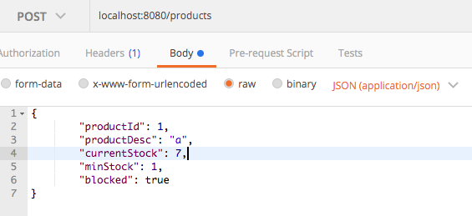

2) GET method to find all the products

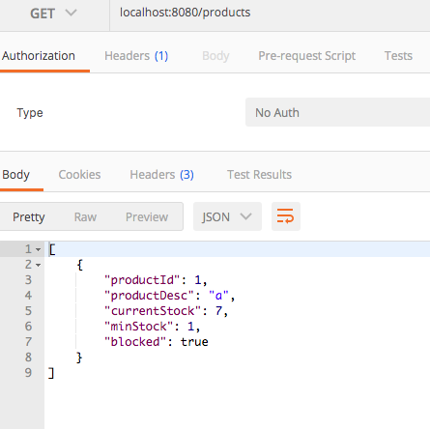

3) To do further testing added 4 products and get all of them

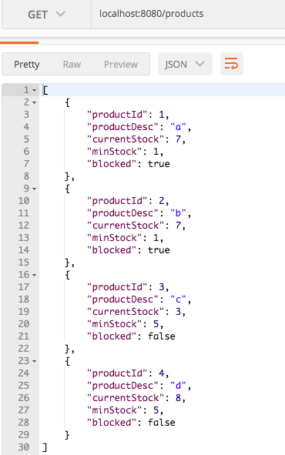

4) PUT method to update the product with ProductId as input

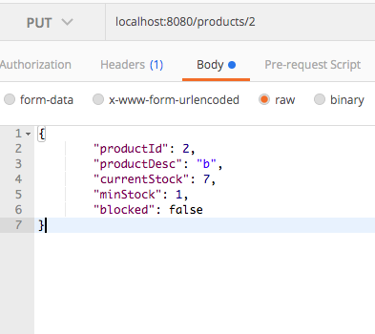

5) GET method to get particular Product data with product id as input

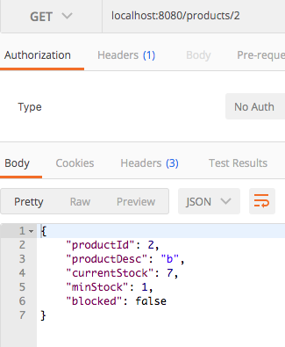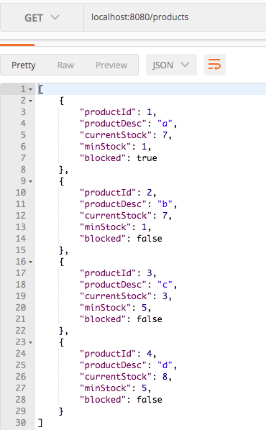

6) GET operation to get ProductsByRule where we will get the products which are unblocked and stock status is greater than min stock

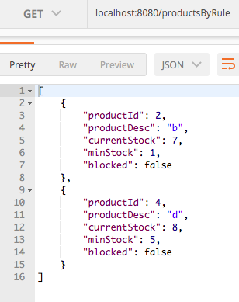

7) Try to get data for product which doesnot exists

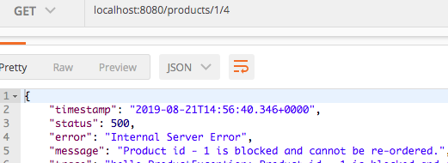

8) Another GET service which takes 2 input i.e. ProductId and Quantity for Product Id 3 stock level is low

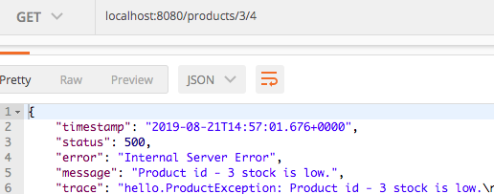

9) So when trying to get the quantity greater than stock will get message about the current stock of the product

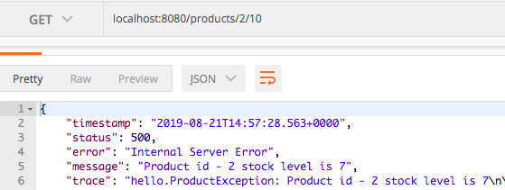

10) It has provision to delete the product by providing the product Id

