**JENKINS:**

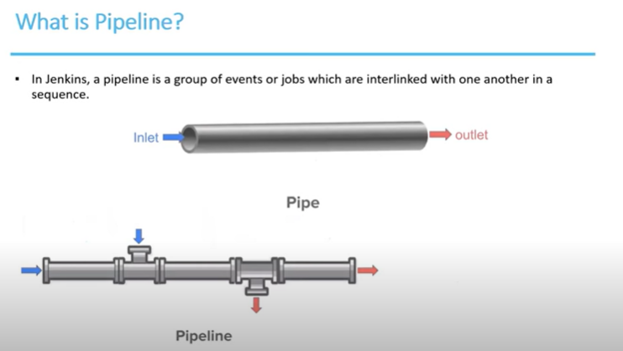

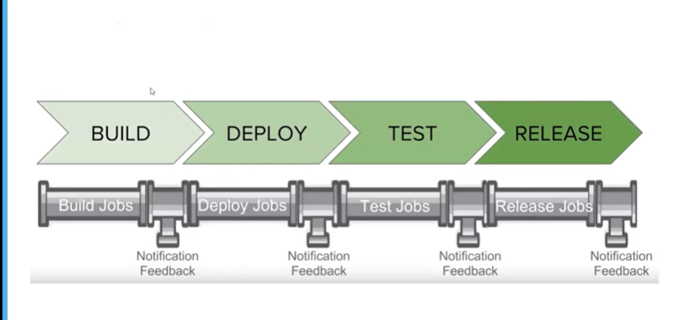

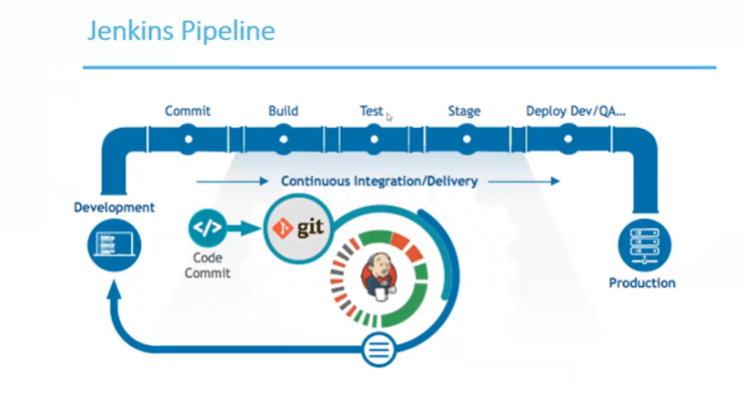

* **Launch AWS instance with custom TCP port**
* Create EC2 instance of tomcat and add port 8080
* Copy public ip address and create session on mobaxterm and paste in remote host and and ec2-user in specify username and then
* Go to advanced settings add .pem file and say ok

1. Please execute the following command to create a tomcat folder which is shown below

mkdir tomcat

1. Please execute the following command to navigate in tomcat folder which is shown below

cd tomcat

1. Please execute the following command to update the existing packages.

sudo yum update

1. In order to run Apache Tomcat, you need a JDK. Execute the following command to install JDK.

sudo yum install java*

1. Execute the following command to download Apache Tomcat 8 which is shown below

sudo wget <https://dlcdn.apache.org/tomcat/tomcat-8/v8.5.72/bin/apache-tomcat-8.5.72.tar.gz>

1. Execute the following command to unzip downloaded Apache tomcat 8

tar -xf apache-tomcat-8.5.72.tar

1. Execute the following command to navigate in the bin folder which is shown below.

cd apache-tomcat-8.5.51/bin/

1. Execute the following command to make all sh file executable file

chmod 777 *.sh

1. Execute the following command to start the Apache tomcat which is shown below

sudo ./startup.sh

1. Now Please open browser and enter instance_IP:8080.
2. Then we need to login to tomcat so rum following commands on mobaxterm 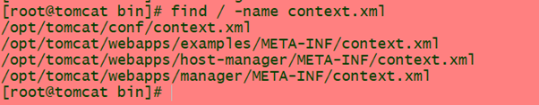
3. Then make changes in this by commenting some text from <!-- <valve to host> 🡪



1. Also same changes in this file



1. Now go to chrome and run following port

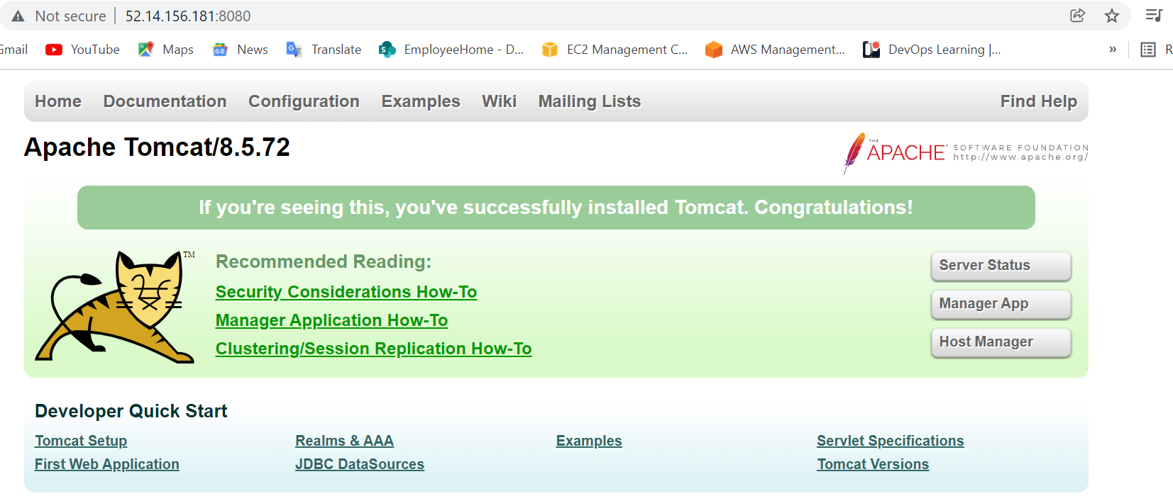

1. Go to manage app and put id password tomcat and then tomcat will run

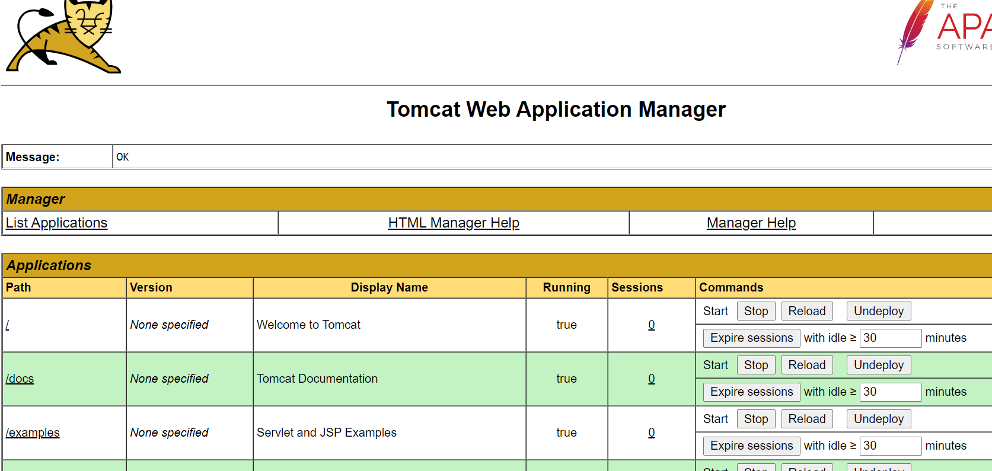

* **To install Jenkins using aws instance:**

1. Create EC2 instance of Jenkins and add port 8080
2. Copy public ip address and create session on mobaxterm and paste in remote host and and ec2-user in specify username and then
3. Go to advanced settings add .pem file and say ok
4. Then go to root
5. Then install java using yum install java-1.8*
6. Run ls -la and then vi .bash_rs and set path there JAVA_HOME=/usr/lib/jvm/java-1.8.0-openjdk-1.8.0.161.0.b14.el7_4.x86_64/  
   PATH=$PATH:$JAVA_HOME:$HOME/bin
7. Run following to download jenkins

sudo wget -O /etc/yum.repos.d/jenkins.repo https://pkg.jenkins.io/redhat/jenkins.repo

sudo rpm --import https://pkg.jenkins.io/redhat/jenkins.io.key

1. Then yum install jenkins
2. Service Jenkins start then Jenkins will start on ec2 instance

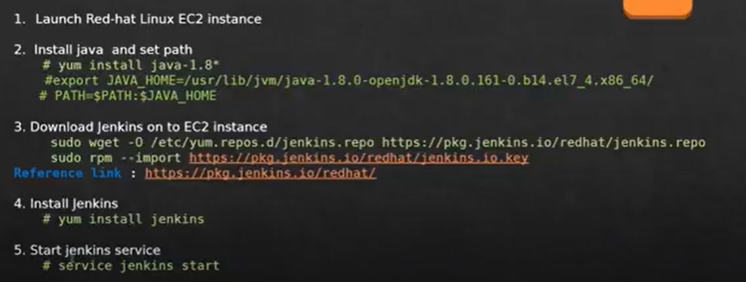

* **How to create, build and deploy Jenkins project**

1. Open Jenkins create new item and select maven project and ok

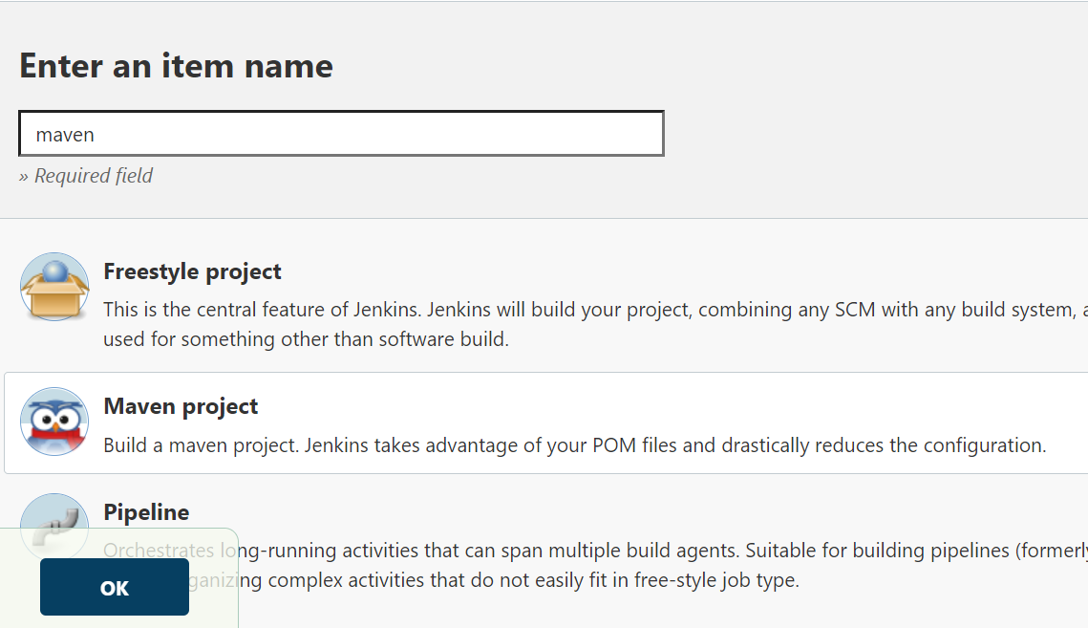

1. Then go to manage jenkins

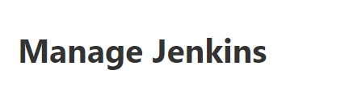

1. Go to manage plugins and download deploy to container and maven integration plugins

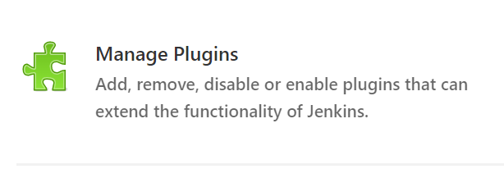

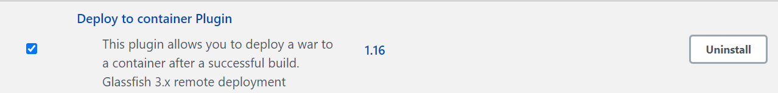

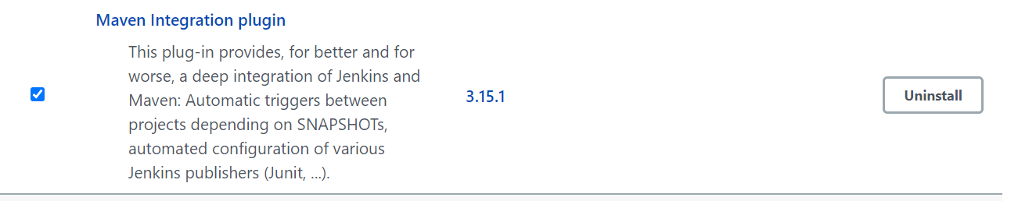

1. Then set global credentials to deploy code on tomcat need to set this

Username:deployer

Password:deployer

Id :tomcat

Description:tomcat

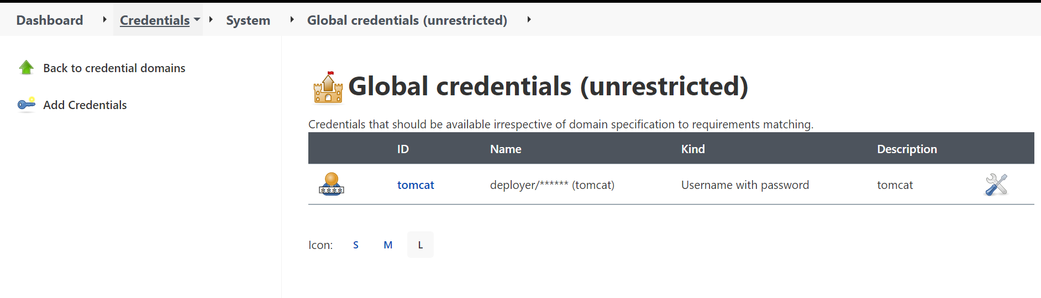

1. Then set git repository where our code is

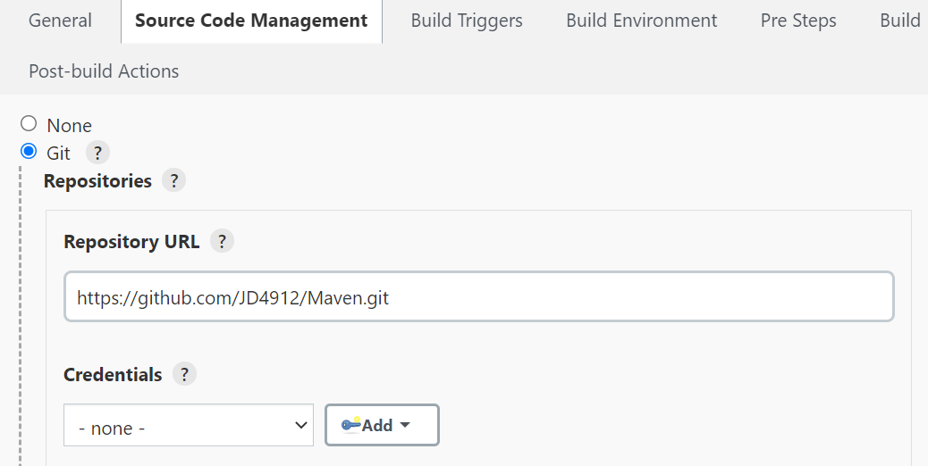

1. Then set poll scm to check build every 1 minute

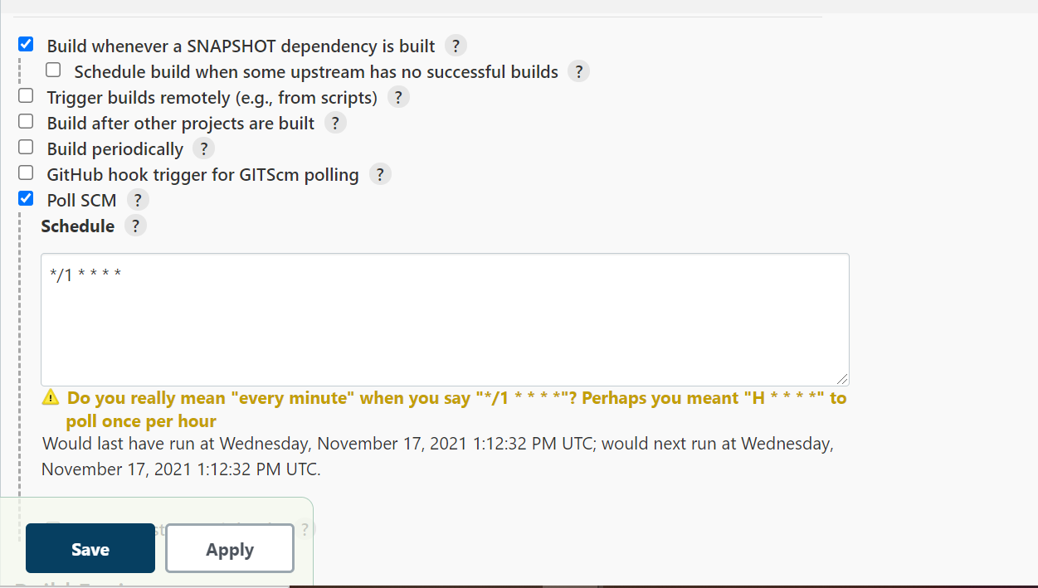

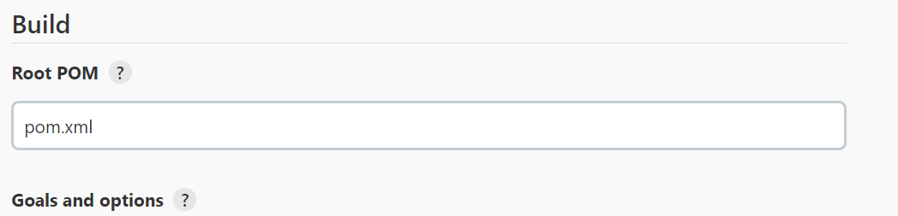

1. In post build actions set war/ear to a container

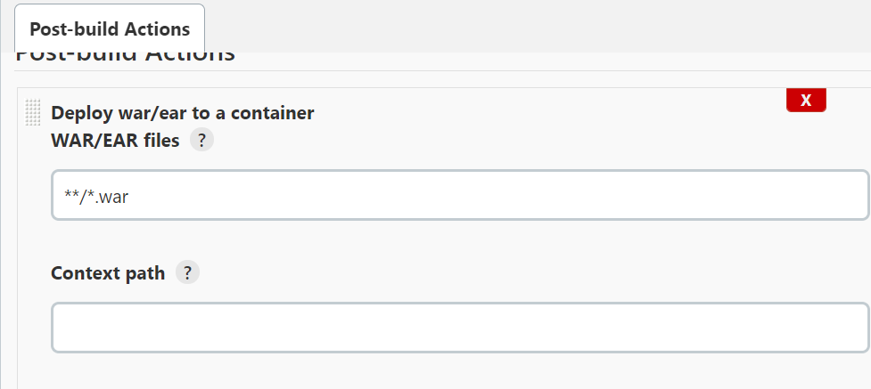

1. Then select tomcat 8.x and select tomcat deployer and paste tomcat url and set it

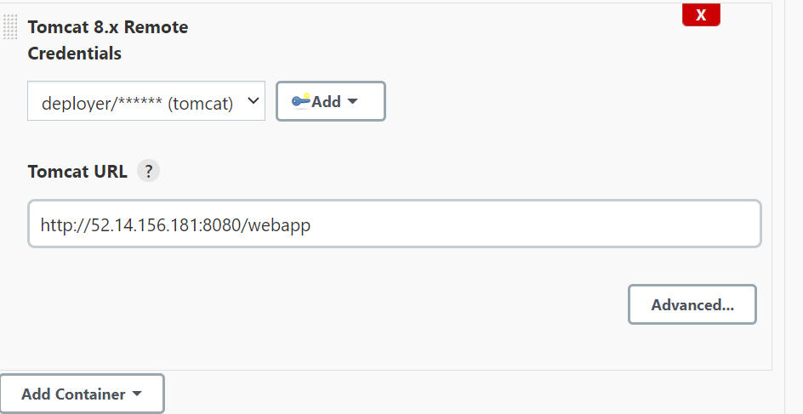

1. Select war/ear container from add post build actions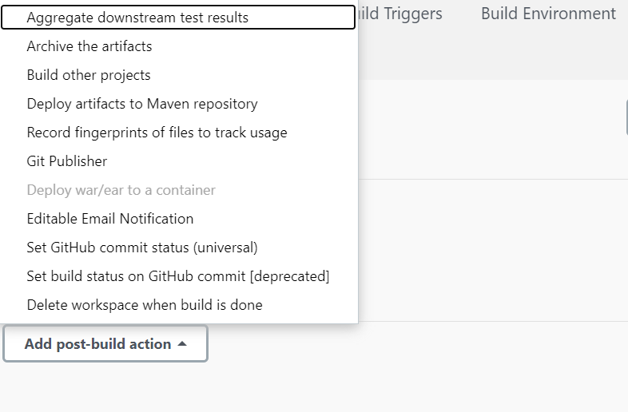
2. Then build now the project and project will build and deploy on tomcat successfully .

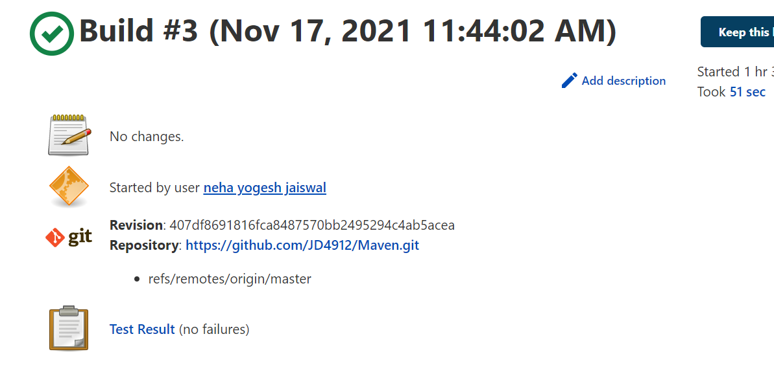

Then go to this url to check what is in file will appear here

