**Shell scripting**: A shell script is a computer program designed to be run by the Unix/Linux shell which could be one of the following:

* The Bourne Shell
* The C Shell
* The Korn Shell
* The GNU Bourne-Again Shell

A shell is a command-line interpreter and typical operations performed by shell scripts include file manipulation, program execution, and printing text.

**Shell**

PowerShell is a modern command shell that includes the best features of other popular shells. Unlike most shells that only accept and return text, PowerShell accepts and returns .NET objects. The shell includes the following features:

**Scripting language**

As a scripting language, PowerShell is commonly used for automating the management of systems. It is also used to build, test, and deploy solutions, often in CI/CD environments. PowerShell is built on the .NET Common Language Runtime (CLR). All inputs and outputs are .NET objects.

1)create folder of shell in c drive and open vs code and create file var.sh and this is how we create variable

And in this there is eg. of command line arguments and run the file using sh filename

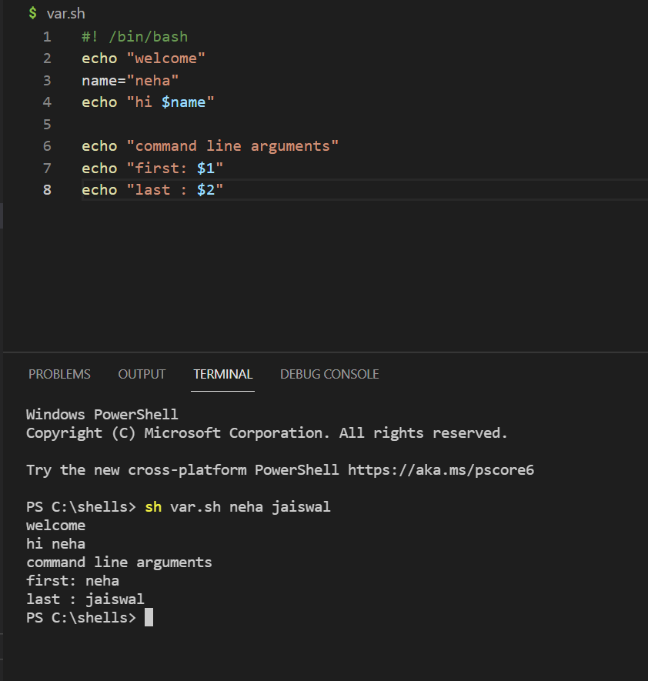

2)code using user input

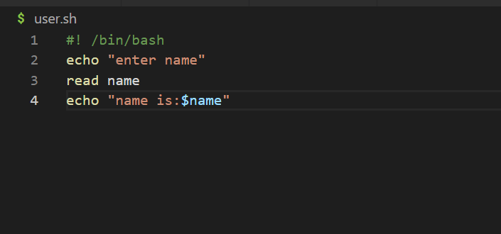

Output:

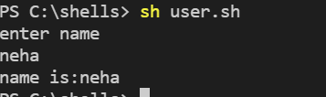

3)for loop:

For value in value1,value2 …;do

Echo

done

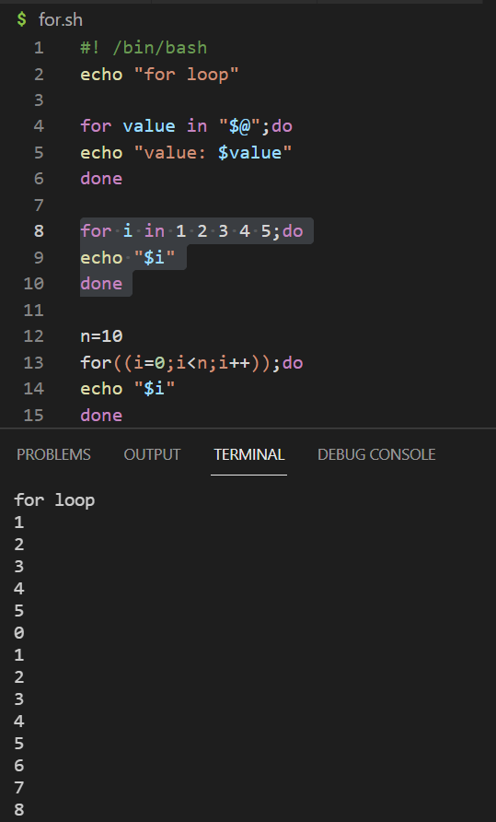

4)Arrays : using for loop

Declare -a name=(“val1” “val2” “val3)

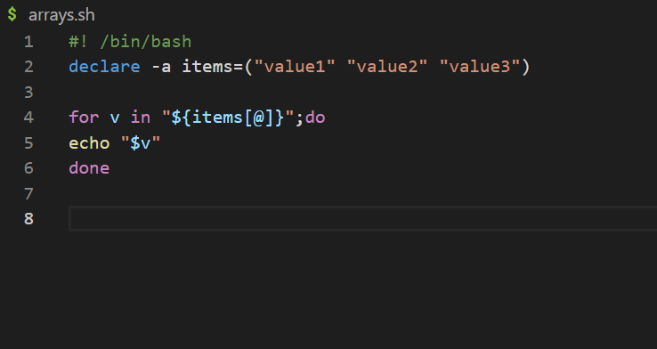

Output:

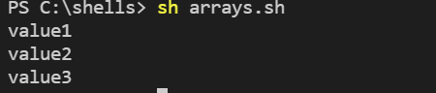

5)conditional statement: if -else

If[condition];then

Echo statement

Elseif[statement]

Echo statement

Else

Echo statement

Fi

Done

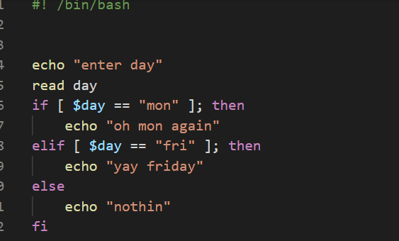

Output:

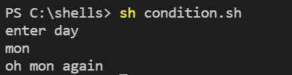

6)loops: until loop

Until [condition]

Do

Echo

Expression

done

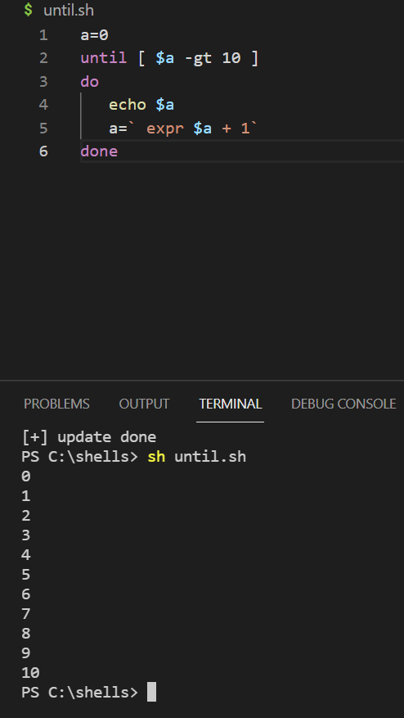

2)while loop:

while [condition]

Do

Echo

Expression

done

