TERRAFORM:

Terraform is an infrastructure as code (IaC) tool that allows you to build, change, and version infrastructure safely and efficiently. This includes low-level components such as compute instances, storage, and networking, as well as high-level components such as DNS entries, SaaS features, etc. Terraform can manage both existing service providers and custom in-house solutions.

1)install terraform on windows using following link

<https://www.terraform.io/downloads.html>

2)then extract the zip file

3)set the terraform path in Environment Variables

**This PC—>properties —>advanced system settings–>environment variables—>system variables—>path–edit–>new**

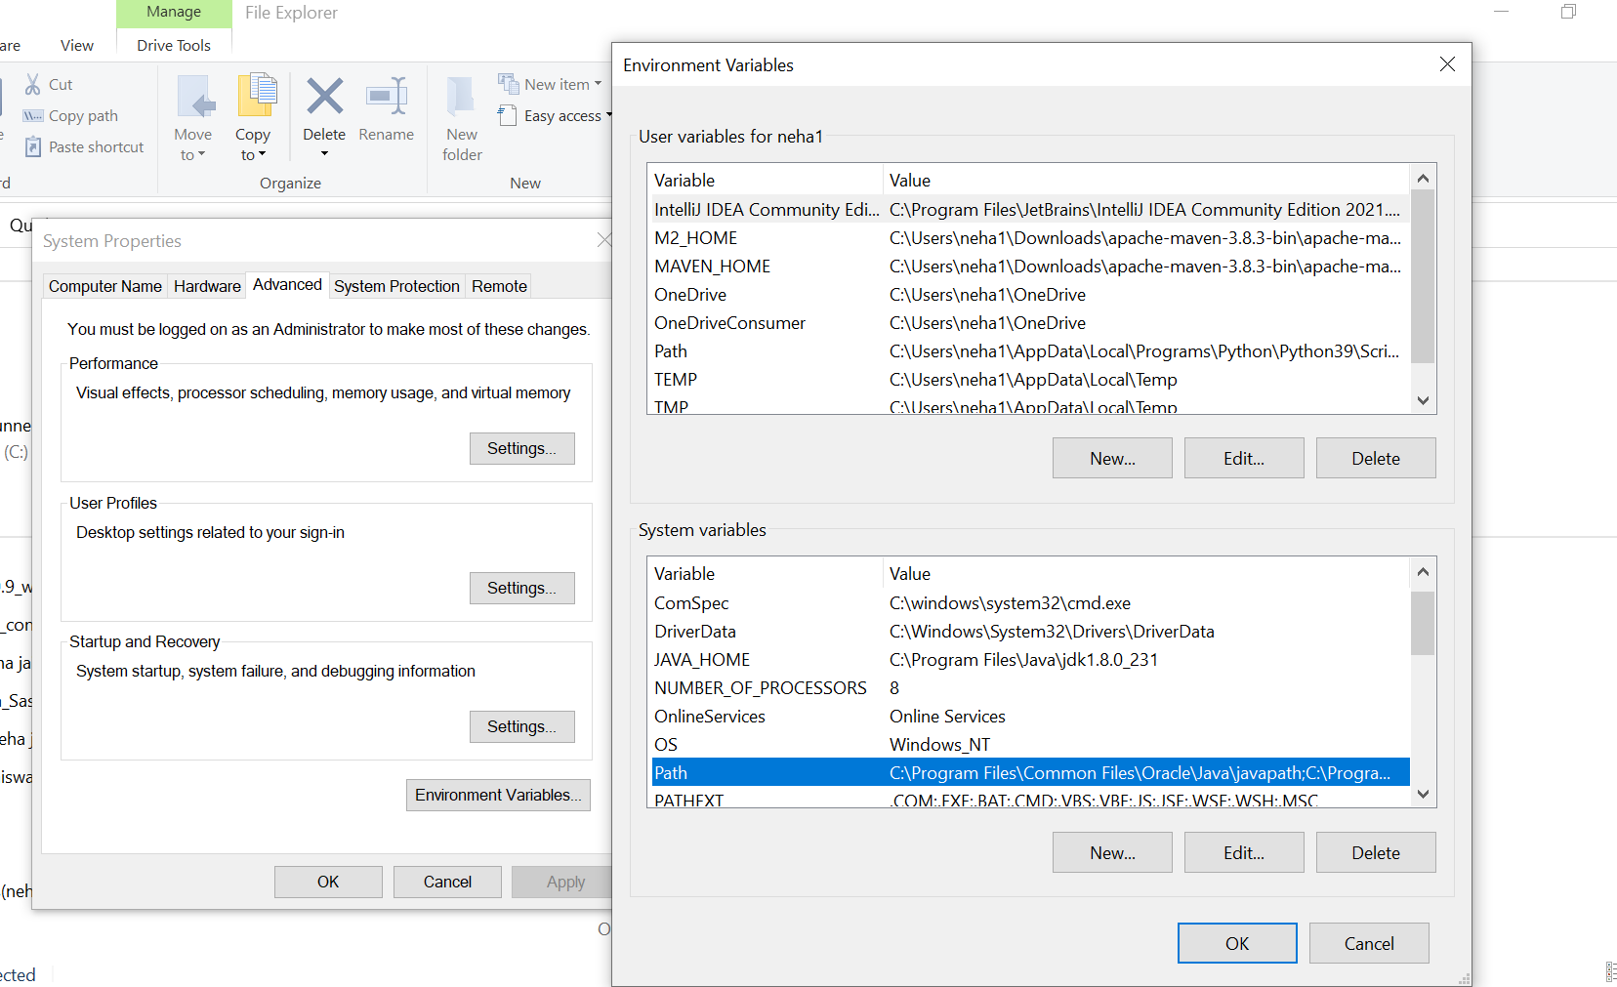



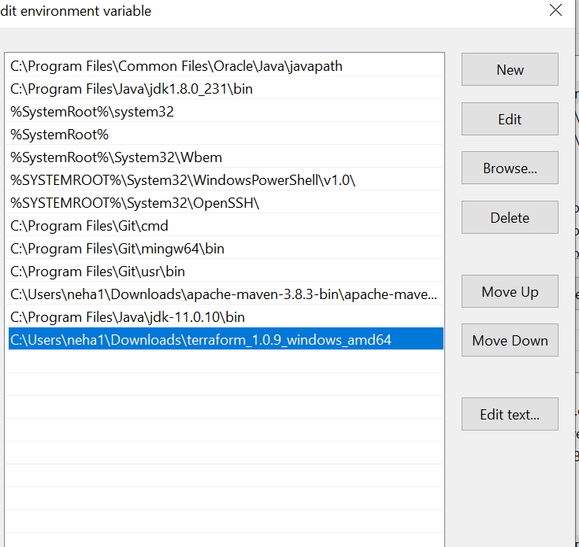



4)create folder in local disk and then open it with vs code



5)After opening it with vs code make a file main.tf

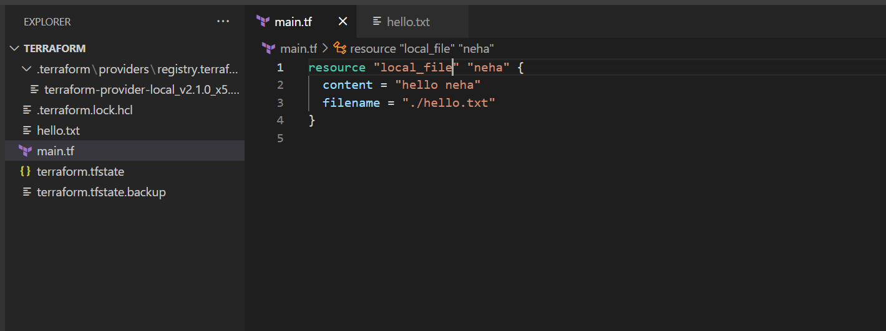

5)then perform commands like terraform init

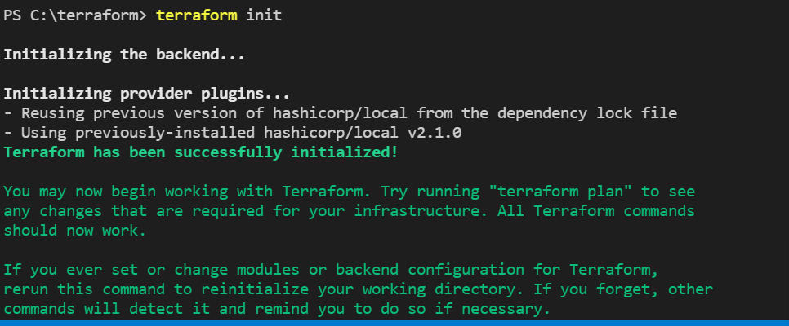

6)after successful initialization use command terraform apply then local file gets created with name neha

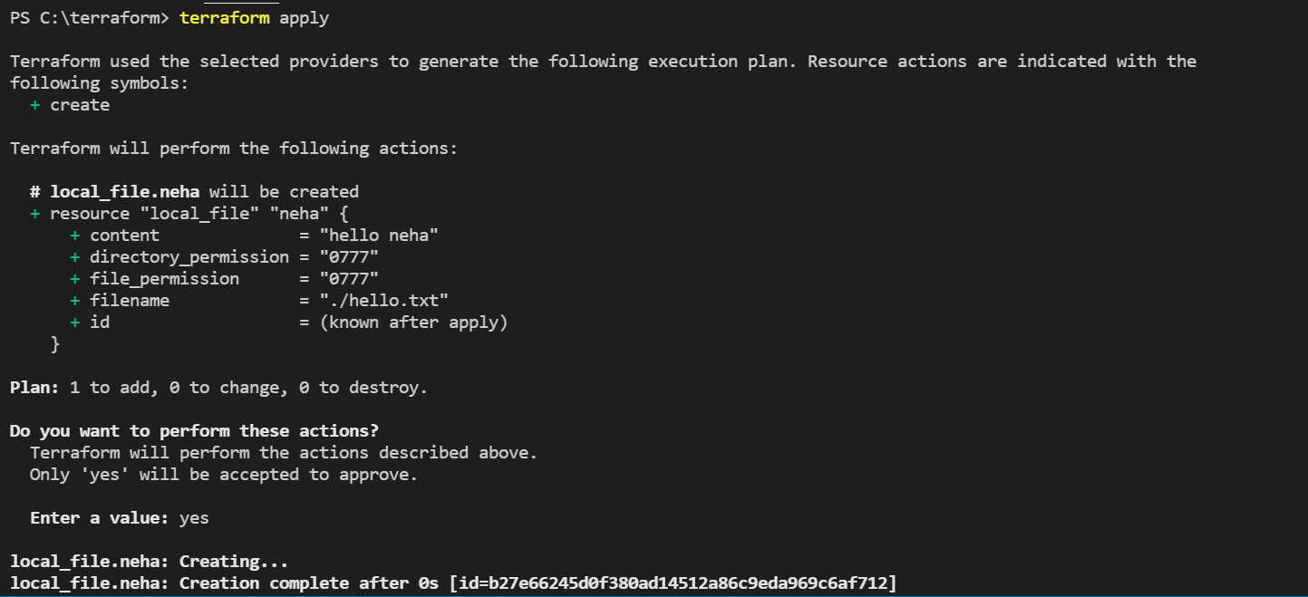

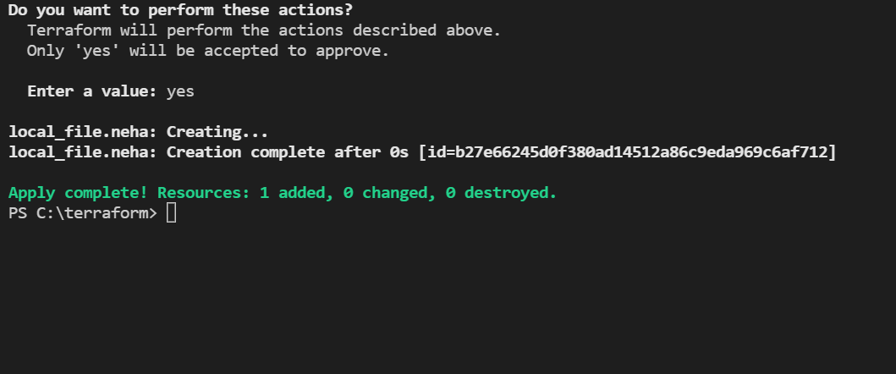

7)create one more file variable.tf and write following code and create variable with type string and give default file name

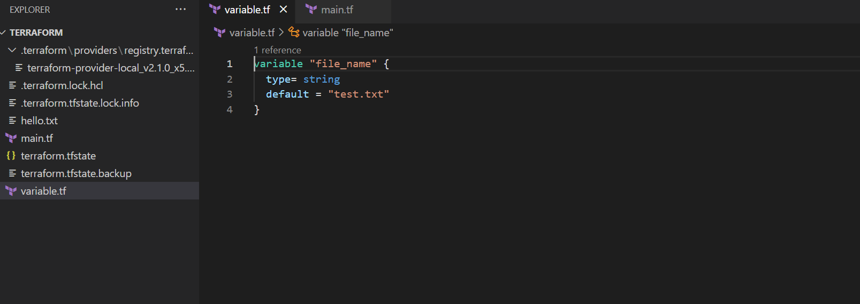

8)and in main give that variable to filename and that default file gets created with content

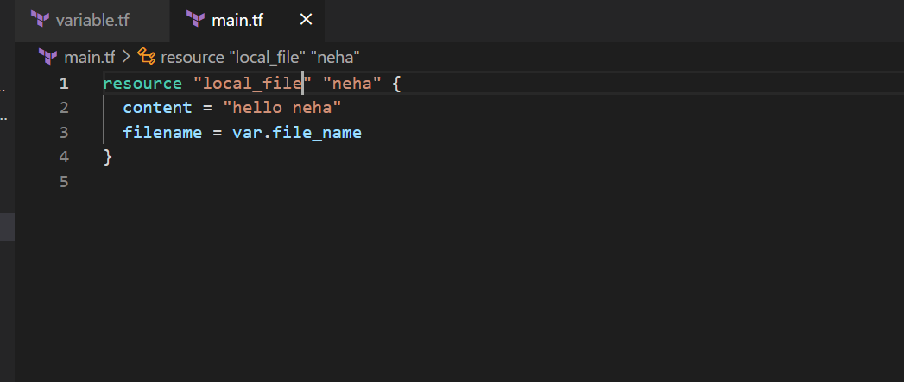

9)then perform same steps terraform init

Terraform validate

Terraform plan

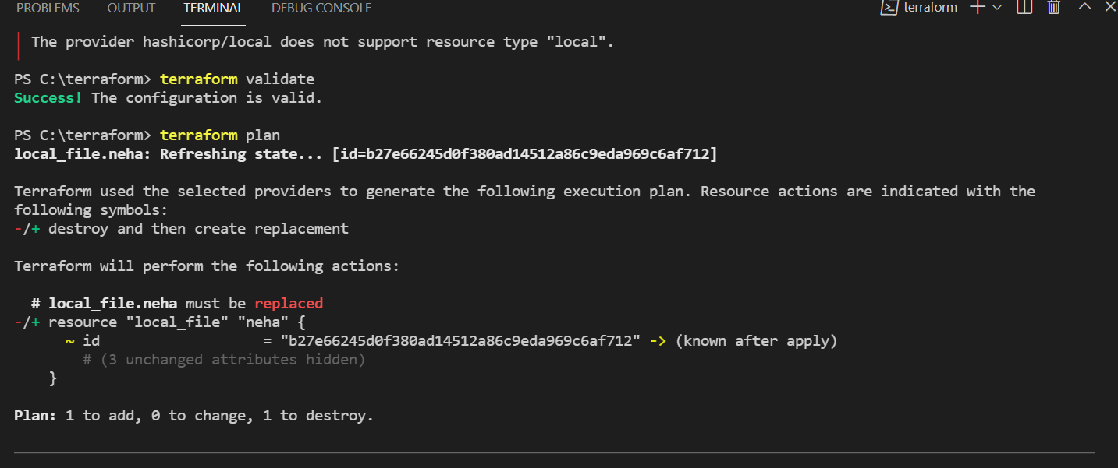

10)finally terraform apply

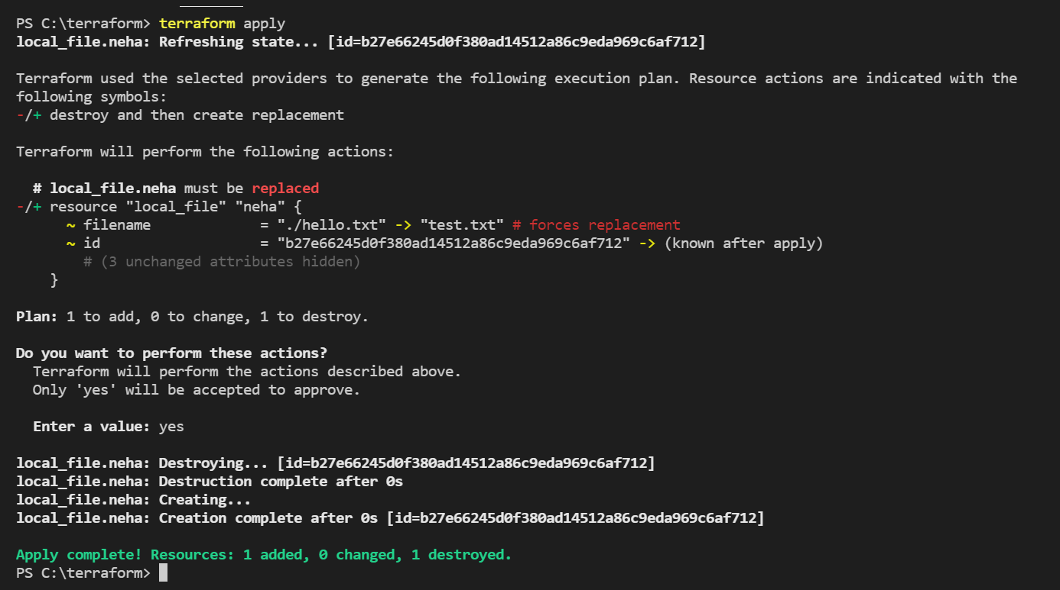

11)using for each loop:

-create variable file-list and give type list

-then in main.tf use foreach loop for each iterative value using toset

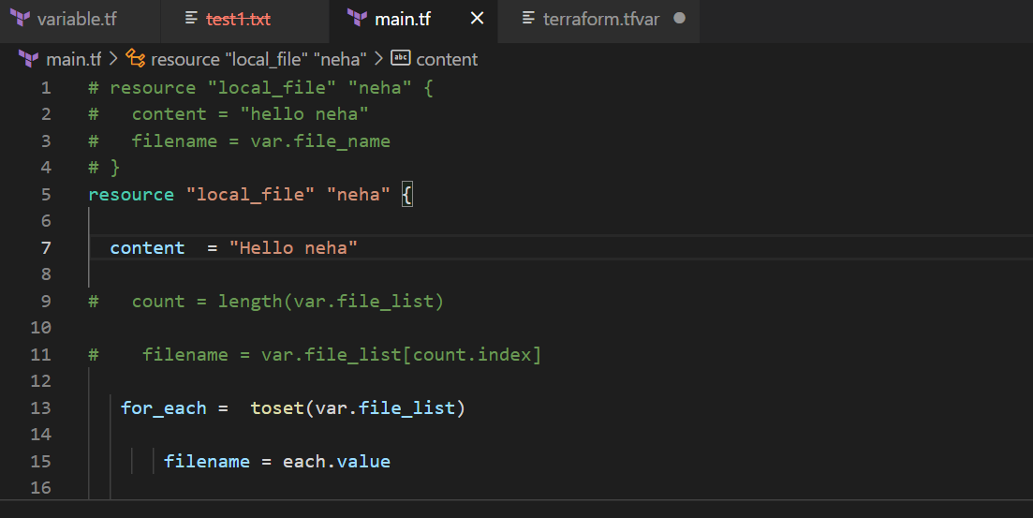

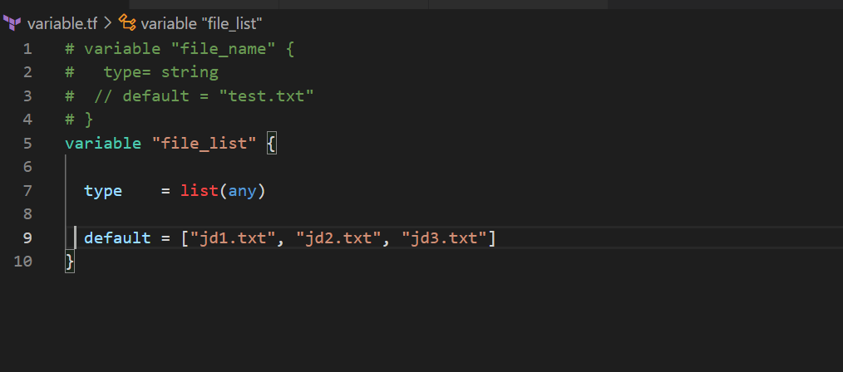

12)after that run same commands to successfully running it

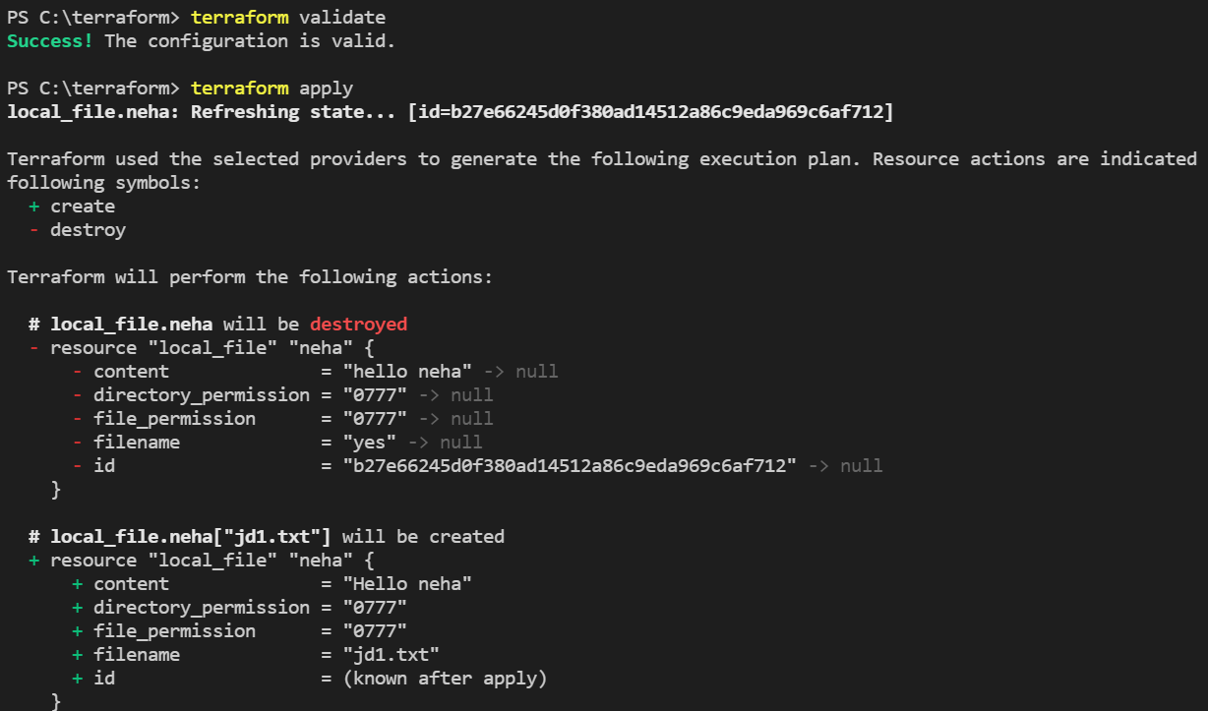

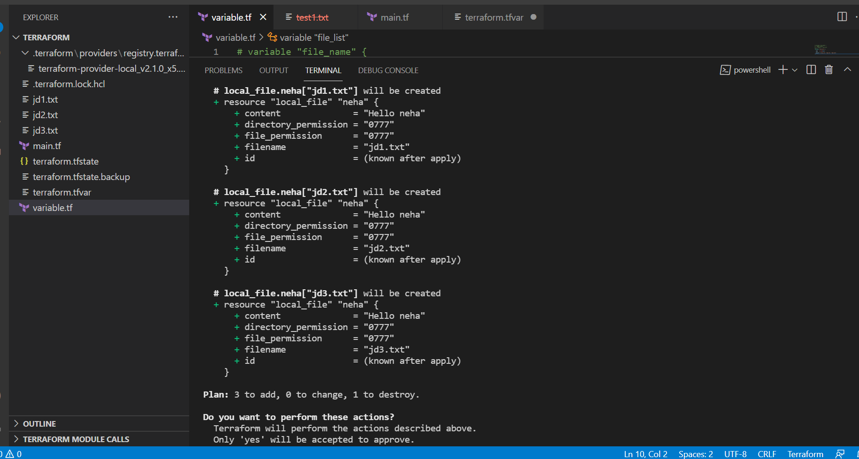

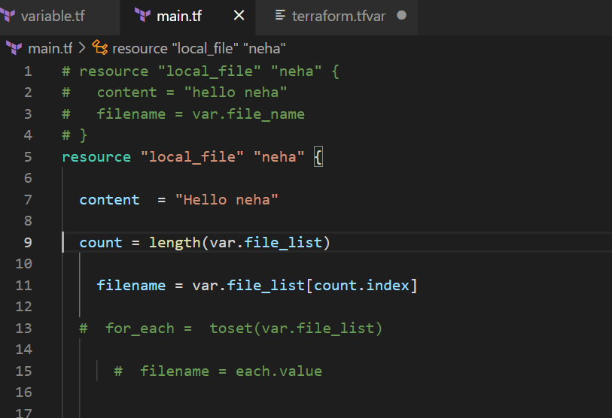

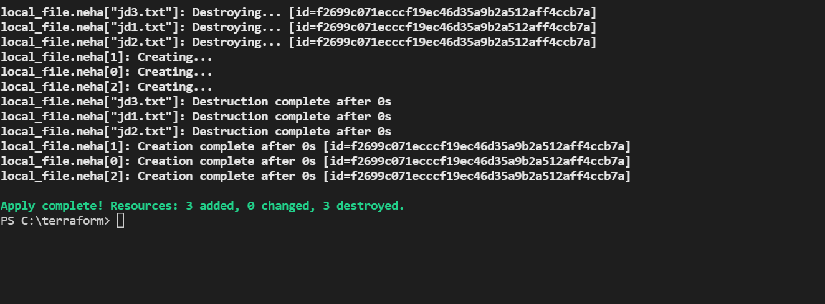

Create IAM user

1)create one IAM user

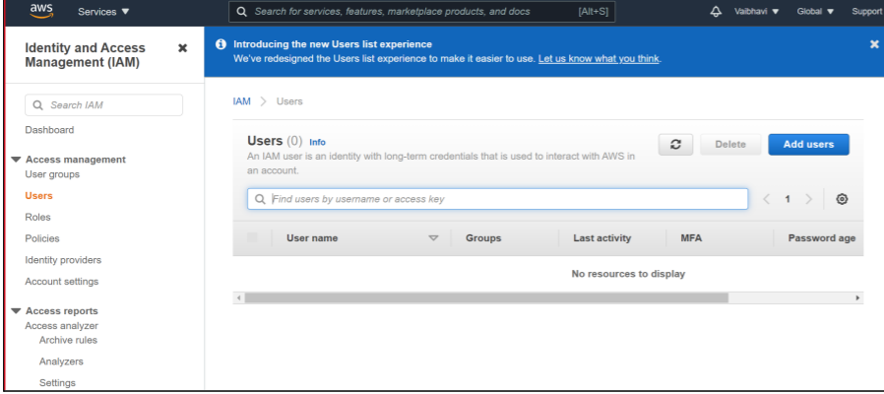

2)put user name select access key and next

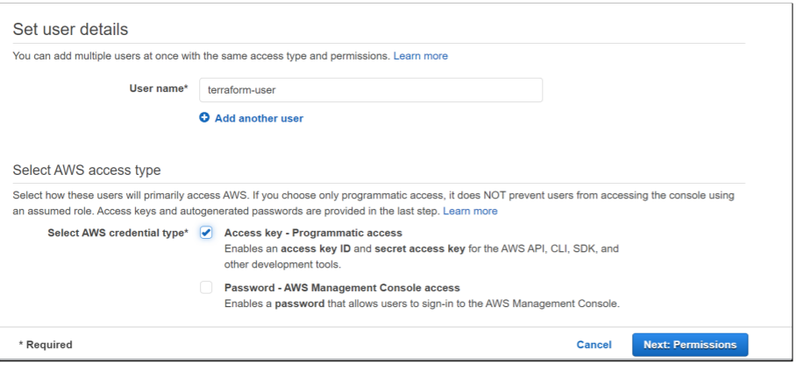

3)select following option and next

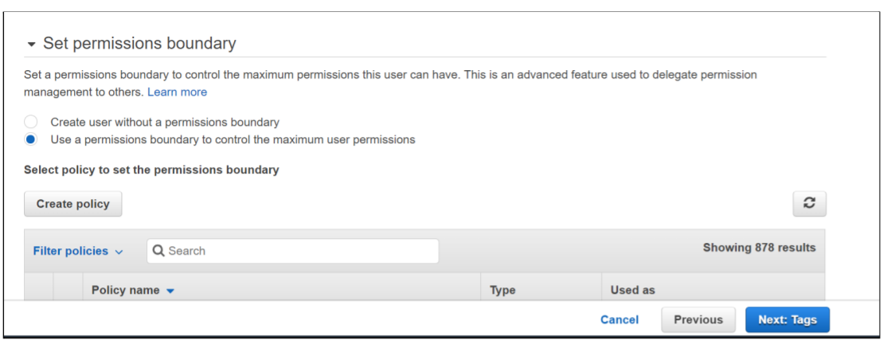

4)select AdminstratorAccess

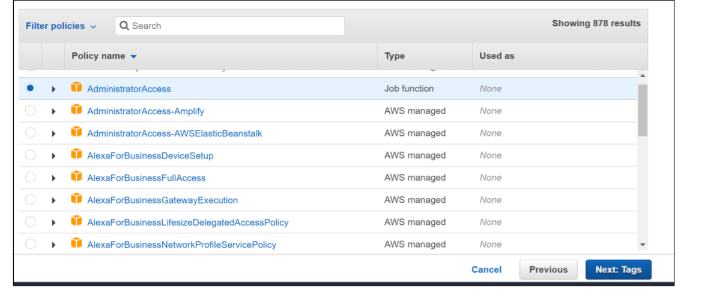

5)add tags

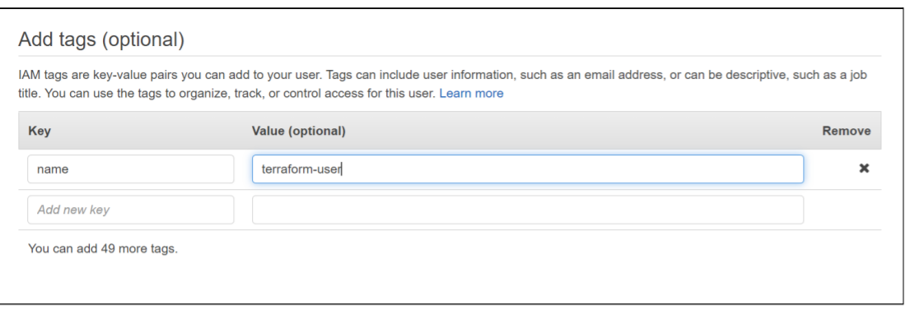

6)success then download .csv file

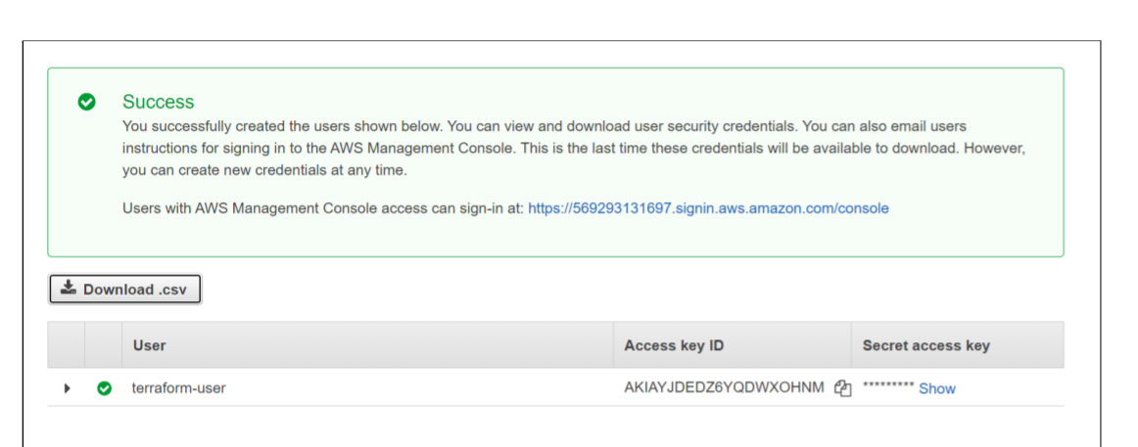

S3 bucket using terraform:

1)First create one folder and open it with vs code

Then create one text file in that folder eg.demo.txt



2)then go to https://registry.terraform.io/

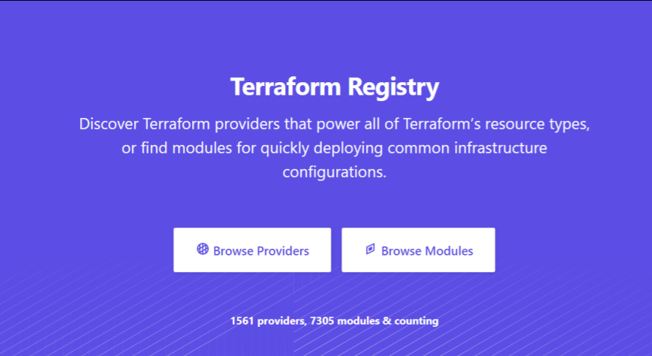

3)select aws provider

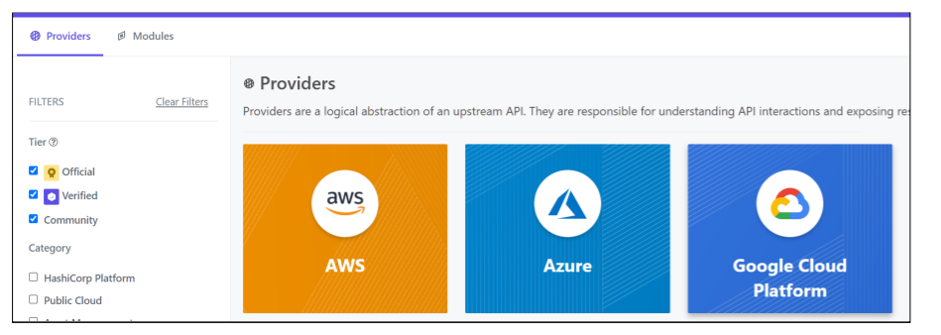

4)then in documentation type aws bucket and aws bucket object and copy following codes

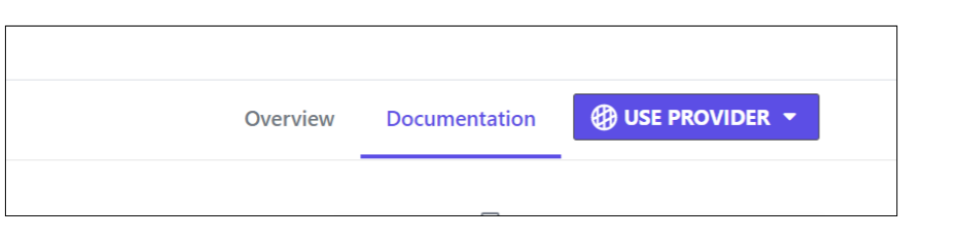

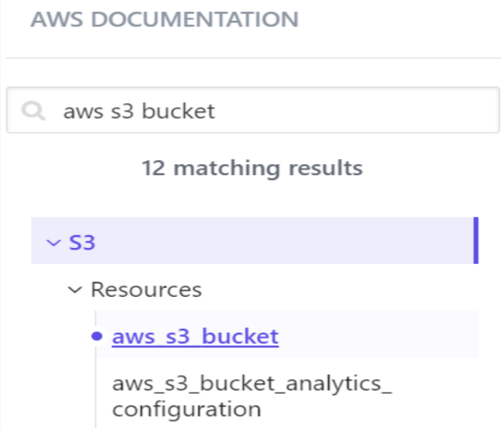

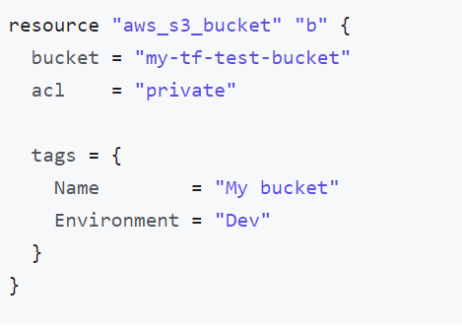

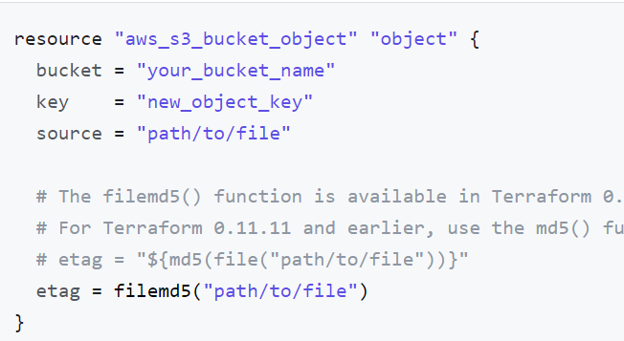

5)paste here that code and give access key and secret key fron .csv file which we saved and change bucket name and save file

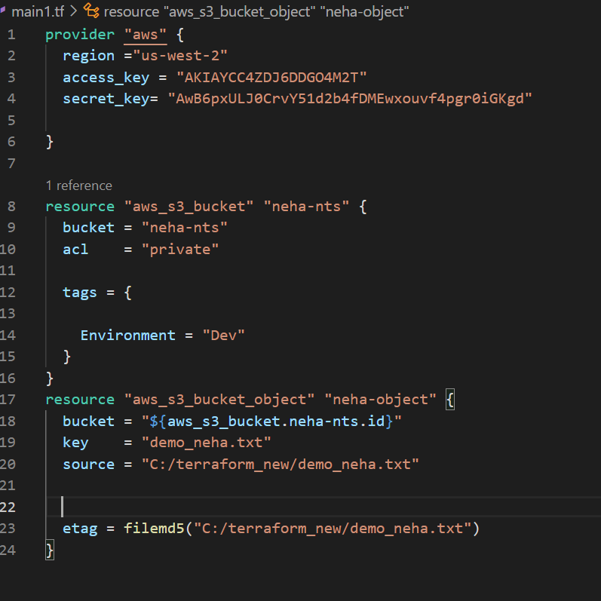

6)and then perform following operations

-terraform init

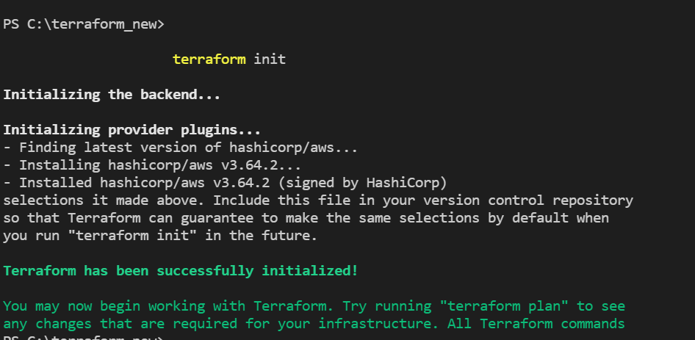

-terraform validate

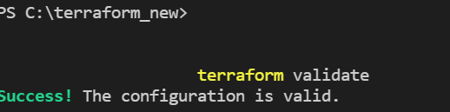

-terraform plan

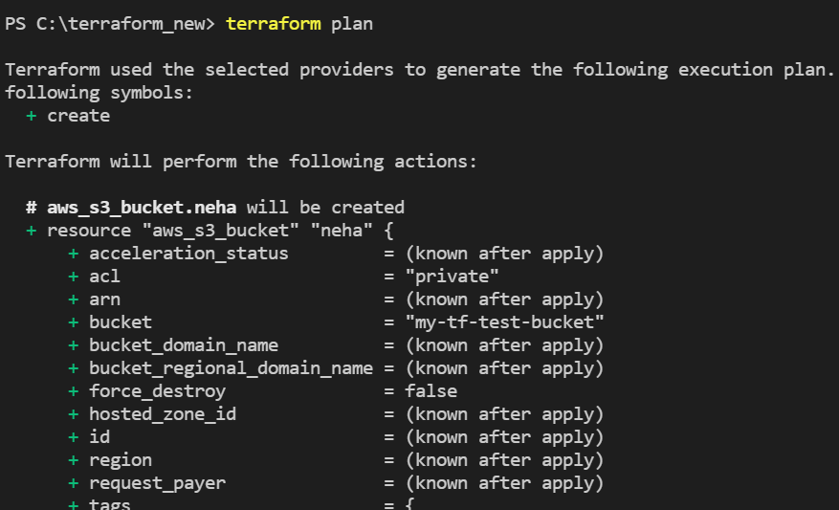

-terraform apply

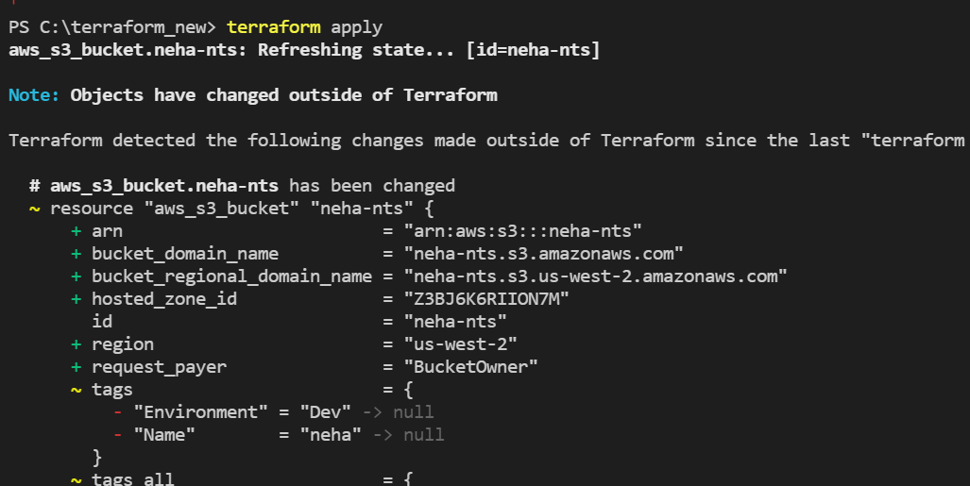

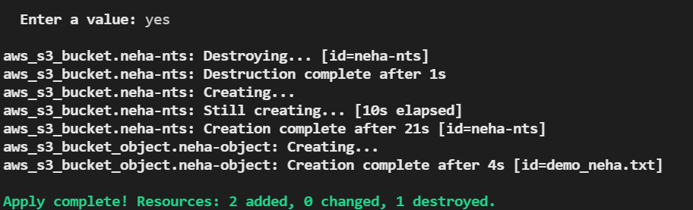

7)then file gets save in s3 bucket

