**Python**-Python is [dynamically-typed](https://en.wikipedia.org/wiki/Type_system#DYNAMIC) and [garbage-collected](https://en.wikipedia.org/wiki/Garbage_collection_(computer_science)). It supports multiple [programming paradigms](https://en.wikipedia.org/wiki/Programming_paradigm), including [structured](https://en.wikipedia.org/wiki/Structured_programming) (particularly, [procedural](https://en.wikipedia.org/wiki/Procedural_programming)), object-oriented and [functional programming](https://en.wikipedia.org/wiki/Functional_programming).

**Python** is an [interpreted](https://en.wikipedia.org/wiki/Interpreted_language) [high-level](https://en.wikipedia.org/wiki/High-level_programming_language) [general-purpose programming language](https://en.wikipedia.org/wiki/General-purpose_programming_language). Its design philosophy emphasizes [code readability](https://en.wikipedia.org/wiki/Code_readability) with its use of [significant indentation](https://en.wikipedia.org/wiki/Off-side_rule). Its [language constructs](https://en.wikipedia.org/wiki/Language_construct) as well as its [object-oriented](https://en.wikipedia.org/wiki/Object-oriented_programming) approach aim to help [programmers](https://en.wikipedia.org/wiki/Programmers) write clear, logical code for small and large-scale projects

Python datastructures: These include Python list, Python tuple, Python set, and Python dictionaries with their syntax and examples.

1)dictionary:

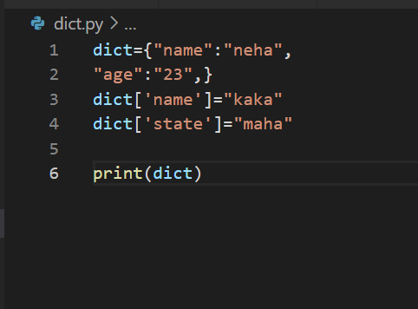



2)list:

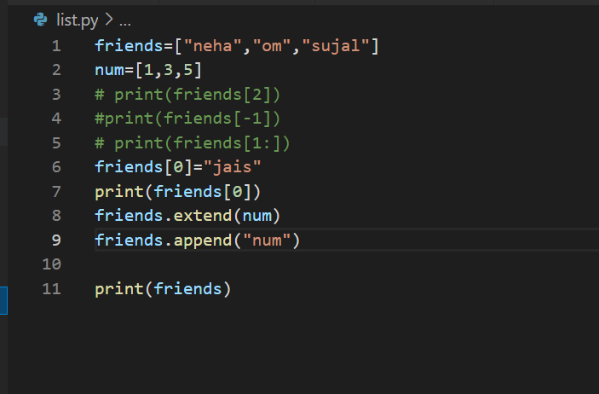

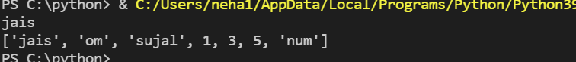

3)tuple:

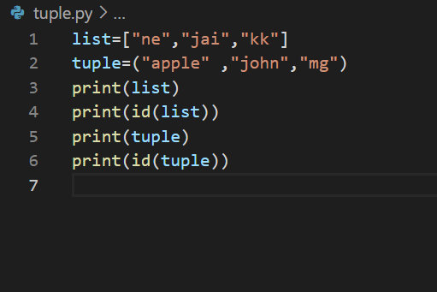

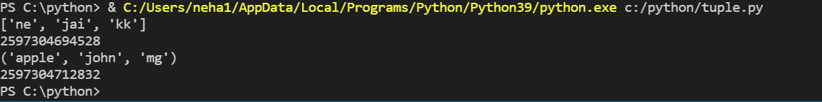

1)user input:

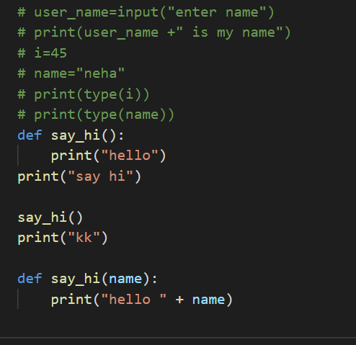

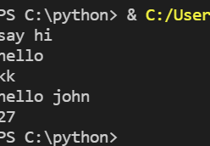

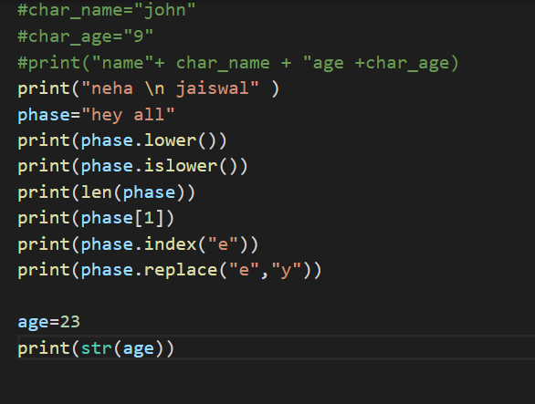

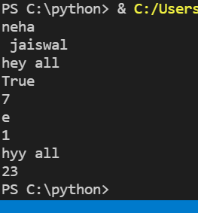

**Functions:** You use functions in programming to bundle a set of instructions that you want to use repeatedly or that, because of their complexity, are better self-contained in a sub-program and called when needed. That means that a function is a piece of code written to carry out a specified task. To carry out that specific task, the function might or might not need multiple inputs. When the task is carried out, the function can or can not return one or more values.

There are three types of functions in Python:

* Built-in functions, such as help() to ask for help, min() to get the minimum value, print() to print an object to the terminal,… You can find an overview with more of these functions [here](https://docs.python.org/3/library/functions.html).
* User-Defined Functions (UDFs), which are functions that users create to help them out; And
* Anonymous functions, which are also called lambda functions because they are not declared with the standard def keyword.

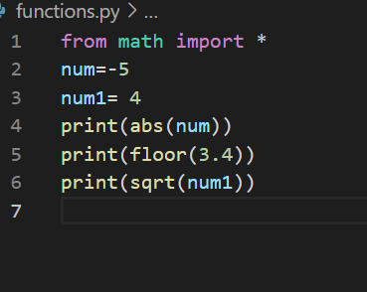

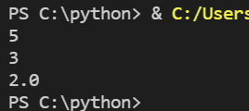

Conditional statement: This is the simplest example of a conditional statement. The syntax is:

if(condition):  
      indented Statement Block

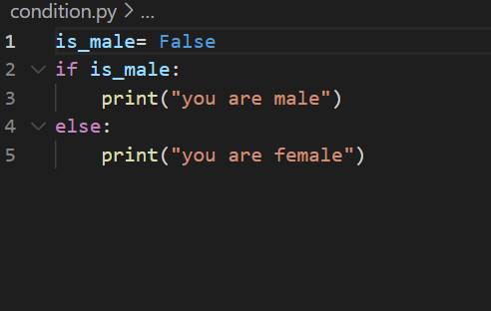

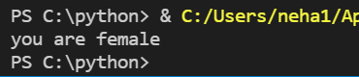

Python modules:

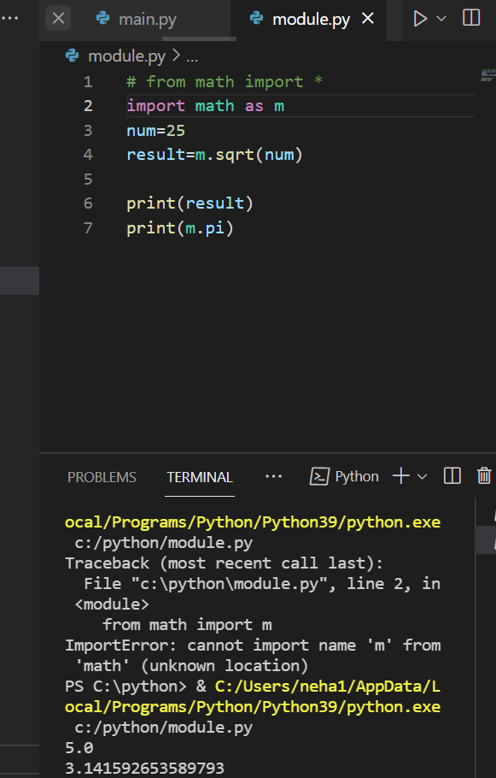

Custom modules:

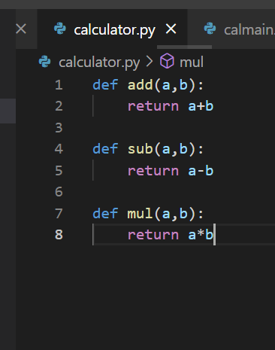

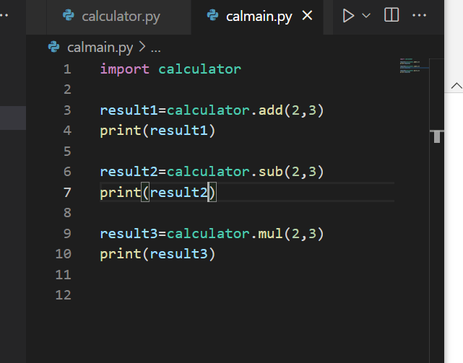

Result: 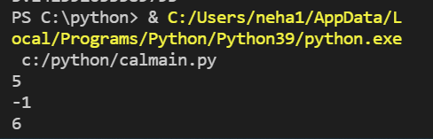

Main function:

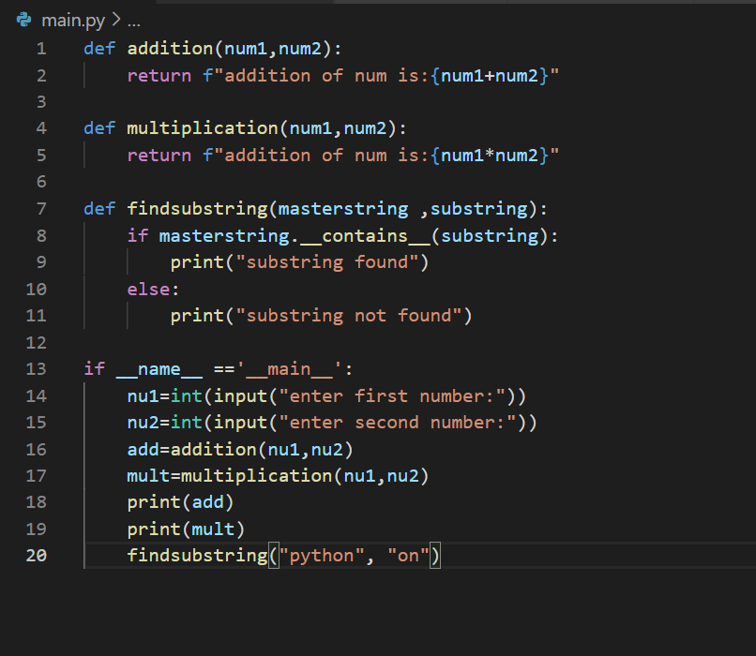

Output:

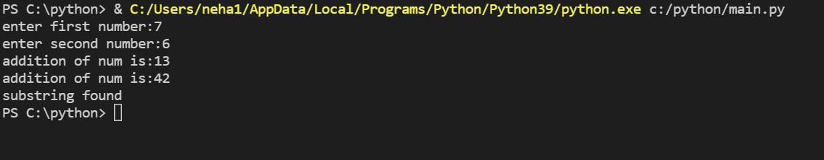

Argparser:

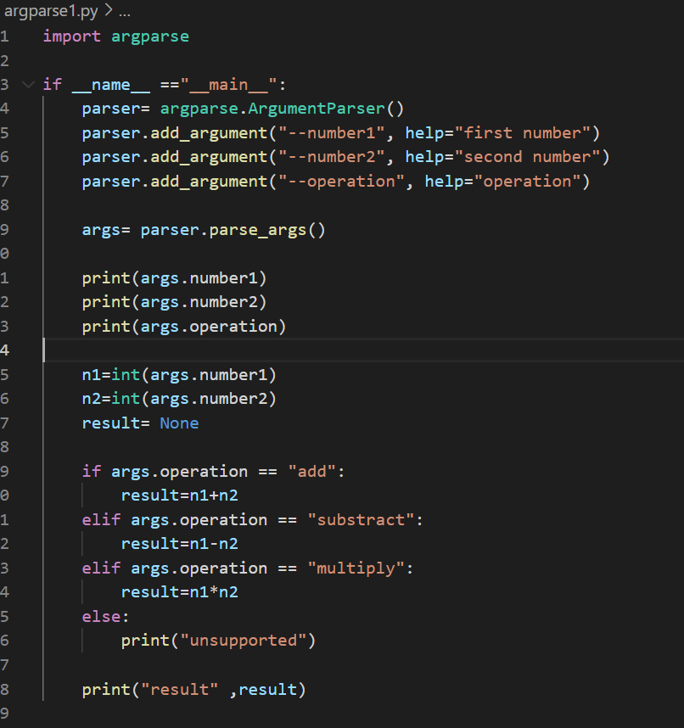

Output:

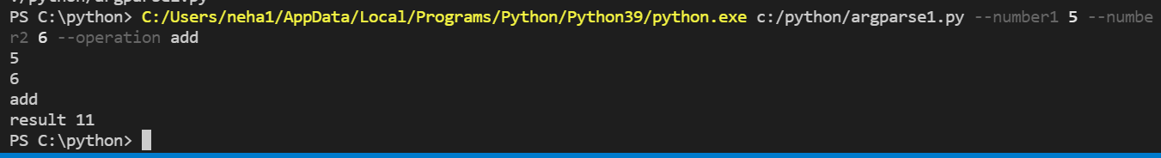

Functions:

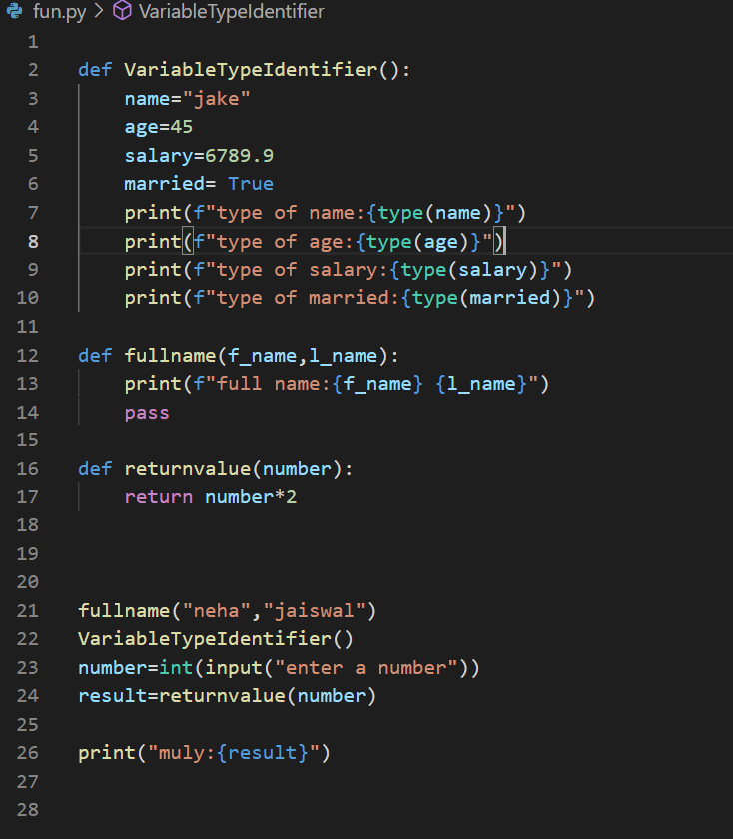

Output:

