Design Report
SPM, SPM Lab, AP Lab
TRIP DRIP (INDIA EDITION)
Submitted By
Name: Neha Jajal,
Ujjwal Savla
SAP ID: 53013240106,
53013240077
Class: T.Y. B.Sc. IT.
Division: A
Department of Information Technology
SVKM’s Usha Pravin Gandhi College of Arts, Science & Commerce
(AUTONOMOUS)
NAAC Accredited ‘A+’ Grade with CGPA 3.27
(Affiliated to University of Mumbai)
Vile Parle (West), Mumbai 400056
2026 - 2027
Contents
1. Introduction 4
1.1 Purpose 4
1.2 Scope 4
1.3 Intended Audience 4
1.4 Document Conventions 5
1.5 Definitions, Acronyms and Abbreviations 5
1.6 References 5
1.7 Document Organization 5
2. System Overview 7
2.1 Product Perspective 7
2.2 System Objectives 7
2.3 Users and Roles 7
2.4 Functional Summary and Traceability 8
2.5 Module Overview 8
2.6 Development Approach and Design Maturity 9
3. Design Goals, Constraints and Assumptions 10
3.1 Design Goals 10
3.2 Design Principles 10
3.3 Technology Stack 10
3.4 Environment Requirements 11
3.5 Design Constraints 12
3.6 Assumptions and Dependencies 12
3.7 Key Design Decisions and Rationale 12
4. Architectural Design 13
4.1 Architectural Style 13
4.2 High-Level Architecture 13
4.3 Frontend Architecture 14
4.4 Backend Architecture 15
4.5 Database Architecture and pgvector Integration 16
4.6 External Service Integration and Fallbacks 16
4.7 Data Flow Between Components 17
4.8 Deployment Architecture 17
5. Module Design 19
5.1 Authentication and Session Module 19
5.2 Trip Creation and Configuration Engine 19
5.3 Itinerary Generation and Deduplication Module 19
5.4 Meteorological Intelligence Service 20
5.5 Wardrobe and Vector Similarity Engine 20
5.6 Visual Reverse Search and Catalog Module 21
5.7 AI Conversational Concierge 21
5.8 Hisaab-Kitaab Expense Splitter 22
5.9 Chai and Station Radar Module 22
5.10 Interactive Vector Mapping Engine 22
5.11 Smart Packing Checklist 22
5.12 Yatra Travel Diary 23
5.13 Offline Storage Subsystem 23
5.14 Squad Collaboration Components 23
5.15 Module, API and Data Traceability 24
6. Data Design 25
6.1 Data Design Overview 25
6.2 Data Stores 25
6.3 Entity-Relationship Model 25
6.4 Table Specifications 26
6.5 Data Dictionary 29
6.6 Semi-Structured Data (JSONB) 29
6.7 Vector Data Design 29
6.8 Data Integrity and Access Rules 30
6.9 Schema Migrations 30
6.10 Client-Side Data and Design Notes 31
7. Algorithm Design 32
7.1 Minimal Cashflow Settlement (Hisaab-Kitaab) 32
7.2 Vector Cosine Similarity 33
7.3 Itinerary Deduplication & Auto-Repair 33
7.4 Haversine Great-Circle Distance 34
8. API & Interface Design 36
8.1 Endpoint Specification 36
8.2 Request / Response Flow 36
9. User Interface Design 38
9.1 Design Tokens 38
9.2 Navigation Flow 38
9.3 Key Screens 39
10. Security Design 40
10.1 JWT Authentication 40
10.2 Authorization 40
10.3 Row-Level Security (RLS) 41
11. Error Handling, Resilience & Deployment Design 42
11.1 Fallback Architecture 42
11.2 Offline Mode 42
11.3 Environment Configuration 42
11.4 Deployment Design 43
12. Limitations, Risks & Future Extensions 44
12.1 Current Limitations 44
12.2 Unsuccessful Feature: Full Outfit Recommendation Using User Photo 44
12.3 Risks 45
12.4 Enhancement Roadmap 45

1. Introduction

1.1 Purpose
This Software Design Document (SDD) describes how Trip Drip (India Edition) is designed: its architecture, modules, data model, algorithms, interfaces, and security and deployment approach. It turns the requirements and analysis recorded in the Final Project Report into a technical blueprint that a developer, evaluator, or maintainer can follow without reading the source code first.
The design described here reflects the system as built and verified in the local workspace (source code and database migrations), which is treated as the primary source of truth. Where the design is planned rather than delivered, the text says so.

1.2 Scope
Trip Drip is a responsive Single-Page Application (SPA) that unifies the travel lifecycle for Indian journeys: planning, packing, on-trip assistance, group expense settlement, and memory keeping. The design covers the following capabilities.
- Multi-modal trip creation with transport fare comparison (Indian Railways classes, buses, car, flight) and 1★–5★ hotel-tier reasoning, priced in INR.
- Weather-aware, day-by-day itinerary generation (1 to 7 days) with guaranteed unique daily routes and themes.
- Wardrobe management with garment vectorization, pgvector cosine similarity, 0–10 climate suitability scoring, and colour coordination.
- Visual reverse attribute search across a 29-item multi-brand catalog (Zara, H&M, Uniqlo, Westside).
- An AI travel concierge that can execute real in-app actions, with a rule-based fallback engine.
- Hisaab-Kitaab group expense splitting with minimal-transaction settlement, Bharat UPI QR codes, and WhatsApp summaries.
- Chai & Station Radar, interactive Leaflet maps, a smart packing checklist, the Yatra travel diary, and squad collaboration by invite link.
- Offline resilience through an IndexedDB caching layer.
Outside the current design. Full outfit recommendation from a user photo was attempted but not completed (documented in Section 12). Live PNR / bus GPS tracking and a voice-activated concierge are planned future enhancements and are not designed here.

1.3 Intended Audience
Audience | How they use this document
Developers and maintainers | Understand module boundaries, data flow, and extension points before changing code.
Project guide and evaluators | Verify that the implementation follows a coherent, traceable design.
QA engineers | Derive test scenarios from module behaviour, constraints, and data rules.
Future contributors and DevOps | Reproduce the environment, deploy to Vercel and Supabase, and manage configuration.

1.4 Document Conventions
- Requirement identifiers follow the project report: FR-nn (functional), NFR-nn (non-functional), and UC-nn (use case).
- File and identifier names appear in monospace (for example HisaabKitaabModal.jsx, api/get-weather.js).
- Figures and tables are numbered by section (Figure 4.1 is the first figure in Section 4). Currency is INR (₹) unless stated otherwise.

1.5 Definitions, Acronyms and Abbreviations
Term | Meaning
API | Application Programming Interface
CLIP | Contrastive Language-Image Pre-Training; used here as a zero-shot image classifier (ViT-B/32) fallback
DeepFashion2 | Clothing dataset whose category labels (for example short_sleeve_top, trousers) are used to classify garments
Hisaab-Kitaab | Hindi for 'accounts'; the group expense and settlement feature
Chai & Station Radar | Curated guide to highway dhabas, railway-platform food, tea varieties, and water-safety tips
IndexedDB | Browser-native structured storage used for offline caching
JWT | JSON Web Token issued by Supabase Auth to represent an authenticated session
LangChain | Framework for prompt templating and LLM chains, used in the backend AI handlers
LLM | Large Language Model (here OpenAI GPT-4o-mini)
pgvector | PostgreSQL extension for vector storage and similarity search
RLS | Row-Level Security; PostgreSQL policies that restrict which rows a user can read or write
SPA | Single-Page Application
UPI / Bharat UPI | Unified Payments Interface and its standard QR / deep-link payment format (upi://pay)

1.6 References
- Trip Drip Final Project Report (T.Y. B.Sc. IT Software Engineering Capstone), Academic Year 2025–2026. This SDD's primary input.
- React, Vite, Tailwind CSS, Supabase, pgvector, LangChain.js, OpenAI API, Open-Meteo, Leaflet, and Vercel official documentation.
- NPCI Unified Payments Interface (UPI) specification and the DeepFashion2 dataset (CVPR 2019).

1.7 Document Organization
The SDD is organised into twelve sections. Sections 1–6 cover the introduction through data design; Sections 7–12 cover algorithm design through limitations, risks and future extensions.
Part | Sections
Part 1 | 1 Introduction  2 System Overview  3 Design Goals, Constraints and Assumptions  4 Architectural Design  5 Module Design  6 Data Design
Part 2 | 7 Algorithm Design  8 API and Interface Design  9 User Interface Design  10 Security Design  11 Error Handling, Resilience and Deployment Design  12 Limitations, Risks and Future Extensions

2. System Overview

2.1 Product Perspective
Travel planning in India is fragmented. A single trip can involve five to eight separate tools: maps, weather, rail and bus portals, fashion sites, notes, and an expense splitter. None of them understand Indian climate variation, Indian Railways fare classes, temple dress etiquette, or UPI settlement. Trip Drip is a self-contained web platform that replaces these tools with one integrated system in which the output of one module becomes the input of the next.
The design responds directly to the five core problems identified in the project analysis.
Table 2.1: Problems and their design responses
Problem | Design response | Where it lives
Itinerary ignores real weather | Weather is fetched first and passed into itinerary generation and wardrobe scoring; the forecast is cached with the trip. | get-weather.js, generate-itinerary.js, trips.weather_json
Packing and dress-code dilemmas | Garments are scored 0–10 against destination climate and style; daily outfit cards use vector similarity. | Wardrobe engine, DayWardrobeCard.jsx
Opaque transport and lodging trade-offs | A rule-based engine compares train classes, bus types, car, and flight with hotel-tier reasoning in INR. | indiaTransport.js, calculate-budget.js
Chaotic group expense splitting | Net balances are reduced to the minimum number of transfers, each with a live UPI QR code. | HisaabKitaabModal.jsx
No connectivity in remote areas | Core trip data is cached in IndexedDB; queries redirect to it when the network drops. | offlineStorage.js, OfflineBanner

2.2 System Objectives
# | Objective | Primary realisation
1 | Automated itinerary generator with sequenced routes, eateries, and daily INR budgets | Itinerary Generation & Deduplication Module
2 | Real-time and historical meteorological data via Open-Meteo | Meteorological Intelligence Service
3 | Wardrobe styling advice tied to daily climate and cultural expectations | Wardrobe & Vector Similarity Engine
4 | Visual attribute search against verified Indian retail catalogs | Visual Reverse Search & Catalog Module
5 | AI concierge that executes application actions from chat | AI Conversational Concierge
6 | Minimal-transaction group settlement with live UPI QR generation | Hisaab-Kitaab Expense Splitter
7 | Chai & Station Radar for highway transit corridors | Chai & Station Radar Module
8 | Full offline data resilience | Offline Storage Subsystem

2.3 Users and Roles
Role | Description | Access rights
Trip Organizer / Owner | Authenticated user who creates and manages trips. | Full create, read, update, delete on owned trips, wardrobe items, expenses, journal entries, and chat sessions.
Trip Companion / Squad Member | Authenticated user who joins a trip through an invite token. | Read access to the shared itinerary, packing list, and expense records; participates in settlement.
Guest / Visitor | Unauthenticated user. | Read-only access to the landing page, outfit inspiration, and login / signup routes.
Owner permissions are enforced at the database layer by Row-Level Security (auth.uid() = user_id), not only in the interface. Section 10 covers the full policy set.

2.4 Functional Summary and Traceability
Each functional requirement is realised by a named module. The mapping below is the backbone that links Section 2 to the module designs in Section 5.
Table 2.2: Functional requirement to module traceability
ID | Requirement | Realised by
FR-01 | User authentication and profile management (Supabase Auth, JWT) | Authentication & Session Module (5.1)
FR-02 | Multi-modal trip creation (destination, origin, dates, style, group size, budget, offbeat preference) | Trip Creation & Configuration Engine (5.2)
FR-03 | Real-time weather integration with geocoding | Meteorological Intelligence Service (5.4)
FR-04 | Itinerary generation and deduplication (1–7 days) | Itinerary Generation & Deduplication (5.3)
FR-05 | Transport and accommodation cost calculator | Trip Creation & Configuration Engine (5.2)
FR-06 | Wardrobe management and suitability scoring | Wardrobe & Vector Similarity Engine (5.5)
FR-07 | Visual reverse attribute search and multi-brand catalog | Visual Reverse Search & Catalog (5.6)
FR-08 | AI concierge with action execution | AI Conversational Concierge (5.7)
FR-09 | Hisaab-Kitaab group expense splitter | Hisaab-Kitaab Expense Splitter (5.8)
FR-10 | Chai & Station Radar | Chai & Station Radar Module (5.9)
FR-11 | Smart packing checklist | Smart Packing Checklist (5.11)
FR-12 | Travel diary (Yatra Journal) | Yatra Travel Diary (5.12)
FR-13 | Interactive offline maps | Interactive Vector Mapping Engine (5.10)
FR-14 | Group collaboration by invite token | Squad Collaboration components (5.14)
NFR-05 | Offline resilience | Offline Storage Subsystem (5.13)

2.5 Module Overview
Trip Drip is decomposed into thirteen modules that follow the natural order of a journey: plan, prepare, travel, then settle and remember. Two modules, authentication and offline storage, cut across every phase. Figure 2.1 shows the grouping; Section 5 specifies each module.
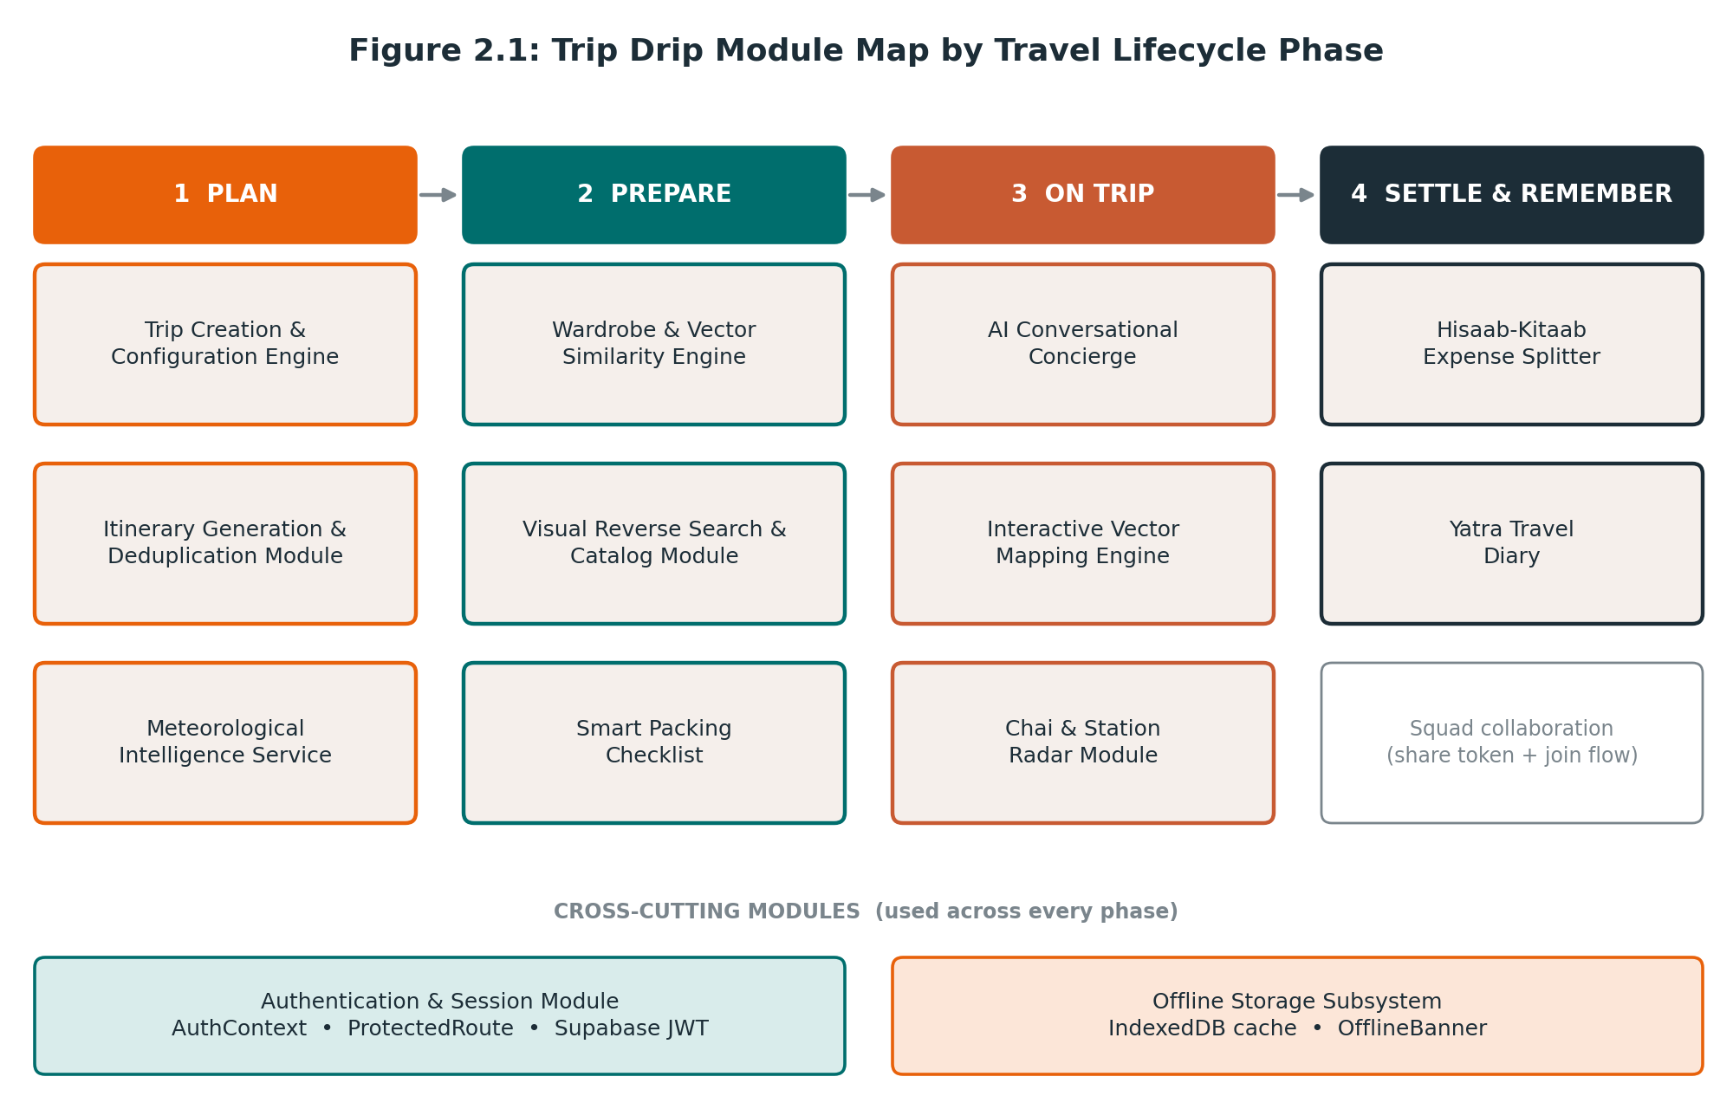
Figure 2.1: Module map grouped by travel lifecycle phase
The modules are deliberately coupled through shared trip state rather than through each other's internals. For example, the itinerary drives wardrobe requirements, wardrobe gaps drive shopping suggestions, and shopping and expense entries both update the trip's live budget view.

2.6 Development Approach and Design Maturity
The system was built with an Agile Evolutionary Prototyping approach across five sprints. The architecture and data model were laid down first and later sprints added capability on top of a stable base.
Table 2.3: Sprint plan and design focus
Sprint | Focus | Design outcome
1 | Core architecture and database schema | PostgreSQL schema, Supabase Auth, RLS policies, Open-Meteo integration
2 | Itinerary and multi-modal engine | India transport models, hotel-tier algorithm, itinerary generation with auto-repair
3 | Wardrobe, vector embeddings, shopping | DeepFashion2 category mapping, OpenAI embeddings, pgvector cosine matching, multi-brand catalog
4 | Advanced features and AI concierge | Action-taking LangChain concierge, minimal cashflow engine, Chai Radar, Leaflet maps, IndexedDB layer
5 | Testing, optimisation, QA | 81 QA assertions, 367 itinerary validator tests, and 8 API handler tests, all passing

3. Design Goals, Constraints and Assumptions

3.1 Design Goals
The non-functional requirements set the quality bar for every design decision. Each goal below is paired with the concrete design response used to meet it.
Table 3.1: Non-functional goals and design responses
ID | Goal | Target | Design response
NFR-01 | Performance and latency | Bundle load < 2.0 s; IndexedDB queries < 50 ms; API proxy responses < 1.5 s | Vite/Rollup bundling; tree-shakeable icon set; stateless handlers; local IndexedDB reads; deterministic rule-based engines for common paths
NFR-02 | Security and privacy | Strict tenant isolation; no plain-text passwords | Supabase Auth with JWT; RLS on all six tables; secrets held only on the server
NFR-03 | Reliability and fault tolerance | Uninterrupted service during AI outages or quota limits | Dual-engine design: LLM first, curated data and rule-based logic as fallback on every AI route
NFR-04 | Usability and aesthetics | Responsive, mobile-first, high contrast | Tailwind design tokens; vintage Indian visual language (boarding-pass and passport-stamp motifs)
NFR-05 | Offline resilience | Cached trips, wardrobe, checklists, expenses available offline | IndexedDB caching layer with transparent query redirection

3.2 Design Principles
- Integrated ecosystem. Modules share trip state so that one action ripples through the app (an expense updates the dashboard and the settlement engine; a packed item updates the progress ring).
- Dual-engine intelligence. Every AI feature has a deterministic fallback, so the app works with zero API keys and survives rate limits.
- Offline resilience. Trip data is cached locally so the app keeps working without a network, and the interface signals connectivity loss instead of failing.
- Defence in depth. Authentication, database-level RLS, storage-path policies, and server-side secrets each protect the data independently.
- Stateless, decoupled services. API handlers hold no session state and can run under Express locally or as Vercel serverless functions.
- India-first domain modelling. INR pricing, Indian Railways classes, UPI settlement, regional cuisine, and cultural dress guidance are first-class concepts, not add-ons.

3.3 Technology Stack
Table 3.2: Technology stack and architectural role
Layer | Technology | Role in the design
Frontend framework | React 18 (SPA) | Component-based declarative UI
Build tool | Vite 5 | Fast hot module replacement and optimised Rollup production bundles
Styling | Tailwind CSS 3 | Utility-first CSS with custom Indian design tokens
Routing | React Router DOM v6 | Client-side routing, nested layouts, route guards
Icons | Lucide React | Lightweight, tree-shakeable SVG icons
Mapping | Leaflet and React-Leaflet | Open-source, mobile-friendly interactive maps
Backend / API | Node.js and Express 4 | Lightweight REST proxy and business-logic layer
Database and Auth | Supabase (PostgreSQL 15) | Managed PostgreSQL with JWT Auth, Storage, and RLS
Vector search | pgvector | 1536-dimensional cosine similarity for clothing matching
AI / LLM | LangChain and OpenAI | Prompt templating and GPT-4o-mini reasoning, with fallback
Weather | Open-Meteo API | Key-free forecast and historical archive
Client storage | IndexedDB (offlineStorage.js) | High-capacity structured offline storage

3.4 Environment Requirements

Hardware
Table 3.3: Hardware requirements
Component | Minimum | Recommended
Processor | Dual-core 2.0 GHz (x86_64 or ARM64) | Quad-core 2.5 GHz+ (Intel i5/i7, Ryzen, Apple M-series)
RAM | 4 GB | 8 GB or higher
Storage | 500 MB free | 2 GB free SSD
Network | 512 Kbps | 10 Mbps or faster
Display | 1024 × 768 | 1920 × 1080 or a responsive mobile screen

Software
Table 3.4: Software requirements
Layer | Technology | Version
Operating system | Windows / macOS / Linux | Windows 10/11, macOS Monterey+, Ubuntu 20.04+
Runtime | Node.js (ES Modules) | v18.x – v22.x (development used v20.x)
Package manager | npm | v9.x – v10.x
Browser | Chrome, Firefox, Safari, Edge | Evergreen browsers with ES2022+ support
Database | PostgreSQL on Supabase | v15.x with pgvector and uuid-ossp
Version control | Git | v2.40+

3.5 Design Constraints
Table 3.5: Constraints and their design impact
Constraint | Design impact
Open-Meteo forecasts cover at most 16 days ahead. | The weather service switches automatically to historical climate archives for later dates.
Image uploads are limited to 15 MB base64 payloads. | Images pass through the client-side optimiser (imageOptimizer.js) to keep payloads small.
OpenAI calls are rate-limited and quota-bounded. | Every AI route has a curated or rule-based fallback; the app must work with no keys.
Itineraries span 1 to 7 days. | Curated templates and the deduplication validator are sized for up to 7 distinct days.
Group size ranges from 1 to 50 travellers. | Settlement and budget calculations are validated against this range.
The retail catalog contains 29 curated items across four brands. | Visual search scores against a bundled catalog, not a live retail feed.
Free-tier hosting (Supabase, Vercel, Open-Meteo). | No mandatory recurring cost; features must degrade gracefully instead of requiring paid services.

3.6 Assumptions and Dependencies
- The user has an internet-connected device during trip creation and synchronisation.
- Indian Rupees (₹) is the base currency for transport and budget estimates.
- Users have a UPI client app (GPay, PhonePe, Paytm) to scan generated settlement QR codes.
- Feasibility: proven open-source components (technical), familiar Indian terminology (operational), and free tiers with rule-based fallbacks (economic).
- External dependencies are Supabase, Vercel, OpenAI, HuggingFace Inference, Open-Meteo, and OpenStreetMap tiles. Each has a defined degraded behaviour (see Section 4.6).

3.7 Key Design Decisions and Rationale
Table 3.6: Key decisions
Decision | Rationale
Decoupled SPA with a separate API layer | The UI and business logic can change independently, and client-side routing plus local caching supports offline use.
One handler per endpoint, runnable under Express or Vercel | The same api/*.js file serves local development and production serverless deployment with no code changes.
Supabase PostgreSQL with pgvector | Vector similarity lives inside the relational database, so embeddings sit beside the rows they describe and share RLS protection. Auth and Storage come built in.
jsonb for itinerary and weather | An itinerary is a nested document of 1–7 days that is read and written as a whole, so a single jsonb column is simpler than a normalised set of tables.
Rule-based and curated fallbacks | They guarantee behaviour when the LLM is unavailable and keep the app free to run.
Deterministic itinerary validator and auto-repair | LLM output was observed to repeat routes across days (defect BUG-01); a deterministic check guarantees unique days regardless of model behaviour.

4. Architectural Design

4.1 Architectural Style
Trip Drip uses a decoupled three-tier architecture. A React 18 Single-Page Application is the client tier. A set of stateless Express / Vercel serverless handlers forms the application tier. Supabase (PostgreSQL with pgvector, Auth, and Storage) is the data tier. Third-party AI, weather, and map services are consumed as external dependencies. The client talks directly to Supabase for authentication and RLS-protected data access, and to the API tier for anything that needs secrets, AI, or heavy computation.

4.2 High-Level Architecture
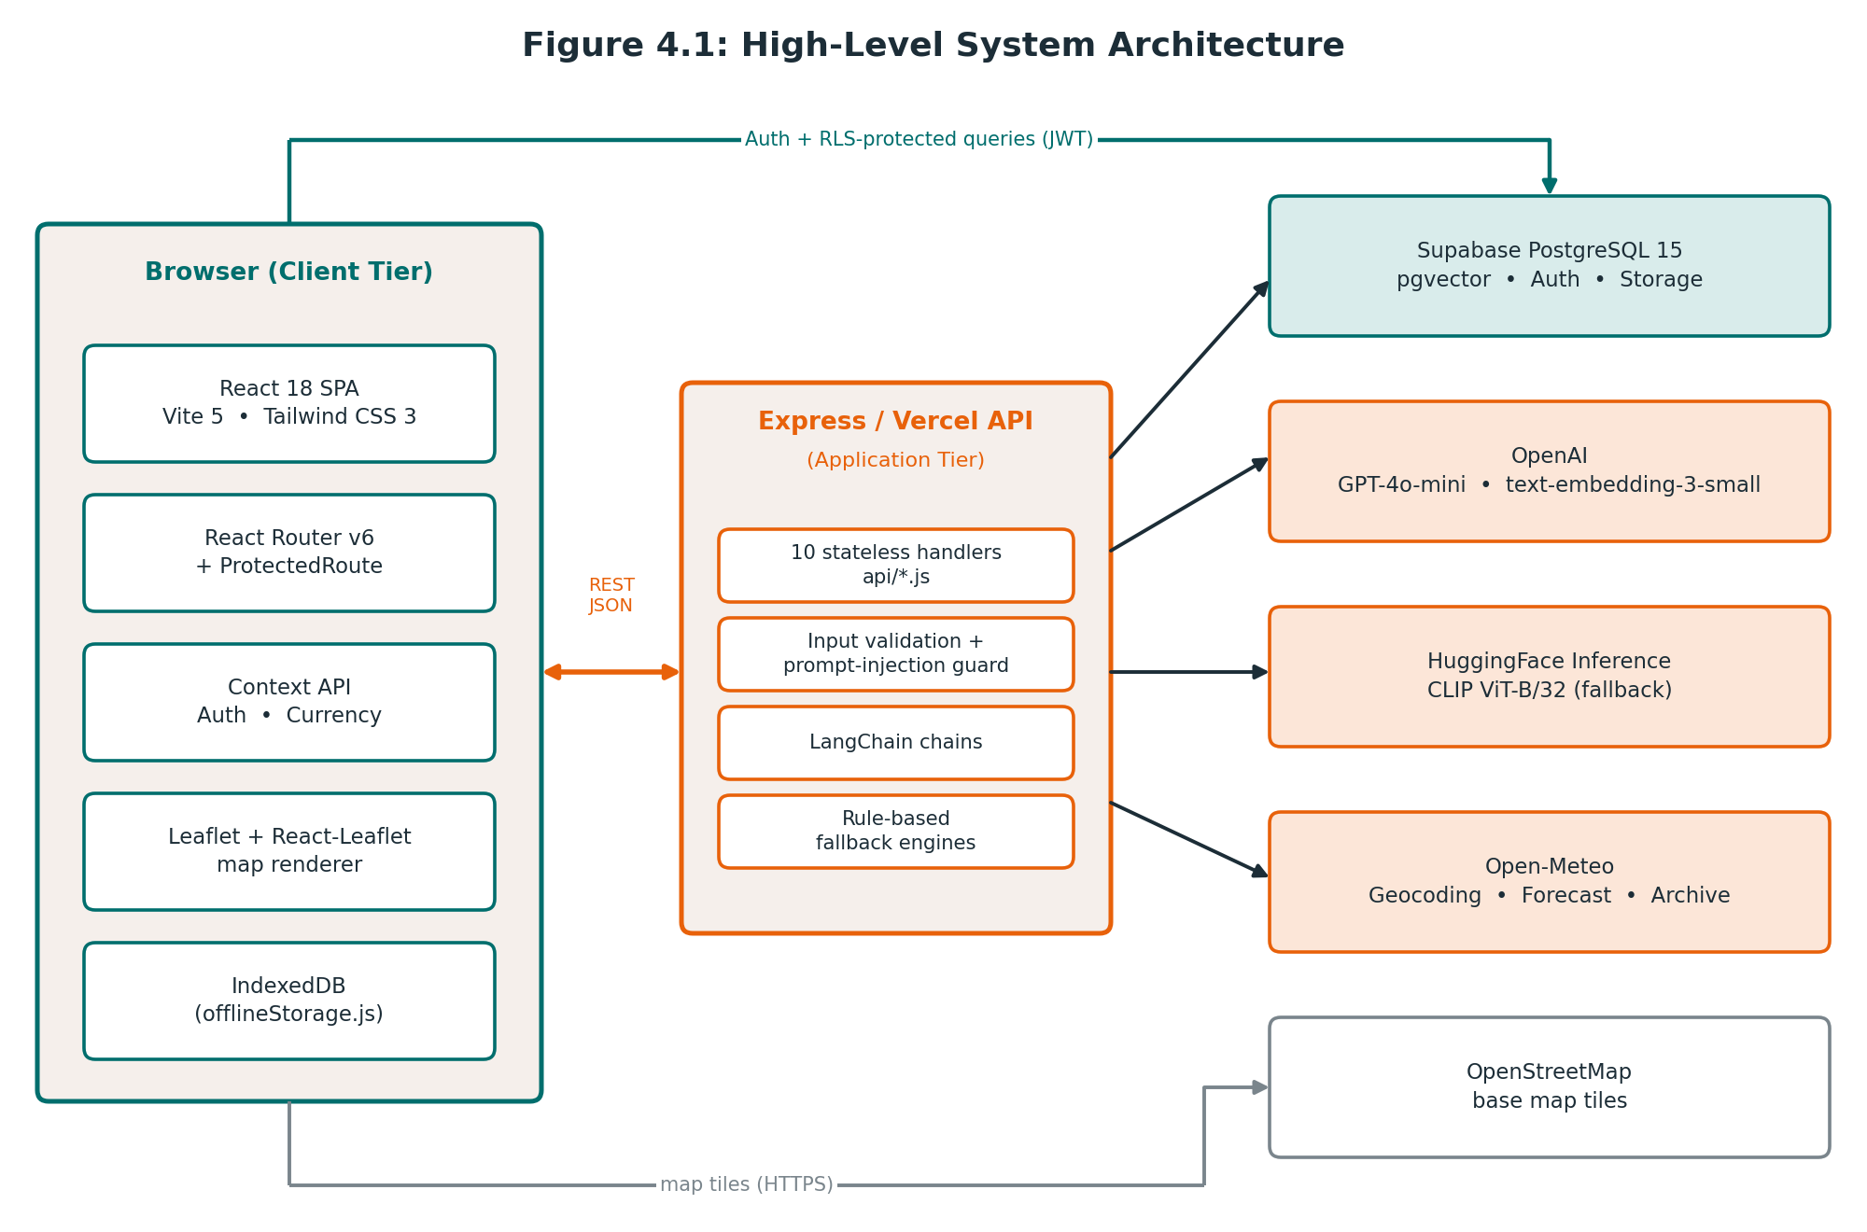
Figure 4.1: High-level system architecture
Table 4.1: Interfaces between architectural elements
From → To | Protocol / payload | Purpose
Browser → API tier | HTTPS, REST, JSON (POST) | Itinerary, weather, budget, wardrobe, catalog, and concierge operations
Browser → Supabase | HTTPS via Supabase client; anon key and user JWT | Sign-in, session refresh, and RLS-protected reads and writes
API tier → Supabase | SQL and vector queries; storage uploads; service key | Embedding storage, similarity queries, garment image storage
API tier → OpenAI | HTTPS | GPT-4o-mini chat and vision; text-embedding-3-small
API tier → HuggingFace | HTTPS | CLIP ViT-B/32 zero-shot classification fallback
API tier → Open-Meteo | HTTPS | Geocoding, 16-day forecast, historical archive
Browser → OpenStreetMap | HTTPS tile requests | Base map imagery for Leaflet

4.3 Frontend Architecture
The frontend is a React 18 application built from functional components and hooks (useState, useEffect, useRef, useCallback, useMemo, useContext). main.jsx mounts App.jsx, which configures routing and layouts and wraps the tree in the global providers.
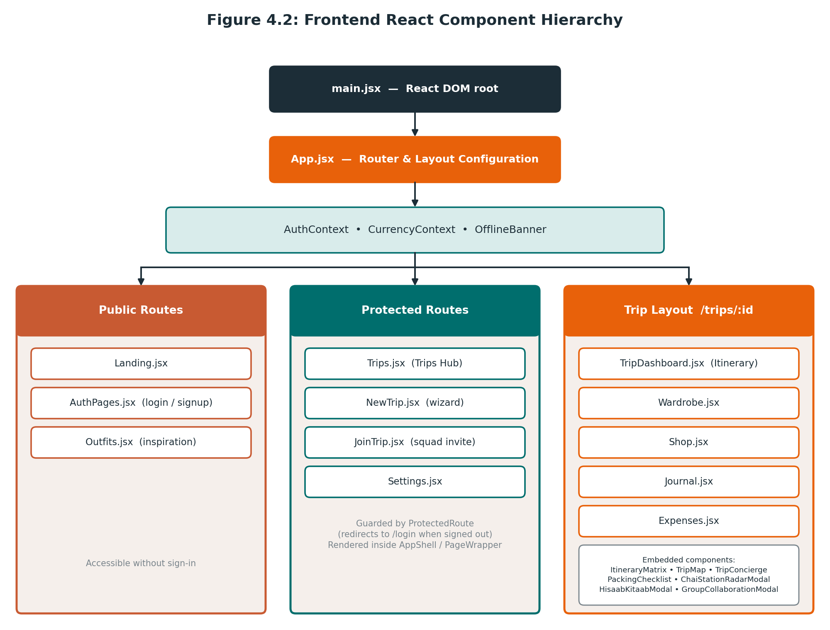
Figure 4.2: Frontend React component hierarchy
State and communication. Components are strictly decoupled and communicate through props, two React contexts (AuthContext for the session and CurrencyContext for display currency), and custom event triggers. Server state is fetched per screen; offline state is mirrored into IndexedDB.
Table 4.2: Component folder organisation (`src/components/`)
Folder | Contents
auth/ | ProtectedRoute.jsx
chat/ | TripConcierge.jsx
checklist/ | PackingChecklist.jsx
expenses/ | HisaabKitaabModal.jsx
food/ | ChaiStationRadarModal.jsx
itinerary/ | ItineraryMatrix.jsx, DayWardrobeCard.jsx
journal/ | PhotoUploader.jsx, PhotoLightbox.jsx
layout/ | AppShell.jsx, PageWrapper.jsx
maps/ | TripMap.jsx (Leaflet vector map)
shop/ | BrandComparisonModal.jsx, ComparisonGrid.jsx, ShoppingCartDrawer.jsx
trip/ | GroupCollaborationModal.jsx, GroupMissingItems.jsx
ui/ | BoardingPassCard, Button, Input, OfflineBanner, PassportStamp, and other shared primitives
Supporting directories: src/pages/ (route pages), src/contexts/ (providers), src/services/ (offlineStorage.js, currency.js), src/lib/ (supabaseClient.js), src/utils/ (imageOptimizer.js), and src/data/ (curated datasets).
Visual system. Tailwind design tokens define the palette: saffron #E8610A, teal #006E6D, sand #F5EFEB, slate #1C2D37, and terracotta #C85A32. Typography pairs editorial serif headings (Playfair Display / Cinzel) with clean sans-serif UI text (Outfit / Inter) and monospaced flight codes (JetBrains Mono). Custom classes such as .geo-border-top and .postcard-card provide the boarding-pass and postcard look.

4.4 Backend Architecture
The backend is a directory of ten isolated handler files in api/. Each exports default async function handler(req, res), accepts an HTTP POST, validates input, runs its business logic, and returns JSON with an appropriate status code. In development server.js (Express 4.19, port 3001, CORS and JSON parsing) mounts every handler. In production Vercel maps /api/* to the same files as serverless functions through vercel.json.
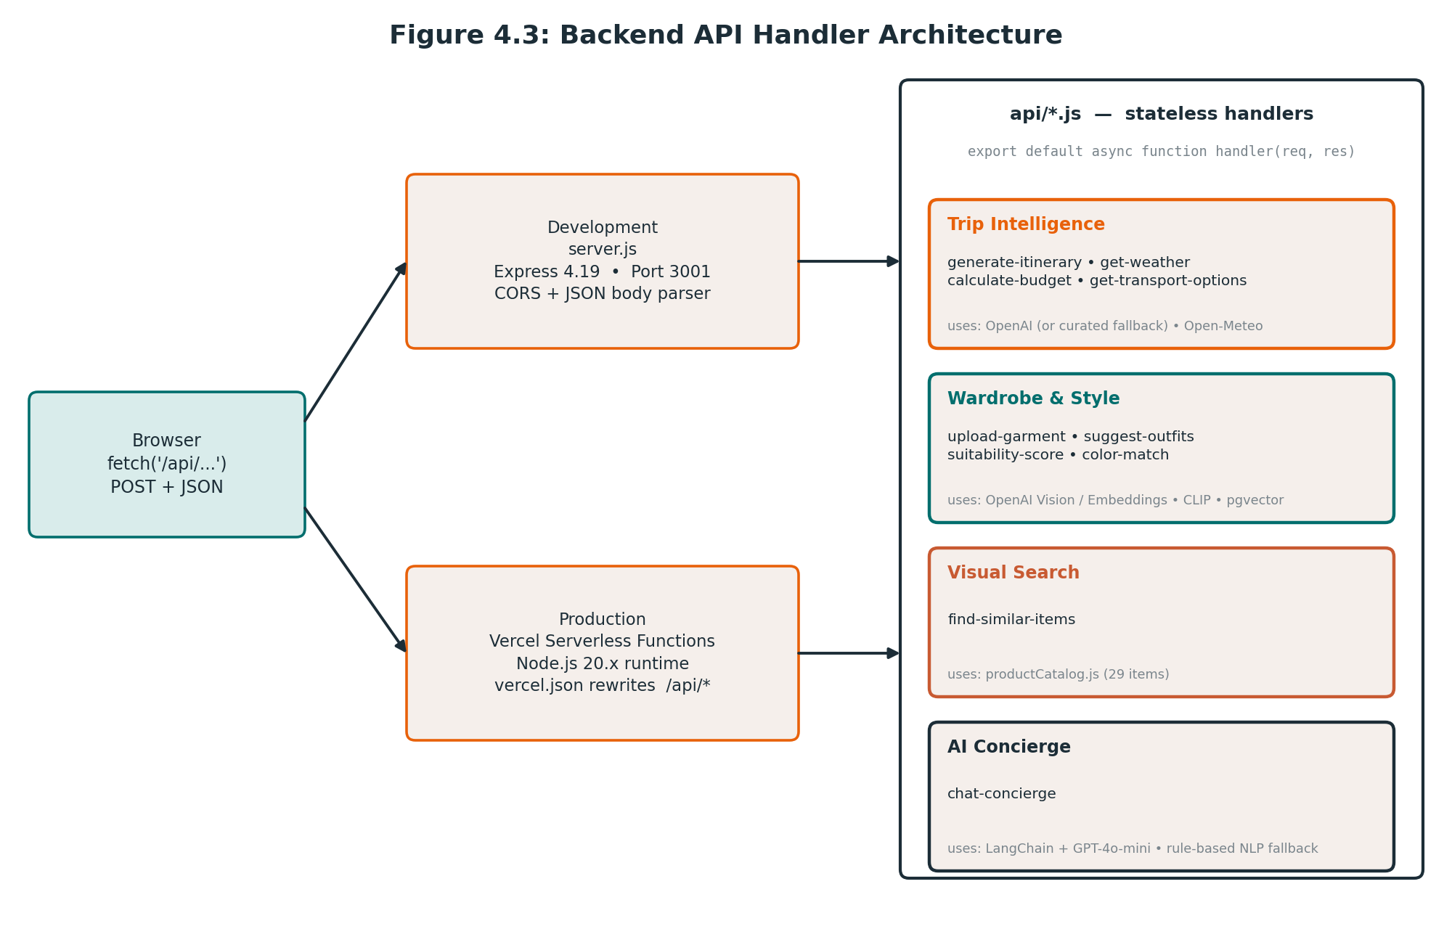
Figure 4.3: Backend API handler architecture
Table 4.3: API endpoint summary
Endpoint | Responsibility | Key dependencies
/api/generate-itinerary | Day-by-day routes with themes, meals, budgets, and wardrobe tips | GPT-4o-mini or curated templates; deduplication validator
/api/get-weather | Geocode a city and return daily high/low, precipitation, humidity | Open-Meteo forecast and archive
/api/calculate-budget | Compare train, bus, car, flight, and 1★–5★ hotel tiers | indiaTransport.js
/api/get-transport-options | Transit fare breakdown and distance | indiaTransport.js
/api/upload-garment | Store image, classify garment, generate embedding | Supabase Storage, GPT-4o-mini Vision or CLIP, embeddings
/api/suggest-outfits | Match daily itinerary needs to wardrobe vectors | pgvector, cosine similarity
/api/suitability-score | 0–10 garment score against destination climate | Weather data, style rules
/api/color-match | Complementary colour pairings with styling rationale | Vector distance inversion, LangChain
/api/chat-concierge | Action-executing conversational assistant | LangChain, GPT-4o-mini, rule-based intent parsing
/api/find-similar-items | Score a garment against the multi-brand catalog | productCatalog.js

4.5 Database Architecture and pgvector Integration
Trip Drip uses PostgreSQL 15 on Supabase with the vector and uuid-ossp extensions enabled. Wardrobe items store a 1536-dimensional embedding produced by OpenAI's text-embedding-3-small (or a padded CLIP vector when the fallback classifier is used). Similarity between two vectors A and B is measured by cosine similarity:
Similarity(A, B) = (A · B) / (‖A‖ × ‖B‖)
Section 6 specifies the schema, relationships, and data rules in detail.

4.6 External Service Integration and Fallbacks
Table 4.4: External services and degraded behaviour
Service | Used for | If unavailable
OpenAI GPT-4o-mini | Itinerary text, vision classification, concierge dialogue | Curated Indian itineraries (indiaItineraries.js) and rule-based intent extraction (chat-concierge.js)
OpenAI embeddings | 1536-d wardrobe vectors | Padded CLIP vectors from the HuggingFace fallback
HuggingFace Inference (CLIP ViT-B/32) | Zero-shot garment classification fallback | Classification relies on GPT-4o-mini Vision, the primary path
Open-Meteo forecast | Daily weather within 16 days | Historical climate archive (archive-api.open-meteo.com) for later dates
OpenStreetMap tiles | Leaflet base map | Leaflet still draws vector waypoints and transit lines; only the base imagery is lost
Network (any) | All remote calls | Offline banner shown; queries redirect to IndexedDB

4.7 Data Flow Between Components
Components synchronise reactively so that one user action updates every view that depends on it.
Table 4.5: Cross-component data flows
Trigger | Effect
An item is added to the cart in Shop.jsx or through TripConcierge.jsx | State updates reach ShoppingCartDrawer.jsx, which refreshes the remaining-budget bar in TripDashboard.jsx and Expenses.jsx.
An item is checked off in PackingChecklist.jsx | The progress ring in the dashboard header is recalculated.
An expense is logged in Expenses.jsx | Summary cards and the category chart update immediately, and the data feeds HisaabKitaabModal.jsx.
A trip is created | The record is written to PostgreSQL and cached in IndexedDB for offline use.
The network drops | OfflineBanner activates and data reads redirect to IndexedDB.

4.8 Deployment Architecture
The frontend is compiled with vite build into dist/ and served from Vercel's global CDN with a single-page-app fallback to index.html. API handlers run as Node.js 20.x serverless functions. Supabase hosts the database, authentication, and storage. Local development uses two processes: Vite on port 5173 and Express on port 3001.
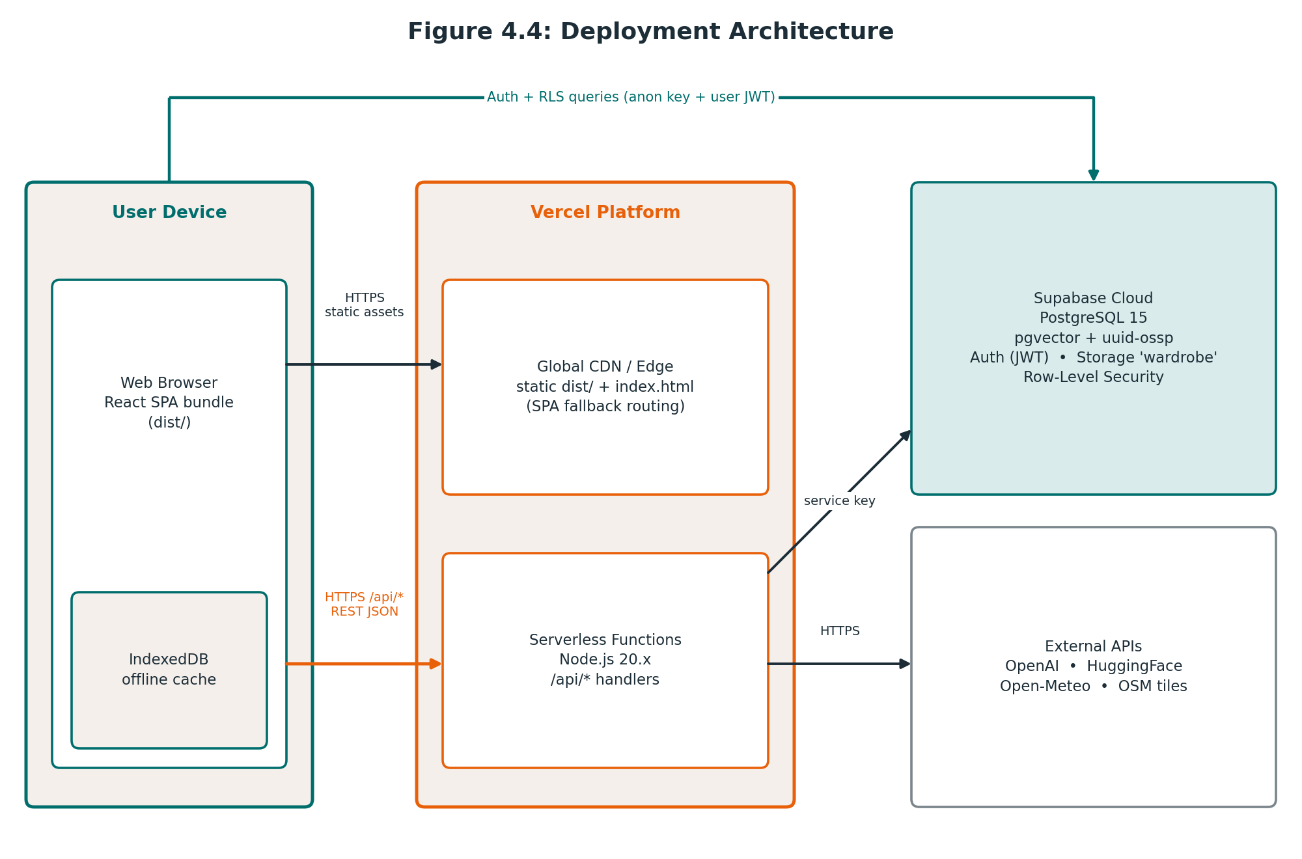
Figure 4.4: Deployment architecture
Table 4.6: Configuration variables
Variable | Scope | Purpose
VITE_SUPABASE_URL | Client | Supabase project URL
VITE_SUPABASE_ANON_KEY | Client | Public anon key; access is limited by RLS
SUPABASE_SERVICE_KEY | Server only | Privileged key for storage and vector operations
OPENAI_API_KEY | Server only | GPT-4o-mini and embeddings
HUGGINGFACE_API_KEY | Server only | CLIP fallback classification
PORT | Server (dev) | Express port; defaults to 3001
Secrets never enter the client bundle: only VITE_-prefixed variables are exposed to the browser, and all privileged keys remain on the server.

5. Module Design
This section specifies the fourteen design units of Trip Drip: the thirteen modules from the module breakdown, plus the squad-collaboration components that realise FR-14. Each module card states its purpose, files, inputs and outputs, design behaviour, and dependencies. Algorithms are named here and specified in full in Section 7.

5.1 Authentication and Session Module
Purpose | Register, sign in, sign out, persist sessions, and guard protected routes (FR-01).
Key files | AuthContext.jsx, ProtectedRoute.jsx, AuthPages.jsx, src/lib/supabaseClient.js
Inputs | Email and password (valid email syntax; minimum 6 characters).
Outputs | Session and user object exposed through context; redirect to /trips on success; redirect to /login when unauthenticated.
Design behaviour | AuthProvider calls supabase.auth.getSession() on mount and subscribes to onAuthStateChange, publishing user and loading. ProtectedRoute renders a loading skeleton while the session resolves, then redirects to /login if no user exists. Supabase issues signed JWTs with automated refresh rotation, and a database trigger creates the matching public.users profile row at registration.
Dependencies | Supabase Auth; public.users table.

5.2 Trip Creation and Configuration Engine
Purpose | Capture trip parameters and compute multi-modal transport and lodging estimates (FR-02, FR-05, UC-01).
Key files | NewTrip.jsx, indiaTransport.js, api/calculate-budget.js, api/get-transport-options.js
Inputs | Destination (with suggestions), origin city, start and end dates, budget in INR, travel style (Beach, City, Mountain, Temple, Mixed), group size, offbeat preference (Mix, Offbeat, Popular).
Outputs | Live fare comparison and hotel-tier recommendation before submission; a saved trips record; navigation to /trips/:id.
Design behaviour | Compares Train (2S, SL, 3AC, 2AC, 1AC), Bus (Ordinary, Express, Volvo-AC), Private Car, and Flight, and recommends a 1★–5★ hotel tier with natural-language reasoning. On submission the wizard orchestrates the pipeline: geocode and fetch weather, generate and validate the itinerary, save to PostgreSQL, cache to IndexedDB, then open the dashboard.
Dependencies | Weather service (5.4), Itinerary module (5.3), Offline Storage (5.13), trips table.

5.3 Itinerary Generation and Deduplication Module
Purpose | Produce sequenced 1–7 day itineraries in which every day has a distinct route and theme (FR-04).
Key files | api/generate-itinerary.js, indiaItineraries.js, ItineraryMatrix.jsx, DayWardrobeCard.jsx
Inputs | Trip parameters and the weather summary.
Outputs | An itinerary document stored in trips.itinerary_json: per-day theme, route (Place A → Place B), time-stamped activities, meal stops, transport notes, daily group and per-person budget, and wardrobe advice.
Design behaviour | The handler first asks GPT-4o-mini through LangChain, with prompt-injection safeguards. If the model is unavailable or rate-limited, it uses curated templates for eight corridors: Goa, Jaipur, Mumbai, Lonavala, Delhi, Rann of Kutch, Kerala, and Kolkata. Either way the result passes isDuplicateOrInvalidItinerary(), and invalid output is repaired by an automatic route rotator. ItineraryMatrix.jsx renders the result as accordion cards.
Dependencies | OpenAI (optional), curated data, Weather service. Algorithm: Deduplication and Auto-Repair (Section 7).

5.4 Meteorological Intelligence Service
Purpose | Supply destination weather to itinerary, wardrobe, and dashboard (FR-03).
Key files | api/get-weather.js
Inputs | City name and date range.
Outputs | Daily high and low temperature, precipitation likelihood, humidity, dominant weather code, mean temperature, and extreme range; cached in trips.weather_json.
Design behaviour | Geocodes the city with the Open-Meteo Geocoding API, then queries the forecast endpoint. Because forecasts stop at 16 days, dates beyond that window automatically use the historical archive endpoint. No API key is required.
Dependencies | Open-Meteo Geocoding, Forecast, and Archive APIs.

5.5 Wardrobe and Vector Similarity Engine
Purpose | Manage a digital closet and match garments to trip weather and daily plans (FR-06).
Key files | Wardrobe.jsx, api/upload-garment.js, api/suggest-outfits.js, api/suitability-score.js, api/color-match.js, imageOptimizer.js
Inputs | Garment images (base64, up to 15 MB), trip weather and itinerary descriptions.
Outputs | wardrobe_items rows with category, colours, description, embedding, suitability score and note; daily outfit suggestions; complementary colour pairings.
Design behaviour | The upload pipeline runs in five steps, listed below the card. Suggestions embed the day's itinerary description and rank stored garments by cosine similarity. Suitability scoring rates a garment from 0 to 10 against climate and style. Colour matching finds complementary owned pieces by inverting vector distance and adds a LangChain styling rationale.
Dependencies | Supabase Storage and pgvector; OpenAI Vision and embeddings; HuggingFace CLIP fallback; Weather service.

Garment upload pipeline
- The client optimises the image and sends it as base64 to /api/upload-garment.
- The handler stores the file in the wardrobe Supabase Storage bucket under the user's own folder.
- The garment is classified to a DeepFashion2 category and primary colour (GPT-4o-mini Vision, or CLIP zero-shot as fallback).
- A 1536-dimensional embedding is generated (text-embedding-3-small, or a padded CLIP vector).
- The wardrobe_items row is inserted with category, colours, description, and embedding.

5.6 Visual Reverse Search and Catalog Module
Purpose | Find similar purchasable items from a garment or lookbook piece and track shopping against budget (FR-07).
Key files | Outfits.jsx, Shop.jsx, api/find-similar-items.js, productCatalog.js, BrandComparisonModal.jsx, ComparisonGrid.jsx, ShoppingCartDrawer.jsx
Inputs | Garment attributes from a lookbook piece or a wardrobe item.
Outputs | Ranked matches with a similarityScore (72–98%) and outbound purchase links; a brand price comparison; a live remaining-budget figure.
Design behaviour | Attribute similarity is scored against 29 catalog items across Zara, H&M, Uniqlo, and Westside. The Outfits page offers five curated collections (Goa Coastal Linen, Jaipur Royal Heritage, Ghats Monsoon Quick-Dry, Himalayan Layering, Spiritual Modest) with a traveller-type filter. Adding to the cart updates the shopping budget shown in the dashboard and expense views.
Dependencies | Bundled product catalog; Shopping cart state.

5.7 AI Conversational Concierge
Purpose | Answer trip questions and change trip state from natural language (FR-08).
Key files | TripConcierge.jsx, api/chat-concierge.js; chat_messages table
Inputs | User chat messages and the current trip context.
Outputs | A reply plus an optional action trigger that the frontend executes; conversation history persisted per trip.
Design behaviour | A LangChain pipeline over GPT-4o-mini drafts the reply. If the model is unavailable, rule-based intent parsing recognises the same actions. TripConcierge.jsx parses the action trigger and calls the relevant module (see the action table below).
Dependencies | OpenAI (optional), Shopping cart, Packing checklist, Expenses, Diary, Chai Radar and Hisaab-Kitaab modals.

Table 5.1: Concierge actions
Action | Effect in the application
ADD_TO_CART | Adds an apparel item to the shopping cart and updates the remaining budget.
MARK_PACKED | Marks a checklist item as packed and updates progress.
ADD_EXPENSE | Logs an expense in the group expense tracker.
ADD_JOURNAL | Creates an entry in the Yatra Diary.
OPEN_CHAI_RADAR | Opens the Chai & Station Radar modal.
OPEN_HISAAB_KITAAB | Opens the Hisaab-Kitaab settlement modal.

5.8 Hisaab-Kitaab Expense Splitter
Purpose | Log group expenses and settle debts with the fewest possible payments (FR-09, UC-06).
Key files | Expenses.jsx, HisaabKitaabModal.jsx; expenses table
Inputs | Expense label, amount (INR), category (Food, Transport, Lodging, Sightseeing, Shopping), and payer.
Outputs | Category totals and budget utilisation; a list of transfers of the form 'Person A pays Person B ₹X'; a scannable UPI QR code and deep links per transfer; a formatted WhatsApp summary.
Design behaviour | The modal totals all spend, computes each person's fair share and net balance (creditors positive, debtors negative), and runs the greedy minimal cashflow algorithm. Selecting a debtor–creditor pair renders a Bharat UPI (upi://pay) QR as SVG. A one-tap action shares the summary on WhatsApp.
Dependencies | expenses table; Currency context. Algorithm: Minimal Cashflow Resolution (Section 7).

5.9 Chai and Station Radar Module
Purpose | Guide travellers to verified highway dhabas, railway-platform food, and safe water (FR-10).
Key files | ChaiStationRadarModal.jsx, chaiStationRadarData.js, indiaTravelKnowledge.js
Inputs | Selected corridor.
Outputs | Corridor cards (CSMT Mumbai, Lonavala Ghats, Old Delhi, Jaipur Highway, Konkan Route, and others), signature teas (Cutting Masala, Irani Chai, Kulhad Adrak-Gud), iconic foods with prices, and Rail Neer hygiene tips.
Design behaviour | Content is a curated, verified dataset shipped with the application rather than fetched at runtime, so the radar needs no network call and no AI service.
Dependencies | Bundled dataset only.

5.10 Interactive Vector Mapping Engine
Purpose | Plot the itinerary's waypoints on an interactive map (FR-13).
Key files | TripMap.jsx
Inputs | Ordered waypoint coordinates from the itinerary.
Outputs | Sequenced markers, great-circle transit lines, and distances.
Design behaviour | Uses Leaflet through React-Leaflet with a custom m4dm4x100 palette over OpenStreetMap tiles. Distances between waypoints are computed with the Haversine formula (Earth radius 6371 km).
Dependencies | Leaflet, OpenStreetMap tiles, itinerary data. Algorithm: Haversine (Section 7).

5.11 Smart Packing Checklist
Purpose | Track packing by category with live progress (FR-11).
Key files | PackingChecklist.jsx, GroupMissingItems.jsx
Inputs | Check and uncheck actions, custom items, and MARK_PACKED from the concierge.
Outputs | Percentage packed, category completion meters, and the dashboard progress ring.
Design behaviour | Items are grouped into Clothing, Documents, Electronics, and Toiletries. Any change recalculates the progress shown on the dashboard header, and the concierge can mark items packed. Squad members' unpacked items are aggregated in the joint missing-items view.
Dependencies | Concierge (5.7), Squad Collaboration (5.14), Offline Storage (5.13).

5.12 Yatra Travel Diary
Purpose | Keep a multi-day travel journal with photos (FR-12).
Key files | Journal.jsx, PhotoUploader.jsx, PhotoLightbox.jsx, imageOptimizer.js; journal_entries table
Inputs | Date, mood (Excited, Peaceful, Wonder, Adventurous, Tired), rich text, and photos.
Outputs | A memory timeline and a full-screen photo lightbox; entries stored with a photos JSONB array of URLs and captions.
Design behaviour | Entries are keyed by trip and date. Photos are optimised before upload and displayed through the lightbox viewer. The concierge can create an entry through ADD_JOURNAL.
Dependencies | journal_entries table; Concierge.

5.13 Offline Storage Subsystem
Purpose | Keep the app usable without a network (NFR-05).
Key files | src/services/offlineStorage.js, OfflineBanner (in components/ui/)
Inputs | Trip, wardrobe, checklist, expense, and journal data after successful loads and saves.
Outputs | The same data served locally when offline, targeted at under 50 ms per query.
Design behaviour | Data is cached in IndexedDB. When connectivity is lost, OfflineBanner appears and data queries are redirected to IndexedDB transparently, so screens keep working without code paths of their own.
Dependencies | Browser IndexedDB. Used by nearly every module.

5.14 Squad Collaboration Components
Purpose | Let friends join a trip and see shared plans (FR-14).
Key files | GroupCollaborationModal.jsx, JoinTrip.jsx, GroupMissingItems.jsx; trips.share_token
Inputs | The trip's share token (UUID) and an invited user's sign-in.
Outputs | A shareable invite URL with a one-tap copy button, a member list, and a joint missing-items view.
Design behaviour | Each trip is created with a unique share_token. The owner shares an invite URL; a companion opens it, signs in, and lands in JoinTrip.jsx. Members can view the shared itinerary, tick packing items, and take part in settlement.
Dependencies | Authentication (5.1), Packing Checklist (5.11), Hisaab-Kitaab (5.8).

5.15 Module, API and Data Traceability
The table below shows which endpoints and data stores each module touches. It is the quickest way to find what to inspect when a module changes.
Table 5.2: Module to endpoint and data mapping
Module | API endpoints | Data stores
Authentication and Session | None (Supabase Auth directly) | users
Trip Creation and Configuration | calculate-budget, get-transport-options | trips
Itinerary Generation | generate-itinerary | trips.itinerary_json
Meteorological Service | get-weather | trips.weather_json
Wardrobe and Vector Engine | upload-garment, suggest-outfits, suitability-score, color-match | wardrobe_items, Storage bucket wardrobe
Visual Search and Catalog | find-similar-items | productCatalog.js (bundled)
AI Concierge | chat-concierge | chat_messages
Hisaab-Kitaab | None | expenses
Chai and Station Radar | None | chaiStationRadarData.js (bundled)
Mapping Engine | None | Reads itinerary waypoints
Packing Checklist | None | Client state and IndexedDB
Yatra Diary | None | journal_entries
Offline Storage | None | IndexedDB
Squad Collaboration | None | trips.share_token

6. Data Design

6.1 Data Design Overview
Persistent application data lives in PostgreSQL 15 on Supabase with the vector and uuid-ossp extensions. The schema has six relational tables. Every primary key is a UUID, every timestamp is timestamptz, semi-structured content uses jsonb, and wardrobe embeddings use vector(1536). All foreign keys cascade on delete, and Row-Level Security is enabled on every table.
Around the database sit three further data holders: Supabase Storage for garment images, IndexedDB for the offline cache, and bundled curated datasets for content that never changes at runtime.

6.2 Data Stores
Table 6.1: Data stores and what they hold
Store | Technology | Contents
Relational database | PostgreSQL 15 (Supabase) | Users, trips, wardrobe items with embeddings, expenses, journal entries, chat messages
File storage | Supabase Storage, bucket wardrobe | Garment images, in per-user folders
Offline cache | IndexedDB (offlineStorage.js) | Trips, wardrobes, checklists, expenses, journals
Curated datasets | Bundled JavaScript in src/data/ | indiaItineraries.js, indiaTransport.js, indiaTravelKnowledge.js, chaiStationRadarData.js, productCatalog.js
Session and view state | React state and Context | Current user, display currency, cart, and other transient UI state

6.3 Entity-Relationship Model
users is the root owner. A user owns many trips and many wardrobe items. Each trip owns its expenses, journal entries, and chat messages. Deleting a user or a trip removes everything beneath it, so no orphaned records can remain.
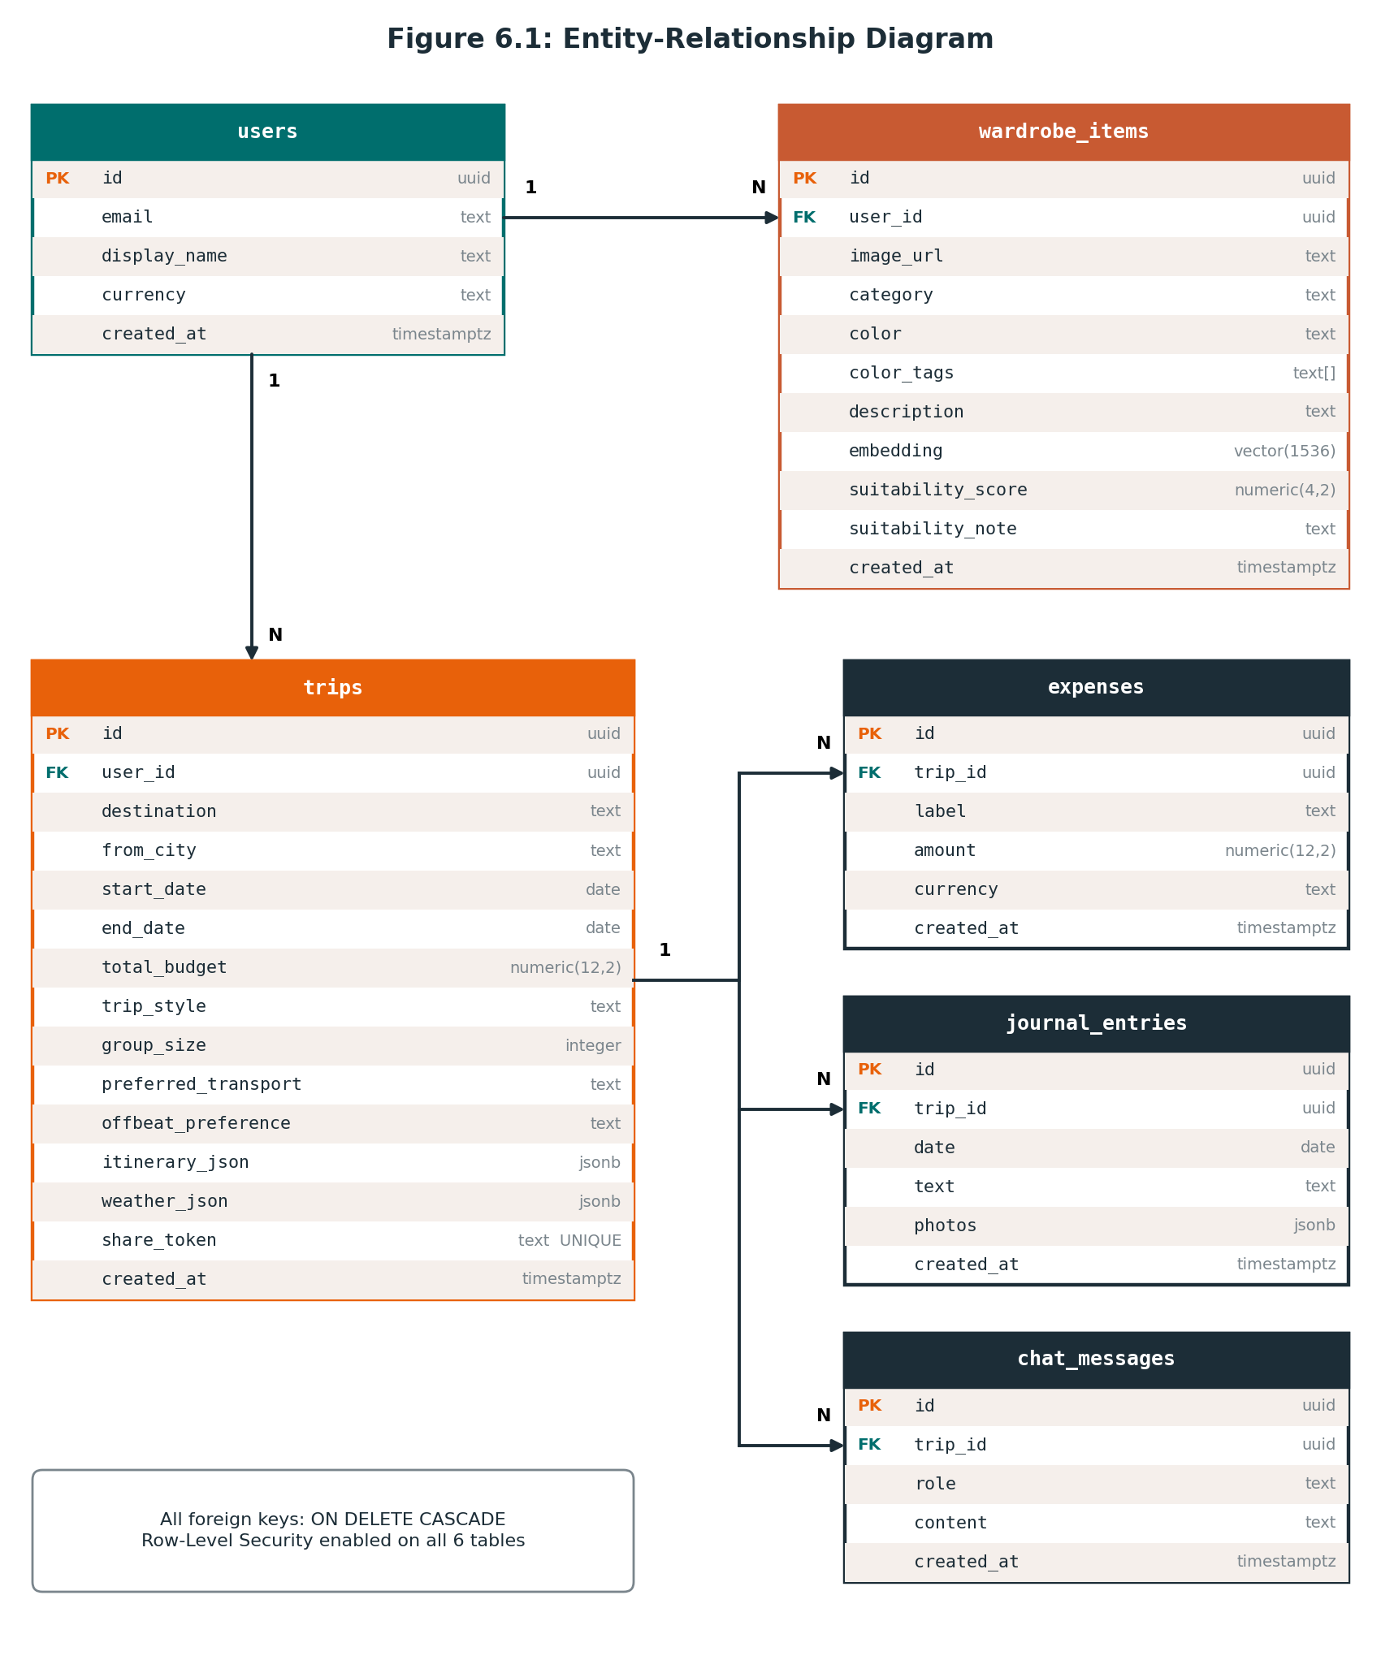
Figure 6.1: Entity-relationship diagram
Table 6.2: Relationships
Parent | Child | Cardinality | Foreign key | On delete
users | trips | 1 : N | trips.user_id | CASCADE
users | wardrobe_items | 1 : N | wardrobe_items.user_id | CASCADE
trips | expenses | 1 : N | expenses.trip_id | CASCADE
trips | journal_entries | 1 : N | journal_entries.trip_id | CASCADE
trips | chat_messages | 1 : N | chat_messages.trip_id | CASCADE

6.4 Table Specifications
Table 6.3: `public.users`
Column | Type | Constraints | Description
id | uuid | PK; references auth.users(id) | User identifier synced with Supabase Auth
email | text | NOT NULL | Email address
display_name | text | NULLABLE | Display name or handle
currency | text | NOT NULL, DEFAULT 'USD' | Preferred currency display code
created_at | timestamptz | NOT NULL, DEFAULT now() | Registration time

Table 6.4: `public.trips`
Column | Type | Constraints | Description
id | uuid | PK, DEFAULT uuid_generate_v4() | Trip identifier
user_id | uuid | NOT NULL, FK users(id) ON DELETE CASCADE | Owner
destination | text | NOT NULL | Destination name
from_city | text | NULLABLE | Origin city
start_date | date | NOT NULL | Journey start
end_date | date | NOT NULL | Journey end
total_budget | numeric(12,2) | NOT NULL, DEFAULT 0 | Target budget in INR
trip_style | text | CHECK in ('Beach','City','Mountain','Temple','Mixed') | Travel style
group_size | integer | DEFAULT 1 | Travellers in the squad
preferred_transport | text | DEFAULT 'train' | Preferred transit mode
offbeat_preference | text | NOT NULL, DEFAULT 'mix' | mix, offbeat, or popular
itinerary_json | jsonb | NULLABLE | Complete daily itinerary document
weather_json | jsonb | NULLABLE | Cached forecast and budget summary
share_token | text | UNIQUE, DEFAULT uuid_generate_v4()::text | Invite token for squad joining
created_at | timestamptz | NOT NULL, DEFAULT now() | Creation time

Table 6.5: `public.wardrobe_items`
Column | Type | Constraints | Description
id | uuid | PK, DEFAULT uuid_generate_v4() | Garment identifier
user_id | uuid | NOT NULL, FK users(id) ON DELETE CASCADE | Owner
image_url | text | NULLABLE | Public URL in Supabase Storage
category | text | NULLABLE | DeepFashion2 category
color | text | NULLABLE | Primary detected colour
color_tags | text[] | NULLABLE | Secondary colour tags
description | text | NULLABLE | Styling description
embedding | vector(1536) | NULLABLE | Semantic vector
suitability_score | numeric(4,2) | NULLABLE | Trip suitability, 0–10
suitability_note | text | NULLABLE | One-line climate explanation
created_at | timestamptz | NOT NULL, DEFAULT now() | Upload time

Table 6.6: `public.expenses`
Column | Type | Constraints | Description
id | uuid | PK, DEFAULT uuid_generate_v4() | Expense identifier
trip_id | uuid | NOT NULL, FK trips(id) ON DELETE CASCADE | Owning trip
label | text | NOT NULL | Expense title
amount | numeric(12,2) | NOT NULL | Amount
currency | text | NOT NULL, DEFAULT 'USD' | Currency code
created_at | timestamptz | NOT NULL, DEFAULT now() | Time recorded

Table 6.7: `public.journal_entries`
Column | Type | Constraints | Description
id | uuid | PK, DEFAULT uuid_generate_v4() | Entry identifier
trip_id | uuid | NOT NULL, FK trips(id) ON DELETE CASCADE | Owning trip
date | date | NOT NULL | Journal date
text | text | NULLABLE | Entry body
photos | jsonb | DEFAULT '[]'::jsonb | Array of photo URLs and captions
created_at | timestamptz | NOT NULL, DEFAULT now() | Creation time

Table 6.8: `public.chat_messages`
Column | Type | Constraints | Description
id | uuid | PK, DEFAULT uuid_generate_v4() | Message identifier
trip_id | uuid | NOT NULL, FK trips(id) ON DELETE CASCADE | Owning trip
role | text | CHECK in ('user','assistant','system') | Sender role
content | text | NOT NULL | Message body
created_at | timestamptz | NOT NULL, DEFAULT now() | Message time

6.5 Data Dictionary
Table 6.9: Data dictionary of constrained and derived fields
Field | Type | Allowed values / format | Description
trip_style | String | 'Beach', 'City', 'Mountain', 'Temple', 'Mixed' | Sets the travel mood and wardrobe rules
offbeat_preference | String | 'mix', 'offbeat', 'popular' | Controls itinerary routing mix
category | String | short_sleeve_top, long_sleeve_top, shorts, trousers, shoes, and other DeepFashion2 labels | Garment category
group_size | Integer | 1 ≤ N ≤ 50 | Number of people in the squad
suitability_score | Float | 0.0 ≤ S ≤ 10.0 | Climate-to-garment compatibility
similarityScore | Integer | 72 ≤ P ≤ 98 (%) | Attribute similarity against catalog items (computed, not stored)
share_token | UUID string | RFC 4122 UUID | Public token for squad joining
role | String | 'user', 'assistant', 'system' | Chat message sender
embedding | vector(1536) | 1536 floating-point values | Semantic vector of a garment
photos | JSONB array | List of photo URL and caption entries | Diary photo attachments

6.6 Semi-Structured Data (JSONB)
Two columns hold whole documents rather than normalised rows.
- `trips.itinerary_json` holds the complete itinerary as an ordered list of 1–7 day objects. Each day carries a theme and a route, both of which the deduplication validator compares across days, together with time-stamped activities, meal stops, transport notes, daily budgets, and wardrobe advice for display in the Itinerary Matrix.
- `trips.weather_json` holds the cached forecast and budget summary so the dashboard and wardrobe scoring do not need to call the weather service again.
- `journal_entries.photos` holds an array of photo URLs and captions, so a variable number of photos attaches to an entry without a separate table.

6.7 Vector Data Design
Each wardrobe item can carry a 1536-dimensional embedding. The vector comes from OpenAI text-embedding-3-small, or from a CLIP vector padded to the same length when the fallback classifier is used, so both sources share a single column type.
- Outfit suggestions. The itinerary's daily description is embedded and compared with stored garment vectors by cosine similarity (suggest-outfits).
- Colour matching. Distance between garment vectors is inverted to find complementary pieces (color-match).
- Isolation. Vectors sit in the same row as the garment they describe, so the row's RLS policy protects them.

6.8 Data Integrity and Access Rules
Integrity is enforced in the database wherever possible.
- CHECK constraints restrict trip_style and role to their allowed values.
- NOT NULL and DEFAULT clauses guarantee required fields and sensible starting values.
- ON DELETE CASCADE on every foreign key removes dependent rows automatically.
- share_token is UNIQUE, so an invite link always identifies exactly one trip.
Access is limited by Row-Level Security on all six tables and by Storage policies. Section 10 gives the full security design; the policies are summarised here for reference.
Table 6.10: Row-Level Security policies
Table | Policy condition
users | auth.uid() = id
trips | auth.uid() = user_id
wardrobe_items | auth.uid() = user_id
expenses | auth.uid() = (SELECT user_id FROM trips WHERE id = trip_id)
journal_entries | auth.uid() = (SELECT user_id FROM trips WHERE id = trip_id)
chat_messages | auth.uid() = (SELECT user_id FROM trips WHERE id = trip_id)
Storage bucket wardrobe | (storage.foldername(name))[1] = auth.uid()::text; users can upload, read, and delete only inside their own folder

6.9 Schema Migrations
The schema is built incrementally by five SQL migrations in supabase/migrations/, applied in order.
Table 6.11: Migration history
Migration | Change
001_initial_schema.sql | Core tables, vector and uuid-ossp extensions, RLS policies, and user-creation triggers
002_storage_wardrobe.sql | Storage bucket policies and wardrobe scoring columns
003_india_edition.sql | from_city, group_size, and preferred_transport on trips
004_journal_photos.sql | jsonb photo storage for diary entries
005_offbeat_preference.sql | offbeat_preference on trips

6.10 Client-Side Data and Design Notes
IndexedDB mirrors the data a traveller needs offline: trips, wardrobes, checklists, expenses, and journals. It is written after successful loads and saves and read in place of the network when connectivity is lost (see 5.13). The following observations describe how the current schema relates to the interface, and should be confirmed against the workspace source before this document is finalised.
Design notes to confirm
1. Expense fields. The Expense Logger captures category and payer, but the persisted expenses table stores only label, amount, and currency. Payer and category handling for settlement should be verified in the source.
2. Cart and checklist. The six-table schema has no dedicated tables for the shopping cart or packing checklist; their state is handled on the client (component state and IndexedDB).
3. Currency default. users.currency and expenses.currency default to 'USD', while INR is the base currency for budgets and estimates. The Settings screen lets the user switch between INR, USD, and EUR.

7. Algorithm Design
Trip Drip's core logic rests on four deterministic algorithms that run entirely client- or server-side without depending on an external AI call, which is what lets the platform guarantee correct results even when the AI and network layers fail. Each is specified below with its purpose, complexity, and reference implementation.

7.1 Minimal Cashflow Settlement (Hisaab-Kitaab)
Purpose: given a set of net balances for a travel squad (who owes / is owed how much after all trip expenses are logged), compute the smallest possible set of peer-to-peer transfers that settles every debt — rather than naively replaying every individual expense as its own transfer.

Design
- Partition members into debtors (net balance < 0) and creditors (net balance > 0); members within ±₹0.01 are treated as settled and excluded.
- Sort both lists in descending order of magnitude — this greedy ordering is what keeps the transfer count close to the theoretical minimum of N−1 for N participants.
- Repeatedly match the largest outstanding debtor against the largest outstanding creditor, transferring min(debt, credit); advance whichever side reaches zero.
- Each match produces one transaction record { from, to, amount }, which the UI renders as a settle-up instruction with a generated Bharat UPI deep-link QR code.

Complexity
- Sorting: O(N log N). Matching loop: O(N) since each iteration fully resolves at least one party. Overall: O(N log N) for N squad members.

Reference Implementation
export function calculateMinimalCashflow(balances) {
// balances: { [person]: netAmount } — positive = creditor, negative = debtor
let debtors = [];
let creditors = [];

for (const [person, amount] of Object.entries(balances)) {
const val = Math.round(amount * 100) / 100;
if (val < -0.01) debtors.push({ person, amount: -val });
else if (val > 0.01) creditors.push({ person, amount: val });
}

debtors.sort((a, b) => b.amount - a.amount);
creditors.sort((a, b) => b.amount - a.amount);

const transactions = [];
let i = 0, j = 0;

while (i < debtors.length && j < creditors.length) {
const debtor = debtors[i];
const creditor = creditors[j];
const settlementAmount = Math.min(debtor.amount, creditor.amount);

transactions.push({
from: debtor.person,
to: creditor.person,
amount: Math.round(settlementAmount),
});

debtor.amount -= settlementAmount;
creditor.amount -= settlementAmount;

if (debtor.amount < 0.01) i++;
if (creditor.amount < 0.01) j++;
}

return transactions;
}
Listing 7.1: Greedy minimal-transaction debt resolution used by HisaabKitaabModal.jsx

7.2 Vector Cosine Similarity
Purpose: measure how semantically close a wardrobe item is to a day's climate/activity requirement by comparing their embedding vectors, so the wardrobe-matching and color-matching engines can rank items by fit rather than by keyword overlap.

Design
- Garment images are embedded into a 1536-dimensional vector (OpenAI text-embedding-3-small over a generated description, or a zero-padded CLIP ViT-B/32 vector as fallback) and stored in pgvector.
- A day's itinerary requirement is embedded the same way; cosine similarity between the two vectors gives a score in roughly [-1, 1], where higher means a closer semantic match.
- Similarity is the normalized dot product: cos(θ) = (A · B) / (‖A‖ ‖B‖), guarded against a zero-magnitude denominator.
- The same routine powers /api/suggest-outfits (itinerary → wardrobe matching) and /api/color-match (inverted-distance complementary pairing).

Complexity
- O(d) per comparison for a d-dimensional vector (d = 1536); ranking k wardrobe items against one query is O(k·d), executed inside PostgreSQL via the pgvector index for scale.

Reference Implementation
function cosineSimilarity(a, b) {
if (!a || !b || a.length !== b.length) return 0;
let dot = 0, magA = 0, magB = 0;
for (let i = 0; i < a.length; i++) {
dot += a[i] * b[i];
magA += a[i] * a[i];
magB += b[i] * b[i];
}
return dot / (Math.sqrt(magA) * Math.sqrt(magB) || 1);
}
Listing 7.2: Cosine similarity between an outfit requirement vector and a wardrobe item vector
Similarity(A, B) = (A · B) / (‖A‖ ‖B‖)

7.3 Itinerary Deduplication & Auto-Repair
Purpose: LLM-generated multi-day itineraries occasionally repeat a route or theme across days (e.g. Day 1 and Day 2 both routed through the same waypoints). This validator detects that failure mode deterministically before the itinerary reaches the user, triggering an automatic regeneration/repair from the curated template library.

Design
- Reject immediately if the itinerary is missing or empty.
- Compare Day 1 and Day 2 directly on both route string and theme string — this catches the most common duplication pattern cheaply before doing a full scan.
- As a general-case check, collect every day's route string into a Set and compare its size against the array length; if the Set is smaller, at least one route repeats somewhere in the itinerary.
- A positive result routes the itinerary back through indiaItineraries.js's rotation logic to substitute a non-duplicate curated route before it is shown to the user.

Complexity
- O(D) for D itinerary days — a single linear pass plus one hash-set construction.

Reference Implementation
export function isDuplicateOrInvalidItinerary(days) {
if (!Array.isArray(days) || days.length === 0) return true;

if (days.length > 1) {
const r0 = days[0]?.route?.trim();
const r1 = days[1]?.route?.trim();
if (r0 && r1 && r0 === r1) return true;

const t0 = days[0]?.theme?.trim();
const t1 = days[1]?.theme?.trim();
if (t0 && t1 && t0 === t1) return true;
}

const routes = days.map(d => d.route?.trim()).filter(Boolean);
return new Set(routes).size < routes.length;
}
Listing 7.3: Deterministic duplicate/invalid-itinerary detector; verified by a 367-assertion test suite

7.4 Haversine Great-Circle Distance
Purpose: compute the real geographic distance between two latitude/longitude waypoints on the itinerary map, used for the Leaflet vector map's transit lines and for distance-aware transport/budget calculations.

Design
- Convert the latitude/longitude delta between two points into radians.
- Apply the haversine formula to get the central angle between the points on a sphere of Earth's mean radius (6371 km).
- a = sin²(Δlat/2) + cos(lat1)·cos(lat2)·sin²(Δlon/2); c = 2·atan2(√a, √(1−a)); distance = R·c.

Complexity
- O(1) per pair of coordinates — constant-time trigonometric evaluation.

Reference Implementation
function calculateDistanceKm(lat1, lon1, lat2, lon2) {
const R = 6371; // Earth radius in km
const dLat = (lat2 - lat1) * (Math.PI / 180);
const dLon = (lon2 - lon1) * (Math.PI / 180);
const a =
Math.sin(dLat / 2) * Math.sin(dLat / 2) +
Math.cos(lat1 * (Math.PI / 180)) * Math.cos(lat2 * (Math.PI / 180)) *
Math.sin(dLon / 2) * Math.sin(dLon / 2);
const c = 2 * Math.atan2(Math.sqrt(a), Math.sqrt(1 - a));
return R * c;
}
Listing 7.4: Great-circle distance used by TripMap.jsx and the multi-modal budget engine

Algorithm Summary
Algorithm | Module | Input | Output | Time Complexity
Minimal Cashflow | HisaabKitaabModal.jsx | Net balances per member | Ordered transfer list | O(N log N)
Cosine Similarity | suggest-outfits.js, color-match.js | Two 1536-d vectors | Similarity score [-1,1] | O(d)
Itinerary Deduplication | indiaItineraries.js | Array of day objects | Boolean + repaired days | O(D)
Haversine Distance | TripMap.jsx | Two (lat, lon) pairs | Distance in km | O(1)

8. API & Interface Design
The backend exposes 10 stateless serverless routes under /api/*, each a default-exported async handler(req, res) that validates its payload, runs business logic (calling Supabase, OpenAI, Open-Meteo, or HuggingFace as needed), and returns JSON with an appropriate HTTP status code. Every route sits behind Supabase Auth JWT verification and PostgreSQL Row-Level Security (see Section 10).

8.1 Endpoint Specification
Method | Endpoint | Description
POST | /api/generate-itinerary | Synthesizes 1–7 day sequenced routes with daily budgets and wardrobe tips via GPT-4o-mini, or curated fallback templates.
POST | /api/get-weather | Geocodes the destination city and returns daily high/low temperature, precipitation and humidity from Open-Meteo.
POST | /api/calculate-budget | Multi-modal transport engine comparing Train (2S/SL/3AC/2AC/1AC), Bus (Ordinary/Express/Volvo-AC), Car, Flight and 1★–5★ hotel tiers.
POST | /api/upload-garment | Uploads a base64 garment image to Supabase Storage, runs GPT-4o-mini Vision / CLIP classification, generates a 1536-d embedding.
POST | /api/suggest-outfits | Matches daily itinerary requirements against stored wardrobe vector embeddings using cosine similarity.
POST | /api/suitability-score | Computes a 0–10 compatibility score for a garment against destination climate and style.
POST | /api/color-match | Finds complementary owned pieces using inverted vector-distance and LangChain styling rationale.
POST | /api/chat-concierge | Action-executing LangChain AI assistant with rule-based intent parsing and prompt-injection safeguards.
POST | /api/get-transport-options | Returns multi-modal transit fare breakdown and Haversine distance calculations.
POST | /api/find-similar-items | Scores a query garment's attributes against the 29-item multi-brand catalog.

8.2 Request / Response Flow
Every authenticated call follows the same envelope: the client attaches the Supabase session JWT as a bearer token, the serverless handler verifies it and forwards it to PostgreSQL so Row-Level Security scopes the query, and any AI/external-API step is wrapped so a failure falls through to a deterministic fallback rather than surfacing an error to the user.
CLIENT (React) API ROUTE (serverless) EXTERNAL / DATA LAYER
------------------ ------------------------ ----------------------
1. Build payload -> 2. Validate input +
(trip params, sanitize prompt
JWT bearer) injection
3. Call AI / weather API -> OpenAI / Open-Meteo
4. On 429 / timeout: <- failure / rate-limit
switch to curated
fallback (no call)
5. Query DB with JWT -> Supabase Postgres
bearer token (RLS-scoped rows)
6. Shape JSON response
{ data, meta,
fallbackUsed }
7. Render UI + <-
write IndexedDB
cache (offline)
Figure 8.1: Generalized request/response flow between the client, API route, and data/AI layer
For AI-backed routes (generate-itinerary, upload-garment, suggest-outfits, color-match, chat-concierge) the response body carries a fallbackUsed flag so the frontend can surface a subtle indicator without blocking the user experience, in keeping with the dual-engine resilience model detailed in Section 11.

9. User Interface Design
Trip Drip's interface follows a vintage-postcard / Indian-railway aesthetic — boarding-pass motifs, geometric saffron/teal trims, and postcard-style bordered cards — built on Tailwind CSS design tokens for consistency across screens.

9.1 Design Tokens
Colors, typography and component primitives are centralized in tailwind.config.js so every screen draws from the same palette rather than ad-hoc hex values.
Token | Hex | Swatch | Usage
saffron | #E8610A |  | Primary accent — CTAs, header trim, highlights
teal | #006E6D |  | Secondary accent — links, active nav state, icons
sand | #F5EFEB |  | Base background — cards, page canvas
slate | #1C2D37 |  | Primary text, dark surfaces, code blocks
terracotta | #C85A32 |  | Tertiary accent — badges, section dividers
- Typography: Playfair Display / Cinzel (editorial serif headers), Outfit / Inter (sans-serif UI body), JetBrains Mono (flight codes, timestamps).
- .geo-border-top — decorative geometric saffron/teal header trim reused across dashboard and modal headers.
- .postcard-card — bordered card with a soft box-shadow, styled after a vintage postcard, used for trip cards, garment cards, and journal entries.

9.2 Navigation Flow
Route guarding is centralized in ProtectedRoute.jsx (see Section 10.1), so the flow below distinguishes public routes (pre-auth) from the protected application shell (post-auth).
[ Landing (/) ] Hero, feature cards, CTA
| Start Planning / Explore Outfits / Sign In
v
[ /login , /signup ] ----------> [ /outfits ]
AuthPages.jsx public lookbook,
| Supabase Auth success no auth required
| (JWT issued)
v
[ /trips -- My Trips Hub ] list view + Plan New Trip FAB
| |
new trip select existing trip
v v
[ /trips/new ] [ /trips/:id -- Trip Dashboard (tab shell) ]
Creation Wizard tabs: Itinerary | Wardrobe | Shop | Journal
| | Expenses
| quick-access: Chai Radar . Hisaab-Kitaab
+----generates----> . Squad Invite modals
+ persists trip (tabs share trip context; every write
mirrors to IndexedDB for offline use)
Figure 9.1: Application navigation flow from public landing page to the protected trip dashboard shell

9.3 Key Screens
Screen | Component | Purpose
Landing Page | Landing.jsx | Public storefront: hero, feature cards, entry points to signup/login/outfits.
Authentication Portal | AuthPages.jsx | Login / registration with email-syntax and 6-char password validation.
My Trips Hub | Trips.jsx | Dashboard of all trips; create, open, or delete (with cascading cleanup).
Trip Creation Wizard | NewTrip.jsx | Captures destination, dates, budget, travel style, squad size, offbeat preference.
Trip Dashboard | TripDashboard.jsx | Itinerary matrix, weather card, Leaflet map, packing checklist, quick-access modals.
Smart Wardrobe | Wardrobe.jsx | Garment upload, suitability scoring, color match, per-item delete.
Outfit Inspiration | Outfits.jsx | Curated lookbooks with reverse visual search across Zara/H&M/Uniqlo/Westside.
Trip Apparel Shop | Shop.jsx | Multi-brand comparison grid with live budget-aware cart drawer.
Yatra Journal | Journal.jsx | Mood-tagged rich-text diary with photo upload and lightbox.
Expenses & Hisaab-Kitaab | Expenses.jsx / HisaabKitaabModal.jsx | Expense logging, spend breakdown, minimal-cashflow settle-up with UPI QR.
Chai & Station Radar | ChaiStationRadarModal.jsx | Transit-corridor food/tea guide for highway and railway stops.
Smart Packing Checklist | PackingChecklist.jsx | Category-tabbed packing list with live completion ring.

10. Security Design
Security follows a defense-in-depth model: authentication establishes identity, route guards enforce authorization at the UI layer, and Row-Level Security enforces it again — non-bypassably — at the database layer.

10.1 JWT Authentication
Authentication is delegated to Supabase Auth, which issues cryptographically signed JSON Web Tokens with automated refresh rotation. The frontend AuthContext subscribes to session state so every component reacts to sign-in/sign-out without manual polling.
export function AuthProvider({ children }) {
const [user, setUser] = useState(null);
const [loading, setLoading] = useState(true);

useEffect(() => {
supabase.auth.getSession().then(({ data: { session } }) => {
setUser(session?.user ?? null);
setLoading(false);
});

const { data: { subscription } } = supabase.auth.onAuthStateChange(
(_event, session) => {
setUser(session?.user ?? null);
setLoading(false);
}
);

return () => subscription.unsubscribe();
}, []);

// Exposes signIn, signUp, signOut
}
Listing 10.1: AuthContext.jsx: session-aware JWT state provider

10.2 Authorization
Every protected route in the React router tree is wrapped by ProtectedRoute.jsx, which blocks rendering until the session check resolves and redirects unauthenticated users to /login.
export default function ProtectedRoute({ children }) {
const { user, loading } = useAuth();
if (loading) return <LoadingSkeleton />;
if (!user) return <Navigate to="/login" replace />;
return children;
}
Listing 10.2: ProtectedRoute.jsx: client-side route guard
Client-side guarding improves UX (no flash of protected content) but is not the security boundary — that boundary is Row-Level Security below, since a client-side check can always be bypassed by a modified client.

10.3 Row-Level Security (RLS)
Every database query is issued with the caller's JWT bearer token attached; Supabase forwards it to PostgreSQL, which evaluates RLS policies before returning a single row. This makes cross-tenant data leakage a database-enforced impossibility rather than an application-logic assumption. All 6 core tables have RLS enabled:
Table | Policy (owner check)
users | auth.uid() = id
trips | auth.uid() = user_id
wardrobe_items | auth.uid() = user_id
expenses | auth.uid() = (SELECT user_id FROM trips WHERE id = trip_id)
journal_entries | auth.uid() = (SELECT user_id FROM trips WHERE id = trip_id)
chat_messages | auth.uid() = (SELECT user_id FROM trips WHERE id = trip_id)
Storage security mirrors this at the object-storage layer: policies restrict upload, read, and delete to the caller's own folder path — bucket_id = 'wardrobe' AND (storage.foldername(name))[1] = auth.uid()::text — so a signed-in user cannot address another user's garment images even with a guessed object key.
Secrets hygiene: SUPABASE_SERVICE_KEY and OPENAI_API_KEY are held server-side only and are never bundled into the client build; only the public VITE_SUPABASE_ANON_KEY ships to the browser, relying on RLS — not key secrecy — to gate data access.

11. Error Handling, Resilience & Deployment Design
Trip Drip is designed to degrade gracefully rather than fail visibly: every external dependency (LLM, weather API, network connectivity) has a deterministic fallback path so the user is never blocked by a third-party outage.

11.1 Fallback Architecture
Failure Mode | Detection | Fallback Behavior
OpenAI API outage / HTTP 429 rate limit | Failed/errored completion call | Falls back to curated itineraries (indiaItineraries.js) and rule-based NLP intent extraction (chat-concierge.js).
Open-Meteo forecast > 16 days out | Date range check before request | Automatically switches from forecast mode to the historical climate archive endpoint (archive-api.open-meteo.com).
Network disconnection | Browser online/offline events | Offline banner activates; all reads/writes transparently redirect to the IndexedDB mirror.
Vision classification failure (GPT-4o-mini Vision) | Failed/errored vision call | Falls back to HuggingFace CLIP ViT-B/32 zero-shot classification.
This is implemented as a dual-engine pipeline: each AI-backed route always has a deterministic, non-AI counterpart ready to serve the same contract, so the platform maintains 100% functional uptime even with zero API credits available.

11.2 Offline Mode
The offline storage subsystem (offlineStorage.js) is an IndexedDB-backed persistence layer that mirrors trips, wardrobe items, packing checklists, expenses, and journal entries.
- Every successful write to Supabase is shadow-written to IndexedDB so the most recent state is always available locally.
- On connectivity loss, reads and writes transparently redirect to IndexedDB; an offline banner (OfflineBanner) signals the degraded mode to the user without blocking interaction.
- Currency and distance calculations (Haversine) run entirely client-side, so trip maps and budgets remain fully functional offline.
- On reconnection, locally queued changes are reconciled back to Supabase, subject to the same RLS policies as an online write.

11.3 Environment Configuration
Runtime configuration is externalized to environment variables rather than hard-coded, split between client-exposed (VITE_ prefixed) and server-only secrets:
VITE_SUPABASE_URL=https://<your-project>.supabase.co
VITE_SUPABASE_ANON_KEY=<your-anon-key>
SUPABASE_SERVICE_KEY=<your-service-key> # server-only
OPENAI_API_KEY=sk-... # server-only
HUGGINGFACE_API_KEY=hf_... # server-only
PORT=3001
Listing 11.1: .env configuration; only VITE_-prefixed values are exposed to the client bundle

11.4 Deployment Design
Aspect | Configuration
Platform | Vercel Global Edge Network
Build command | vite build
Output directory | dist
Runtime | Node.js 20.x Serverless Runtime (api/* handlers)
Database | Supabase-managed Cloud PostgreSQL with pgvector + RLS
Environments | Separate production and staging environment variable sets, deployed with zero downtime
Local setup: clone the repository, run npm install, populate .env as above, then run npm run dev:api (backend) and npm run dev (Vite frontend) in parallel terminals. The automated suites — node test_all_features.js, node test_itinerary_tester.js, node test_api.js — validate the deployment before promotion.

12. Limitations, Risks & Future Extensions

12.1 Current Limitations
- Visual reverse search relies on a static 29-item multi-brand catalog rather than live dynamic web scraping of retail e-commerce sites.
- Live Indian Railways PNR status and live train GPS tracking are not yet integrated.
- Photo-based full outfit recommendation from a user's own portrait photo is non-operational (see Section 12.2).

12.2 Unsuccessful Feature: Full Outfit Recommendation Using User Photo

Objective
Allow a traveler to upload a full-body photo or portrait and receive an end-to-end, head-to-toe outfit recommendation (top, bottom, footwear, accessories, color coordination) tailored to their visual appearance, body silhouette and skin tone, in conjunction with the destination's climate.

Intended Workflow
- User uploads a personal photo via a dedicated capture/upload interface.
- System analyzes the photo with computer vision / a multi-modal LLM to detect silhouette, skin-tone undertones and personal aesthetic style.
- System maps those attributes against destination climate, humidity, and scheduled itinerary activities.
- System outputs a complete, customized multi-piece outfit recommendation tailored to that person's appearance.

What Was Attempted
- Research into multi-modal vision prompting using GPT-4o Vision and CLIP image-to-image embeddings.
- Architectural exploration of segmenting user portrait features and mapping them to wardrobe catalog items.
- Draft experimental prompt templates and image-payload pipelines for processing full-body user imagery.

Result
The feature was NOT completed into a stable, production-ready implementation. Related capabilities — individual garment upload, DeepFashion2 category detection, suitability scoring, and visual reverse search — were completed successfully (Wardrobe.jsx, Outfits.jsx, api/upload-garment.js); it is specifically the end-to-end user-photo-to-full-outfit generation pipeline that was not completed. Available project evidence is insufficient to pin down the exact technical cause of non-completion, and the feature is excluded from the successful test counts (status: PENDING / ATTEMPTED BUT UNSUCCESSFUL).

Impact
Non-completion is isolated to this one feature and does not affect the stability of the rest of the application — individual wardrobe upload, daily AI outfit cards, cross-brand reverse search, and all itinerary/budgeting/mapping/concierge/expense-splitting features remain fully operational.

Future Implementation Path
- Integrate specialized body-pose and semantic segmentation models (e.g. DensePose or Segment Anything Model) to isolate apparel regions.
- Implement colorimetry algorithms to determine seasonal color palettes (Warm Autumn, Cool Summer, etc.) from facial skin tones.
- Leverage generative virtual try-on diffusion pipelines (e.g. IDM-VTON) to render recommended garments directly onto the user's uploaded photo.

12.3 Risks
Risk | Likelihood | Mitigation
LLM route-duplication in generated itineraries | Medium | Deterministic isDuplicateOrInvalidItinerary() validator with automated repair (Section 7.3).
Third-party AI/API quota exhaustion | Medium | Dual-engine fallback pipeline guarantees 100% uptime with zero API credits (Section 11.1).
Cross-tenant data exposure | Low (mitigated) | Enforced at the database layer via RLS on all 6 tables plus storage-path policies (Section 10.3).
Catalog staleness (static 29-item list) | Medium | Planned migration to live retail scraping / affiliate APIs (Section 12.4).
Offline/online state divergence | Low | IndexedDB shadow-writes with reconciliation on reconnect, governed by the same RLS on sync (Section 11.2).

12.4 Enhancement Roadmap
- Full Outfit Recommendation Using User Photo — complete the attempted photo-based styling feature using computer vision and virtual try-on diffusion pipelines (IDM-VTON).
- Live Indian Railways PNR & GPS Tracking — integrate live NTES APIs for platform tracking and train delay alerts.
- Live E-Commerce Retail Scraping — connect real-time scrapers or affiliate APIs for Myntra, Ajio, Zara and Uniqlo live inventory, replacing the static catalog.
- Voice-Activated Multilingual Travel Butler — add speech-to-text in Hindi, Marathi, Tamil, Bengali and English for hands-free queries during transit.

