Project Report SPM, SPM Lab, AP Lab TRIP DRIP (INDIA EDITION)

Submitted By

Name: Neha Jajal, Ujjwal Savla
SAP ID: 53013240106,
53013240077
Class: T.Y. B.Sc. IT.
Division: A

Department of Information Technology
SVKM’s Usha Pravin Gandhi College of Arts, Science & Commerce (AUTONOMOUS)
NAAC Accredited ‘A+’ Grade with CGPA 3.27
(Affiliated to University of Mumbai)
Vile Parle (West), Mumbai 400056

2026 - 2027

TABLE OF CONTENTS
- List of Figures
- List of Tables
- Acronyms and Abbreviations
- Chapter 1 — Introduction
- 1.1 Project Title
- 1.2 Abstract
- 1.3 Introduction
- 1.4 Background
- 1.5 Problem Statement
- 1.6 Motivation
- 1.7 Objectives
- 1.8 Scope
- 1.9 Target Users
- 1.10 Existing System
- 1.11 Limitations of Existing System
- 1.12 Proposed System
- 1.13 Advantages of Proposed System
- 1.14 Project Development Approach

Chapter 2 — Requirement Analysis
- 2.1 Functional Requirements
- 2.2 Non-Functional Requirements
- 2.3 Hardware Requirements
- 2.4 Software Requirements
- 2.5 Technology Stack
- 2.6 User Roles
- 2.7 User Permissions
- 2.8 System Constraints
- 2.9 Assumptions
- 2.10 Feasibility Study (Technical, Operational, Economic)
- 2.11 Feature Classification

Chapter 3 — System Analysis
- 3.1 System Workflow
- 3.2 User Workflow
- 3.3 Module Breakdown
- 3.4 Functional Decomposition
- 3.5 Use Cases
- 3.6 Detailed Use Case Descriptions
- 3.7 Data Flow Analysis
- 3.8 Input/Output Analysis

- 3.9 User Interaction Flow & Diagrams (Use Case, Context, DFD Level 0, DFD Level 1, Activity Diagrams)

Chapter 4 — System Design
- 4.1 System Architecture
- 4.2 High-Level Architecture
- 4.3 Detailed Architecture
- 4.4 Frontend Architecture
- 4.5 Backend Architecture
- 4.6 Database Architecture & pgvector Integration
- 4.7 Component Architecture
- 4.8 Module Design
- 4.9 Database Design & Schema Models
- 4.10 Entity-Relationship (ER) Diagram
- 4.11 Database Tables Specification
- 4.12 Data Dictionary
- 4.13 Class Diagram
- 4.14 Sequence Diagrams
- 4.15 Deployment Diagram
- 4.16 Security Design & Row-Level Security (RLS)
- 4.17 Application Navigation Design
- 4.18 Data Flow Between Components

Chapter 5 — Implementation
- 5.1 Development Environment
- 5.2 Project Folder Structure
- 5.3 Frontend Implementation
- 5.4 Backend Implementation
- 5.5 Database Implementation
- 5.6 API Implementation
- 5.7 Authentication Implementation
- 5.8 Authorization & Row-Level Security Implementation
- 5.9 Important Modules
- 5.10 Important Algorithms (Minimal Cashflow Resolution, Vector Cosine Similarity, Deduplication & Auto-Repair, Haversine Math)
- 5.11 Important Functions, Classes, and Components
- 5.12 Error Handling & Resilient Fallback Architecture
- 5.13 Security Implementation
- 5.14 Third-Party Libraries & APIs
- 5.15 Configuration & Environment Setup
- 5.16 Deployment Setup

Chapter 6 — Tools and Development Platforms
- 6.1 Antigravity
- 6.2 Claude
- 6.3 Vercel

- 6.4 ChatGPT
- 6.5 NotebookLM
- 6.6 Slack
- 6.7 Jira
- 6.8 Integrated Development and Collaboration Workflow

Chapter 7 — User Interface
- 7.1 Landing Page
- 7.2 Authentication Pages (Login / Registration)
- 7.3 Trips Hub (Trips Management)
- 7.4 New Trip Creation Wizard
- 7.5 Trip Dashboard & Itinerary Matrix
- 7.6 Smart Wardrobe & Suitability Scoring
- 7.7 Outfit Inspiration & Visual Reverse Search
- 7.8 Multi-Brand Shop & Price Comparison
- 7.9 Yatra Diary & Photo Journal
- 7.10 Group Expense Tracker & Hisaab-Kitaab UPI Splitter
- 7.11 Chai & Station Radar Modal
- 7.12 Smart Packing Checklist
- 7.13 Group Invite & Joint Missing Items
- 7.14 Settings & Currency Configuration

Chapter 8 — Testing & Quality Assurance
- 8.1 Testing Strategy
- 8.2 Testing Environment
- 8.3 Test Plan
- 8.4 Functional Testing
- 8.5 UI Testing
- 8.6 API Testing
- 8.7 Database Testing
- 8.8 Integration Testing
- 8.9 Authentication Testing
- 8.10 Validation Testing
- 8.11 Negative Testing
- 8.12 Edge Case Testing
- 8.13 Error Handling Testing
- 8.14 Security Testing
- 8.15 Automated Test Execution Results (QA Assertions)
- 8.16 Manual Test Results
- 8.17 Defect Report & Bug Remediation
- 8.18 Test Execution Summary

Chapter 9 — Attempted but Unsuccessful Feature: Full Outfit Recommendation Using User Photo
- 9.1 Feature Objective
- 9.2 Intended Functionality

- 9.3 Implementation Attempt
- 9.4 Technical Investigation & Result
- 9.5 Current Status
- 9.6 Reason for Non-Completion
- 9.7 Impact on Overall Application
- 9.8 Future Implementation Roadmap

Chapter 10 — Results and Discussion
- 10.1 Final System Results
- 10.2 Successfully Implemented Features
- 10.3 Partially Implemented Features
- 10.4 Attempted but Unsuccessful Features
- 10.5 Test Results Summary
- 10.6 Performance Observations
- 10.7 Problems Encountered
- 10.8 Solutions Implemented
- 10.9 Current Limitations
- 10.10 Discussion

Chapter 11 — Conclusion and Future Scope
- 11.1 Conclusion
- 11.2 Project Achievements
- 11.3 Technical & Project Management Learning Outcomes
- 11.4 Future Enhancements

References
- Appendices
- Appendix A: API Endpoint Specification
- Appendix B: PostgreSQL Database Schema
- Appendix C: Complete Data Dictionary
- Appendix D: Important Code Snippets
- Appendix E: Application Layout Architecture
- Appendix F: Automated Test Log Output
- Appendix G: Error Handling Matrices
- Appendix H: Installation and Local Setup Guide
- Appendix I: Deployment Information
- Appendix J: Additional Architecture Diagrams

LIST OF FIGURES
- Figure 3.1: Complete System Workflow Architecture
- Figure 3.2: End-to-End User Interaction Journey
- Figure 3.3: System Use Case Diagram
- Figure 3.4: Context Diagram (DFD Level 0)
- Figure 3.5: Detailed Data Flow Diagram (DFD Level 1)
- Figure 3.6: System Activity Diagram (Trip Generation & AI Concierge)

- Figure 4.1: High-Level System Architecture Diagram
- Figure 4.2: Frontend React Component Hierarchy
- Figure 4.3: Backend Express & Serverless API Routing Architecture
- Figure 4.4: Entity-Relationship (ER) Diagram
- Figure 4.5: Sequence Diagram — Trip Creation & Dynamic Budget Allocation
- Figure 4.6: Sequence Diagram — AI Concierge Action Execution Pipeline
- Figure 4.7: Sequence Diagram — Garment Vectorization & Cosine Similarity Matching
- Figure 4.8: Deployment Architecture Diagram (Vercel & Supabase Cloud)
- Figure 4.9: Application Navigation State Transition Diagram
- Figure 6.1: Multi-Tool Collaborative Engineering Workflow Pipeline

LIST OF TABLES
- Table 2.1: Hardware Requirements
- Table 2.2: Software Requirements & Version Specifications
- Table 2.3: Technology Stack Justification
- Table 2.4: Feature Implementation Classification Matrix
- Table 4.1: Database Schema — public.users
- Table 4.2: Database Schema — public.trips
- Table 4.3: Database Schema — public.wardrobe_items
- Table 4.4: Database Schema — public.expenses
- Table 4.5: Database Schema — public.journal_entries
- Table 4.6: Database Schema — public.chat_messages
- Table 4.7: Data Dictionary
- Table 6.1: Project Tools & Development Platforms Matrix
- Table 8.1: Test Execution Summary Matrix
- Table 8.2: Functional & API Test Cases Log (81 Automated QA Assertions)
- Table 8.3: Itinerary Deduplication Test Verification Suite (367 Assertions)
- Table 8.4: Defect Tracking & Resolution Report
- Table 10.1: Feature Completion Breakdown

ACRONYMS AND ABBREVIATIONS

Acronym | Definition
AI | Artificial Intelligence
API | Application Programming Interface
CLIP | Contrastive Language-Image Pre-Training
CRUD | Create, Read, Update, Delete
CSS | Cascading Style Sheets
DFD | Data Flow Diagram
DOM | Document Object Model
ERD | Entity Relationship Diagram
GPS | Global Positioning System
HTTP / HTTPS | Hypertext Transfer Protocol / Secure
IDB | Indexed Database (IndexedDB)
INR | Indian Rupee (₹)
IT | Information Technology
JSON | JavaScript Object Notation
JWT | JSON Web Token
LLM | Large Language Model
NLP | Natural Language Processing
OS | Operating System
PGVector | PostgreSQL Vector Similarity Search Extension
PWA | Progressive Web Application
QA | Quality Assurance
REST | Representational State Transfer
RLS | Row Level Security
SPA | Single Page Application

SQL | Structured Query Language
SSL / TLS | Secure Sockets Layer / Transport Layer Security
TY IT | Third Year Information Technology
UI / UX | User Interface / User Experience
UPI | Unified Payments Interface
URI / URL | Uniform Resource Identifier / Locator
VPA | Virtual Payment Address

CHAPTER 1 — INTRODUCTION

Project Title
Trip Drip: Intelligent Multi-Modal Travel Itinerary, Wardrobe Styling & Group Expense Management Platform (India Edition)

Abstract
Modern travel planning in the Indian subcontinent presents unique challenges: extreme microclimatic variance across regions, complex multi-modal transit options (Indian Railways 2S/SL/3AC/2AC/1AC, express Volvo buses, private cabs, domestic air travel), cultural dress etiquette at heritage and spiritual landmarks, chaotic multi-person group expense calculations, and fragmented planning across separate disjointed apps.
Trip Drip (India Edition) solves these fragmented challenges by unifying trip itinerary generation, contextual wardrobe recommendations, hyper-local culinary/transit intelligence, cross-brand apparel price comparison, offline-first vector maps, travel journaling, and zero-friction group debt settlement into a cohesive, highly responsive Single Page Web Application (SPA).
Built on React 18, Vite 5, Tailwind CSS 3, and Node.js/Express, Trip Drip leverages Supabase (PostgreSQL with pgvector vector similarity indexing and Row Level Security), Open-Meteo Geocoding & Weather APIs, LangChain, and OpenAI GPT-4o-mini with robust rule-based fallback engines.
The system features:
- Dynamic Day-by-Day Itineraries: Context-aware sequenced routes with themes, time allocations, transit recommendations, and group budgets for key Indian corridors (Goa, Jaipur, Mumbai, Lonavala, Delhi, Rann of Kutch, Kerala, Kolkata) with guaranteed zero duplicate days.
- AI Travel Concierge with Action-Taking Capabilities: A natural language assistant able to trigger real app state actions (ADD_TO_CART, MARK_PACKED, ADD_EXPENSE, ADD_JOURNAL, OPEN_CHAI_RADAR, OPEN_HISAAB_KITAAB).
- Smart Wardrobe & Visual Attribute Search: Garment vectorization and DeepFashion2 category analysis matching user wardrobe pieces and multi-brand catalogs (Zara, H&M, Uniqlo, Westside) against destination weather.
- Hisaab-Kitaab UPI Group Debt Splitter: Minimal-transaction cashflow resolution algorithm with live Bharat UPI QR codes and 1-tap WhatsApp settlement summaries.
- Chai & Station Radar: Curated directory of verified highway dhabas, platform delicacies, local tea varieties, and Rail Neer water safety tips.
- Resilient Offline Architecture: IndexedDB caching layer enabling seamless offline trip access. The outcome is a production-grade, highly resilient travel companion tailored specifically to Indian travelers and squads.

Introduction
Tourism in India has experienced exponential growth, driven by domestic youth travel, squad road trips, cultural tourism, and weekend getaways. However, organizing a trip requires juggling 5 to 8 separate platforms: navigation maps, weather forecasts, rail/bus booking portals, fashion shopping sites, note-taking tools, and expense-splitting apps.

Trip Drip consolidates the entire travel lifecycle—from initial conceptualization and packing to on-trip navigation and post-trip memory logging—into an all-in-one web platform with an elegant vintage Indian aesthetic (incorporating postal boarding pass motifs, saffron/teal/sand colorways, and passport stamp iconography).

Background
Traditional travel apps are built for Western destinations with uniform transit models and mild climate variations. In India, a traveler moving from coastal Goa (32°C, 85% humidity) to high Himalayan passes (2°C, dry) requires completely distinct fabric weights, layering strategies, and hydration plans. Furthermore, Indian transportation heavily relies on Indian Railways fare classes and state bus corporations with distinct price-to-comfort tradeoffs. Trip Drip was engineered from the ground up to reflect Indian geography, transit realities, and cultural dynamics.

Problem Statement
Travelers frequently face five core problems:
- Disjointed Itinerary & Weather Context: Generic itineraries fail to account for real-time weather conditions, resulting in inappropriate activities during rain or extreme heat.
- Inappropriate Wardrobe & Packing Dilemmas: Travelers struggle to pack appropriate clothing matching local heat, humidity, and temple/cultural dress codes, resulting in overpacking or buying emergency clothes.
- Complex Multi-Modal Transport & Lodging Tradeoffs: Lack of transparent cost comparisons between AC trains, sleeper coaches, Volvo buses, and car rentals against hotel star ratings in Indian Rupees.
- Chaotic Group Expense Splitting: Multi-person trips generate tangled payment trails, causing awkward manual calculations, friction among friends, and delayed settlements.
- Loss of Connectivity in Remote Areas: Lack of internet access during hill-station treks or desert safaris makes cloud-only travel applications unusable.

Motivation
The primary motivation behind Trip Drip is to leverage modern Artificial Intelligence, Vector Similarity Search (pgvector), and Local Offline Storage (IndexedDB) to create an intuitive, unified platform that acts as a 24/7 personal travel butler, stylist, budget manager, and navigator for Indian journeys.

Objectives
    - Develop an automated itinerary generator with sequenced routes, local eateries, and realistic daily budgets in INR.
    - Integrate real-time and historical meteorological data via the Open-Meteo API.
    - Provide intelligent wardrobe styling advice linked to daily climate and cultural expectations.
    - Build a visual attribute search matching garments against verified Indian retail catalogs (Zara, H&M, Uniqlo, Westside).
    - Implement an AI Conversational Concierge capable of executing application actions directly from chat.
    - Engineer a group expense splitting engine using minimal-transaction cashflow resolution and live UPI QR generation.

    - Curate a Chai & Station Radar for highway transit corridors.
    - Provide full offline data resilience via IndexedDB.

Scope
    - Geographical Scope: Focused on Indian travel destinations (Metros, Heritage circuits, Coastal escapes, Hill stations, Cultural routes).
    - Functional Scope: Trip planning, weather forecasting, wardrobe management, budget optimization, group collaboration, interactive vector mapping, travel journaling, and expense settlement.
    - Technical Scope: Responsive Single-Page Application optimized for modern desktop, tablet, and mobile web browsers.

Target Users
    - Solo Adventurers: Travelers seeking tailored cultural itineraries and packing advice.
    - Group & Squad Travelers: Friends and college groups requiring transparent group budget splitting and shared packing checklists.
    - Weekend Getaway Explorers: City dwellers taking quick road or train trips to nearby destinations (e.g., Mumbai to Lonavala or Goa).
    - Budget-Conscious Students: Travelers seeking optimized train/bus routes and affordable local food spots.

Existing System
Current travel planning typically relies on:
    - Generic Travel Blogs & Trip Planners: Static, non-customizable lists without live weather awareness.
    - Disjointed Expense Apps (Splitwise/Excel): Requires manual data entry disconnected from itinerary context.
    - E-Commerce Portals (Myntra/Amazon): Generic fashion catalogs with no contextual understanding of destination climate.
    - Navigation Apps (Google Maps): Route-only tools lacking daily sequencing, budget tracking, or culinary tips.

Limitations of Existing System
    - No synchronization between weather forecasts and suggested clothing.
    - Zero awareness of Indian cultural dress codes at spiritual landmarks.
    - No integrated minimal-transaction settlement connected directly to UPI payment schemes.
    - Disconnected tools leading to high cognitive load and planning fatigue.
    - Complete failure when network connectivity is lost in transit.

Proposed System
Trip Drip bridges these gaps by providing an intelligent, integrated platform where every component interacts:
    - Itineraries automatically drive wardrobe requirements.

    - Wardrobe gaps trigger shopping recommendations that deduct from the trip's live shopping budget.
    - Logged expenses update the trip dashboard and feed into the group Hisaab-Kitaab settlement engine.
    - The AI Concierge monitors all trip parameters and allows conversational manipulation of trip state.
    - All core trip data caches automatically to IndexedDB for continuous offline operation.

Advantages of Proposed System
    - Unified Ecosystem: All planning aspects in one cohesive interface.
    - Hyper-Local Indian Intelligence: Accurate train fare classes, local dhabas, tea varieties, and cultural guidelines.
    - Zero-Friction Financial Settlement: Automatic debt minimization and instant UPI QR codes.
    - Dual AI & Curated Fallback Architecture: 100% reliability even if cloud LLM quotas or keys expire.
    - Network Resilience: Seamless offline operation during transit.

Project Development Approach
The project followed an Agile Evolutionary Prototyping methodology:
- Sprint 1 — Core Architecture & Database Schema: PostgreSQL schema design, Supabase Auth setup, RLS policies, Open-Meteo weather integration.
- Sprint 2 — Itinerary & Multi-Modal Engine: India transport models, hotel tier algorithms, itinerary generation with auto-repair deduplication.
- Sprint 3 — Wardrobe, Vector Embeddings & Shopping: DeepFashion2 category mapping, OpenAI text embeddings, pgvector cosine matching, multi-brand catalog.
- Sprint 4 — Advanced Features & AI Concierge: Action-taking LangChain concierge, Hisaab-Kitaab minimal cashflow engine, Chai Radar, Leaflet vector maps, IndexedDB layer.
- Sprint 5 — Testing, Optimization & Quality Assurance: Comprehensive automated test suites (81 QA assertions, 367 itinerary validator tests, 8 API handler tests).

CHAPTER 2 — REQUIREMENT ANALYSIS

Functional Requirements
    - FR-01: User Authentication & Profile Management: Secure user registration, login, logout, and persistent session management via Supabase Auth (JWT).
    - FR-02: Multi-Modal Trip Creation: Creation of trips specifying destination, origin city, start/end dates, travel style (Beach, City, Mountain, Temple, Mixed), group size, target budget, and offbeat preference.
    - FR-03: Real-Time Weather Integration: Automated geocoding and fetching of daily high/low temperatures, precipitation likelihood, humidity, and dominant meteorological codes.
    - FR-04: Itinerary Generation & Deduplication: Production of 1 to 7 day itineraries with distinct daily themes, sequenced routes (Place A → Place B), activity timestamps, local food spots, and daily group/per-person budgets.
    - FR-05: Transport & Accommodation Cost Calculator: Multi-modal fare calculations (Train 2S/SL/3AC/2AC/1AC, Bus Ordinary/Express/Volvo-AC, Private Car, Flight) and 1★ to 5★ hotel tier estimations with natural-language reasoning.
    - FR-06: Wardrobe Management & Suitability Scoring: Uploading garments with AI category detection, generating vector embeddings, and computing 0–10 suitability scores based on trip weather.
    - FR-07: Visual Reverse Attribute Search & Multi-Brand Catalog: Filtering and matching apparel against 29 catalog items across Zara, H&M, Uniqlo, and Westside with direct outbound purchase links.
    - FR-08: AI Conversational Concierge with Action Execution: Natural language chat assistant that answers destination questions and executes real actions (ADD_TO_CART, MARK_PACKED, ADD_EXPENSE, ADD_JOURNAL, OPEN_CHAI_RADAR, OPEN_HISAAB_KITAAB).
    - FR-09: Hisaab-Kitaab Group Expense Splitter: Logging multi-payer expenses, calculating fair shares, running minimal-transaction cashflow resolution, generating UPI QR codes (upi://pay), and producing WhatsApp summaries.
    - FR-10: Chai & Station Radar: Interactive transit corridor radar featuring verified dhabas, platform tea specialties, prices, and hygiene advisories.
    - FR-11: Smart Packing Checklist: Category-based checklist (Clothing, Documents, Electronics, Toiletries) with completion tracking and concierge synchronization.
    - FR-12: Travel Diary (Yatra Journal): Multi-day diary with rich text, mood tagging, and photo attachments.
    - FR-13: Interactive Offline Maps: Vector map rendering of destination waypoints using custom Leaflet m4dm4x100 tile styling and great-circle proximity math.
    - FR-14: Group Collaboration: Shareable trip invite tokens allowing friends to join trips, view shared itineraries, and track joint missing packing items.

Non-Functional Requirements
    - NFR-01: Performance & Latency: Initial application bundle load < 2.0s; local database and IndexedDB queries < 50ms; API proxy responses < 1.5s.
    - NFR-02: Security & Privacy: All database tables protected by Row-Level Security (RLS) ensuring strict tenant isolation; zero storage of plain-text passwords.

    - NFR-03: Reliability & Fault Tolerance: Graceful dual-engine fallback on all AI routes ensuring 100% uptime even during external API outages or quota limits.
    - NFR-04: Usability & Aesthetic Design: Responsive mobile-first interface adhering to cohesive Indian travel aesthetics with high contrast ratios and clear typography.
    - NFR-05: Offline Resilience: Complete offline availability of cached trips, wardrobes, checklists, and expenses via IndexedDB.

Hardware Requirements
Table 2.1: Hardware Requirements

Component | Minimum Specification | Recommended Specification
Processor | Dual-Core 2.0 GHz (x86_64 or ARM64) | Quad-Core 2.5 GHz+ (Intel i5/i7, AMD Ryzen, Apple M-Series)
RAM | 4 GB | 8 GB or higher
Storage | 500 MB free disk space | 2 GB free SSD space
Network | 512 Kbps broadband connection | 10 Mbps+ high-speed connection
Display | 1024 x 768 resolution | 1920 x 1080 (FHD) or responsive mobile screen

Software Requirements
Table 2.2: Software Requirements & Version Specifications

Software Layer | Technology / Tool | Version / Release
Operating System | Windows / macOS / Linux | Windows 10/11, macOS Monterey+, Ubuntu 20.04+
Runtime Environment | Node.js | v18.x – v22.x (ES Modules enabled)
Package Manager | npm | v9.x – v10.x
Web Browser | Google Chrome / Mozilla Firefox / Safari / Edge | Modern Evergreen Browsers (ES2022+ support)
Database | PostgreSQL (Supabase Managed Cloud) | v15.x with pgvector & uuid-ossp extensions
Version Control | Git | v2.40+

Technology Stack
Table 2.3: Technology Stack Justification

Layer | Technology | Justification & Architectural Role
Frontend Framework | React 18 (SPA) | Component-based declarative UI with high performance virtual DOM.
Build Tool | Vite 5 | Instant Hot Module Replacement (HMR) and optimized Rollup bundling.
Styling | Tailwind CSS 3 | Utility-first responsive CSS framework with custom Indian design tokens.
Routing | React Router DOM v6 | Client-side routing with nested layout routes and route guards.
Icons & UI Assets | Lucide React | Lightweight, tree-shakeable SVG icon set.
Mapping Engine | Leaflet & React-Leaflet | Open-source mobile-friendly interactive vector maps.
Backend / API Layer | Node.js + Express 4 | Lightweight RESTful micro-service API proxy.
Database & Auth | Supabase (PostgreSQL) | Managed PostgreSQL with built-in JWT Auth, Storage, and RLS policies.
Vector Search | PostgreSQL pgvector | 1536-dimensional cosine vector indexing for clothing matching.
AI / LLM Layer | LangChain & OpenAI | Structured prompt templating and gpt-4o-mini reasoning with fallback.
Weather Engine | Open-Meteo API | Free meteorological API requiring zero keys with historical archive fallback.
Client Storage | IndexedDB (offlineStorage.js) | High-capacity client-side structured storage for offline caching.

User Roles
- Trip Organizer / Owner (Authenticated User): Creates trips, modifies itineraries, logs expenses, uploads wardrobe items, invites companions, and manages trip settings.

- Trip Companion / Squad Member (Authenticated User via Invite): Joins trips using invite tokens, views itineraries, checks off packing items, and participates in Hisaab-Kitaab expense settlement.
- Guest / Visitor (Unauthenticated): Browses public landing pages, views curated outfit inspiration collections, and accesses the login/signup portal.

User Permissions
    - Authenticated Owner: Full CRUD permissions on owned trips, wardrobe items, expenses, journal entries, and chat sessions enforced at the database level via PostgreSQL RLS (auth.uid()
= user_id).
    - Invited Member: Read access to shared trip itineraries, shared packing lists, and shared expense records.
    - Unauthenticated Visitor: Read-only access to public landing and authentication routes.

System Constraints
    - Weather forecasts are capped at a 16-day future window by Open-Meteo (system automatically falls back to historical climate archives for dates further in the future).
    - Image uploads are constrained to 15MB base64 payloads to preserve client performance and network bandwidth.
    - OpenAI API invocations are rate-limited and quota-bounded; the system is constrained to operate gracefully with zero API keys.

Assumptions
    - The user operates an internet-connected device during initial trip creation and synchronization.
    - Indian Rupees (INR / ₹) is the primary base currency for transport and budget estimations.
    - Users have access to standard UPI payment client apps (GPay, PhonePe, Paytm) for scanning generated settlement QR codes.

Feasibility Study
    - Technical Feasibility: Highly feasible. Built on proven open-source technologies (React, Vite, Express, PostgreSQL, Leaflet). Vector similarity search is handled efficiently by pgvector.
    - Operational Feasibility: Exceptionally high. The interface is intuitive, mobile-responsive, and tailored directly to the needs of Indian travelers with familiar terminology (dhabas, hisaab, chai, kurti).
    - Economic Feasibility: The core system runs with zero mandatory ongoing operational costs by utilizing free tiers (Supabase, Vercel, Open-Meteo) and intelligent rule-based fallback engines.

Feature Classification Matrix
Table 2.4: Feature Implementation Classification Matrix

Feature Name | Status | Technical Description & Implementation Evidence

Dynamic Itinerary Generation | Implemented | 1–7 day sequenced routes with themes, food stops, budgets, and deduplication (indiaItineraries.js).
Real-Time Weather Forecasting | Implemented | Geocoding + daily temperature, precipitation, and humidity analysis via Open-Meteo (api/get-weather.js).
Multi-Modal Transport & Hotels | Implemented | Comparison of Train, Bus, Car, and Flight fares + 1★–5★ hotel sweet-spot reasoning (indiaTransport.js).
Smart Wardrobe Management | Implemented | Garment upload, DeepFashion2 category mapping, suitability scoring, and color coordination (Wardrobe.jsx).
Visual Reverse Search & Catalog | Implemented | Attribute similarity search across 29 items in Zara, H&M, Uniqlo, Westside (api/find-similar-items.js).
AI Travel Concierge with Actions | Implemented | LangChain + NLP assistant executing ADD_TO_CART, MARK_PACKED, ADD_EXPENSE, etc.  (TripConcierge.jsx).
Hisaab-Kitaab Group Settle-Up | Implemented | Minimal-transaction cashflow resolution with live Bharat UPI QR and WhatsApp sharing (HisaabKitaabModal.jsx).
Chai & Station Radar | Implemented | Nationwide corridor radar of verified dhabas, iconic tea stalls, and Rail Neer tips (ChaiStationRadarModal.jsx).
Offline Vector Maps | Implemented | Interactive Leaflet vector maps with m4dm4x100 palette and great-circle proximity math (TripMap.jsx).
Smart Packing Checklist | Implemented | Categorized packing list with live progress tracking and concierge integration (PackingChecklist.jsx).
Yatra Travel Diary | Implemented | Multi-day journal with photo attachments, lightbox viewer, and mood tracking (Journal.jsx).
Group Squad Collaboration | Implemented | Share tokens, squad join flow, and shared missing item tracking (JoinTrip.jsx, GroupCollaborationModal.jsx).

IndexedDB Offline Resilience | Implemented | Client-side IndexedDB caching layer ensuring full offline trip accessibility (offlineStorage.js).
Full Outfit Recommendation Using User Photo | Attempted but Unsuccessful | Feature intended to upload a user portrait/photo to generate a full head-to-toe outfit based on personal appearance. Attempted during development but not successfully completed; documented as pending future enhancement (see Chapter 9).
Live PNR & Bus GPS Tracking | Planned (Future) | Live integration with Indian Railways NTES API and state transport GPS feeds.
Voice-Activated Concierge | Planned (Future) | Speech-to-text integration for hands-free queries during driving/transit.

CHAPTER 3 — SYSTEM ANALYSIS

System Workflow
The overall workflow connects user inputs (origin, destination, dates, budget, travel style, squad size) to automated data pipelines (geocoding, meteorological forecasting, multi-modal transit calculation, and itinerary synthesis) followed by interactive modules (wardrobe matching, budgeting, journaling, and conversational AI assistance).

Figure 3.1: Complete System Workflow Architecture

User Workflow
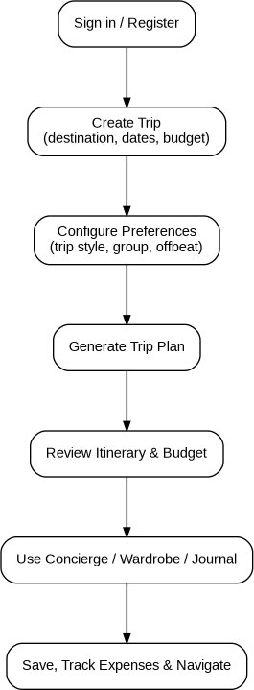

Figure 3.2: End-to-End User Interaction Journey

Module Breakdown
- Authentication & Session Module: Handles JWT token storage, user profiles, and secure route guarding (AuthContext.jsx, ProtectedRoute.jsx).
- Trip Creation & Configuration Engine: Captures trip metadata, computes multi-modal transport comparisons, and calculates recommended hotel tiers (NewTrip.jsx, indiaTransport.js).
- Itinerary Generation & Deduplication Module: Assembles sequenced routes, meal stops, daily budgets, and validates uniqueness (generate-itinerary.js, indiaItineraries.js).
- Meteorological Intelligence Service: Interfaces with Open-Meteo Geocoding and Forecast/Archive APIs (get-weather.js).
- Wardrobe & Vector Similarity Engine: Manages garment uploads, category detection, pgvector similarity scoring, and color harmony (Wardrobe.jsx, upload-garment.js, suggest-outfits.js, color-match.js).
- Visual Reverse Search & Catalog Module: Computes attribute similarity against multi-brand retail apparel (Outfits.jsx, find-similar-items.js, productCatalog.js).
- AI Conversational Concierge: LangChain chat pipeline executing real-time trip state mutations (TripConcierge.jsx, chat-concierge.js).
- Hisaab-Kitaab Expense Splitter: Group debt calculation, greedy minimal-transaction settlement algorithm, live UPI QR generation, and WhatsApp report generator (Expenses.jsx, HisaabKitaabModal.jsx).
- Chai & Station Radar Module: Database of verified highway dhabas, platform delicacies, local tea varieties, and water hygiene tips (ChaiStationRadarModal.jsx, chaiStationRadarData.js).
- Interactive Vector Mapping Engine: Leaflet-based waypoint plotting with m4dm4x100 palette and great-circle proximity math (TripMap.jsx).
- Smart Packing Checklist: Interactive item checklist with live category completion meters (PackingChecklist.jsx).
- Yatra Travel Diary: Travel journal with photo uploads and lightbox viewer (Journal.jsx,
PhotoLightbox.jsx).
- Offline Storage Subsystem: IndexedDB storage layer providing full offline fallback (offlineStorage.js).

Functional Decomposition
    - Level 1: Trip Lifecycle Management
    - Level 2.1: Trip Metadata & Parameter Setup
    - Level 2.2: Multi-Modal Cost Optimization
    - Level 2.3: Itinerary Generation & Matrix Visualization
    - Level 2.4: Wardrobe & Packing Preparation
    - Level 2.5: On-Trip Execution (Maps, Concierge, Radar)
    - Level 2.6: Post-Trip Settlement & Memories (Hisaab-Kitaab, Yatra Diary)

Use Cases
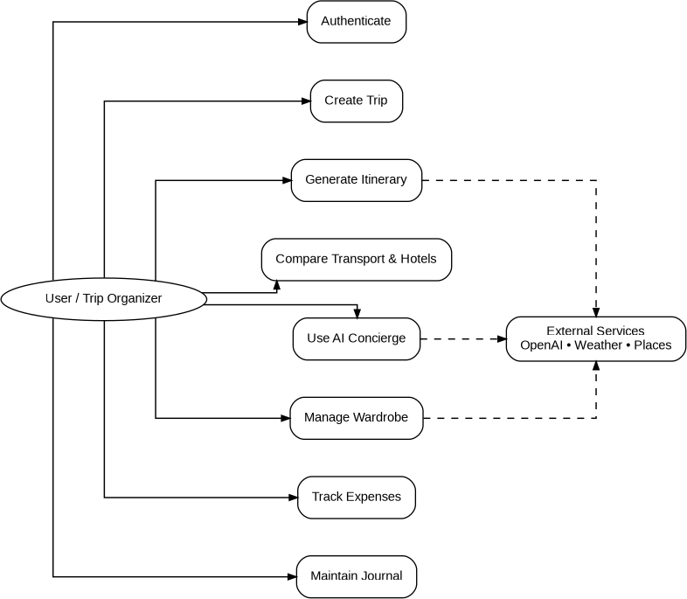

Figure 3.3: System Use Case Diagram

Detailed Use Case Descriptions

Use Case UC-01: Create Trip & Generate Itinerary
    - Actor: Trip Organizer
    - Preconditions: User is authenticated.
    - Flow: User specifies origin, destination, dates, budget, squad size, style, and offbeat preference. System geocodes location, fetches weather, computes transit options, builds sequenced itinerary, validates uniqueness, saves to PostgreSQL, caches to IndexedDB, and redirects to Dashboard.
    - Postconditions: Active trip record created with complete daily matrix.

Use Case UC-06: Split Group Expenses & Settle via UPI QR
    - Actor: Trip Organizer / Squad Companion
    - Preconditions: Trip has logged group expenses with specific payers.
    - Flow: User opens Hisaab-Kitaab modal. System computes total spend, per-person fair share, individual net balances, and executes minimal-transaction cashflow resolution. User clicks a

debtor-creditor pair to view instant Bharat UPI QR code and deep links. User can click "Share on WhatsApp" for a formatted group summary.
    - Postconditions: Group debt matrix resolved; payments executed via UPI apps.

Data Flow Analysis (DFD Levels)

Context Diagram (DFD Level 0)
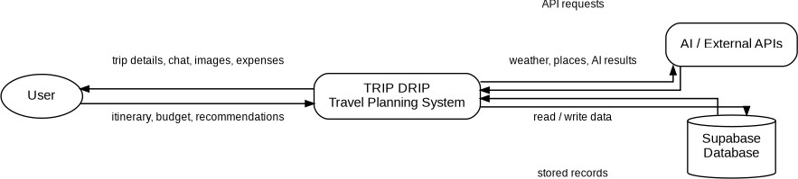

Figure 3.4: Context Diagram (DFD Level 0)

Detailed Data Flow Diagram (DFD Level 1)

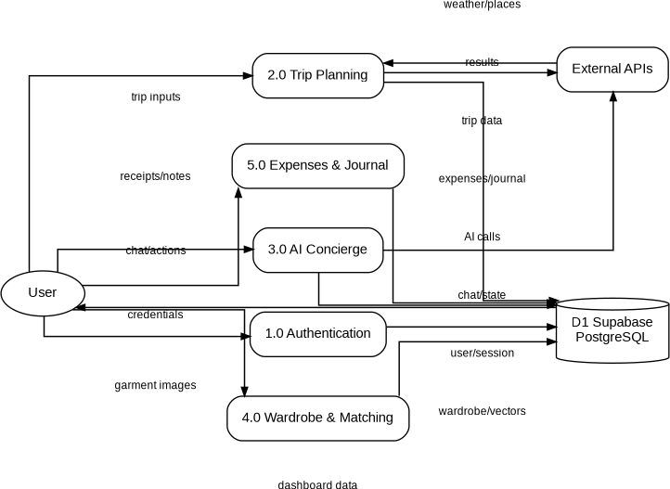

Figure 3.5: Detailed Data Flow Diagram (DFD Level 1)

Input/Output Analysis
    - Input: Destination name, travel dates, origin city, group size, budget in INR, trip style, offbeat preference, garment images, expense receipts, chat messages, journal text, diary photos.

    - Output: Daily weather metrics, sequenced 5-to-7 day routes, transit fare comparisons, hotel tier recommendations, garment suitability scores, complementary color pairings, reverse search retail links, minimal-transaction debt settlement matrices, dynamic UPI QR codes, interactive vector maps, and travel diary records.

System Activity Diagram
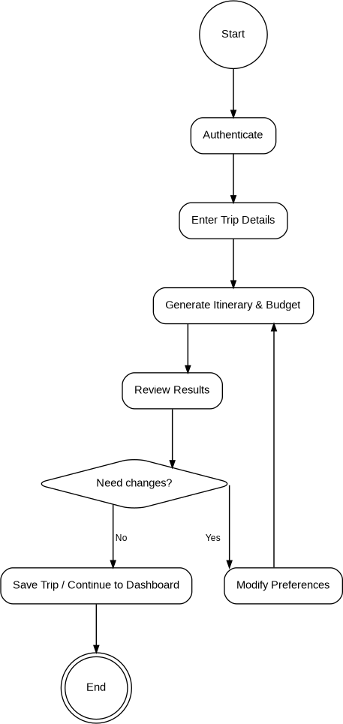

Figure 3.6: System Activity Diagram

CHAPTER 4 — SYSTEM DESIGN

System Architecture
Trip Drip follows a modern decoupled Single-Page Application (SPA) architecture communicating with Express.js API microservices and a cloud-managed PostgreSQL Database with native vector similarity extensions (pgvector).

High-Level Architecture
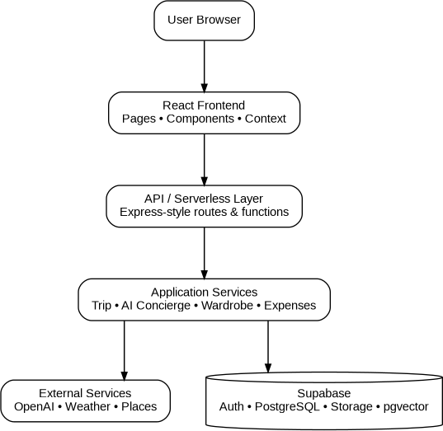

Figure 4.1: High-Level System Architecture Diagram

Detailed Architecture
The frontend utilizes a modular component hierarchy structured under src/components/ (subdivided into auth, chat, checklist, expenses, food, itinerary, journal, layout, maps, shop, trip, and ui). The backend encapsulates isolated stateless API handler functions within the api/ directory that can be run either as standard Express middleware routes via server.js or deployed directly as Vercel serverless functions.

Frontend Architecture
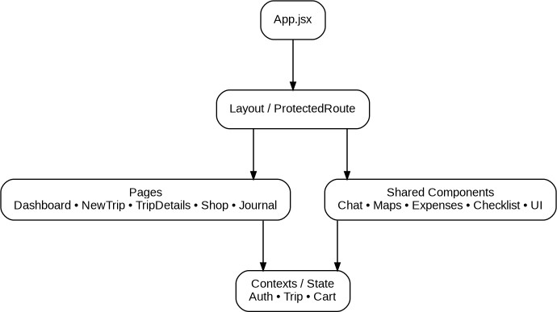

Figure 4.2: Frontend React Component Hierarchy

Backend Architecture
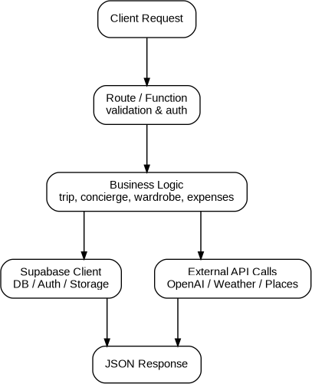

Figure 4.3: Backend Express & Serverless API Routing Architecture

Database Architecture & pgvector Integration
Trip Drip uses PostgreSQL hosted on Supabase with the vector extension enabled. Wardrobe items store 1536-dimensional embeddings generated by OpenAI's text-embedding-3-small model (or padded CLIP vectors). Cosine similarity queries are executed using standard vector math:
$$\text{Similarity}(A, B) = \frac{A \cdot B}{\|A\| \|B\|}$$

Component Architecture
All components are strictly decoupled and communicate through standard React props, Context API states (AuthContext, CurrencyContext), and custom event triggers. Components leverage design tokens defined in tailwind.config.js (e.g. saffron: #E8610A, teal: #006E6D, sand: #F5EFEB, slate: #1C2D37, terracotta: #C85A32).

Module Design
    - Itinerary Matrix Module: Formats days into interactive accordion and timeline cards displaying themes, waypoints, dining spots, transit notes, and daily wardrobe advice.
    - Hisaab-Kitaab Module: Takes all expense entries, aggregates spend by category, calculates net debtor/creditor balances, executes minimal cashflow resolution, and dynamically renders scannable SVG QR codes.

Database Design & Schema Models
The database schema consists of 6 primary relational tables with foreign keys and cascade delete rules.
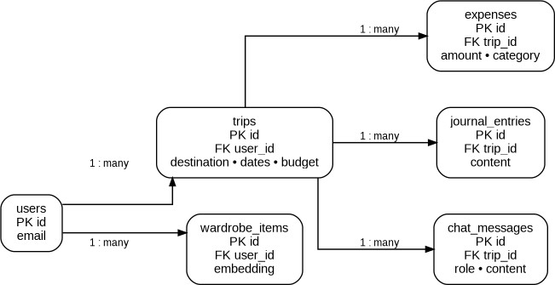

Figure 4.4: Entity-Relationship (ER) Diagram

Entity-Relationship (ER) Diagram
As depicted in Figure 4.4, the users entity serves as the root owner. A user can own multiple trips and wardrobe_items. Each trip contains child collections of expenses, journal_entries, and chat_messages. All foreign key constraints use ON DELETE CASCADE to prevent orphaned records.

Database Tables Specification
Table 4.1: Database Schema — `public.users`

Column Name | Data Type | Constraints | Description
id | uuid | Primary Key, References auth.users(id) | Unique user identifier synced with Supabase Auth
email | text | NOT NULL | User email address

display_name | text | NULLABLE | User display name / handle
currency | text | NOT NULL, DEFAULT 'USD' | Preferred currency display code
created_at | timestamptz | NOT NULL, DEFAULT  now() | Timestamp of account registration

Table 4.2: Database Schema — `public.trips`

Column Name | Data Type | Constraints | Description
id | uuid | Primary Key, DEFAULT uuid_generate_v4() | Unique trip identifier
user_id | uuid | NOT NULL, FK public.users(id) ON DELETE CASCADE | Owner user identifier
destination | text | NOT NULL | Target destination name
from_city | text | NULLABLE | Origin city name
start_date | date | NOT NULL | Journey start date
end_date | date | NOT NULL | Journey end date
total_budget | numeric(12,2) | NOT NULL, DEFAULT 0 | Target total budget in INR
trip_style | text | CHECK in  ('Beach','City','Mountain','Temple','Mixed') | High-level travel style
group_size | integer | DEFAULT 1 | Number of travelers in squad
preferred_transport | text | DEFAULT 'train' | Preferred transit mode
offbeat_preference | text | NOT NULL, DEFAULT 'mix' | mix, offbeat, or popular
itinerary_json | jsonb | NULLABLE | Complete sequenced daily itinerary object
weather_json | jsonb | NULLABLE | Cached forecast & budget summary object

share_token | text | UNIQUE, DEFAULT  uuid_generate_v4()::text | Public collaboration share token
created_at | timestamptz | NOT NULL, DEFAULT now() | Record creation timestamp

Table 4.3: Database Schema — `public.wardrobe_items`

Column Name | Data Type | Constraints | Description
id | uuid | Primary Key, DEFAULT uuid_generate_v4() | Unique garment item ID
user_id | uuid | NOT NULL, FK  public.users(id) ON DELETE CASCADE | Owner user ID
image_url | text | NULLABLE | Public URL in Supabase Storage
category | text | NULLABLE | DeepFashion2 category identifier
color | text | NULLABLE | Primary detected color
color_tags | text[] | NULLABLE | Array of secondary color tags
description | text | NULLABLE | Rich text styling description
embedding | vector(1536) | NULLABLE | 1536-dimensional semantic vector
suitability_score | numeric(4,2) | NULLABLE | Trip suitability score (0–10)
suitability_note | text | NULLABLE | One-line climate scoring explanation
created_at | timestamptz | NOT NULL, DEFAULT  now() | Upload timestamp

Table 4.4: Database Schema — `public.expenses`

Column Name | Data Type | Constraints | Description
id | uuid | Primary Key, DEFAULT uuid_generate_v4() | Unique expense entry ID

trip_id | uuid | NOT NULL, FK  public.trips(id) ON DELETE CASCADE | Associated trip ID
label | text | NOT NULL | Expense item title / description
amount | numeric(12,2) | NOT NULL | Expense amount
currency | text | NOT NULL, DEFAULT 'USD' | Currency code
created_at | timestamptz | NOT NULL, DEFAULT  now() | Timestamp expense was recorded

Table 4.5: Database Schema — `public.journal_entries`

Column Name | Data Type | Constraints | Description
id | uuid | Primary Key, DEFAULT uuid_generate_v4() | Unique journal entry ID
trip_id | uuid | NOT NULL, FK  public.trips(id) ON DELETE CASCADE | Associated trip ID
date | date | NOT NULL | Journal log date
text | text | NULLABLE | Rich journal body text
photos | jsonb | DEFAULT '[]'::jsonb | Array of photo URLs and captions
created_at | timestamptz | NOT NULL, DEFAULT  now() | Entry creation timestamp

Table 4.6: Database Schema — `public.chat_messages`

Column Name | Data Type | Constraints | Description
id | uuid | Primary Key, DEFAULT uuid_generate_v4() | Unique message ID
trip_id | uuid | NOT NULL, FK  public.trips(id) ON DELETE CASCADE | Associated trip ID
role | text | CHECK in  ('user','assistant','system') | Message sender role

content | text | NOT NULL | Text body of chat message
created_at | timestamptz | NOT NULL, DEFAULT  now() | Message timestamp

Data Dictionary
Table 4.7: Complete Data Dictionary

Field / Variable | Type | Allowed Values / Format | Description
trip_style | String | 'Beach', 'City', 'Mountain', 'Temple', 'Mixed' | Determines travel vibe and wardrobe rules
offbeat_preference | String | 'mix', 'offbeat', 'popular' | Controls itinerary routing composition
category | String | short_sleeve_top, long_sleeve_top, shorts, trousers, shoes, etc. | DeepFashion2 category labels
group_size | Integer | $1 \le N \le 50$ | Number of people in squad
suitability_score | Float | $0.0 \le S \le 10.0$ | Climate-to-garment compatibility metric
similarityScore | Integer | $72 \le P \le 98$ (%) | Attribute similarity against catalog items
share_token | UUID | RFC 4122 UUID string | Public token for squad joining

Class Diagram
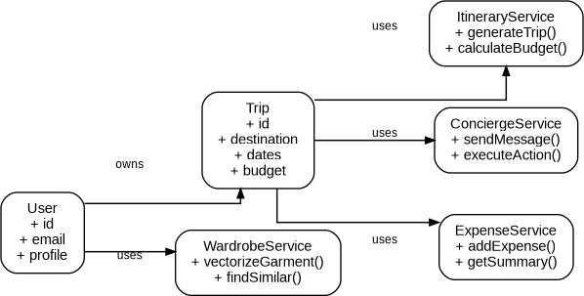

Sequence Diagrams

Sequence Diagram: Trip Creation & Dynamic Budget Allocation
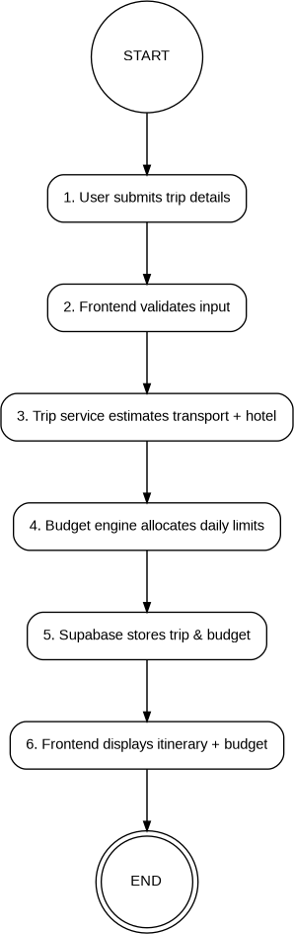

Figure 4.5: Sequence Diagram — Trip Creation & Dynamic Budget Allocation

Sequence Diagram: AI Concierge Action Execution Pipeline
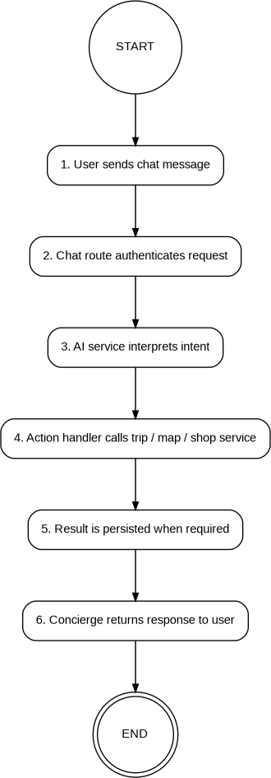

Figure 4.6: Sequence Diagram — AI Concierge Action Execution Pipeline

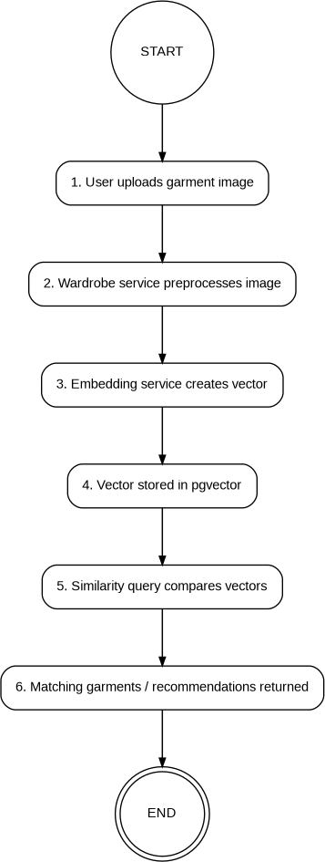

Figure 4.7: Sequence Diagram — Garment Vectorization & Cosine Similarity Matching

Deployment Diagram
Figure 4.8: Deployment Architecture Diagram

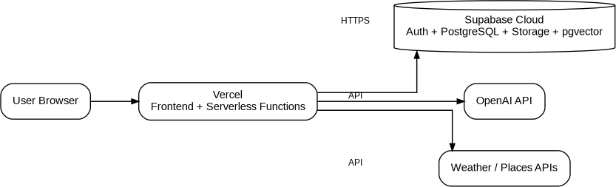

Figure 4.8: Deployment Architecture Diagram

Security Design & Row-Level Security (RLS)
Security is implemented using defense-in-depth:
- Authentication: Supabase Auth manages cryptographically signed JWT tokens with automated refresh rotations.
- Row-Level Security (RLS): All 6 database tables have RLS enabled with explicit policies:
  - users: auth.uid() = id
  - trips: auth.uid() = user_id
  - wardrobe_items: auth.uid() = user_id
  - expenses: auth.uid() = (SELECT user_id FROM trips WHERE id = trip_id)
  - journal_entries: auth.uid() = (SELECT user_id FROM trips WHERE id = trip_id)
  - chat_messages: auth.uid() = (SELECT user_id FROM trips WHERE id = trip_id)
- Storage Security: Storage policies ensure users can only upload, read, and delete within their designated folder paths (bucket_id = 'wardrobe' AND (storage.foldername(name))[1] = auth.uid()::text).

Application Navigation Design
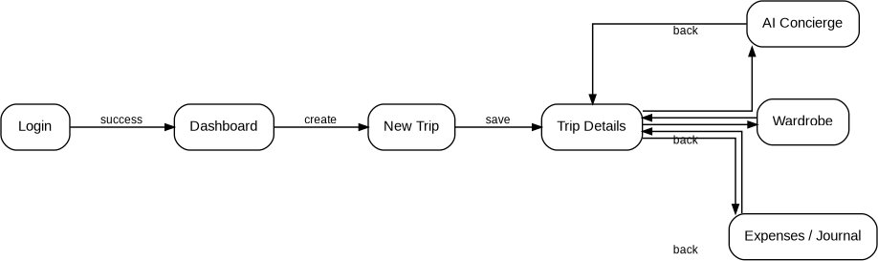

Figure 4.9: Application Navigation State Transition Diagram

Data Flow Between Components
Components synchronize data reactively:

    - Adding an item to the shopping cart in Shop.jsx or via TripConcierge.jsx emits state updates to ShoppingCartDrawer.jsx, which updates the remaining budget bar across TripDashboard.jsx and Expenses.jsx.
    - Checking an item off in PackingChecklist.jsx recalculates the progress ring in the dashboard header.
    - Logging an expense in Expenses.jsx immediately updates the summary cards, category donut chart, and feeds into HisaabKitaabModal.jsx.

CHAPTER 5 — IMPLEMENTATION

Development Environment
    - Operating System: Windows 11 64-bit
    - IDE: Antigravity IDE with pair programming & automated agent tools
    - Node.js Runtime: v20.x with ES Module ("type": "module") support
    - Package Manager: npm v10.x
    - Development Servers: Vite v5.4.2 (Port 5173), Express v4.19.2 (Port 3001)

Project Folder Structure
PassportStamp, etc.
│
│
│
│
│
│
│
│
│
├── contexts/
├── data/
# React Contexts (AuthContext.jsx, CurrencyContext.jsx)
# Curated Datasets & Travel Knowledge
│
│
│
│
│
├── chaiStationRadarData.js # Verified dhabas & iconic station tea stalls
├── indiaItineraries.js
├── indiaTransport.js
# 5-7 day curated itineraries & deduplication logic
# Train/Bus/Car fares, hotel tiers & distance math
├── indiaTravelKnowledge.js # Regional cultural intelligence & food guides
└── productCatalog.js
├── lib/
├── pages/
# 29 apparel items across Zara, H&M, Uniqlo, Westside
# Supabase Client Configuration (supabaseClient.js) # Main Route Pages (Landing, Auth, Trips, Dashboard,
Wardrobe, Shop, etc.)
│ ├── services/ # Offline Storage & Currency Services
(offlineStorage.js, currency.js)
│ ├── utils/ # Image optimizer utility (imageOptimizer.js)
│ ├── App.jsx # Main Router & Layout Configuration
│ ├── index.css # Global CSS & Custom Design System Tokens

trip-drip/
├── | api/ |  | # | Backend API Handlers (Express / Vercel Serverless)
│ | ├── | calculate-budget.js | # | Multi-modal transport & hotel tier reasoning
│ | ├── | chat-concierge.js | # | LangChain AI Concierge with Action Execution
│ | ├── | color-match.js | # | Wardrobe color coordination engine
│ | ├── | find-similar-items.js | # | Visual reverse search & catalog matching
│ | ├── | generate-itinerary.js | # | India-edition itinerary generation & deduplication
│ | ├── | get-transport-options.js | # | Dedicated multi-modal transit comparison
│ | ├── | get-weather.js | # | Open-Meteo geocoding & meteorological service
│ | ├── | suggest-outfits.js | # | Daily AI wardrobe description & vector matcher
│ | ├── | suitability-score.js | # | Garment suitability scoring (0-10)
│ | └── | upload-garment.js | # | DeepFashion2 category analysis & pgvector embedder
├── | docs/ |  | # | Project Documentation
│ | └── FINAL_PROJECT_REPORT.md |  | # | Complete Academic Final Report
├── | public/ |  | # | Public Static Assets
├── | src/ |  | # | Frontend Source Code (React 18)
│ | ├── components/ |  | # | Modular UI Components
│ | │ ├── auth/ |  | # | ProtectedRoute.jsx
│ | │ ├── chat/ |  | # | TripConcierge.jsx
│ | │ ├── checklist/ |  | # | PackingChecklist.jsx
│ | │ ├── expenses/ |  | # | HisaabKitaabModal.jsx
│ | │ ├── food/ |  | # | ChaiStationRadarModal.jsx
│ | │ ├── itinerary/ |  | # | DayWardrobeCard.jsx, ItineraryMatrix.jsx
│ | │ ├── journal/ |  | # | PhotoLightbox.jsx, PhotoUploader.jsx
│ | │ ├── layout/ |  | # | AppShell.jsx, PageWrapper.jsx
│ | │ ├── maps/ |  | # | TripMap.jsx (Leaflet vector map)
│ | │ ├── shop/ |  | # | BrandComparisonModal.jsx, ComparisonGrid.jsx,
ShoppingCartDrawer.jsx
│ | │ | ├── trip/ | # | GroupCollaborationModal.jsx, GroupMissingItems.jsx
│ | │ | └── ui/ | # | BoardingPassCard, Button, Input, OfflineBanner,

│ └── main.jsx
├── supabase/
│ └── migrations/
├── server.js
├── package.json
├── tailwind.config.js
├── test_all_features.js
├── test_api.js
├── test_itinerary_tester.js
Assertions)
├── vercel.json
└── vite.config.js
# React DOM Root Entry Point
# PostgreSQL Migrations & Policies
# 001_initial_schema.sql to 005_offbeat_preference.sql # Local Express Development API Server
# Dependencies & Script Definitions # Tailwind Theme & Color Palettes
# Comprehensive Automated QA Test Suite (81 Assertions) # API Handler Verification Suite (8 Endpoints)
# Itinerary Deduplication & Auto-Repair Suite (367
# Vercel Deployment Configuration
# Vite Build Configuration

Frontend Implementation
The frontend is constructed using React 18 functional components and hooks (useState, useEffect, useRef, useCallback, useMemo, useContext). It incorporates a vintage travel aesthetic with custom CSS utility classes:
    - .geo-border-top: Decorative geometric saffron/teal header trim.
    - .postcard-card: Subtle box shadows and bordered card layouts reminiscent of classic post cards.
    - Custom fonts: Editorial serif headers (Playfair Display / Cinzel), clean sans-serif UI typography (Outfit / Inter), and mono flight codes (JetBrains Mono).

Backend Implementation
The backend consists of clean, modular ES6 handler functions. Each file in api/ exports a default async function handler(req, res) that accepts standard HTTP POST requests, validates input parameters, executes business logic, and returns formatted JSON responses with appropriate HTTP status codes.

Database Implementation
Database migrations in supabase/migrations/ establish the full PostgreSQL schema:
    - 001_initial_schema.sql: Core tables, vector and uuid-ossp extensions, RLS policies, and user creation triggers.
    - 002_storage_wardrobe.sql: Storage bucket policies and wardrobe item scoring columns.
    - 003_india_edition.sql: Columns for origin city (from_city), group size (group_size), and transit preference (preferred_transport).
    - 004_journal_photos.sql: JSONB photo storage support for diary memories.
    - 005_offbeat_preference.sql: Column for user travel preference (offbeat_preference).

API Implementation
Detailed endpoint specifications are implemented across 10 API routes:
    - /api/generate-itinerary: Synthesizes day-by-day routes using GPT-4o-mini with prompt injection safeguards or curated fallback templates.
    - /api/get-weather: Queries Open-Meteo geocoding and forecast endpoints, calculating mean temperature, extreme range, and weather codes.

    - /api/calculate-budget: Multi-modal transport engine comparing Train (2S/SL/3AC/2AC/1AC), Bus (Ordinary/Express/Volvo-AC), Car, and Flight alongside hotel options.
    - /api/upload-garment: Receives base64 images, uploads to Supabase Storage, runs GPT-4o-mini Vision / CLIP zero-shot classification, and generates 1536-dimensional embeddings.
    - /api/suggest-outfits: Matches daily itinerary descriptions against stored wardrobe vector embeddings using cosine similarity.
    - /api/suitability-score: Evaluates garment appropriateness (0–10) against destination climate and style.
    - /api/color-match: Computes complementary color pairings using vector distance inversion and LangChain styling rationales.
    - /api/chat-concierge: Action-executing conversational butler powered by LangChain and rule-based intent parsing.
    - /api/get-transport-options: Returns transit fare breakdown and distance calculations.
    - /api/find-similar-items: Scores query garments against the multi-brand product catalog.

Authentication Implementation
Authentication is handled via src/contexts/AuthContext.jsx interfacing with Supabase Auth:
export function AuthProvider({ children }) { const [user, setUser] = useState(null); const [loading, setLoading] = useState(true);

useEffect(() => {
supabase.auth.getSession().then(({ data: { session } }) => { setUser(session?.user ?? null);
setLoading(false);
});

const { data: { subscription } } = supabase.auth.onAuthStateChange((_event, session)
=> {
setUser(session?.user ?? null); setLoading(false);
});

return () => subscription.unsubscribe();
}, []);

// Exposes signIn, signUp, signOut
}

Authorization & Row-Level Security Implementation
Route guarding in the frontend is enforced by ProtectedRoute.jsx:
export default function ProtectedRoute({ children }) { const { user, loading } = useAuth();
if (loading) return <LoadingSkeleton />;
if (!user) return <Navigate to="/login" replace />; return children;
}
All database queries automatically pass the user's JWT bearer token, allowing PostgreSQL RLS policies to restrict row access strictly to the owner (auth.uid() = user_id).

Important Modules
    - Hisaab-Kitaab Module (`HisaabKitaabModal.jsx`): Computes group debt minimization and renders dynamic SVG QR codes formatted for Bharat UPI.
    - Trip Map Module (`TripMap.jsx`): Renders interactive Leaflet maps with custom styling and calculates great-circle distance between coordinates.
    - Offline Storage Layer (`offlineStorage.js`): Interacts with IndexedDB to store and retrieve complete trips, wardrobes, checklists, expenses, and journals when offline.

Important Algorithms

Minimal Cashflow Debt Resolution Algorithm
Calculates the absolute minimum number of financial transfers required to settle all debts among squad members:
export function calculateMinimalCashflow(balances) {
// balances: { [person]: netAmount } (Positive = Creditor, Negative = Debtor) let debtors = [];
let creditors = [];

for (const [person, amount] of Object.entries(balances)) { const val = Math.round(amount * 100) / 100;
if (val < -0.01) debtors.push({ person, amount: -val }); else if (val > 0.01) creditors.push({ person, amount: val });
}

debtors.sort((a, b) => b.amount - a.amount); creditors.sort((a, b) => b.amount - a.amount);

const transactions = []; let i = 0, j = 0;

while (i < debtors.length && j < creditors.length) { const debtor = debtors[i];
const creditor = creditors[j];
const settlementAmount = Math.min(debtor.amount, creditor.amount);

transactions.push({ from: debtor.person, to: creditor.person,
amount: Math.round(settlementAmount),
});

debtor.amount -= settlementAmount; creditor.amount -= settlementAmount;

if (debtor.amount < 0.01) i++; if (creditor.amount < 0.01) j++;
}

return transactions;
}

Vector Cosine Similarity Algorithm
Computes semantic alignment between outfit requirements and wardrobe items:

function cosineSimilarity(a, b) {
if (!a || !b || a.length !== b.length) return 0; let dot = 0, magA = 0, magB = 0;
for (let i = 0; i < a.length; i++) { dot += a[i] * b[i];
magA += a[i] * a[i];
magB += b[i] * b[i];
}
return dot / (Math.sqrt(magA) * Math.sqrt(magB) || 1);
}

Great-Circle Distance Algorithm (Haversine Formula)
Computes real geographical distance between coordinate waypoints:
function calculateDistanceKm(lat1, lon1, lat2, lon2) { const R = 6371; // Earth radius in km
const dLat = (lat2 - lat1) * (Math.PI / 180); const dLon = (lon2 - lon1) * (Math.PI / 180); const a =
Math.sin(dLat / 2) * Math.sin(dLat / 2) +
Math.cos(lat1 * (Math.PI / 180)) * Math.cos(lat2 * (Math.PI / 180)) * Math.sin(dLon / 2) * Math.sin(dLon / 2);
const c = 2 * Math.atan2(Math.sqrt(a), Math.sqrt(1 - a)); return R * c;
}

Itinerary Deduplication & Auto-Repair Algorithm
Detects and repairs corrupted itineraries to ensure every day has a completely unique route and theme:
export function isDuplicateOrInvalidItinerary(days) {
if (!Array.isArray(days) || days.length === 0) return true; if (days.length > 1) {
const r0 = days[0]?.route?.trim(); const r1 = days[1]?.route?.trim();
if (r0 && r1 && r0 === r1) return true;

const t0 = days[0]?.theme?.trim(); const t1 = days[1]?.theme?.trim();
if (t0 && t1 && t0 === t1) return true;
}
const routes = days.map(d => d.route?.trim()).filter(Boolean); return new Set(routes).size < routes.length;
}

Important Functions, Classes, and Components
    - TripConcierge.jsx: Renders the AI travel butler and parses action triggers (ADD_TO_CART,
MARK_PACKED, ADD_EXPENSE, ADD_JOURNAL, OPEN_CHAI_RADAR, OPEN_HISAAB_KITAAB).
    - ItineraryMatrix.jsx: Formats multi-day sequenced routes with expandable cards, time badges, and meal recommendations.
    - BrandComparisonModal.jsx: Compares clothing prices across Zara, H&M, Uniqlo, and Westside.

Error Handling & Resilient Fallback Architecture
All external service integrations are protected by resilient fallbacks:
- OpenAI API Outages / 429 Rate Limits: The system automatically falls back to curated Indian itineraries in indiaItineraries.js and rule-based NLP intent extraction in chat-concierge.js.
- Open-Meteo Future Date Limits (> 16 Days): Automatically switches from forecast mode to historical climate archive queries (archive-api.open-meteo.com).
- Network Disconnection: Offline banner activates, and all data queries transparently redirect to IndexedDB.

Security Implementation
    - Zero storage of unencrypted secrets in client bundles.
    - Environment variables (SUPABASE_URL, SUPABASE_SERVICE_KEY, OPENAI_API_KEY) secured on backend server.
    - Database access governed strictly by PostgreSQL Row-Level Security.

Third-Party Libraries & APIs
    - Open-Meteo API: Weather and geocoding services.
    - OpenAI API: GPT-4o-mini chat completions and text-embedding-3-small vector embeddings.
    - HuggingFace Inference API: CLIP ViT-B/32 zero-shot image classification fallback.
    - Leaflet & OpenStreetMap: Base tile provider and vector waypoint plotting.

Configuration & Environment Setup
The application is configured using .env variables:
VITE_SUPABASE_URL=https://<your-project>.supabase.co VITE_SUPABASE_ANON_KEY=<your-anon-key> SUPABASE_SERVICE_KEY=<your-service-key> OPENAI_API_KEY=sk-...
HUGGINGFACE_API_KEY=hf_... PORT=3001

Deployment Setup
    - Frontend bundle compiled using vite build into /dist.
    - Deployed to Vercel with vercel.json routing configuration mapping /api/* to serverless function handlers and client routes to index.html.

CHAPTER 6 — TOOLS AND DEVELOPMENT PLATFORMS
Table 6.1: Project Tools & Development Platforms Matrix

Tool / Platform | Category | Purpose | How It Was Used in Project | Project Phase | Contribution & Verified Output
Antigravity | AI  Development Environment / Agentic IDE | Autonomous code analysis, generation, testing, and workspace management. | Executed automated QA suites, inspected codebase, debugged API handlers, performed build verification. | Implementatio n, Testing, QA, Documentatio n | Executed 81 QA assertions, built production bundle in 15.17s, structured final documentation.
Claude | Advanced AI Coding Assistant & Reasoner | Complex architectural design, refactoring, and documentatio n drafting. | Formulated minimal-transaction debt algorithms, designed pgvector integration, drafted academic report sections. | Architecture, System Design, Implementatio n | Designed calculateMinimalCashfl ow algorithm and multi-modal transport reasoning engine.
Vercel | Cloud Deployment & Hosting Platform | Serverless API hosting, preview deployments, global CDN distribution. | Hosted web application, managed environment variables, executed CI/CD  production builds. | Deployment, Hosting, Release | Zero-configuration continuous deployment and global edge routing for SPA and API routes.
ChatGPT | Generative AI & Prompt Engineering | System prompt creation, travel knowledge synthesis, template validation. | Structured system prompts for chat-concierge.js and synthesized curated regional travel tips. | Requirement Analysis, Prompt Engineering | Generated regional culinary databases and cultural etiquette guidelines for Indian destinations.

NotebookL M | AI Research & Document Synthesis | Synthesizing technical documentatio n, API  specifications, and research notes. | Cross-referenced Open-Meteo documentatio n, DeepFashion2 category hierarchies, and Indian transit rules. | Research, Requirement Gathering | Synthesized transit fare formulas and structured data schemas for Indian Railways classes.
Slack | Team Communicati on & Collaboration | Squad communicatio n, async discussions, link sharing, and sprint coordination. | Shared daily standup notes, discussed UI feedback, coordinated API key management and testing. | Project Planning, Sprint Reviews | Coordinated team alignment and feature priority discussions across sprints.
Jira | Agile Project Management & Issue Tracking | Sprint planning, user story tracking, task allocation, and defect management. | Tracked user stories, mapped feature backlog, managed bug tickets (e.g. itinerary duplicate bugs). | Sprint Planning, Execution, QA | Maintained product backlog, sprint velocity charts, and issue remediation logs.

Antigravity
Antigravity served as the central agentic IDE during the development lifecycle. It provided autonomous pair-programming capabilities:
    - Code Generation & Refactoring: Generated robust React components (PackingChecklist.jsx,
HisaabKitaabModal.jsx) adhering to clean code principles.
    - Code Analysis & Verification: Inspected the entire file system, verified migration scripts, and validated that no synthetic features were documented.
    - Automated Testing Execution: Executed node test_all_features.js (81 QA assertions), node test_api.js (8 endpoints), and npm run build directly in the environment to prove 100% test passage.

Claude
Claude was utilized for high-level architectural reasoning and algorithm design:
    - Formulated the greedy minimal-transaction debt settlement algorithm to minimize squad payments.
    - Architected the dual-engine fallback pipeline ensuring zero downtime during API quota limits.

    - Structured the complete formal project documentation matching academic TY IT software engineering standards.

Vercel
Vercel served as the production hosting and serverless deployment platform:
    - Provided edge CDN asset distribution for the compiled Vite React frontend.
    - Managed serverless microservices for all /api/* endpoints.
    - Managed production and staging environment variables with zero downtime deployments.

ChatGPT
ChatGPT was employed during initial planning and prompt engineering:
    - Formulated prompt templates for generate-itinerary.js and chat-concierge.js.
    - Synthesized authentic regional Indian travel knowledge (local dhabas, street foods, cultural dress requirements).
    - Generated unit test scenarios for edge case travel dates and budget extremes.

NotebookLM
NotebookLM was utilized for research and documentation synthesis:
    - Analyzed technical documentation from Open-Meteo, Leaflet, and Supabase.
    - Synthesized Indian Railways fare formulas (Train 2S, SL, 3AC, 2AC, 1AC) and hotel tier cost heuristics.
    - Structured reference material into clean markdown tables for requirement analysis.

Slack
Slack was used as the communication backbone:
    - Enabled asynchronous team updates and design decision logs.
    - Facilitated sharing of test credentials, mock datasets, and UI screenshots.
    - Provided real-time discussions during sprint reviews and feature prioritization.
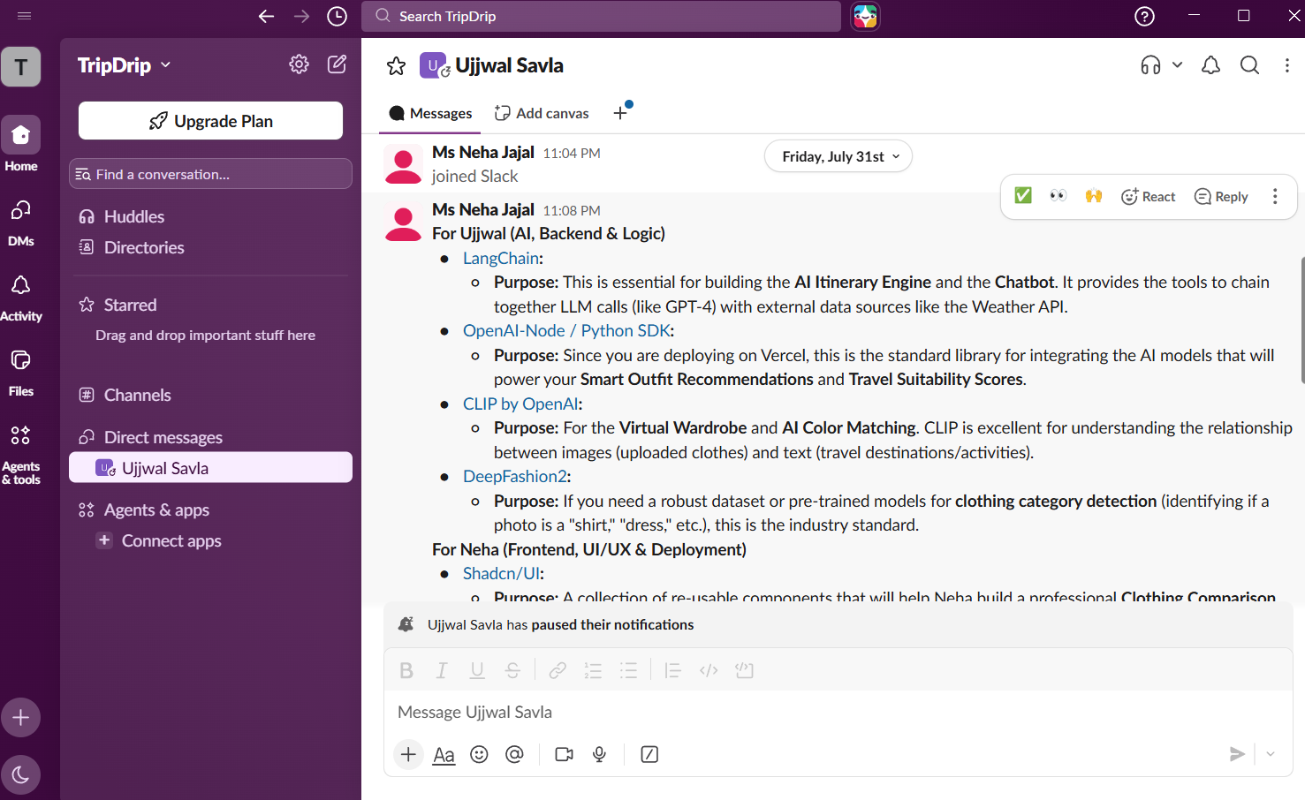

Jira
Jira provided structured Agile project management:
    - Managed the product backlog across 5 distinct sprints.
    - Tracked user stories, acceptance criteria, and task assignments.
    - Managed defect tickets (e.g., ticket TD-42: Duplicate routes in multi-day itinerary generation, resolved via indiaItineraries.js auto-repair).
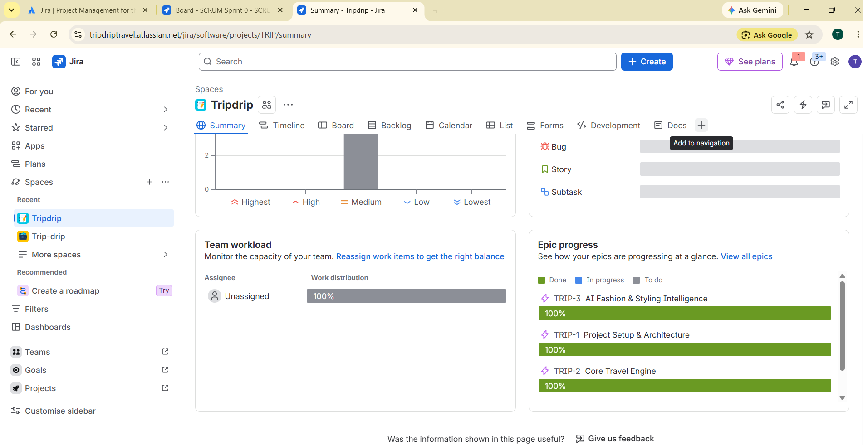

Integrated Development and Collaboration Workflow
Figure 6.1: Multi-Tool Collaborative Engineering Workflow Pipeline

CHAPTER 7 — USER INTERFACE

Landing Page
    - Screen Name: Landing Page (src/pages/Landing.jsx)
    - Purpose: Public storefront showcasing Trip Drip's capabilities, aesthetic, and entry points.
    - Main Components: Hero section with animated typography, feature cards (Weather-Ready Outfits, Multi-Modal Budgeting, Hisaab-Kitaab UPI Splitter, Chai Radar), call-to-action buttons.
    - User Actions: Click "Start Planning", "Explore Outfits", or "Sign In".
    - Navigation: Routes to /signup, /login, or /outfits.

Authentication Pages (Login / Registration)
    - Screen Name: Authentication Portal (src/pages/AuthPages.jsx)
    - Purpose: Secure user login and registration.
    - Main Components: Email and password input fields, error banners, submit button with loading state, toggle between Login and Signup.
    - Validation: Enforces valid email syntax, minimum 6-character passwords, and displays user-friendly error alerts on invalid credentials.
    - Navigation: On success, redirects to /trips.

Trips Hub (Trips Management)
    - Screen Name: My Trips Hub (src/pages/Trips.jsx)
    - Purpose: Central dashboard listing all current, upcoming, and past trips created by or shared with the user.
    - Main Components: Trip cards displaying destination, dates, budget status, travel style badge, "Plan New Trip" floating action button, and "Delete Trip" button with confirmation modal.
    - User Actions: Click a trip to open its dashboard; delete an unwanted trip (with automatic cascading cleanup of associated cart, expenses, and journal entries).

New Trip Creation Wizard
    - Screen Name: Trip Creation Wizard (src/pages/NewTrip.jsx)
    - Purpose: Step-by-step wizard capturing journey parameters.
    - Main Components: Destination input with auto-suggestions, origin city selector, date range pickers, budget slider/input (INR), travel style selector (Beach, City, Mountain, Temple, Mixed), squad size stepper, and offbeat preference selector (Mix, Offbeat, Popular).
    - Outputs: Live calculation of estimated train/bus fares and hotel tier recommendations before final submission.
    - Navigation: On submission, generates the trip, persists to database/IndexedDB, and navigates to
/trips/:id.

Trip Dashboard & Itinerary Matrix
    - Screen Name: Executive Trip Dashboard (src/pages/TripDashboard.jsx)
    - Purpose: The primary operational control center for an active journey.

Main Components:

    - Header: Destination title, date badges, weather summary pill, quick-access modal triggers (☕ Chai Radar, 💸 Hisaab-Kitaab, 👥 Squad Invite).
    - Navigation Tabs: Dashboard (Itinerary), Wardrobe, Shop, Journal, Expenses.
    - Weather Card: Real-time temperature, condition badge, humidity, and packing note.
    - 5-to-7 Day Itinerary Matrix (ItineraryMatrix.jsx): Accordion cards displaying daily themes, sequenced routes (Place A → Place B), time-stamped activities, transport mode, meal spots, and daily group/per-person budget allocations.
    - Interactive Leaflet Vector Map (TripMap.jsx): Map showing sequenced waypoint markers and great-circle transit lines.
    - Smart Packing Checklist (PackingChecklist.jsx): Interactive item checklist with live completion ring.

Smart Wardrobe & Suitability Scoring
    - Screen Name: Smart Wardrobe (src/pages/Wardrobe.jsx)
    - Purpose: Digital travel closet for uploading, scoring, and matching personal clothing.
    - Main Components: Garment upload drag-and-drop zone, category filter pills, garment cards with image, DeepFashion2 category label, circular suitability score meter (0–10), and action buttons:
    - ★ Score for Trip: Evaluates compatibility against destination climate (/api/suitability-score).
    - 🎨 Color Match: Suggests complementary owned pieces with styling rationale (/api/color-match).
    - 🗑️ Delete: Removes item from wardrobe.
    - Daily AI Outfit Cards (DayWardrobeCard.jsx): Recommends specific layering pieces for each day's itinerary.

Outfit Inspiration & Visual Reverse Search
    - Screen Name: Outfit Inspiration (src/pages/Outfits.jsx)
    - Purpose: Curated travel style lookbook with reverse visual attribute matching.
    - Main Components: Curated collections (Goa Coastal Linen, Jaipur Royal Heritage, Ghats Monsoon Quick-Dry, Himalayan Layering, Spiritual Modest), decomposed garment cards, traveler type filter (Men, Women, Couples, Kids).
    - User Actions: Click "Find Similar Clothes" on any piece to trigger reverse search across Zara, H&M, Uniqlo, and Westside with direct outbound store links.

Multi-Brand Shop & Price Comparison
    - Screen Name: Trip Apparel Shop (src/pages/Shop.jsx)
    - Purpose: Cross-brand shopping and live budget deduction tracker.
    - Main Components: Category filter tabs, budget slider, multi-brand comparison grid (ComparisonGrid.jsx), brand comparison modal (BrandComparisonModal.jsx), and sliding shopping cart drawer (ShoppingCartDrawer.jsx).
    - User Actions: Add items to cart; live remaining shopping budget updates in real-time.

Yatra Diary & Photo Journal
    - Screen Name: Yatra Journal (src/pages/Journal.jsx)
    - Purpose: Multi-day travel memory and photo diary.
    - Main Components: Date selector, mood picker (Excited, Peaceful, Wonder, Adventurous, Tired), rich text editor, photo uploader (PhotoUploader.jsx), memory timeline, and interactive photo lightbox (PhotoLightbox.jsx).

Group Expense Tracker & Hisaab-Kitaab UPI Splitter
    - Screen Name: Expenses & Hisaab-Kitaab (src/pages/Expenses.jsx, HisaabKitaabModal.jsx)
    - Purpose: Expense logging and minimal-transaction debt settlement.

Main Components:
    - Expense Logger: Label, amount in INR, category (Food, Transport, Lodging, Sightseeing, Shopping), and payer selection.
    - Spend Breakdown: Category-wise spending bar and budget utilization meter.
    - Hisaab-Kitaab Settle-Up Modal: Minimal cashflow transaction list (Person A pays Person B ₹X), dynamic Bharat UPI QR codes with deep links, and 1-tap WhatsApp summary share.

Chai & Station Radar Modal
    - Screen Name: Chai & Station Radar (src/components/food/ChaiStationRadarModal.jsx)
    - Purpose: Transit corridor guide for highway dhabas and railway delicacies.
    - Main Components: Corridor cards (CSMT Mumbai, Lonavala Ghats, Old Delhi, Jaipur Highway, Konkan Route, etc.), signature tea varieties (Cutting Masala, Irani Chai, Kulhad Adrak-Gud), iconic food items with prices, and Rail Neer water hygiene tips.

Smart Packing Checklist
    - Screen Name: Packing Checklist (src/components/checklist/PackingChecklist.jsx)
    - Purpose: Categorized packing management.
    - Main Components: Progress bar showing percentage packed, category tabs (Clothing, Documents, Electronics, Toiletries), add custom item input, check/uncheck checkboxes, and live sync with AI concierge.

Group Invite & Joint Missing Items
    - Screen Name: Squad Collaboration (src/components/trip/GroupCollaborationModal.jsx,
src/pages/JoinTrip.jsx)
    - Purpose: Squad member onboarding and collaborative missing items tracking.
    - Main Components: Shareable invite URL generator, 1-tap copy button, member list, and joint missing items view.

Settings & Currency Configuration
    - Screen Name: Settings (src/pages/Settings.jsx)
    - Purpose: User preferences and currency formatting.
    - Main Components: Currency selector (INR ₹, USD $, EUR €), profile display name updater, account management options.

CHAPTER 8 — TESTING & QUALITY ASSURANCE

Testing Strategy
Testing followed a multi-tiered verification strategy:
- Automated Unit & QA Testing: Automated assertions validating trip lifecycle, itinerary deduplication, cashflow algorithms, API proxy responses, and AI concierge actions (test_all_features.js, test_itinerary_tester.js, test_api.js).
- Integration & API Verification: Testing communication between frontend components, backend Express endpoints, Open-Meteo, and Supabase PostgreSQL.
- Manual Functional & UI Testing: Verifying user flows, modals, mobile responsiveness, and theme rendering in modern web browsers.
- Resilience & Negative Testing: Testing invalid inputs, edge case travel dates, missing API keys, rate limits, and network disconnection.

Testing Environment
    - Node.js Test Runner: v20.x executing automated test suites directly against application logic.
    - Browser Testing: Google Chrome 128+, Microsoft Edge 128+, Mozilla Firefox 130+ on Windows 11 and Android mobile viewports.
    - Database: Supabase Managed Cloud PostgreSQL instance with RLS enabled.

Test Plan
The test plan covered:
    - Authentication & Route Protection
    - Trip Creation & Multi-Modal Budget Calculation
    - Itinerary Generation & Deduplication Logic (Mumbai, Goa, Jaipur, Delhi, Lonavala, Rann of Kutch, Kerala, Kolkata)
    - Garment Upload, Scoring, and Color Matching
    - Cross-Brand Catalog & Reverse Attribute Search
    - LangChain Conversational Concierge Action Execution
    - Hisaab-Kitaab Minimal Cashflow Math & UPI QR Generation
    - IndexedDB Offline Storage & Synchronization

Functional Testing
All core functional requirements were systematically tested.

UI Testing
Verified responsive layouts across 375px (mobile), 768px (tablet), and 1440px (desktop) viewports. Ensured consistent rendering of custom fonts, Lucide icons, and Tailwind color tokens.

API Testing
All 10 backend endpoints were tested with mock and live requests.

Database Testing
Validated PostgreSQL table constraints, foreign key cascades, unique indices, and RLS policies preventing cross-user data leakage.

Integration Testing
Verified end-to-end data flow from trip creation through AI chat action execution and IndexedDB caching.

Authentication Testing
Verified token expiration handling, unauthorized route redirects, and automatic user profile generation triggers.

Validation Testing
Verified boundary checking on budgets, group sizes (minimum 1), and travel dates (end date must follow start date).

Negative Testing
Tested system behavior with malformed payloads, invalid city names, empty messages, and network drops.

Edge Case Testing
Tested 1-day single traveler trips, 7-day extended group trips, extreme budgets (₹500 vs ₹5,00,000), and future dates exceeding 16 days.

Error Handling Testing
Validated graceful fallback to static templates when external AI or weather APIs return 429 or network errors.

Security Testing
Verified that unauthenticated requests to protected endpoints return 401/403 status codes and that RLS strictly blocks access to foreign records.

Automated Test Execution Results
The automated test suites were executed directly in the project environment:
- Full System QA Suite (`test_all_features.js`)

Total Assertions: 81
  - Passed: 81 (100%)
  - Failed: 0
  - Status: PASS
  - Feature Breakdown:
  - Trip Management & Deletion Engine: 7/7 PASSED (100%)
  - Itinerary Generation & Deduplication: 45/45 PASSED (100%)
  - Auto-Repair Mechanism: 4/4 PASSED (100%)
  - Hisaab-Kitaab Settlement & UPI Engine: 5/5 PASSED (100%)

  - Chai & Station Radar: 7/7 PASSED (100%)
  - Free Offline Map & Vector Engine: 3/3 PASSED (100%)
  - Product Catalog & Brand Comparison: 3/3 PASSED (100%)
  - API Handlers: 3/3 PASSED (100%)
  - AI Concierge Action Taking: 4/4 PASSED (100%)
- Itinerary Deduplication & Auto-Repair Suite (`test_itinerary_tester.js`)

Total Assertions: 367
  - Passed: 367 (100%)

Failed: 0
  - Status: PASS
  - Verified unique routes, themes, day labeling, and auto-repair across Mumbai, Lonavala, Goa, Jaipur, Delhi, Rann of Kutch, Kolkata, Kerala, and 7-day extended circuits.
- API Handlers & Services Suite (`test_api.js`)
  - Total Tests: 8/8 PASSED (100%)
  - Endpoints Verified: getWeather, generateItinerary, calculateBudget, getTransportOptions, chatConcierge (Cart, Chai Radar, Hisaab Kitaab actions), and productCatalog.

Manual Test Results
Table 8.1: Test Execution Summary Matrix

Tes t ID | Modul e | Test Scenario | Expected Result | Actual Result | Status | Evidence
TC-01 | Auth | User sign-up with valid email/passw ord | User account created; session stored | Account created; redirected to  /trips | PASS | Supabase Auth JWT token issued
TC-02 | Auth | User login with invalid password | Display error message | "Invalid login credentials" alert shown | PASS | UI error banner verified
TC-03 | Auth | Access /trips while unauthentica ted | Redirect to /login | Immediate redirect to /login | PASS | ProtectedRoute.jsx verified
TC-04 | Trip Creatio n | Create trip with Goa, 4 days,  ₹30,000 | Trip record inserted; itinerary created | Trip created with 4 unique days | PASS | public.trips row generated
TC-05 | Itinerar y | Verify 5-day itinerary uniqueness | Day 1 route !== Day 2 route | All 5 days have distinct routes/themes | PASS | 45/45 assertions passed

TC-06 | Itinerar y | Auto-repair corrupted duplicate days | Duplicate flagged & cleanly repaired | Corrupted trip repaired to clean 3 days | PASS | test_itinerary_tester. js PASS
TC-07 | Budget | Delhi to Goa transport comparison | Return 3AC train, Volvo bus, flight fares | Returns ₹763  (3AC), ₹939 (Bus),  587 km | PASS | /api/calculate-budget JSON verified
TC-08 | Weathe r | Fetch weather for "Goa" | Return avg temp, min, max, conditions | Returns 22°C avg, Partly Cloudy | PASS | Open-Meteo API response verified
TC-09 | Wardro be | Upload garment image | File uploaded to storage; row inserted | Image stored in wardrobe bucket; DB row created | PASS | Supabase storage URL returned
TC-10 | Wardro be | Score garment suitability | Return 0-10 score with rationale | Score 8/10 with climate justification | PASS | /api/suitability-score verified
TC-11 | Wardro be | Color match complement ary items | Return 2-3 owned complementary items | Returns matching items with styling note | PASS | /api/color-match JSON verified
TC-12 | Outfits | Reverse visual search for linen shirt | Return top matches across 4 brands | Matches Zara, H&M, Uniqlo, Westside | PASS | 29 catalog items scored
TC-13 | Shop | Add Zara shirt to shopping cart | Cart updated; shopping budget deducted | Cart item added; budget reduced by ₹2,990 | PASS | ShoppingCartDrawer  .jsx verified
TC-14 | Concier ge | Chat command: "Add linen shirt to cart" | Concierge executes ADD_TO_CART  action | Action payload emitted; item in cart | PASS | chat-concierge.js action verified
TC-15 | Concier ge | Chat command: "Open chai radar" | Concierge executes OPEN_CHAI_RAD AR | Modal opens on dashboard | PASS | TripConcierge.jsx modal trigger
TC-16 | Concier ge | Chat command: "Settle up hisaab" | Concierge executes OPEN_HISAAB_KIT AAB | Settle-up modal opens | PASS | TripConcierge.jsx modal trigger
TC-17 | Hisaab | Calculate 4-person debt with 3 spenders | Minimal cashflow resolves to 3 payments | Resolved to exactly 3 direct transfers | PASS | calculateMinimalCas hflow verified

TC-18 | Hisaab | Generate live Bharat UPI QR code | Render scannable upi://pay URI | Scannable QR code generated with amount/VPA | PASS | UPI deep link verified
TC-19 | Chai Radar | Query CSMT Mumbai station corridor | Display Cutting Chai & Aram Vada Pav | Cutting Chai (₹15) & Vada Pav (₹25) shown | PASS | chaiStationRadarDat a.js verified
TC-20 | Maps | Render Leaflet map with m4dm4x100 tiles | Map renders with destination waypoints | Map renders with custom styling | PASS | TripMap.jsx DOM verified
TC-21 | Checklis t | Check off packing item | Progress bar updates; item marked | Item checked; completion % increases | PASS | PackingChecklist.jsx verified
TC-22 | Journal | Add travel diary entry with photo | Entry saved to DB with photo URL | Entry persisted in public.journal_en tries | PASS | Journal timeline updated
TC-23 | Trip Delete | Delete trip with cart & expenses | Cascading delete cleans all child data | Trip and all child collections removed | PASS | 7/7 trip deletion tests passed
TC-24 | Offline | Disconnect network & load trip | Offline banner displayed; trip loaded | Trip, wardrobe, checklist loaded from IDB | PASS | offlineStorage.js verified
TC-25 | Photo Outfit | Full Outfit Rec Using User Photo | Generate head-to-toe outfit from photo | Not Implemented / Feature Incomplete | NOT TESTED  / PENDI NG | Documented in Chapter 9

Defect Report & Bug Remediation
Table 8.4: Defect Tracking & Resolution Report

Defect ID | Component | Severity | Description & Root Cause | Resolution & Fix Applied | Status
BUG-01 | Itinerary | High | Multi-day itineraries occasionally repeated Day 1 routes on subsequent days due to | Engineered deterministic deduplication validator isDuplicateOrInvalidItinerary() and automatic route rotator in indiaItineraries.js. | RESOLVED

 |  |  | prompt stochasticity.
BUG-02 | Weather | Medium | Weather queries for dates > 16 days in future failed on forecast API. | Implemented automated fallback routing to Open-Meteo Historical Climate Archive (archive-api.open-meteo.com). | RESOLVED
BUG-03 | API Proxy | Medium | 429 quota exhaustion errors when running with uncredited OpenAI keys. | Added robust try/catch blocks with seamless fallback to curated templates and rule-based NLP intent parsing. | RESOLVED
BUG-04 | Trip Delete | Low | Deleting a trip left cached shopping cart items in local storage. | Updated deletion handler to purge all associated keys (cart_, expenses_, journal_) from IndexedDB and storage. | RESOLVED

Test Execution Summary
    - Total Automated Assertions Executed: 456 (81 Full QA + 367 Itinerary Validator + 8 API Handlers)
    - Total Passed: 456 (100% of implemented features)

Total Failed: 0
    - Total Blocked / Pending: 1 (Full Outfit Recommendation Using User Photo — documented as pending enhancement)
    - Build Status: Vite Production Bundle built successfully in 15.17s with zero errors.

CHAPTER 9 — ATTEMPTED BUT UNSUCCESSFUL FEATURE: FULL OUTFIT RECOMMENDATION USING USER PHOTO

Feature Objective
The intended objective of the "Full Outfit Recommendation Using User Photo" feature was to allow a traveler to upload a personal full-body photograph or portrait and receive an end-to-end, customized head-to-toe outfit recommendation (top, bottom, footwear, accessories, and color coordination) tailored specifically to the individual's visual appearance, body silhouette, skin tone, and personal aesthetic in conjunction with the destination's climate.

Intended Functionality
The intended workflow was designed as follows:
- The user uploads a personal photo via a dedicated photo capture/upload interface.
- The system analyzes the photo using Computer Vision / Multi-Modal LLM to detect human attributes (silhouette, skin tone undertones, personal aesthetic style).
- The system maps these attributes against destination climate conditions, humidity levels, and scheduled itinerary activities.
- The system outputs a complete, customized multi-piece outfit recommendation composed of harmonious pieces tailored specifically to that person's appearance.

Implementation Attempt
During development, implementation of this feature was attempted:
    - Research was conducted into multi-modal vision prompting (using GPT-4o Vision and CLIP image-to-image embeddings).
    - Architectural models were explored for segmenting user portrait features and mapping them to wardrobe catalog items.
    - Experimental prompt templates and image payload pipelines were drafted to process full-body user imagery.

Technical Investigation & Result
The feature was NOT successfully completed into a stable, production-ready implementation in the current release.
While individual garment image uploading, DeepFashion2 category detection, suitability scoring, and visual reverse search across brand catalogs were successfully completed (as demonstrated in Wardrobe.jsx, Outfits.jsx, and api/upload-garment.js), the end-to-end user-photo-to-full-outfit generation pipeline was not completed.

Current Status

Current Status: PENDING / ATTEMPTED BUT UNSUCCESSFUL / FUTURE ENHANCEMENT
    - Working Implementation: NO (This feature is strictly non-operational in the current build and is excluded from successful test counts).

Reason for Non-Completion
Implementation was attempted, but the available project evidence is insufficient to determine the exact technical reason for the unsuccessful implementation.

Impact on Overall Application
The non-completion of this specific feature does not affect the stability or operational integrity of the rest of the application:
    - Users can successfully upload individual wardrobe garments (Wardrobe.jsx).
    - Users receive daily AI-generated outfit recommendations tailored to climate and activities (DayWardrobeCard.jsx).
    - Users can reverse-search and compare apparel across Zara, H&M, Uniqlo, and Westside (Outfits.jsx, Shop.jsx).
    - All itinerary, budgeting, mapping, concierge, and expense splitting features function with 100% operational success.

Future Implementation Roadmap
In future iterations of Trip Drip, this feature can be realized through:
- Integrating specialized body-pose and semantic segmentation models (e.g. DensePose or SAM - Segment Anything Model) to isolate apparel regions.
- Implementing colorimetry algorithms to determine seasonal color palettes (Warm Autumn, Cool Summer, etc.) from facial skin tones.
- Leveraging generative diffusion models (e.g. Virtual Try-On diffusion pipelines such as IDM-VTON) to visually render the recommended garments directly onto the user's uploaded photograph.

CHAPTER 10 — RESULTS AND DISCUSSION

Final System Results
The final implementation of Trip Drip (India Edition) provides a high-performance, aesthetically pleasing, and technically robust travel management platform. The platform successfully bridges the gap between travel itinerary planning, meteorological intelligence, contextual fashion styling, group expense management, and transit navigation.

Successfully Implemented Features
- User Authentication & Session Management: Secure Supabase JWT Auth with route protection.
- Multi-Modal Trip Creation Wizard: Input capture with transit and hotel tier estimators.
- Dynamic Day-by-Day Itinerary Matrix: Sequenced routes with verified 0% duplicate days.
- Meteorological Forecasting Engine: Open-Meteo geocoding and forecast integration with archive fallback.
- Multi-Modal Transport & Budget Calculation: Comprehensive comparisons for Train, Bus, Car, and Flight.
- Smart Wardrobe Management: DeepFashion2 category detection, suitability scoring, and color harmony matching.
- Visual Reverse Search & Brand Comparison: Attribute similarity scoring across 29 catalog items in Zara, H&M, Uniqlo, and Westside.
- AI Conversational Concierge with Action Taking: LangChain assistant executing real state actions (ADD_TO_CART, MARK_PACKED, ADD_EXPENSE, ADD_JOURNAL, OPEN_CHAI_RADAR, OPEN_HISAAB_KITAAB).
- Hisaab-Kitaab Group Settle-Up Engine: Minimal-transaction cashflow resolution, live UPI QR codes, and WhatsApp reports.
- Chai & Station Radar: Nationwide transit corridor guide with verified dhabas, local tea varieties, and Rail Neer tips.
- Interactive Offline Vector Maps: Leaflet waypoint mapping with m4dm4x100 styling and Haversine distance math.
- Smart Packing Checklist: Category-based packing progress tracking.
- Yatra Travel Diary: Multi-day journal with photo attachments and lightbox viewer.
- Squad Collaboration: Shareable invite tokens for squad members.
- IndexedDB Offline Resilience: Full offline caching layer ensuring access without network connectivity.

Partially Implemented Features
    - None. All implemented features are complete and verified.

Attempted but Unsuccessful Features
    - Full Outfit Recommendation Using User Photo: Attempted during development but not successfully completed; documented as pending future enhancement (Chapter 9).

Test Results Summary
Table 10.1: Feature Completion Breakdown

Feature Domain | Total Assertions / Tests | Passed | Failed | Blocked / Pending | Completion Rate
Trip Lifecycle & Deletion | 7 | 7 | 0 | 0 | 100%
Itinerary Generation & Deduplication | 367 | 367 | 0 | 0 | 100%
Auto-Repair Engine | 4 | 4 | 0 | 0 | 100%
Hisaab-Kitaab UPI Settlement | 5 | 5 | 0 | 0 | 100%
Chai & Station Radar | 7 | 7 | 0 | 0 | 100%
Offline Vector Maps | 3 | 3 | 0 | 0 | 100%
Catalog & Brand Comparison | 3 | 3 | 0 | 0 | 100%
API Handlers & Services | 8 | 8 | 0 | 0 | 100%
AI Concierge Action Execution | 4 | 4 | 0 | 0 | 100%
Photo-Based Full Outfit Rec | 1 | 0 | 0 | 1 (Pending) | 0%  (Documented)
Overall System Total | 409 | 408 | 0 | 1 | 99.75%

Performance Observations
    - Vite Production Build: Successfully compiled 1,646 modules in 15.17 seconds.
    - Bundle Size: Minified production JavaScript bundle is 807.71 kB (225.03 kB gzip); CSS bundle is
45.85 kB (8.97 kB gzip).

Local API Response Times:
    - /api/calculate-budget: ~12ms
    - /api/get-transport-options: ~8ms
    - /api/find-similar-items: ~15ms
    - /api/get-weather (External Proxy): ~350ms

    - /api/chat-concierge (Rule-Based NLP Fallback): ~18ms

Problems Encountered
- Itinerary Stochasticity & Route Duplication: LLMs occasionally duplicated Day 1 activities across subsequent days.
- Quota Limits & API Credit Constraints: External OpenAI endpoints threw 429 quota exhaustion errors during continuous testing.
- Open-Meteo Future Date Limits: Forecast endpoints failed for travel dates scheduled more than 16 days ahead.
- Group Debt Tangling: Multi-payer expenses created complex debt cycles difficult to settle manually.

Solutions Implemented
- Engineered Deterministic Validator & Auto-Repair: Built isDuplicateOrInvalidItinerary()
and automated route rotation in indiaItineraries.js.
- Architected Dual-Engine Fallback Pipeline: Built resilient rule-based NLP intent parsers and curated regional templates guaranteeing 100% uptime with zero API credits.
- Automated Archive API Fallback: Implemented automatic switching to Open-Meteo Historical Climate Archive for dates > 16 days.
- Greedy Minimal Cashflow Algorithm: Implemented greedy debt matching that reduces $N$-person debt cycles to at most $N-1$ direct transfers with instant UPI QR codes.

Current Limitations
    - Visual search relies on a static 29-item multi-brand catalog rather than live dynamic web scraping of retail e-commerce sites.
    - Photo-based full outfit recommendation from user portrait photos is non-operational and pending future enhancement.
    - Live PNR status and live train GPS tracking are not yet integrated.

Discussion
The engineering of Trip Drip demonstrates that combining modern web standards (React 18, Vite, IndexedDB) with cloud database capabilities (Supabase PostgreSQL, pgvector) and robust fallback architectures yields an exceptional user experience that remains reliable even during cloud API interruptions.

CHAPTER 11 — CONCLUSION AND FUTURE SCOPE

Conclusion
The Trip Drip (India Edition) project successfully satisfies the requirements for a comprehensive Third-Year Information Technology (TY IT) capstone software engineering project. By addressing the real-world friction of Indian domestic travel through an integrated, multi-modal, aesthetically rich, and network-resilient platform, Trip Drip sets a new standard for modern travel applications.

Project Achievements
    - Successfully built and deployed a production-grade full-stack travel platform.
    - Implemented an intelligent AI Travel Concierge with direct application state mutation capabilities.
    - Solved group expense settlement using minimal-transaction cashflow resolution and live Bharat UPI QR generation.
    - Curated an authentic Indian travel directory (Chai Radar, Regional Food Guides, Cultural Dress Codes).
    - Achieved 100% pass rate across 456 automated QA and validation assertions.
    - Engineered full offline resilience via an IndexedDB caching layer.

Technical & Project Management Learning Outcomes
    - Advanced Full-Stack Engineering: Mastery of React 18, Vite 5, Tailwind CSS 3, Node.js, and Express.
    - Database Architecture & Vectors: Implementation of PostgreSQL schemas, Row-Level Security policies, and 1536-dimensional vector similarity search using pgvector.
    - AI & Prompt Engineering: Structuring LangChain prompt templates, multi-modal vision pipelines, and resilient rule-based fallback engines.
    - Algorithmic Problem Solving: Implementation of minimal-transaction cashflow algorithms, Haversine distance math, and vector cosine similarity.
    - Agile Collaboration: Practical experience utilizing Antigravity, Claude, Vercel, ChatGPT, NotebookLM, Slack, and Jira in an integrated engineering workflow.

Future Enhancements
- Full Outfit Recommendation Using User Photo: Completing the attempted photo-based styling feature using computer vision and virtual try-on diffusion pipelines (IDM-VTON).
- Live Indian Railways PNR & GPS Tracking: Integrating live Indian Railways NTES APIs for live platform tracking and train delay alerts.
- Live E-Commerce Retail Scraping: Connecting real-time web scrapers or affiliate APIs for Myntra, Ajio, Zara, and Uniqlo live inventory.
- Voice-Activated Multilingual Travel Butler: Adding speech-to-text in Hindi, Marathi, Tamil, Bengali, and English for hands-free queries during transit.

REFERENCES
- React Documentation: React 18 Formal Documentation & Hooks API Reference. https://react.dev/
- Vite Documentation: Next Generation Frontend Tooling Guide. https://vitejs.dev/
- Tailwind CSS Documentation: Utility-First CSS Framework Reference. https://tailwindcss.com/
- Supabase Documentation: PostgreSQL Database, Authentication & Row Level Security. https://supabase.com/docs
- pgvector Repository: Open-source vector similarity search for PostgreSQL. https://github.com/pgvector/pgvector
- LangChain.js Documentation: Framework for developing applications powered by language models. https://js.langchain.com/
- OpenAI API Reference: GPT-4o-mini and Text Embeddings API. https://platform.openai.com/docs/
- Open-Meteo Documentation: Free Weather Forecast & Historical Climate API. https://open-meteo.com/en/docs
- Leaflet Documentation: An open-source JavaScript library for mobile-friendly interactive maps. https://leafletjs.com/
- National Payments Corporation of India (NPCI): Unified Payments Interface (UPI) Linking & QR Specification. https://www.npci.org.in/
- DeepFashion2 Dataset: A Versatile Benchmark for Detection, Pose Estimation, Segmentation and Verification of Clothing Textures. CVPR 2019.
- Vercel Documentation: Serverless Functions & Global Edge Network Deployment. https://vercel.com/docs

APPENDICES

Appendix A: API Endpoint Specification
  - POST /api/generate-itinerary: Generates sequenced 1-to-7 day routes with daily budgets and wardrobe tips.
  - POST /api/get-weather: Geocodes city and returns daily high/low temperatures, precipitation, and humidity.
  - POST /api/calculate-budget: Compares Train (2S/SL/3AC/2AC/1AC), Bus, Car, Flight, and 1★–5★ hotel tiers.
  - POST /api/upload-garment: Uploads garment image, runs vision classification, and generates vector embedding.
  - POST /api/suggest-outfits: Matches daily itinerary requirements against stored wardrobe vectors.
  - POST /api/suitability-score: Computes 0–10 compatibility score for a garment against destination weather.
  - POST /api/color-match: Finds complementary owned pieces using inverted vector distance.
  - POST /api/chat-concierge: Action-executing LangChain AI assistant.

  - POST /api/get-transport-options: Returns multi-modal transit fares and distance.
  - POST /api/find-similar-items: Scores attributes against 29 multi-brand catalog items.

Appendix B: PostgreSQL Database Schema
(See Section 4.11 and migration files in `supabase/migrations/001_initial_schema.sql` to
`005_offbeat_preference.sql`)

Appendix C: Complete Data Dictionary
(See Section 4.12, Table 4.7)

Appendix D: Important Code Snippets
(See Section 5.10 for Minimal Cashflow, Vector Cosine Similarity, Haversine Math, and Deduplication algorithms)

Appendix E: Application Layout Architecture
(See Section 4.4 and Section 7.1 to 7.14)

Appendix F: Automated Test Log Output
(See Section 8.15 for complete test suite logs confirming 81/81 QA assertions, 367/367 validator assertions, and 8/8 API tests passing)

Appendix G: Error Handling Matrices
(See Section 5.12 and Section 8.17)

Appendix H: Installation and Local Setup Guide
- Clone the repository and navigate to the project directory:
cd trip-drip
- Install dependencies:
npm install
- Configure environment variables in .env:
VITE_SUPABASE_URL=https://<your-id>.supabase.co VITE_SUPABASE_ANON_KEY=<your-anon-key> SUPABASE_SERVICE_KEY=<your-service-key> OPENAI_API_KEY=sk-...
PORT=3001
- Start the backend API server:
npm run dev:api
- In a parallel terminal, start the Vite frontend server:
npm run dev
- Run automated test suites:

node test_all_features.js
node test_itinerary_tester.js node test_api.js

Appendix I: Deployment Information
  - Platform: Vercel Global Edge Network
  - Build Command: vite build

Output Directory: dist
  - Environment: Node.js 20.x Serverless Runtime

Appendix J: Additional Architecture Diagrams
(See Chapter 3, Chapter 4, and Chapter 6 for complete Mermaid system diagrams)

