Problem Chosen: Smart Safety and Assistance System for Sanitation Workers of Solapur Municipal Corporation
Problem Definition
Problem context
Sanitation workers frequently operate in hazardous environments such as underground drainage systems, waste handling areas, and confined spaces, where they are exposed to toxic gases, extreme temperatures, and serious health risks. These working conditions have resulted in accidents, long-term health complications, and in severe cases, loss of life.

Currently, there is no reliable system in place to continuously monitor environmental safety conditions in real time and provide early warnings during emergencies. The absence of such monitoring mechanisms leads to delayed response, significantly increasing the risk to sanitation workers.

Objectives

- Real-time safety monitoring
- Wearable and portable design
- Reliable alert generation
- User-friendly operation
- Cost-effective implementation
- Scalable system architecture

Constraints
- The device must be lightweight and suitable for continuous wearable use
- Power consumption must be low to support extended operation on battery power
- The system should operate reliably in humid and harsh working environments
- The overall cost of the system must be affordable for large-scale deployment
- The system should function with limited or no continuous internet connectivity
- The response time for alerts must be minimal to ensure timely intervention

Functions
- Monitor environmental conditions around the sanitation worker
- Detect the presence of hazardous gases
- Measure temperature and humidity levels
- Generate audible and visual alerts during unsafe conditions
- Allow manual emergency alert activation by the worker • Display real-time status information to the user

Consolidated Problem Definition (Derived from Objectives, Constraints, and Functions)

Sanitation workers operate in hazardous environments such as underground drainage systems and waste handling areas, where exposure to toxic gases and extreme environmental conditions poses serious health and safety risks. The lack of a real-time monitoring and alert system results in delayed response during emergencies, leading to accidents and health complications.
The proposed solution aims to develop a wearable, real-time safety monitoring system for sanitation workers that continuously observes environmental conditions and alerts the worker during unsafe situations. The system should be compact, reliable, affordable, and suitable for daily use in municipal operations.

The solution must function under limited power availability, withstand harsh working environments, and use cost-effective components to enable large-scale deployment. The system shall monitor hazardous gas levels, temperature, and humidity, provide visual and audible alerts when safety thresholds are exceeded, and include an emergency push-button for manual distress signalling. Collected data can be extended to mobile or backend systems for remote monitoring and future analysis.

Early-Stage Solution Architecture
Problem Chosen: Smart Safety and Assistance System for Sanitation
Workers of Solapur Municipal Corporation
List of subsystems

Sl.No | Subsystem  Name | Functionality
1 | Sensing Unit | Collects environmental and safety-related parameters such as gas presence, temperature, and humidity around the sanitation worker.
2 | Processing and  Control Unit | Processes sensor data, evaluates safety conditions, and controls the overall operation of the system including alert generation.
3 | Alert and  Actuation Unit | Generates audible and visual alerts to warn the sanitation worker during unsafe or emergency conditions.
4 | User Interaction  Unit | Enables manual emergency alert activation and displays real-time system status information to the user.
5 | Power Supply  Unit | Provides regulated electrical power to all subsystems to ensure continuous and reliable operation of the wearable device.

Subsystems Interaction matrix

From \ To | Sensing Unit | Processing &  Control Unit | Alert &  Actuation  Unit | User  Interaction  Unit | Power  Supply  Unit
Sensing Unit | — | Data: environmental readings | — | — | Energy: power supply
Processing  & Control  Unit | Data: sensor data | — | Data: alert control signals | Data: status & user input | Energy: power supply
Alert &  Actuation  Unit | — | Data: alert trigger signals | — | — | Energy: power supply
User  Interaction  Unit | — | Data: user commands & display data | — | — | Energy: power supply
Power  Supply  Unit | Energy:  electrical power | Energy:  electrical power | Energy:  electrical power | Energy:  electrical power | —

Architecture Diagram
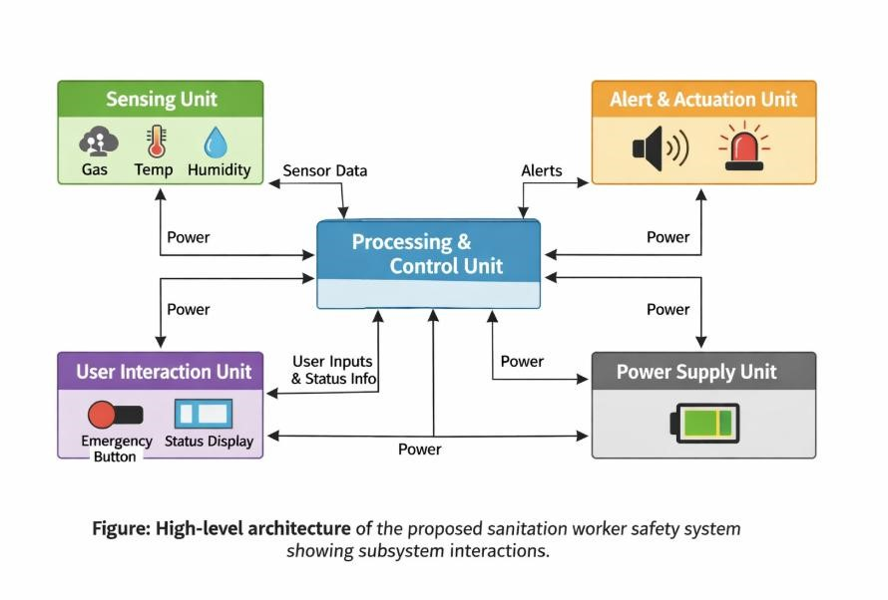

Team Information
Team name: Elevate |  |  | Institute code: E016
Institute name: KLE Technological University
City: Hubli |  |  | State: Karnataka
Mentor Details
Mentor name: Satwik Mathad
Contact number: 8618693221 |  |  | Email: satwik.mathad@kletech.ac.in
Participant Details
SN | Participant name | Program | Sem | Contact number | Email
1 | Neha  Jambanagoud | B.E.  EEE | 3rd | 9380885522 | nehajambangoud@gmail.com
2 | Anusha Patil | B.E.  EEE | 3rd | 6363572825 | anusha.b.patil9611@gmail.com
3 | Bhumi R  Hanehalli | B.E.  EEE | 3rd | 9019479615 | bhumirh0706@gmail.com
4 | Tejas  Chandargi | B.E.  EEE | 3rd | 9108806885 | tejaschandaragi@gmail.com
5 | Ritish Halagali | B.E.  EEE | 3rd | 7975510335 | ritishhalagali50@gmail.com

Declaration
We hereby declare that the work titled “Smart Safety and Assistance System for
Sanitation Workers of Solapur Municipal Corporation” submitted for
SAMVED-2026 is the original outcome of our team’s efforts.
The work has been carried out by us under the guidance of the undersigned mentor and is neither copied from any source nor generated using artificial intelligence (AI) tools.

Place: Hubli
Date: 10/02/2026
Team Leader Name: Neha Jambanagoud
Mentor Name:
Satwik Mathad

