SAVITRIBAI PHULE PUNE UNIVERSITY A SDL MINI PROJECT REPORT ON

DAILY VISIT REPORT APPLICATION

SUBMITTED TOWARDS THE

PARTIAL FULFILLMENT OF THE REQUIREMENTS OF

BACHELOR OF ENGINEERING (Computer

Engineering)

BY

Name of the students Exam No:

Neha Kale 71922610E

Harshita Shinde 71922826T

Darshan Deshmukh 71922503F

Mohit Jha 71922677F

Under The Guidance of

Prof. Ketaki Bhoyar

Academic Year 2020-21



DEPARTMENT OF COMPUTER ENGINEERING Dr. D. Y. Patil Institute of Engineering, Management & Research

Akurdi, Pune.



Dr. D. Y. Patil Institute of Engineering, Management & Research

DEPARTMENT OF COMPUTER ENGINEERING

CERTIFICATE

This is to certify that the Project Entitled

DAILY VISIT REPORT APPLICATION

Submitted by

Name of the students Exam No:

Neha Kale 71922610E

Harshita Shinde 71922826T

Darshan Deshmukh 71922503F

Mohit Jha 71922677F

is a bonafide work carried out by Students under the supervision of **Prof. Ketaki Bhoyar** and it is submitted towards the partial fulfillment of the requirement of Bachelor of Engineering (Computer Engineering).

**Prof. Ketaki Bhoyar** Prof. P.P. Shevatekar

Internal Guide H.O.D

Dept. of Computer Engg. Dept. of Computer Engg.

Dr. A. V. Patil

Principal

Dr. D. Y. Patil Institute of Engineering, Management & Research

Sign of Internal Examiner Sign of External Examiner

PROJECT APPROVAL SHEET

DAILY VISIT REPORT APPLICATION

Is successfully completed by

Name of the students Exam No:

At

Neha Kale 71922610E

Harshita Shinde 71922826T

Darshan Deshmukh 71922503F

Mohit Jha 71922677F

DEPARTMENT OF COMPUTER ENGINEERING

(Dr. D. Y. Patil Institute of Engineering, Management & Research) SAVITRIBAI PHULE PUNE UNIVERSITY,PUNE ACADEMIC YEAR 2020-2021

**Prof. Ketaki Bhoyar** Prof. P.P.Shevtekar

Internal Guide H.O.D

Dept. of Computer Engg. Dept. of Computer Engg.

Abstract

(Abstract Should not exceed more than one page.)

Daily Visit Report is an application to record all the visit reports by the employee which will be reported directly to the unit head. This app is a must-have for anyone working in the field and on

sites. Easily log in hours each employee has spent to complete a task will get recorded through this application.

This app will also have the GPS based location service that will help to managers to get the live location of the employee working on the different field or sites.

(Neha)

Acknowledgments

It gives us great pleasure in presenting the preliminary project report on

‘Daily Visit Report Application’.

I would like to take this opportunity to thank my internal guide **Prof. Ketaki Bhoyar** for giving me all the help and guidance I needed. I am really grateful to them for their kind support. Their valuable suggestions were very helpful.

I am also grateful to Prof. P.P. Shevtekar, Head of Computer Engineer- ing Department, Dr. D. Y. Patil Institute of Engineering, Management

& Research for his indispensable support, suggestions.

In the end our special thanks to **Prof. Ketaki Bhoyar** for providing various resources such as laboratory with all needed software platforms, continuous Internet connection, for Our Project.

Name & Roll No of Students

Neha Kale 18101

Harshita Shinde 18104

Darshan Deshmukh 18147

Mohit Jha 18118

(T.E. Computer Engg.)

Contents

1 Synopsis 10

|  |  |  |  |  |  |  |  |  |  |  |  |  |  |  |  |  |  |  |  |  |  |  |  |  |  |  |  |  |  |  |
| --- | --- | --- | --- | --- | --- | --- | --- | --- | --- | --- | --- | --- | --- | --- | --- | --- | --- | --- | --- | --- | --- | --- | --- | --- | --- | --- | --- | --- | --- | --- |
| 1.1 | | Project Title . . | | . | . | . | . | . | . | . | . | . | . | . | . | . | . | . | . | . | . | . | . | . | . | . | . | . | . | 10 |
| 1.2 | | Project Option | | . | . | . | . | . | . | . | . | . | . | . | . | . | . | . | . | . | . | . | . | . | . | . | . | . | . | 10 |
| 1.3 | | Internal Guide . | | . | . | . | . | . | . | . | . | . | . | . | . | . | . | . | . | . | . | . | . | . | . | . | . | . | . | 10 |
| 1.4 | | Problem Statement | | | | . | . | . | . | . | . | . | . | . | . | . | . | . | . | . | . | . | . | . | . | . | . | . | . | 10 |
| 1.5 | | Abstract . . . . . . | | | | . | . | . | . | . | . | . | . | . | . | . | . | . | . | . | . | . | . | . | . | . | . | . | . | 10 |
|  | 1.6 Goals and Objectives | | | | | | . | . | . | . | . | . | . | . | . | . | . | . | . | . | . | . | . | . | . | . | . | . | . | 11 |
| 2 | Technical Keywords | | | | | |  |  |  |  |  |  |  |  |  |  |  |  |  |  |  |  |  |  |  |  |  |  |  | 12 |
|  | 2.1 Area of Project . . . | | | | | | . | . | . | . | . | . | . | . | . | . | . | . | . | . | . | . | . | . | . | . | . | . | . | 12 |
|  | 2.2 Technical Keywords . | | | | | | . | . | . | . | . | . | . | . | . | . | . | . | . | . | . | . | . | . | . | . | . | . | . | 12 |
| 3 | Introduction | | | | | |  |  |  |  |  |  |  |  |  |  |  |  |  |  |  |  |  |  |  |  |  |  |  | 13 |
|  | 3.1 Project Idea . . . . . | | | | | | . | . | . | . | . | . | . | . | . | . | . | . | . | . | . | . | . | . | . | . | . | . | . | 13 |
| 3.2 Motivation of the Project . . . . . . . . . . . . . . . . . . . . 13 | | | | | | | | | | | | | | | | | | | | | | | | | | | | | | |
| 4 Problem Definition and scope | | | | | | | | | | | |  |  |  |  |  |  |  |  |  |  |  |  |  |  |  |  |  |  | 14 |
| 4.1 Problem Statement: . . . . . . . . . . . . . . . . . . . . . . . . 14 | | | | | | | | | | | | | | | | | | | | | | | | | | | | | | |
| 4.1.1 | | | Goals and objectives: | | | | | | | | . | . | . | . | . | . | . | . | . | . | . | . | . | . | . | . | . | . | . | 14 |
| 4.1.2 | | | Statement of scope . | | | | | | | | . | . | . | . | . | . | . | . | . | . | . | . | . | . | . | . | . | . | . | 14 |
|  | | | | | | | | | | | | | | | | | | | | | | | | | | | | | | |
| 4.2 | | Applications: . . . . . . . . . | | | | | | | | | | . | . | . | . | . | . | . | . | . | . | . | . | . | . | . | . | . | . | 15 |
| 4.3 | | Hardware Resources Required | | | | | | | | | | . | . | . | . | . | . | . | . | . | . | . | . | . | . | . | . | . | . | 16 |
| 4.4 | | Software Resources Required . | | | | | | | | | | . | . | . | . | . | . | . | . | . | . | . | . | . | . | . | . | . | . | 16 |

|  |  |  |  |  |  |  |  |  |  |  |  |  |  |  |  |
| --- | --- | --- | --- | --- | --- | --- | --- | --- | --- | --- | --- | --- | --- | --- | --- |
| 5 | Software requirement specification |  |  |  |  |  |  |  |  |  |  |  |  |  | 17 |
|  | 5.1 Data Model and Description . . . . . . | . | . | . | . | . | . | . | . | . | . | . | . | . | 18 |
|  | 5.1.1 Data Description . . . . . . . . | . | . | . | . | . | . | . | . | . | . | . | . | . | 18 |
|  |  |  |  |  |  |  |  |  |  |  |  |  |  |  |  |
|  | 5.2 Functional Model and Description . . . | . | . | . | . | . | . | . | . | . | . | . | . | . | 18 |
|  |  |  |  |  |  |  |  |  |  |  |  |  |  |  |  |

|  |  |  |  |  |  |  |  |  |  |  |  |  |  |  |  |  |  |  |  |  |  |  |
| --- | --- | --- | --- | --- | --- | --- | --- | --- | --- | --- | --- | --- | --- | --- | --- | --- | --- | --- | --- | --- | --- | --- |
|  |  |  |  |  |  |  |  |  |  |  |  |  |  |  |  |  |  |  |  |  |  |  |
| 5.2.1 | ER Diagram: . . . | . | . | . | . | . | . | . | . | . | . | . | . | . | . | . | . | . | . | . | . | 22 |

|  |  |  |  |  |  |  |  |  |  |  |  |  |  |  |  |  |  |  |  |  |  |  |  |  |  |  |  |
| --- | --- | --- | --- | --- | --- | --- | --- | --- | --- | --- | --- | --- | --- | --- | --- | --- | --- | --- | --- | --- | --- | --- | --- | --- | --- | --- | --- |
| 6 | Pro ject Implementation | | | |  |  |  |  |  |  |  |  |  |  |  |  |  |  |  |  |  |  |  |  |  |  | 23 |
|  | 6.1 Introduction . . . . . . | | | | . | . | . | . | . | . | . | . | . | . | . | . | . | . | . | . | . | . | . | . | . | . | 23 |
| 6.2 Tools and Technologies Used . . . . . . . . . . . . . . . . . . . 23 | | | | | | | | | | | | | | | | | | | | | | | | | | | |
| 6.2.1 | | Tool: . . . . | . | . | . | . | . | . | . | . | . | . | . | . | . | . | . | . | . | . | . | . | . | . | . | . | 23 |
| 6.2.2 | | Technology: | . | . | . | . | . | . | . | . | . | . | . | . | . | . | . | . | . | . | . | . | . | . | . | . | 23 |

|  |  |  |  |  |  |  |  |  |  |  |  |  |  |  |  |  |  |  |  |  |  |
| --- | --- | --- | --- | --- | --- | --- | --- | --- | --- | --- | --- | --- | --- | --- | --- | --- | --- | --- | --- | --- | --- |
| 7 | Software Testing |  |  |  |  |  |  |  |  |  |  |  |  |  |  |  |  |  |  |  | 25 |
|  | 7.1 Type of Testing Used . . . . | . | . | . | . | . | . | . | . | . | . | . | . | . | . | . | . | . | . | . | 25 |
|  | 7.1.1 Unit testing: . . . . . | . | . | . | . | . | . | . | . | . | . | . | . | . | . | . | . | . | . | . | 25 |
|  | 7.1.2 Integration testing: . | . | . | . | . | . | . | . | . | . | . | . | . | . | . | . | . | . | . | . | 26 |

|  |  |  |  |  |  |  |  |  |  |  |  |  |  |  |  |  |  |  |  |  |  |  |
| --- | --- | --- | --- | --- | --- | --- | --- | --- | --- | --- | --- | --- | --- | --- | --- | --- | --- | --- | --- | --- | --- | --- |
| 8 | Results |  |  |  |  |  |  |  |  |  |  |  |  |  |  |  |  |  |  |  |  | 28 |
|  | 8.1 Screen shots | . . . . . . . . . | . | . | . | . | . | . | . | . | . | . | . | . | . | . | . | . | . | . | . | 28 |
|  | 8.2 Outputs . . | . . . . . . . . . | . | . | . | . | . | . | . | . | . | . | . | . | . | . | . | . | . | . | . | 29 |
| 9 | Conclusion and | future scope |  |  |  |  |  |  |  |  |  |  |  |  |  |  |  |  |  |  |  | 32 |
| 10 | References |  |  |  |  |  |  |  |  |  |  |  |  |  |  |  |  |  |  |  |  | 33 |

List of Figures

|  |  |  |  |  |  |  |  |  |  |  |  |  |  |  |  |  |  |  |  |  |  |  |  |  |  |  |  |  |
| --- | --- | --- | --- | --- | --- | --- | --- | --- | --- | --- | --- | --- | --- | --- | --- | --- | --- | --- | --- | --- | --- | --- | --- | --- | --- | --- | --- | --- |
| 5.1 | PMS 0 diagram | . | . | . | . | . | . | . | . | . | . | . | . | . | . | . | . | . | . | . | . | . | . | . | . | . | . | 19 |
| 5.2 | PMS 1 diagram | . | . | . | . | . | . | . | . | . | . | . | . | . | . | . | . | . | . | . | . | . | . | . | . | . | . | 19 |
| 5.3 | PMS 2 diagram | . | . | . | . | . | . | . | . | . | . | . | . | . | . | . | . | . | . | . | . | . | . | . | . | . | . | 20 |
| 5.4 | Activity diagram |  | . | . | . | . | . | . | . | . | . | . | . | . | . | . | . | . | . | . | . | . | . | . | . | . | . | 21 |
| 5.5 | ER diagram . . | . | . | . | . | . | . | . | . | . | . | . | . | . | . | . | . | . | . | . | . | . | . | . | . | . | . | 22 |
| 7.1 | unit test . . . . | . | . | . | . | . | . | . | . | . | . | . | . | . | . | . | . | . | . | . | . | . | . | . | . | . | . | 26 |
| 7.2 | Integration test | . | . | . | . | . | . | . | . | . | . | . | . | . | . | . | . | . | . | . | . | . | . | . | . | . | . | 27 |
| 8.1 | screenshot . . . | . | . | . | . | . | . | . | . | . | . | . | . | . | . | . | . | . | . | . | . | . | . | . | . | . | . | 28 |

List of Tables

4.1 Hardware Requirements . . . . . . . . . . . . . . . . . . . . . 16

Chapter 1

Synopsis

1.1 Pro ject Title

Daily Visit Report Application

1.2 Pro ject Option

Internal project

1.3 Internal Guide

Prof. Ketaki Bhoyar

1.4 Problem Statement

Implement a location based Daily Visit Report Application with additional

features for convenience.

1.5 Abstract

Daily Visit Report is an application to record all the visit reports by the employee which will be

reported directly to the unit head. This app is a must-have for anyone working in the field and on

sites. Easily log in hours each employee has spent to complete a task will get recorded through this application.

This app will also have the GPS based location service that will help to managers to get the live

location of the employee working on the different field or sites.

1.6 Goals and Objectives(Darshan)

Chapter 2

Technical Keywords

2.1 Area of Pro ject

Business

2.2 Technical Keywords

Chapter 3

Introduction

3.1 Project Idea

3.2 Motivation of the Project

Chapter 4

Problem Definition and scope

4.1 Problem Statement:

Daily Visit Report Application

4.1.1 Goals and objectives:

4.1.2 Statement of scope

Business andMarketing

4.2 Applications:

For marketing employees and companies so they can monitor day-to-day activities/visits of their sales team.

The tracker is location based which will use GPS.

Tracking becomes so easy for the employers so that they can focus on right things to help their business growth.

Expenses, billings and total work hours are also monitored by the DVR system.

4.3 Hardware Resources Required

|  |  |  |
| --- | --- | --- |
| Sr. No | Parameter | Minimum Requirement |
| 1 | Electronic Device | RAM, ROM, OS |

Table 4.1: Hardware Requirements

4.4 Software Resources Required

Tool : Notepad Operating System: All

Application : Web Browser Programming Languages: PHP (Hypertext

Preprocessor).

(Mohit)

Chapter 5

Software requirement specification

5.1 Data Model and Description

5.1.1 Data Description

*Below data is given for your reference*

1. MYSQL Data:

MYSQL stands for My Strucured Query Language. It is a database which stores the details of the placement management system.

Component of MYSQL:

1. Database : Stores Tables.

2. Tables : Stores Attributes

3. Attributes : Attributes are columns which store data

4. Record : Records are horizontal entity which store data corresponding to all attributes in the table.

(Neha)

5.2 Functional Model and Description

(Darshan)

5.2.1 ER Diagram: (Harshi)

Chapter 6

Project Implementation

6.1 Introduction

6.2 Tools and Technologies Used

6.2.1 Tool: Mohit

Tool : Notepad ++

Operating System: WINDOWS,MAC OSX,LINUX Environment: XAMPP

Support System: XAMPP or Apache Server

Programming Language: HTML, CSS, PHP, MYSQL.

6.2.2 Technology:

IOT:

The internet of things (IoT) is the internetworking of physical devices,

vehicles, buildings and other items embedded with electronics, software, sensors, actuators, and network connectivity that enable these objects to collect and exchange data.

Chapter 7

Software Testing

*Below data is given for your reference*

7.1 Type of Testing Used

7.1.1 Unit testing:

It is a software testing method by which individual units of source code, are tested to determine whether they are fit for use. It provides a sort of living documentation of the system. It is performed by using the White Box testing method. It is performed by software developer. It increase the confidence of changing or maintaining code.

It ensure that all statements in the unit have been executed at least once. It tests data structures ( like stacks, queues) that represent rela- tionships among individual data elements.

• Function:

• Module Interface: Ensure that information flows properly into and out of module.

• Local data structures: Ensure that data stored temporarily maintain its integrity during all steps in an algorithm execution.

• Driver and Stub:

Driver is a module that takes input from test case, passes this input to the unit to be tested and prints the output produced. Stub is a module that works as a unit referenced by the unit being tested. It uses the interface of the subordinate unit, does minimum data manipulation, and returns control back to the unit being tested.

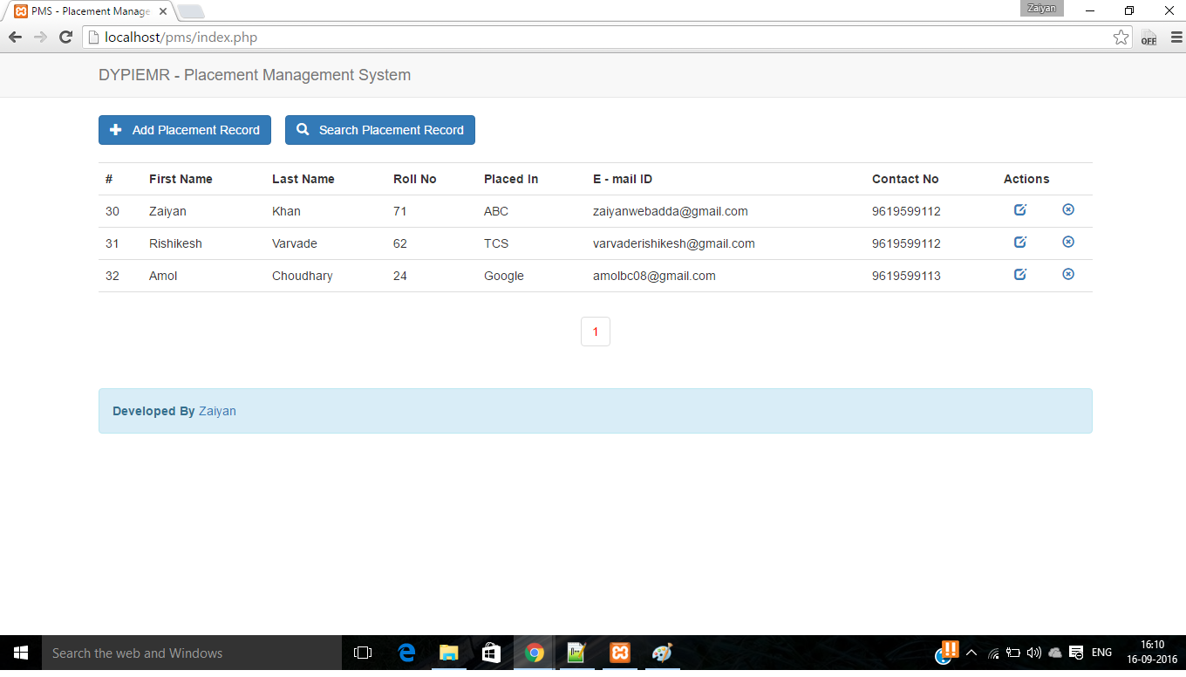

Figure 7.1: unit test

7.1.2 Integration testing:

It tests integration or interface between components, interactions to different part of the system. It is to verify the functional, performance, and reliability between the modules that are integrated.

Defined as a systematic technique for constructing the software archi- tecture At the same time integration is occurring, conduct tests to uncover errors associated with interfaces.

Objective is to take unit tested modules and build a program structure based on the prescribed design.

It ensures that all modules work together properly and transfer accu- rate data across their interfaces.

It is performed with an intention to uncover errors that lie in the in- terfaces among the integrated components.

It tests those components that are new or have been modified or af- fected due to a change.

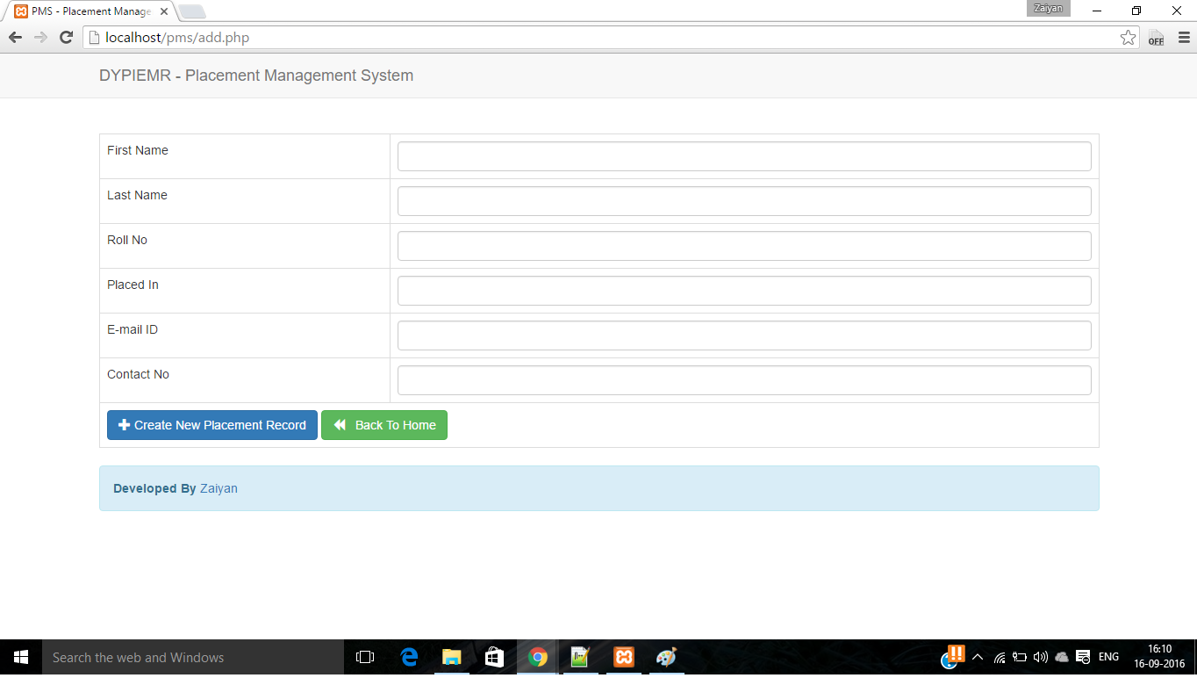

Figure 7.2: Integration test

27

Chapter 8

Results

*Below data is given for your reference*

8.1 Screen shots



Figure 8.1: screenshot

28

8.2 Outputs



29

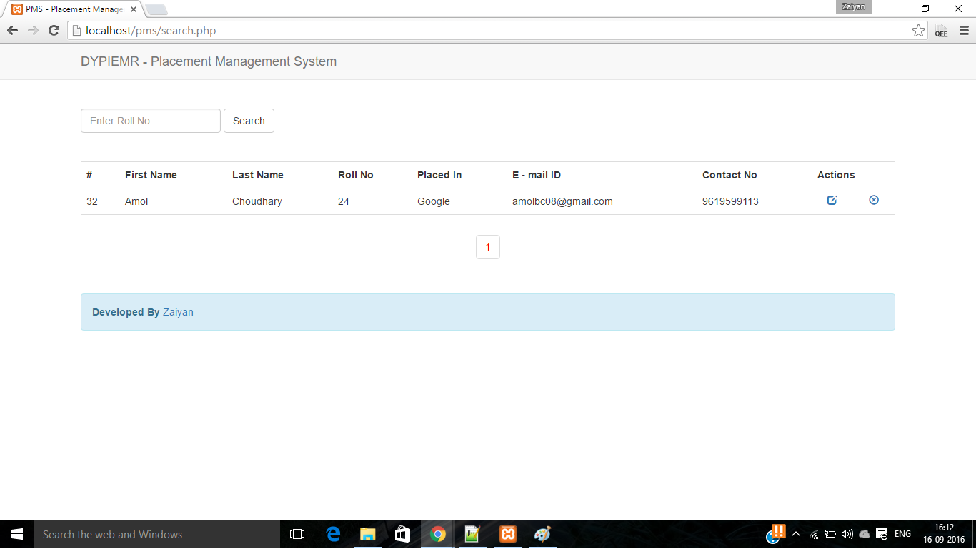

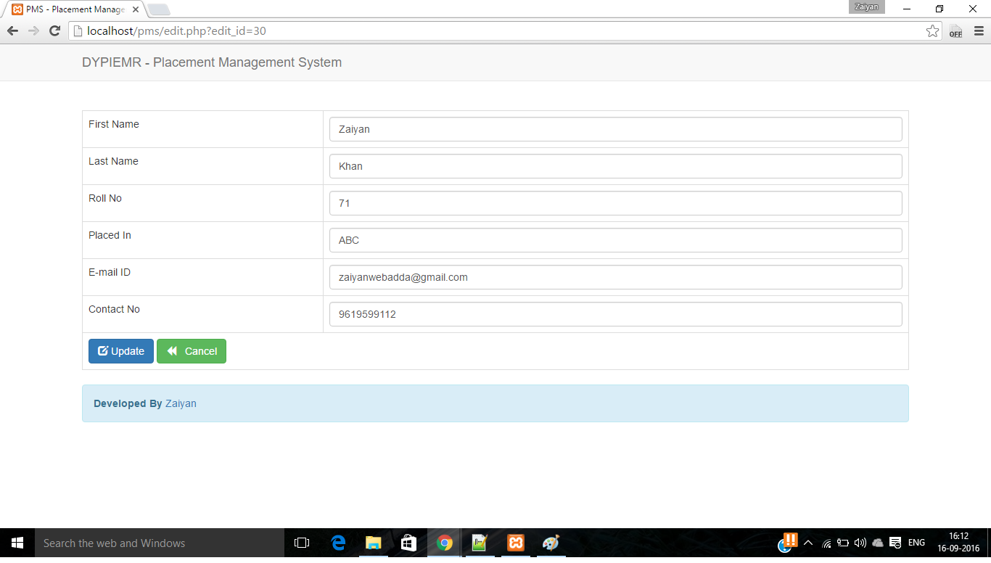

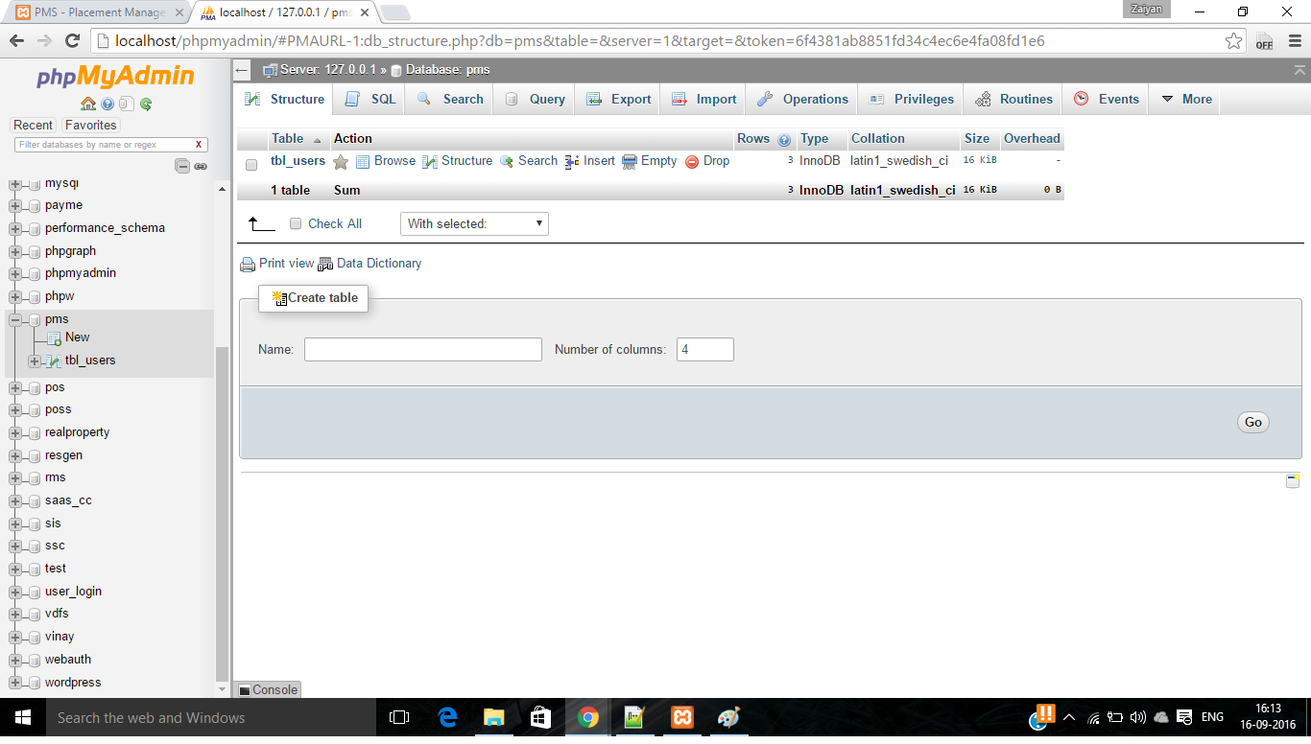

30

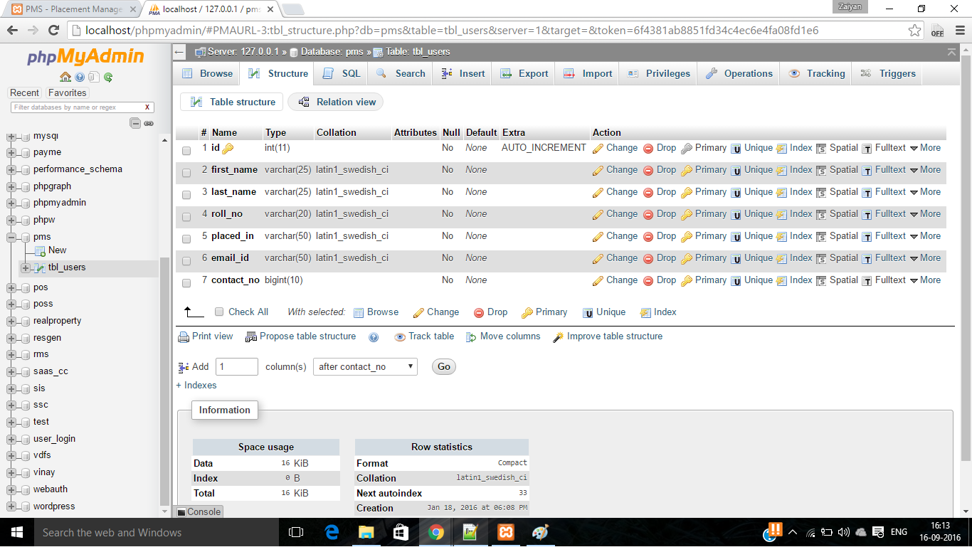

31

Chapter 9

Conclusion and future scope

*Below data is given for your reference*

We can finally conclude that using this project we can have greater efficiency in providing the daily

visit reports of the employee and a great interface between the unit head and the

employees working on sites, thus becoming time saving and error free.

Future Scope: (Harshi)

The future scope of this project is including more funcitonalities such as :

1. Mobile App

2. Extensive Interface

3. Student Login

4. Extended Functionality

5. Email System

6. College Data Integration

Chapter 10

References(Mohit)

*Below data is given for your reference*

• 1. HTML5. 2011. Vocabulary and associated APIs for HTML and

XHTML, [http://dev.w3.org/html5/spec/.](http://dev.w3.org/html5/spec/)

• 2. PHP, MySQL, JavaScript HTML5 All-in-One For Dummies, by Steve Suehring.