PREFACE
In today's digital era, video content has become one of the most popular and effective mediums of communication, education, and entertainment. With the rapid growth of internet usage and the increasing demand for on-demand content, video streaming platforms have become an integral part of everyday life. This project, “StreamHub – Full-Stack Video Streaming Platform,” has been developed with the objective of designing and implementing a full-fledged web-based application that allows users to upload, manage, and stream video content efficiently and securely.
The primary motivation behind choosing this project topic was to gain practical, hands-on experience in building a real-world, scalable application that integrates modern web technologies with robust backend architecture. The project covers the complete development lifecycle – right from requirement analysis and system design to implementation, testing, and deployment – thereby providing an opportunity to apply the theoretical concepts learned during the course of the Master of Computer Applications (MCA) program in a practical setting.
The application is built using a modern technology stack, comprising React.js, Vite, TypeScript, and Tailwind CSS on the front-end, and Java with Spring Boot, Spring Security, and JPA on the back-end. Video content is processed and delivered using adaptive HTTP Live Streaming (HLS) technology, which ensures smooth playback across different devices and varying network conditions. The system also implements secure authentication and role-based access control, distinguishing between regular users and administrators, along with features such as video upload, video management, user feedback, and an administrative dashboard for monitoring platform activity.
This report presents a detailed account of the “StreamHub” project, including the problem statement, system analysis, design methodology, development environment, implementation details, testing procedures, and the conclusions drawn from the project, along with the challenges faced during development and the possible future enhancements that can be made to further improve its functionality and scalability. It is hoped that this report will provide a clear and comprehensive understanding of the project and serve as a useful reference for anyone seeking to understand the design and implementation of a modern video streaming application.

ACKNOWLEDGEMENT
The successful completion of this project, “StreamHub – Full-Stack Video Streaming Platform,” would not have been possible without the guidance, support, and encouragement of several individuals, to whom we would like to express our sincere gratitude.
First and foremost, we would like to express our heartfelt thanks to our Project Guide, Dr. Aruna Gurjar for her invaluable guidance, constant encouragement, and constructive feedback throughout the course of this project, which helped us overcome numerous technical challenges and greatly enhanced the quality of this work.
We would also like to express our sincere gratitude to our Project Coordinator, Dr. C. D. Patel, for his continuous support, timely guidance, and for helping us manage and organize the various stages of this project effectively, and to our Principal, Dr. Nirbhay Chaubey, for providing us with the necessary infrastructure, resources, and a conducive environment that enabled us to carry out this project successfully.
We would also like to extend our sincere thanks to all the faculty members of the Department of Computer Applications, Acharya Motibhai Patel Institute of Computer Studies, Ganpat University, for their continuous support and for sharing their knowledge throughout this course, and to our friends and classmates for their valuable suggestions and moral support during the various stages of this project.
Finally, we would like to express our deepest gratitude to our families for their unwavering support, patience, and encouragement, without which this project, “StreamHub,” would not have been possible. This project has been a valuable learning experience, and we sincerely thank everyone who contributed, directly or indirectly, to its successful completion.
Yours Sincerely,
Neha V. Kaneriya
Vidhi K. Kansagara

CONTENTS
StreamHub – Full-Stack Video Streaming Platform
Chapter  No. | Section  No. | Sub-Section  No. | Topic | Page  No.
1 |  |  | INTRODUCTION
 | 1.1 |  | Project Profile
 | 1.2 |  | About the Organization
 | 1.3 |  | About the Project / Objective
2 |  |  | SYSTEM STUDY AND ANALYSIS
 | 2.1 |  | Problem Statement
 | 2.2 |  | Existing System Drawbacks
 | 2.3 |  | Proposed System
 |  | 2.3.1 | → Advantages / Comparison Study
 |  | 2.3.2 | → Modules (with short description)
3 |  |  | DEVELOPMENT ENVIRONMENTS
 | 3.1 |  | Hardware Requirement
 | 3.2 |  | Software Requirement
 | 3.3 |  | Programming Environment
 |  | 3.3.1 | → About Front-End (React, Vite, TypeScript, Tailwind CSS)
 |  | 3.3.2 | → About Back-End (Java, Spring Boot, Spring Security, JPA)
4 |  |  | SYSTEM DESIGN AND DEVELOPMENT
 | 4.1 |  | Time Line Chart (Gantt Chart)
 | 4.2 |  | Data Dictionary
 | 4.3 |  | E-R Diagram
 | 4.4 |  | User Modeling Language (UML) Diagrams
 |  | 4.4.1 | → Use Case Diagrams
 |  | 4.4.2 | → Activity Diagrams
 |  | 4.4.3 | → Sequence Diagrams
 |  | 4.4.4 | → Collaboration Diagrams
 |  | 4.4.5 | → Class Diagrams
 | 4.5 |  | Input Design
 | 4.6 |  | Output Design
5 |  |  | SYSTEM TESTING
 | 5.1 |  | System Testing
 |  | 5.1.1 | → Output Testing
 |  | 5.1.2 | → Validation and Verification Testing
6 |  |  | CONCLUSION AND FUTURE ENHANCEMENT
 | 6.1 |  | Conclusion
 | 6.2 |  | Future Enhancements
7 |  |  | BIBLIOGRAPHY & REFERENCES
 | 7.1 |  | Books References
 | 7.2 |  | Web References

CHAPTER – 1
INTRODUCTION
1.1 Project Profile
Project Title | StreamHub – Full-Stack Video Streaming Platform
Project Type | Web-Based Full-Stack Application
Objective | To develop a customizable, secure, and full-stack video streaming platform with adaptive HLS streaming, user authentication, role-based access, and administrative management.
Front-End Technology | React.js, TypeScript, Vite, Tailwind CSS
Back-End Technology | Java, Spring Boot, Spring Security, Spring Data JPA
Database & Streaming | MySQL, Redis | HTTP Live Streaming (HLS) – Adaptive Bitrate Streaming
Authentication & API | JWT-Based Authentication with OAuth2 Login Support | Swagger / OpenAPI
IDE / Tools Used | IntelliJ IDEA / VS Code, Postman, Maven, Git & GitHub
Group No. | 04
Project Guide | Dr. Aruna Gurjar (Internal Guide)
Project Co-Ordinator | Prof. C. D. Patel
Principal | Dr. Nirbhay Chaubey
Submitted By | Neha V. Kaneriya  Vidhi K. Kansagara

1.2 About the Organization
Acharya Motibhai Patel Institute of Computer Studies (AMPICS) is a reputed institute specializing in Computer Applications and Information Technology. It focuses on quality education, technical skills, innovation, and industry-oriented learning.
Ganpat University (GUNI) is a multidisciplinary university in Gujarat offering programs across various fields. It focuses on education, research, innovation, and skill development. AMPICS is a constituent institute of Ganpat University.
The Master of Computer Applications (MCA) is a postgraduate program focused on software development, programming, database management, web technologies, and modern computing practices. The program combines theoretical knowledge with practical learning to develop technical and problem-solving skills.
1.3 About the Project
“StreamHub” is a full-stack, web-based video streaming application that enables users to upload, manage, and stream video content in a secure and efficient manner. The system is designed to closely resemble real-world streaming platforms by combining a modern, responsive front-end with a robust and scalable back-end. It focuses on providing smooth video playback through adaptive bitrate streaming, along with secure user authentication, role-based access control, and a complete administrative module for managing users, videos, and feedback.
The front-end of the application is built using React.js, TypeScript, Vite, and Tailwind CSS, providing a fast, responsive, and modern user interface. The back-end is developed using Java and Spring Boot, following a layered architecture with RESTful APIs, Spring Security, and Spring Data JPA for database operations. Uploaded videos are converted into HTTP Live Streaming (HLS) format, which allows the platform to deliver adaptive bitrate streaming – automatically adjusting video quality based on the user's device and network conditions.
The application supports two types of users – regular users and administrators – each with role-based access to different features. Regular users can register, log in, upload their own videos, browse and watch videos uploaded by other users, manage their profile, and submit feedback. Administrators have access to a dedicated dashboard from which they can manage users, monitor and moderate uploaded videos, and review user feedback, ensuring smooth and secure operation of the platform.
To ensure that only genuine users can access the platform, the application includes a secure email verification system, where every new account must be verified using a one-time password (OTP) sent to the registered email address. Login access is restricted until the email is successfully verified, which helps prevent fake accounts and unauthorized registrations. Additionally, the application uses Redis as a caching layer to store OTP codes, user data, and JWT session information, which improves response time, reduces database load, and enhances the overall performance and scalability of the system.
1.3 Objectives
The main objectives of the “StreamHub” project are as follows:
- To design and develop a full-stack web application for uploading, managing, and streaming video content.
- To implement adaptive video streaming using HTTP Live Streaming (HLS) technology, ensuring smooth playback across different devices and varying network speeds.
- To provide secure user authentication and authorization using JWT (JSON Web Token) and OAuth2, protecting user data and restricting access based on user roles.
- To implement role-based access control, distinguishing between regular users and administrators, each having access to features relevant to their role.
- To develop a user-friendly interface using React.js, TypeScript, and Tailwind CSS that allows users to easily browse, search, and watch videos.
- To build a dedicated administrative dashboard for managing registered users, monitoring and moderating uploaded videos, and reviewing user feedback.
- To design a well-structured back-end using Java and Spring Boot, following industry-standard practices such as layered architecture, RESTful APIs, and proper exception handling.
- To ensure that the application is scalable, maintainable, and secure, making it suitable for real-world deployment and future enhancement.
- To implement secure email verification using OTP, SMTP-based email delivery, and Redis TTL, ensuring that every new account uses a genuine email address and OTPs expire automatically.
- To provide secure OTP resend functionality with a cooldown period and restrict login access until email verification is successfully completed, preventing fake accounts, spam, and misuse of the email service.

CHAPTER – 2
SYSTEM STUDY AND ANALYSIS
2.1 Problem Statement
Video streaming applications need to provide smooth playback, secure access, and proper management of video content. However, basic video hosting approaches can create several practical problems. Storing videos as raw files and using direct playback can result in slow loading, buffering, and poor streaming performance, especially when video files are large. Another challenge is the lack of proper role-based access control, which makes it difficult to clearly separate normal users from administrators.
Basic hosting solutions may also provide limited authentication and user management, creating security concerns. In addition, managing video uploads, user feedback, and administrative activities can become complex and unorganized. Therefore, there is a need for a structured video streaming system that can provide efficient streaming, secure authentication, controlled access, and organized management of users and content.
2.2 Existing System Drawbacks
Several existing video-streaming solutions, including ClipBucket, PeerTube, and Datarhei Restreamer, were studied before developing StreamHub. These platforms provide useful video-sharing, streaming, and stream-management capabilities, but each follows its own architecture and workflow. ClipBucket focuses on video sharing, PeerTube follows a self-hosted and federated approach, while Datarhei Restreamer mainly focuses on video streaming and stream management.
However, their predefined technology stacks and workflows may not match our specific project requirements. Customizing an existing platform can require adapting our requirements to its existing structure. We wanted direct control over authentication, user roles, video processing, administration, and other application features. Therefore, these limitations motivated us to develop StreamHub as a customized full-stack video streaming platform according to our specific requirements.
2.3 Proposed System
StreamHub is a customized full-stack video streaming platform developed to provide greater control over the application's features, workflows, and architecture. It supports video uploading and uses FFmpeg to process videos into HLS format, enabling adaptive streaming and efficient playback. The system provides secure authentication using JWT, refresh-token rotation, and Google OAuth2, along with separate roles for users and administrators. Users can upload, stream, and manage their videos, while administrators can manage users, videos, and feedback through a dedicated dashboard. The platform also includes email verification using OTP with Redis-based expiration and provides search and pagination for efficient content browsing. The application is built using React.js, Spring Boot, and MySQL, providing a customizable and maintainable full-stack solution.
2.3.1 Advantages / Comparison Study
Feature | Existing System | Proposed System (StreamHub)
Main Purpose | Ready-made video platform | Custom video platform
Technology | Existing technology stack | React.js + Spring Boot
Login & Security | Platform-managed | JWT + Google OAuth2
User Roles | Existing role system | User + Admin
Video Streaming | Platform-managed streaming | HLS + FFmpeg
Administration | Platform's management system | Custom Admin Dashboard
Extra Features | Platform-specific features | Videos + Feedback + User Management
Customization | Limited to platform | Fully Customizable
2.3.2 Modules (with short description)
User Authentication Module
Handles user registration and secure login using JWT-based authentication with rotating refresh tokens stored in HTTP-only cookies. Also supports Google OAuth2 login, automatically provisioning a local account for first-time OAuth users.
Admin Authentication Module
A separate, dedicated login flow for administrators, using distinct refresh tokens and validating the ROLE_ADMIN authority before granting access to admin-only features.
User Management Module
Allows users to view and update their profile information, while enabling administrators to view, update, or delete any user account, with proper owner-or-admin authorization checks.
Video Upload & Streaming Module
Enables users to upload videos with metadata (title, description). Uploaded videos are automatically converted into HLS format (master.m3u8 + .ts segments) using FFmpeg for adaptive streaming, and also support direct HTTP range-based streaming for smooth seeking.
Category Module
The Category module organizes videos for easy discovery. Admins manage categories, while users can browse and filter videos by category.
Comment Module
The Comment module enables video discussions. Authenticated users can comment and delete their comments, while admins can moderate them.
My Videos Module
Provides each user with a personalized view of the videos they have uploaded, along with options to manage or delete their own content.
Admin Dashboard Module
Provides administrators with aggregate platform statistics, along with the ability to manage all users (including promoting a user to admin) and manage all uploaded videos across the platform.
Feedback Module
Allows users to submit feedback messages about the platform, while administrators can view all submitted feedback and delete inappropriate or resolved entries.
Email Verification (OTP) Module
The Email Verification module verifies the user's email using a 6-digit OTP sent through Mail Service. The OTP is stored in Redis with a 5-minute TTL, and the account remains disabled until verification is completed. A 60-second resend cooldown prevents OTP spam and unnecessary email-server load.
Supporting Components
The system uses Global Exception Handling for consistent JSON errors and DTOs to separate API data from entities. ModelMapper simplifies conversions, while Swagger/OpenAPI provides API documentation. Docker & Docker Compose ensure consistent deployment across environments.
CHAPTER – 3
DEVELOPMENT ENVIRONMENTS
3.1 Hardware Requirement
The following hardware configuration was used for the development and testing of the “StreamHub” application:
Processor | Intel Core i5 (10th Generation) or higher / AMD Ryzen 5 or higher
RAM | 8 GB minimum (16 GB recommended for smooth video processing and multitasking)
Hard Disk / Storage | 256 GB SSD or higher (additional storage required for storing uploaded videos and generated HLS segments)
Display | 1366 x 768 resolution or higher
Internet Connection | Broadband connection (minimum 5 Mbps) for testing video streaming and API integrations
Other | Keyboard, Mouse, and a stable power supply
3.2 Software Requirement
The following software tools and technologies were used during the development of the “StreamHub” project:
Operating System | Windows 10 / 11
Front-End IDE | Visual Studio Code
Back-End IDE | IntelliJ IDEA
Programming Languages | Java (JDK 21), TypeScript, JavaScript
Front-End Framework / Libraries | React.js, Vite, Tailwind CSS, Zustand, Axios, Video.js, React Router DOM
Back-End Framework | Spring Boot 3.5.7 (Spring Web, Spring Security, Spring Data JPA, Spring Validation, OAuth2 Client)
Database | MySQL
Video Processing Tool | FFmpeg (for converting uploaded videos into HLS format)
Authentication | JJWT (JSON Web Token library), Spring Security, OAuth2 (Google Login)
API Documentation Tool | Swagger / OpenAPI (springdoc-openapi)
Object Mapping Tool | ModelMapper
Version Control | Git & GitHub
API Testing Tool | Postman
Build Tool | Maven (Back-End), npm / Vite (Front-End)
Containerization | Docker & Docker Compose
3.3 Programming Environment
The StreamHub project is developed using modern programming languages, frameworks, libraries, and development tools. The backend is implemented using Java 21 and Spring Boot 3.5.7, while the frontend is developed using React.js and Vite. MySQL is used for persistent data storage and Redis for caching and temporary data. FFmpeg is used for video processing and HLS generation. Development and API testing are supported through IntelliJ IDEA, Visual Studio Code, Maven, and Swagger/OpenAPI.
3.3.1 About Front-End
The front-end of “StreamHub” is developed using React.js along with TypeScript, providing a type-safe, component-based architecture that improves code reliability and maintainability. The project is bundled and served using Vite, a modern front-end build tool that offers fast development server startup and hot module replacement, significantly improving the development experience.
Styling is handled using Tailwind CSS, a utility-first CSS framework that enables rapid development of a clean, responsive, and consistent dark-themed user interface, styled similar to modern video streaming platforms. State management across the application is handled using Zustand, a lightweight state management library used to manage authentication state for both regular users and administrators. Video playback is implemented using Video.js, a widely used HTML5 video player library that supports adaptive HLS streaming. Communication with the back-end REST APIs is handled using Axios, while React Router DOM manages client-side routing across public, user, and admin sections of the application.
————— Key Frontend Specifications —————
Category | Details | Category | Details
Technology Stack | React 19.2, TypeScript 5.9, Vite 7.3 | API Communication | Axios 1.13 with Request & Response Interceptors
Styling | Tailwind CSS 4.2 with Radix UI & Flowbite React | Video Player | Video.js 8.23 + Quality Levels (HLS Adaptive Streaming)
Routing | React Router DOM 7 (Nested Routes & Layouts) | State Management | Zustand 5 – User Store + Admin Store
Optimization | Code Splitting (Vendor Chunks) + Dev Proxy for CORS | Responsive Design | Desktop & Mobile Support
3.3.2 About Back-End
The back-end of “StreamHub” is developed using Java (JDK 21) and the Spring Boot framework (version 3.5.7), following a clean, layered architecture consisting of controllers, services, repositories, DTOs, and entities. Spring Web is used to expose RESTful APIs, while Spring Data JPA is used to interact with the MySQL database through entity-based repositories, simplifying database operations and reducing boilerplate code.
Security is implemented using Spring Security, JWT, BCrypt, and OAuth2. The application uses stateless authentication with a short-lived access token and an HttpOnly refresh cookie, while Google OAuth2 login is also supported. Redis is used for caching frequently accessed users and videos, JWT blacklisting, and temporary OTP storage. For video processing, the backend uses FFmpeg to convert uploaded videos into multiple resolutions and generate HLS output with .m3u8 playlists and .ts segments, enabling adaptive streaming. Additional components such as ModelMapper, Lombok, Global Exception Handling, and Swagger/OpenAPI simplify development, provide consistent error handling, reduce boilerplate code, and support interactive API testing.
————— Key Backend Specifications —————
Category | Details | Category | Details
Database | MySQL 8.0 with Spring Data JPA (Hibernate ORM) | Authentication | JWT + Refresh Token + OAuth2 Google Login
Caching | Redis 7.0 for caching, OTP, and JWT blacklist | Video Processing | FFmpeg – Multi-resolution Transcoding
Search & Pagination | JPA Specifications + Keyset/Cursor Pagination | API Documentation | Springdoc OpenAPI / Swagger
Build & Configuration | Maven + dev, qa, prod profiles | Backend Structure | 8 Controllers + 9 Entities

CHAPTER – 4
SYSTEM DESIGN AND DEVELOPMENT
4.1 Time Line Chart (Gantt Chart)
Id | Task Name | Start | Finish | Duration | Jul-2026 |  |  |  | Aug-2026 |  |  |  |  | Sep-2026 |  |  |  | Oct-2026
 |  |  |  |  | 6-Jul | 13-Jul | 20-Jul | 27-Jul | 3-Aug | 10-Aug | 17-Aug | 24-Aug | 31-Aug | 7-Sep | 14-Sep | 21-Sep | 28-Sep | 03-Oct
1. | Planning & Requirement Analysis | 06-07-2026 | 15-07-2026 | 10  Days
2. | Backend Development – Authentication & User Module | 16-07-2026 | 04-08-2026 | 20  Days
3. | Backend Development – Video Module | 05-08-2026 | 22-08-2026 | 18  Days
4. | Backend Development – Admin, Comment & Feedback Modules | 23-08-2026 | 03-09-2026 | 12  Days
5. | Frontend Development | 04-09-2026 | 21-09-2026 | 18  Days
6. | Integration & Testing | 22-09-2026 | 28-10-2026 | 7  Days
7. | Deployment & Documentation | 29-10-2026 | 03-10-2026 | 5  Days
4.2 Data Dictionary
The Data Dictionary describes the structure of the main database tables (entities) used in the “StreamHub” application, along with their fields, data types, and constraints.
Table: User
Field | Data Type | Constraint | Description
user_id | UUID (CHAR 36) | Primary Key | Unique identifier of the user
user_email | VARCHAR (300) | NOT NULL, UNIQUE | Email address used for login
name | VARCHAR (255) | NOT NULL | Full name of the user
password | VARCHAR (255) | NULL (for OAuth users) | BCrypt-hashed password
enable | Boolean | DEFAULT true | Whether the account is active (enabled after OTP verification)
provider | Enum | DEFAULT 'LOCAL' | Source of account: LOCAL / GOOGLE / GITHUB
providerId | VARCHAR (255) | NULL | Unique user ID from the OAuth provider
createdAt | TIMESTAMP | NOT NULL | Registration date (auto-generated)
updatedAt | TIMESTAMP | NOT NULL | Last update time (auto-generated)
Table: roles
Field | Data Type | Constraint | Description
id | UUID (CHAR 36) | Primary Key | Unique identifier for each video
name | VARCHAR (255) | NOT NULL, UNIQUE | Name of the role (ROLE_USER, ROLE_ADMIN)
Table: user_roles
Field | Data Type | Constraint | Description
user_id | CHAR(36) | PK, FK → users(user_id) | Reference to the user
role_id | CHAR(36) | PK, FK → roles(id) | Reference to the role
Table: yt_video
Field | Data Type | Constraint | Description
video_id | CHAR(36) | Primary Key | Unique identifier for each video
title | VARCHAR(255) | NOT NULL | Title of the uploaded video
description | TEXT | NULL | Short description of the video
contentType | VARCHAR(255) | NOT NULL | MIME type of the uploaded video file
category | VARCHAR(50) | NOT NULL, DEFAULT 'other' | Category name of the video
filePath | VARCHAR(255) | NOT NULL | Path where the video / HLS files are stored
view_count | BIGINT | NOT NULL, DEFAULT 0 | Total views (denormalized for faster reads)
user_id | CHAR(36) | NOT NULL, FK → users(user_id) | Uploader / owner of the video
createdAt | TIMESTAMP | NOT NULL | Timestamp when the video was uploaded
updated_at | TIMESTAMP | NOT NULL | Last update time
Table: categories
Field | Data Type | Constraint | Description
id | CHAR(36) | Primary Key | Unique identifier of the category
name | VARCHAR(100) | NOT NULL,UNIQUE | Name of the category (e.g., Music, Education)
slug | VARCHAR(100) | NOT NULL, UNIQUE | URL-friendly name (e.g., music)
description | VARCHAR(500) | NULL | Short description of the category
created_at | TIMESTAMP | NOT NULL | Creation date
updated_at | TIMESTAMP | NOT NULL | Last update time
Table: comments
Field | Data Type | Constraint | Description
id | CHAR(36) | Primary Key | Unique identifier of the comment
text | VARCHAR(100) | NOT NULL | Content of the comment
user_id | CHAR(36)) | NOT NULL, FK → users(user_id) | User who posted the comment
video_id | CHAR(36) | NOT NULL, FK → yt_video(video_id) | Video on which the comment was posted
parent_comment_id | CHAR(36) | NULL, FK → comments(id) | Parent comment for replies (NULL = top-level comment)
created_at | TIMESTAMP | NOT NULL | Comment date
updated_at | TIMESTAMP | NOT NULL | Last update time
Table: refresh_tokens
Field | Data Type | Constraint | Description
id | CHAR(36) | Primary Key | Unique identifier of the token record
jti | VARCHAR(255) | NOT NULL, UNIQUE, UPDATABLE-FALSE | JWT ID — identity of the token
user_id | CHAR(36) | NOT NULL, FK → users(user_id | User to whom the token belongs
expires_at | TIMESTAMP | NOT NULL | Expiry time of the token
revoked | BOOLEAN (TINYINT 1) | NOT NULL, DEFAULT false | Whether the token is revoked (set true on logout/rotation)
replaced_by_token | VARCHAR(255) | NULL | Reference to the new token after rotation
created_at | TIMESTAMP | NOT NULL | Token issue date
updated_at | TIMESTAMP | NOT NULL | Last update time
Table: feedbacks
Field | Data Type | Constraint | Description
id | CHAR(36) | Primary Key | Unique identifier of the feedback
message | VARCHAR(1000) | NOT NULL | Feedback text of the user
user_id | CHAR(36) | NOT NULL, FK → users(user_id) | User who submitted the feedback
created_at | TIMESTAMP | NOT NULL | Submission date
updated_at | TIMESTAMP | NOT NULL | Last update time
Table: video_views
Field | Data Type | Constraint | Description
id | BIGINT | Primary Key | Unique identifier of the view record
video_id | CHAR(36) | NOT NULL, FK → yt_video(video_id) | Which video was viewed
user_id | CHAR(36) | NULL, FK → users(user_id) | Logged-in user (NULL for guests)
viewer_ip | VARCHAR(45) | NULL | IP address of guest viewers (used for repeat-view detection)
viewed_at | TIMESTAMP | NOT NULL, UPDATABLE-FALSE | Time of the view
4.3 E-R Diagram
The E-R diagram illustrates the database entities and their relationships in the “StreamHub” application. The User entity is central, connecting with Video, Feedback, Comments, Video Views, Refresh Tokens, and Roles.
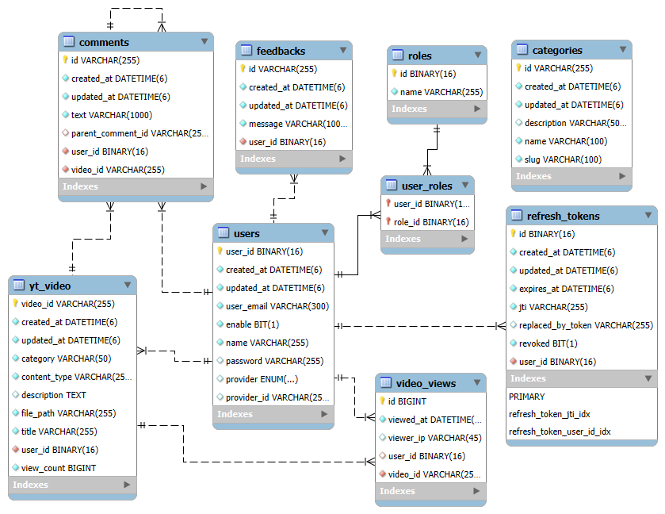

4.4 User Modeling Language (UML) Diagrams
4.4.1 Use Case Diagrams
The use case diagram below shows the interaction between the two main actors of the system – User and Administrator – and the various use cases they can perform.
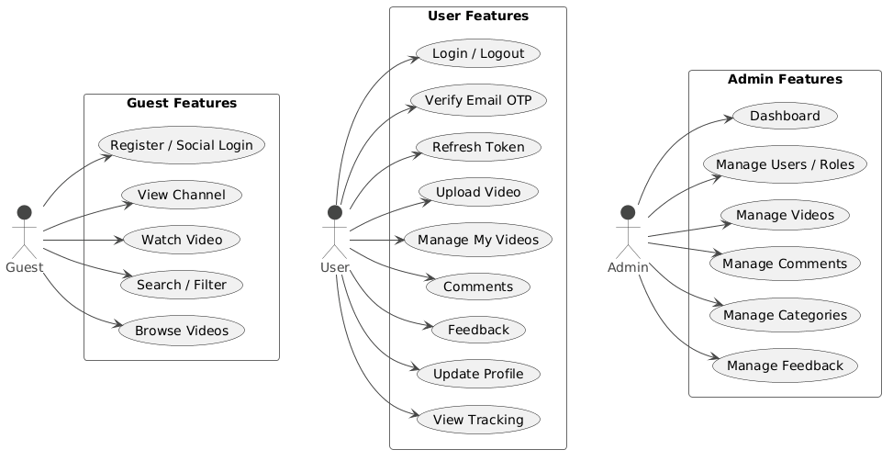
4.4.2 Activity Diagrams
The activity diagram below represents the step-by-step flow of the video upload process, from file selection to HLS conversion and final display of the uploaded video.
Activity Diagram 1 — User Registration & Login
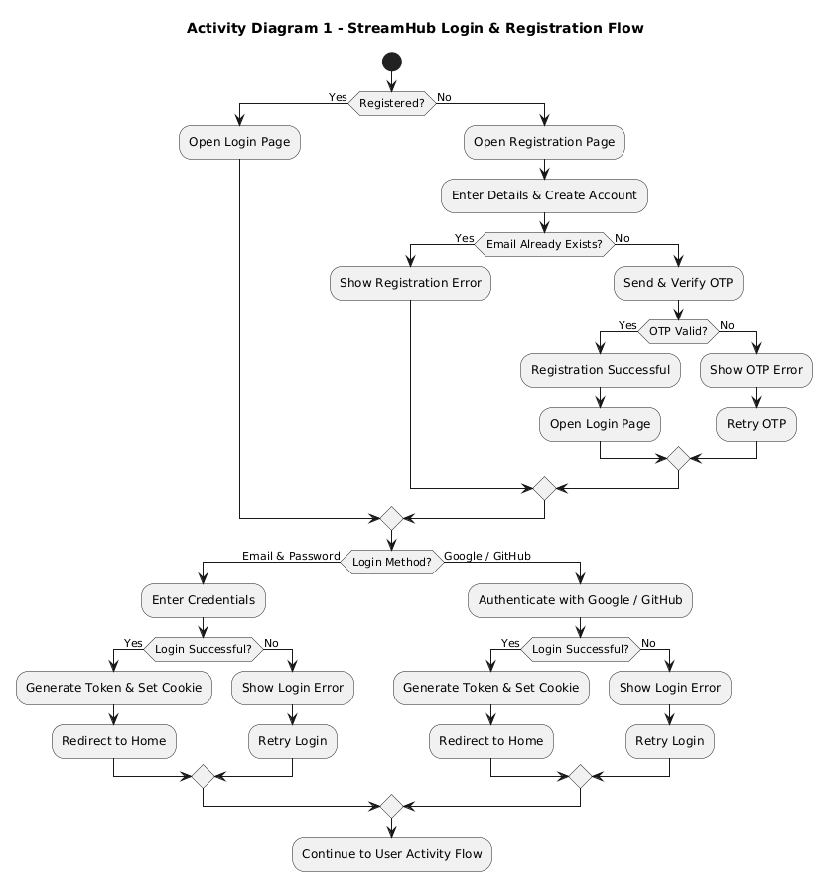
Activity Diagram 2 — Video Upload & Streaming Flow
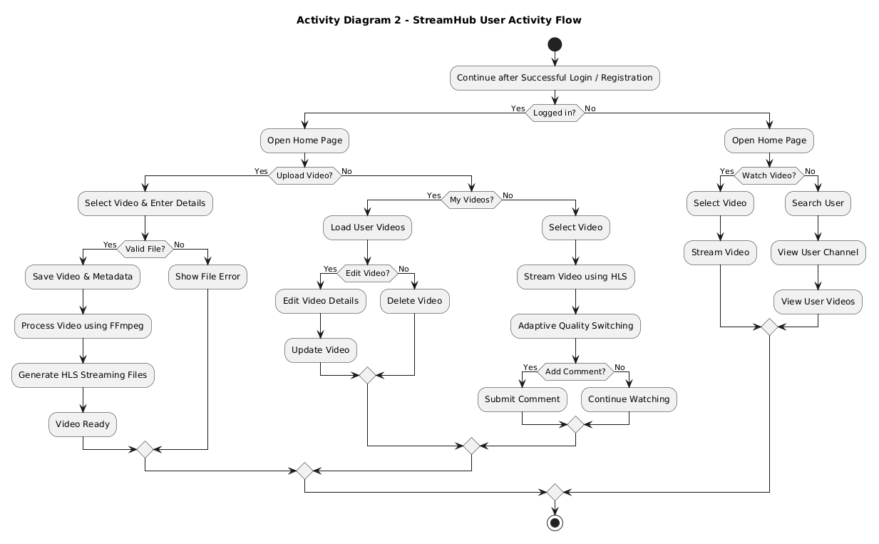
Activity Diagram 3 — Admin Moderation (Video + User)
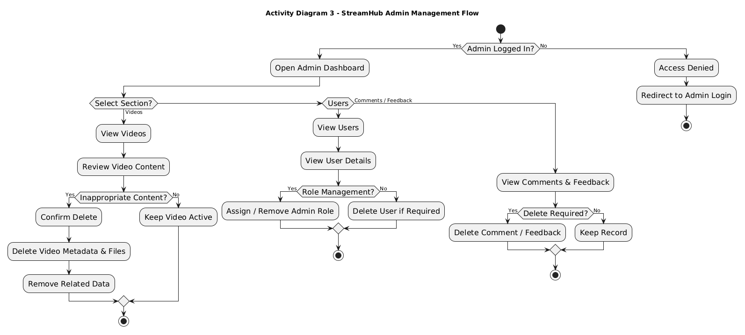
4.4.3 Sequence Diagrams
The sequence diagram illustrates the end-to-end interaction between the user, front-end, backend services, FFmpeg, and database during video uploading, processing, and HLS-based streaming.

Sequence Diagram 1 — Authentication (Registration + OTP + Login + Refresh + Logout)
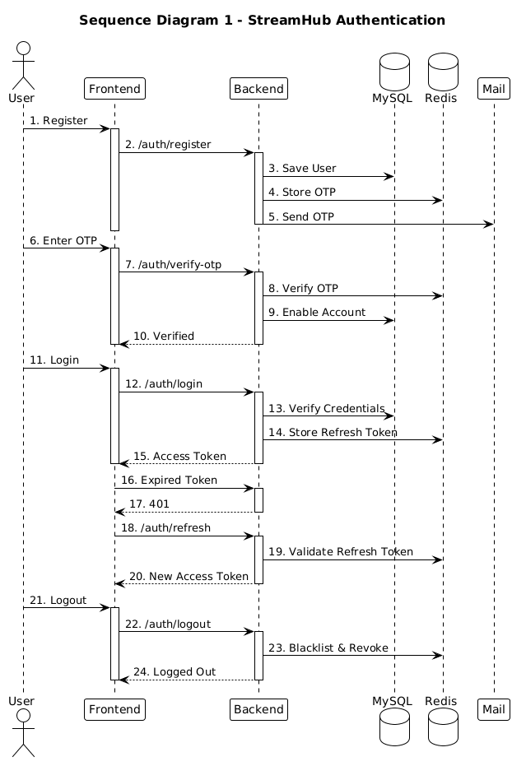
Sequence Diagram 2 — Video (Upload + HLS Processing + Streaming)
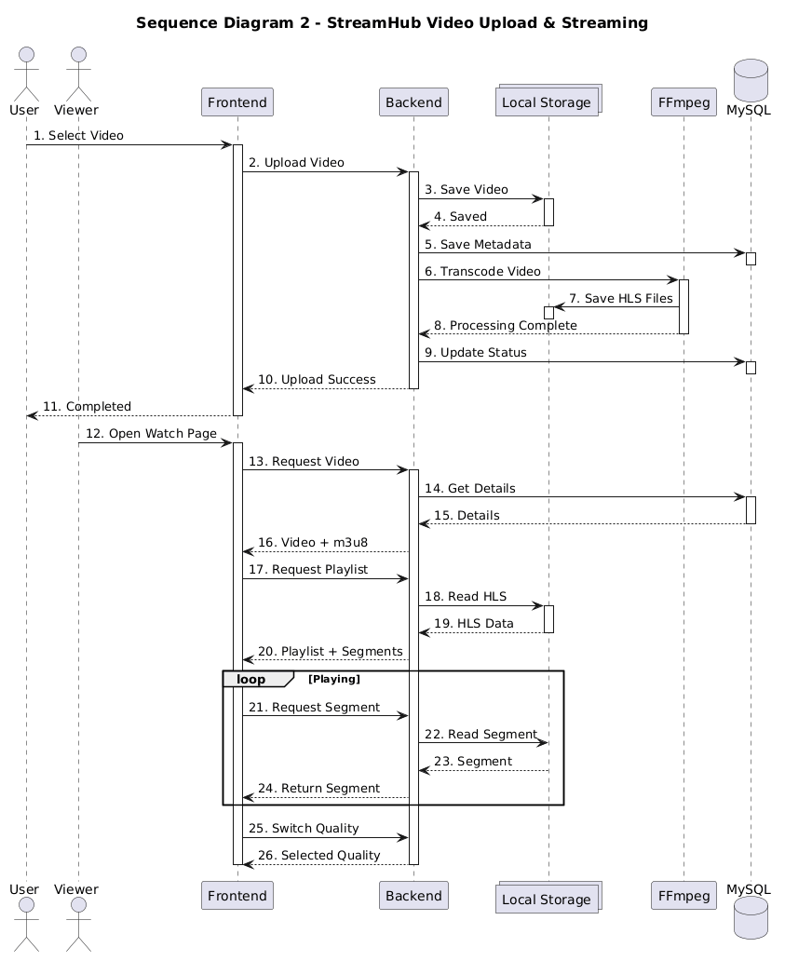

Sequence Diagram 3 — Admin (Dashboard + Users + Videos + Comments + Feedback)
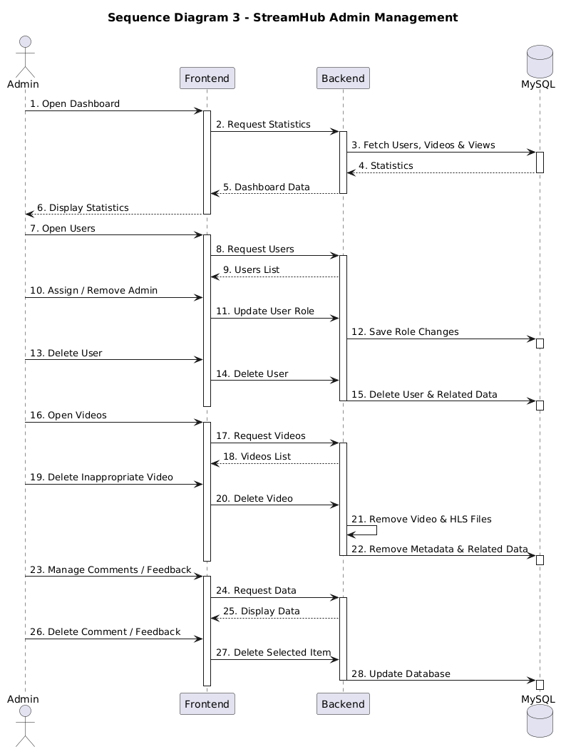

4.4.4 Collaboration Diagrams
The collaboration diagram illustrates how system objects interact and exchange messages during video upload and processing.
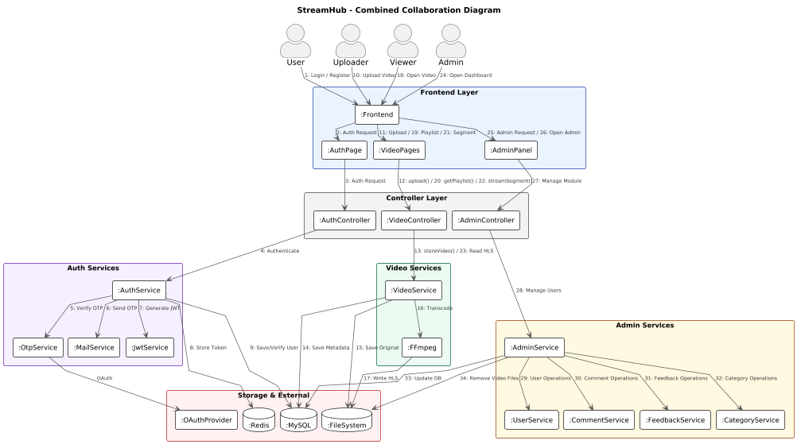
4.4.5 Class Diagrams
The class diagram below shows the main classes of the “StreamHub” system, including controller classes, service classes, and entity classes, along with their attributes, methods, and relationships.
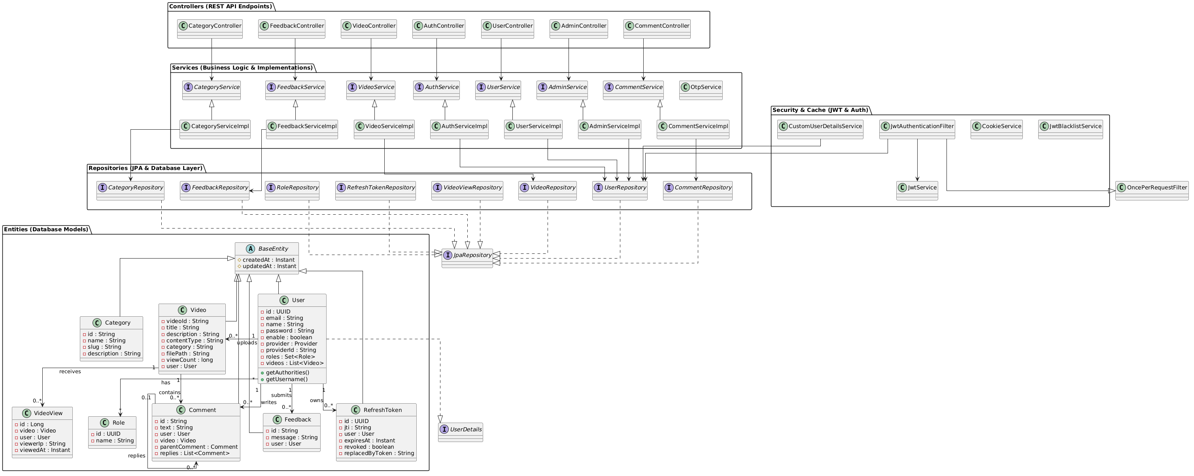
4.5 Input Design
Input design focuses on how data is collected from users and validated before being processed by the system. In “StreamHub,” the primary input forms include the registration form, login form, video upload form, and feedback form. Each form is designed to be simple, responsive, and user-friendly, with proper client-side and server-side validation to ensure data accuracy and security.
4.5.1 User Registration Form
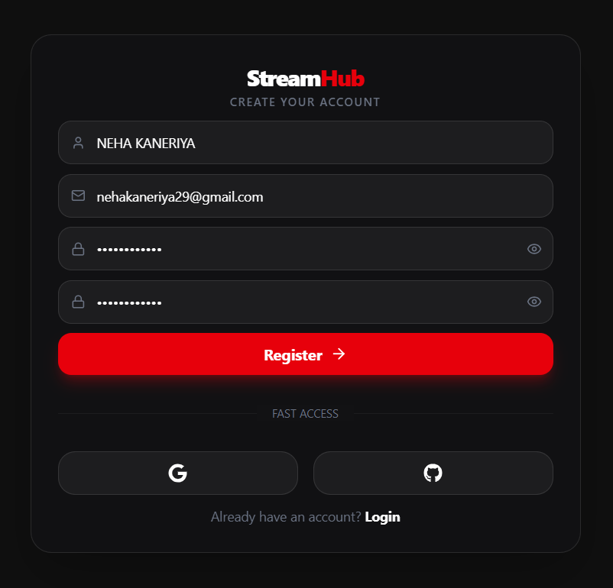
4.5.2 Email OTP Verification
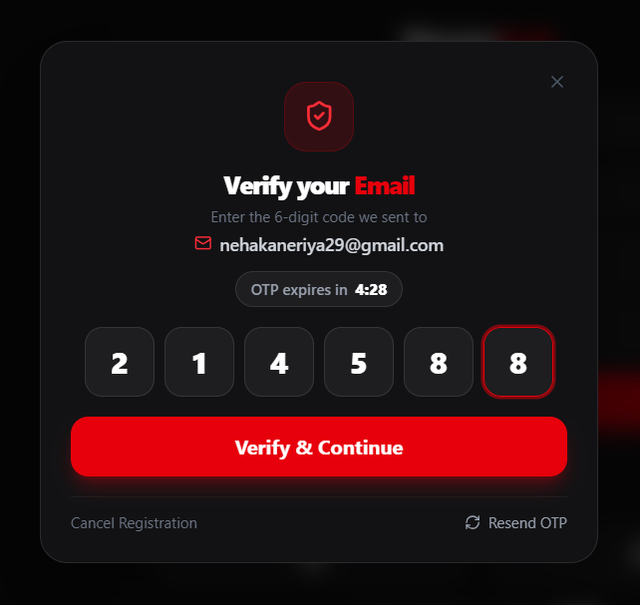
4.5.3 User Login Form
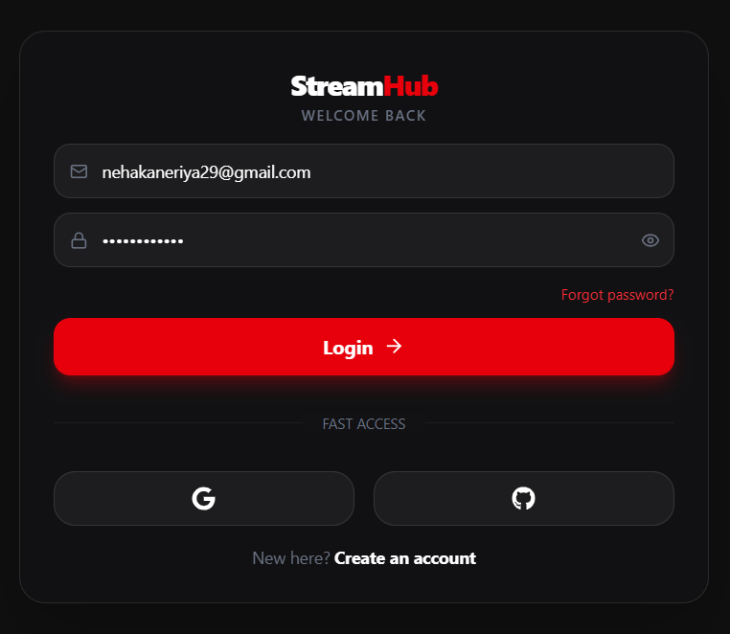
4.5.4 Admin Login Form
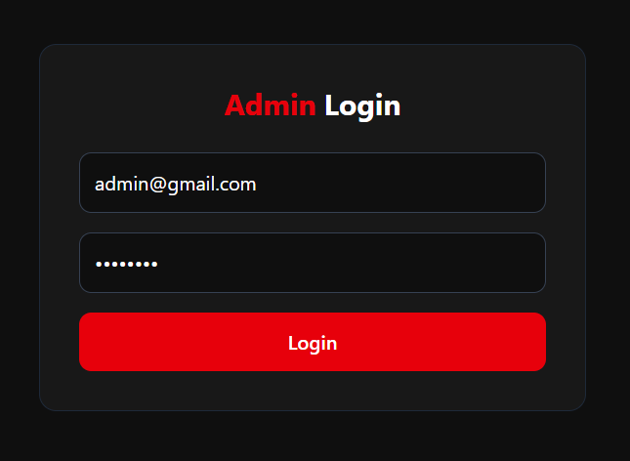
4.5.5 Video Upload Form
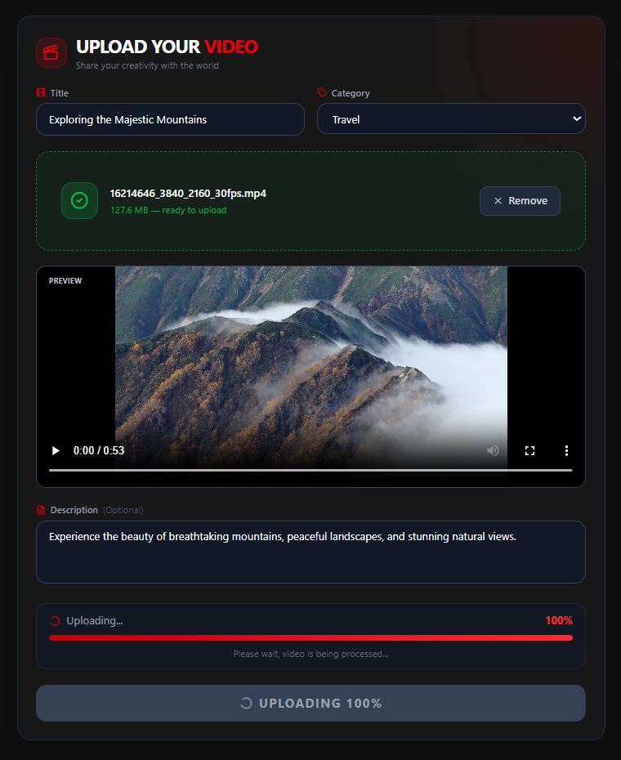

4.5.6 Edit Video Form
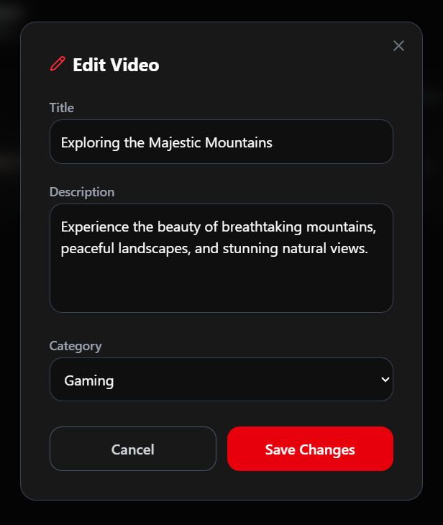
4.5.7 Comment Input
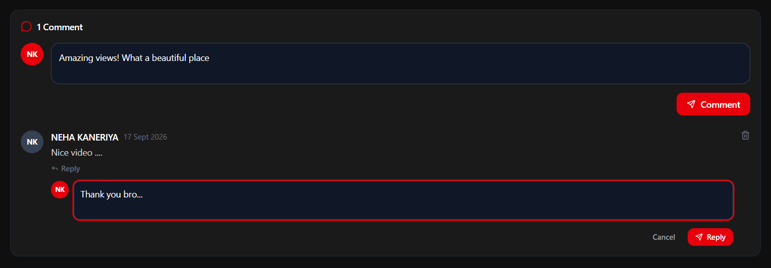

4.5.8 Feedback Form
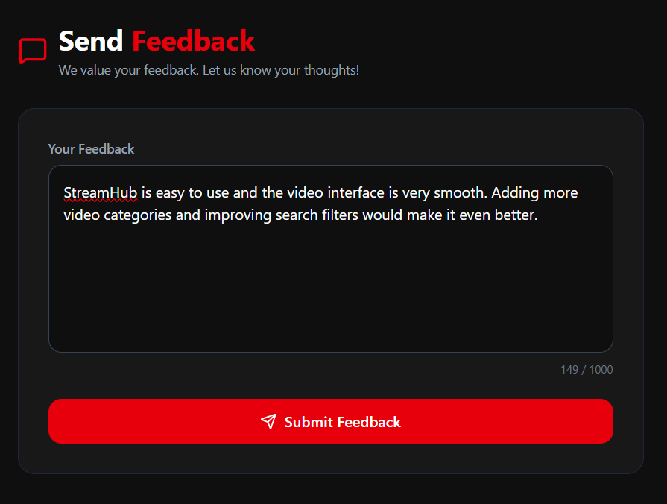
4.5.9 Category Management Form
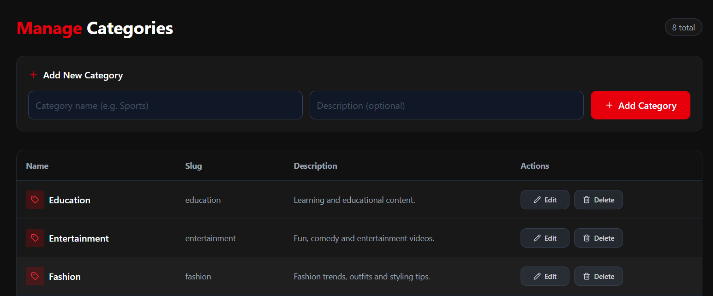

4.5.10 Edit Category Form
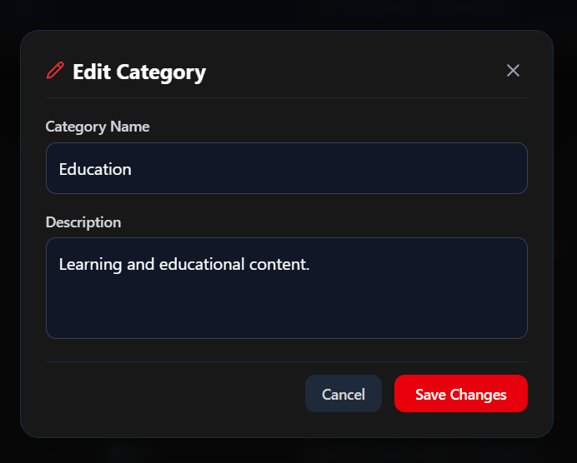
4.5.11 Search Bar
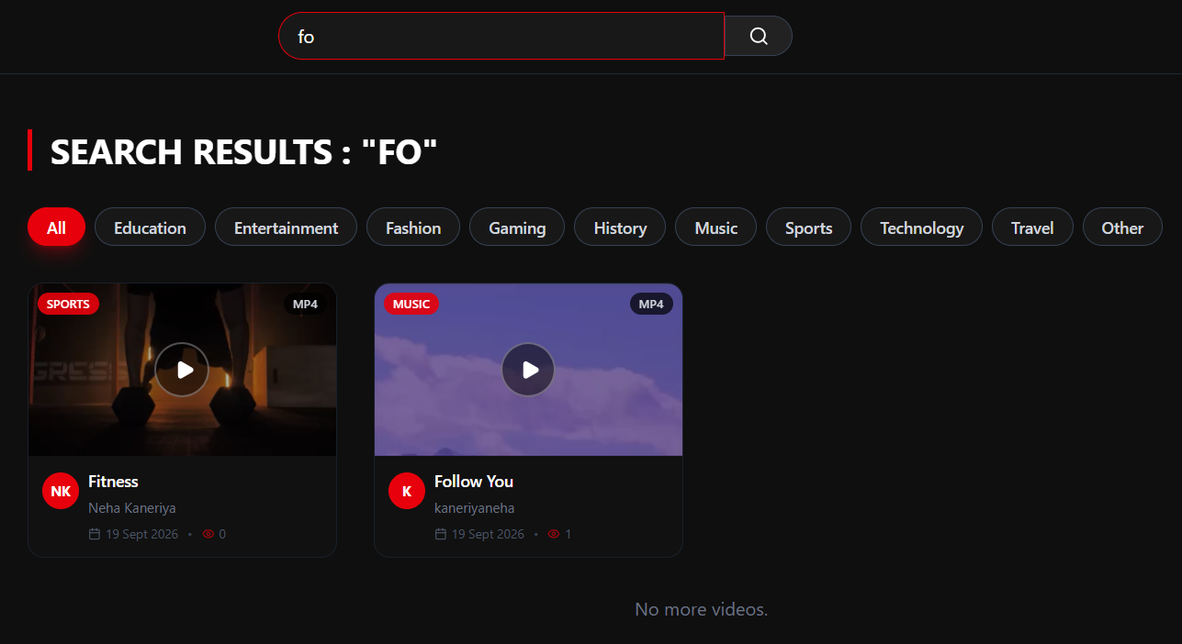

4.6 Output Design
Output design focuses on how information is presented back to the user after processing. In “StreamHub,” outputs are primarily displayed through the web interface in the form of video listings, video playback, success/error messages, and administrative reports.
4.6.1 Home Page (Video Feed)
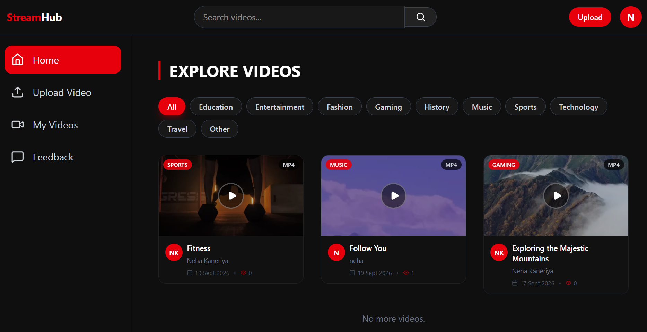
4.6.2 Video Watch Page
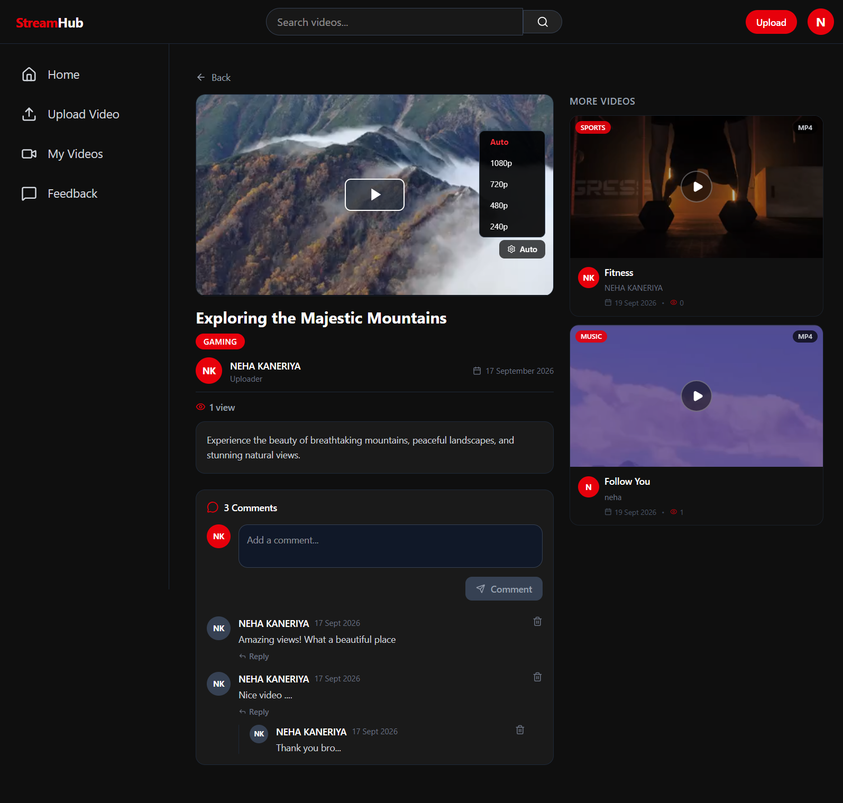
4.6.3 User Channel Page
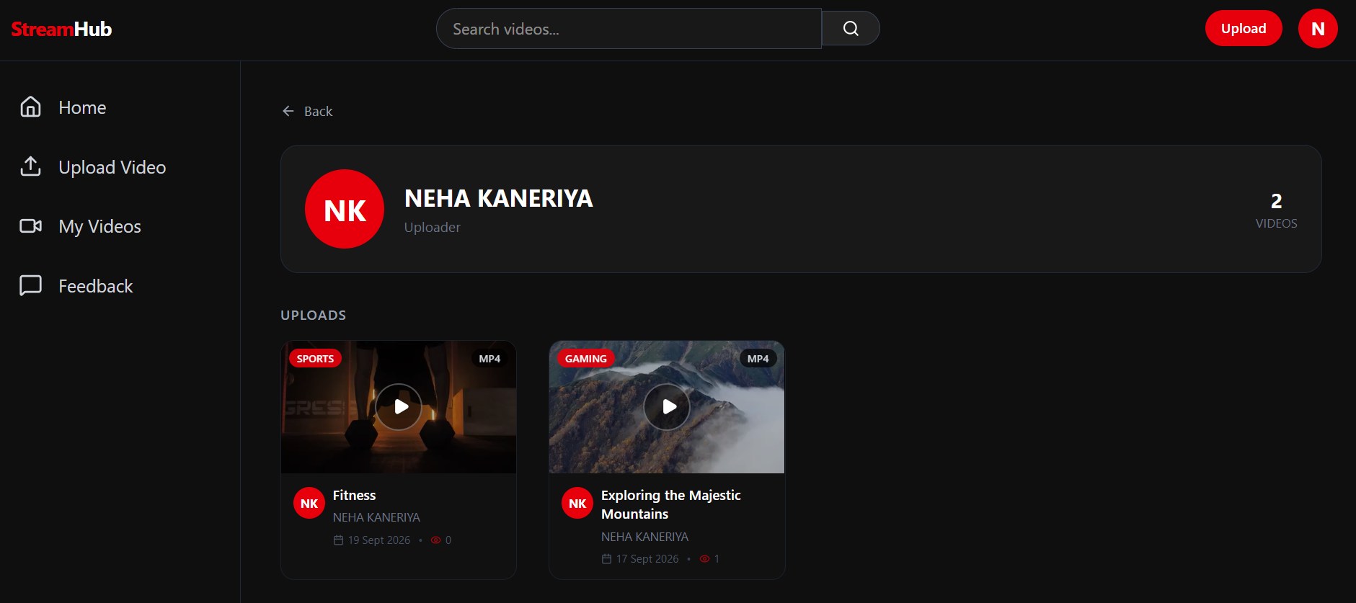
4.6.4 My Videos Page (User Dashboard)
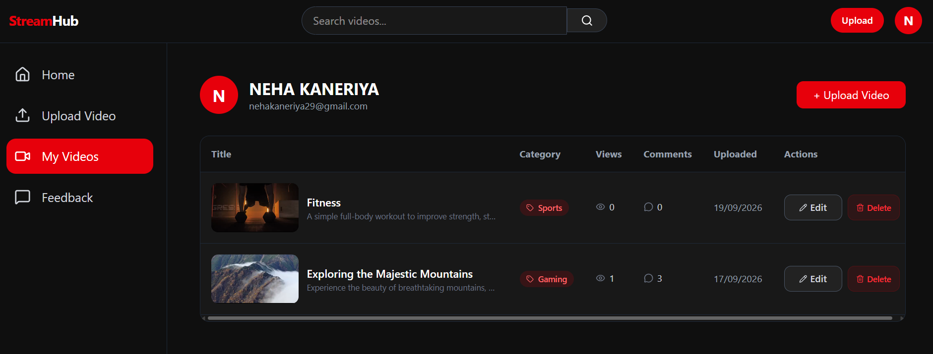
4.6.5 User Profile Page
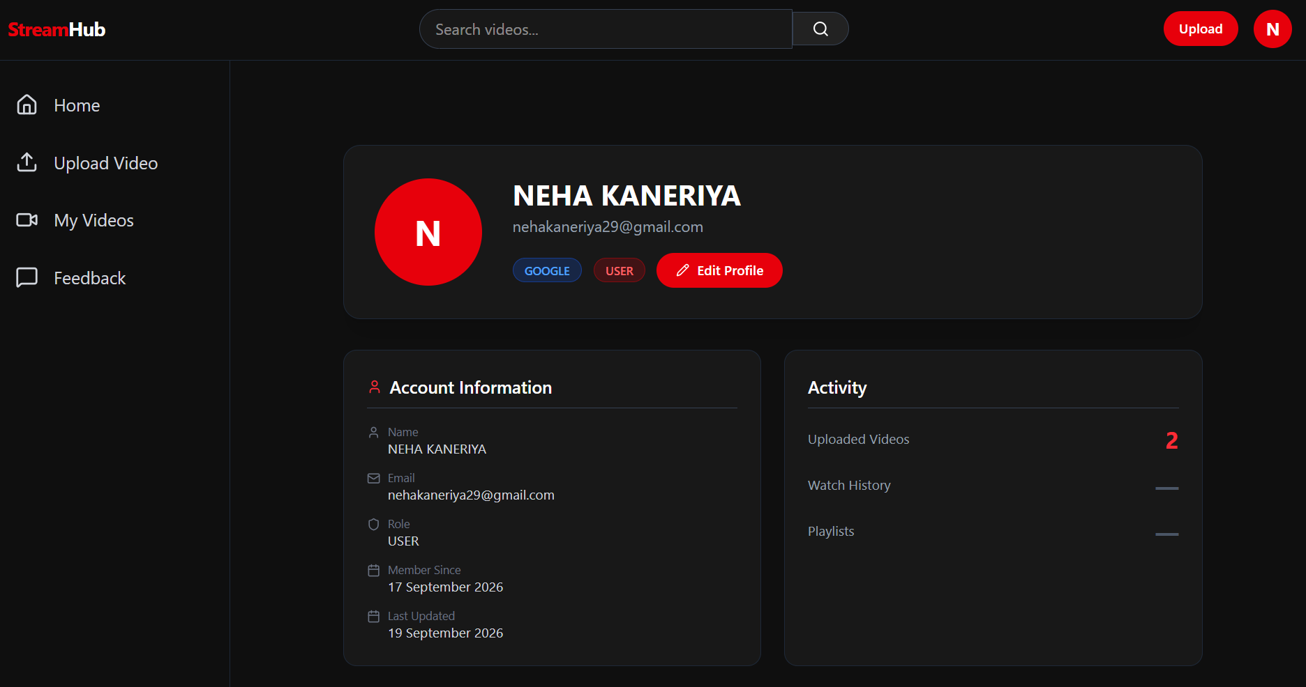
4.6.6 Admin Dashboard
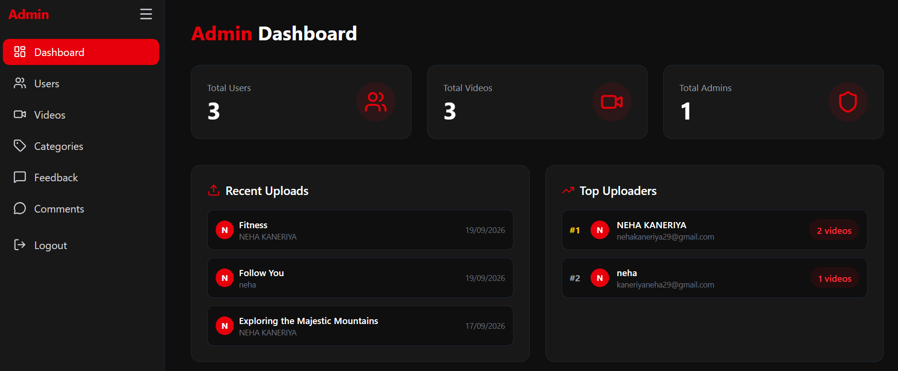
4.6.7 Admin – Manage Users
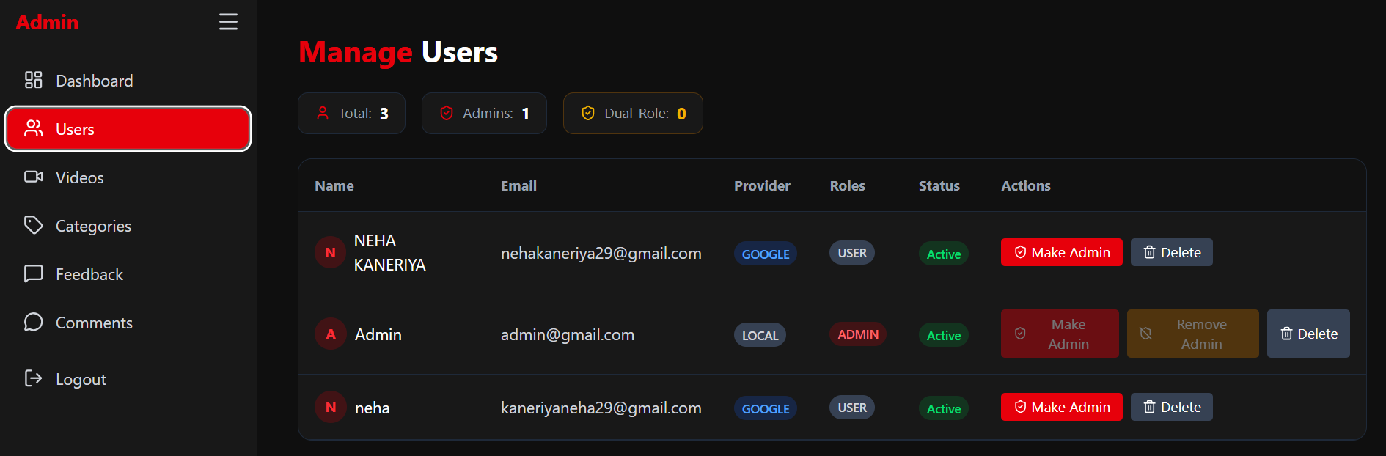
4.6.8 Admin – Manage Videos
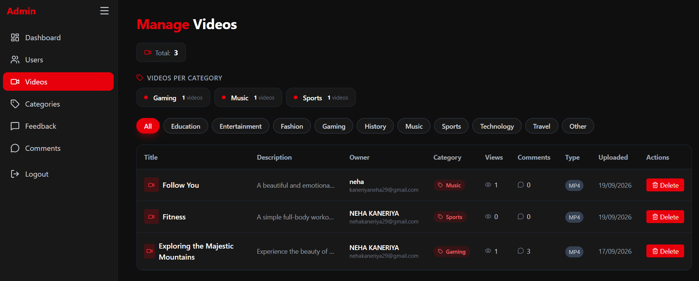

4.6.9 Admin – Manage Categories
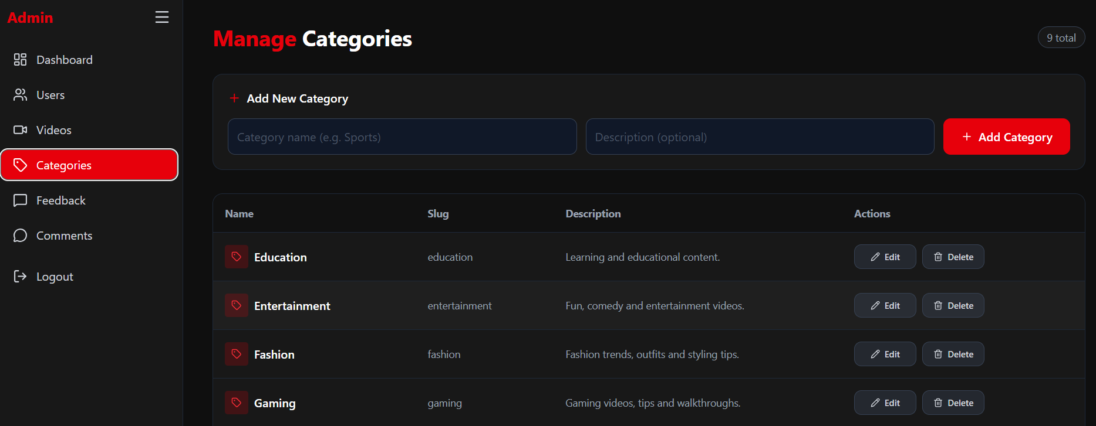
4.6.10 Admin – Manage Comments
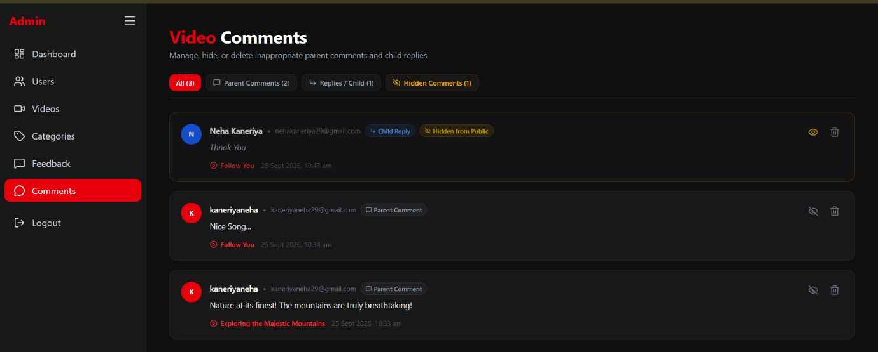
4.6.11 Admin – View Feedback
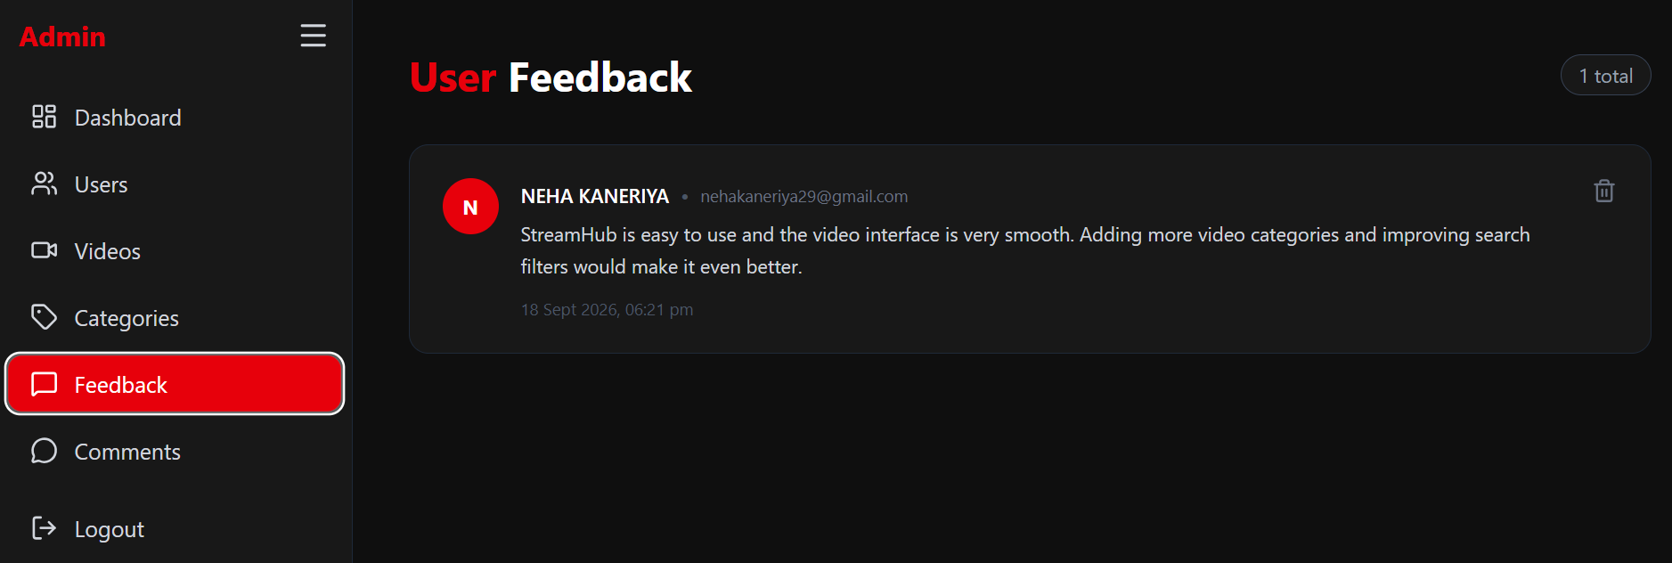

4.6.12 Logout Page
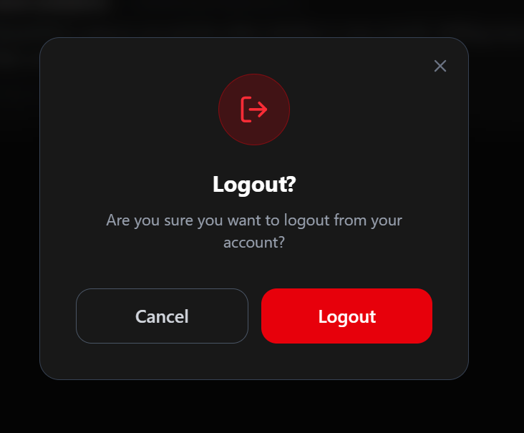

CHAPTER – 5
SYSTEM TESTING
5.1 System Testing
System testing is a phase of software testing where the complete and integrated software application is evaluated to verify that it meets all specified functional and non-functional requirements. In StreamHub, system testing validates the seamless interaction between the React frontend, Spring Boot backend, MySQL database, Redis cache, and FFmpeg media processing pipeline.
5.1.1 Output Testing
Output testing focuses on verifying whether the system produces the correct, expected, and formatted outputs upon receiving valid inputs. It ensures that media streams, user interfaces, notifications, and generated data reports comply with user expectations.
Home Feed
Video Playback + Quality
Upload Success
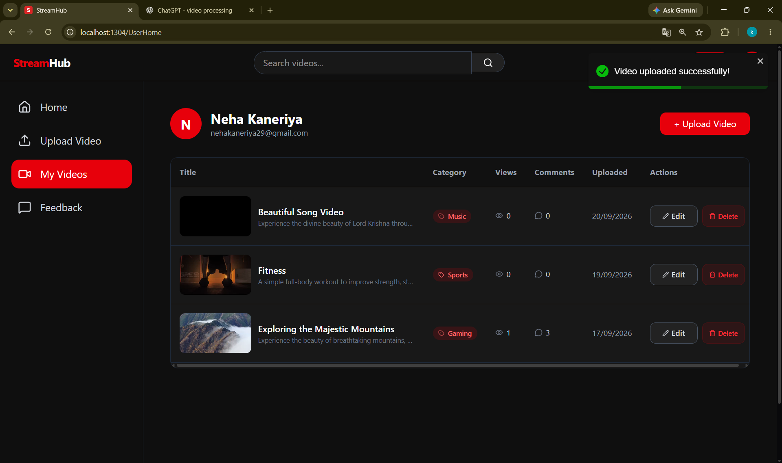
Email Verification Success
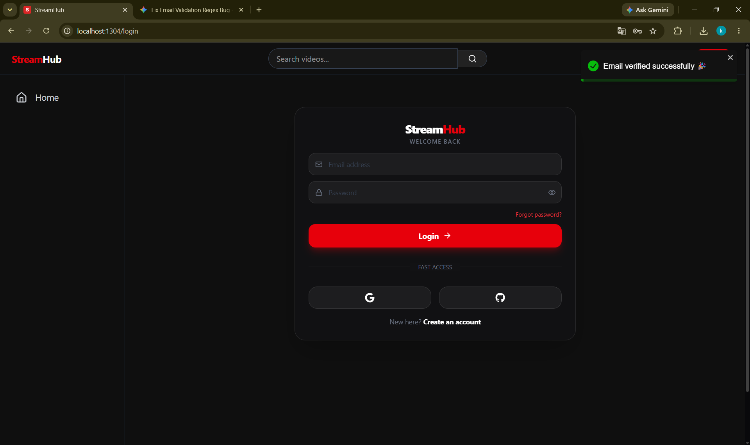
Login Success
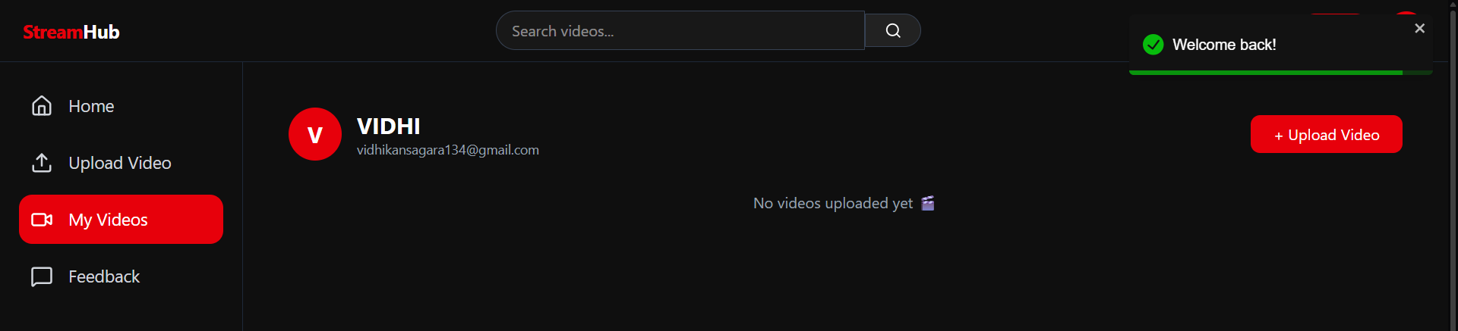
Search Result
5.1.2 Validation and Verification Testing
Validation and verification testing ensures that the system satisfies both business rules and technical specifications:
Empty registration
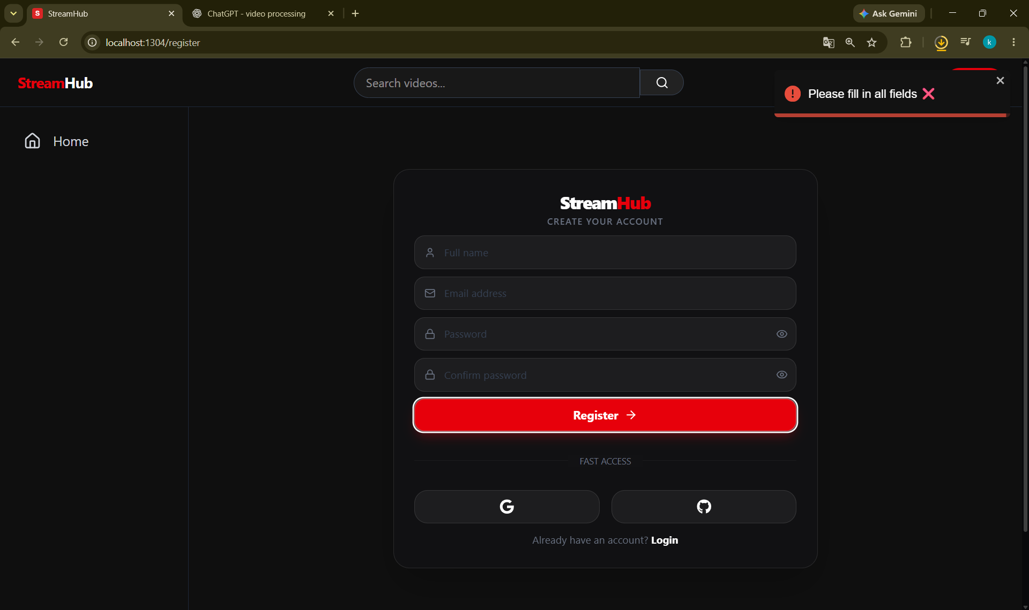
Password validation
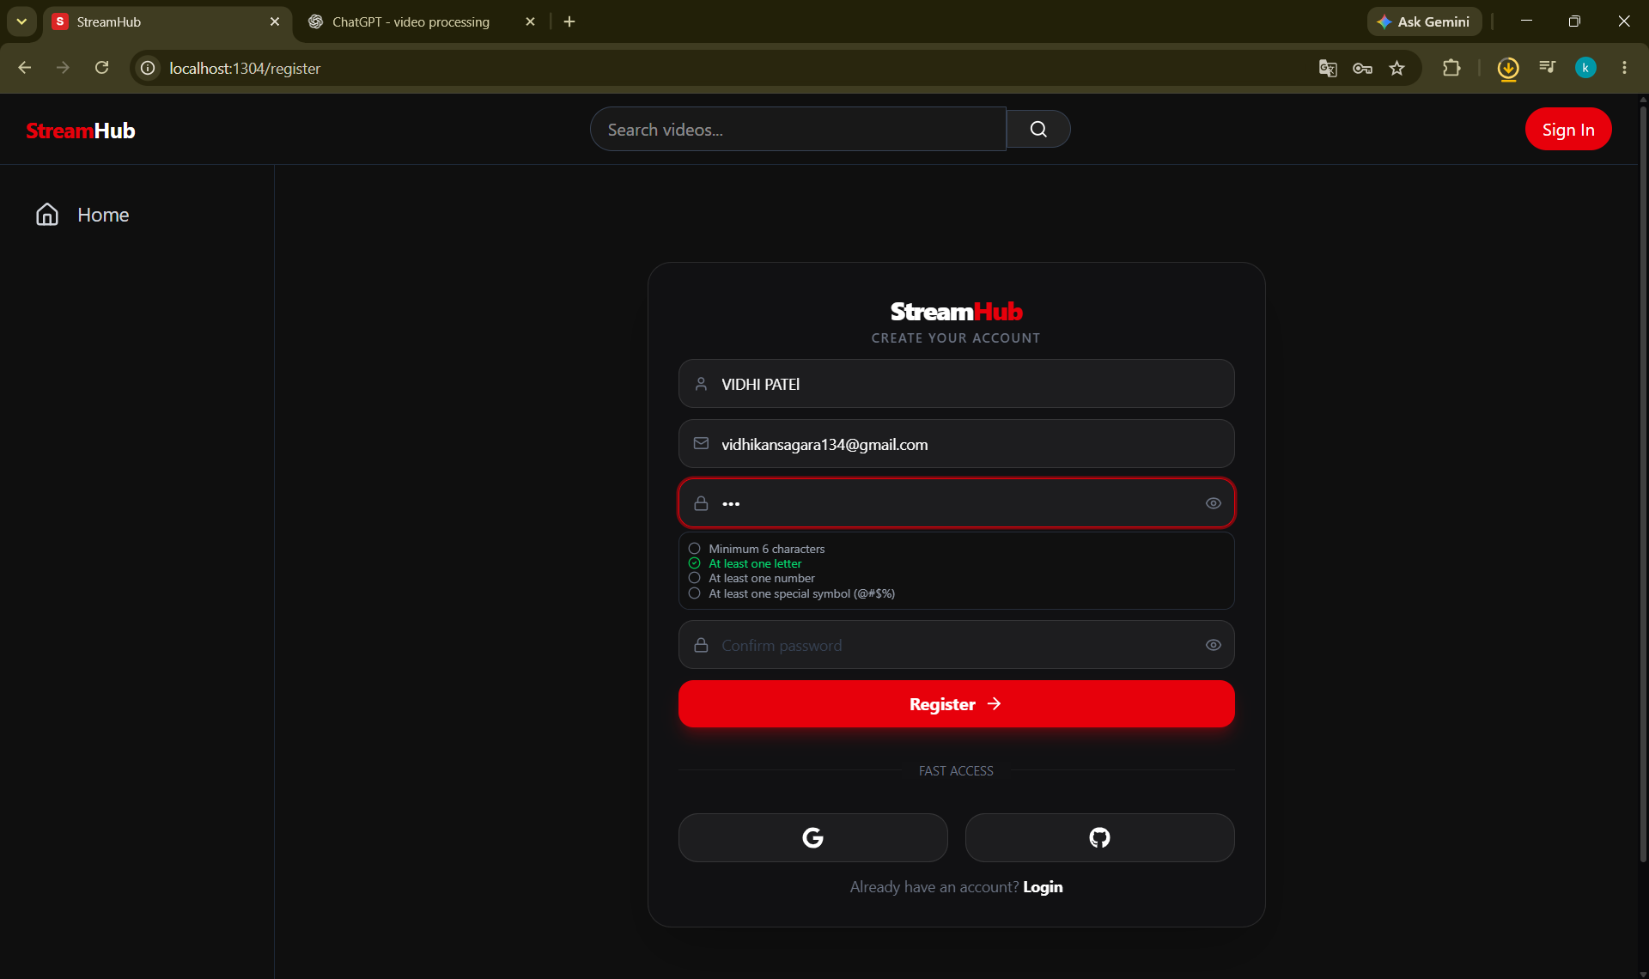
Password mismatch
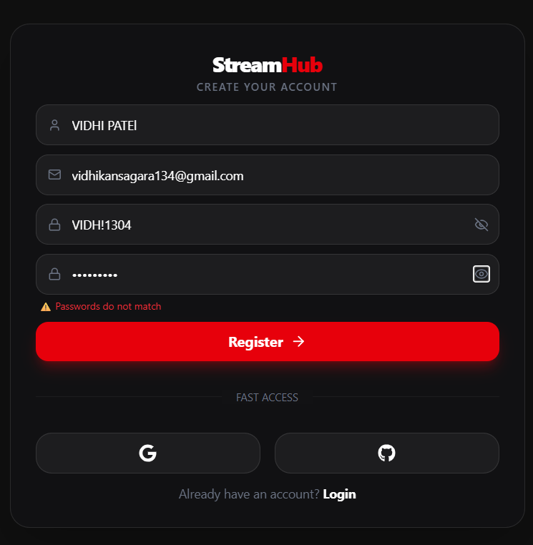
Existing email
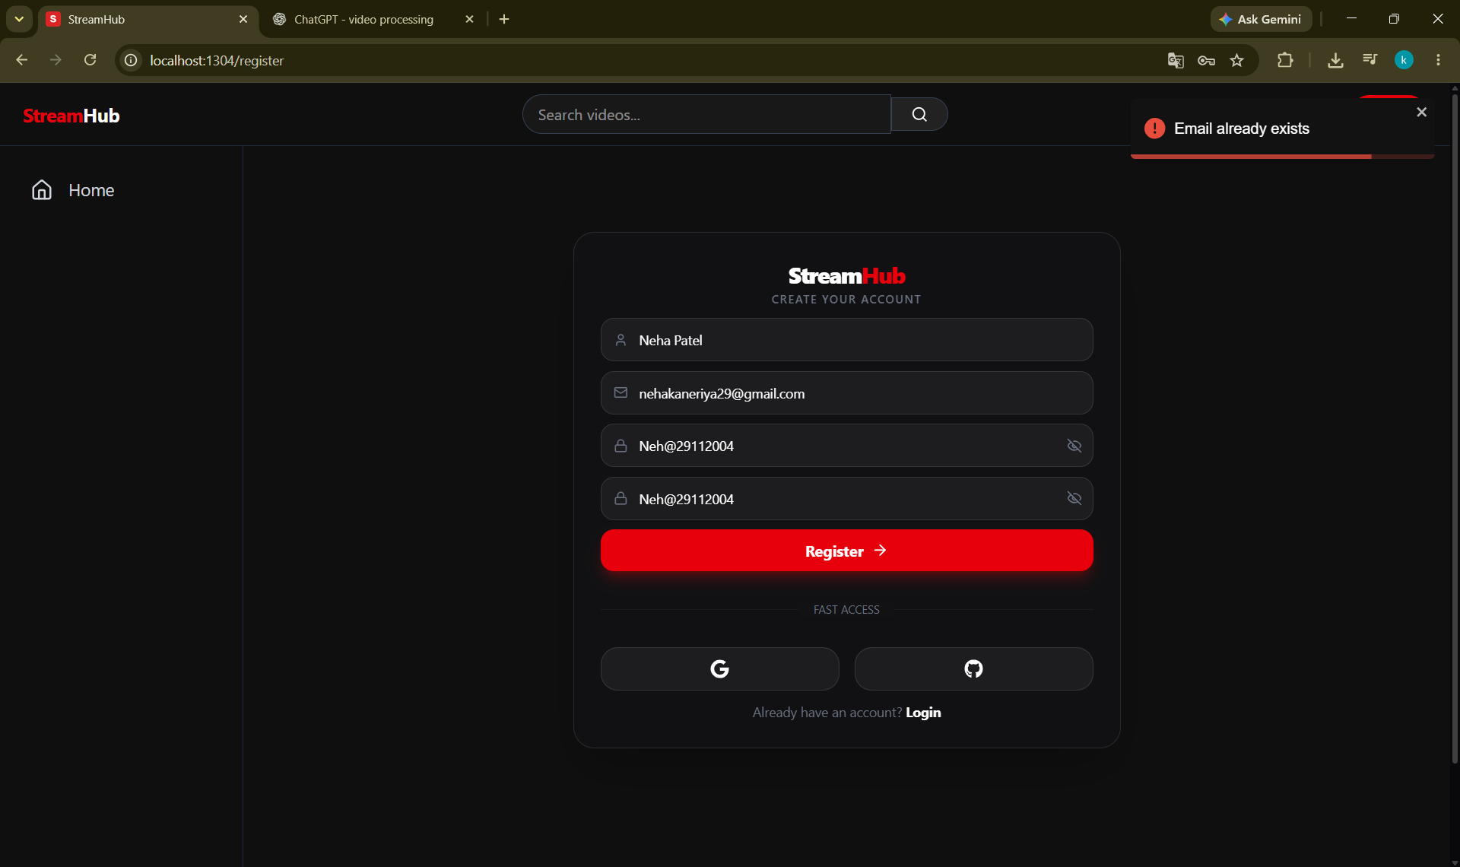
Empty OTP
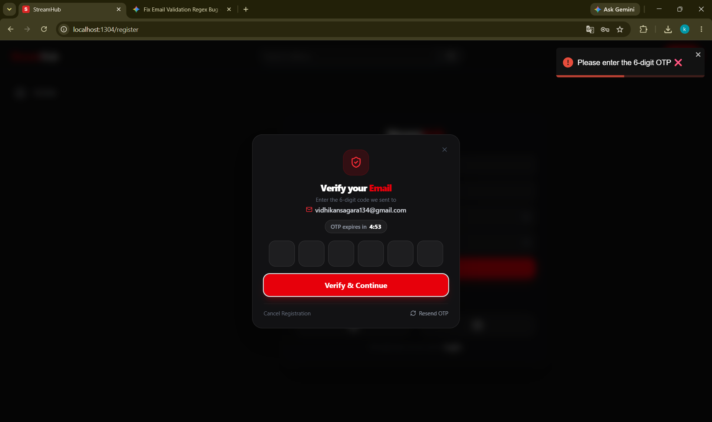
Wrong OTP
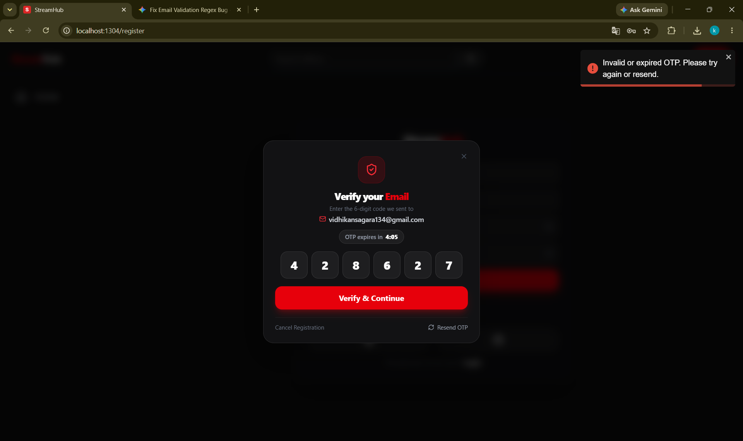
Registration cancelled
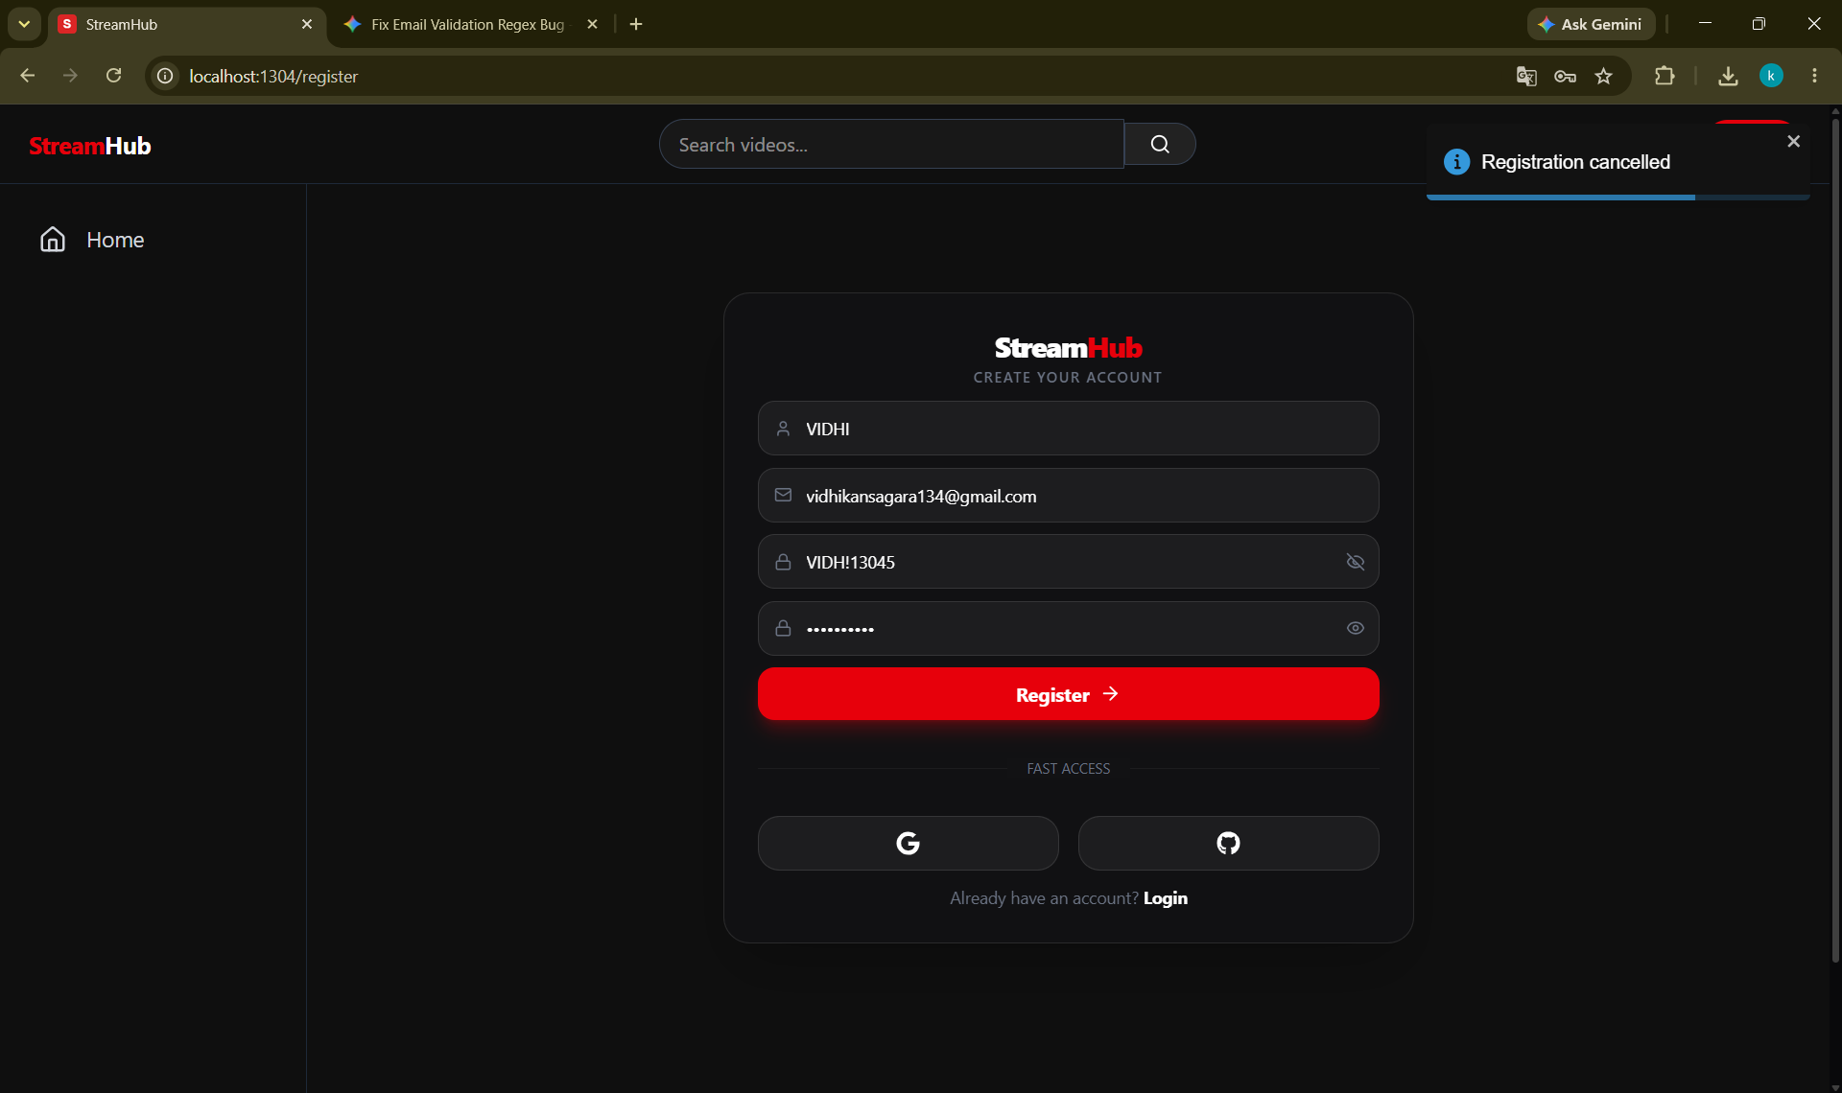
File Too Large
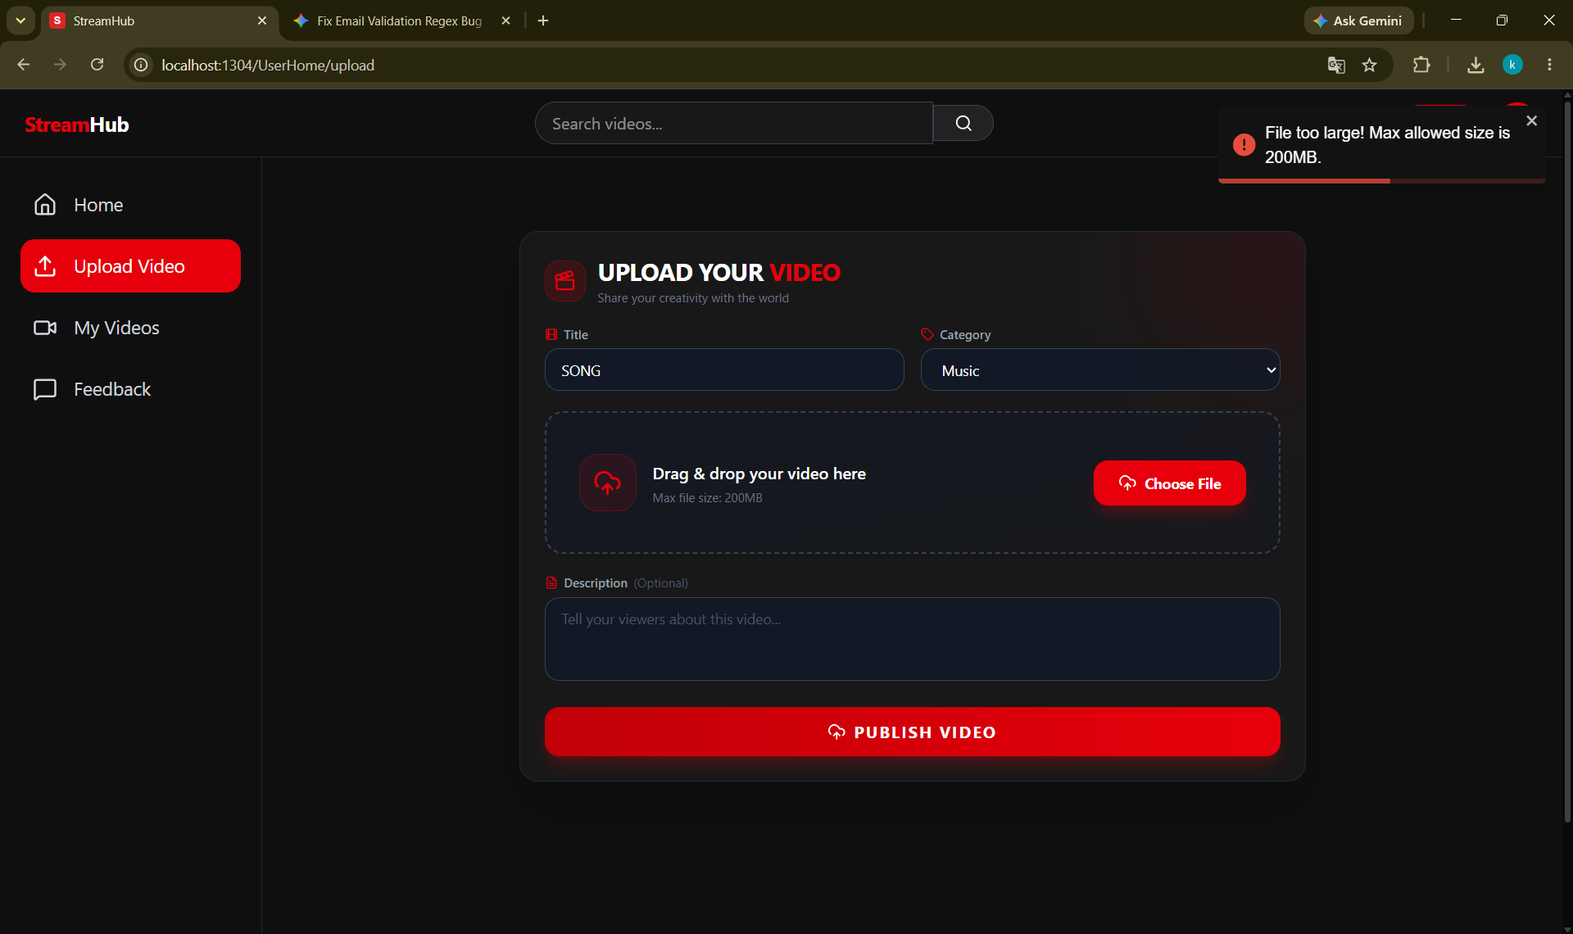
Comment Hide
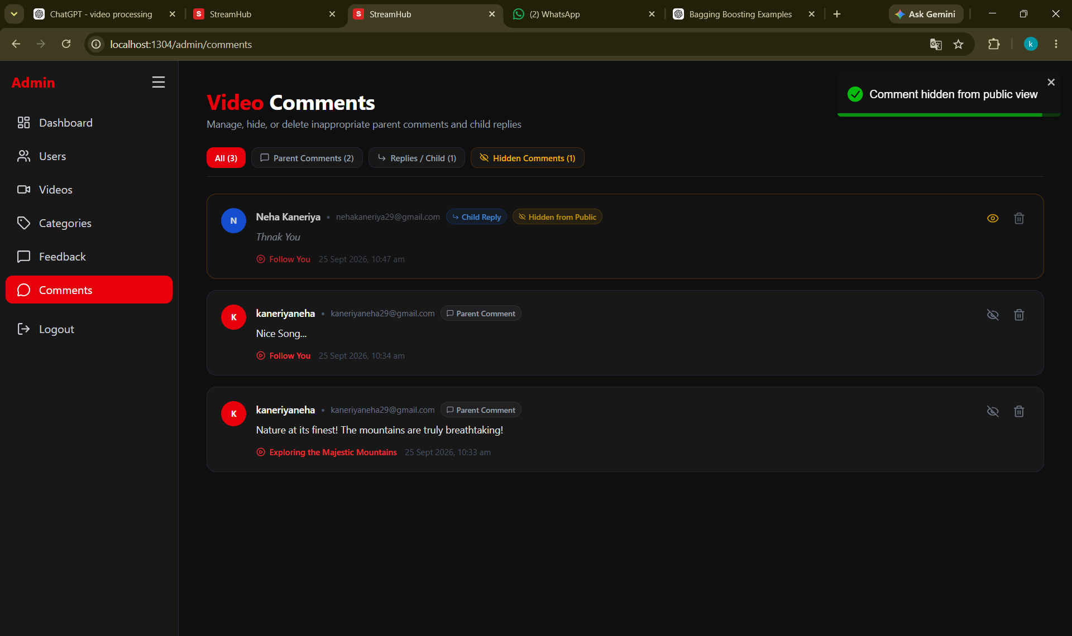
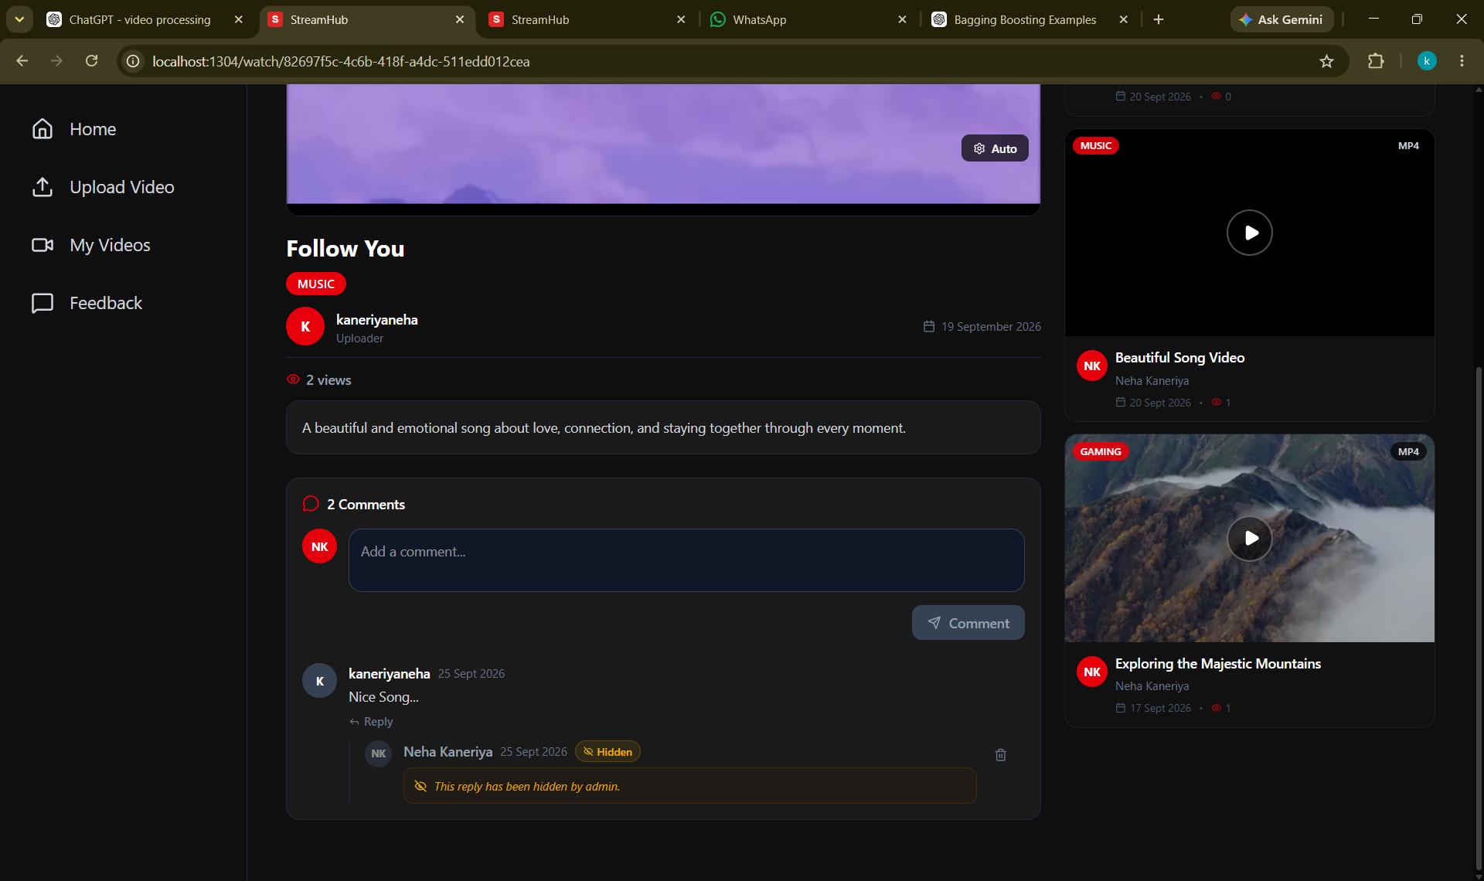

CHAPTER – 6
CONCLUSION AND FUTURE ENHANCEMENT
6.1 Conclusion
The StreamHub – Full-Stack Video Streaming Platform was successfully designed and developed as a web-based application for uploading, managing, discovering, and watching video content. The project provides a structured platform where users can securely register, authenticate themselves, upload videos with relevant metadata, browse available videos, and watch video content through the web interface.
The system was developed using modern technologies such as React, TypeScript, Vite, Tailwind CSS, Java, Spring Boot, Spring Security, Spring Data JPA, and MySQL. The frontend provides an interactive and responsive user interface, while the Spring Boot backend handles business logic, REST APIs, authentication, authorization, database operations, and video processing.
Security is an important part of the system. JWT-based authentication, access and refresh tokens, role-based authorization, and email/OTP verification help provide controlled and secure access to the application. Different permissions can be provided to normal users and administrators according to their roles.
The application also implements video processing and streaming functionality using FFmpeg and HLS (HTTP Live Streaming). Uploaded videos can be processed into HLS format containing playlists and video segments, which can then be delivered through the backend and played through the frontend. The system also supports direct streaming and HTTP Range-based video delivery.
Overall, the project demonstrates how frontend technologies, backend services, database management, authentication, video processing, and streaming technologies can be integrated into a single full-stack application. The developed system provides a strong foundation for building a more advanced and scalable video streaming platform in the future.

6.2 Limitations of the Current System
Although StreamHub meets its main objectives, the current system has some limitations:
- Video files and HLS segments are stored on the local server, which can make large-scale deployment difficult.
- FFmpeg-based video processing can consume significant CPU, memory, and storage resources.
- The current upload-size limit may not be sufficient for very large video files.
- Caching and background processing can be further improved for better performance.
- Advanced features such as detailed analytics, automated moderation, subtitles, and recommendations are not yet included.
6.3 Future Enhancements
Scalable Media Storage and Delivery
Local video storage can be replaced with cloud storage such as Amazon S3 or MinIO, along with CDN-based delivery.
Asynchronous Video Processing
Video processing can be moved to background jobs using message queues and worker services. This would allow users to continue using the application while videos are being processed.
Advanced Search and Recommendations
Advanced search with filters, tags, and better relevance can be implemented. A recommendation system can also suggest videos based on viewing history, categories, and user interactions.
Engagement and Creator Features
Future versions can include likes, playlists, subscriptions, notifications, watch history, creator dashboards, scheduled publishing, and private or unlisted videos.
Accessibility and Internationalization
Subtitle and caption support, transcripts, keyboard-friendly controls, screen-reader support, and multiple interface languages can be added to make the platform more accessible.
Security, Reliability, and Monitoring
Additional security features such as malware scanning, rate limiting, audit logs, automated backups, centralized logging, metrics, and alerting can improve system reliability and security.

CHAPTER – 7
BIBLIOGRAPHY & REFERENCES
The following books, official documentation, and web resources were referred to during the analysis, design, development, and documentation of the “StreamHub” project.
7.1 Books Referencess
[1] Craig Walls, “Spring Boot in Action,” Manning Publications, 2016.
[2] Craig Walls, “Spring in Action,” 6th Edition, Manning Publications, 2022.
[3] Alex Banks and Eve Porcello, “Learning React: Modern Patterns for Developing React Apps,” 2nd Edition, O'Reilly Media, 2020.
[4] Boris Cherny, “Programming TypeScript: Making Your JavaScript Applications Scale,” O'Reilly Media, 2019.
[5] Herbert Schildt, “Java: The Complete Reference,” 12th Edition, McGraw-Hill Education, 2021.
[6] Laurentiu Spilca, “Spring Security in Action,” Manning Publications, 2020.
[7] Silberschatz, Korth, and Sudarshan, “Database System Concepts,” 7th Edition, McGraw-Hill Education, 2019.
[8] Roger S. Pressman and Bruce R. Maxim, “Software Engineering: A Practitioner's Approach,” 9th Edition, McGraw-Hill Education, 2019.
[9] Grady Booch, James Rumbaugh, and Ivar Jacobson, “The Unified Modeling Language User Guide,” 2nd Edition, Addison-Wesley, 2005.
7.2 Web References
[1] Spring Boot Documentation – https://docs.spring.io/spring-boot/documentation.html
[2] Spring Security Documentation – https://docs.spring.io/spring-security/reference/
[3] Spring Data JPA Documentation – https://docs.spring.io/spring-data/jpa/reference/
[4] React Official Documentation – https://react.dev/
[5] Vite Official Documentation – https://vite.dev/
[6] TypeScript Official Documentation – https://www.typescriptlang.org/docs/
[7] Tailwind CSS Official Documentation – https://tailwindcss.com/docs
[8] Video.js Official Documentation – https://videojs.com/guides/
[9] FFmpeg Official Documentation – https://ffmpeg.org/documentation.html
[10] HTTP Live Streaming (HLS) Overview – Apple Developer Documentation – https://developer.apple.com/streaming/
[11] JWT (JSON Web Token) Introduction – https://jwt.io/introduction
[12] Zustand State Management Documentation – https://zustand.docs.pmnd.rs/
[13] MySQL Official Documentation – https://dev.mysql.com/doc/
[14] Swagger / OpenAPI Documentation – https://swagger.io/docs/
[15] Postman Learning Center – https://learning.postman.com/
[16] Stack Overflow Developer Community – https://stackoverflow.com/
[17] GeeksforGeeks – https://www.geeksforgeeks.org/
[18] GitHub Documentation – https://docs.github.com/

