CHAPTER – 4
SYSTEM DESIGN AND DEVELOPMENT
4.1 Time Line Chart (Gantt Chart)
Id | Task Name | Start | Finish | Duration | Jul-2026 |  |  |  | Aug-2026 |  |  |  |  | Sep-2026 |  |  |  | Oct-2026
 |  |  |  |  | 6-Jul | 13-Jul | 20-Jul | 27-Jul | 3-Aug | 10-Aug | 17-Aug | 24-Aug | 31-Aug | 7-Sep | 14-Sep | 21-Sep | 28-Sep | 03-Oct
1. | Planning & Requirement Analysis | 06-07-2026 | 15-07-2026 | 10  Days
2. | Backend Development – Authentication & User Module | 16-07-2026 | 04-08-2026 | 20  Days
3. | Backend Development – Video Module | 05-08-2026 | 22-08-2026 | 18  Days
4. | Backend Development – Admin, Comment & Feedback Modules | 23-08-2026 | 03-09-2026 | 12  Days
5. | Frontend Development | 04-09-2026 | 21-09-2026 | 18  Days
6. | Integration & Testing | 22-09-2026 | 28-10-2026 | 7  Days
7. | Deployment & Documentation | 29-10-2026 | 03-10-2026 | 5  Days
4.2 Data Dictionary
The Data Dictionary describes the structure of the main database tables (entities) used in the “StreamHub” application, along with their fields, data types, and constraints.
Table: User
Field | Data Type | Constraint | Description
user_id | UUID (CHAR 36) | Primary Key | Unique identifier of the user
user_email | VARCHAR (300) | NOT NULL, UNIQUE | Email address used for login
name | VARCHAR (255) | NOT NULL | Full name of the user
password | VARCHAR (255) | NULL (for OAuth users) | BCrypt-hashed password
enable | Boolean | DEFAULT true | Whether the account is active (enabled after OTP verification)
provider | Enum | DEFAULT 'LOCAL' | Source of account: LOCAL / GOOGLE / GITHUB
providerId | VARCHAR (255) | NULL | Unique user ID from the OAuth provider
createdAt | TIMESTAMP | NOT NULL | Registration date (auto-generated)
updatedAt | TIMESTAMP | NOT NULL | Last update time (auto-generated)
Table: roles
Field | Data Type | Constraint | Description
id | UUID (CHAR 36) | Primary Key | Unique identifier for each video
name | VARCHAR (255) | NOT NULL, UNIQUE | Name of the role (ROLE_USER, ROLE_ADMIN)
Table: user_roles
Field | Data Type | Constraint | Description
user_id | CHAR(36) | PK, FK → users(user_id) | Reference to the user
role_id | CHAR(36) | PK, FK → roles(id) | Reference to the role
Table: yt_video
Field | Data Type | Constraint | Description
video_id | CHAR(36) | Primary Key | Unique identifier for each video
title | VARCHAR(255) | NOT NULL | Title of the uploaded video
description | TEXT | NULL | Short description of the video
contentType | VARCHAR(255) | NOT NULL | MIME type of the uploaded video file
category | VARCHAR(50) | NOT NULL, DEFAULT 'other' | Category name of the video
filePath | VARCHAR(255) | NOT NULL | Path where the video / HLS files are stored
view_count | BIGINT | NOT NULL, DEFAULT 0 | Total views (denormalized for faster reads)
user_id | CHAR(36) | NOT NULL, FK → users(user_id) | Uploader / owner of the video
createdAt | TIMESTAMP | NOT NULL | Timestamp when the video was uploaded
updated_at | TIMESTAMP | NOT NULL | Last update time
Table: categories
Field | Data Type | Constraint | Description
id | CHAR(36) | Primary Key | Unique identifier of the category
name | VARCHAR(100) | NOT NULL,UNIQUE | Name of the category (e.g., Music, Education)
slug | VARCHAR(100) | NOT NULL, UNIQUE | URL-friendly name (e.g., music)
description | VARCHAR(500) | NULL | Short description of the category
created_at | TIMESTAMP | NOT NULL | Creation date
updated_at | TIMESTAMP | NOT NULL | Last update time
Table: comments
Field | Data Type | Constraint | Description
id | CHAR(36) | Primary Key | Unique identifier of the comment
text | VARCHAR(100) | NOT NULL | Content of the comment
user_id | CHAR(36)) | NOT NULL, FK → users(user_id) | User who posted the comment
video_id | CHAR(36) | NOT NULL, FK → yt_video(video_id) | Video on which the comment was posted
parent_comment_id | CHAR(36) | NULL, FK → comments(id) | Parent comment for replies (NULL = top-level comment)
created_at | TIMESTAMP | NOT NULL | Comment date
updated_at | TIMESTAMP | NOT NULL | Last update time
Table: refresh_tokens
Field | Data Type | Constraint | Description
id | CHAR(36) | Primary Key | Unique identifier of the token record
jti | VARCHAR(255) | NOT NULL, UNIQUE, UPDATABLE-FALSE | JWT ID — identity of the token
user_id | CHAR(36) | NOT NULL, FK → users(user_id | User to whom the token belongs
expires_at | TIMESTAMP | NOT NULL | Expiry time of the token
revoked | BOOLEAN (TINYINT 1) | NOT NULL, DEFAULT false | Whether the token is revoked (set true on logout/rotation)
replaced_by_token | VARCHAR(255) | NULL | Reference to the new token after rotation
created_at | TIMESTAMP | NOT NULL | Token issue date
updated_at | TIMESTAMP | NOT NULL | Last update time
Table: feedbacks
Field | Data Type | Constraint | Description
id | CHAR(36) | Primary Key | Unique identifier of the feedback
message | VARCHAR(1000) | NOT NULL | Feedback text of the user
user_id | CHAR(36) | NOT NULL, FK → users(user_id) | User who submitted the feedback
created_at | TIMESTAMP | NOT NULL | Submission date
updated_at | TIMESTAMP | NOT NULL | Last update time
Table: video_views
Field | Data Type | Constraint | Description
id | BIGINT | Primary Key | Unique identifier of the view record
video_id | CHAR(36) | NOT NULL, FK → yt_video(video_id) | Which video was viewed
user_id | CHAR(36) | NULL, FK → users(user_id) | Logged-in user (NULL for guests)
viewer_ip | VARCHAR(45) | NULL | IP address of guest viewers (used for repeat-view detection)
viewed_at | TIMESTAMP | NOT NULL, UPDATABLE-FALSE | Time of the view

4.3 E-R Diagram
The E-R diagram illustrates the database entities and their relationships in the “StreamHub” application. The User entity is central, connecting with Video, Feedback, Comments, Video Views, Refresh Tokens, and Roles.
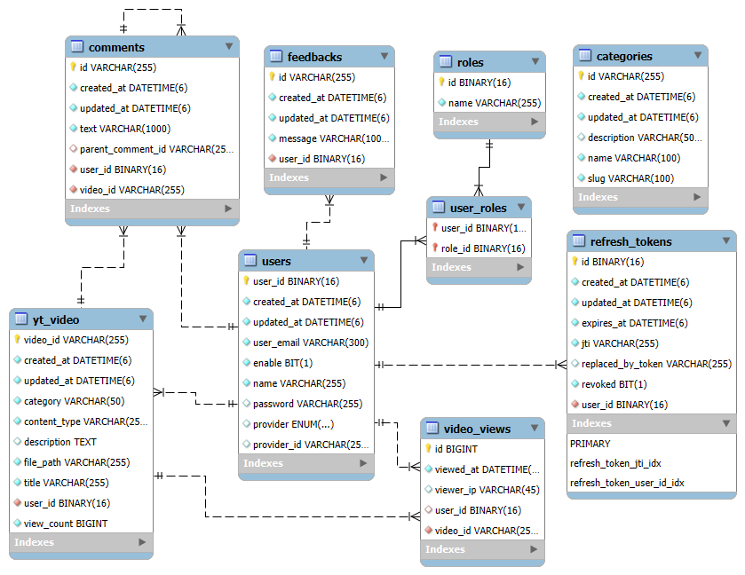
4.4 User Modeling Language (UML) Diagrams
4.4.1 Use Case Diagrams
The use case diagram below shows the interaction between the two main actors of the system – User and Administrator – and the various use cases they can perform.
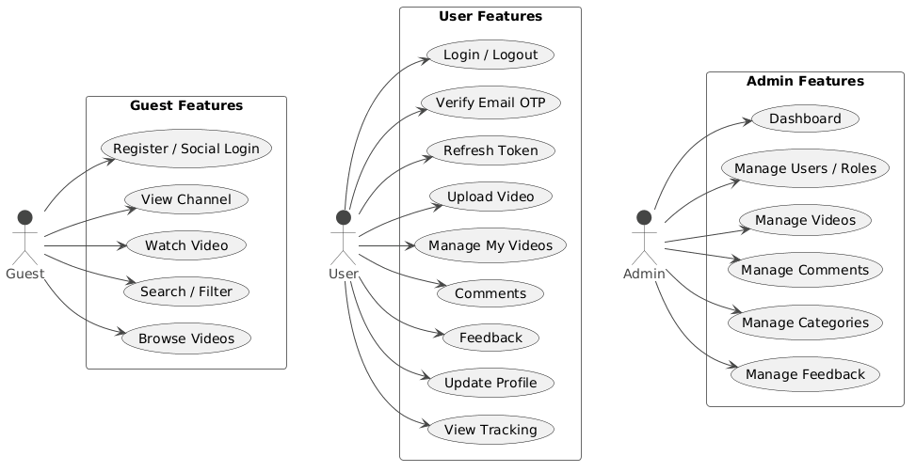
4.4.2 Activity Diagrams
The activity diagram below represents the step-by-step flow of the video upload process, from file selection to HLS conversion and final display of the uploaded video.
Activity Diagram 1 — User Registration & Login
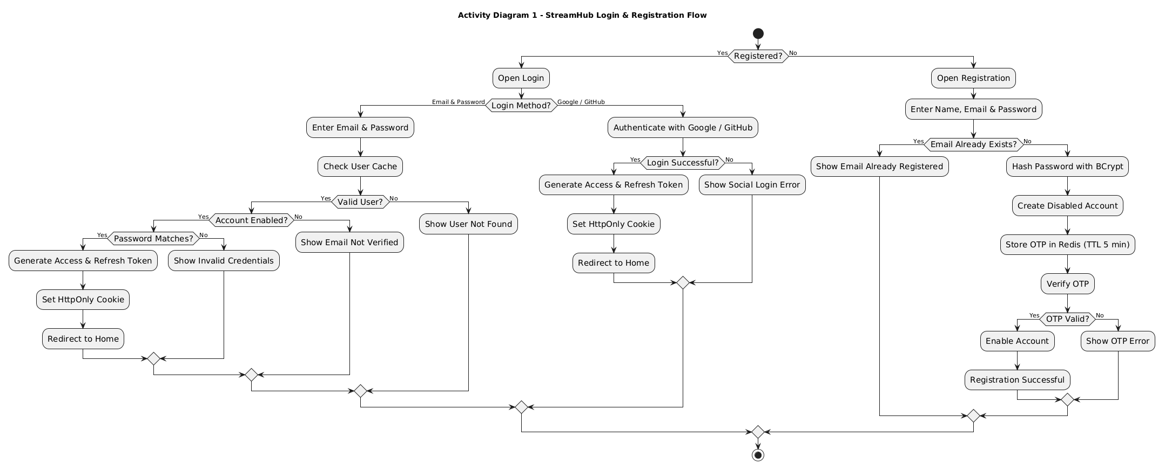
Activity Diagram 2 — Video Upload & Streaming Flow
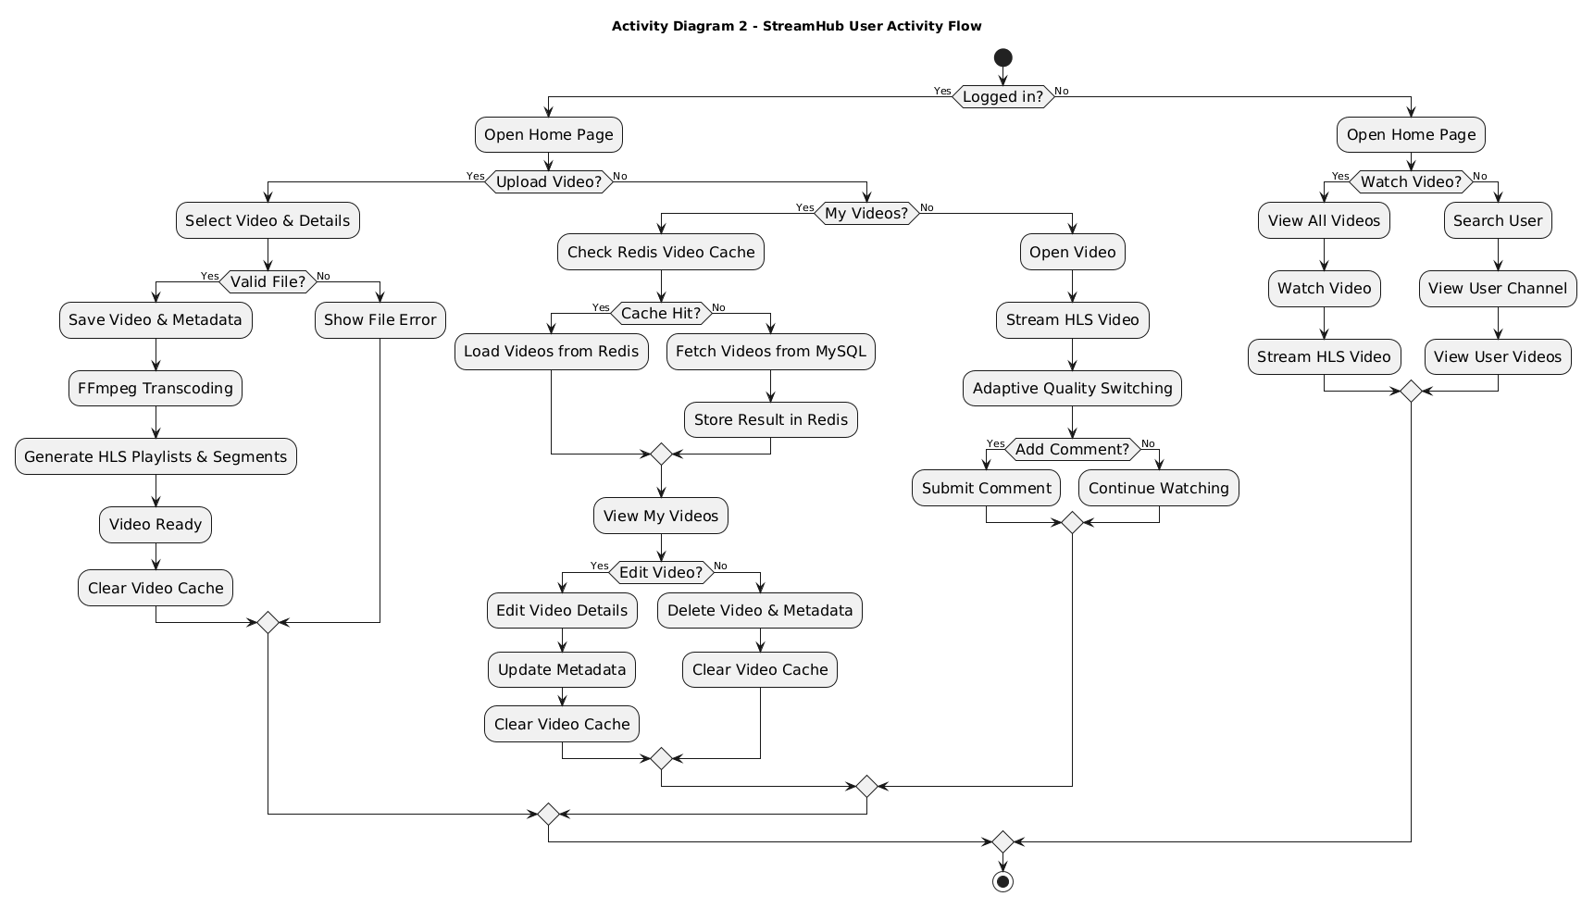
Activity Diagram 3 — Admin Moderation (Video + User)
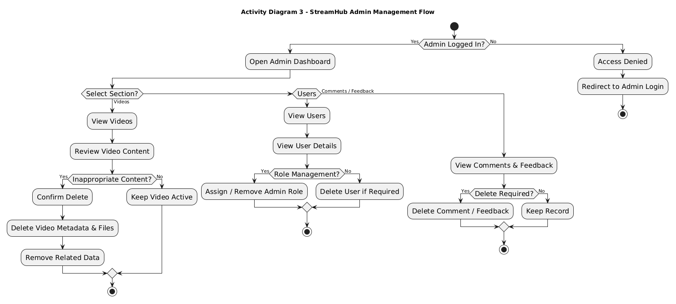
4.4.3 Sequence Diagrams
The sequence diagram illustrates the end-to-end interaction between the user, front-end, backend services, FFmpeg, and database during video uploading, processing, and HLS-based streaming.
Sequence Diagram 1 — Authentication (Registration + OTP + Login + Refresh + Logout)
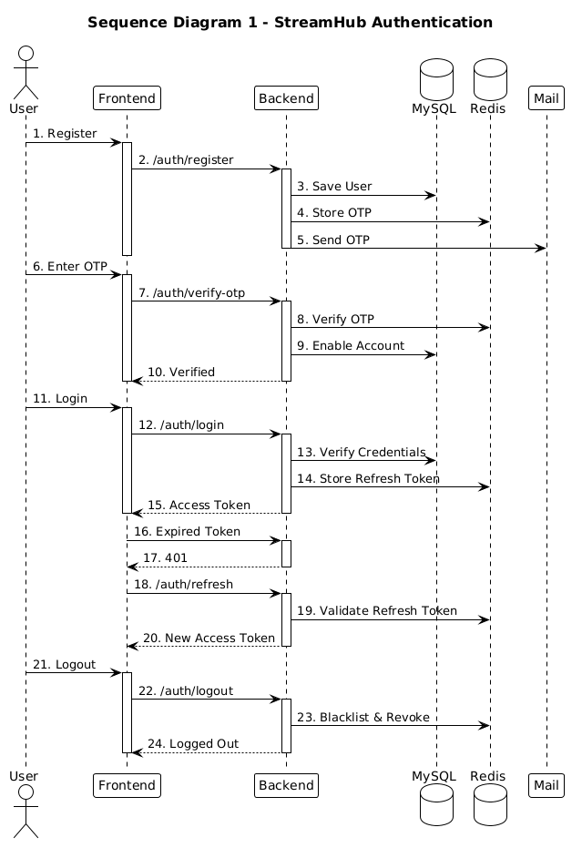

Sequence Diagram 2 — Video (Upload + HLS Processing + Streaming)
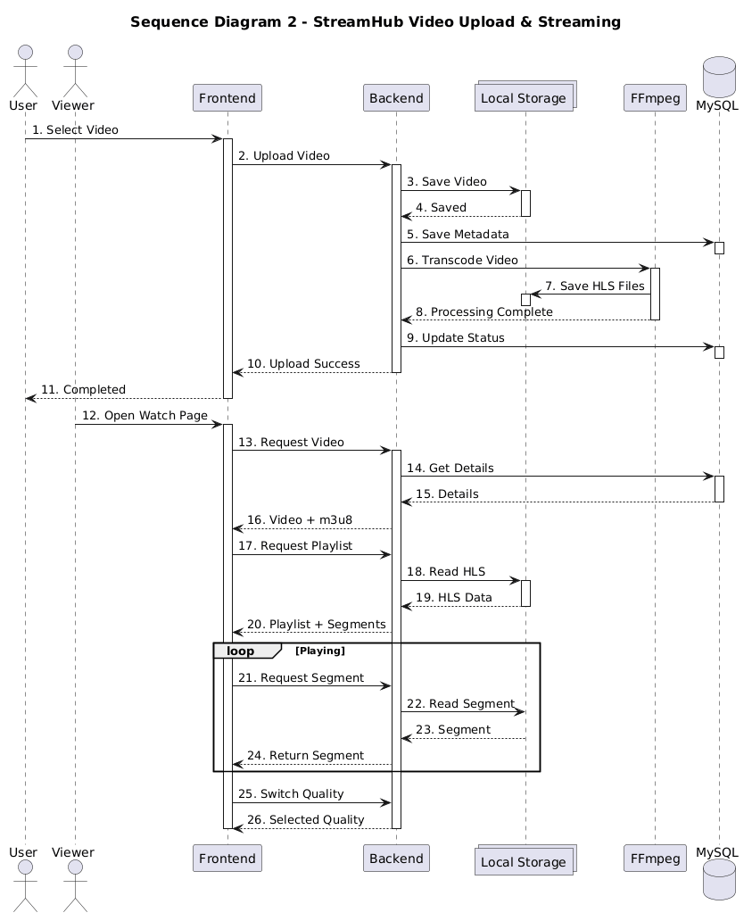

Sequence Diagram 3 — Admin (Dashboard + Users + Videos + Comments + Feedback)
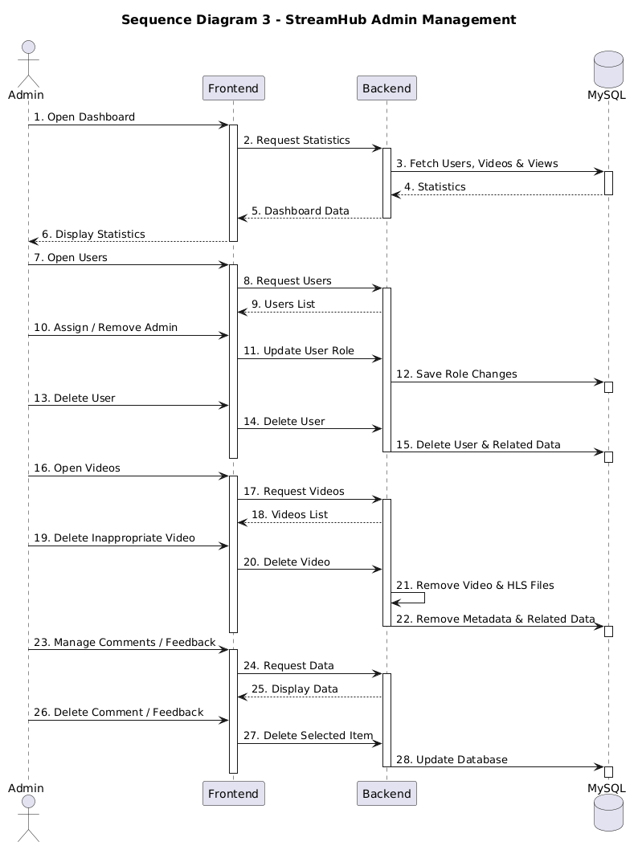

4.4.4 Collaboration Diagrams
The collaboration diagram illustrates how system objects interact and exchange messages during video upload and processing.
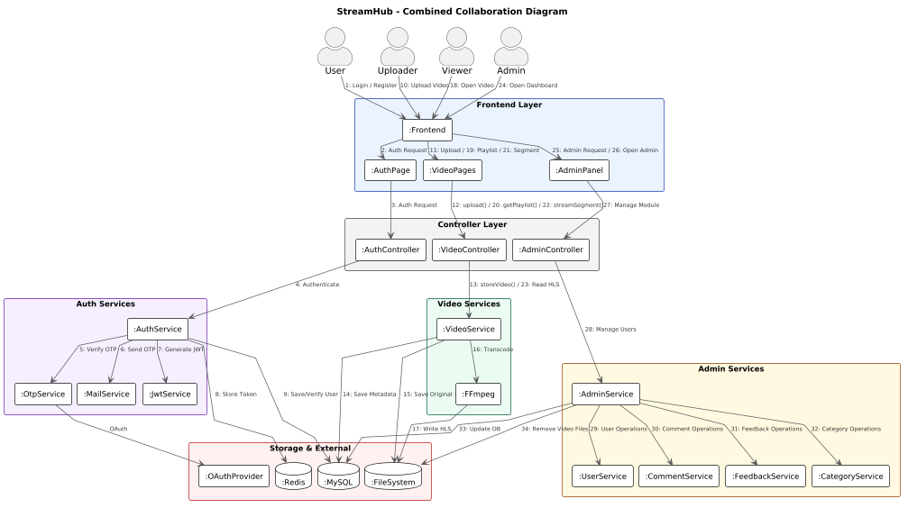
4.4.5 Class Diagrams
The class diagram below shows the main classes of the “StreamHub” system, including controller classes, service classes, and entity classes, along with their attributes, methods, and relationships.
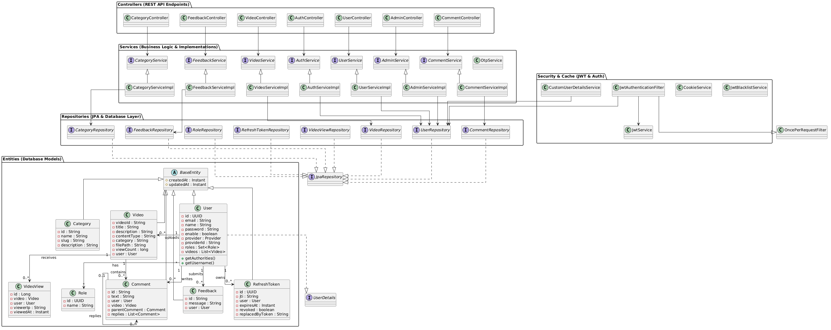
4.5 Input Design
Input design focuses on how data is collected from users and validated before being processed by the system. In “StreamHub,” the primary input forms include the registration form, login form, video upload form, and feedback form. Each form is designed to be simple, responsive, and user-friendly, with proper client-side and server-side validation to ensure data accuracy and security.
4.5.1 User Registration Form
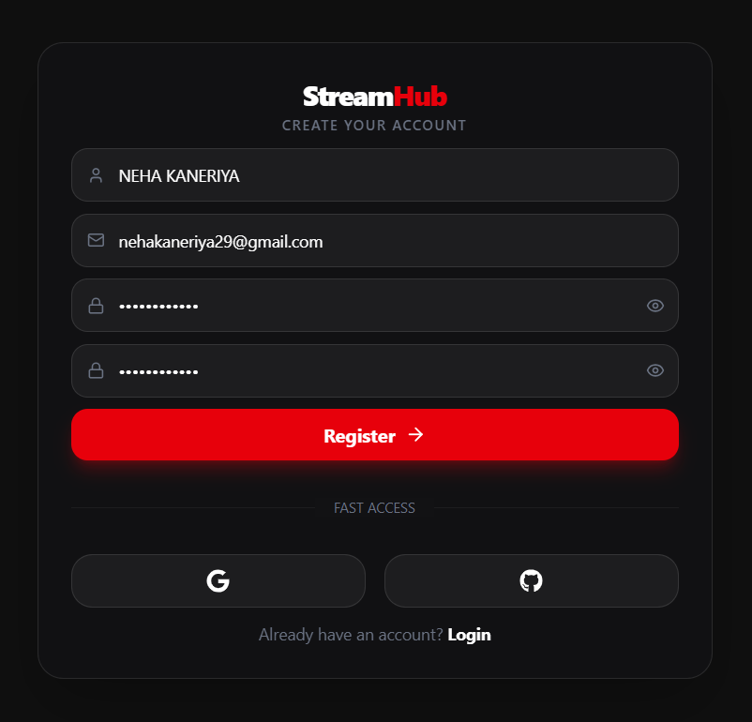
4.5.2 Email OTP Verification
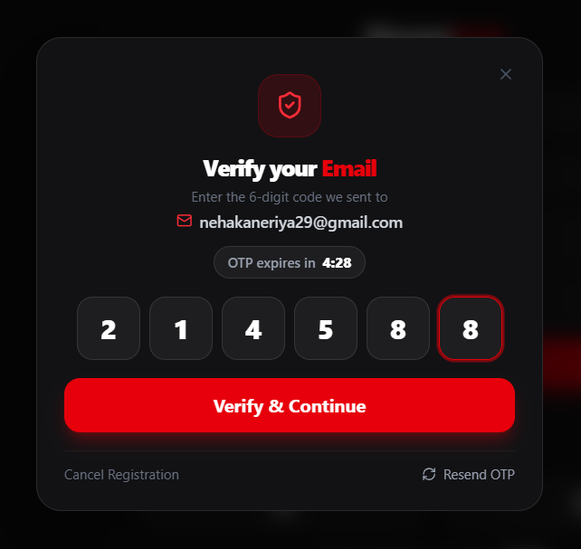
4.5.3 User Login Form
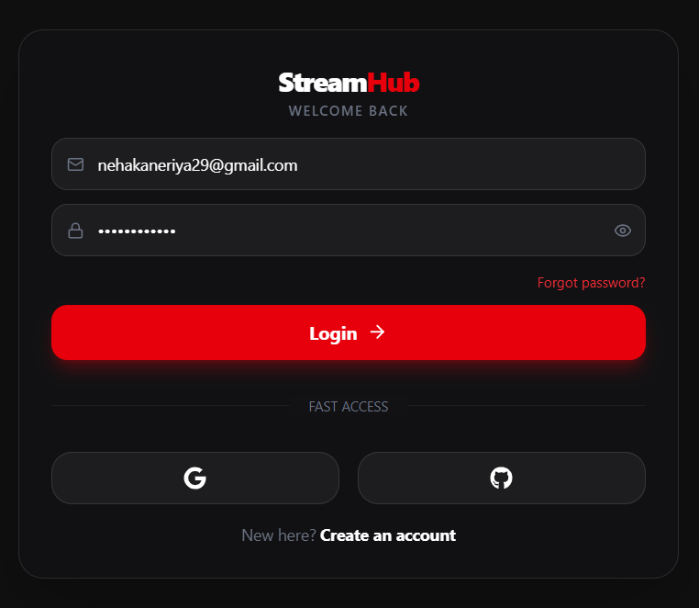
4.5.4 Admin Login Form
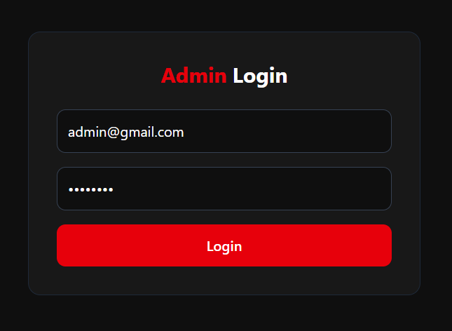
4.5.5 Video Upload Form
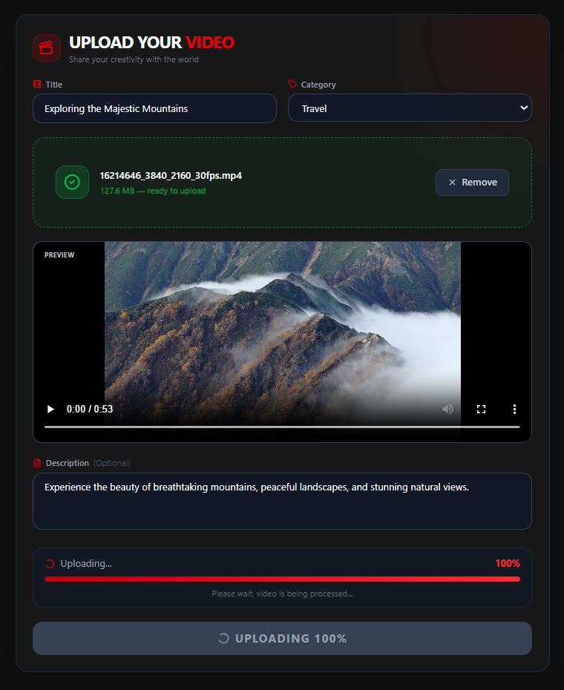
4.5.6 Edit Video Form
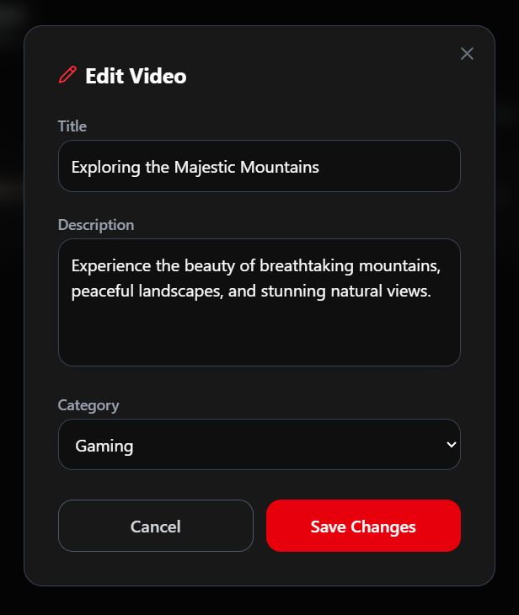
4.5.7 Comment Input
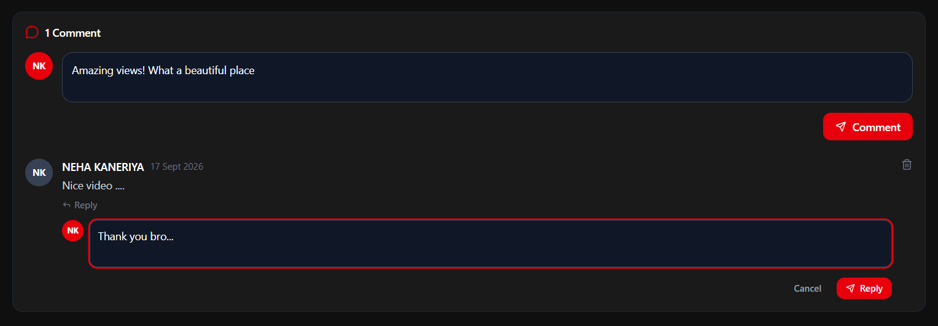
4.5.8 Feedback Form
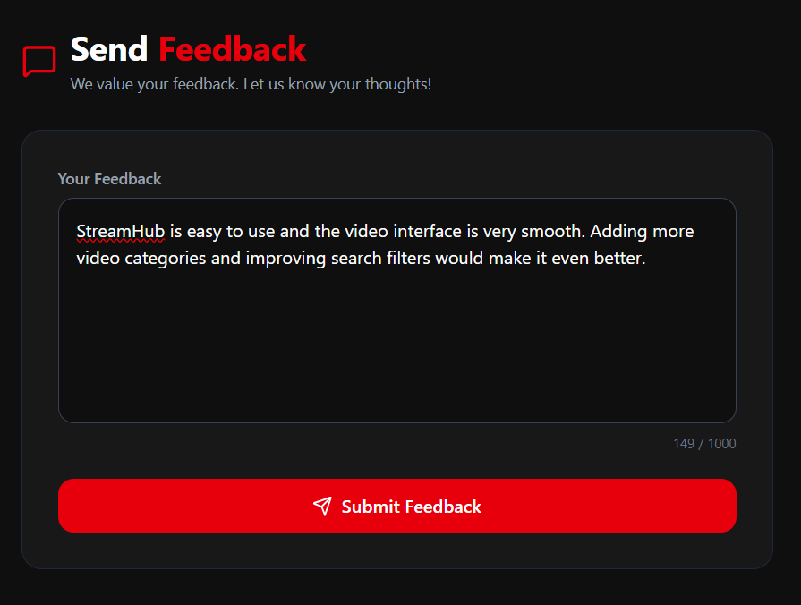
4.5.9 Category Management Form
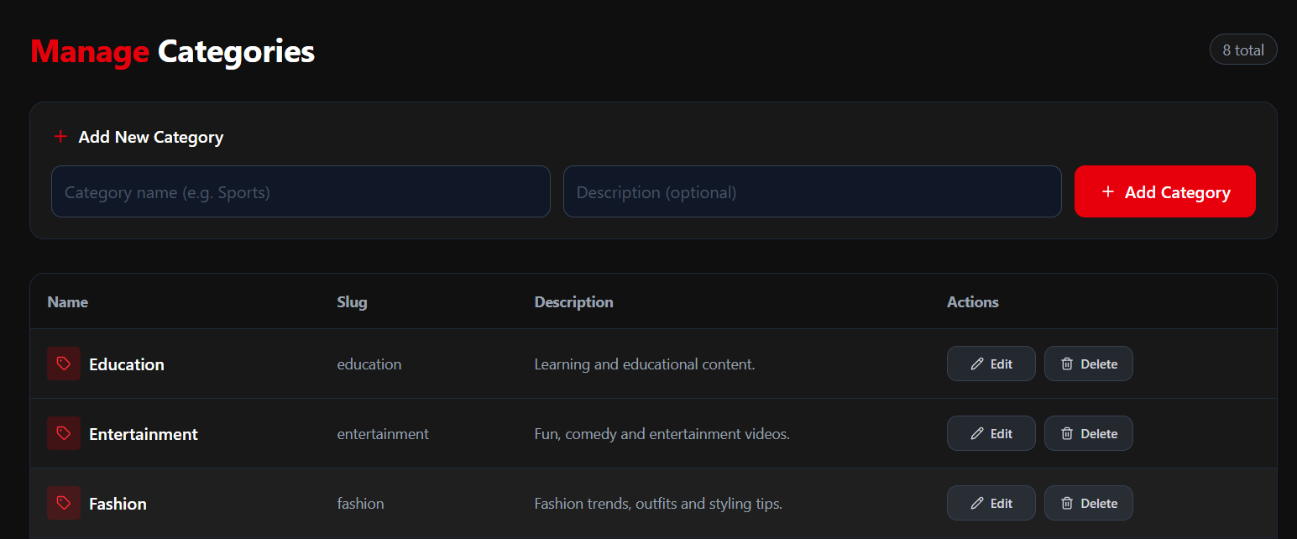
4.5.10 Edit Category Form
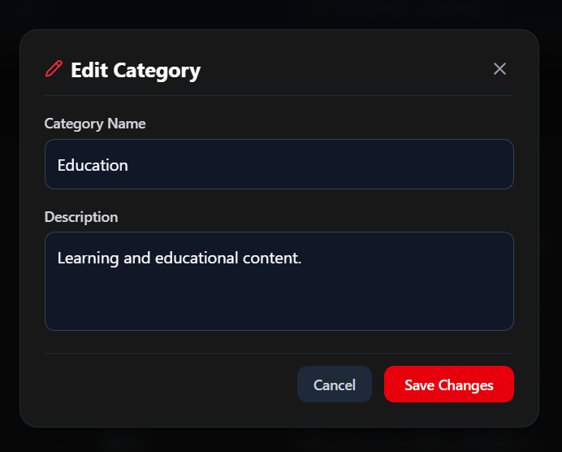
4.5.11 Search Bar
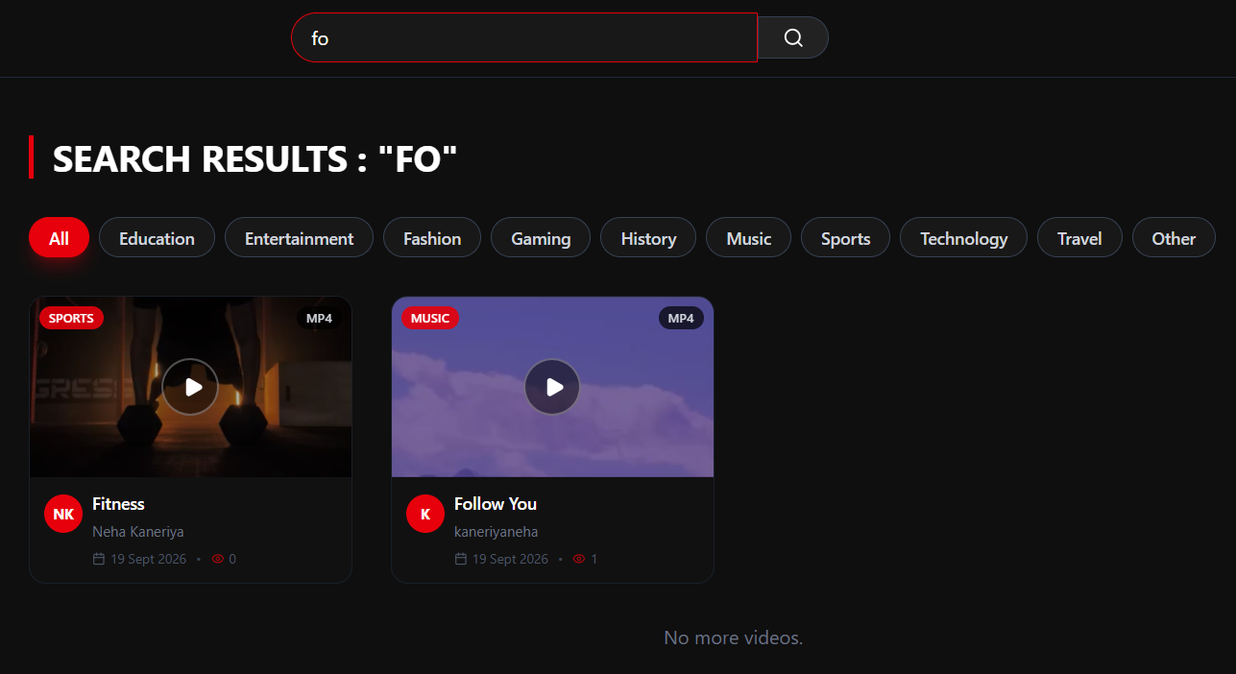
4.6 Output Design
Output design focuses on how information is presented back to the user after processing. In “StreamHub,” outputs are primarily displayed through the web interface in the form of video listings, video playback, success/error messages, and administrative reports.
4.6.1 Home Page (Video Feed)
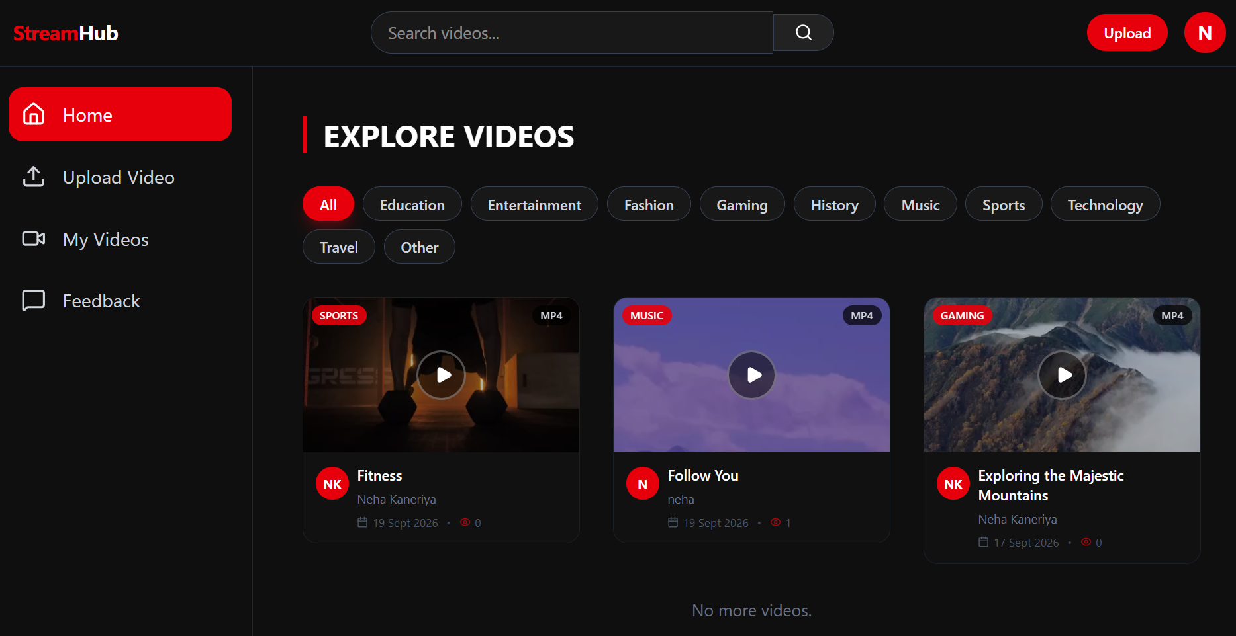
4.6.2 Video Watch Page
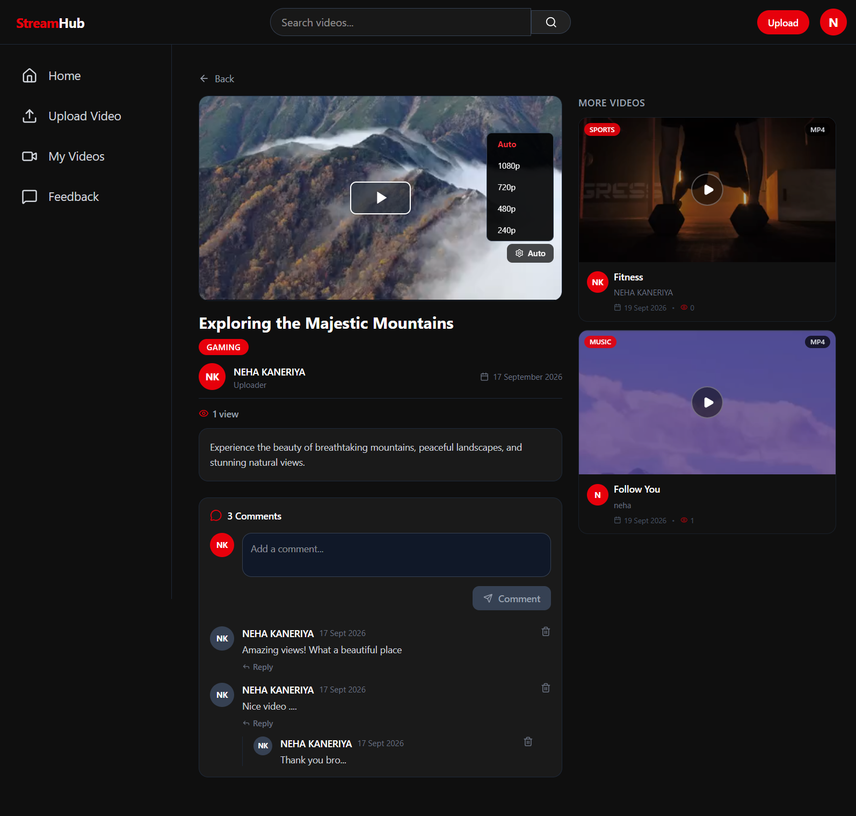
4.6.3 User Channel Page
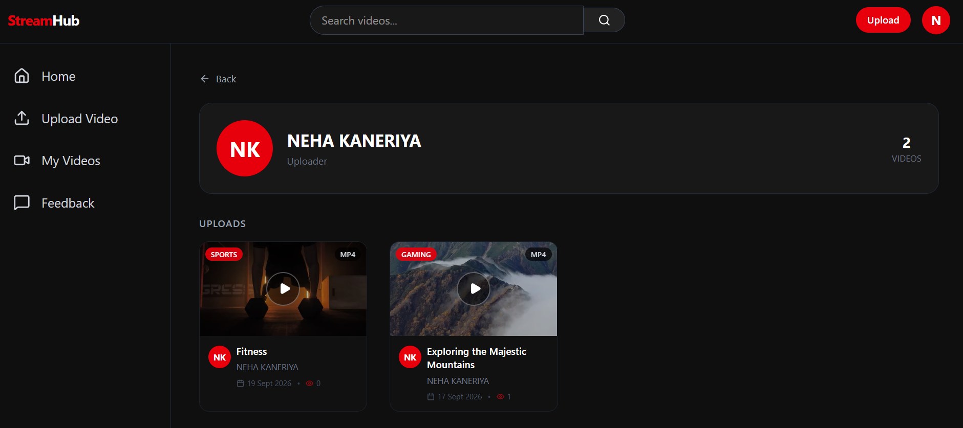
4.6.4 My Videos Page (User Dashboard)
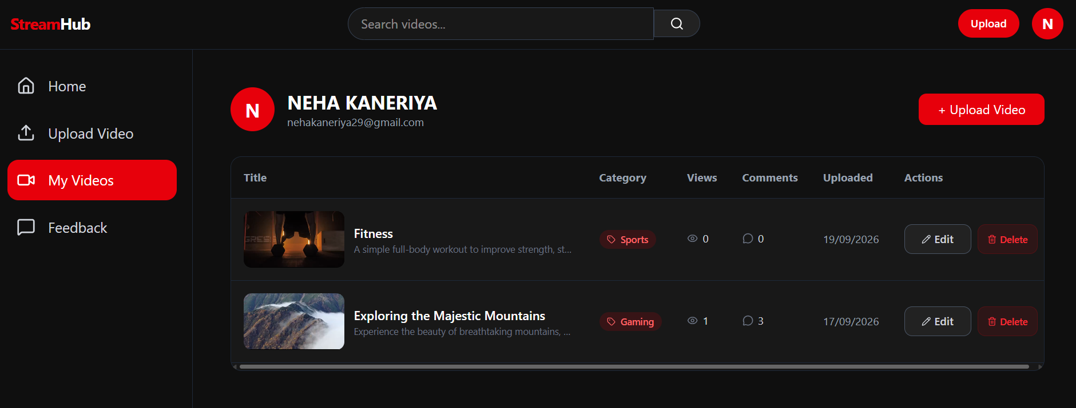
4.6.5 User Profile Page
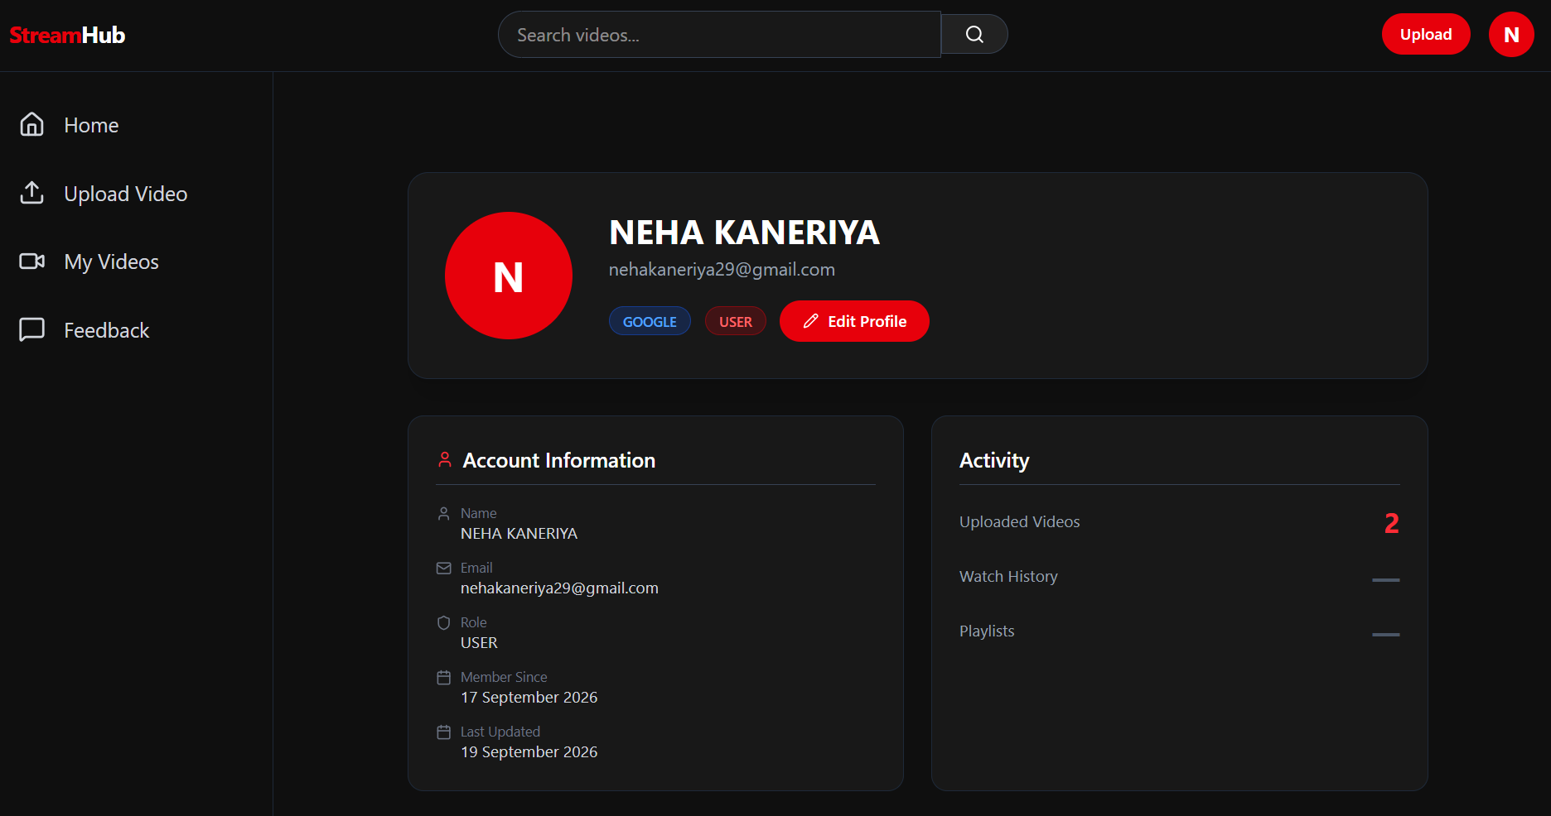
4.6.6 Admin Dashboard
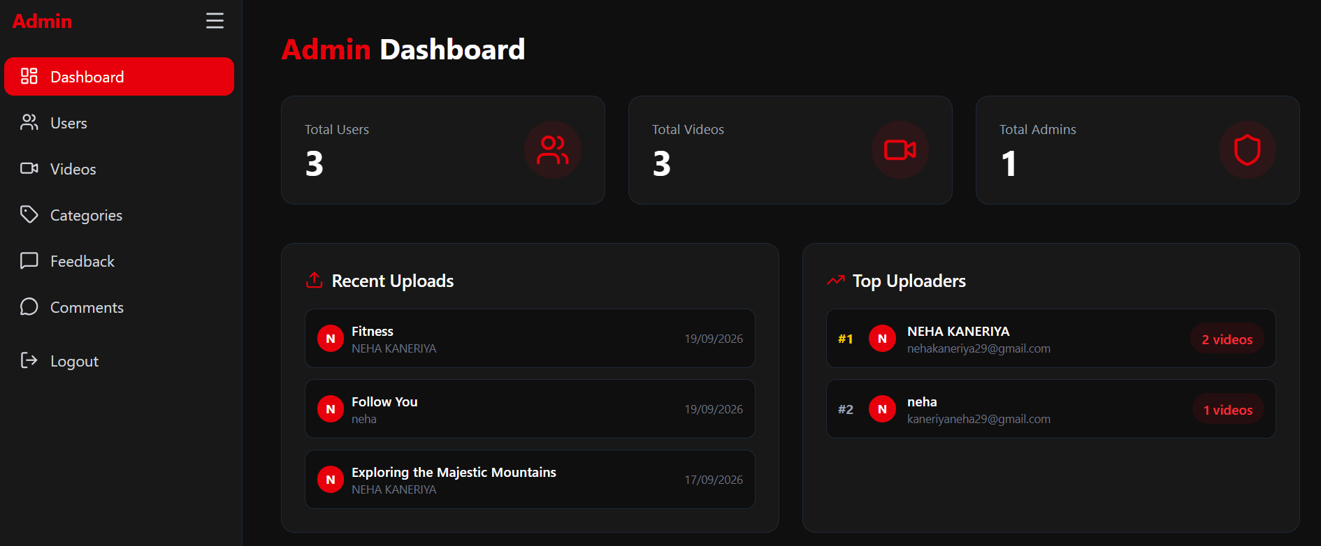
4.6.7 Admin – Manage Users
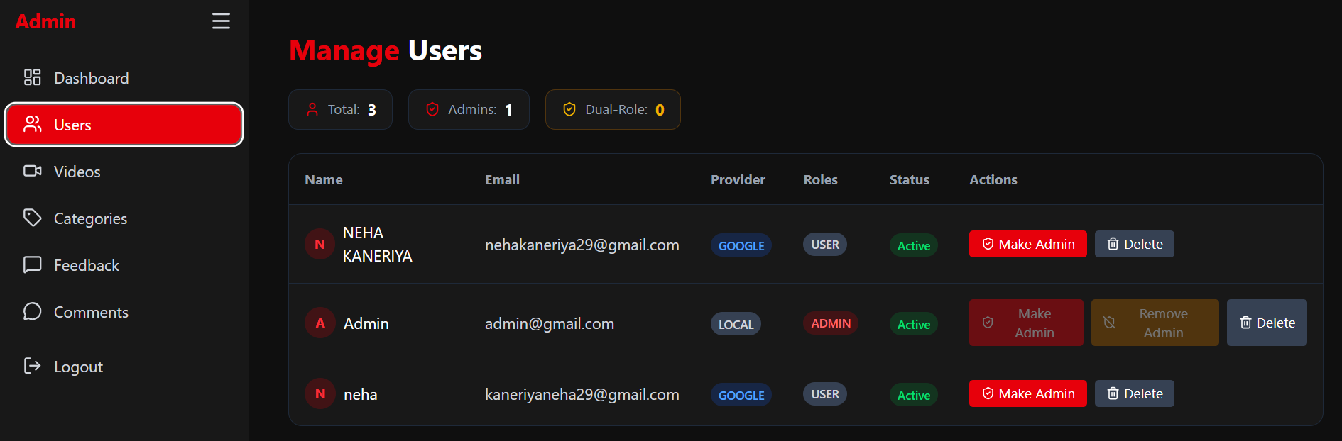
4.6.8 Admin – Manage Videos
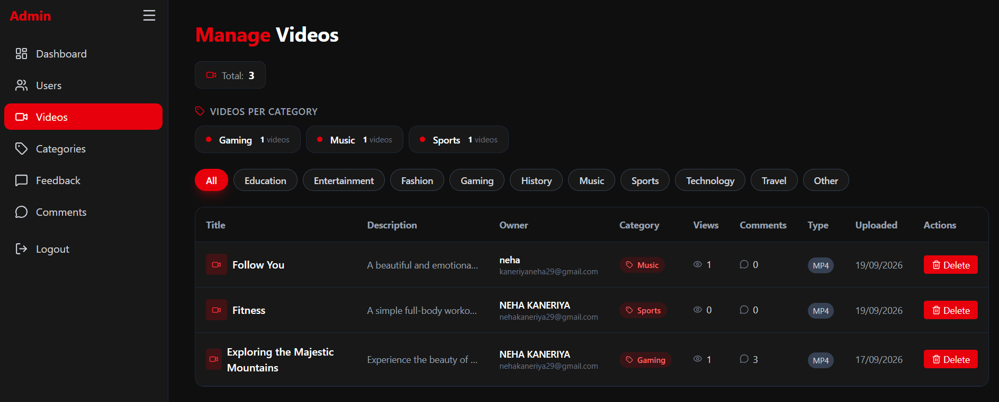
4.6.9 Admin – Manage Categories
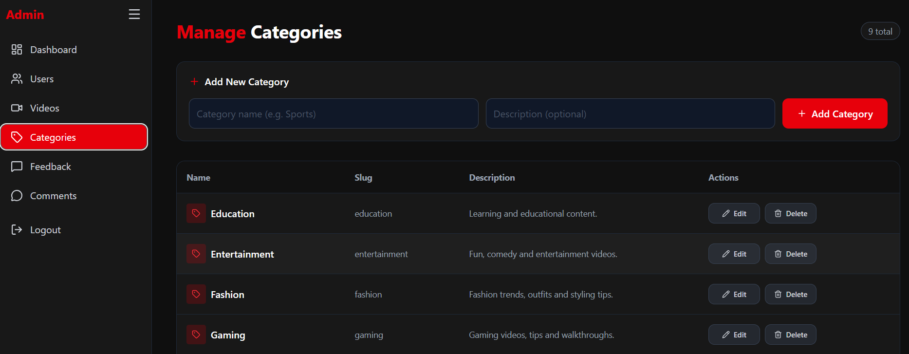
4.6.10 Admin – Manage Comments
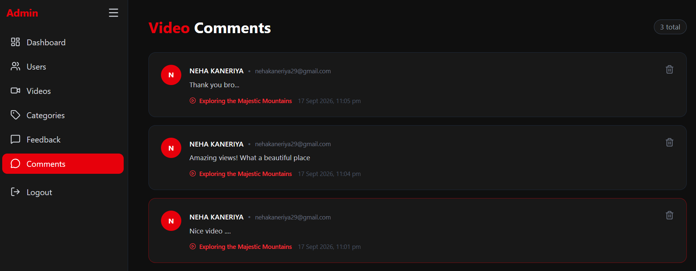
4.6.11 Admin – View Feedback
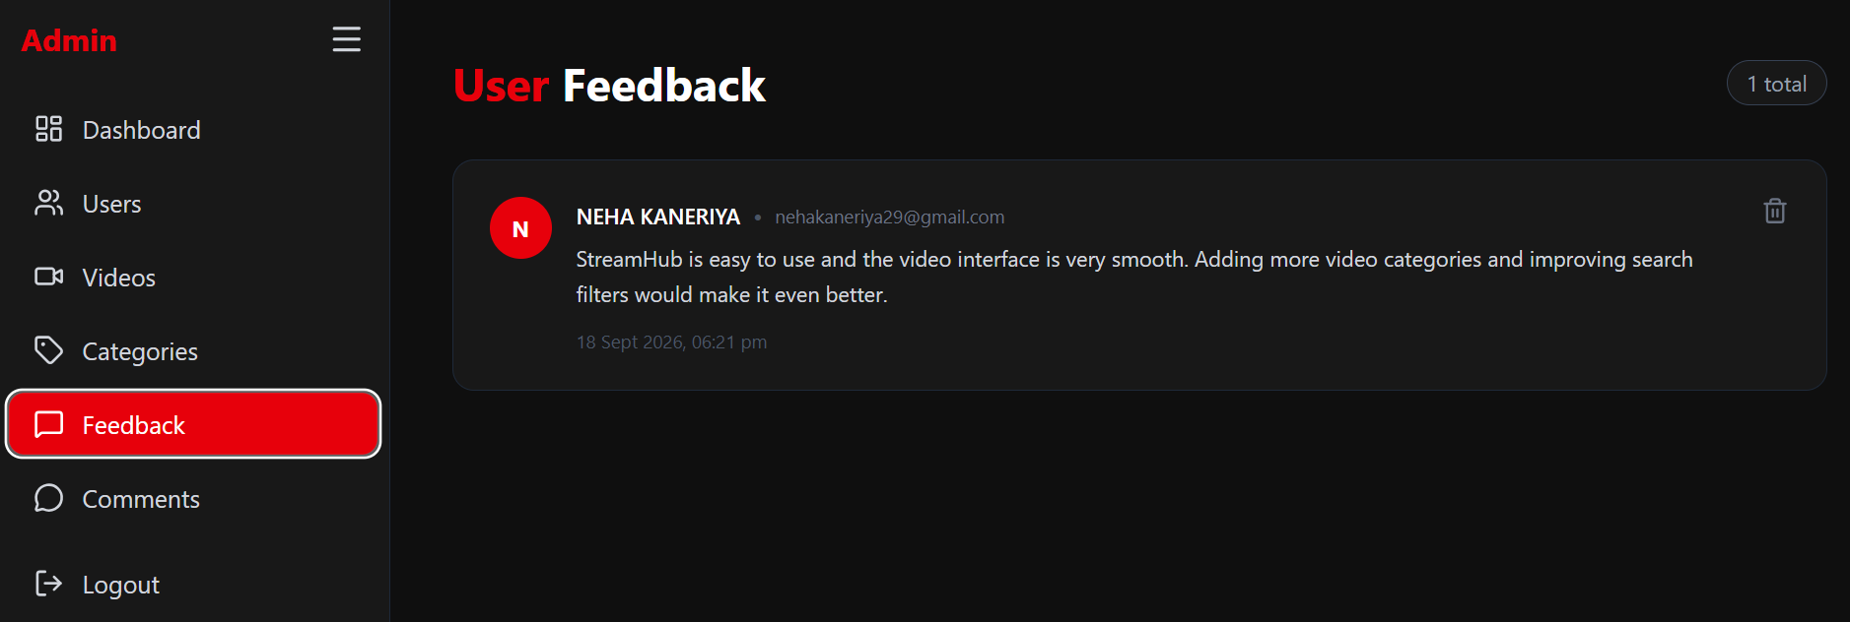
4.6.12 Logout Page
