CHAPTER – 4
SYSTEM DESIGN AND DEVELOPMENT
4.1 Time Line Chart (Gantt Chart)
The Gantt chart below represents the planned development timeline of the “StreamHub” project, showing the various phases of development from requirement analysis to final deployment and documentation.
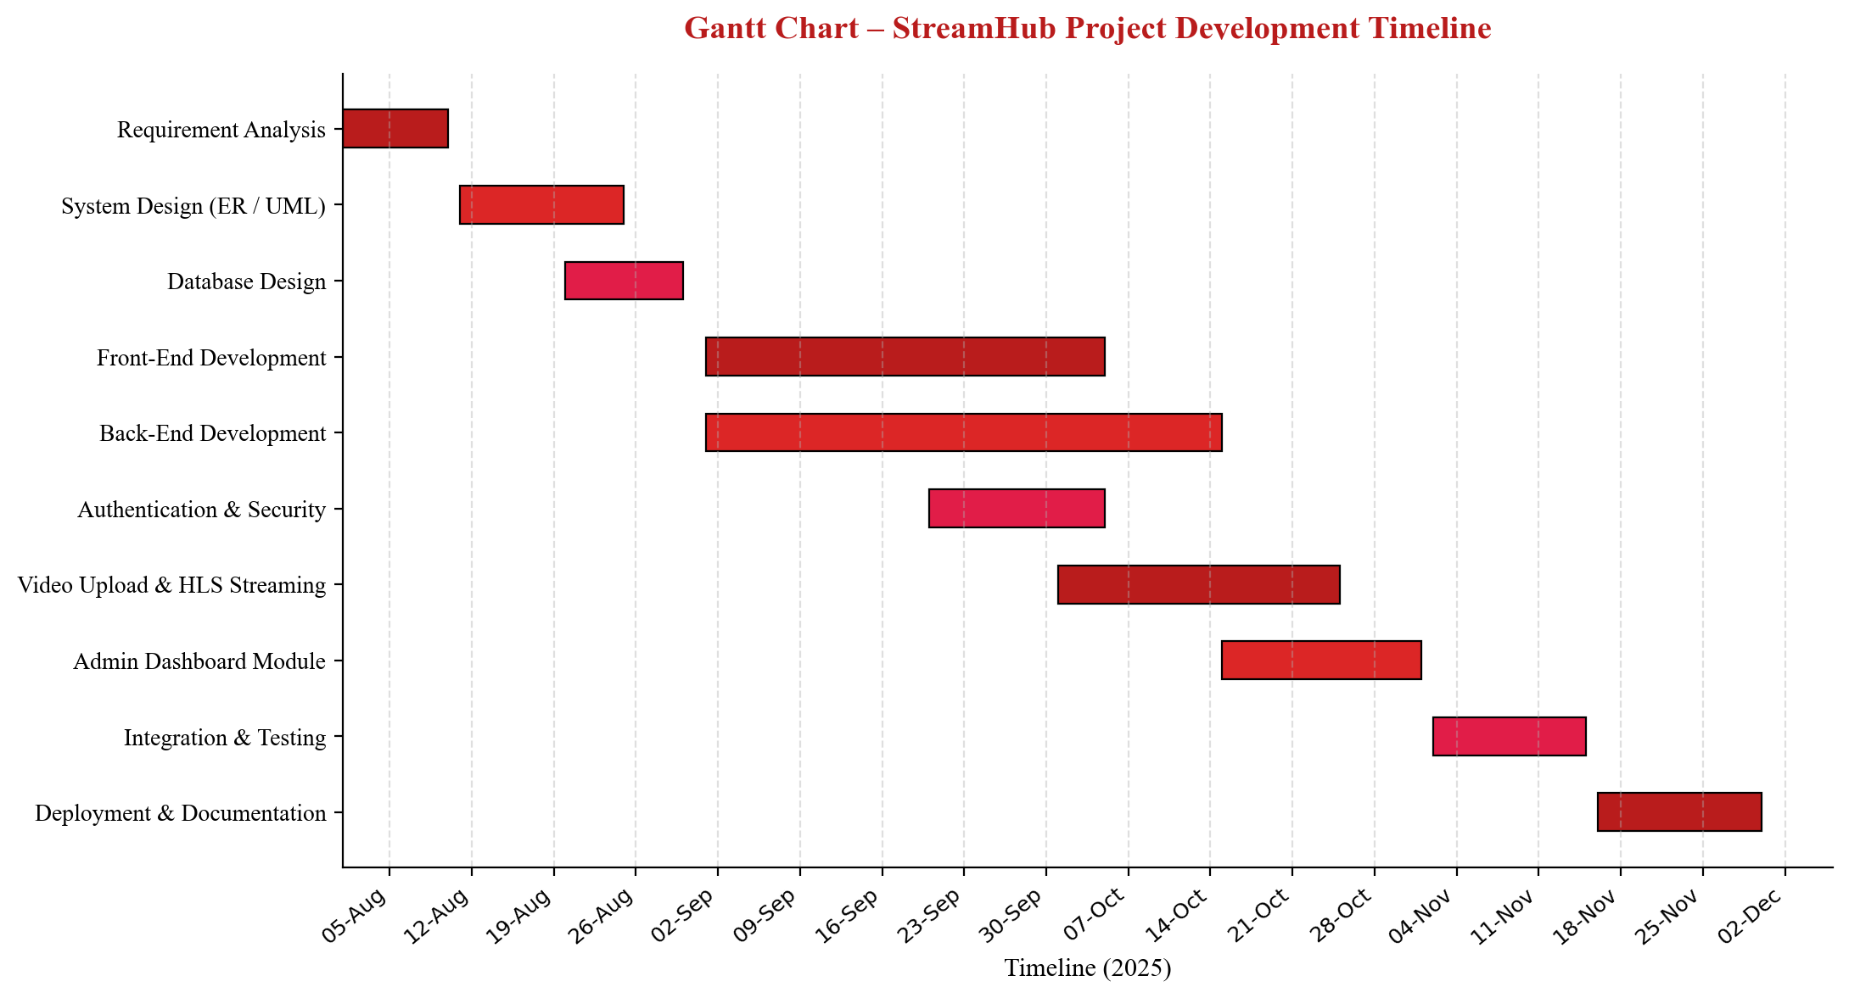
Fig. 4.1 – Gantt Chart showing StreamHub Project Development Timeline
4.2 Data Dictionary
The Data Dictionary describes the structure of the main database tables (entities) used in the “StreamHub” application, along with their fields, data types, and constraints.
Table: User
Field | Data Type | Constraint | Description
id | UUID | Primary Key | Unique identifier for each user
email | String | Unique, Not Null | User's email address, used for login
name | String | Not Null | Full name of the user
password | String | Not Null | Encrypted password (hidden in JSON responses)
enable | Boolean | Default: true | Indicates if the account is active
provider | Enum | Not Null | LOCAL, GOOGLE, GITHUB, or FACEBOOK
providerId | String | Nullable | ID returned by OAuth provider (if applicable)
createdAt | DateTime | Not Null | Timestamp when the account was created
updatedAt | DateTime | Not Null | Timestamp of the last profile update

Table: Video
Field | Data Type | Constraint | Description
videoId | String (UUID) | Primary Key | Unique identifier for each video
title | String | Not Null | Title of the uploaded video
description | String | Nullable | Short description of the video
contentType | String | Not Null | MIME type of the uploaded video file
filePath | String | Not Null | Path where the video / HLS files are stored
createdAt | DateTime | Not Null | Timestamp when the video was uploaded
user_id | UUID | Foreign Key | References the User who uploaded the video

Table: Feedback
Field | Data Type | Constraint | Description
id | String (UUID) | Primary Key | Unique identifier for each feedback entry
message | String | Not Null, Max 1000 | Feedback message submitted by the user
createdAt | DateTime | Not Null | Timestamp when the feedback was submitted
user_id | UUID | Foreign Key | References the User who submitted the feedback

Table: Role
Field | Data Type | Constraint | Description
id | UUID | Primary Key | Unique identifier for the role
name | String | Unique, Not Null | Role name, e.g., ROLE_USER, ROLE_ADMIN

Table: RefreshToken
Field | Data Type | Constraint | Description
id | UUID | Primary Key | Unique identifier for the refresh token record
jti | String | Unique, Not Null | Unique JWT ID associated with the token
createdAt | DateTime | Not Null | Timestamp when the token was created
expiresAt | DateTime | Not Null | Expiration timestamp of the token
revoked | Boolean | Default: false | Indicates if the token has been revoked
replacedByToken | String | Nullable | jti of the new token that replaced this one
user_id | UUID | Foreign Key | References the User who owns the token

4.3 E-R Diagram
The Entity-Relationship (E-R) diagram below illustrates the database entities used in the “StreamHub” application and the relationships between them. The User entity forms the central entity, related to Video, Feedback, RefreshToken, and Role.
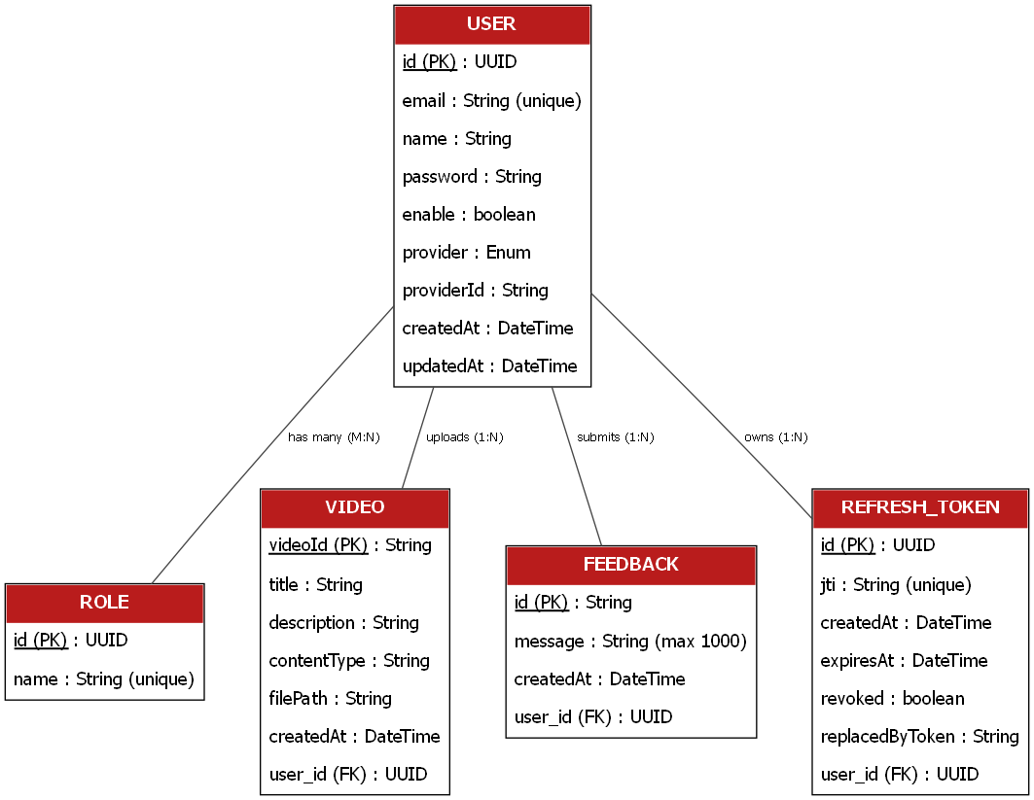
Fig. 4.2 – Entity-Relationship (E-R) Diagram of StreamHub Database
4.4 User Modeling Language (UML) Diagrams
The following UML diagrams illustrate the structural and behavioral design of the “StreamHub” system, including the use cases, activity flow, sequence of operations, object collaboration, and class structure.
4.4.1 Use Case Diagrams
The use case diagram below shows the interaction between the two main actors of the system – User and Administrator – and the various use cases they can perform.
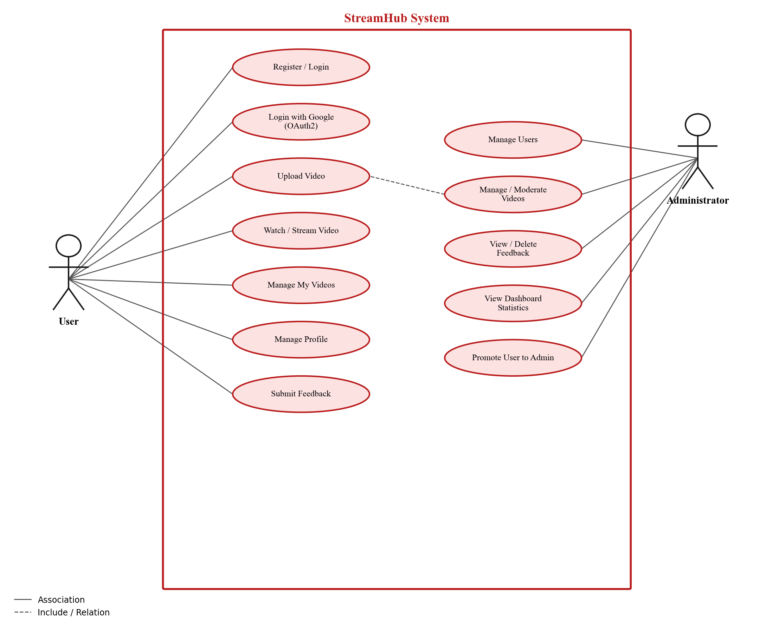
Fig. 4.3 – Use Case Diagram of StreamHub
4.4.2 Activity Diagrams
The activity diagram below represents the step-by-step flow of the video upload process, from file selection to HLS conversion and final display of the uploaded video.
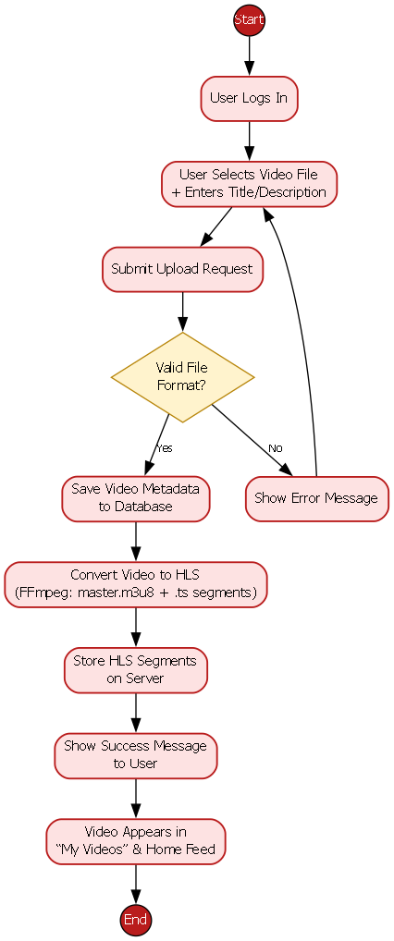
Fig. 4.4 – Activity Diagram for Video Upload Process
4.4.3 Sequence Diagrams
The sequence diagram below illustrates the interaction sequence between the User, Front-End, Video Controller, Video Service, FFmpeg, and the Database during the video upload and HLS streaming process.
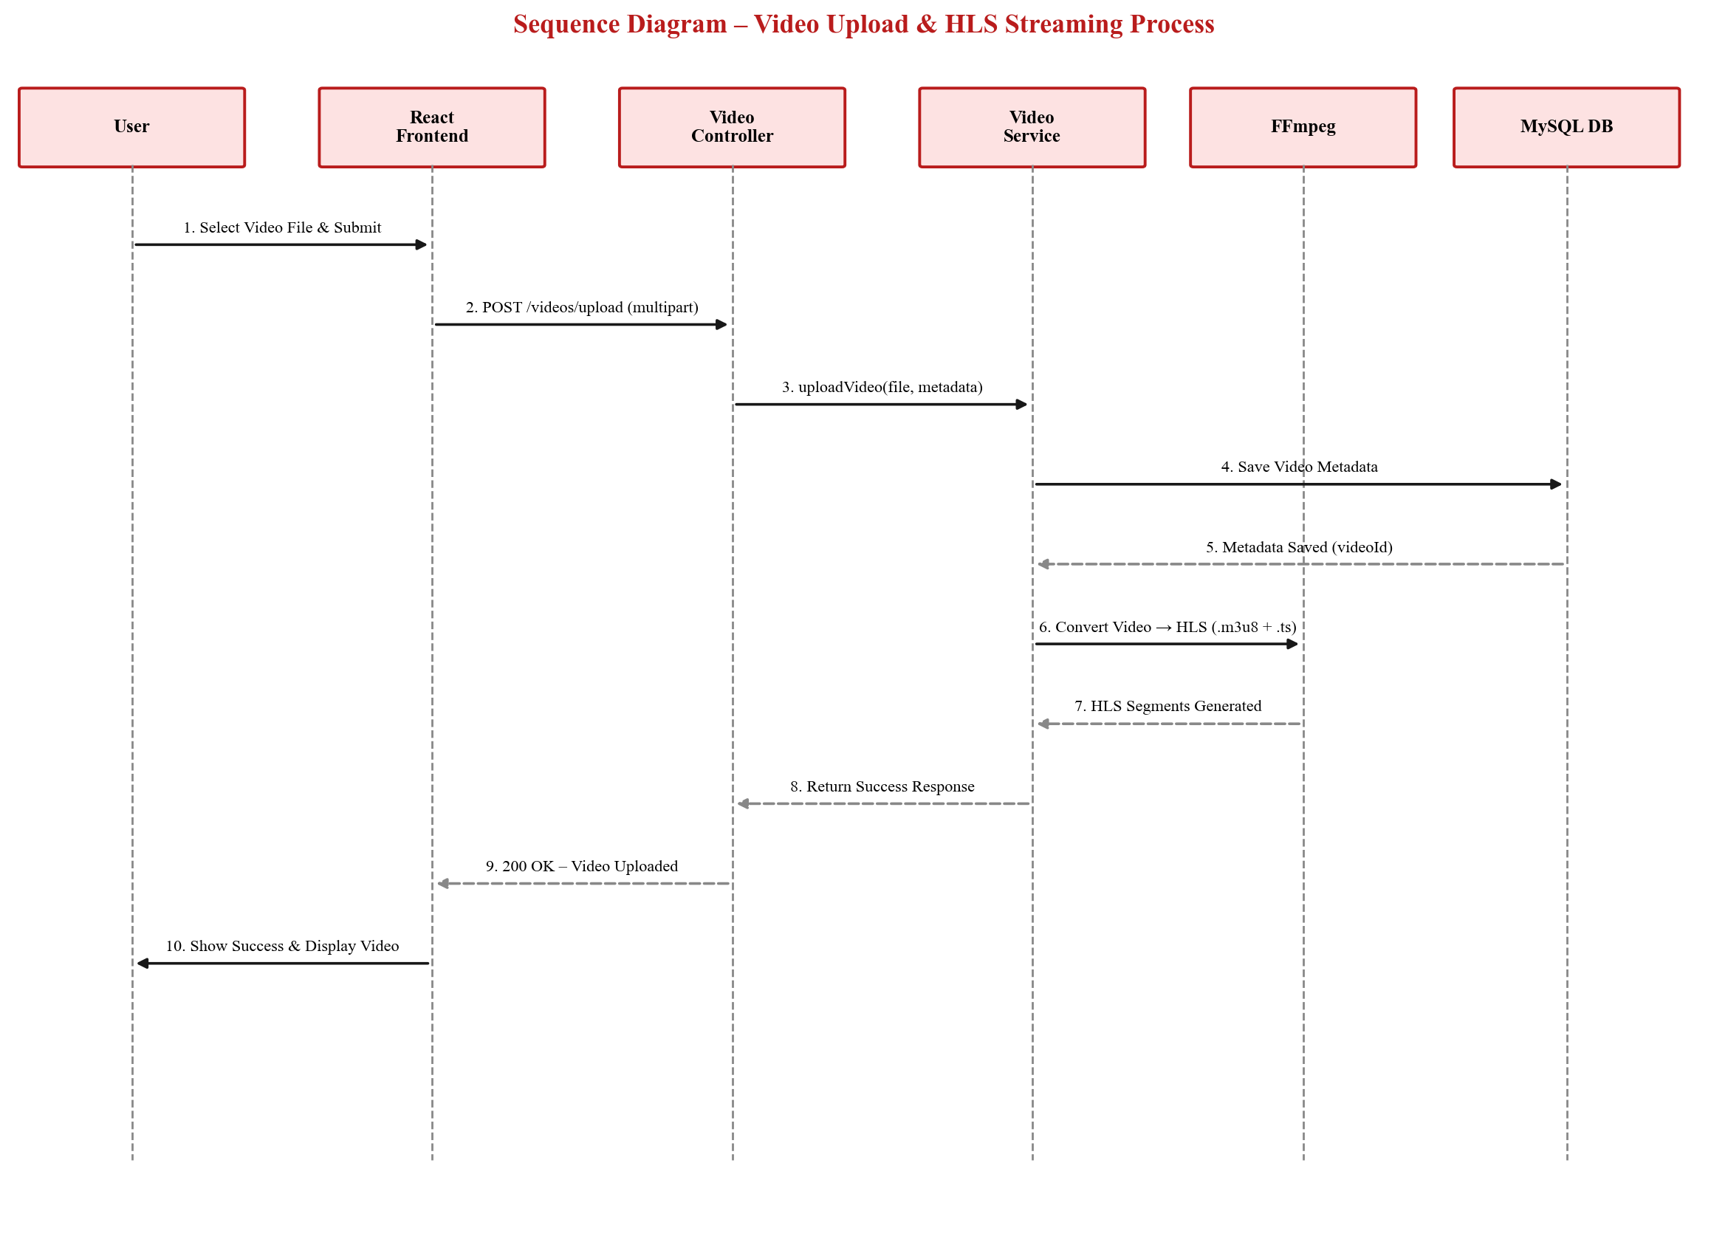
Fig. 4.5 – Sequence Diagram for Video Upload & HLS Streaming
4.4.4 Collaboration Diagrams
The collaboration diagram below shows the objects involved in the video upload process and the numbered messages exchanged between them.
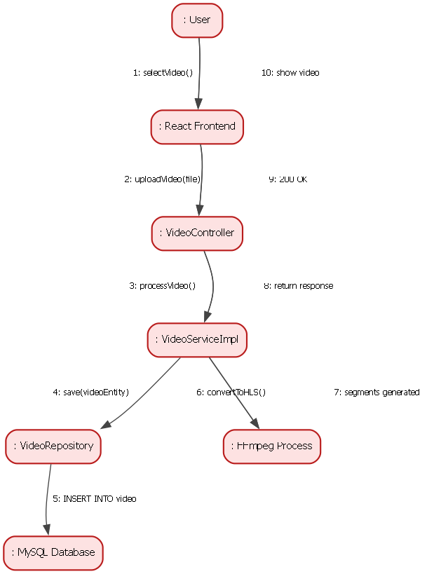
Fig. 4.6 – Collaboration Diagram for Video Upload Process
4.4.5 Class Diagrams
The class diagram below shows the main classes of the “StreamHub” system, including controller classes, service classes, and entity classes, along with their attributes, methods, and relationships.
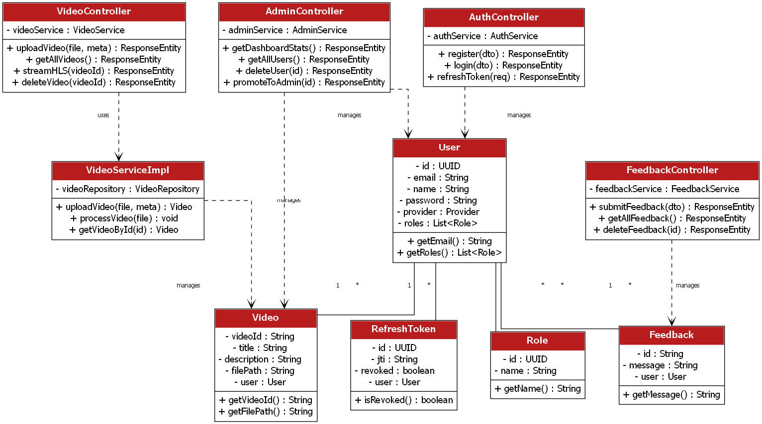
Fig. 4.7 – Class Diagram of StreamHub
4.5 Input Design
Input design focuses on how data is collected from users and validated before being processed by the system. In “StreamHub,” the primary input forms include the registration form, login form, video upload form, and feedback form. Each form is designed to be simple, responsive, and user-friendly, with proper client-side and server-side validation to ensure data accuracy and security.
Input Form | Fields | Validation
Registration Form | Name, Email, Password | Validates required fields, unique email, minimum password length
Login Form | Email, Password | Validates credentials against the database; returns JWT access & refresh tokens on success
Video Upload Form | Video File, Title, Description | Validates file type/size; title and description are required
Feedback Form | Feedback Message | Validates that the message is not empty and does not exceed 1000 characters
Admin Login Form | Email, Password | Validates credentials and checks for ROLE_ADMIN before granting access

4.6 Output Design
Output design focuses on how information is presented back to the user after processing. In “StreamHub,” outputs are primarily displayed through the web interface in the form of video listings, video playback, success/error messages, and administrative reports.
Output Screen | Description
Home Feed | Displays a grid/list of all available videos with thumbnails and titles
Video Player Page | Streams the selected video using adaptive HLS playback with player controls (play, pause, seek, volume, quality, fullscreen)
My Videos Page | Displays a list of videos uploaded by the logged-in user, with options to manage or delete them
Admin Dashboard | Displays aggregate statistics such as total users, total videos, and recent activity
Admin Users / Videos / Feedback Pages | Displays tabular reports of all users, videos, and feedback entries with management actions
Toast Notifications | Displays success or error messages for actions such as login, upload, delete, and feedback submission

4.7 Video Upload & HLS Streaming Architecture
One of the core components of the “StreamHub” system is its video upload and adaptive streaming architecture, which is responsible for accepting uploaded videos, converting them into a streaming-friendly format, and delivering them efficiently to end users. This architecture combines the front-end upload interface, the Spring Boot back-end, and FFmpeg for media processing, working together to provide smooth, adaptive video playback.
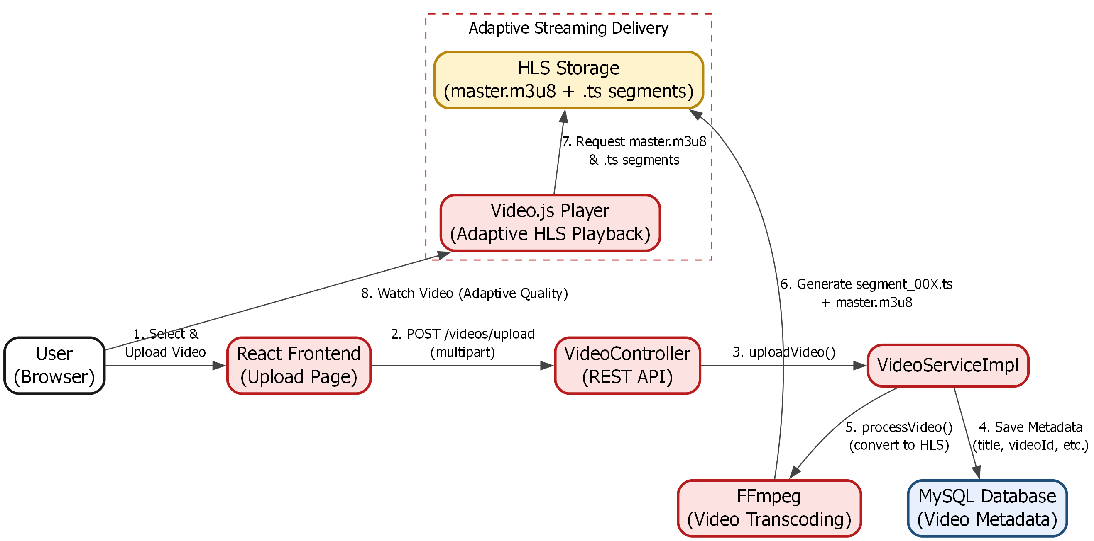
Fig. 4.8 – Video Upload & HLS Streaming Architecture
Video Upload Process
When a user uploads a video through the “Upload” page, the video file, along with its title and description, is sent to the back-end as a multipart HTTP request to the VideoController. The controller passes this data to the VideoServiceImpl, which first saves the video's metadata (title, description, content type, owner) to the MySQL database and generates a unique videoId for the video.
HLS Conversion using FFmpeg
After the metadata is saved, the raw video file is passed to FFmpeg, which is invoked from the back-end using a system process (ProcessBuilder). FFmpeg transcodes the video into H.264 video and AAC audio, and splits it into small segments (segment_001.ts, segment_002.ts, etc.), along with a master playlist file (master.m3u8) that references these segments. This process is known as HTTP Live Streaming (HLS), and it is what enables adaptive bitrate streaming – allowing the video player to adjust playback quality dynamically based on the user's available network bandwidth.
Storage and Delivery
The generated HLS segments and playlist file are stored on the server under a dedicated directory (configured via the file.video.hls property), organized by videoId. Dedicated REST endpoints are exposed to serve these files with the correct MIME types – application/vnd.apple.mpegurl for the master playlist, and video/mp2t for the .ts segments – allowing any HLS-compatible video player, such as Video.js on the front-end, to fetch and play the stream seamlessly.
Alternative: HTTP Range Streaming
In addition to HLS, the system also supports direct HTTP range-based streaming through a dedicated endpoint. This allows the server to respond with 206 Partial Content responses and proper Content-Range headers, enabling users to seek or scrub to any part of the video without downloading the entire file – providing a fallback streaming mechanism alongside adaptive HLS playback.
Overall, this architecture ensures that videos uploaded to “StreamHub” are automatically optimized for smooth, adaptive playback across a wide range of devices and network conditions, closely resembling the streaming experience provided by modern, real-world video platforms.

