**Create a flume agent that streams data from Twitter and stores it in the HDFS cluster.**

**CONFIGURING BASHRC FOR FLUME**

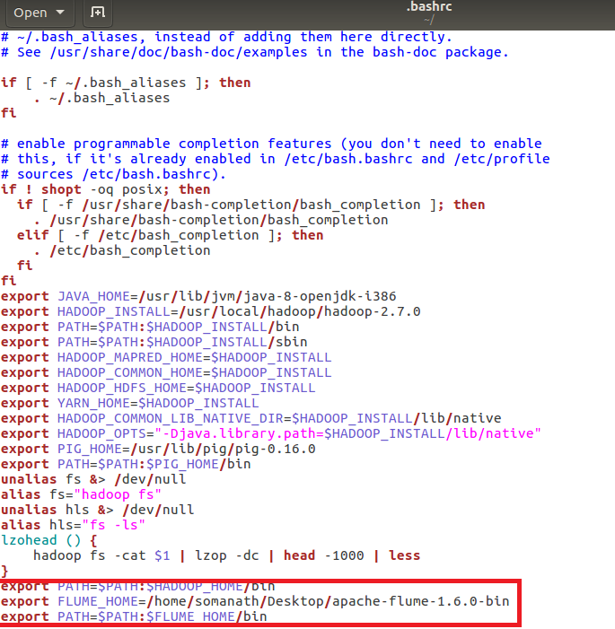

**CONFIGURING FLUME**

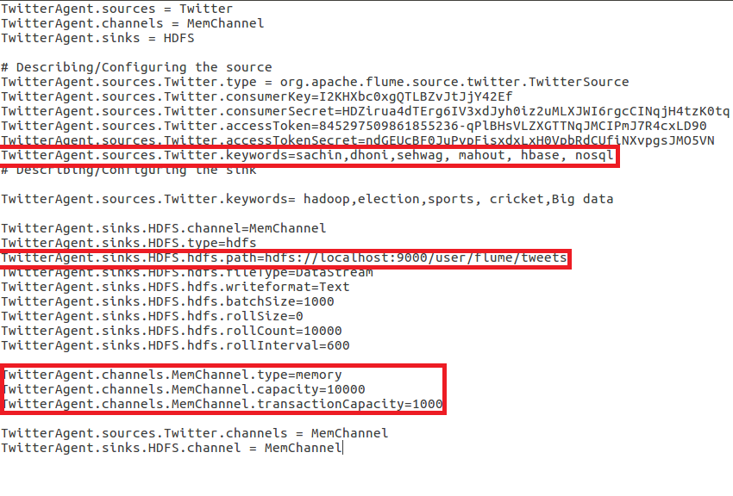

**RUNNING FLUME**

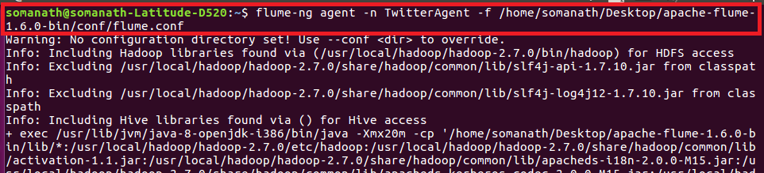

**CHECKING OUTPUT**

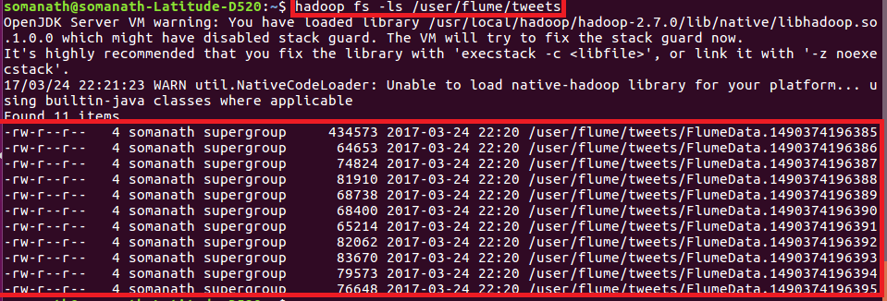

**SAMPLE OUTPUT**

