**Assignment 16.3**

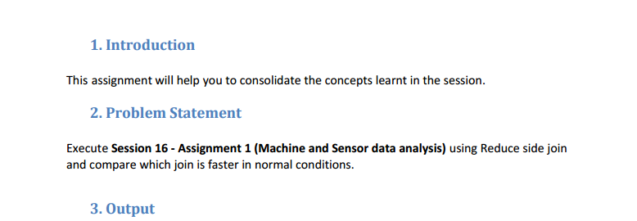

**Driver class**

**Use mulitiple Input paths to get multiple in puts for mapper**

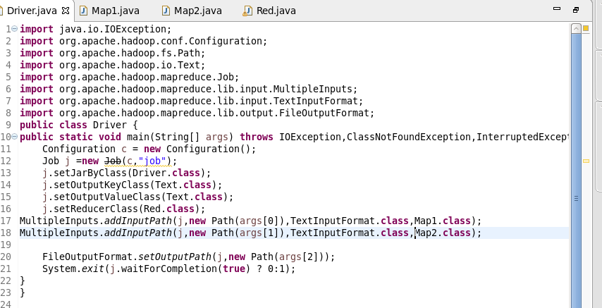

**Mapper1 Class**

**mapper 1 sending the BUILDING ID and Country as key and value respectively**

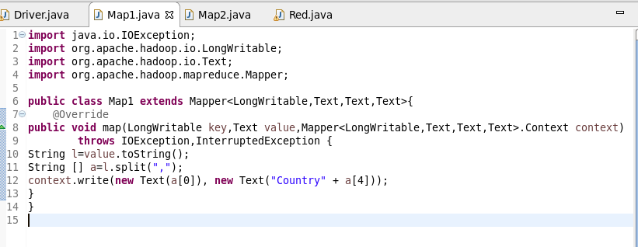

**Mapper2 Class**

In this checked for variation(actual temperature not equal to targeted temperature) and then sent BUILDING ID AS KEY AND A COUNT OF 1 AS VALUE

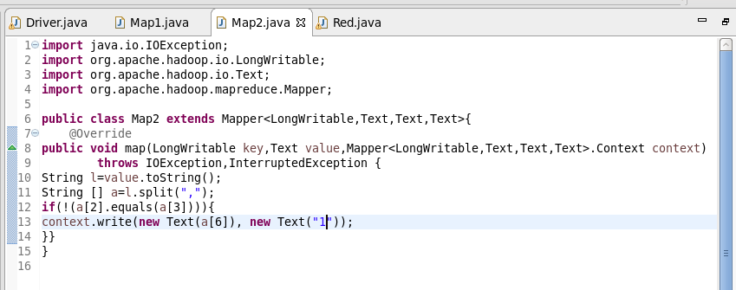

**Reducer Class**

IF VALUE MATCHED “CTRY ” I USED SUBSTRING TO TAKE THE COUNTRY FOR A GIVEN ID ELSE MADE TOTAL COUNT AND GAVE COUNTRY AS KEY AND TOTAL COUNT AS VALUE

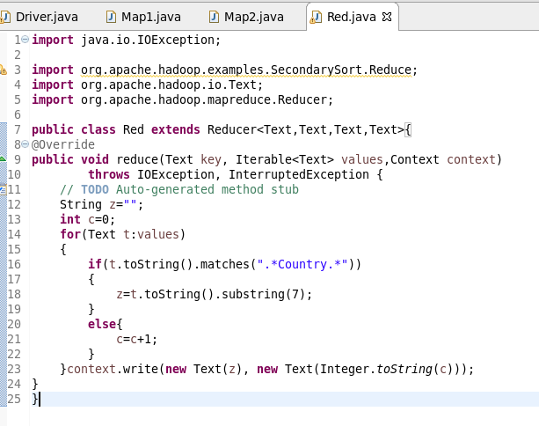

**Running Jars**

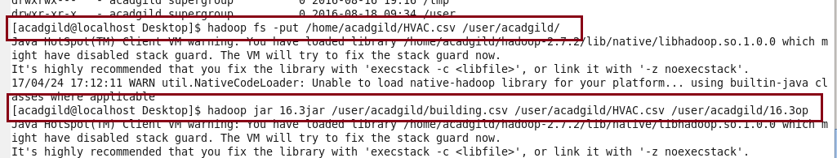

**OUTPUT**

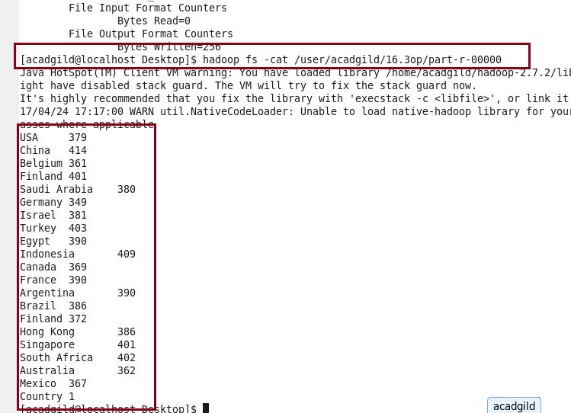

**-** joining the Reduce Side will happen after the completion of Map Phase. So data will come from different map/Machine.

- Reduce-Side joins are more simple than Map-Side joins since the input datasets need not to be structured.  
- It is slower and less efficient then the Map Side join.